Memory Hierarchy
（SRAM, DRAM, Flash)
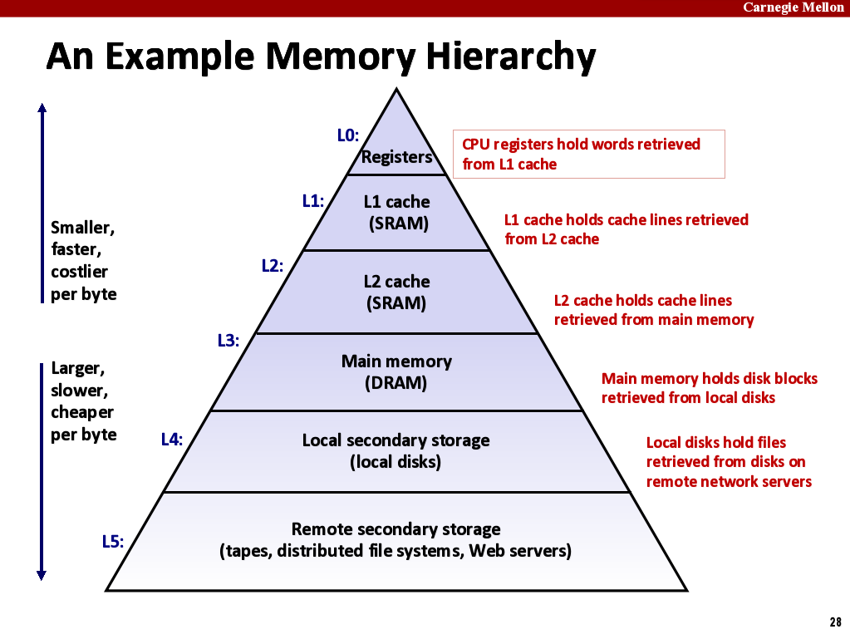
As the distance from the processor increases, the size of the memories and the access time both increase. This structure, with the appropriate operating mechanisms, allows the processor to have an access time that is determined primarily by level 1 of the hierarchy and yet have a memory as large as level n.
DRAM：电容的充电与放电。但电荷会流失，需定期充电刷新。
SRAM：CMOS的应用。但需6个晶体管，导致集成度低。

Principle of Locality(程序的局部性原理)
①时间局部性temporal locality: 最近被访问的存储单元很快被再次访问
Recently referenced items are likely to be referenced again in the near future
②空间局部性spatial locality: 正在被访问的存储单元的附近单元更有可能被访问
Items with nearby addresses tend to be referenced close together in time
实验: 一个1G的数组，遍历一次所消耗的时间 > 随机访问n次所消耗的时间

cache-friendly code:
1. Keep working set reasonably small (temporal locality)
2. Use small strides步长 (spatial locality)

Cache
程序局部性原理的应用, 寄存器与内存的折中（只是硬件实现的优化，而对软件屏蔽其细节）
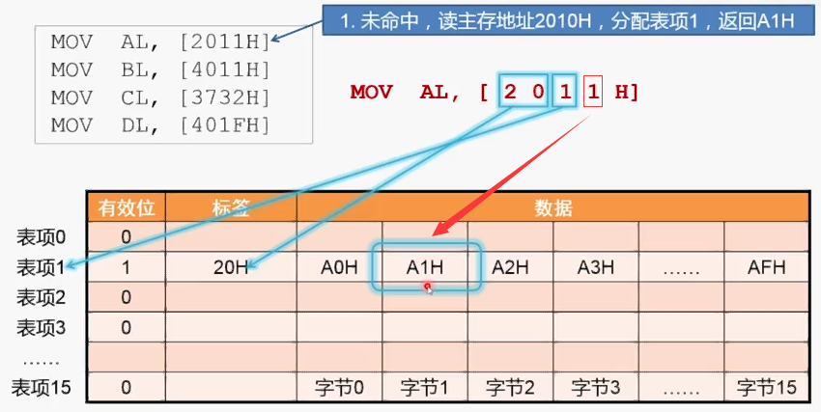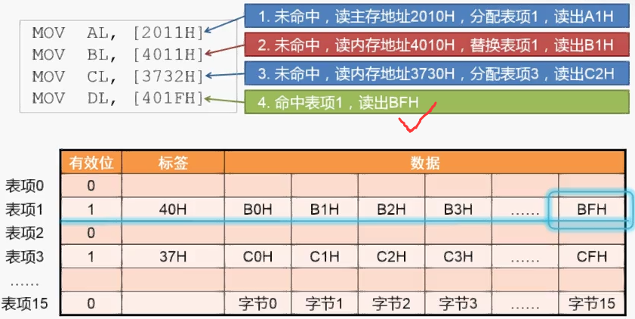
Cache读失效时：
·Placement policy:放置 determines where block goes
·Replacement policy:替换 determines which block gets evicted (victim)
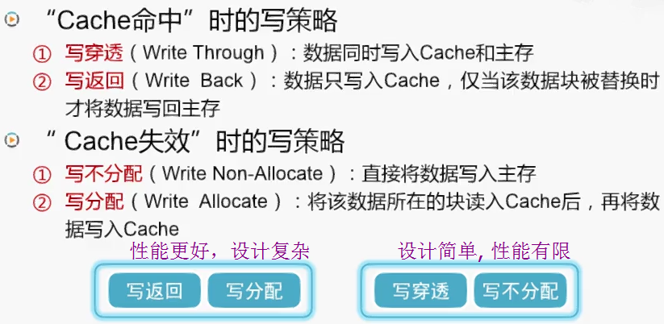

后期评估及改进
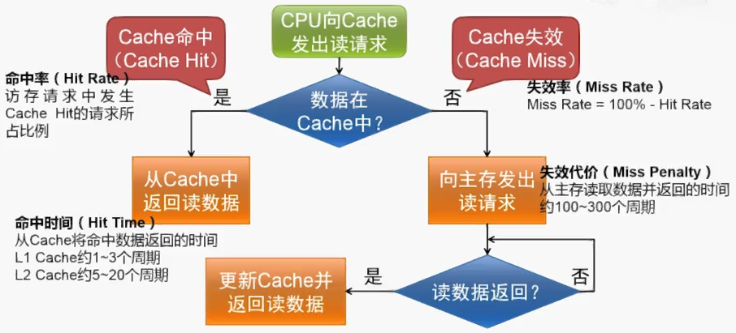
CPU time = CPU execution time + Memory-stall time
计算时间 I/O阻塞 (primarily miss penalty)
AMAT(Average Memory Access Time) = Hit time + Miss rate × Miss penalty

待解决的问题：提高命中率(hit rate) + 降低失效代价 + 数据的一致性(coherence)

set associative: direct mapped 和fully associative的折中
解决的问题：避免只有Tag和Data不同的地址对同一个位置的竞争
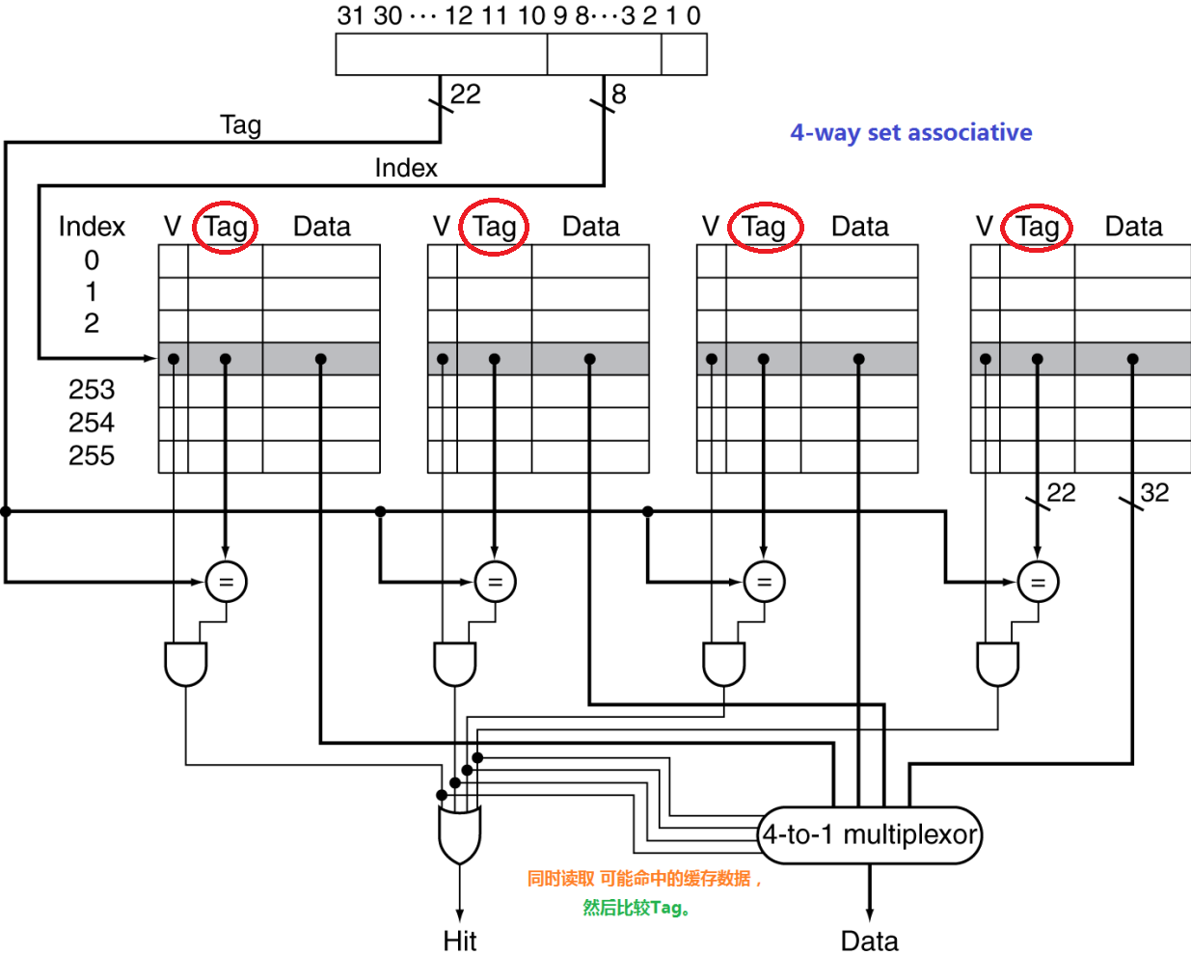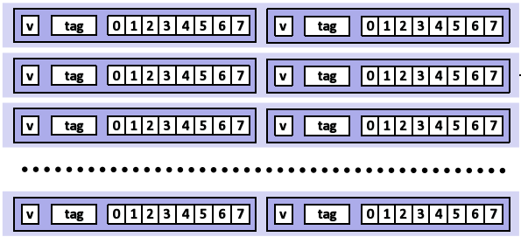
Replacement Policy（缺失后的替换策略）：
- least-recently used 最近最少使用者
- random随机化

Multilevel Cache： 既然缺失是无可避免的，不如在缓存与内存之间，再来一个缓存？
L1（I-Cache + D-Cache） -> L2 -> L3
First-level caches are more concerned about hit time,
and second-level caches are more concerned about miss rate.

Virtual Memory
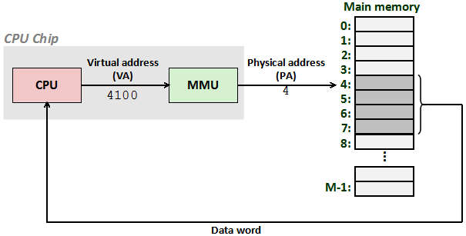
TLB(Translation Lookaside Buffer)：加速页表查找的缓存，mall hardware cache in MMU.
1 提供简化、高效而安全的内存共享机制
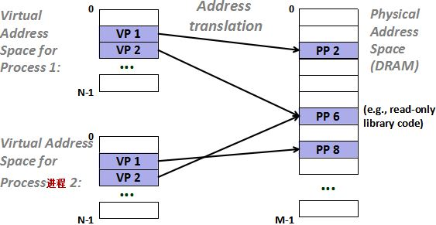
2 利用下一级的存储设备为内存扩容
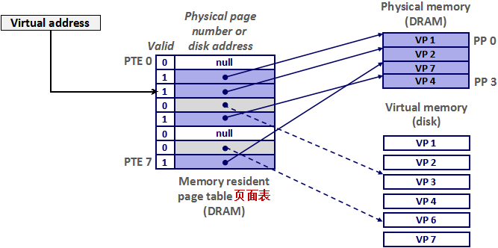

Hard Disk Drive
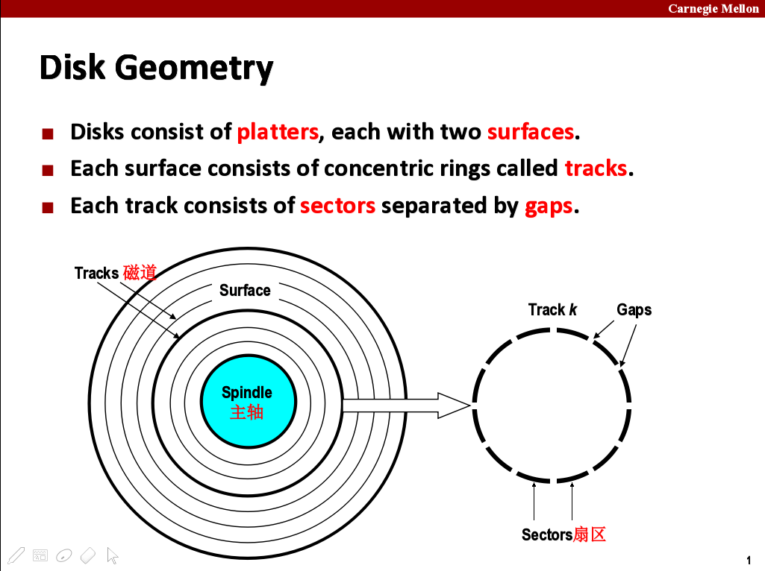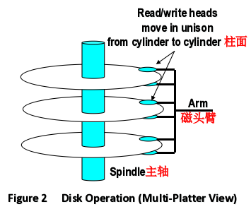
Capacity = (cylinders/disk) * (tracks/cylinder) * (avg. sectors/track) * (bytes/sector)
数据接口： SATA、IDE
运行过程：
·Seek 寻道
·Rotate 旋转
·Data transfer 传输

首个扇区(512KB) = 主引导记录(Master Boot Record, 446KB) + 分区表(Partion Table, 64KB) + 55AA
硬盘逻辑分区 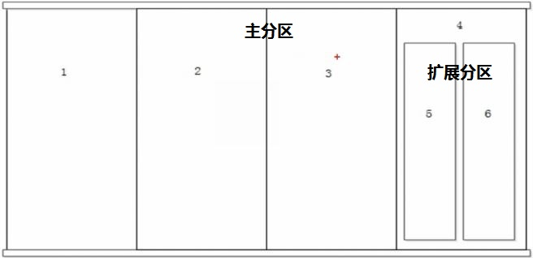
格式化: 写入文件系统(如: ext4, NTFS, FAT32), 为了更好地管理。
- 等分成4K的block 2. 建立分区规则表

Solid-state Disk
组成： Flash + PCB
优点： 快
缺点： 贵！先擦除再写入，存储单元的改写次数有限。

