Structure and Interpretation of Computer Programs
·primitive expression(计算) and statement(控制)
·means of combination
·means of abstraction

Function
Input ^{function}_{> Ouput}
expression tree(表达式展开树) + context(上下文)
Control Flow: branch, iteration

思想： 函数是一等公民。 多元函数，不断地取定值，以减少变量个数.
1 Function As Arguments
既然能以定值传参，那么可否以变数传参？

2 Nested Definition
作用域受限于所属函数的局部函数
优点: 可以捕获上下文来获取数据，而不必通过参数传递.
Locally defined functions are often called closure, because they enclose(装入) information in this way.
Closure is the key to power in any means of combination because it permits us to create hierarchical structures -- structures made up of parts, which themselves are made up of parts, and so on.
解释: (匿名局部函数)
lambda x : f(g(x))
“A function that takes x and returns f(g(x))”

3 Function As Returned Value
返回值是函数

Object
primitive = built-in data type + computation
↓
compound = attribute + method
↓
generic

local、global 要点：
存在性existence？ 作用范围(scope)？

box-and-pointer模型
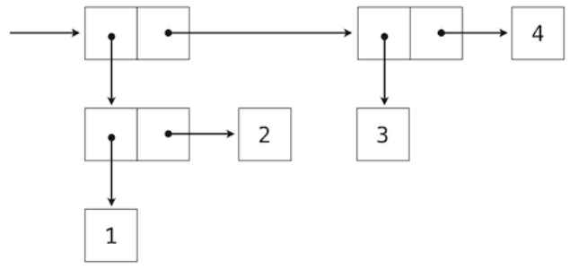
In general, a method for combining data values satisfies the closure property if the result of combination can itself be combined using the same method. 组合后的结果能以相同的方式被组合

Python中的对象模型： (注意：等值性、同一性的区别)
name-value的dictionary

Advanced
recursion、hierarchical、order of growth

