“Make implementation-level EWS (data model + APIs + workflow diagrams + UI images)”

🔷 1. OBJECTIVE
To implement an AI-driven Early Warning System (EWS) that:
- Identifies potential default before delinquency
- Reduces NPA proactively
- Supports credit risk monitoring
- Integrates with CBS, IFRS 9, AML, Collection
🔷 2. SYSTEM ARCHITECTURE
CBS / LOS / Transactions / External Data
↓
Data Warehouse (DWH)
↓
EWS Engine
├── Rule Engine
├── AI Model (PD / Risk Score)
├── Scenario Engine
↓
Alert Engine
↓
UI Dashboard + Mobile + API
↓
Collection / Risk / Credit Teams

🔷 3. CORE MODULES:
📊 3.1 Data Aggregation Module
Sources:
- CBS (loan, DPD, repayment)
- Account transactions
- Customer profile
- External data (bureau, market)
🚨 3.2 Indicator Engine (KEY COMPONENT)
Types of Indicators:
🔻 Financial Indicators
- Drop in balance (>30%)
- Irregular payments
📉 Behavioral Indicators
- EMI delay
- Frequent overdraft
📊 Transaction Indicators
- Sudden withdrawal spike
- Salary not credited
🏦 Credit Indicators
- New loans elsewhere
- Credit score drop

3.3 Rule Engine
- Example Rules: IF (Balance Drop > 30%) AND (DPD > 15)
- → Risk Level = HIGH

🤖 3.4 AI Risk Scoring Engine

Output:
- PD Score (Probability of Default)
- Risk Level:
  - Low
  - Medium
  - High

🚨 3.5 Alert Engine

Generates:
- Real-time alerts
- Risk triggers

Alert Types:
- High-risk customer
- Potential default
- Fraud suspicion

📋 3.6 Case Management (Linked to Collection)

Alert → Case → Assign → Action → Monitor

🔷 4. AI CAPABILITIES (VERY STRONG 🚀)

🤖 4.1 PD Prediction Model
- Predict default probability
- Based on:
  - Behavior
  - History
  - Transactions

🧠 4.2 Early Risk Detection
- Identify risk before DPD

🔮 4.3 Scenario Simulation
- What-if analysis:
  - GDP drop
  - Interest rate change

📊 4.4 Smart Alert Prioritization
- Rank alerts:
  - Critical
  - Medium
  - Low

🔁 4.5 Continuous Learning Model
- AI improves with data

🔷 5. UI SCREENS (FIGMA-STYLE)

📊 5.1 EWS DASHBOARD

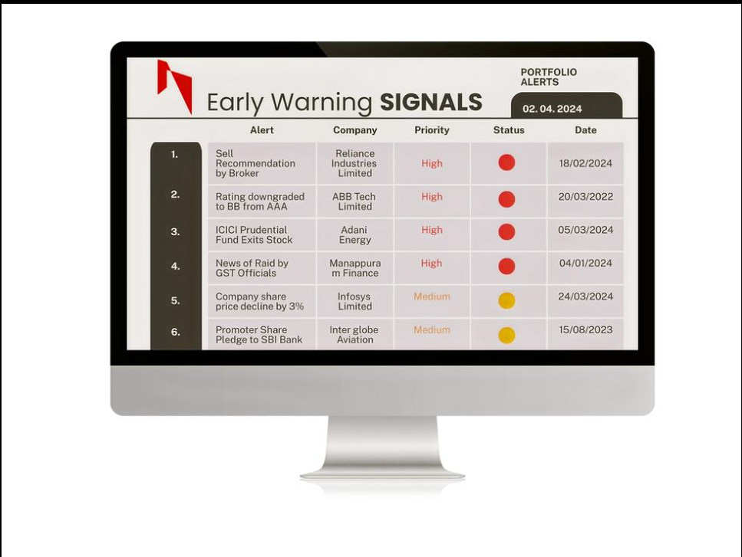

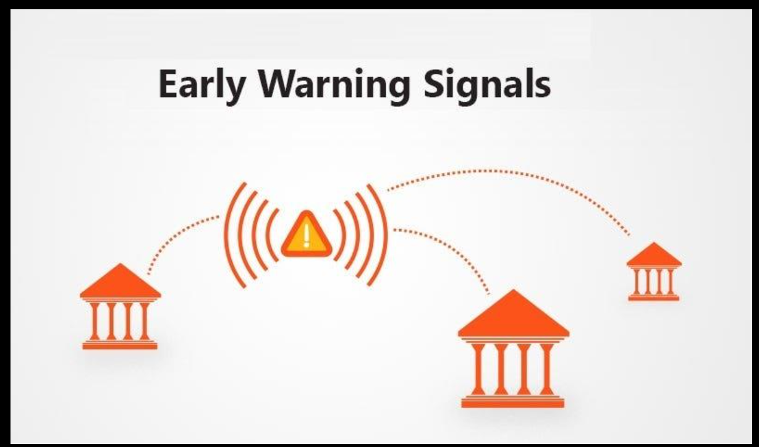

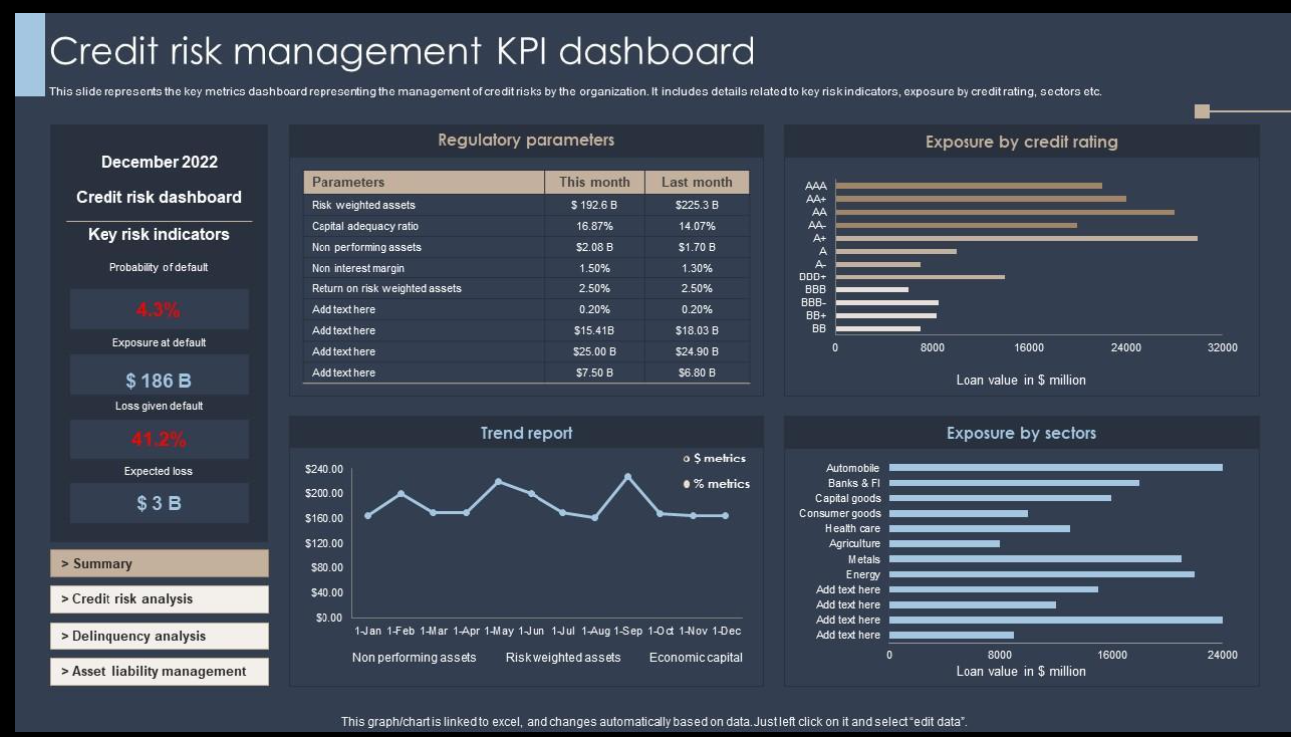

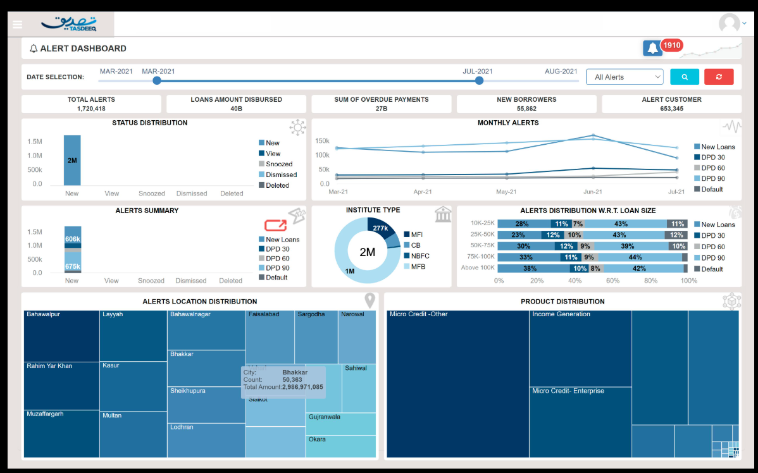

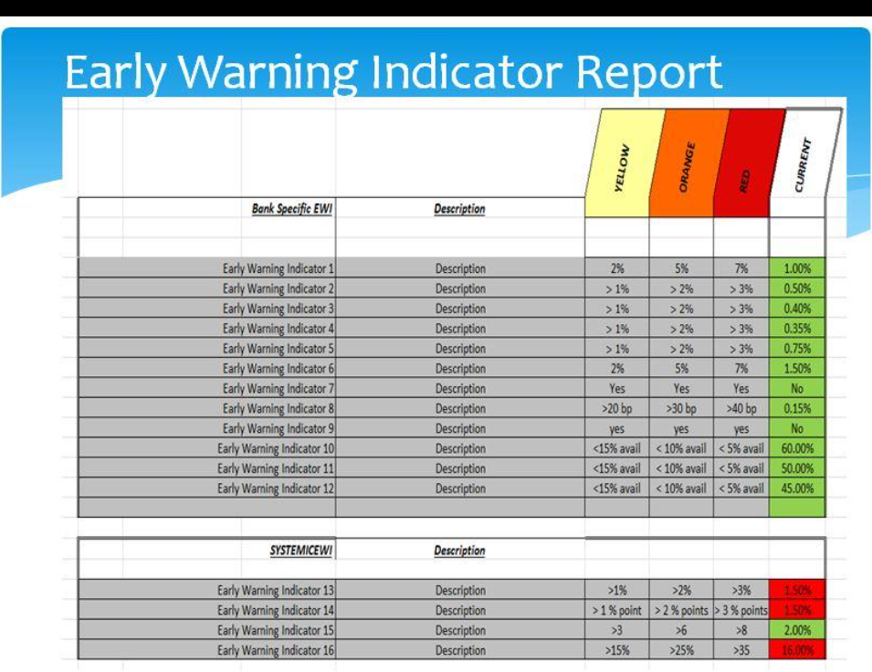

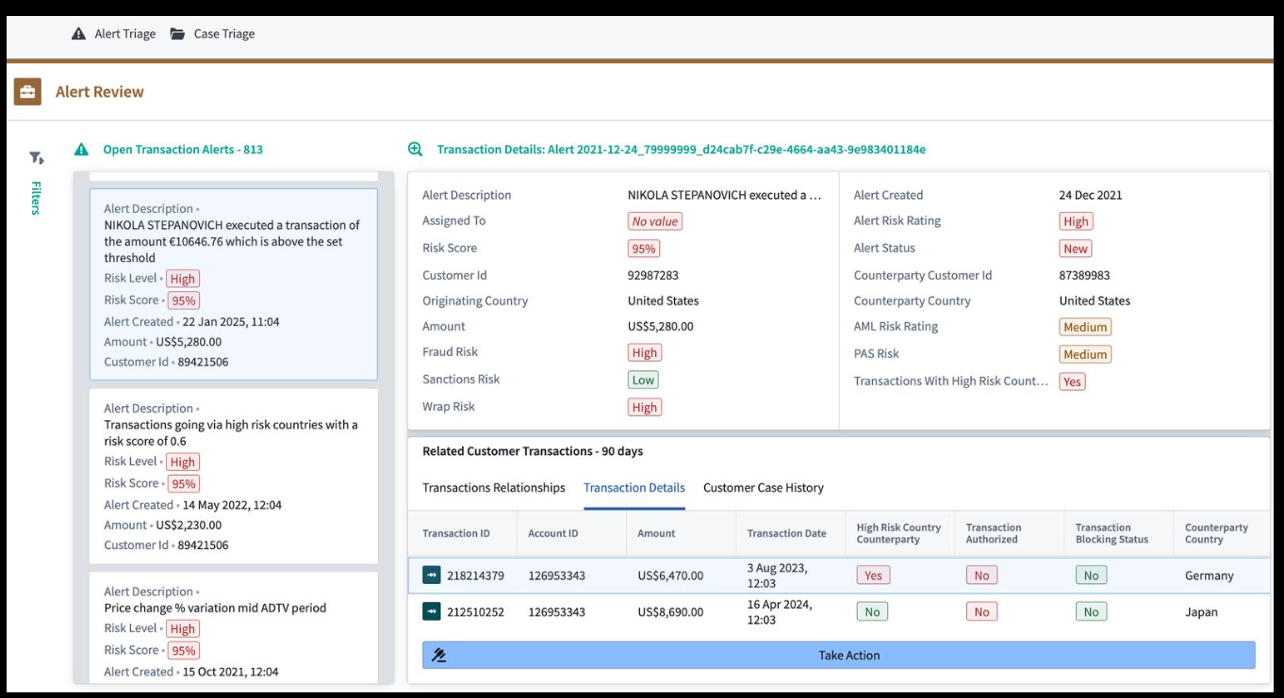

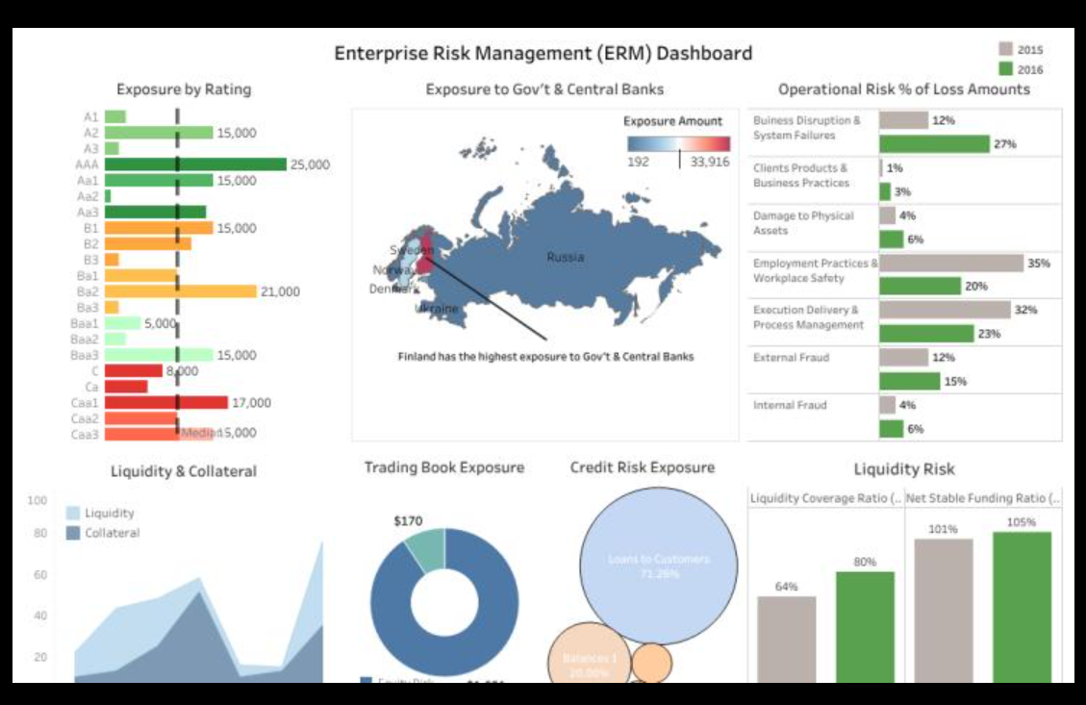

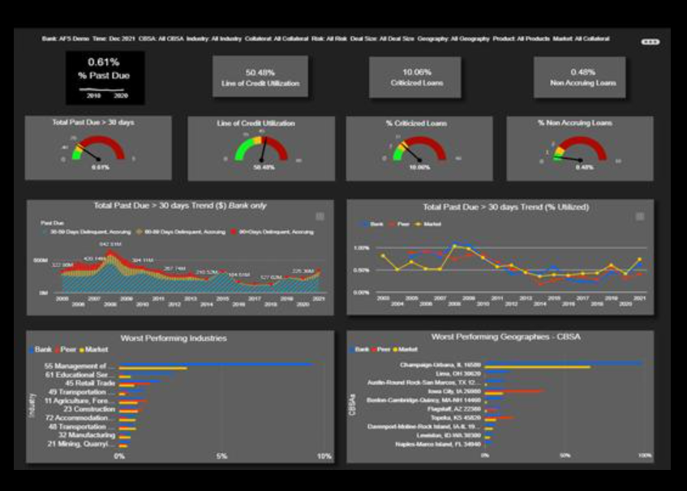

Widgets:
- Total alerts
- High-risk customers
- PD distribution
- Trend of alerts

5.2 ALERT LIST SCREEN:

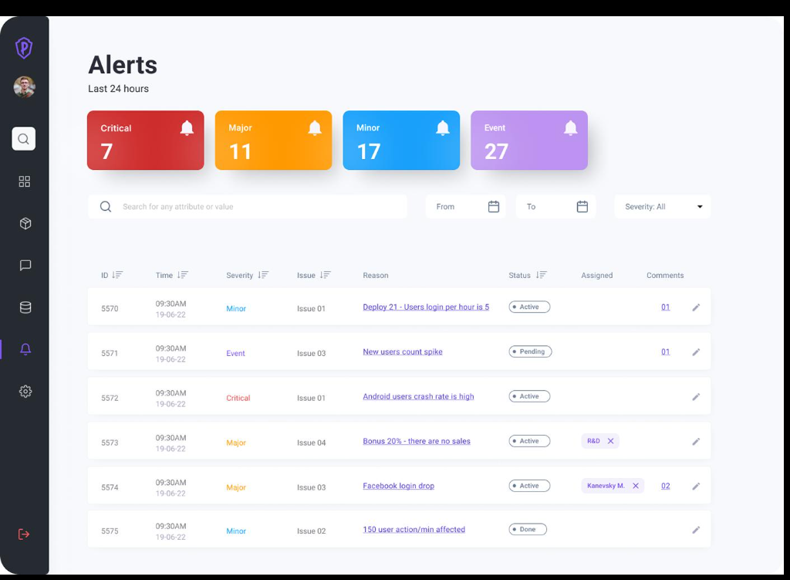

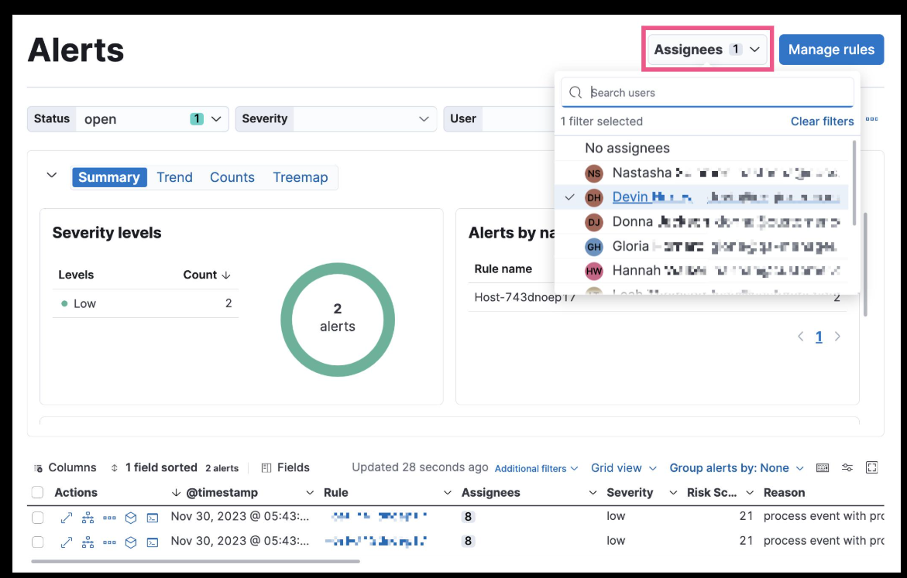

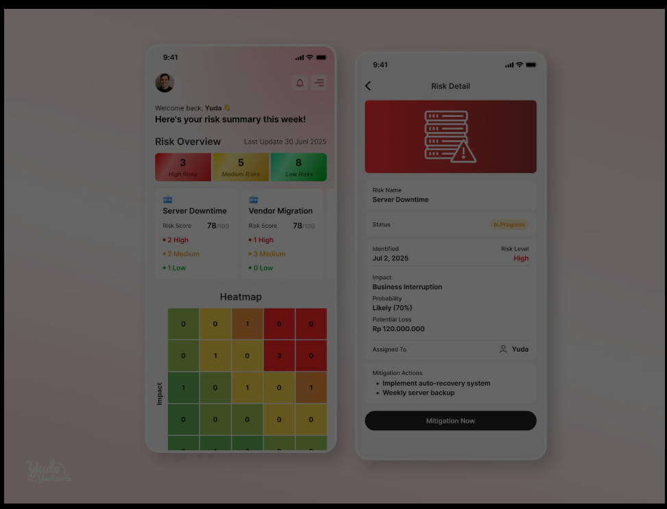

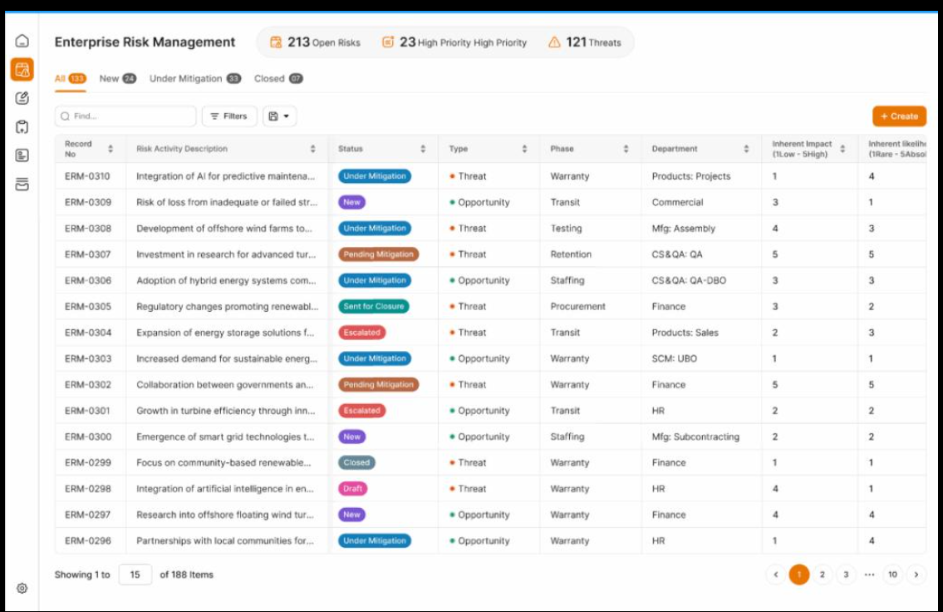

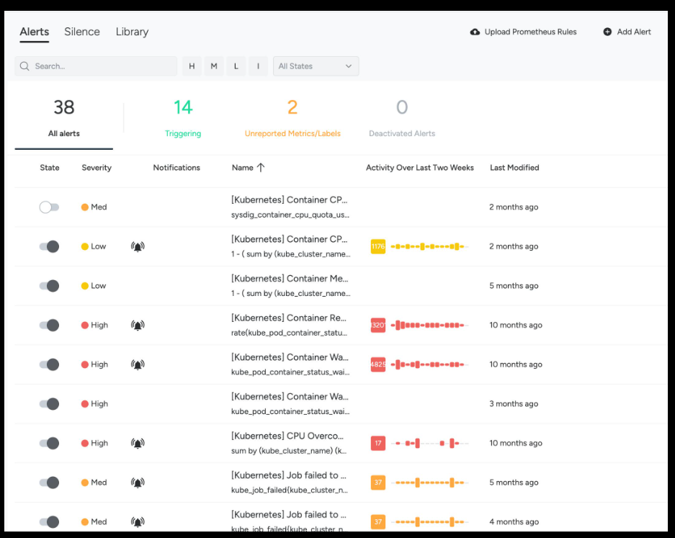

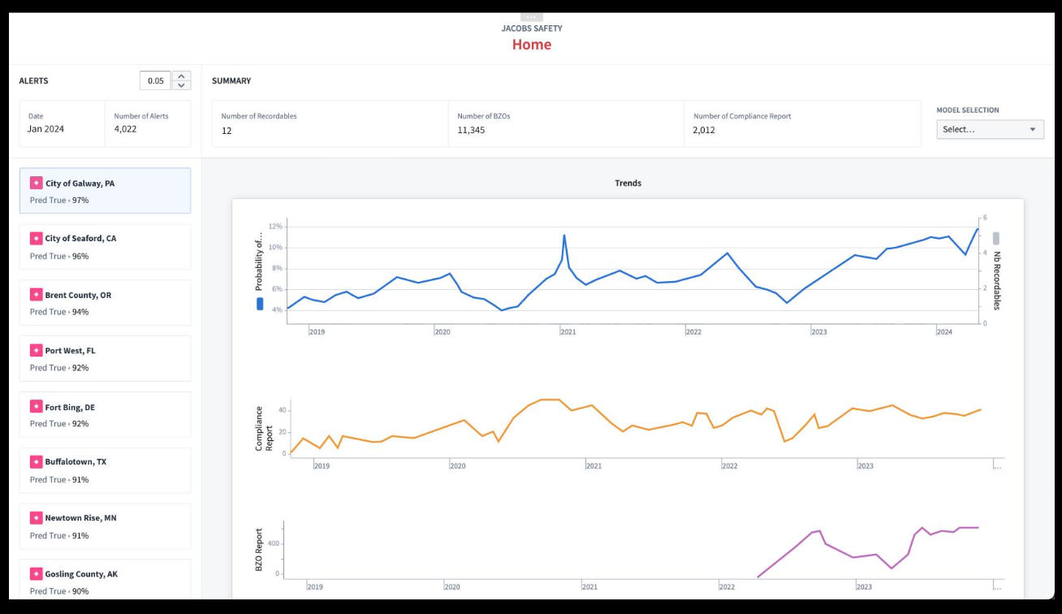

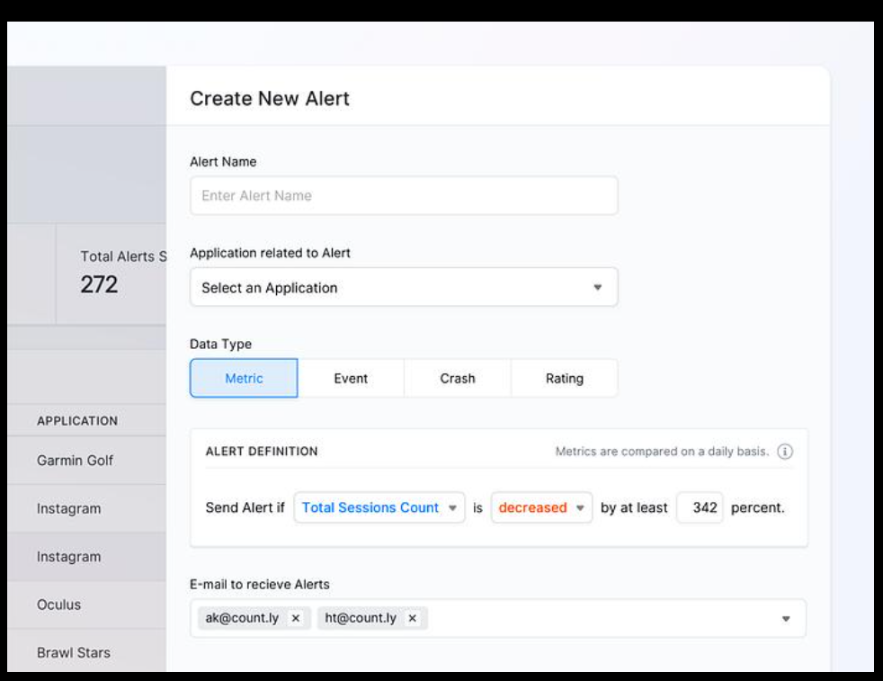

Columns:
- Customer ID
- Risk Score
- Indicator
- Severity
- Status

5.3 CUSTOMER RISK PROFILE:

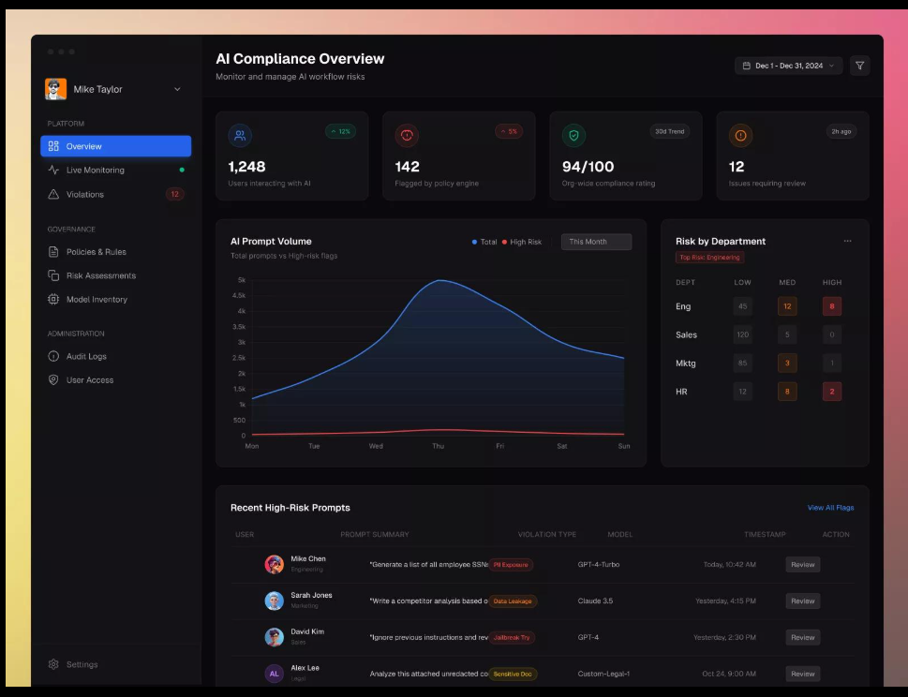

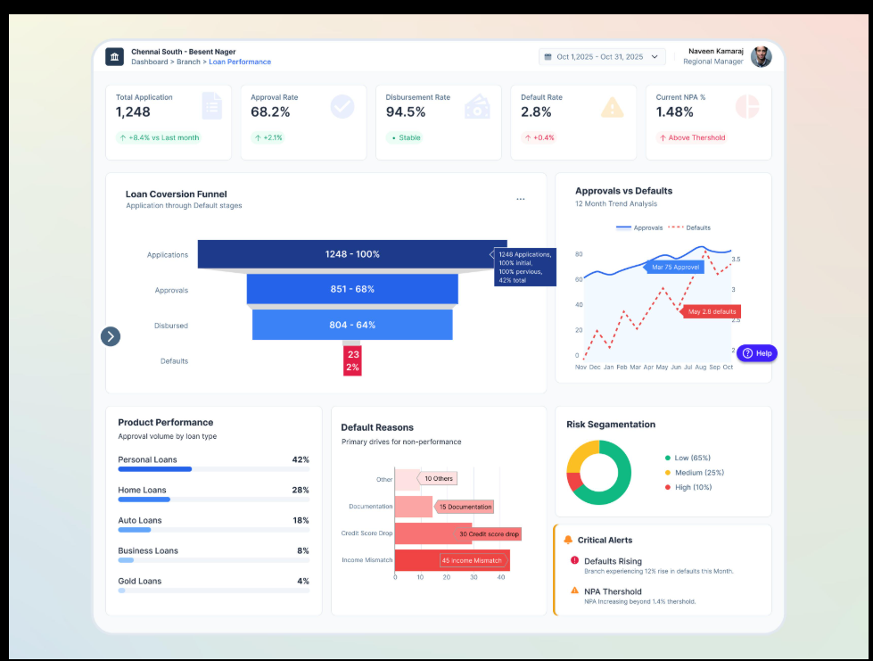

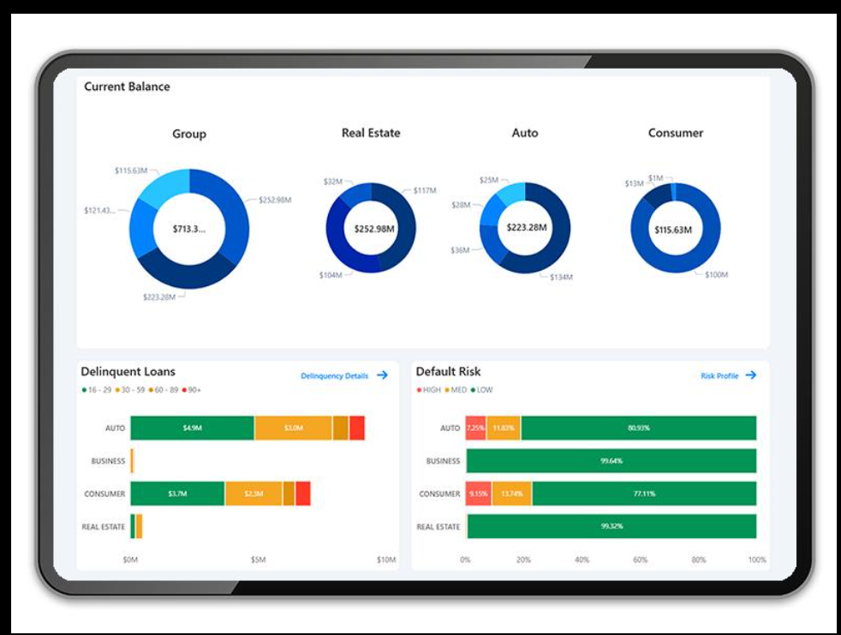
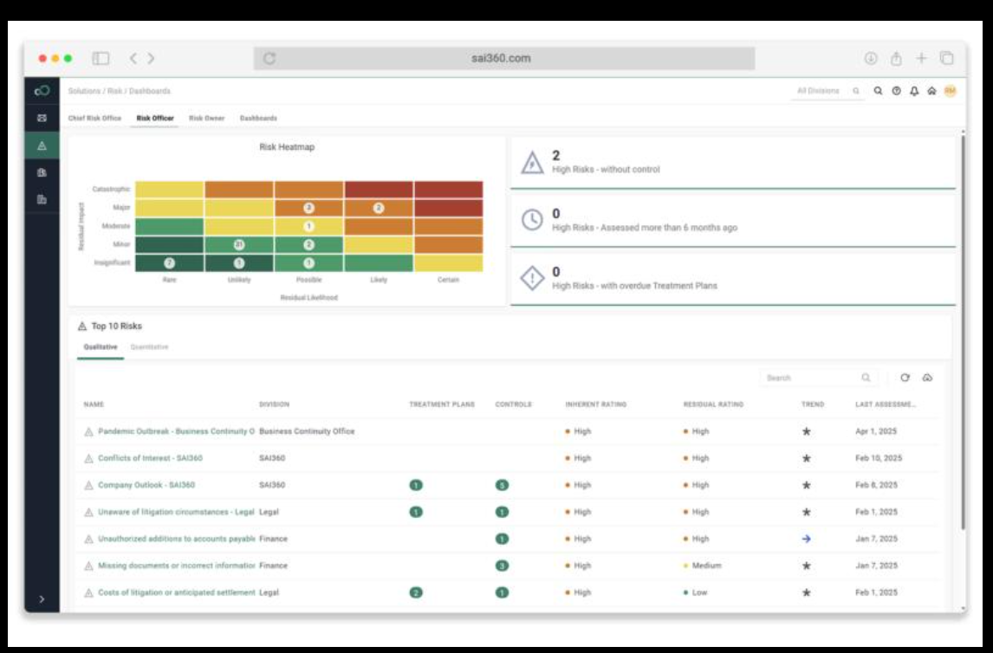
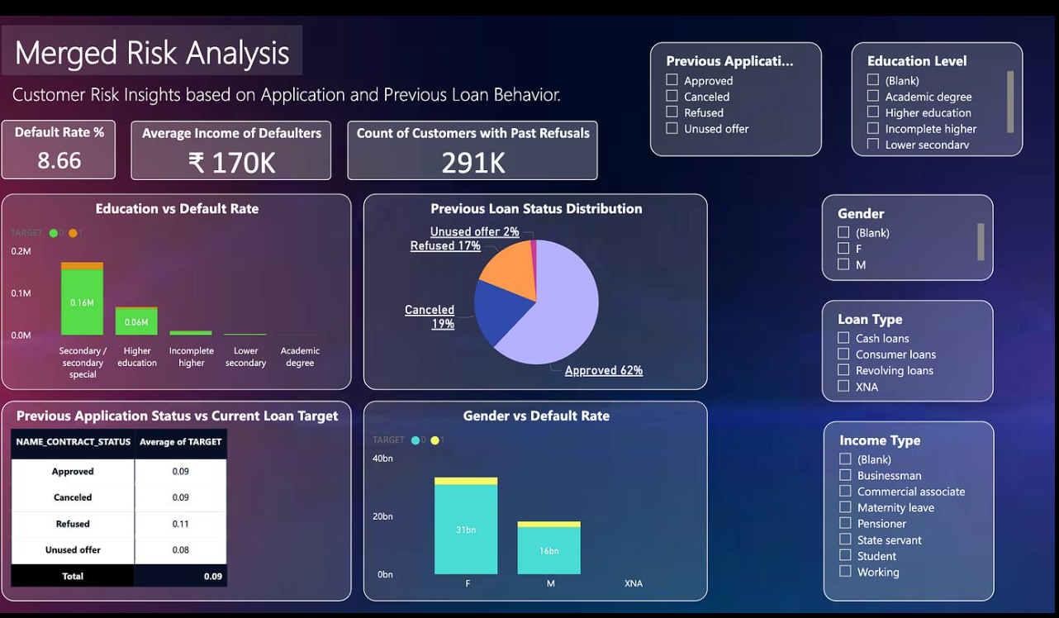
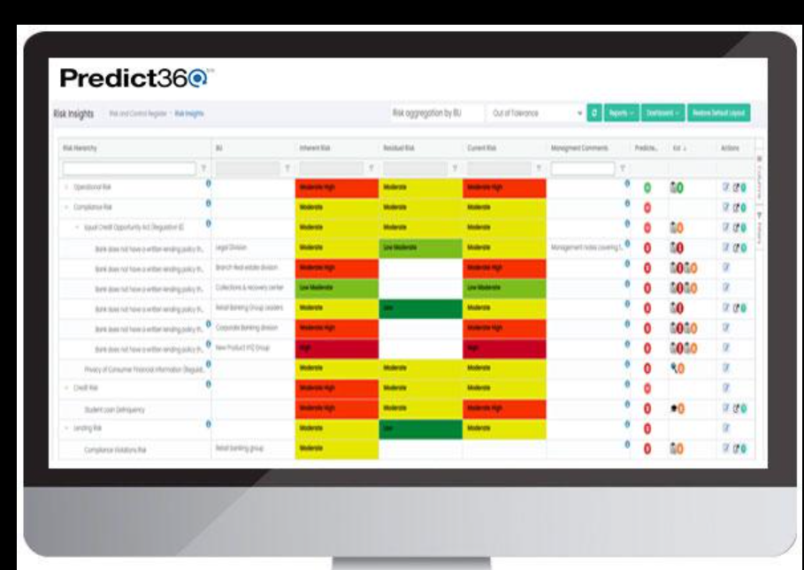

⚙️ 5.4 RULE CONFIGURATION SCREEN:
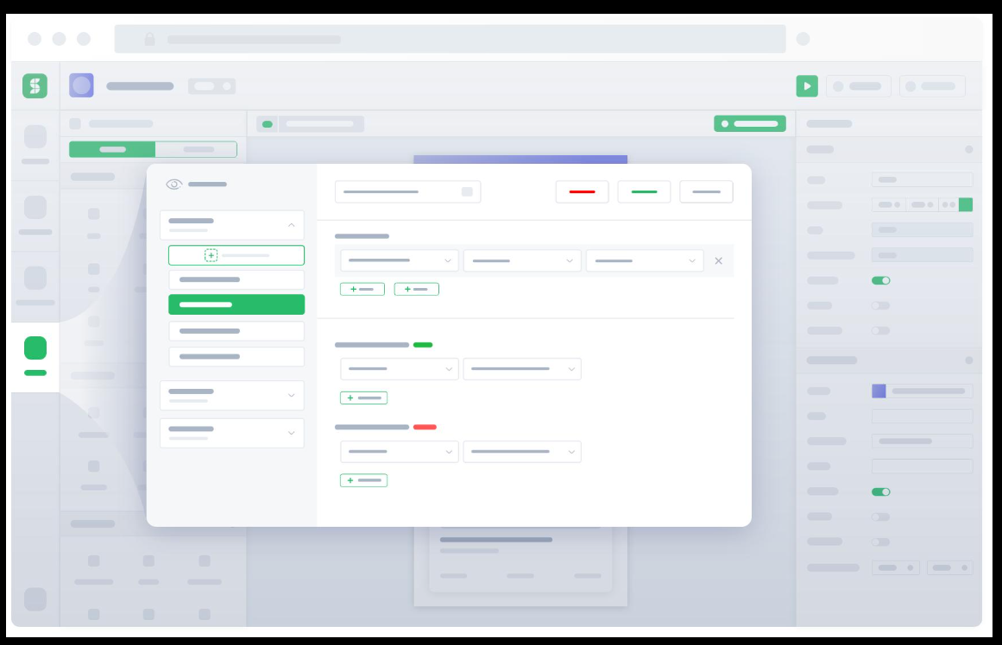

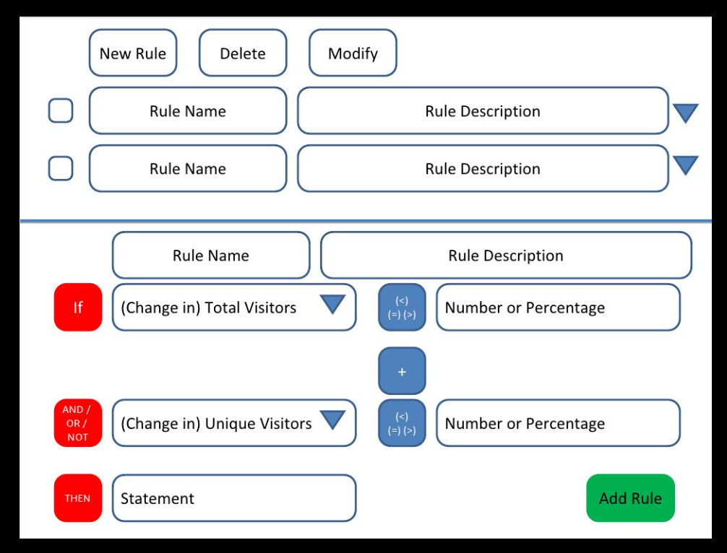

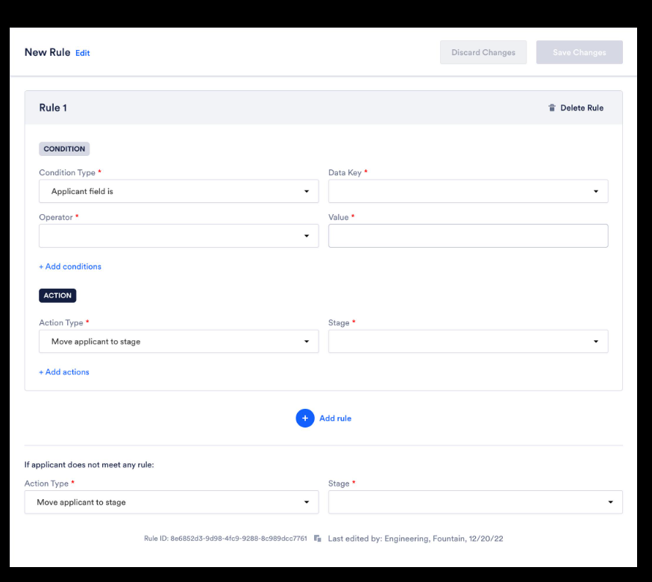

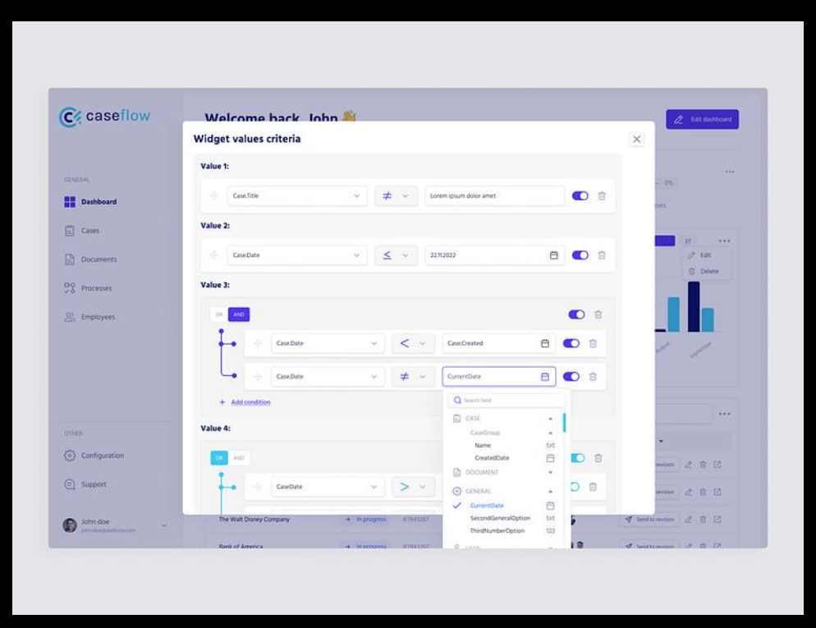

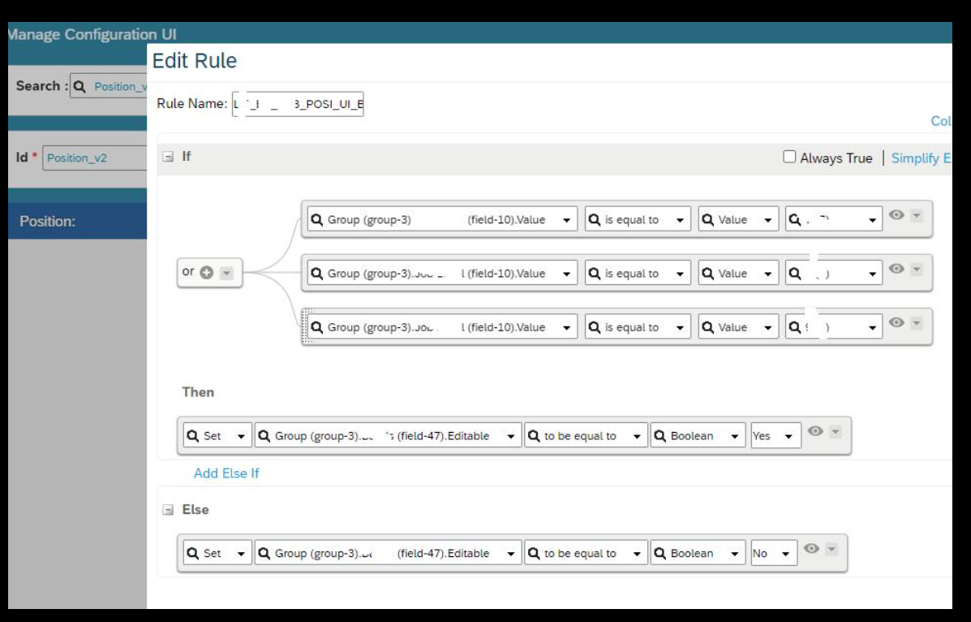

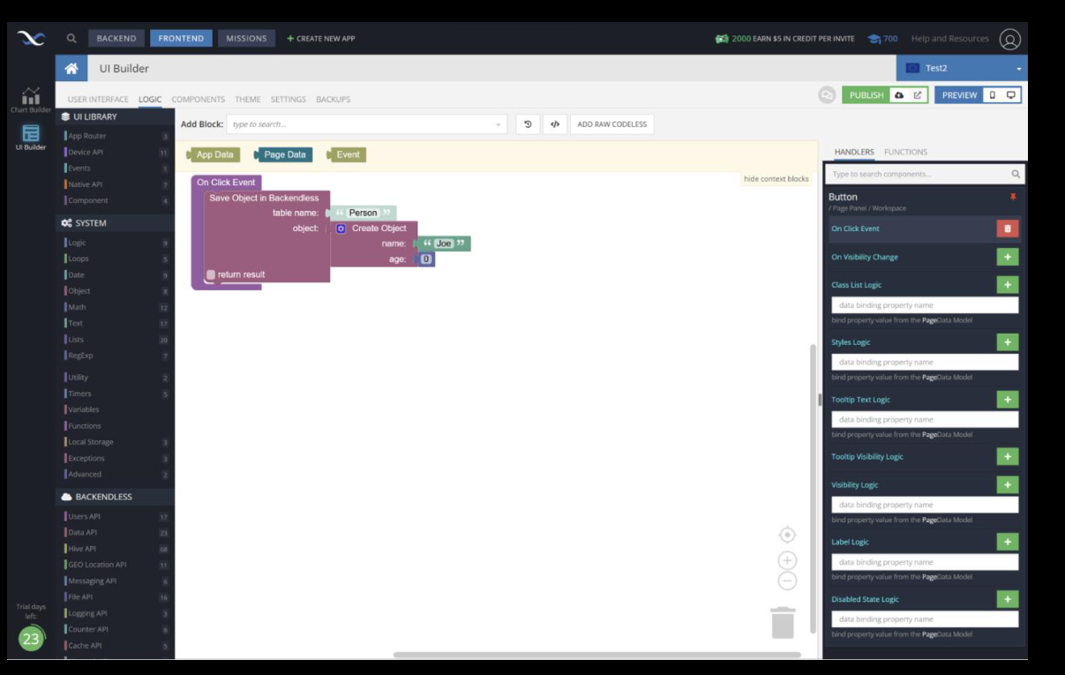

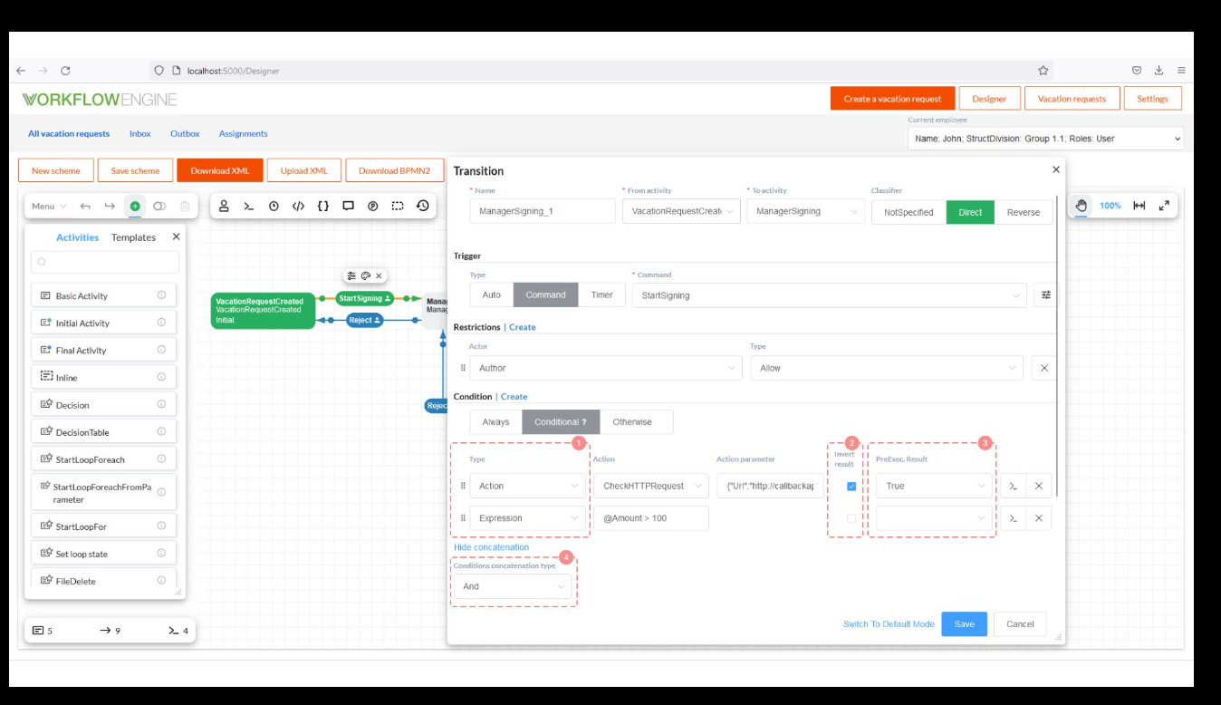

📊 5.5 ANALYTICS DASHBOARD

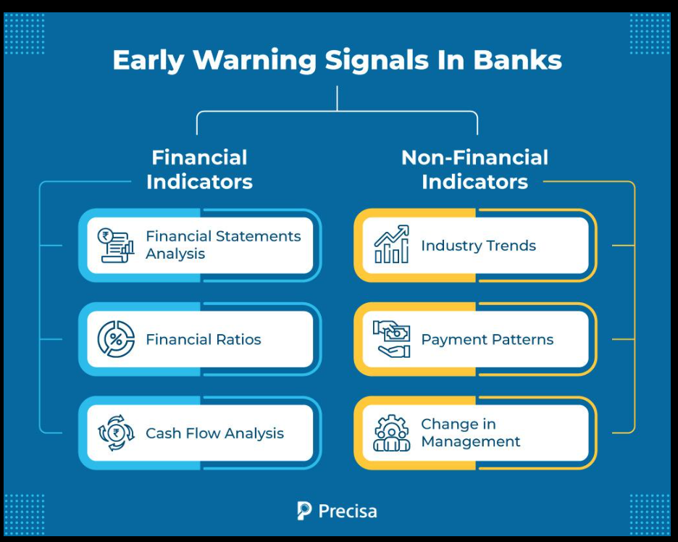

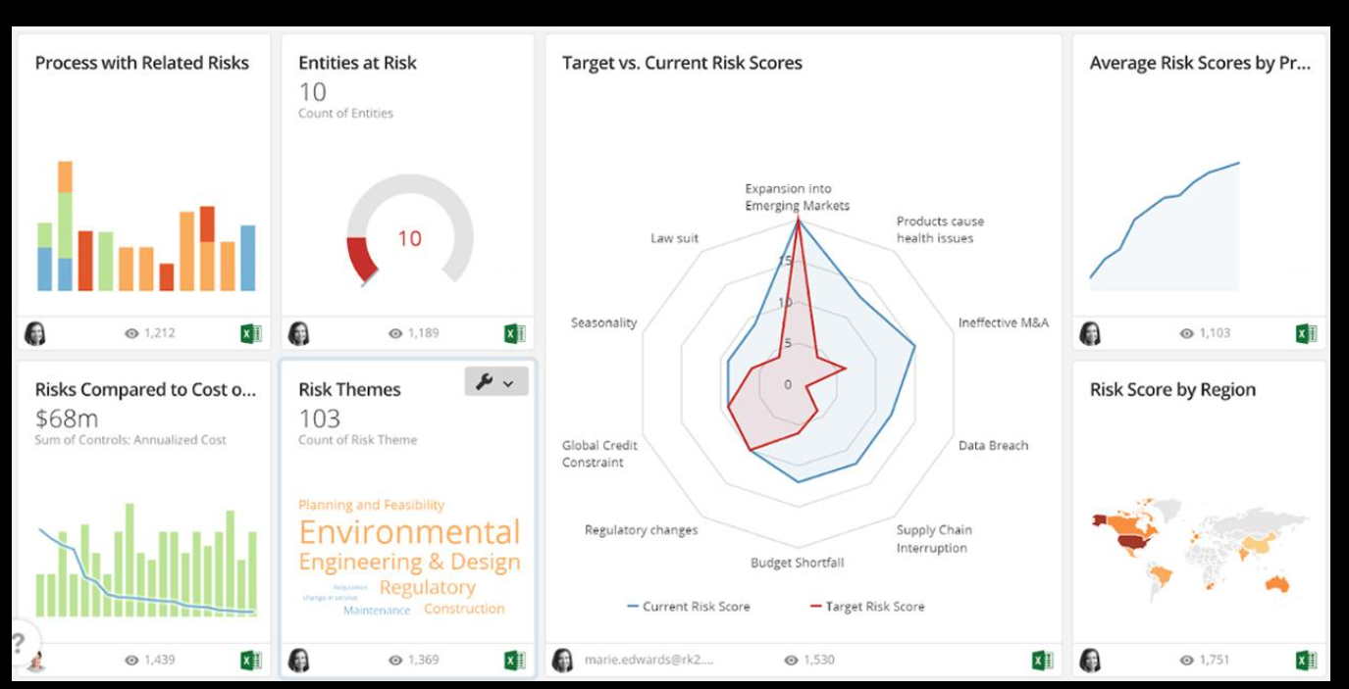
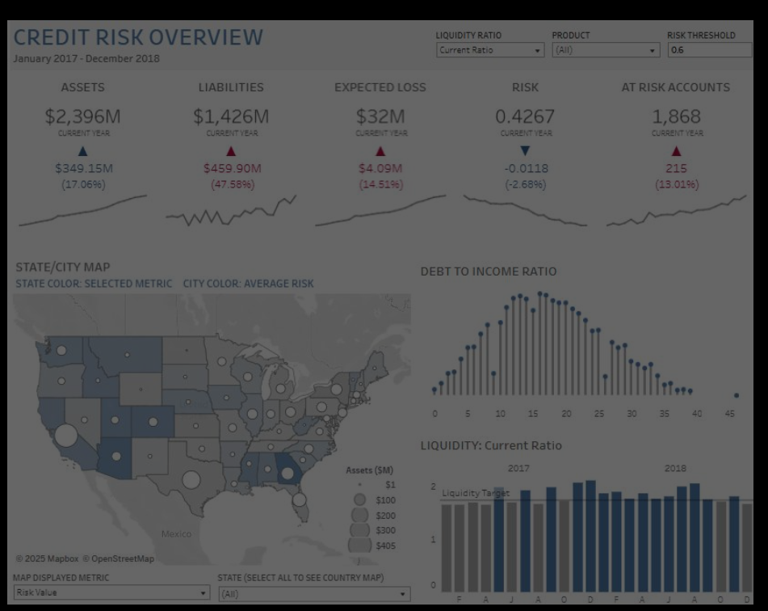

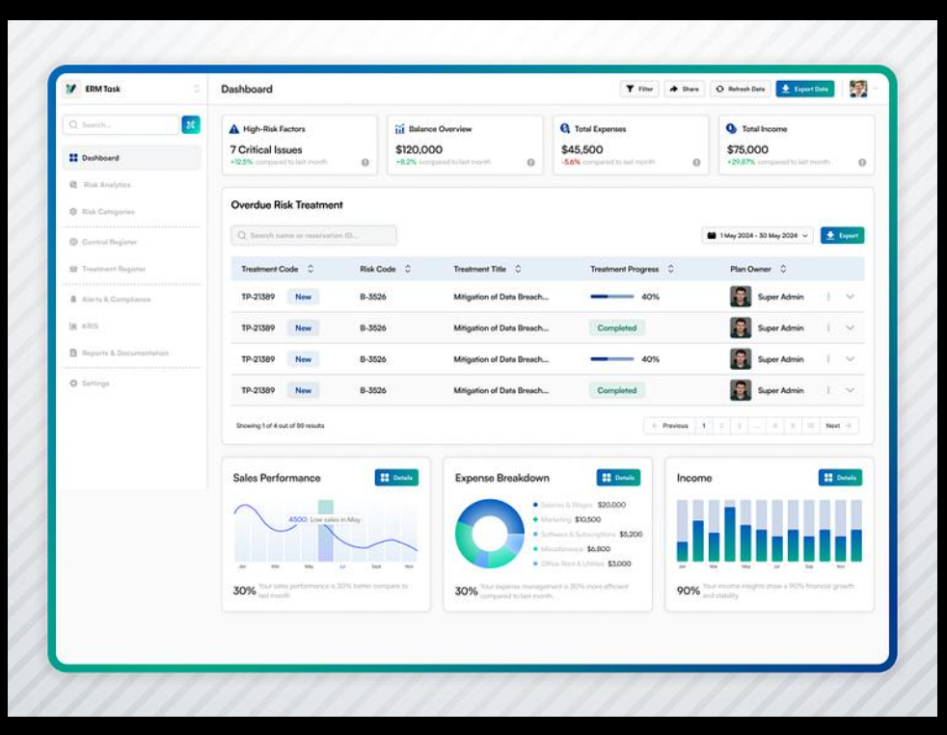

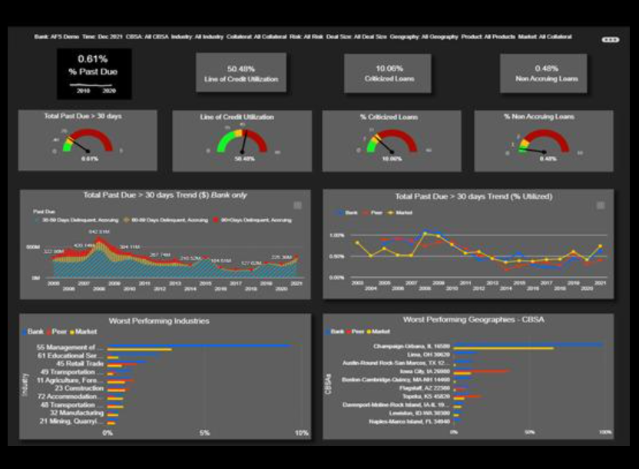
🔷 Features:
🔔 Alerts
- Real-time risk alerts
📋 Case View
- Customer risk summary
📞 Action
- Call / Visit
📍 Location
- Field tracking

🔷 7. INTEGRATION

CBS
- Loan + repayment
IFRS 9
- Stage movement
- ECL
Collection System
- Auto case creation
AML
- Suspicious activity

🔷 8. REPORTING

Dashboards:
- Risk trend
- PD distribution
- Stage migration
- Alert resolution

🔷 9. API FRAMEWORK

- POST /ews/evaluate
- GET /ews/alerts
- GET /ews/risk-profile
- POST /ews/action

🔷 10. FINAL POSITIONING
This EWS is:
👉 Proactive risk system
👉 AI-driven decision engine
👉 Integrated with IFRS + Collection
👉 Real-time monitoring

