UM-SJTU Joint Institute
Lab Report
X
Ve270 Introduction to Logic Design

by
<Names>

<Date>

Title of the Lab

Objectives

To design a FSM-Counter by both schematics and HDL modeling.

Problem Definition

To design a 4-bit up/down synchronous binary counter which is capable for 0 to 15 using 4 flip-flops sharing the same clock signal. It should be able to count up and down, controlled by an 1-bit inputting called “up/down” implemented by a switch. It is to increment when “up/down” signal is a binary 1 and to decrement if the signal is 0. There should be another input called “Reset” provided by a button. The counter should be 0 if the signal “Reset” is 1.

System Partitioning

- Switches and buttons. Used to input signals like “Up/down mode choose”, “Reset” and the signals to count.
- Inside circuit. It is designed by using ISE and used to process the input signals and come up with output signals.
- LED. The output the digits got by the circuit by illuminating different segments of LED. The rule of illumination according to the output digits is the same as Lab 2.

Design Entry
The function table of this Counter:
Input signals |  |  | Output: Count+
Reset | Up/down | Count | Output: Count+
0 | X | X | 0
1 | 1 | 0 | Count
1 | 1 | 1 | Count+1
1 | 0 | 0 | Count
1 | 0 | 1 | Count-1

The rule of illumination according to the output: (from Lab 2 SSD Driver)
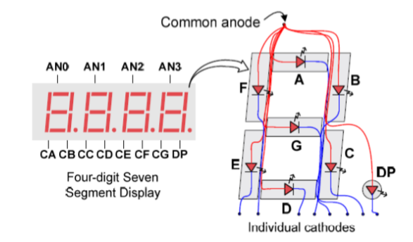
Digit  (decimal) | Outputs(LED segments)
Digit  (decimal) | A | B | C | D | E | F | G
1 | 0 | 1 | 1 | 0 | 0 | 0 | 0
2 | 1 | 1 | 0 | 1 | 1 | 0 | 1
3 | 1 | 1 | 1 | 1 | 0 | 0 | 1
4 | 0 | 1 | 1 | 0 | 0 | 1 | 1
5 | 1 | 0 | 1 | 1 | 0 | 1 | 1
6 | 1 | 0 | 1 | 1 | 1 | 1 | 1
7 | 1 | 1 | 1 | 0 | 0 | 0 | 0
8 | 1 | 1 | 1 | 1 | 1 | 1 | 1
9 | 1 | 1 | 1 | 1 | 0 | 1 | 1
0 | 0 | 0 | 0 | 0 | 0 | 0 | 0

Inside circuits design:

Test Plan

Test content | Test method
Up counter | Switch the counter on up/down mode, then input an “count” signal, observe the output digit.  If the output digit gets larger by 1 in “up” mode/smaller by 1 in “down” mode, it passes the test, otherwise it fails.

Down counter
Reset button | Input an “reset” signal by the button, then observe the output digit.  If the output digit becomes 0, it passes the test, otherwise it fails.

Simulation Results

Test results are displayed here. Do not put any figure without a reference in your text.

Hardware Implementation and Testing

Logic synthesis, FPGA implementation, and board testing. Describe how your design is tested on the hardware implementation.

Conclusions

In this lab, we made a counter which has “up/down” mode and a button “Reset”. We practiced using schematics and HDL modeling. In the HDL code writing, we used the result from the previous lab(SSD) to implement the LED illumination to output the decimal digit from 0 to 9.

Appendix

Schematics and/or Verilog HDL codes for your design.

