UM-SJTU Joint Institute
Lab Report
X
Ve270 Introduction to Logic Design

by
<Names>

<Date>

Title of the Lab

Objectives

To design a simple datapath using combinational building blocks in Xilinx ISE, and to implement the circuit in an FPGA chip.

Problem Definition
To form a Arithmetic and Logic Unit (ALU) which takes 4-bit input data and outputs the result(F and Cout). The algorithm being used is decided on the 2-input select signal. The algorithms are shown in the table below.
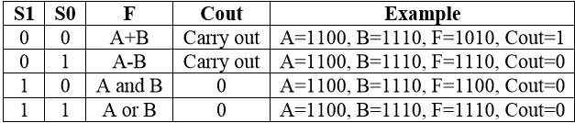

System Partitioning

1. 8 Switches and 2 select signal buttons. Switches are used to input two 4-bit binary input A and B. The buttos are used to select the algorithm to be executed. Then the input signals will be transmitted to the inside circuit to calculate and come up with the result.
- Inside circuit. To receive the input signals and get the result. It will outputs some signals that controls the LED to illuminate.
- LED. LED is used as the output indicator. The illumination of different LED can indicate different different binary digit as the output F and Cout.

Design Entry

The algorithms in this system:
Select signal |  | algorithm | Output
S1 | S0 | algorithm | F | Cout
0 | 0 | Add | A+B | Carry out
1 | 0 | AND | A and B | 0
0 | 1 | Subtract | A-B | Carry out
1 | 1 | OR | A or B | 0

According to the table above, we have the overall circuit :
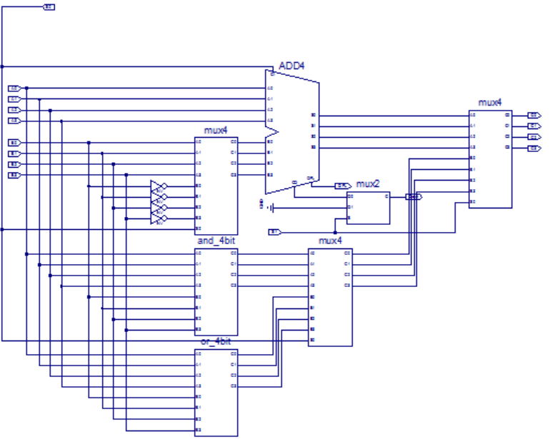

Test Plan
Test content | Test method
Add | Input A,B and select signal to the corresponding algorithm, and calculate the result. Then observe the output signal and read the binary result. If the result is correct, then this algorithm passes the test; otherwise it fails.

Subtract

And

Or
The overall system | The whole system pass the test if and only if all the four algorithms pass the corresponding test.

Simulation Results

Test results are displayed here. Do not put any figure without a reference in your text.

Hardware Implementation and Testing

Logic synthesis, FPGA implementation, and board testing. Describe how your design is tested on the hardware implementation.

Conclusions

In this lab, we successfully finished it finally, but we also met with some problems in the process. Some existing modules in ISE will cause error in the simulation and pace process, such as the inverse-4 and mux-4, so we have to build a new module ourselves. We practiced build a ALU with 2-bit select input signal and four kinds of algorithms.

Appendix

Schematics and/or Verilog HDL codes for your design.

