Ve370 Introduction to Computer Organization
Homework 3

- Exercise 2.21.4(b). (10 points)
- Exercise 2.21.5(b). (10 points)
- Exercise 2.21.6(b). (10 points)
- Exercise 2.31.1(b). (5 points)
- Exercise 2.31.2(b). (5 points)
- Exercise 2.31.3(b). (5 points)
- Describe a 32-bit 2-to-1 MUX in Verilog. Simulate your Verilog module. (10 points)

A
B
sel
F
Mux
32
32
32
0
1
- Model the following 1-bit ALU with Verilog. Simulate your Verilog module. Note: the Overflow Detection circuit doesn’t have to be included. (20 points)
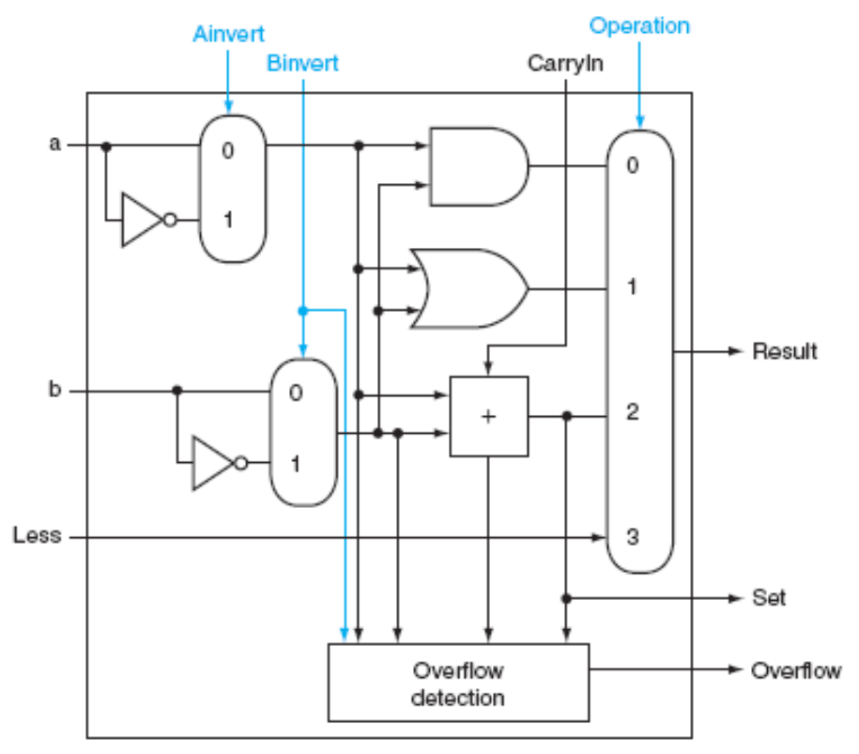

- Model a 32 x 32-bit register file shown as following diagram using Verilog. Simulate your Verilog module with Xilinx ISE. Assume the device is not clock triggered. (25 points)

