

### Physics Laboratory Vp141

Exercise 2 Measurement of Fluid Viscosity

This lab manual is based on materials provided by the Department of Physics, Shanghai Jiaotong University. rev 4 Edited by: Qin Tian, Feng Yaming, Mateusz Krzyzosiak

# Pre-lab Reading

Sections: 5.3 – part on fluid resistance, and 12.1, 12.3, 12.6 (Young and Freedman)

# Objectives

The objective of this exercise is to get familiar with an experimental technique of measur- ing fluid viscosity, which is one of the most important properties of fluids, determining the fluid’s flow. The method you will learn is known as Stokes’ method and it a common and simple method for characterizing transparent or translucent fluids with high viscosity.

# Theoretical Background

Motion of an object in a fluid is hindered by a drag force acting in the direction opposite to the direction of motion, *i.e.* opposite to the object’s velocity. The magnitude of the drag force is related to the shape and speed of the object as well as to the internal friction in the fluid. This internal friction can be quantified by a number known as the viscosity coefficient *η*.

For a spherical object with radius *R* moving at speed *v* in an infinite volume of a liquid, the magnitude of the drag force is usually modeled as linear in the speed

*F*1 = 6*πηvR.* (1)

When a spherical object falls vertically downwards in a fluid, it is being acted upon by the following three forces: The viscous force **F**1 and the buoyancy force **F**2 both act upwards, and the weight of the object **F**3 is directed downwards. The magnitude of the buoyancy force is

4 3

*F*2 = 3 *πR ρ*1*g*

where *ρ*1 is the density of the fluid and *g* is the acceleration due to gravity. The weight of the object

4 3

*F*3 = 3 *πR ρ*2*g*

with *ρ*2 being the density of the object. After some time, the three forces will balance each other

*F*1 + *F*2 = *F*3*,* (2)

so that the net force on the object will be zero and from that instant on, the object will be moving with constant speed *v*t, known as the terminal speed. Applying the condition (2), we can find

*η* = 2 *gR*2 *ρ* 2 *− ρ*1 *.* (3)

9 *v*t

Therefore, the fluid viscosity can be found by measuring the terminal speed. Taking into account that the motion with terminal speed is a motion with constant velocity, Eq. (3) can be rewritten as

*η* = 2 *gR*2 ( *ρ*2 *− ρ*1)*t,* (4)

9 *s*

where *s* is the distance traveled in time *t* after reaching the terminal speed.

Since the volume of the fluid used in the measurement is not infinite, the results are affected by some boundary effects due to the presence of the container. Therefore, Eq.(1) should be modified, and the formula for the corrected magnitude of the viscous force for a infinitely long cylindrical container with radius *R*c is

Consequently, Eq. (4) reads

*F*1 = 6*πηvR*

*R*

1 + 2*.*4 *.*

*R*c

2 (*ρ*2 *− ρ*1)*gt* 1

*η* = *R*2 *.* (5)

9 *s* 1 + 2*.*4 *R*

*R*

c

Since the length *L* of the container is limited, there may be further corrections intro- duced, depending on the ratio on *R*c*/L*.

# Apparatus and Measurement Procedure

## Apparatus

The experimental setup consists of a Stokes’ viscosity measurement device (see Figure

1) filled with castor oil in which motion of small metal balls will be observed. Measure- ments of various physical quantities in the experiment are performed with a number of measurement devices: micrometer, calliper, densimeter, electronic scales, stopwatch, and thermometer.

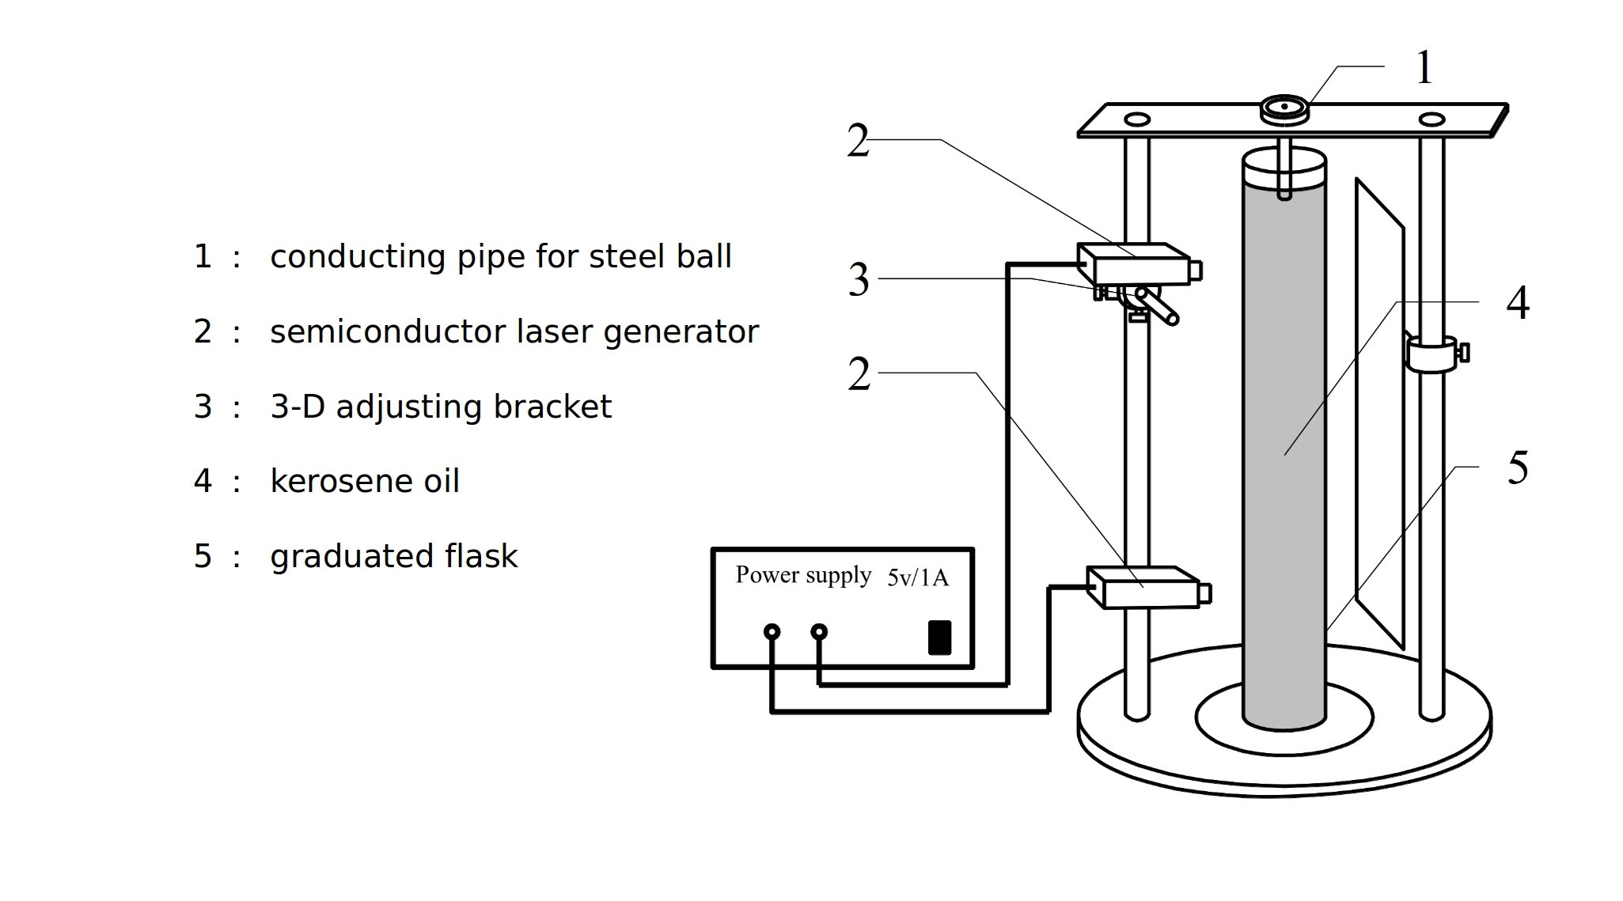

Figure 1. Stokes’ viscosity measurement apparatus.

## Measurement Procedure

* + 1. Adjustment of the Stokes’ viscosity measurement device.
       1. Adjust the knobs beneath the base to make the plumb aiming at the center of the base.
       2. Turn on the two lasers, adjust the beams so that they are parallel and aim at the plumb line.
       3. Remove the plumb and place the graduated flask with castor oil at the center of the base.
       4. Place the guiding pipe on the top of the viscosity measurement device.
       5. Put a metal ball into the pipe and check whether the ball, falling down in the oil, can blocks the laser beams. If not, repeat Step 1.
    2. Measurement of the (constant) velocity of a falling ball.
       1. Measure the vertical distance *s* between the two laser beams at least three times.
       2. Put a metal ball into the guiding pipe. Start the stopwatch when the ball passes through the first beam, and stop it when it passes through the second one. Record the time *t* and repeat the procedure for at least six times.
    3. Measurement of the ball density *ρ*2.
       1. Use electronic scales to measure the mass of 40 metal balls. Calculate the average to find the mass of a single ball.
       2. Use a micrometer to measure the diameter of the metal balls. Repeat for ten times and calculate the average value.
       3. Calculate the ball density *ρ*2.
    4. Measure of the density *ρ*1 of the castor oil by using the provided densimeter (one measurement). Use a calliper to measure the inner diameter *D* of the graduated flask for six times. Read the ambient temperature from the thermometer placed in the lab.
    5. Calculate the value of viscosity coefficient *η* using Eq. (5).

# Caution

� Do not move the graduated flask during the measurement.

� Be careful with the castor oil: do not spill it on the desk.

� Do not forget to read the ambient temperature, as fluid viscosity is sensitive to the temperature.

# Preview Questions

� What are factors determining the viscosity of a fluid?

� Briefly describe the idea of the Stokes’ method.

� How can we make sure that the ball reaches constant speed?

� If we change the temperature in the lab, how will it affect the velocity of the ball?

� When the ball moves in the fluid, there might be some bubbles attached to the surface of the ball. Does the experiment over– or underestimate the value of the viscosity coefficient? Explain.

� If we choose balls with different radii and densities to repeat the experiment, will we obtain different values of the viscosity coefficient?

� Can we use balls made of a material with the density smaller than that the density of the fluid?