

### Physics Laboratory Vp141

Exercise 3

Simple Harmonic Motion: Oscillations in Mechanical Systems

This lab manual is based on the materials provided by the Department of Physics, Shanghai Jiaotong University. rev 5 Edited by: Qin Tian, Zheng Huan, Li Yingyu, Mateusz Krzyzosiak

# Pre-lab Reading

Chapters 17 and 18 (Young and Freedman); Volume 1, chapter 21 (Feynman)

# Objectives

The main objective of this exercise is to study simple harmonic oscillation. You will learn how to find the spring constant and effective mass of a spring, and how to use the air track. We will analyze the relationship between the oscillation period and the mass of the oscillator, check whether the oscillation period depends on the the amplitude, and examine the relationship between the maximum speed and the amplitude.

# Theoretical Background

There are various kinds of periodic motion in nature, among which the simplest and the most fundamental one is the simple harmonic motion, where the restoring force is proportional to the displacement from the equilibrium position and as a result, the position of a particle depends on time as the sine (or cosine) function. Discussion of the simple harmonic motion is a basis for studying more complex situations.

## Hooke’s Law

Within the elastic limit of deformation, the force *Fx* needed to be applied in order to stretch or compress a spring by the distance *x* is proportional to that distance, *i.e.*,

*Fx* = *kx,* (1)

where *k* is a constant (called the spring constant) characterizing how easy it is to deform the spring. This constant will be found in the present exercise using a measurement device called the *Jolly balance*. The linear relation (1), between the force and the deformation, is known as the *Hooke’s Law*. According to Newton’s third law of dynamics, the spring exerts a reaction force (called the elastic force) of the same magnitude but opposite direction. As this force tries to restore the system back to the equilibrium, it is known as the restoring force.

## Equation of Motion of the Simple Harmonic Oscillator

As shown in Figure 2, an object with mass *M* is set on an air track with a spring attached to both of its sides. The purpose of using the air track is to eliminate frictional forces between moving surfaces. The other ends of the springs are fixed to the air track. The spring constants *k*1 and *k*2 are to be measured with the Jolly balance. The origin (*x* = 0) of the coordinate system is set at the equilibrium position of the mass *M* . Assuming that the masses of the springs can be ignored, and neglecting damping in the

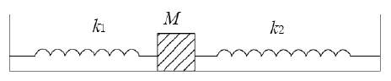

Figure 1. Mass–spring system.

system, the elastic (restoring) forces of the springs are the only forces acting on mass *M* .

According to Newton’s second law of dynamics, the equation of motion of mass *M* is

d2*x*

*M*

The general solution to Eq. (2) is

d*t*2

+ (*k*1 + *k*2)*x* = 0*.* (2)

*x*(*t*) = *A* cos(*ω*0*t* + *ϕ*0)*,* (3)

where *ω*0 = /(*k*1 + *k*2)*/M* is the natural angular frequency of the oscillations, *A* is their amplitude, and *ϕ*0 is the initial phase. The natural angular frequency is determined by the parameters of the system itself, whereas the initial phase is determined by initial conditions. The natural period of oscillation is

2*π*

*T* = = 2*π*

*ω*0

/ *M*

*k*1 + *k*2

*.* (4)

In this exercise, the relationship between the oscillation period and the mass of the oscil- lator will be studied.

## Effect of the Mass of the Spring

Whenever the mass of the springs cannot be ignored, we take it into account in terms of the so-called effective mass. The effective mass of the oscillator is the sum of the mass of the object and the effective mass of the spring. When we take the effective mass of the spring into account, the angular frequency of the system can be expressed as

/ *k*1 + *k*2

*ω*0 =

*M* + *m*0

(5)

where *m*0 is the effective mass of the spring, which is 1*/*3 of the actual mass of the spring.

## Mechanical Energy in Harmonic Motion

The elastic potential energy for a spring-mass system is *U* = *kx*2*/*2 and the kinetic energy of an oscillating mass *m* is *K* = *mv*2*/*2.



At the equilibrium position (*x* = 0), the speed of the mass is maximum *v* = *v*max. At this point the total mechanical energy is equal to maximum kinetic energy *K*max. On the other hand, at maximum displacement (*x* = ±*A*) the mass is instantaneously at rest,

*i.e. v* = 0, and the contribution to the total mechanical energy is due to the potential

energy only, which is at its maximum *U*max. In the absence of non-conservative forces (such as frictional forces or drag forces), the total mechanical energy is conserved and *K*max = *U*max, which implies

*m v*2

*k* = max

*A*2 *.* (6)

# Apparatus and Measurement Procedure

## Apparatus

The measurement equipment consists of the following elements: springs, Jolly balance, air track, electronic timer, electronic balance, and masses.



 



Figure 2. Jolly balance.

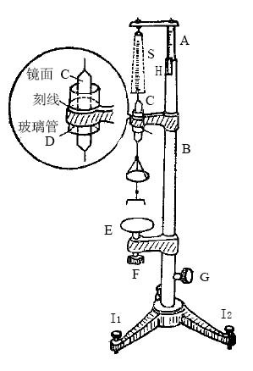

In order to measure the spring constant using the Jolly balance, we need to place the small mirror *C* (see Figure 2) in the tube *D* and make three lines coincide: the line on on the mirror, the line on the glass tube and its reflection in the mirror. First, without adding any weight on the bottom end of the spring, tune the knob *G* and make the three lines coincide. Then read the scale *L*1.

Second, add mass *m* to the bottom of the spring. The spring is stretched and the

three lines no longer coincide. Tune knob *G* to make them into one line again and read

the corresponding number on scale *L*2. The spring constant may be then found as

*mg*

*k* =

*L*2 − *L*1

*.* (7)

When you have a series of measurements, for different masses *m*, you may use the least square method to estimate the spring constant by finding a linear fit to the data.

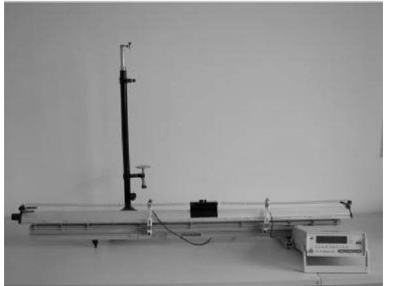

Figure 3. The experimental setup.

A photoelectric measuring system consists of two photoelectric gates and an electronic timer. When a shutter placed on the object passes a gate, it blocks the light emitted from the light source at the top of the gate, and the receiver sends a signal to the electronic timer. Please note that for period measurements we use, we use the I-shape shutter.

When measuring the speed of the object, we use a U-shaped shutter (Figure 4), so that the light is blocked twice during a pass. The timer will then record the time interval

∆*t* between the two generated signals. After the distance ∆*x* = 1 (*x*in + *x*out) between

2

the two arms of the U-shape shutter is measured, the speed of the object at the point of passing the gate is calculated as *v* = ∆*x/*∆*t*.

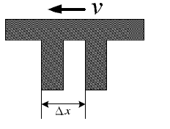

Figure 4. The U-shape shutter.

## Measurement Procedure

#### Spring Constant

* + - 1. Adjust the Jolly balance to be vertical: Attach the spring and the mirror as shown in Figure 2. Add a 20 g **preload** and adjust knob *I*1 and *I*2 to make sure the mirror can move freely through the tube.

Check whether the Jolly balance is parallel to the spring, and adjust knobs if nec- essary. You should look at the balance from two orthogonal directions: from one direction, adjust the balance to be parallel to the spring; from the direction orthog- onal to the previous one, check if the balance coincides with the spring.

* + - 1. Adjust knob *G* and make the three lines in the tube coincide. Adjust the position of the tube to set the initial position *L*0 within 5.0 ∼ 10.0 cm.
      2. Record the reading *L*0 on the scale, add mass *m*1 and record *L*1.
      3. Keep adding masses and take measurements for six different positions. The order of the masses should be recorded.
      4. Estimate the spring constant *k*1 using the least square method.
      5. Replace spring 1 with spring 2, repeat the measurements and calculate *k*2.
      6. Remove the preload and repeat the measurement for springs 1 and 2 connected in series. Calculate *k*3 and compare it with the theoretical value.

#### Relation between the Oscillation Period *T* and the Mass of the Oscil- lator *M*

1. Adjust the air track so that it is horizontal.

**Caution:** Do not place anything on the air track before you turn on the air pump.

* 1. Turn on the air pump and check if any of the holes on the air track are blocked. Call the instructor for help if you find blocked holes.
  2. Place the object (cart) on the track without any initial velocity. Adjust the track until the object moves slowly back and forth in both directions.

*Adjustment method*. The air track has three knobs at the bottom: two on one side and another one on the other side. You can only adjust that single knob.

1. Horizontal air track
   1. Attach springs to the sides of the cart, and set up the I-shape shutter. Make sure that the photoelectric gate is at the equilibrium position.
   2. Add weight *m*1. Let the cart oscillate about the photoelectric gate. The amplitude of oscillations should be about 5 cm. Release the cart with a caliper or a ruler. Set the timer into the ”T” mode. The timer in this mode will automatically record the time of 10 oscillation periods. Record the mass of the cart and the period.
   3. Add weights to the object, repeat Step 2 and take measurements for 5 times.
   4. Analyze the relation between *M* and *T* by plotting a graph.
2. Inclined air track
   1. Inclination of the air track is controlled with plastic plates. Place them under the air track, using three plates at a time.
   2. Repeat the steps in (b) for two different inclinations (*i.e.*, with 3 and 6 plates beneath the air track).
   3. Discuss the relation between *M* and *T* by plotting a graph.

#### Relation Between the Oscillation Period *T* and the Amplitude *A*

1. Keep the mass of the cart unchanged and change the amplitude (choose 6 different values). The recommended amplitude is about 5.0/ 10.0/ 15.0/ ... /30.0 cm.
2. Apply linear fit to the data and comment on the relation between the oscillation period

*T* and the amplitude *A* based on the correlation coefficient *γ*.

#### Relation Between Maximum Speed and the Amplitude

1. Measure the outer distance *x*out and the inner distance *x*in of the U-shape shutter by a caliper. Calculate the distance ∆*x* = (*x*out + *x*in)*/*2.
2. Change the shutter from I- to U-shape. Set the timer into the ”S1” mode. Let the cart oscillate. Record the second readings of the time interval ∆*t* only if the two subsequent readings show the same digits to the left of the decimal point.
3. Change the amplitude (choose 6 different values). The recommended amplitude is about 5.0/ 10.0/ 15.0/ ... /30.0 cm.
4. Measure the maximum speed *v*max for different values of the amplitude *A*. Obtain the spring constant from Eq. (6). Compare this result to that of the first part.

#### Mass measurement

1. Adjust the electronic balance every time before you use it. The level bubble should be in the center of the circle.
2. Add weights according to a fixed order. Weigh the cart with the I-shape shutter and with the U-shape shutter. Measure the mass of spring 1 and spring 2.
3. Record the data only after the circular symbol on the scales display disappears.

# Caution

� **Do not stretch the spring over its elastic limit**, otherwise the spring will not return to its original shape.

� When using the Jolly balance, the mirror should be moving freely in the glass tube without any friction. When adding weight, hold the tray steady to avoid errors due to vibrations.

� Please use tweezers to move the weights around.

� Make sure that no air holes on the air tracks are blocked.

� Avoid scratching the cart. **Do not move the cart when pressed against the air track.**

# Preview Questions

� State the Hooke’s law. When is it applicable?

� Give an example of a harmonic oscillator system other than a mass–spring system.

� Does the period of oscillations depend on initial conditions?

� Is motion of a simple pendulum an example of the simple harmonic motion? Explain.

� Sketch the graphs *x* = *x*(*t*), *vx* = *vx*(*t*), and *ax* = *ax*(*t*) for a particle moving in simple harmonic motion.

� Sketch the graphs *K* = *K*(*t*) and *U* = *U* (*t*) for a particle moving in simple harmonic motion.

� Will the oscillation period change when the inclination angle of the air track is changed? Explain.

� How to check whether the Jolly balance is vertical?