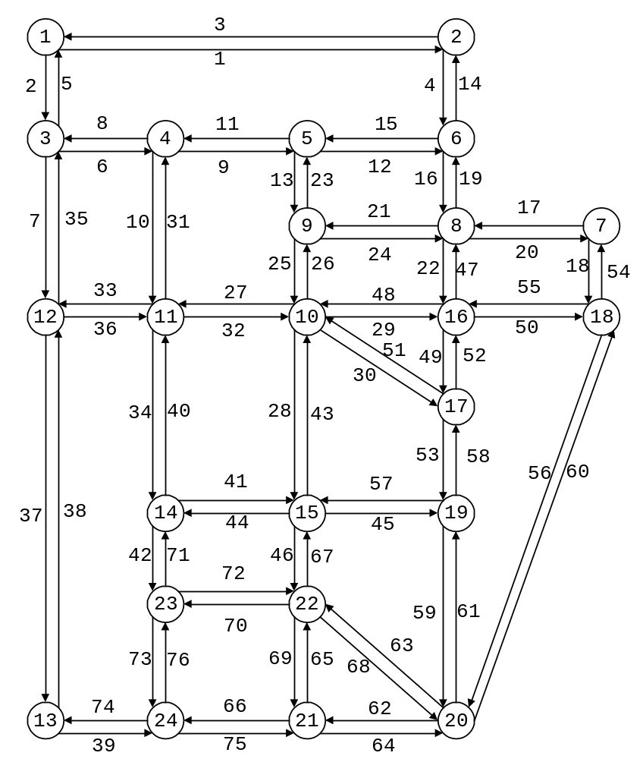

Sioux Falls Test Network

Prepared by Hai Yang and Meng Qiang, Hong Kong University of Science and Technology

