SkillForge Social Media Content Plan
Prepared by Tanya Chauhan | DecodeLabs Project 1 | Batch 2026
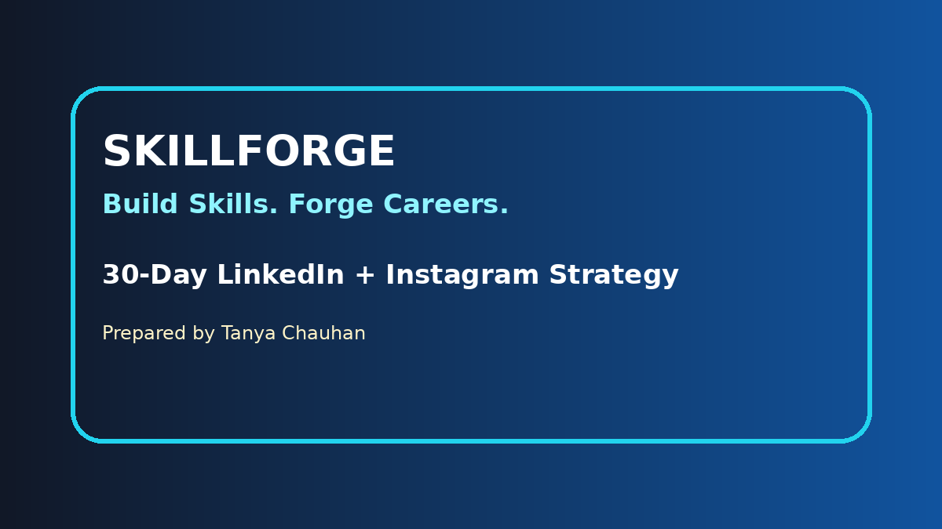

Project Objective
Create a simple and professional social media content plan for SkillForge covering audience, content pillars, posting schedule, posts, metrics and workflow.

Brand Overview
SkillForge is an EdTech platform helping students build practical skills through real projects, mentorship and certification.

Target Audience
LinkedIn targets TPOs, faculty, HRs and decision makers. Instagram targets engineering, BCA and MCA students aged 18-25.

Thought Expression Theory
Start with the problem, show proof, give useful value, and end with a clear CTA. This makes the campaign easy to understand and professional.

Conclusion
This project demonstrates strategic content planning using audience mapping, 30-day scheduling, content pillars and measurable success metrics.

Weekly Strategy
Week | Stage | Hook | Goal
1 | Problem Awareness | Theory vs Practice Gap | Validate the audience problem
2 | Authority Building | Proving Legitimacy | Build trust with proof
3 | Technical Value | Reciprocity | Teach useful technical value
4 | Conversion | FOMO and Urgency | Drive DM, click, and enrollment action

Workflow Picture
