Digital Marketing Project 3
Content Writing & Optimization | Prepared by Tanya Chauhan
This updated project has been redesigned according to the Project 1 and Project 2 UI and layout standards. It includes a responsive website, dashboard-style metrics, filterable keyword table, content analyzer, workflow images, SEO-optimized content assets, and complete documentation.

Project Objective
Write and optimize content for digital platforms using keyword research, natural keyword placement, proper heading hierarchy, metadata, readability, and on-page SEO fundamentals.

UI and Layout Consistency
The website uses the same navy/orange color palette, sticky navigation, hero dashboard, cards, tables, workflow timeline, and interactive features used in the Project 1 and Project 2 portfolio.

Core Theory
Content optimization means structuring written content so that users can read it easily and search engines can understand the topic clearly. This is achieved through H1/H2/H3 hierarchy, keyword placement, metadata, URL slugs, image alt text, and concise formatting.

Information Gain
High-value content should not repeat common information only. It should add a unique angle, practical insight, examples, or checklists that reduce user uncertainty.

Keyword Placement
Primary keywords should appear in the meta title, URL slug, H1, introduction, one H2, image alt text, and conclusion. Supporting LSI keywords should be used naturally in body content.

Readability Rules
Use short paragraphs, bullet points, bold text, headings, white space, and clear CTAs. This reduces cognitive load and improves engagement.

Website Features
- Responsive landing page
- Dark/light theme toggle
- Interactive article tabs
- Filterable keyword database
- Content optimization analyzer
- Search result preview
- Dashboard metrics
- Workflow diagrams
- Offline working JSON data
- Beginner-friendly code comments

Sample Keyword Research Table
Keyword | Intent | Cluster | Volume | Allintitle | KGR | Priority
content writing and optimization | Informational | Content Writing | 2219 | 410 | 0.19 | High
content writing and optimization guide | Informational | Content Writing | 2238 | 574 | 0.26 | Medium
content writing and optimization template | Informational | Content Writing | 2257 | 672 | 0.31 | Medium
content writing and optimization examples | Informational | Content Writing | 2276 | 672 | 0.31 | Medium
content writing and optimization for students | Informational | Content Writing | 2295 | 803 | 0.36 | Medium
content writing and optimization for beginners | Informational | Content Writing | 2314 | 836 | 0.38 | Medium
content writing and optimization India | Informational | Content Writing | 2333 | 574 | 0.26 | Medium
content writing and optimization checklist | Informational | Content Writing | 2352 | 705 | 0.32 | Medium
content writing and optimization 2026 | Informational | Content Writing | 2371 | 541 | 0.25 | High
seo content writing for beginners | Informational | SEO Writing | 1990 | 315 | 0.17 | High
seo content writing for beginners guide | Informational | SEO Writing | 2009 | 441 | 0.24 | High
seo content writing for beginners template | Informational | SEO Writing | 2028 | 516 | 0.29 | Medium
seo content writing for beginners examples | Informational | SEO Writing | 2047 | 516 | 0.29 | Medium
seo content writing for beginners for students | Informational | SEO Writing | 2066 | 617 | 0.34 | Medium
seo content writing for beginners for beginners | Informational | SEO Writing | 2085 | 642 | 0.36 | Medium
seo content writing for beginners India | Informational | SEO Writing | 2104 | 441 | 0.24 | High
seo content writing for beginners checklist | Informational | SEO Writing | 2123 | 541 | 0.3 | Medium
seo content writing for beginners 2026 | Informational | SEO Writing | 2142 | 415 | 0.23 | High

Optimized Article Assets

How to Write SEO-Friendly Content That Ranks and Converts
Primary Keyword: seo friendly content writing | Slug: /blog/seo-friendly-content-writing-guide | Score: 94/100 | Density: 1.35%
Meta Title: SEO Friendly Content Writing Guide for Students | SkillForge
Meta Description: Learn how to write SEO-friendly content using keywords, headings, metadata, and readable structure for better rankings and engagement.
- H1: SEO Friendly Content Writing Guide
- H2: Understand Search Intent
- H2: Build a Clear Heading Structure
- H2: Use Keywords Naturally
- H2: Optimize Metadata
- H2: Improve Readability and CTA

Content Optimization Checklist for Digital Marketing Interns
Primary Keyword: content optimization checklist | Slug: /blog/content-optimization-checklist | Score: 91/100 | Density: 1.22%
Meta Title: Content Optimization Checklist for Digital Marketing Interns
Meta Description: A practical checklist for optimizing blog posts, website pages, and social media content using on-page SEO basics.
- H1: Content Optimization Checklist
- H2: Keyword Planning
- H2: Heading Hierarchy
- H2: Metadata Optimization
- H2: Readability Review
- H2: Publishing Audit

Why Heading Structure Matters in On-Page SEO
Primary Keyword: heading structure seo | Slug: /blog/heading-structure-on-page-seo | Score: 89/100 | Density: 1.10%
Meta Title: Heading Structure SEO: H1, H2 and H3 Best Practices
Meta Description: Understand how H1, H2 and H3 headings improve readability, SEO structure, and user experience for optimized content.
- H1: Heading Structure SEO
- H2: Why H1 Matters
- H2: How H2 Organizes Sections
- H2: Where H3 Adds Detail
- H2: Common Mistakes
- H2: Final Checklist

Workflow Diagrams
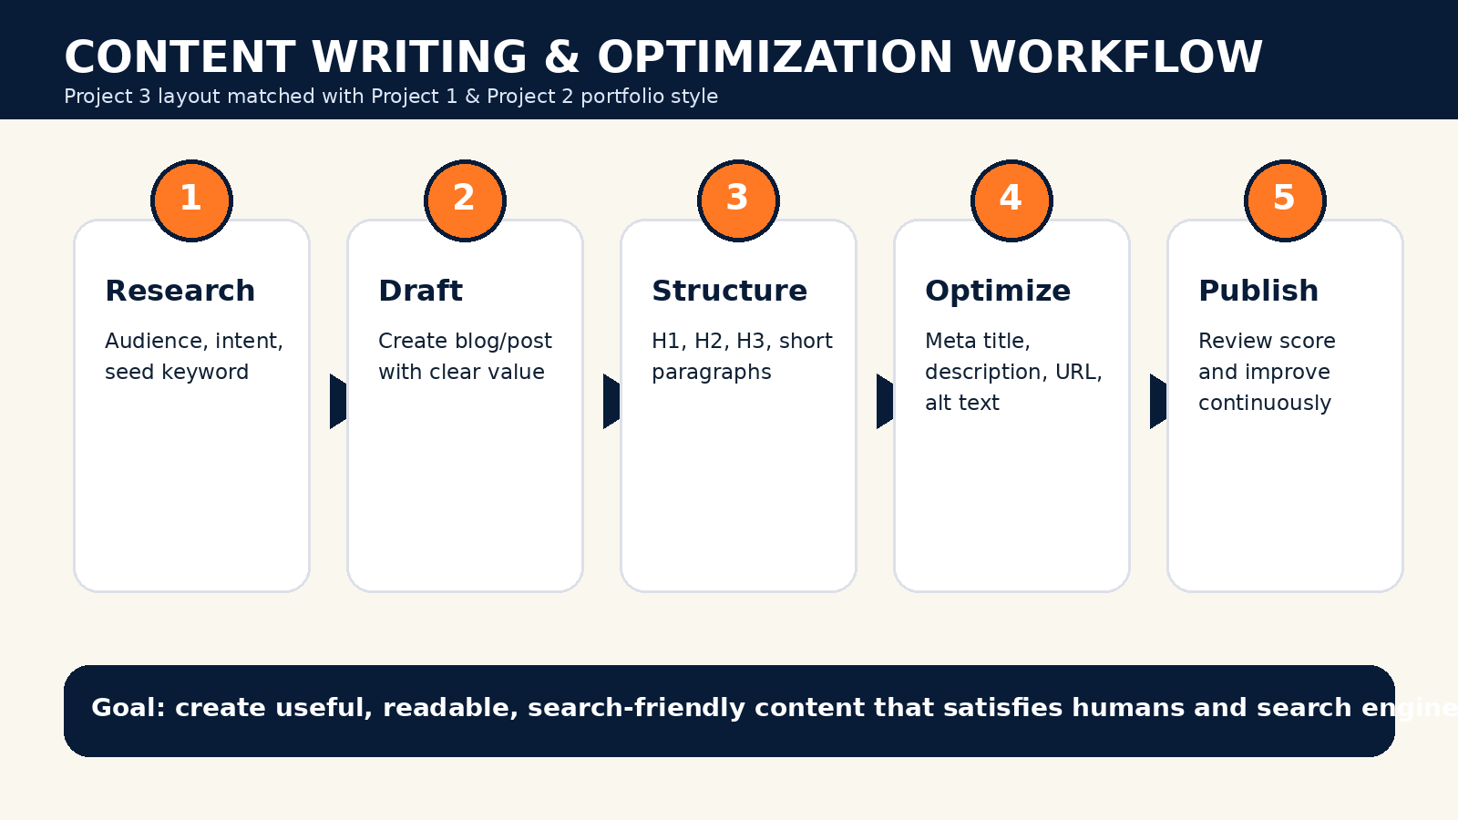
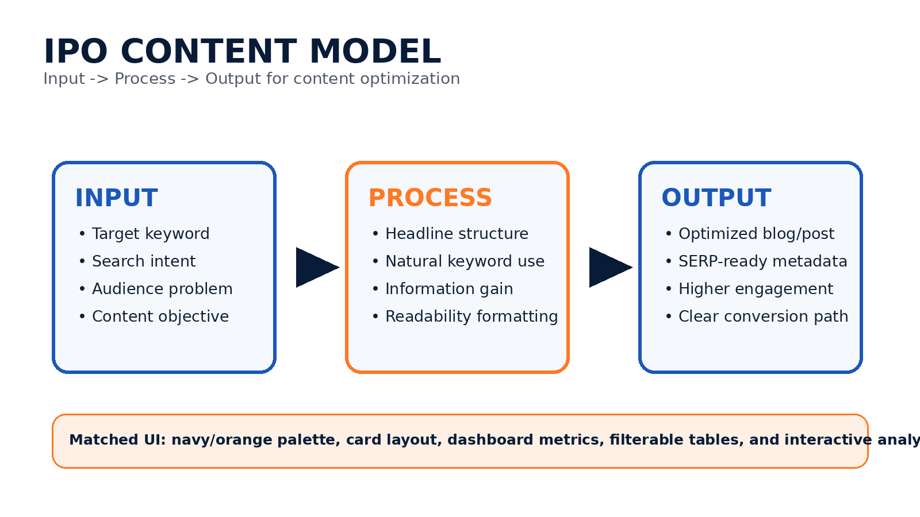
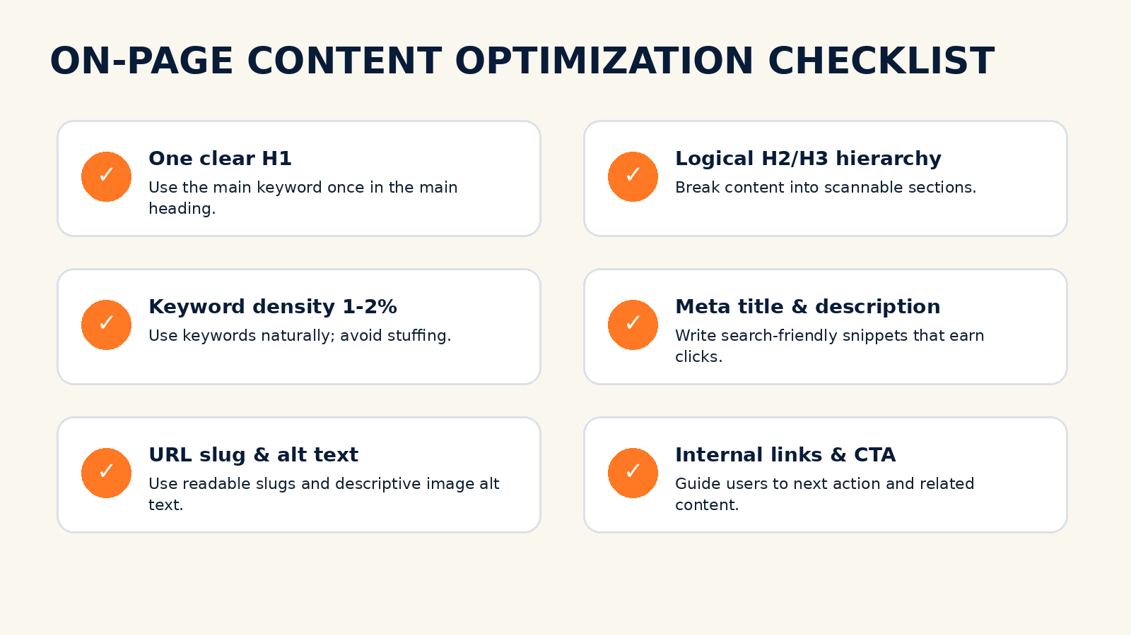

Conclusion
This Project 3 package is suitable for internship submission, academic evaluation, GitHub hosting, and resume portfolio use. It maintains visual and functional consistency with Project 1 and Project 2 while focusing specifically on content writing and on-page SEO optimization.

