Digital Marketing Project 2
SEO Basics & Keyword Research
Prepared by: Tanya Chauhan | DecodeLabs Industrial Training Kit | Batch 2026
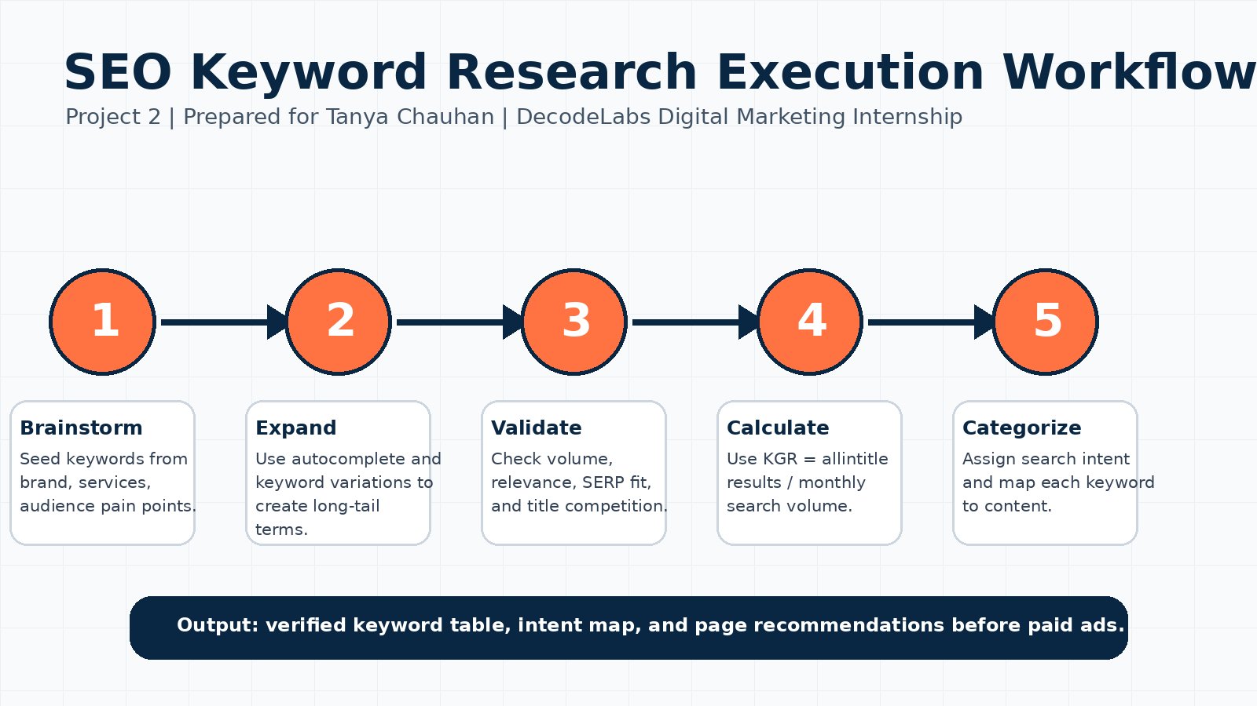

1. Project Objective
The objective of this project is to perform basic keyword research for a website or blog. The work includes finding relevant keywords, identifying search intent, and suggesting keywords for content. This aligns with Project 2 requirements: SEO fundamentals and keyword research.

2. Brand / Website Selected
The selected brand concept is SkillForge by DecodeLabs, an internship and project-based learning platform for students. The target audience includes B.Tech students, beginner coders, digital marketing learners, and career-focused students searching for practical internships.

3. SEO Theory in Simple Language
SEO means making a webpage easier for search engines and users to understand. A good SEO plan does not start with random content. It starts with the user query, checks the search intent, validates demand, and then creates a page that answers the query better than existing results.

4. How to Express SEO Thoughts
A professional SEO explanation should connect evidence with decision-making. The structure is: user problem, keyword phrase, search intent, content recommendation, and expected outcome. Example: “This keyword should be targeted because it has transactional intent, low KGR, and can be answered with a focused application landing page.”

5. Search Intent Analysis
Search intent explains why a user searches. Informational intent means the user wants to learn. Navigational intent means the user wants a specific page. Commercial intent means the user compares options. Transactional intent means the user is ready to act.

6. Long-Tail Keyword Strategy
Long-tail keywords are specific phrases. They usually have lower competition and higher conversion probability than broad keywords. Instead of targeting only “internship,” this project targets phrases like “remote data science internship 2026.”

7. KGR Formula
KGR means Keyword Golden Ratio. Formula: KGR = allintitle results / monthly search volume. A KGR below 0.25 is considered a strong low-competition opportunity for new content.

8. Execution Workflow
The workflow is: brainstorm seed keywords, expand with autocomplete and variations, validate volume and SERP competition, calculate KGR, then categorize by search intent and map each keyword to a content type.

9. Keyword Research Table
Keyword | Volume | Allintitle | KGR | Intent | Suggested Content
remote data science internship 2026 | 320 | 45 | 0.14 | Transactional | Internship landing page
python internship for btech students | 590 | 120 | 0.20 | Commercial | Comparison blog + CTA
best digital marketing internship 2026 | 480 | 110 | 0.23 | Commercial | Program landing page
seo basics for beginners internship | 170 | 28 | 0.16 | Informational | Educational blog
keyword research project example | 210 | 35 | 0.17 | Informational | Portfolio article
full stack internship with projects | 390 | 85 | 0.22 | Commercial | Service page
ai ml internship for beginners | 720 | 160 | 0.22 | Commercial | Cluster landing page
how to do keyword research for a website | 880 | 190 | 0.22 | Informational | How-to guide
decodelabs internship login | 90 | 8 | 0.09 | Navigational | Support page
apply for seo internship online | 260 | 50 | 0.19 | Transactional | Application page
technical seo checklist for students | 140 | 22 | 0.16 | Informational | Checklist post
remote python sql internship | 150 | 30 | 0.20 | Transactional | Landing page

10. Meta Title and Meta Description Examples
Keyword | Meta Title | Meta Description
remote data science internship 2026 | Remote Data Science Internship 2026 | SkillForge | Apply for a remote data science internship built for B.Tech students. Learn Python, SQL, analytics and build portfolio projects.
python internship for btech students | Python Internship for B.Tech Students | Career Roadmap | Compare Python internship paths, skills, projects and outcomes for B.Tech students planning a technical career.
best digital marketing internship 2026 | Best Digital Marketing Internship 2026 | SEO & Ads Track | Explore a practical digital marketing internship focused on SEO, keyword research, content planning and paid ads readiness.
seo basics for beginners internship | SEO Basics for Beginners | Internship Learning Guide | Learn SEO basics in simple language: keywords, search intent, meta tags, SERP and keyword validation.
keyword research project example | Keyword Research Project Example | Step-by-Step SEO Plan | See a complete keyword research example with intent mapping, KGR calculation and content suggestions.
full stack internship with projects | Full Stack Internship With Projects | Build Real Apps | Join a project-based full stack internship covering React, Node.js, databases and deployable applications.

11. Content Recommendations
• Create one main internship landing page for each high-intent keyword cluster.
• Use informational blogs to answer beginner questions and internally link them to application pages.
• Place the primary keyword in the title tag, URL slug, H1 heading, first paragraph and meta description naturally.
• Use comparison content for commercial keywords and clear CTA sections for transactional keywords.
• Track outcome metrics such as organic impressions, ranking keywords, clicks, profile views and application leads.

12. Conclusion
This project demonstrates that SEO is a data-driven visibility strategy. By using long-tail keywords, search intent categories, KGR validation and content mapping, a brand can create pages that answer real user demand. The final strategy is ready for website implementation and internship submission.

