
Assignment 5: Student Record Manager, built with Python and PyQt6

Student Number: 08230214
Name of the Student: Tenzin Choden
Programme and Section: B.Ed IT ‘D’
College Name: Samtse College of Education (SCE)
Module Name: PRG 304

Samtse College of Education
Samtse
Royal University of Bhutan

Module Code and Title: PRG304 GUI Programming with Python Module Tutor: Mr. Anup Gurung
Date: 11.6.2026

2. Abstract
This project is a desktop Student Record Manager built with Python and PyQt6 for B.Ed IT students. It lets a user add, edit, delete and search student records and enter marks for five subjects, where the subject list depends on the student's year of study. The total, percentage and grade are calculated automatically, with a live preview while marks are typed. Records are stored in an SQLite database, so they are still there when the application is closed and reopened. The code is separated into a UI layer (ui.py), a data layer (database.py) and a Qt style sheet (style.qss), and all input is validated with friendly error messages instead of crashes. The report also compares PyQt6/PySide6, Kivy, Tkinter and wxPython, using a comparison matrix and three hello-world programs, and explains why PyQt6 was chosen. It then documents the design, implementation, testing and the problems met along the way.

3. Introduction

3.1 Problem statement
Student marks are often kept on paper or in loose spreadsheets. This makes it easy to enter a student twice, make arithmetic mistakes in totals and grades, and spend time searching for one record. A small program that checks input, calculates results automatically and keeps all records in one place removes these problems.

3.2 Scope
The system manages student records for one programme, B.Ed IT, with five subjects per year (the subjects depend on the year of study), each marked out of 100. It supports adding, editing, deleting and searching records, automatic calculation of total, percentage and grade, and permanent storage on the local computer. It is a single-user desktop application. It does not include user logins, network or multi-user access, printing, or importing and exporting of files.

3.3 Target users
The intended users are teachers, class coordinators and administrative staff who need to record and look up student marks quickly. The project is also meant as a worked example of a structured GUI application for students learning Python GUI programming.

Part A: Framework Study - PyQt6, Kivy, Tkinter and wxPython

A1. Framework profiles

PyQt6 / PySide6
PyQt6 is the Python binding for the Qt 6 toolkit, developed by Riverbank Computing. PySide6 is the competing binding, published by the Qt Company as the official "Qt for Python". Both wrap Qt, a large C++ toolkit that draws the interface and handles events, so a Python program using either one runs the same Qt code underneath. The two APIs are almost identical, with small differences such as the way enums are named.
The licence is the main difference. PyQt6 is released under the GPL v3 or under a paid commercial licence from Riverbank, which means a program distributed without its source code needs the commercial licence. PySide6 is released under the LGPL v3, which allows closed-source distribution under its terms. For a coursework project that is not sold, either is fine.
Qt runs on Windows, macOS and Linux. It has a very rich widget set: tables, trees, tabs, dialogs, menus, progress bars, charts and web views. A UI can be written directly in Python code, or drawn in Qt Designer and saved as a .ui file that the program loads. Styling uses Qt Style Sheets (QSS), which look like CSS. Typical applications are large desktop tools such as editors, data-entry systems and dashboards.

Kivy
Kivy is an open-source framework maintained by the Kivy community. Unlike Qt or Tk, it does not wrap the operating system's native widgets. It draws everything itself with OpenGL, so the app looks the same on every platform. It is released under the MIT licence.
Kivy runs on Windows, macOS and Linux, and also on Android and iOS, which is its main strength. It was designed for touch and multi-touch input. Its widget set is smaller and more touch-oriented than Qt's, and there is no ready-made table widget like Qt's QTableWidget. A UI can be built in Python code or in Kivy's own KV language, which describes widgets and their properties in a separate file. Styling is done through KV properties or custom graphics. Typical applications are mobile apps, kiosks, games and touch interfaces.

Tkinter
Tkinter is Python's built-in interface to the Tk toolkit, and it is part of the standard library, so nothing needs to be installed. It is maintained as part of Python and is covered by the Python licence (Tcl/Tk itself uses a permissive BSD-style licence). It runs on Windows, macOS and Linux.
The basic widget set covers labels, buttons, entries, listboxes, canvases and menus. The themed ttk module adds a Combobox, Treeview (used for tables) and Notebook (tabs). The UI is written in code only, with no official designer, and styling is limited compared with Qt. Typical applications are small utilities, teaching examples and quick prototypes.

wxPython
wxPython is the Python binding for wxWidgets, a C++ toolkit. Its distinguishing idea is that it uses the operating system's own native controls, so programs look like normal Windows, macOS or GTK applications. It is released under the wxWindows Library Licence, which is permissive and allows closed-source distribution. It runs on Windows, macOS and Linux, and it does not target mobile.
The widget set is rich, with grids, trees, notebooks, dialogs and menus. Layout uses sizers. The UI is written in code, and third-party tools such as wxFormBuilder and wxGlade can generate it. Styling options are limited because the look comes from the operating system. Typical applications are native-looking desktop programs.

A2. Comparison matrix

Comparison of Python GUI Frameworks
Features | PyQt6 / PySide6 | Kivy | Tkinter | wxPython
Licence | PyQt6: GPL v3 or commercial; PySide6: LGPL v3 | MIT | Python licence (Tcl/Tk is BSD-style) | wxWindows Library Licence
Platforms | Windows, macOS, Linux | Windows, macOS, Linux, Android, iOS | Windows, macOS, Linux | Windows, macOS, Linux
Widget Set | Very rich: tables, trees, tabs, charts, dialogs | Moderate, touch-oriented | Basic, plus ttk widgets | Rich, native controls
Layout System | QVBoxLayout, QHBoxLayout, QGridLayout, QFormLayout | BoxLayout, GridLayout, FloatLayout, StackLayout | pack, grid, place | BoxSizer, GridSizer, FlexGridSizer
Event / Signal Model | Signals and slots (clicked.connect) | Property binding and events | Callbacks and bind() | Bind(wx.EVT_BUTTON, handler)
Styling / Theming | Qt Style Sheets (QSS), palettes | KV language, fully custom look | Limited; ttk themes | Mostly native OS look
Designer Tooling | Qt Designer (.ui files) | No official visual designer | No official designer | wxFormBuilder, wxGlade
Packaging / Deployment | PyInstaller, cx_Freeze, PySide6 deploy tool | PyInstaller, Buildozer, python-for-android | PyInstaller | PyInstaller
Learning Curve | Medium to steep | Medium | Easiest | Medium
Community Size | Very large | Medium, active | Large | Smaller than Qt
Best Suited For | Complex desktop applications | Touch, mobile and kiosk apps | Small utilities, learning and quick prototypes | Native-looking desktop applications

A3. Hello-world evidence
Each program shows a label that says "Hello!" and a button. Clicking the button changes the label to "Button clicked!". The programs are in the partA/ folder.
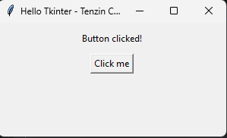
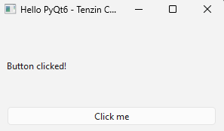

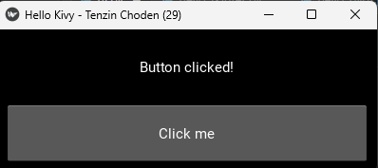
What felt different.
Tkinter needed one import and no installation, and its button took a function directly through command=. PyQt6 needed a separate pip install and several imported classes, plus a QApplication object and an explicit event loop (app.exec()), and its signal and slot connection (clicked.connect) made it clear exactly which event triggers which function. Kivy was the hardest to set up. Its installer did not support my Python 3.14, so I had to create a separate environment with Python 3.13 before it would install. Its program also had the most structure, with an App subclass, a build method and bind(on_press=...) for the event. Of the three, Tkinter had the least boilerplate and Kivy the most.

A4. Recommendation
I chose PyQt6 for the student record manager.
Widget set. The system needs a table of students, a combo box for the year, spin boxes for marks, a checkbox, a progress bar and message dialogs. Qt provides all of these ready-made, including QTableWidget and QMessageBox. Kivy has no equivalent table widget, and Tkinter would need the ttk Treeview with more manual work.
Event model. Signals and slots let me connect each button, the search box, row selection and the marks spin boxes to a separate handler method, and the application uses ten such events. The connections are explicit, so it is easy to see what triggers what and to add a new handler.
Styling and design tooling. Qt Style Sheets let me keep all the styling in one style.qss file, away from the Python code, which supports the split between the UI layer and the data layer. Tkinter's styling options are much more limited, and Kivy would have needed a separate KV file and a custom look for every widget.
A practical factor also mattered. PyQt6 installed with one pip command on my Python 3.14, while Kivy would not install until I switched to Python 3.13.
A different framework would be better in one clear situation. If the system had to run on Android phones with touch input, for example a student attendance app used by teachers in a classroom, Kivy would be the better choice, because Qt desktop bindings from PyQt6 do not target mobile in the same way. If the program had to be sold without releasing its source, PySide6 would be preferable to PyQt6 because of its LGPL licence.

References and AI assistance
Riverbank Computing. (n.d.). PyQt6 documentation. https://www.riverbankcomputing.com/static/Docs/PyQt6/
Qt for Python. (n.d.). Qt for Python documentation (PySide6). https://doc.qt.io/qtforpython-6/
Kivy. (n.d.). Kivy documentation. https://kivy.org/doc/stable/
Python Software Foundation. (n.d.). tkinter — Python interface to Tcl/Tk. Python documentation. https://docs.python.org/3/library/tkinter.html
wxPython. (n.d.). wxPython documentation. https://docs.wxpython.org/
AI assistance disclosure: Claude (Anthropic) was used to draft the framework profiles, the comparison matrix and the recommendation in Part A, and to help write and debug the code for the student record manager. I have reviewed this content and can explain it.

5. System design

5.1 Feature list
- Add a new student with roll number, name, year, marks and enrolment status.
- Edit a student: clicking a table row fills the form, and the Update button saves the changes.
- Delete a student, after a confirmation dialog.
- Search students by name or roll number; the table filters as the user types.
- Marks for five subjects, each out of 100. The subject names change automatically when a different year is chosen (Year 1: DZO, PSY, MATH, IT, EAE; Year 2: MATH, EAE, PSY, EDU, DDD; Year 3: MATH, BPY, DDD, EDU, RES; Year 4: EDU, RES, PRG 305, PRG 404, CAP).
- Automatic total (out of 500), percentage and grade, with a live preview and progress bar while marks are entered.
- Input validation with friendly error popups (empty fields, duplicate roll number, marks outside 0 to 100).
- Data saved in an SQLite database, so it survives closing and reopening the app.
- A stylesheet (style.qss) so the app does not use the default look.
- A Help > About dialog and a window title showing the student's name and roll number, read from config.json.
Grade scale used: A for 80% and above, B for 70%, C for 60%, D for 50%, F below 50%.

5.2 UI wireframe
The application has one main window, plus three message dialogs (error, delete confirmation, About).
Student Record Manager-Name(Roll No)
File Help
Marks(Out of 100)
Student Details
CAP
PRG405
PRG305
RES
EDU
Roll No:
Year:
Name: Nam

Total:0/500 Grade:

ADD
Update
Delete
Clear Form

Search:
Roll No | Name | Year | EDU | CAP | RES | PRG | CAP | Total/%  Grade/Active

5.3 Widget and layout plan
Area | Layout manager | Widgets
Whole window | QVBoxLayout | Holds every row below, top to bottom
Top row | QHBoxLayout | Two group boxes side by side (details and marks)
Student details box | QFormLayout | QLabel, QLineEdit (roll no, name), QComboBox (year), QCheckBox (enrolled)
Marks box | QGridLayout | Five QLabel headings (renamed when the year changes) over five QSpinBox inputs
Result row | QHBoxLayout | QLabel (total and grade), QProgressBar (percentage)
Button row | QHBoxLayout | Four QPushButton: Add, Update, Delete, Clear form
Search row | QHBoxLayout | QLabel, QLineEdit
Student list | (added to the main layout with a stretch factor of 1) | QTableWidget, which takes all spare space when the window is resized
Menu bar | QMenuBar | File > Exit, Help > About
Dialogs | none | QMessageBox: error popup, delete confirmation, About box
Widget types used: QLabel, QLineEdit, QPushButton, QComboBox, QSpinBox, QCheckBox, QProgressBar and QTableWidget (eight), plus QGroupBox and QMessageBox. Layout managers used: QVBoxLayout, QHBoxLayout, QFormLayout and QGridLayout (four).

5.4 Data design
The data is stored in one SQLite table called students, in the file students.db in the project folder.
Column | Type | Rule
id | INTEGER, primary key | Generated automatically
roll_no | TEXT | Required and unique
name | TEXT | Required
year | INTEGER | 1 to 4 (chosen from a combo box)
mark1 | INTEGER | 0 to 100 (first subject of the student's year)
mark2 | INTEGER | 0 to 100 (second subject)
mark3 | INTEGER | 0 to 100 (third subject)
mark4 | INTEGER | 0 to 100 (fourth subject)
mark5 | INTEGER | 0 to 100 (fifth subject)
active | INTEGER | 1 for enrolled, 0 for not (default 1)
The five mark columns hold the marks for the subjects of the student's year, in this order. The subject names are kept in the program (a dictionary in database.py), not in the database, so the labels change when the year is chosen.

Year | mark1 | mark2 | mark3 | mark4 | mark5
1 | DZO | PSY | MATH | IT | EAE
2 | MATH | EAE | PSY | EDU | DDD
3 | MATH | BPY | DDD | EDU | RES
4 | EDU | RES | PRG 305 | PRG 404 | CAP
Total, percentage and grade are not stored. They are calculated from the five marks whenever students are loaded, so they can never become out of date.
The student's own name and roll number (shown in the title bar and About dialog) are kept separately in config.json:
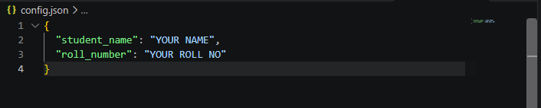

5.5 Architecture
The code is split into a UI layer and a data layer. The UI never writes SQL; it calls functions in database.py, which does all the database work and the validation.
File | Layer | Role
app/main.py | Entry point | Creates the database table if needed, loads style.qss, shows the window and starts the event loop
app/ui.py | UI layer | MainWindow class: widgets, layouts, menu, signals and slots, dialogs
app/database.py | Data layer | SQLite add, update, delete, get and search functions, validation, and the total, percentage and grade calculation
app/style.qss | Styling | Qt style sheet
students.db | Data | SQLite database file
config.json | Settings | Student name and roll number
How the parts connect:
Read/write
student.db
Database.py
ui.py
(MainWindow)

MainWindoww
shows
Main.py
calls
sh

loads
reads
Data and resources file
Python Module
config.joson
Name,roll no
style.qss

6. Implementation
This section shows how each mandatory requirement was met, with short snippets from the real code.

6.1 Main window with title, size and menu bar
MainWindow inherits from QMainWindow, which provides a menu bar and a status bar. The title shows the student's name and roll number, which are read from config.json.

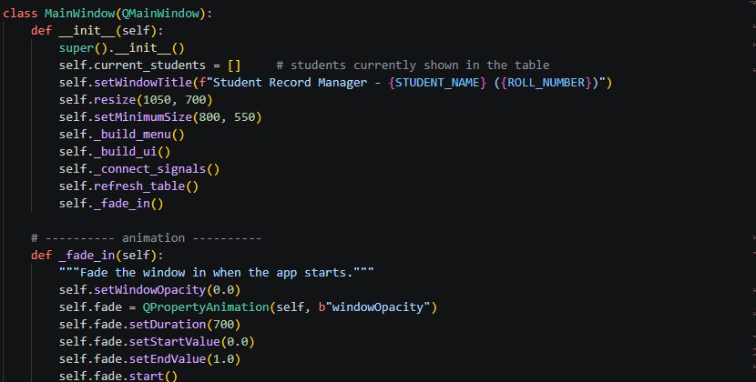
The constructor also calls _fade_in(), which fades the window in when the application starts.

File and Help menus in the menu bar
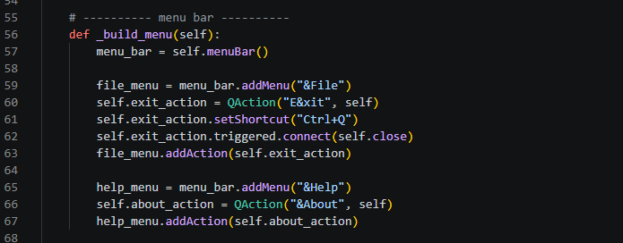

6.2 Widgets (eight types)
The form uses QLabel, QLineEdit (roll number, name, search), QComboBox (year), QCheckBox (enrolled), QSpinBox (five marks), QPushButton (four buttons), QProgressBar (percentage) and QTableWidget (student list). QGroupBox groups the form fields. This snippet creates three of them:
Input widgets in the student details form.
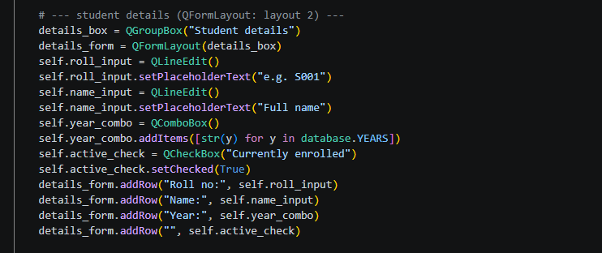
Subject labels and mark spin boxes created in a loop.
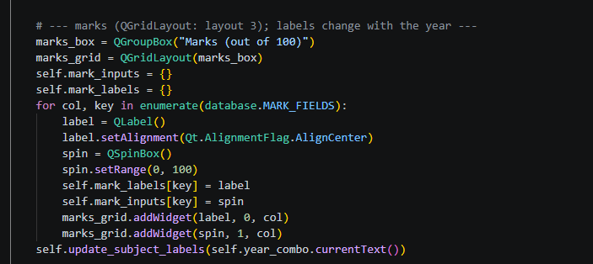

6.3 Layout managers
A QFormLayout aligns the labels and inputs in the student details box (Figure Input widgets in the student details form.), and a QGridLayout places each subject label above its spin box in the marks box (Subject labels and mark spin boxes created in a loop.). The main window also uses a QVBoxLayout to stack its rows from top to bottom and a QHBoxLayout to place the details box and the marks box side by side. The table is added with a stretch factor of 1, so it grows and shrinks when the window is resized, and the minimum size stops the window from becoming too small to use.

6.4 Signals and slots (ten events)

Qt widgets emit signals when something happens, and a slot is the method that responds. The _connect_signals method links each signal to its slot.
Source file: app/ui.py
Signals connected to slots
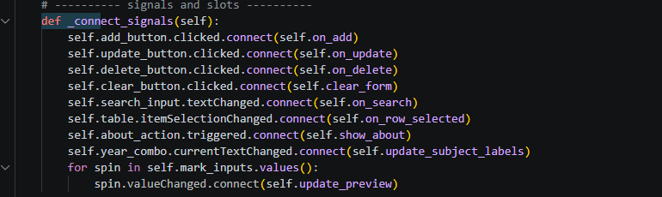

The handled events are: Add, Update, Delete and Clear clicks, search text changed, table row selected, About menu action, marks value changed, year changed (which relabels the subject boxes), and the Exit menu action (connected in _build_menu). That is ten, against a minimum of five.
For example, update_preview runs whenever any marks box changes. It updates the total and grade and slides the progress bar to the new percentage with a short animation.

Source file: app/ui.py
Live preview updated when a mark changes

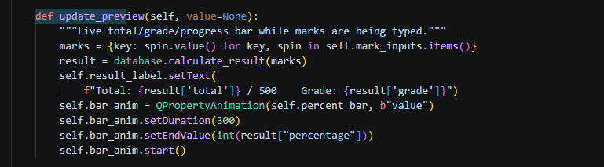

6.5 Dialogs

Three dialogs are used, all built from QMessageBox: an error popup for invalid input, a Yes/No confirmation before deleting, and an About box showing the student's name and roll number. The confirmation defaults to No, so a stray Enter key does not delete a record.

Source file: app/ui.py
Delete confirmation dialog
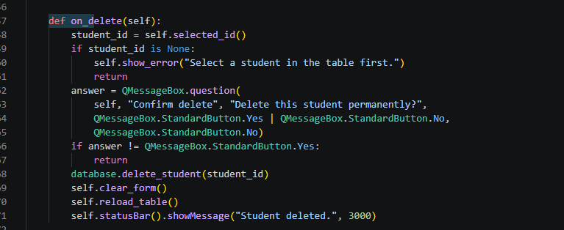

6.6 Input validation

All the rules live in one function in the data layer, validate_student. It raises a ValueError with a readable message when something is wrong. The UI catches the error and shows it in a popup, so the program never crashes on bad input.

Source file: app/database.py
Required fields and year check in validate_student
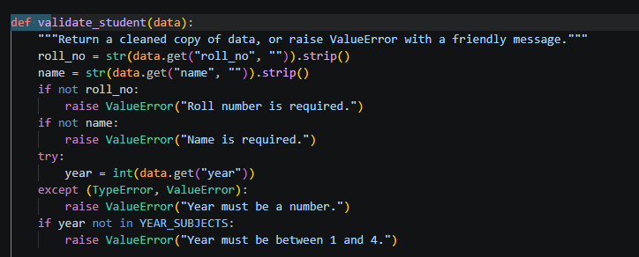

Source file: app/database.py
Marks must be whole numbers between 0 and 100
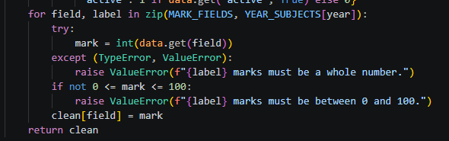

Source file: app/ui.py
The UI catches the error and shows it in a popup
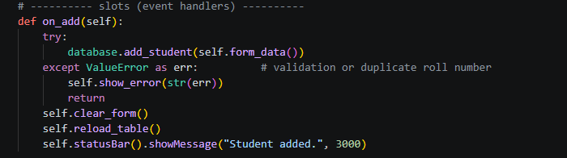

A duplicate roll number is caught by the database's UNIQUE rule: SQLite raises IntegrityError, which add_student converts into the message "Roll number ... already exists."

6.7 Data persistence

Records are stored in an SQLite database, so they survive closing and reopening the application. The path is built from the location of the code file, so no absolute path is hard-coded and the project works on any computer.

Source file: app/database.py
Database path built from the location of the code file
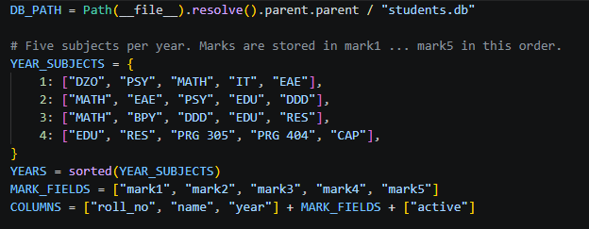

The init_db function creates the students table the first time the application runs. The CREATE TABLE IF NOT EXISTS statement leaves existing data untouched on later runs, and the table also keeps an older version of the data if the table layout changes.

Source file: app/database.py
Creating the students table
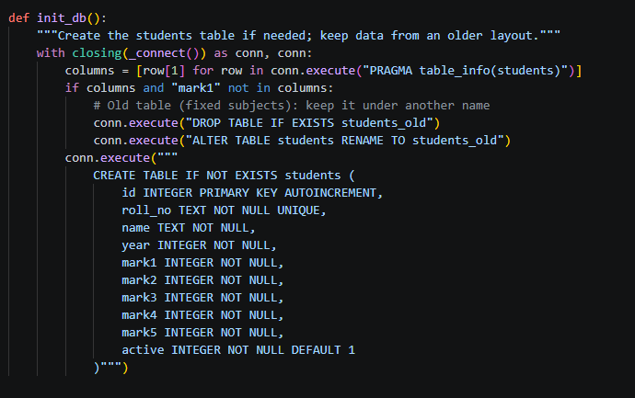
Values are passed to SQL through ? placeholders instead of being pasted into the query text, which prevents SQL injection.

Source file: app/database.py
Parameterised INSERT using ? placeholders
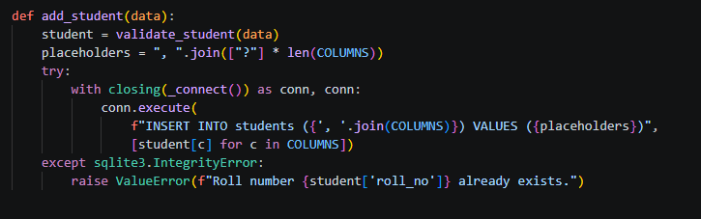

6.8 Styling

All styling is in a separate Qt style sheet, style.qss, which main.py loads when the program starts. The Delete button is given an object name so only it turns red.

Source file: app/main.py
Loading style.qss when the program starts
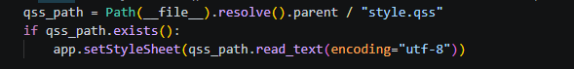

Source file: app/ui.py
Giving the Delete button an object name
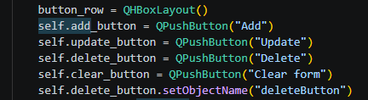

Source file: app/style.qss
Style rules for the buttons
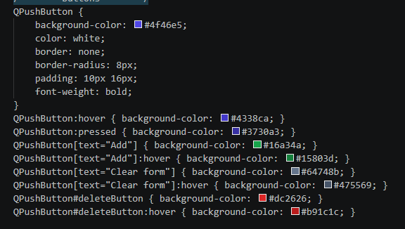

6.9 Separation of UI and logic

ui.py contains only windows, widgets and event handlers, and never writes SQL. database.py contains the validation, all database operations and the result calculation, and has no GUI code, so it can be tested on its own by running python app/database.py. For example, the grade rules exist in one place and the UI simply calls them.

Source file: app/database.py
Result calculation in the data layer
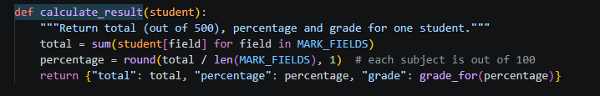
Settings that differ between users, the name and roll number, are kept in config.json instead of the code, so the same program can be used by anyone by editing one small file.

Source file: config.json
config.json holds the student name and roll number
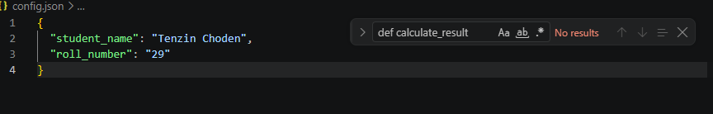

7. Testing
The application was tested by hand on 5 November 2026, running Windows with Python 3.14 and PyQt6 6.12.0. The data layer was also tested on its own by running python app/database.py, which adds a sample student, prints the calculated result, and checks that an out-of-range mark and a duplicate roll number are rejected.
# | Action | Input | Expected | Actual | Pass/Fail
1 | Add a valid student | Roll S10, name Pema, year 2, marks 70/65/80/75/60 | Row appears in the table and the status bar says "Student added." | Row appeared and the message was shown | Pass
2 | Add with empty roll number (invalid) | Roll blank, name Pema | Popup: "Roll number is required." | Popup shown, nothing saved | Pass
3 | Add with empty name (invalid) | Roll S11, name blank | Popup: "Name is required." | Popup shown, nothing saved | Pass
4 | Add a duplicate roll number (invalid) | Roll S10 again | Popup: "Roll number S10 already exists." | Popup shown, no second row | Pass
5 | Add with a name of only spaces (invalid) | Roll S12, name of three spaces | Popup: "Name is required." | Popup shown, nothing saved | Pass
6 | Live preview of results | All five marks set to 100 | Label shows 500 / 500, grade A, progress bar at 100% | Showed 500 / 500, grade A, bar full | Pass
7 | Select a row | Click a row in the table | Form fills with that student's data | Form filled correctly | Pass
8 | Update a student | Select a row, change EDU to 90, click Update | Table shows the new mark and a recalculated total | Table updated, total recalculated | Pass
9 | Update with nothing selected (invalid) | Click Clear form, then Update | Popup: "Select a student in the table first." | Popup shown | Pass
10 | Search by name | Type "Pem" | Only matching students are shown | Only matching rows shown | Pass
11 | Search with no match | Type "zzz" | Table is empty | Table was empty | Pass
12 | Delete and answer No | Select a row, click Delete, click No | Student stays in the table | Student remained | Pass
13 | Delete and answer Yes | Select a row, click Delete, click Yes | Student is removed | Student removed | Pass
14 | Persistence | Close the app and open it again | Remaining students are still listed | Records were still there | Pass
15 | About dialog | Help > About | Shows the student's name and roll number | Dialog showed the details | Pass
16 | Change the year | Choose Year 1, then Year 2, 3 and 4 in the Year box | The five subject labels above the marks boxes change to that year's subjects | [write what you saw after testing] | [Pass/Fail]
Cases 2, 3, 4, 5 and 9 are invalid-input cases, more than the three required. In every one the application showed a message and carried on, and there were no unhandled crashes.

8. Screenshots
Take each of these screenshots with the name and roll number visible in the title bar (set them in config.json first), and paste them into the placeholders.
Figure 1. Main window when first opened, with the form empty.
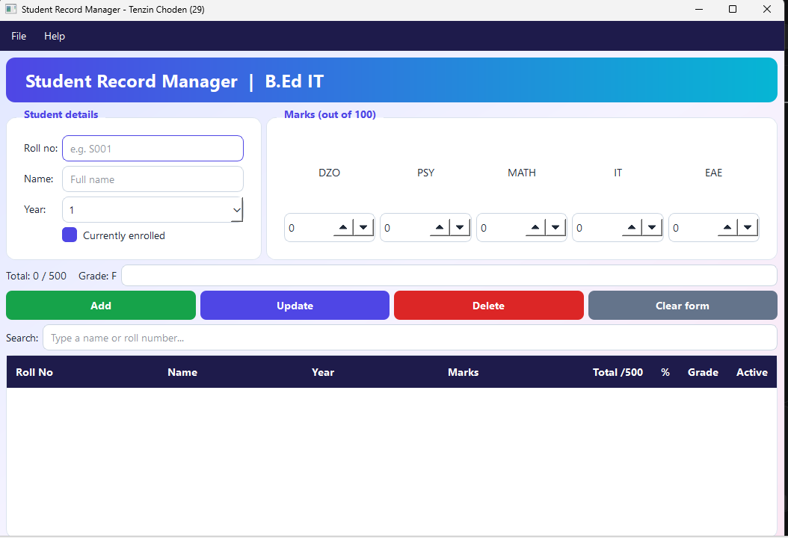
Figure 2. Main window with several students in the table.
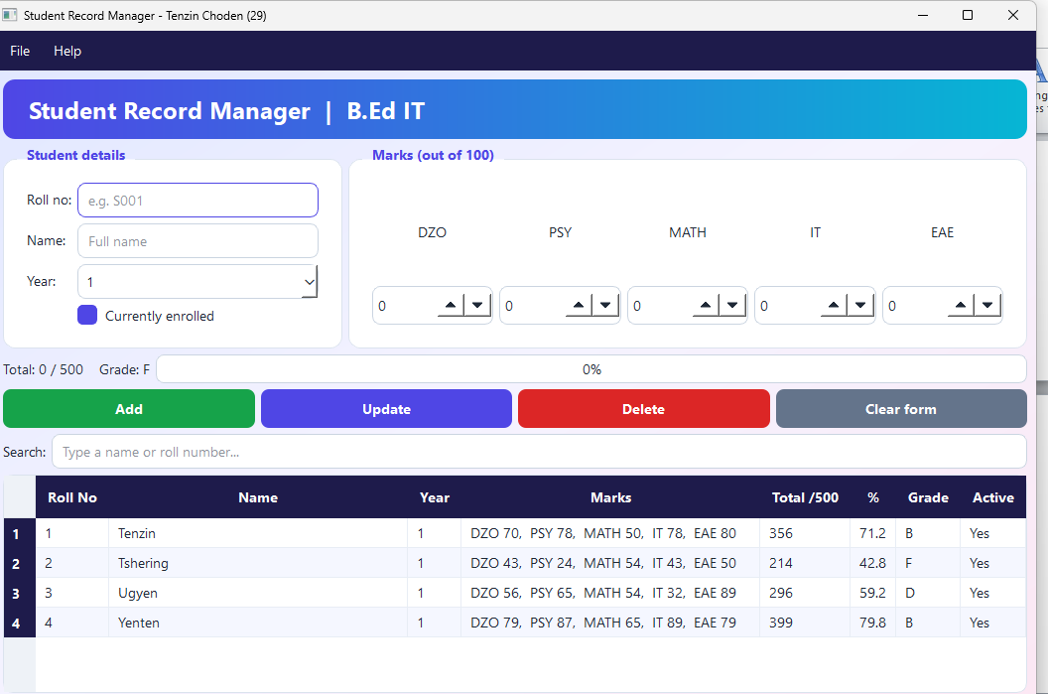
Figure 3. A student selected, with the form filled in for editing.
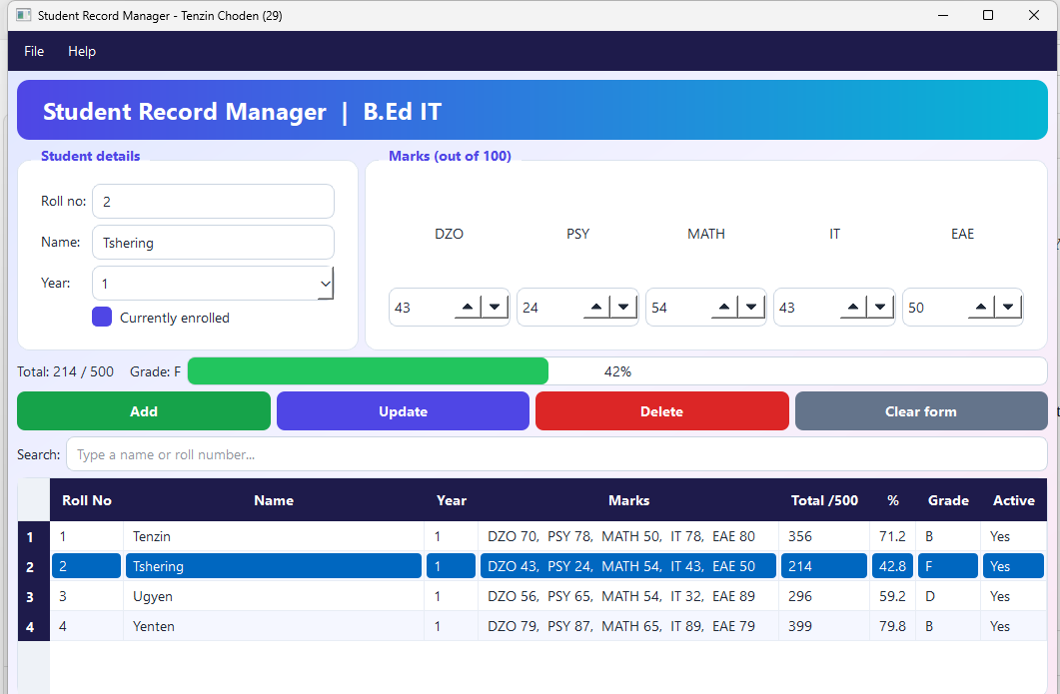
Figure 4. Search in use, with the table filtered.
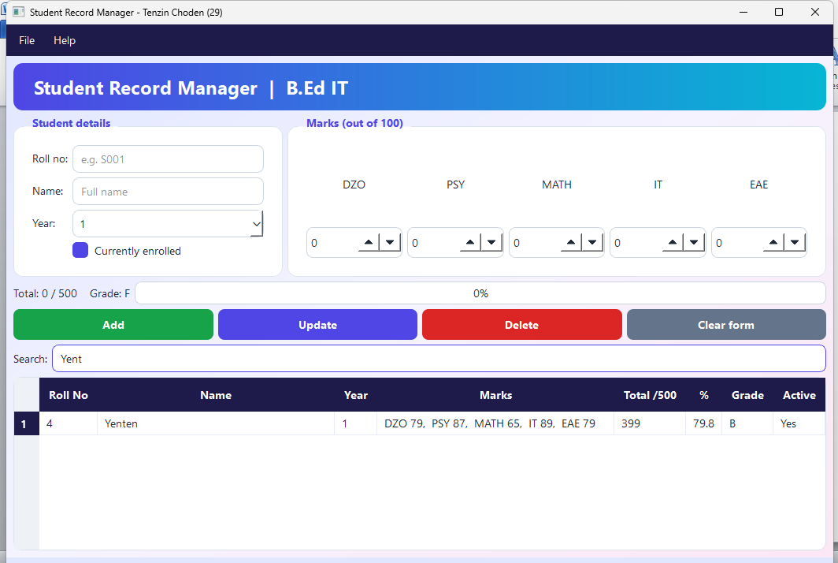
Figure 5. Validation error popup, for example "Roll number is required." or the duplicate roll number message.
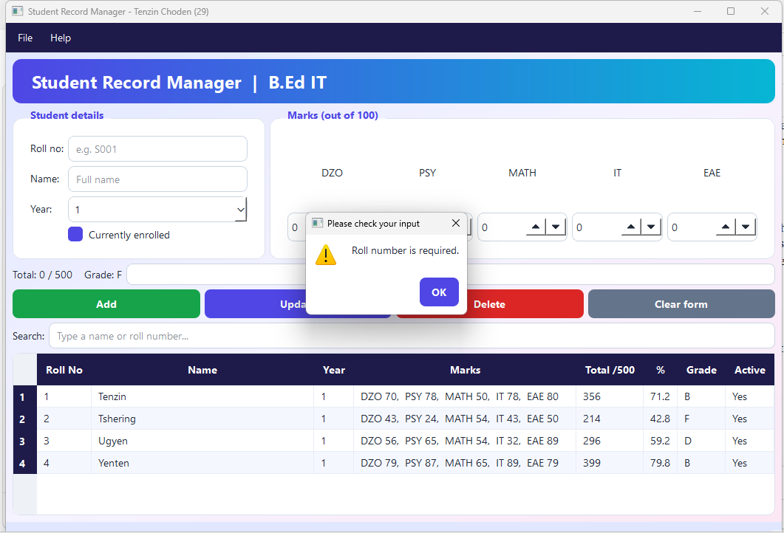
Figure 6. Delete confirmation dialog.
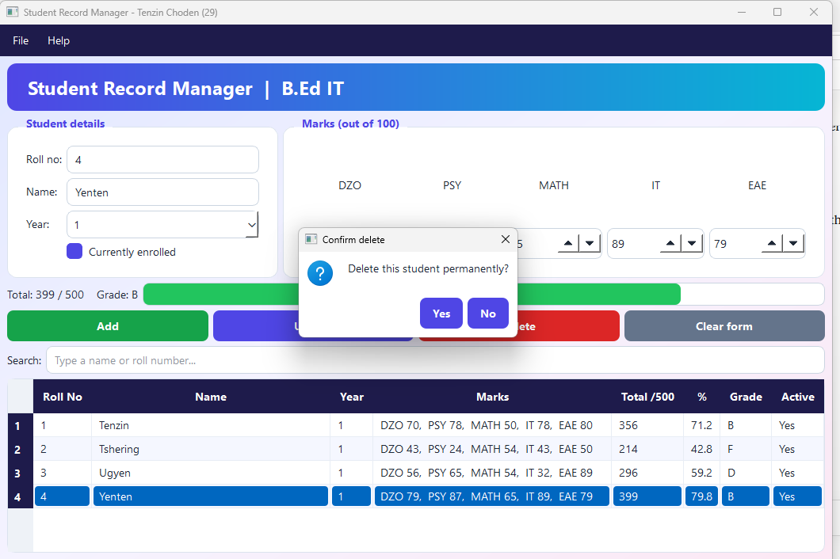
Figure 7. Help > About dialog.
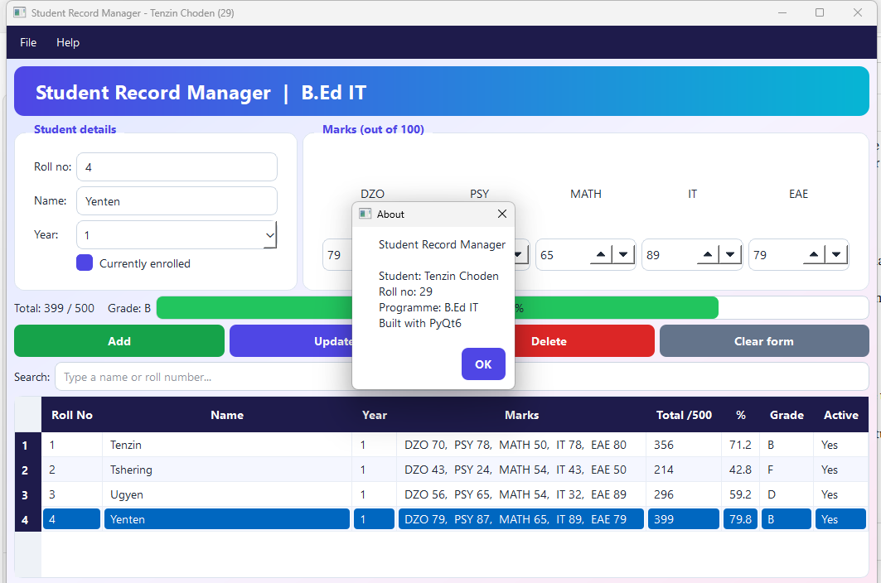
The three hello-world screenshots are in section 4.3 (Hello-world evidence) of the framework study.

9. Challenges and reflection

9.1 Three problems and how they were solved
Problem 1: Kivy would not install. The hello-world program for Kivy failed at pip install kivy. The error said the build could not find a matching kivy_deps.sdl2_dev package, because my Python 3.14 was too new for the Kivy release available, so pip tried to build Kivy from source and failed. I solved it by installing Python 3.13 next to Python 3.14 and creating a separate virtual environment, venv_kivy313, just for Kivy. Kivy 2.3.1 then installed and the program ran. Keeping Kivy in its own environment also kept it out of the project's requirements.txt.
Problem 2: AttributeError: 'MainWindow' object has no attribute 'search_input'. After I replaced part of ui.py, the program crashed on startup. The cause was a damaged copy of the file, where the search box was used before it had been created. I fixed it by clearing the whole file and pasting the complete, correct version again, then checking that the last line of the file was intact. I learned to replace whole files instead of patching small pieces, and to read the line number in the traceback.
Problem 3: The checkbox lost its box after styling. When the style sheet was applied, the "Currently enrolled" checkbox showed only a tick with no square around it. I solved it by adding QCheckBox::indicator rules to style.qss, giving the indicator a size, a border, a white background when unticked and a solid blue background when ticked.

9.2 What I would do differently
I would write the test table earlier, as I built each feature, instead of at the end. I would also replace QTableWidget with QTableView and a model, which is better for larger amounts of data, and I would add the stretch goals: a chart of marks and packaging the app with PyInstaller. A further improvement would be a subject list that depends on the course, so the program could manage other programmes besides B.Ed IT.

9.3 Would I still choose PyQt6?
Yes. PyQt6 gave me every widget the project needed, installed with a single command, and let me keep styling in one file and logic in another. Its signal and slot model made each event easy to follow. Kivy would be my choice for a touch or mobile app, and Tkinter for a very small tool, but for a data-entry desktop application PyQt6 was the best fit.

10. References
Kivy Organization. (n.d.). Kivy documentation. https://kivy.org/doc/stable/
Python Software Foundation. (n.d.-a). sqlite3—DB-API 2.0 interface for SQLite databases. Python documentation. https://docs.python.org/3/library/sqlite3.html
Python Software Foundation. (n.d.-b). tkinter—Python interface to Tcl/Tk. Python documentation. https://docs.python.org/3/library/tkinter.html
Qt Company. (n.d.-a). Qt for Python (PySide6) documentation. https://doc.qt.io/qtforpython-6/
Qt Company. (n.d.-b). Qt style sheets reference. Qt documentation. https://doc.qt.io/qt-6/stylesheet-reference.html
Riverbank Computing. (n.d.). PyQt6 documentation. https://www.riverbankcomputing.com/static/Docs/PyQt6/
wxPython. (n.d.). wxPython documentation. https://docs.wxpython.org/

I used Claude (an AI assistant by Anthropic) during this project.
- Code: Claude wrote the first versions of database.py, ui.py, main.py, style.qss and the three hello-world programs, and helped debug the errors in section 9. I ran, tested and changed the code, and I can explain it.
- Design: Claude proposed the project choice, the data table and the screen layout, which I approved.
- Report text: Claude drafted the framework study, the comparison matrix, the recommendation, and the system design, implementation, testing and reflection sections. I reviewed and edited them.
- Test results: I ran the 15 test cases myself and recorded the results.

