Theater Ticket System

CS 650 Software Engineering Process

Team Project Proposal

2014 September 24

**Team Name:** Team D

**Project Team Members:**

Kesterson, Andy

Knight, Samantha

Kore, Sumeet

Madyun, Rashad

McComas, Angela

Morse, Anthony

# Scope

The Theater Ticket System, TTS, manages the different tasks involved with handling ticket sales to all events and associated venues. Customer service agents, CSA, interact with the TTS to handle ticket sales to customers either by telephone or in person. The CSA handles reservations for reserved and general admission seating. Once the CSA has entered the reservation information into the system, a database stores the information for future use. The database stores customer name and address information, seat choices, special needs information, payment information, and whether the customer is a season ticket buyer or an individual ticket buyer.

The Level 0 Use Case diagram is presented in Figure 1. In creating this diagram, several assumptions were made. The customer only interacts with the customer service agent. The CSA provides the interaction between the TTS and the database.

Figure 1- Level 0 Use Case Diagram

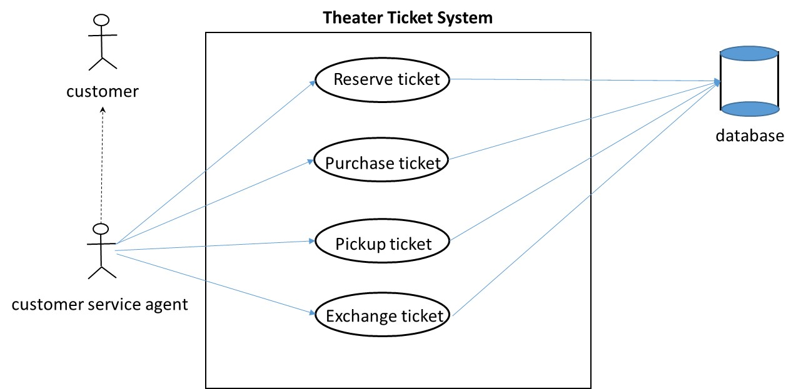

## Analysis Classes

Initial analysis classes derived from this diagram are the ticket, the event, the venue, the customer, and the customer service agent.

## Assumptions And Constraints

Several assumptions about the system were identified:

1. The system is up and running.
2. Tickets are available for the desired event.
3. There is a working telephone line at the organizations office.
4. There are CSAs available to work telephone lines and any event ticket booth.
5. The customer can provide a valid form of payment.
6. There is a third party payment system available to handle non cash payments.
7. Operating system versions are compatible.
8. A third party database system will be utilized to handle persistent data for the TTS.
9. A ticket booth at an event will have a data connection to the database.

A constraint was identified: The Theater Ticket system software must operate on a typical Windows machine that can be used both at the organization’s office and at any ticket booth of the event.

# Team Organization

## Meetings

The team has decided to meet weekly on Tuesday and Wednesday at 7:00 pm at the university. Telephone conferences may be scheduled as necessary.

## General Communications

The team will use Angel and UAH email for general communication during the semester.

## Documentation

The team has decided to utilize git for documentation version control, and UMLet to develop UML diagrams. We plan to utilize the services of either BitBucket or GitHub for hosting the change tracking and version control repository.

## Process

Initially Team D plans to utilize a component model process. This is to facilitate concurrent activities such as building requirements, use cases, and models. Furthermore we plan to subdivide these tasks between 3 pairs to accomplish these tasks.

# Initial Plan

The team has tentatively identified a plan as follows:

1. Implement a concurrent process model.
2. Identify the Customer requirements.
3. Refine the Level 0 Use Case diagram.
4. Develop use case descriptions based on the Level 0 Use Case diagram.
5. Develop activity diagrams from the use case descriptions.
6. Develop sequence diagrams from the activity diagrams.
7. Derive software requirements from the previous activities.
8. Develop any other artifacts as required by the professor.
9. Perform reviews on a regular basis (TBD).
10. Take meeting minutes for every meeting which will become part of the project paper.
11. Note lessons learned during the course of the semester and add to the project paper.