System Requirements Specification

Theater Ticket System

Version 1.0

Prepared By Team D

UAH / CS650 / Software Engineering Process

This page intentionally left blank.

Table of Contents

1.0 Introduction 1

1.1 Purpose <Of This Document> 1

1.2 Glossary of Terminology 1

1.3 Document References 1

2.0 Overall Description 2

2.1 Scope 2

2.2 System Features 2

2.3 System Constraints 2

3.0 Requirements 3

3.1 Customer Requirements 3

3.2 Functional Requirements 3

3.3 Requirements Matrix 3

4.0 Models and Diagrams 4

4.1 Use Case Diagram – TTS Level 0 4

4.1.1 Reserve Ticket 4

**Index Of Tables**

Table 3.1‑1Customer Requirements 3

Table 3.2‑1 Functional Requirements 3

Table 4.1‑1 Reserve Ticket Use Case 4

Table 4.1‑2 Reserve Ticket Function Point Estimation 5

**Index Of Figures**

Figure 4.1‑1TTS Level 0 Use Case 4

Figure 4.1‑2 Reserve Ticket Function Point Diagram 5

Revision History

| **Date** | **Revision** | **Change Description** | **Name** |
| --- | --- | --- | --- |
| 2014/10/08 | 1.0 | Initial document creation | A. Kesterson |
|  |  |  |  |
|  |  |  |  |
|  |  |  |  |

Project Team Members

|  |  |  |
| --- | --- | --- |
| **Name** |  |  |
| Kesterson, Andy |  |  |
| Knight, Samantha |  |  |
| Kore, Sumeet |  |  |
| Madyun, Rashad |  |  |
| McComas, Angela |  |  |
| Morse, Anthony |  |  |

# Introduction

## Purpose <Of This Document>

## Glossary of Terminology

## Document References

# Overall Description

## Scope

The Theater Ticket System, TTS, manages the different tasks involved with handling ticket sales to all events and associated venues. Customer service agents, CSA, interact with the TTS to handle ticket sales to customers either by telephone or in person. The CSA handles reservations for reserved and general admission seating. Once the CSA has entered the reservation information into the system, a database stores the information for future use. The database stores customer name and address information, seat choices, special needs information, payment information, and whether the customer is a season ticket buyer or an individual ticket buyer.

## System Features

## System Constraints

1. The TTS software must operate on a typical Windows machine that can be used at both the organizations office and at any ticket booth of an event.
2. An external system will handle the management of events in the database. Items such as creating an event, cancelling an event, setting the maximum event tickets, etc. would all be handled by this external system.

# Requirements

## Customer Requirements

Table ‑Customer Requirements

| **REQ** | **DESCRIPTION** |  |
| --- | --- | --- |
|  |  |  |

## Functional Requirements

Table ‑ Functional Requirements

| **REQ** | **DESCRIPTION** |  |
| --- | --- | --- |
|  |  |  |

## Requirements Matrix

# Models and Diagrams

## Use Case Diagram – TTS Level 0

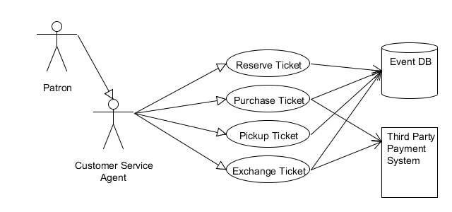

Figure ‑TTS Level 0 Use Case

### Reserve Ticket

#### Use Case Description

Table ‑ Reserve Ticket Use Case

| **UC Name** | **Reserve Ticket** | |
| --- | --- | --- |
| Description |  | |
| Actors | Customer Service Agent (CSA) | |
| Pre-Conditions | A CSA is available.  The TTS is operational.  The CSA is logged in to TTS. | |
| Post-Conditions | A ticket is reserved for a patron.  The selected tickets are no longer available for other patrons. | |
| Triggers | A patron wishes to reserve a ticket. | |
| Flow | | |
|  | Actor | System |
|  | Query seats for a specific event |  |
|  |  | Search for a specific Event. |
|  |  | Return results available seats. |
|  | Select a seat |  |
|  |  | Verify seat is available, and lock selected seat. |
|  | Query for the patron’s information. |  |
|  |  | Search for the patron. |
|  |  | Return results for the searched patron. |
|  | Select the correct patron. |  |
|  |  | Verify selected patron. |
|  |  | Associate locked seat with selected patron. |
| Exceptions | The ticket(s) for the desired event are sold out.  The patron does not exist within the system.  A selected seat is not available when selected.  The desired event is not available or exists within the Event database. | |
| Extension Points |  | |

#### Activity Diagram

#### Function Point Estimate

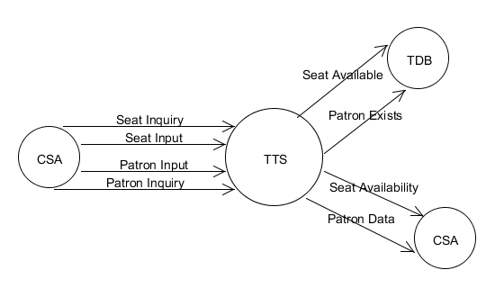

Figure ‑ Reserve Ticket Function Point Diagram

|  |  | **Simple** | **Average** | **Complex** | **Count** |
| --- | --- | --- | --- | --- | --- |
| External Inputs | 2 | 3 | 4 | 6 | 8 |
| External Outputs | 2 | 4 | 5 | 7 | 10 |
| External Inquiry | 2 | 3 | 4 | 6 | 8 |
| Internal Logic Files | 0 | 7 | 10 | 15 | 0 |
| External Interface Files | 2 | 5 | 7 | 10 | 14 |
|  | | | **Count Sub Total** | | 40 |
| **∑F** | | 38 |
| **FP Total** | | 42 |

Table ‑ Reserve Ticket Function Point Estimation

This page intentionally left blank.

**Appendix A – Deliverable**

1. How We Operate
   1. Roles
   2. Tools Used
   3. Team Communication Strategy
   4. Team Quality Assurance Strategy
   5. Project Schedule (Deliverable 1)

This page intentionally left blank.