# Report on fairness of sailing scoring

## Problem

## The problem we are looking into is how the scoring system for sailing rewards consistency in competitors. And to whether it is better to do consistently well or so have a medium skill level with a high amount of variance. Also looking into the example sailors given to see how the differing skill levels and variation would affect placement over a large number of races.

## Long Term Skill Vs Versatility

To try and solve the two different problems two different methods were used. Firstly, to find the effect of skill over a massive number of races. The above 2 graphs show the effect of running 10^4 races for the 5 sailors with skill and variance characteristics defined in the brief. Every iteration represents a race being held and the score that they achieve in the race is then added to a register for each character and then divided by the number of races already held. This means that the average keeps getting more accurate the more the races that there are.

It is clear to see the effect of this increasing accuracy as with the graph for Clare and Eva after only a few races are run their averages change violently due to the range of possible scores that they could have. How variance effected the racing can be most easily seen when observing Clare’s graph on the right-hand graph showing a sharp dive into 3rd place and staying there whereas the other graph on the right shows how the variance worked in her favor to keep her in 1st place for a large amount of the first half of the graph.

However, as the number of runs increases you can see as the graphs begin to converge Clare taking longer due to her higher variance. The graphs of the sailors with variance begin to approach their skill value which can be seen by the graph of Alice and Dennis.

This shows that variance becomes less and less import the greater the number of races and that in the beginning when it can cause a big difference it can just as easily cause a loss as it could a win. Making it better to maintain a high skill and a low variance.

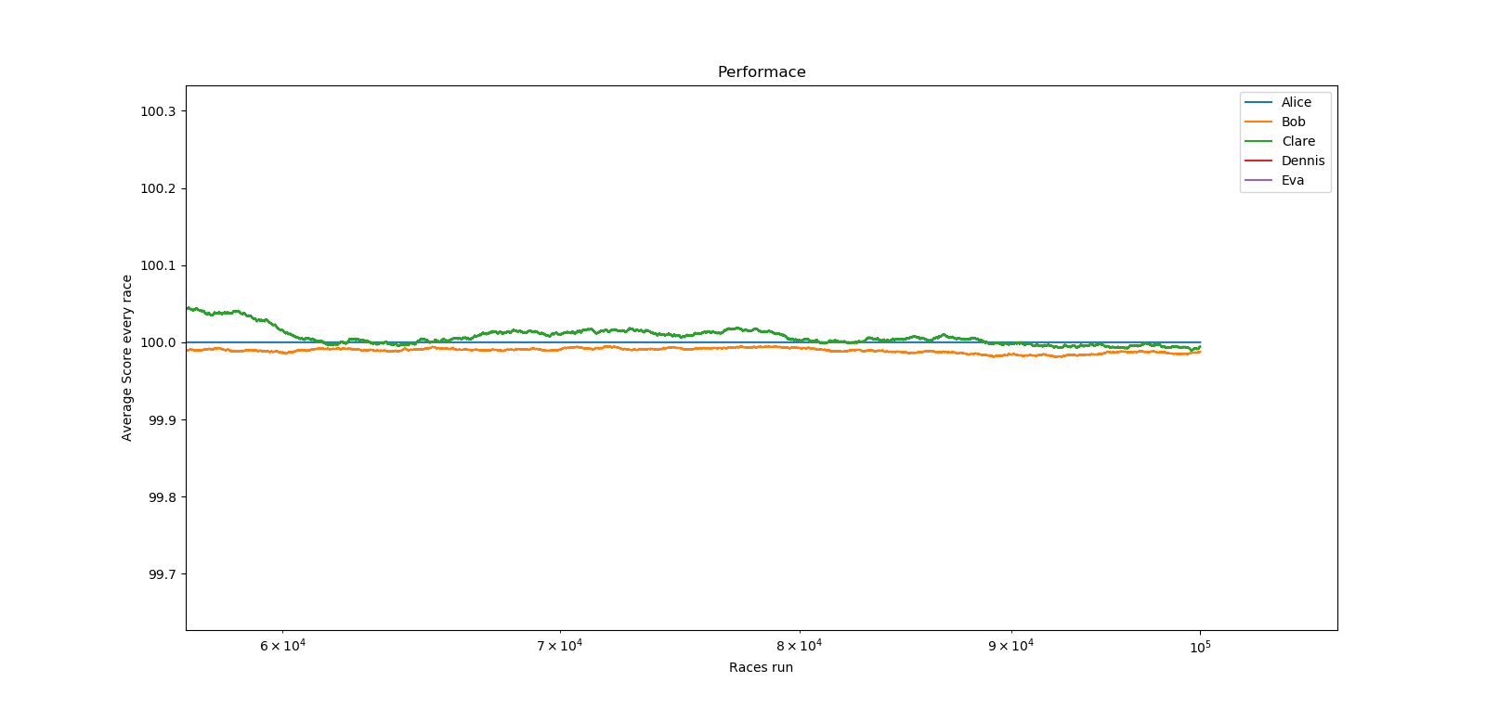

This is assuming that the skill level of the sailors would remain constant over the thousands of races that it would take for the variance to become inconsequence. Also, this relies on the ability to be able to run thousands of races with the same group of people in the same conditions which is unrealistic.

The graph on the right shows a zoomed in view of the Alice Bob and Clare graphs converging. This shows the evolving average.

## Better to have a Medium skill and high variance or a slightly higher skill and lower variance.

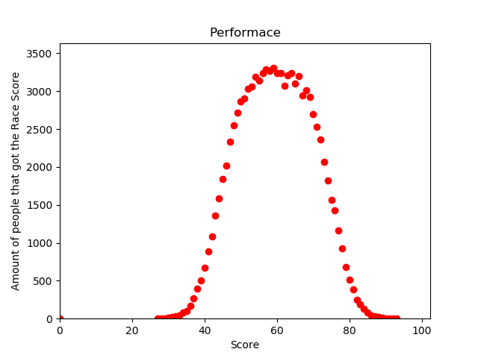

The question here is if there is a correct balance between the two values that together cause the best performance from a sailor.

The two Bell Curves on the right are showing the result of 100000 sailors with randomly generated skill levels between 2 levels and a set variance level.

The Top graph uses a random skill level from 45 to 75. Whilst the bottom one uses 30 to 60. As we are trying to find the effect variance has at different skill levels the top graph has a variance of 5 whilst the bottom has 20.

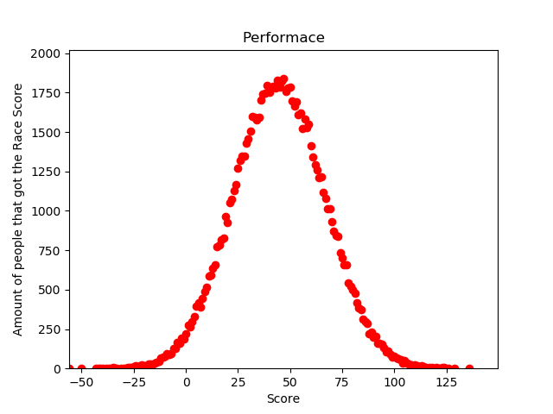The graph shows the score that the sailors achieved on the x axis and the number of the 100000 sailors that also achieved the same score. The variance effects the steepness of the graph along with the width of the plateau of the top. The small the variance the larger the plateau as seen in the top graph.

The base of the bell curve is affected by the range of which the random skill level is draw from.

Looking at the Blue vertical line on the graph that marks a score of 50 we can clearly see that on the top graph a larger majority of the sailors are passed the line. This shows how that despite how the high variance of the bottom graph does allow many of its sailors to reach high scores and allows many of them to get a higher score than any on the top graph. However due to the consistency that comes from the high skill level the sailors of the top graph are getting the statistically higher score. Making a higher skill level and medium to low variance superior to the alternative medium skill high variance.

## Conclusion

In conclusion, I do feel that the simulation did a good job of representing the sailing racing. And therefore, allowed some real conclusions to be formed. I do feel that there are ways that the experiment could be improved, for example as the sailors complete more and more races their skill level would rise and their variance would fall. This would represent the learning curve for the sailors and allow for a more realistic result. Also adding in other random occurrences to account for such as different conditions or competition formats.