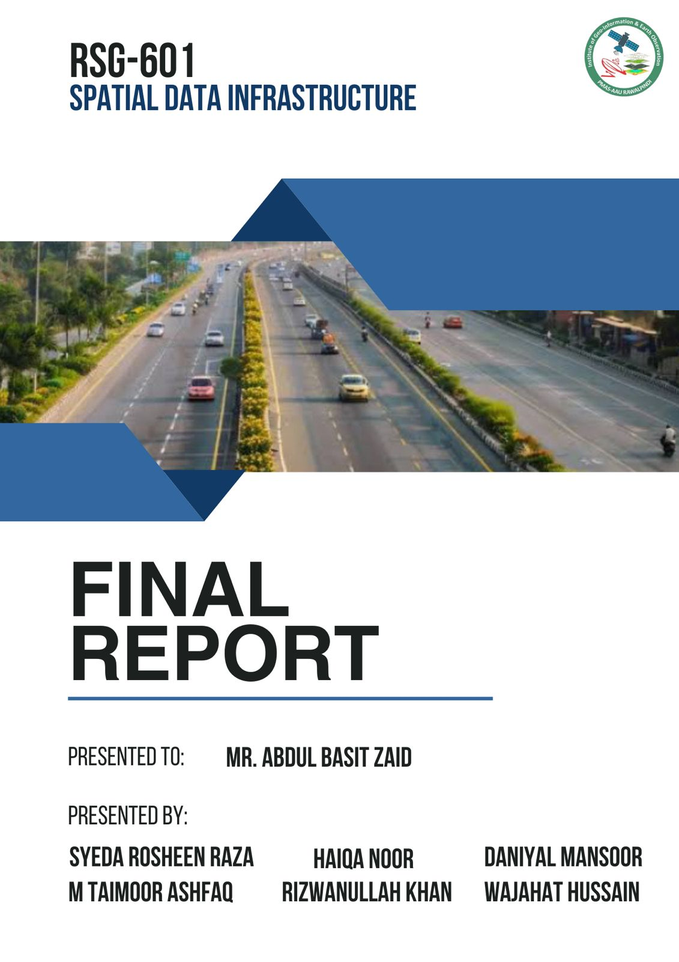



SUBMITTED TO: Mr. Abdul Basit
SUBMITTED BY: Syeda Rosheen Raza Kazmi || M. Taimoor Ashfaq Malik
M. Daniyal Mansoor || Wajahat Hussain || Rizwan || Haiqa Noor
ARID NO: 21-ARID-1041 || 21-ARID-1032 || 21-ARID-1025
21-ARID-1044 || 21-ARID-1037 || 21-ARID-1014
SUBJECT: Spatial Data Infrastructure
DISCIPLINE: BS-Geo Informatics
SEMESTER: 7th A
PMAS Arid Agriculture University
Rawalpindi

Contents
Abstract 4
1. Introduction 4
2. Problem Statement 5
3. Objectives 5
4. Road Networks of Pakistan 6
5. Methodology 7
5.1 Data Acquisition 7
5.2 Data Standardization 7
5.3 Attribute Enrichment 8
5.4 Spatial Adjustment 8
5.5 Data Integration and Simplification 10
5.6 Quality Assurance and Validation 10
6. Results 10
6.1 Punjab 10
6.2 Sindh 11
6.3 Balochistan 12
6.4 Azad Kashmir 13
6.5 Khyber Pakhtunkhwa 14
6.6 Gilgit 15
7. Conclusion 17
8. References 17

Building a National SDI for Pakistan: A Case Study on Road Networks Digitization

Abstract
This report outlines the development of a refined and consistent road network dataset as a foundational component of Pakistan’s National Spatial Data Infrastructure (NSDI). The project addresses key challenges in the existing datasets, including fragmentation, incomplete metadata, and misaligned geometries. A systematic methodology was employed, encompassing data acquisition from OpenStreetMap, translation of road names from Urdu to English, attribute enrichment, spatial adjustments, and rigorous quality assurance. The study highlights significant reductions in road segment redundancies across regions such as Punjab, Sindh, and Khyber Pakhtunkhwa, resulting in an accurate and streamlined dataset. The enhanced road network supports seamless geospatial analysis and fosters data-sharing capabilities for informed decision-making. This initiative sets a benchmark for similar geospatial refinement projects aimed at strengthening SDIs for sustainable development.

Introduction
Spatial Data Infrastructures (SDIs) are intricate, not only due to their technical aspects but also because of the diverse ways they are understood and implemented. This complexity is reflected in the various definitions and perspectives found in the literature. For instance, Crompvoets et al. (2004) describe SDIs as mechanisms for facilitating and coordinating the exchange and sharing of spatial data among stakeholders within the spatial data community. This perspective emphasizes the importance of collaboration and communication in the effective implementation of SDIs. Other scholars have contributed to the understanding of SDIs. Williamson (2003) describes SDIs both as an initiative and as a concept, highlighting the process of "building SDIs." Meanwhile, Groot and McLaughlin (2000) focus on SDIs in terms of specific activities. These varied descriptions underscore the multifaceted nature of SDIs, which encompass technical, organizational, and social dimensions. The effective development and use of SDIs require a comprehensive approach that considers these complexities. By viewing SDIs as socio-technical assemblies, their performance can be better evaluated and monitored, ensuring sustainability and effectiveness in facilitating spatial data exchange and sharing. Moreover, navigating the complexity of communications and relationships between sectors and agencies is critical for achieving a common understanding of spatially related issues. Such understanding is essential for addressing national priorities, including economic development, environmental management, social issues, and security. National SDIs are established to form a framework for sharing and exchanging data across agencies and disciplines to meet these objectives. They create an environment where a wide variety of users can access and retrieve complete and consistent data securely and efficiently. When coordinated at the national level, such infrastructures enhance bilateral and multilateral interactions and strengthen domestic institutional and commercial relationships (Borrero, 2002; Crompvoets and Bregt, 2003; Masser, 2003). A National SDI serves as an initiative to provide an enabling environment for users to access comprehensive and consistent datasets with national coverage. The complexity of decision-making across sectors makes it impractical for a single organization to produce and maintain the vast array of data needed. However, a National SDI fosters collaboration and information sharing, enabling a common understanding of spatially related issues. The establishment of a National SDI provides the institutional, political, and technical foundation necessary to ensure national data consistency while addressing user needs in the context of sustainable development. Within this framework, fundamental data can be collected and maintained through partnerships. This data, encompassing both spatial and non-spatial forms, is crucial for stakeholders to gain a holistic understanding of the country (Rajabifard et al., 2002). National SDI has a full impact and relationship on the other levels of the SDI hierarchy through its components. In terms of policy, National SDIs have an important effect on the upper and lower levels. However, policy at a global level has only a direct impact on and relationship with Regional and National SDIs. In terms of fundamental data sets, a National SDI has an important role in forming this component of the upper levels, and its data sets are created based on the data sets from the lower levels of SDIs. But the fundamental data sets at a national level can have an indirect impact on the fundamental data sets at a state level. Users at a state level might need to use national fundamental data sets for their applications before using state data sets that are in more detail. In terms of technical standards, a National SDI has a direct influence on the State and Local SDIs, and its position is important for the upper levels to decide on their strategies and standards (Rajabifard et al., 2002).
However, many countries, including Pakistan, face significant challenges in establishing National SDIs due to fragmented data, lack of coordination, and policy issues (Ali et al., 2021). A case study documenting the digitization of Pakistan's road network, covering primary, secondary, trunk, and motorway roads, exemplifies efforts to address these challenges. The objective was to create a seamless geospatial database as a foundational component of Pakistan's National SDI.

Problem Statement
- Road network datasets in Pakistan are often incomplete, inconsistent, or fragmented, making them unreliable for decision-making and geospatial analysis.
- Road names recorded in Urdu create challenges for standardization and integration into geospatial systems that primarily operate in English.
- Many road segments lack crucial metadata, such as road type, connectivity, and attributes, leading to gaps in usability and analysis.
- Misaligned road features result in inaccurate spatial representations, which undermine the reliability of the road network dataset.

Objectives
The main objectives of this study include:
- Translate and harmonize road names from Urdu to English to ensure uniformity and compatibility with global geospatial systems.
- Fill metadata gaps by manually adding missing road attributes and validating them with reliable sources such as the Google Roads basemap.
- Align road features with high-resolution basemaps to improve the positional accuracy of the road network dataset.
- Merge redundant and fragmented road segments to develop a seamless and navigable representation of the road network.
- Conduct comprehensive topology checks to eliminate gaps, overlaps, and disconnections in the road network.
- Build a validated, consistent, and comprehensive road network dataset as a foundational component of Pakistan’s National Spatial Data Infrastructure (NSDI).

Road Networks of Pakistan
The total number of roads in Pakistan, according to the latest available data from the National Transport & Research Center (NTRC), is approximately 493,089 kilometers as of March 2020.
This includes:
- National Highways: Maintained by the National Highway Authority (NHA), covering around 11,995 kilometers.
- Provincial Roads:
Managed by respective provincial governments.
- Local Roads:
Maintained by local authorities.

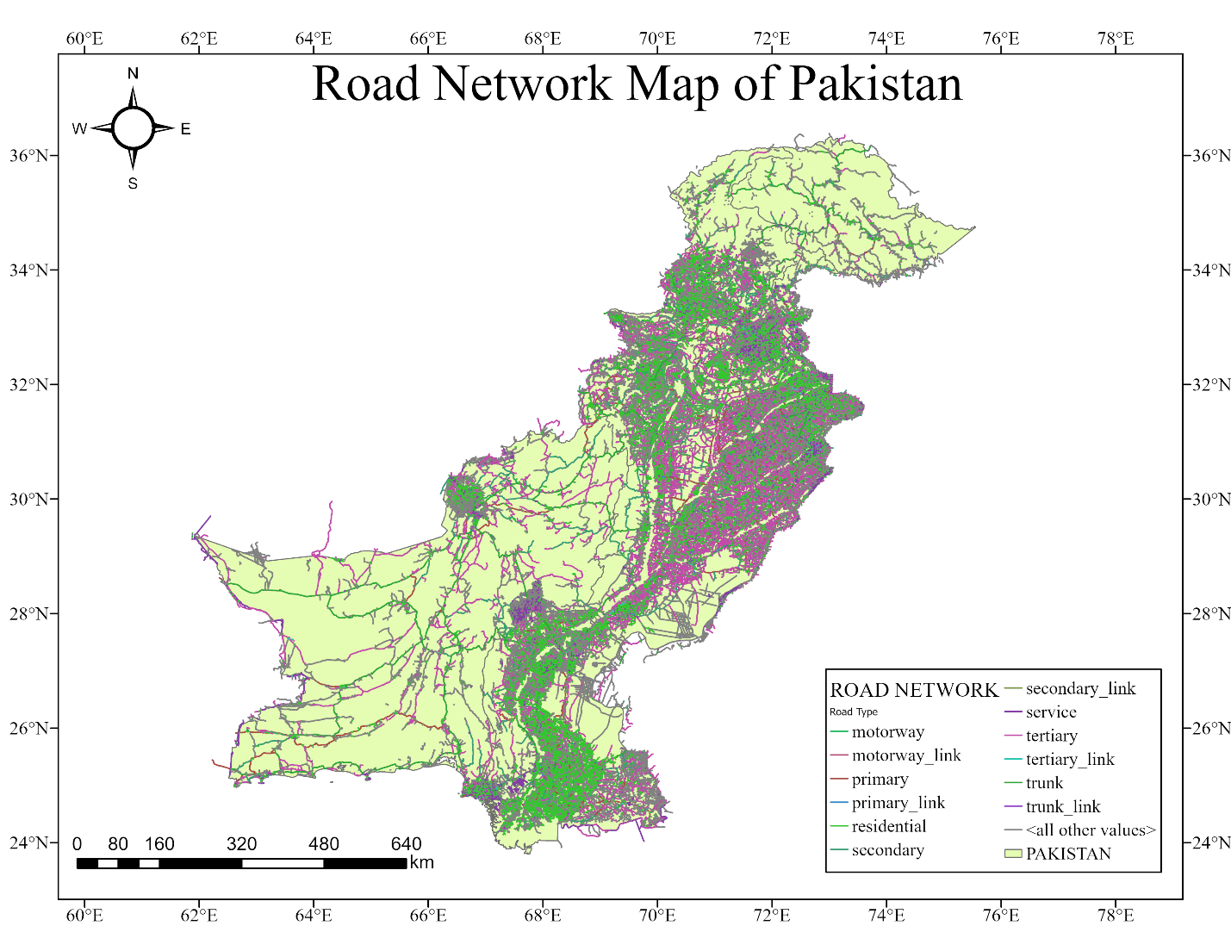
Figure 1: Road Network Map of Pakistan

Methodology

5.1 Data Acquisition
OpenStreetMap (OSM) served as the primary data source due to its open-access nature, detailed global coverage, and frequent updates (Campalani et al., 2023). Road features, including primary, secondary, and tertiary roads, were extracted using the HCMGIS plugin in QGIS. This ensured an efficient and systematic approach to capturing spatial road data.

5.2 Data Standardization
To achieve uniformity, road names were translated from Urdu to English by leveraging local expertise and verified against updated Google Roads basemaps (Izdebski et al., 2021). A consistent naming convention was established to avoid ambiguities and discrepancies in the dataset.

5.3 Attribute Enrichment
Manual validation and enrichment of attributes were conducted to address missing road names and incomplete metadata. The Google Roads basemap was cross-referenced to ensure the completeness and reliability of road attributes, including road type, width, and connectivity (Rajabifard et al., 2019). Additional local knowledge was incorporated to verify attributes not captured in automated processes.
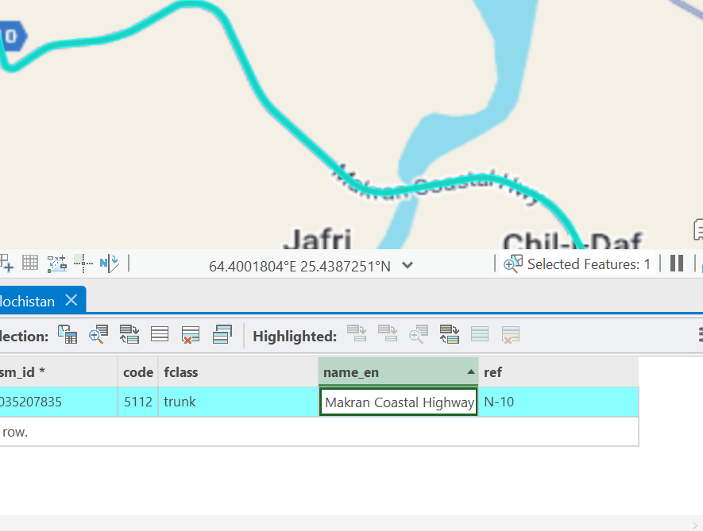
Figure 2: Inserting Missing Names

5.4 Spatial Adjustment
Spatial alignment was performed to ensure the synchronization of road features with high-resolution basemaps, improving positional accuracy. Inaccurate geometry of the existing data was edited using editor tool in ArcGIS pro (Richter et al., 2016). Vertices were edited to make sure that the road is aligned with the base map. This step ensured the creation of a seamless and navigable network.
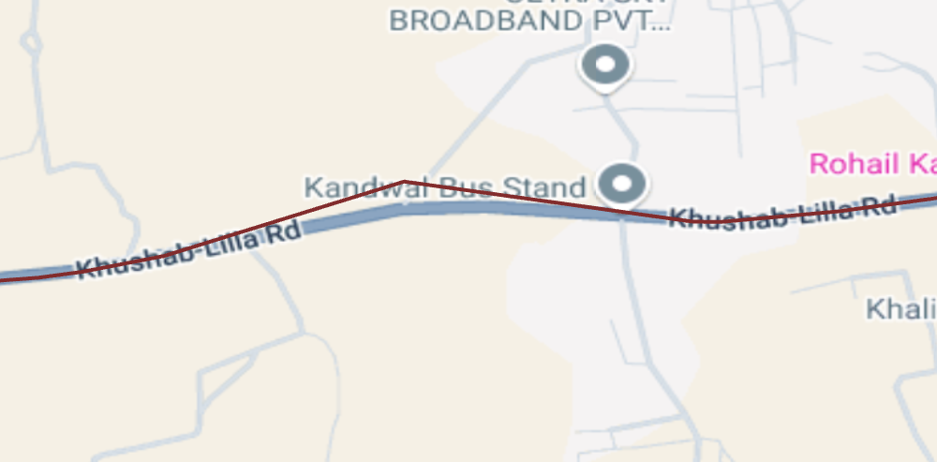
Figure 3: Inaccurate Geometry

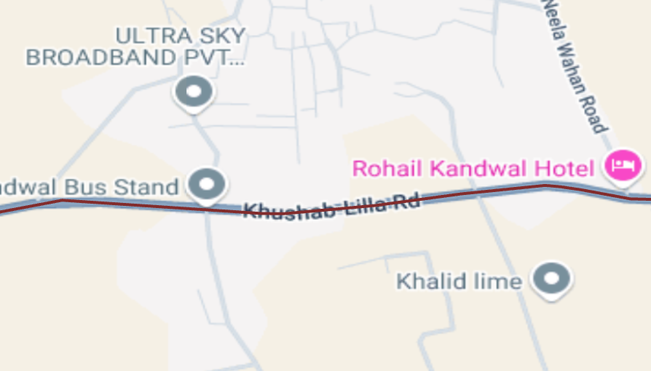
Figure 4: Corrected Geometry

5.5 Data Integration and Simplification
Road segments with identical names and overlapping geometries were merged to reduce redundancy and enhance the continuity of the road network (Naghavi et al., 2022). This process included the consolidation of fragmented segments into a unified representation, allowing for more accurate network analysis and improved usability.
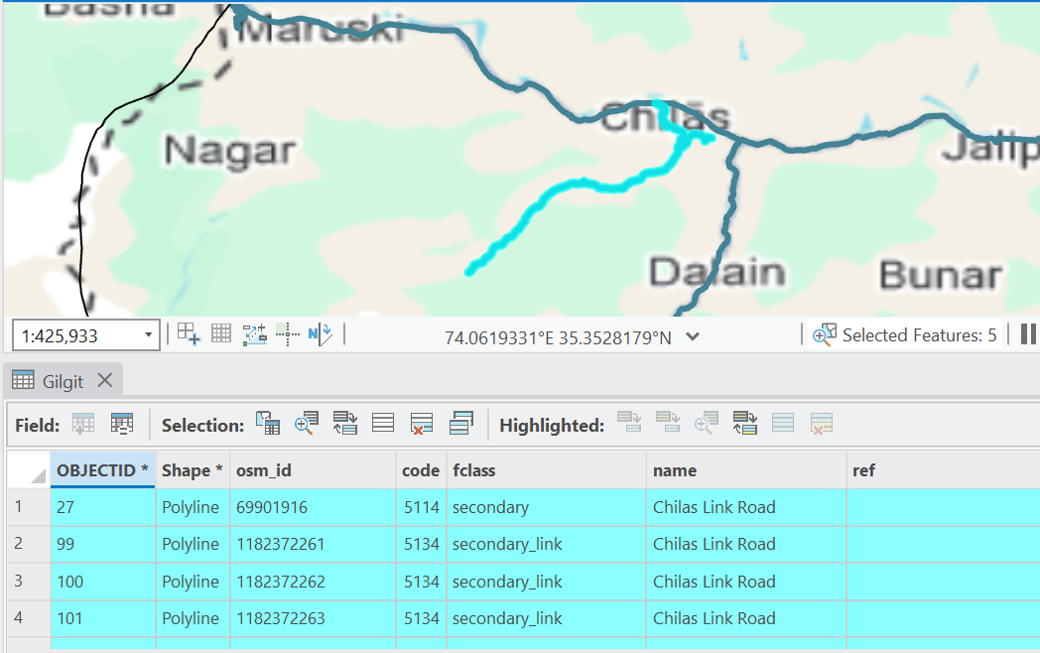
Figure 5: Merging Similar Name

5.6 Quality Assurance and Validation
A rigorous quality assurance process was implemented to verify the accuracy of the final dataset. This involved cross-referencing the updated road network with external datasets, field verification for critical areas, and stakeholder review to ensure data integrity and reliability.

Results
The applied methodology significantly improved the quality, consistency, and usability of the road network dataset.

6.1 Punjab
Punjab, with the highest number of initial road segments at 23,000, was refined to 2131.

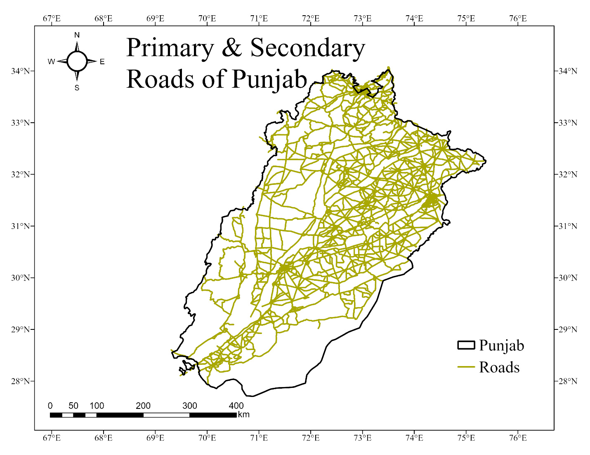
Refined Roads 2131
Initial Roads 23000
Figure 6: Primary and Secondary Roads of Punjab

6.2 Sindh
Sindh's dataset initially contained 15,000 road segments, and 3,000 remained after processing.
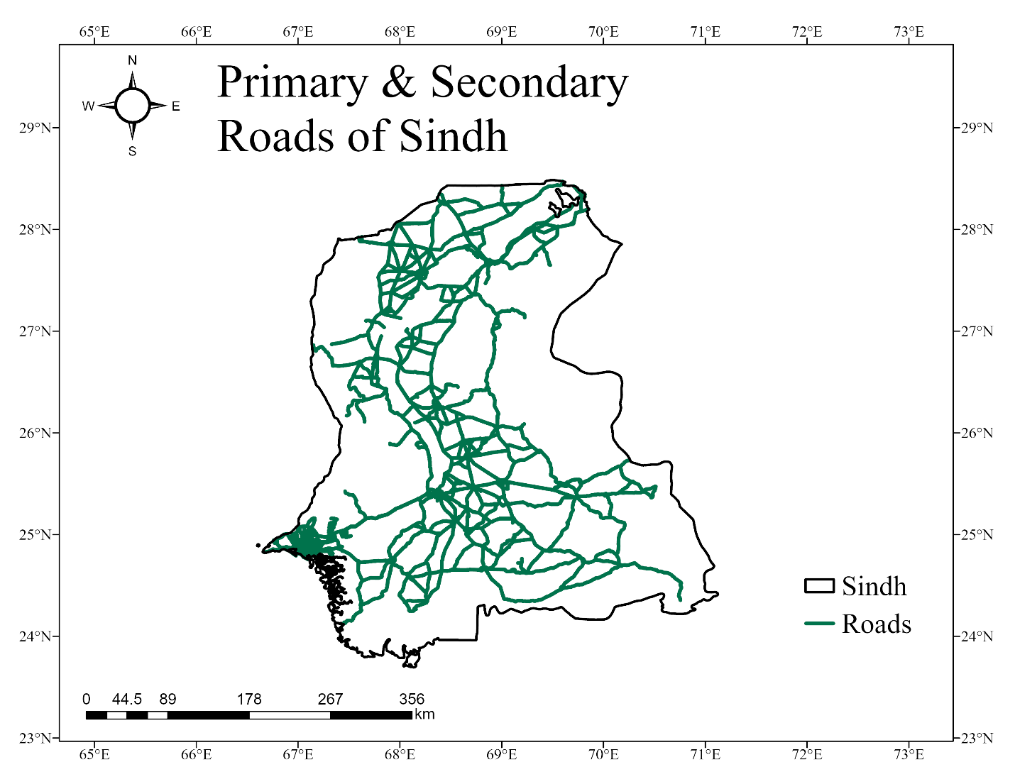
Refined Roads 3000
Initial Roads 15000
Figure 7: Primary and Secondary Roads of Sindh

Balochistan
Balochistan had 2409 road segments, which were reduced to 232 after merging redundant segments and editing.
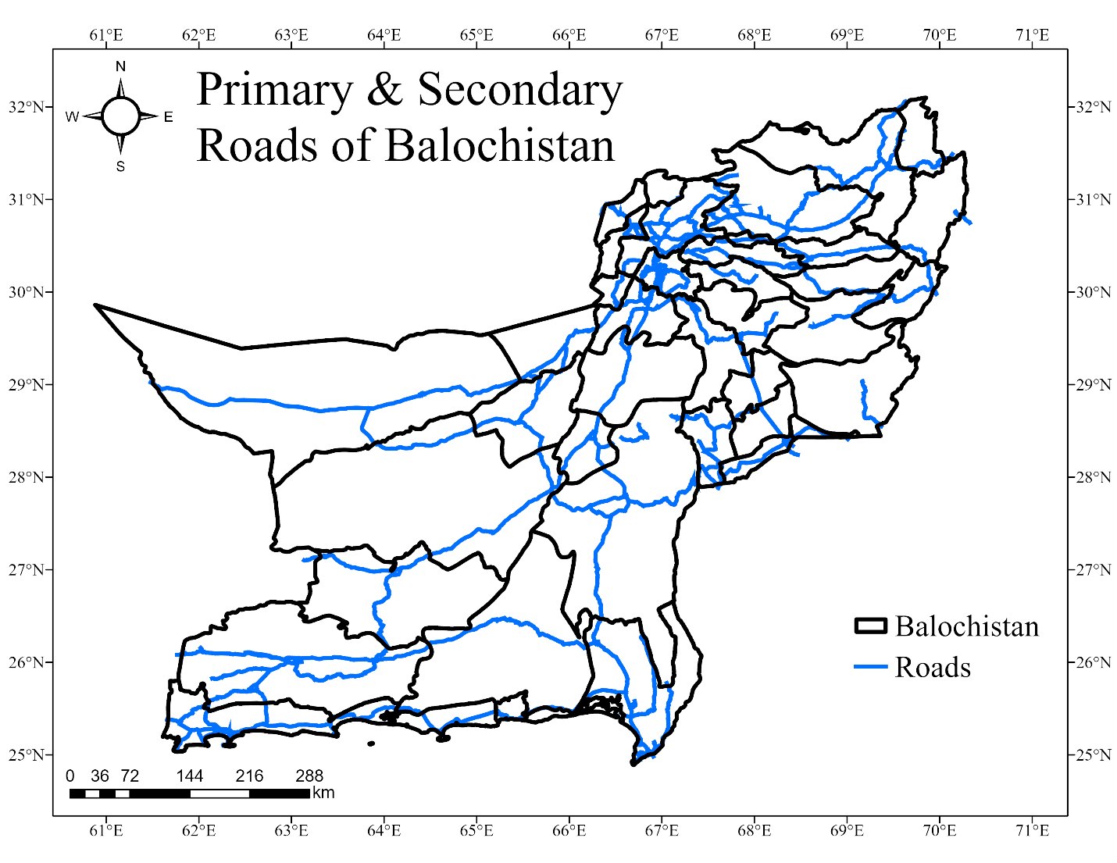
Refined Roads 200
Initial Roads 2500
Figure 8: Primary and Secondary Roads of Balochistan

6.4 Azad Kashmir
In Azad Kashmir, 550 road segments were reduced to 173
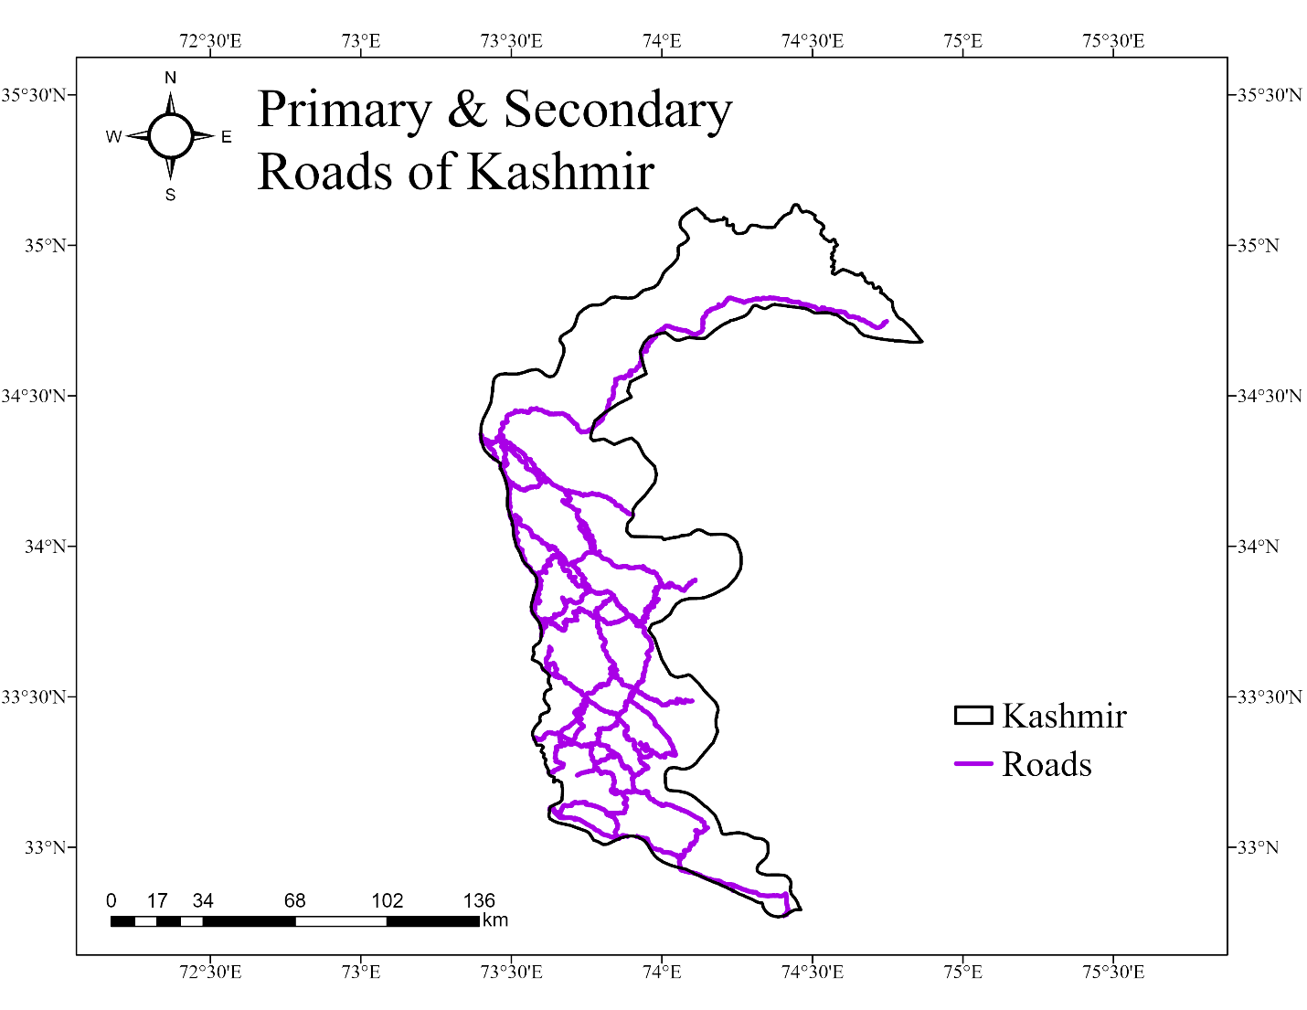
Refined Roads 173
Initial Roads 550
Figure 9: Primary and Secondary Roads of Kashmir

6.5 Khyber Pakhtunkhwa
Khyber Pakhtunkhwa (KPK) initially had 3,000 road segments that were streamlined to 1,000.
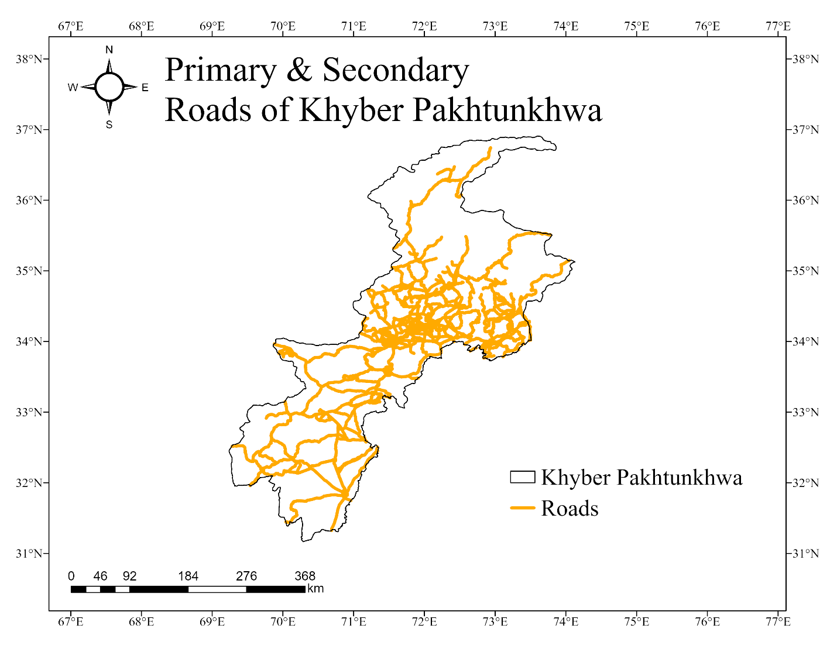
Refined Roads 1000
Initial Roads 3000
Figure 10: Primary and Secondary Roads of KPK

6.6 Gilgit
Gilgit had 650 road segments initially, which were refined to 119.
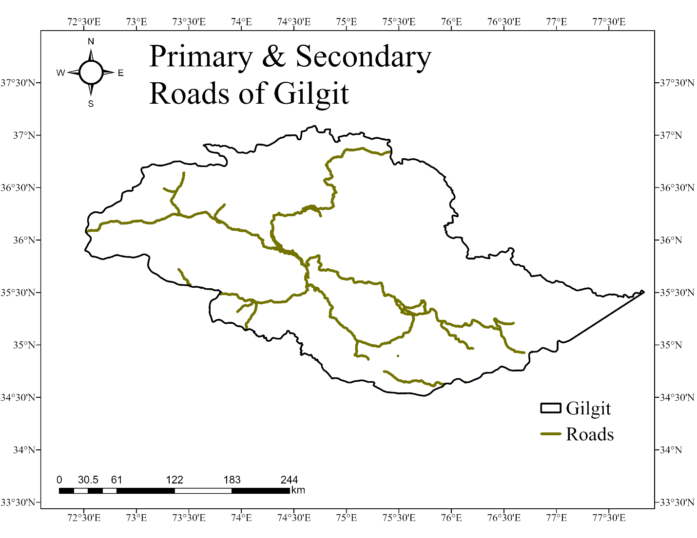
Refined Roads 173
Initial Roads 650
Figure 11: Primary and Secondary Roads of Gilgit

These results highlight the effectiveness of the merging and editing process in reducing redundancy and enhancing the dataset's accuracy. The reduction in road segments represents a cleaner, more reliable network that is well-suited for integration into the National Spatial Data Infrastructure (NSDI).

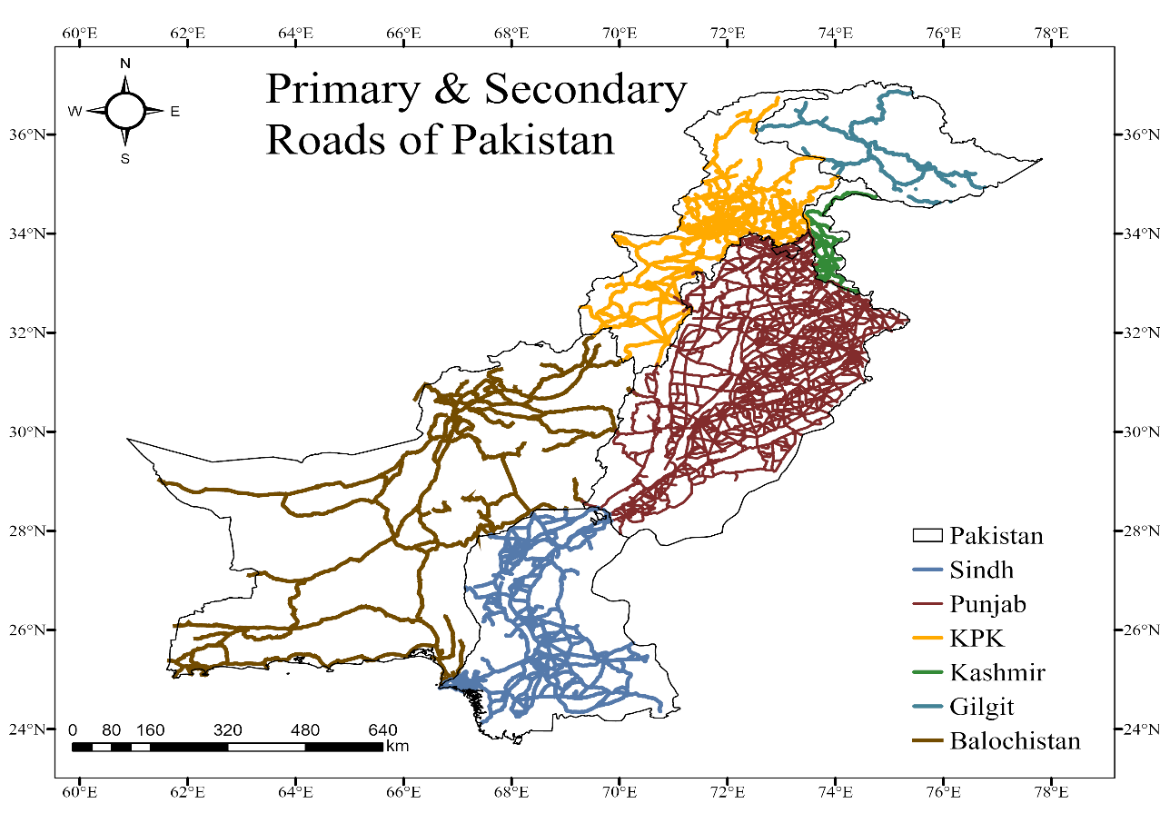
Figure 12: Primary and Secondary Roads of Pakistan

Conclusion
The refined road network dataset is now streamlined, accurate, and ready for deployment in the NSDI framework. This enhanced dataset supports seamless geospatial analysis and ensures stakeholders can access reliable data for decision-making. The methodology demonstrated here can serve as a model for similar geospatial data refinement projects in other regions.

References
- Erik de Man, W. H. (2006). Understanding SDI; complexity and institutionalization. International Journal of Geographical Information Science, 20(3), 329-343.
- Rajabifard, A., Feeney, M. E. F., & Williamson, I. P. (2002). Directions for the Future of SDI Development. International Journal of Applied Earth Observation and Geoinformation, 4(1), 11-22.
- Ali, A., & Imran, M. (2021). National Spatial Data Infrastructure vs Cadastre System for Economic Development: Evidence from Pakistan. Land.
- Izdebski, W., Zwirowicz-Rutkowska, A., & Costa, J.N. (2021). Open data in spatial data infrastructure: the practices and experiences of Poland. International Journal of Digital Earth, 14, 1547 - 1560.
- Akrimullah, A., Sima, B.S., & Akhadi, Y. (2018). OpenStreetMap Infrastructure Mapping and Its Usage on Flood Impact Assessment Using InaSAFE in Surabaya. IPTEK Journal of Proceedings Series.
- Erik de Man, W. H. (2006). Understanding SDI; complexity and institutionalization. International Journal of Geographical Information Science, 20(3), 329-343.
- Masser, I., Rajabifard, A., & Williamson, I. (2008). Spatially enabling governments through SDI implementation. International Journal of Geographical Information Science, 22(1), 5-20.
- Nedović-Budić, Z., Pinto, J. K., & Budhathoki, N. R. (2008). SDI effectiveness from the user perspective. A multi-view framework to assess SDIs, 273.
- Isradi, M., Hedianto, A. D., Rifai, A. I., & Mufhidin, A. (2021). Comparison of PCI (Pavement Condition Index) and SDI (Surface Disstres Index) in Identification of Urban Road Damage. ADRI International Journal of Sciences, Engineering and Technology, 6(1), 90-98.

