Task Report: Digitization and Hazard Assessment of Energy Sector Infrastructure in Pakistan

SUBMITTED TO: Mr. Mubushar Hussain
SUBMITTED BY: Mr. Muhammad Taimoor Ashfaq Malik
TASK NAME: Digitization and Hazard Assessment of Energy Sector Data
DATE: 28th July 2025

Contents
1 Introduction 2
2 Scope of Work 2
3 Data Sources 2
3.1 Provided Data Sources 2
3.2 Additional Data Sources 2
4 Methodology 3
4.1 Data Collection 3
4.2 Data Cleaning & Validation 3
4.3 Digitization 3
4.4 Data Storage 4
5 Results 4
5.1 Hazard Assessment 4
5.2 Flash Flood Hazard Assessment: 7
5.3 Riverine Flood Hazard Assessment 17
6. Deliverables 29
7. Conclusion 31

Introduction

This report details the digitization of energy sector infrastructure data in Pakistan, focusing on transmission lines and grid stations, and the subsequent assessment of their vulnerability to natural hazards. The task involved creating accurate geospatial datasets and overlaying them with hazard maps for ﬂoods (riverine and ﬂash ﬂoods), cyclones, and earthquakes to evaluate risks. The objective was to provide a comprehensive analysis to support infrastructure planning and disaster preparedness.

Scope of Work

The scope of this task included:

- Digitizing energy sector data using Google Earth Pro to produce shapeﬁles and KML ﬁles.
- Collecting and digitizing data from the "Consolidated List of Data Sources" (Word document).
- Identifying additional data sources for energy infrastructure in Pakistan.
- Consolidating digitized data into a geodatabase.
- Overlaying the digitized data with hazard maps for ﬂoods (50-year return period), cyclones (50-year return period), and earthquakes (495-year return period) to assess vulnerability.
- Preparing a detailed report covering the scope, data sources, methodology, and deliverables.

Data Sources

Provided Data Sources
    - Consolidated List of Data Sources (Word Document): This document listed primary data sources for energy sector infrastructure in Pakistan, including transmission lines and grid stations.
    - Attachment 1 (PDF): Provided coordinates for grid stations and a list of 30 transmission lines with associated attributes.

Additional Data Sources
- OpenStreetMap (OSM): Transmission line data extracted using the Quick OSM plugin in QGIS.
- Google Imagery Basemap: Used for digitizing grid stations based on provided coordi- nates.
- Hazard Maps: Sourced for ﬂoods (50-year return period), cyclones (50-year return period), and earthquakes (495-year return period).

No further open-access data sources for energy infrastructure (e.g., power plants or renewable energy assets) were identified due to restricted access or lack of publicly available datasets.

Data Type | Data Name | Data Source
Primary | Consolidated List of Data Sources | NDRMF
 | Requisite Information of Affected Energy Infrastructure | National Transmission and Dispatch Company (Formerly NGC)
Secondary | Transmission Lines & Grid Stations | Open Street Maps  (https://www.osm.org/)
 | Satellite Imagery | Google Satellite Basemap  (https://mt1.google.com/vt/lyrs=s&x={x}&y={y}&z={z})
 | Disaster Hazard Layer | https://natcat.ndrmf.pk/

Methodology
The methodology followed these steps:

Data Collection
    - Transmission Lines: Transmission line data was extracted using the Quick OSM plugin in QGIS, providing a reliable open-source dataset for geospatial analysis.
    - Grid Stations: Coordinates for grid stations were obtained from the provided PDF (Attachment 1). These were cross-verified and digitized using Google Imagery Basemap in ArcGIS Pro

Data Cleaning & Validation
    - Transmission Lines: Reduced from 30 to 27 unique lines after removing duplicates and accounting for missing entries.
    - Grid Stations: 35 stations identiﬁed and validated.

Digitization
    - Transmission Lines: The PDF listed 30 transmission lines, but analysis revealed:
      - One duplicate entry, reducing the count to 29.
      - Two missing lines, further reducing the valid count to 27 unique transmission lines.
    - Grid Stations: Digitized as point features using provided coordinates.

Data Storage
Datasets were exported as shapeﬁles, KML ﬁles, and a geodatabase with consistent spatial references.

Results

Hazard Assessment
The digitized data was overlaid with hazard maps for:
    - Floods (riverine and ﬂash ﬂoods): 50-year return period.
    - Cyclones: 50-year return period
    - Earthquakes: 495-year return period

For each hazard, tables were generated detailing:

    - Severity score: Based on hazard intensity and infrastructure exposure.
    - Affected length of transmission lines: Measured as the length within hazard zones.
    - District and Tehsil: Administrative locations of affected features.

The results are presented below:
Sr. | Name of Grid Station | District | Tehsil | Severity Level | Voltage
1 | 500kV Grid Station NTDC Dadu | Dadu | Dadu | Moderate-Very High | 500kV
2 | 220kV Grid Station NTDC Rohri | Sukkur | Rohri | Very High | 220kV
3 | 500kV Grid Station NTDC Shikarpur | Shikarpur | Shikarpur | Moderate | 500kV
4 | 500kV Grid Station Sheikhupura | Sheikhupura | Sheikhupura | Low | 500kV
5 | 500 kV Grid Station Guddu | Rajanpur | Rajanpur (Tribal Area) | High | 500kV
6 | Natural Gas Power Station PiranGheb | Multan | Multan Saddar | Very High | N/A
7 | 660kV Convertor Station Faqir Noorthiani | Matiari | Matiari | Moderate | 660kV
Table 1 Flood Severity Assessment of Affected Grid Stations
Sr. | Name of Transmission Line | District | Tehsil | Severity Level |  | Affected Length(km) |  | Voltage
1 | Dadu – Jamshoro II | Dadu | Dadu | Moderate-Very High |  |  | 53.57 |  | 500kV
2 | Dadu – Jamshoro I | Dadu | Dadu | Moderate-Very High |  |  | 47.53 |  | 500kV
3 | Shikarpur – Dadu II (Guddu – Dadu II ) | Dadu | Dadu | Moderate-Very High |  |  | 178.40 |  | 500kV
4 | Shikarpur – Dadu I (Guddu – Dadu I ) | Dadu | Dadu | Moderate-Very High |  |  | 157.75 |  | 500kV
5 | Sibbi – Quetta I & II | Kachhi | Dhadar | Low |  |  | 46.90 |  | 220kV
6 | Dadu – Khuzdar I & II | Jhal Magsi | Jhal Magsi | Low-Moderate |  |  | 52.75 |  | 220kV
7 | Sibbi – D.M. Jamali(Sibbi – Uch-II PP I & II ) | Kachhi | Balanari | Low-Moderate |  |  | 43.87 |  | 220kV
8 | D.M. Jamali – Uch-I PP (Sibbi – Uch-II PP I & II ) | Nasirabad | Dera Murad Jamali | Very Low |  |  | 3.23 |  | 220kV
9 | KAPCO PP – Multan V & VI | Multan | Multan Saddar | Very High |  |  | 31.96 |  | 220kV
10 | D.G. Khan – Guddu (Multan – Guddu III ) | Dera Ghazi Khan | Kot Chatta |  | Very High |  | 29.39 |  | 500kV
11 | Bund Road – Sheikhupura I & II | Sheikhupura | Sheikhupura |  | Low |  | 20.78 |  | 220kV
12 | Nokhar – Sheikhupura II | Gujranwala | Nowshera Virkan |  | Very Low |  | 1.65 |  | 500kV
13 | Rawat – Nokhar II | Gujranwala | Nowshera Virkan |  | Very Low |  | 21.38 |  | 500kV
14 | Mangla HPP – Rawat I & II | Mirpur | Mirpur |  | Very Low |  | 1.05 |  | 220kV
15 | Multan – NGPS I & II | Multan | Multan Saddar |  | Very High |  | 12.25 |  | 220kV
16 | C-3/C-4 PP – Bannu I & II | Bannu | Bannu |  | Very Low |  | 21.56 |  | 220kV
17 | Port Qasim CFPP – Matiari I & II | Matiari | Matiari |  | Moderate |  | 23.87 |  | 500kV
Table 2 Flood Severity Assessment of Affected Transmission Lines

Sr. | Name of Grid Station | District | Tehsil | Severity Level | Voltage
1 | 500kV Grid Station NTDC Shikarpur | Shikarpur | Shikarpur | Very Low | 500kV
2 | NKI 500/220kV Grid Station NTDC | South Karachi | Kemari Town | Severe | 220kV/500kV
3 | 500 kV Grid Station Guddu | Rajanpur | Rajanpur (Tribal Area) | Very Low | 500kV
4 | 220 kV Grid Station NTDC Khuzdar | Khuzdar | Khuzdar | Very Low | 220kV
5 | 220kV Grid Station NTDC Dera Murad Jamali | Nasirabad | Dera Murad Jamali | Very Low | 220kV
6 | 500KV Grid Station NTDC DG Khan | Dera Ghazi Khan | Dera Ghazi Khan | Very Low | 500kV
7 | 220kV Grid Station NTDC Jhampir-II | Thatta | Thatta | Low | 220kV
8 | Lucky 660 Power Plant Bin Qasim Town Malir | Malir | Bin Qasim Town | High | 500kV
9 | 660kV Convertor Station Faqir Noorthiani | Matiari | Matiari | Moderate | 660kV
 | GENCO-1 JPCL, Thermal Power Plant Jamshoro | Jamshoro | Kotri | Moderate | 500kV
 | 500kV Grid Station NTDC Dadu | Dadu | Dadu | Very Low | 500kV
 | 220kV Grid Station NTDC Rohri | Sukkur | Rohri | Very Low | 220kV
Table 3 Cyclone Severity Assessment of Affected Grid Stations

Sr. | Name of Transmission Line | District | Tehsil | Severity Level | Affected Length(km) | Voltage
1 | Shikarpur – Dadu II (Guddu – Dadu II ) | Dadu | Dadu | Very Low | 53.57 | 500kV
2 | Shikarpur – Dadu I (Guddu – Dadu I ) | Dadu | Dadu | Very Low | 47.53 | 500kV
3 | D.G. Khan – Guddu (Multan – Guddu III ) | Dera Ghazi Khan | Kot Chatta | Very Low | 178.40 | 500kV
4 | NKI – Jamshoro (Hub PP – Jamshoro I ) | Jamshoro | Kotri | Moderate | 157.75 | 500kV
5 | Dadu – Khuzdar I & II | Jhal Magsi | Jhal Magsi | Very Low | 46.90 | 220kV
6 | Sibbi – D.M. Jamali(Sibbi – Uch-II PP I & II ) | Kachhi | Balanari | Very Low | 52.75 | 220kV
7 | D.M. Jamali – Uch-I PP (Sibbi – Uch-II PP I & II ) | Nasirabad | Dera Murad Jamali | Very Low | 43.87 | 220kV
8 | Gharo - Jhimpir II (Jhimpir – Gharo I & II ) | Malir Karachi | Bin Qasim Town | High | 3.23 | 220kV
9 | Port Qasim CFPP – Matiari I & II | Matiari | Matiari | Moderate | 31.96 | 220kV
10 | Dadu – Jamshoro II | Dadu | Dadu | Very Low | 29.39 | 500kV
11 | Dadu – Jamshoro I | Dadu | Dadu | Very Low | 20.78 | 220kV
Table 4 Cyclone Severity Assessment of Affected Transmission Lines

Sr. | Name of Grid Station | District | Tehsil | Severity Level | Voltage
1 | 220kV Grid Station NTDC Dera Murad Jamali | Nasirabad | Dera Murad Jamali | Severe | 220k V
2 | Grid Station Sibbi | Sibbi | Sibbi | Severe | 220kV
3 | 500kV Grid Station NTDC Rawat | Rawalpindi | Rawalpindi | Severe | 500kV
4 | Duber Khwar Hydroelectic Plant | Kohistan Lower | Pattan | Severe | 132kV
5 | 17 MW Ranolia Hydro Power Station | Kohistan Lower | Bankad | Severe | 132kV
6 | Khan Khwar Hydel Power Station | Shangla | Bisham | Severe | 132kV
7 | 220kV Grid Station Bannu | Bannu | Domel | Very Strong to Severe | 220kV
8 | 220KV Grid Station Sheikh Muhammadi | Peshawar | Peshawar | Very Strong to Severe | 500/220/132kV
Table 5 Earthquake Severity Assessment of Affected Grid Stations

Flash Flood Hazard Assessment:
- Quetta – Sibbi I & II Transmission Line:
The Quetta-Sibbi I & II Transmission Line is a critical component of Pakistan’s power transmission network, connecting the 220kV Grid Station Sibbi to the 220kV Grid Station Quetta Industrial. Spanning 147.3 km, this 220kV transmission line plays a pivotal role in supplying electricity to Quetta, the provincial capital of Balochistan, and its surrounding areas. Managed by the National Transmission and Despatch Company (NTDC), or potentially the National Grid Company of Pakistan (NGCP) following the 2025 restructuring, this line is essential for addressing Balochistan’s power shortfall, estimated at over 600MW due to limited local generation and inadequate infrastructure. However, its route through flood-prone regions, particularly near the Bolan and Nari Rivers, exposes it to significant flash flood risks, necessitating a detailed hazard assessment to ensure the reliability of the power supply.
Balochistan’s arid climate, mountainous terrain, and seasonal rivers make it highly susceptible to flash floods, particularly during the monsoon season. The 2022 Pakistan floods, which submerged one-third of the country and affected 33 million people, underscored the region’s vulnerability, with Balochistan experiencing 336 deaths, the destruction of 426,897 houses, and significant damage to infrastructure, including roads and bridges. Quetta was declared a disaster area, and an emergency was announced in the province, highlighting the severity of flood impacts.
For the Quetta-Sibbi transmission line, approximately 7.38 km (about 5% of its total length) and 22 transmission poles are identified as being at risk from flash floods across major five hazardous areas, primarily near the Bolan and Nari Rivers. These areas are:
- Near Bibi Nani Shrine, Quetta-Jacobabad Highway, Mach Tehsil, Kacchi District:
  - Location: Along National Highway 65, near the Bibi Nani area at coordinates approximately 29.70°N, 67.38°E, a historically significant site.
  - Flood Risk: Prone to flooding from seasonal watercourses, with historical records noting damage to the nearby Bibi Nani bridge during floods [6].
  - Impact: Flooding could damage transmission poles and conductors, leading to potential outages.
- Near Gokirat Police Station, Bolan River, Boundary of Mach and Dhadar Tehsils, Kacchi District:
  - Location: Positioned near the Bolan River, a major watercourse flowing through the Bolan Pass.
  - Flood Risk: The Bolan River is notorious for flash floods during heavy rainfall, posing a significant threat to infrastructure.
  - Impact: Riverine flooding could undermine pole foundations, causing structural failures.
- Near Gokartha Wild Park and Darazbent Recreation Park, Bolan River, Dhadar Tehsil:
  - Location: On the banks of the Bolan River, these recreational areas are in a high-risk flood zone.
  - Flood Risk: The riverbank location increases exposure to rapid water surges, making this section highly vulnerable.
  - Impact: Floodwaters could damage or destroy transmission infrastructure, leading to prolonged outages.

- Near Mashkaaf, Dhadar Tehsil:
  - Location: Likely near tributaries or low-lying areas connected to the Bolan River system.
  - Flood Risk: Localized flooding from tributaries or poor drainage increases the risk to infrastructure.
  - Impact: Water accumulation could weaken pole stability, necessitating frequent maintenance.
- Near Nari Bank Bridge, Nari River, Tehsil Sibi, Sibi District:
  - Location: Close to the Nari River, near a bridge in Sibi Tehsil.
  - Flood Risk: The Nari River experiences rapid rises in water levels during monsoon rains, threatening nearby infrastructure.
  - Impact: Flooding could disrupt power transmission to Sibi and beyond.
- Near Perak Railway Station, National Highway 65, Boundary of Sibi Tehsil:
  - Location: Along National Highway 65, near Perak Railway Station, close to the Quetta-Jacobabad route.
  - Flood Risk: Susceptible to both riverine and urban flooding due to its proximity to transportation routes and potential drainage issues.
  - Impact: Flood damage could complicate repair efforts due to the area’s strategic location.
- In Balanari Tehsil, passing through cropland near National Highway 65:
  - Location: Through agricultural land in Balanari Tehsil, near National Highway 65, likely in a flat or low-lying area.
  - Flood Risk: Croplands are prone to flooding when irrigation systems or natural drainage are overwhelmed during heavy rainfall.
  - Impact: Water accumulation could destabilize transmission poles, affecting reliability.

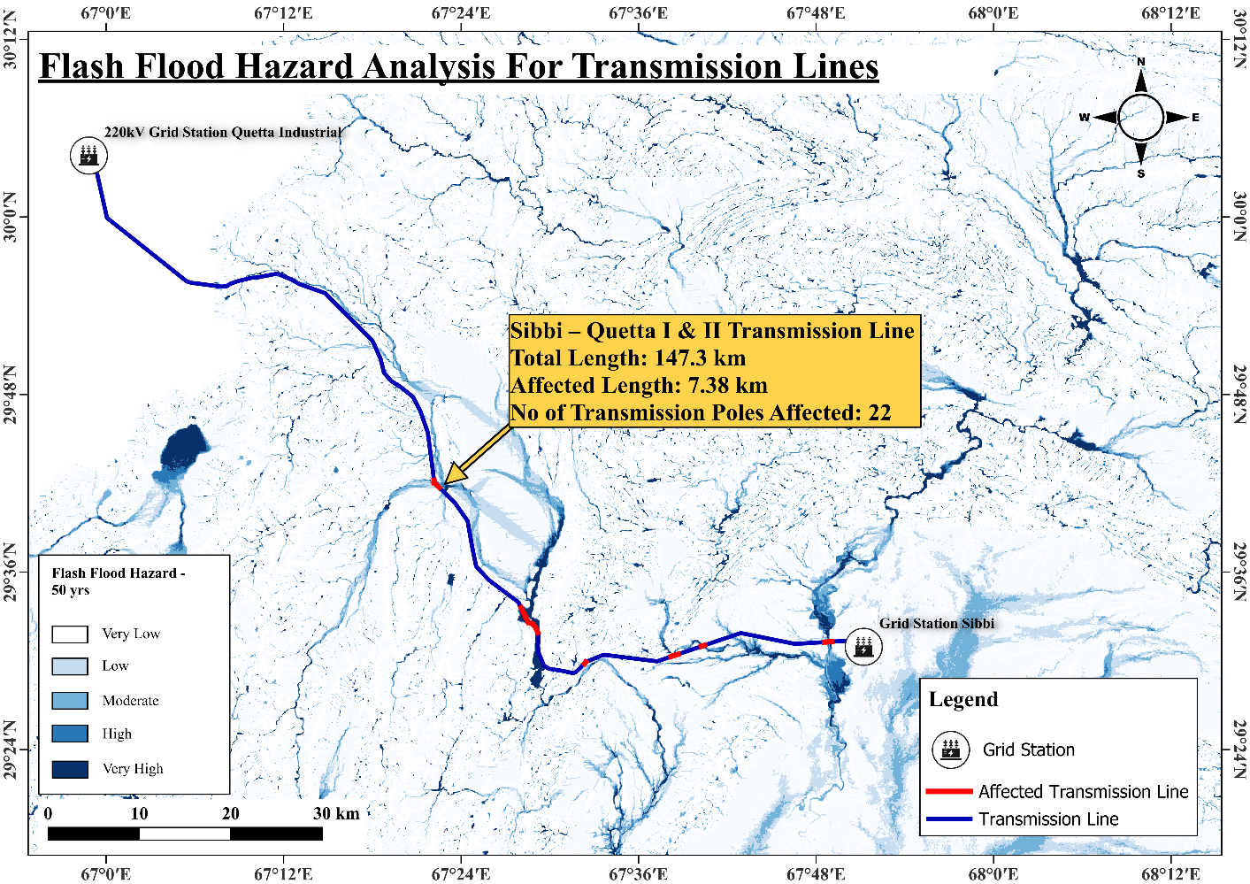

- Sibbi – D.M. Jamali(Sibbi – Uch II PP I & II) Transmission Line:
The Sibbi - D.M. Jamali (Sibbi - Uch II PP 1 & II) Transmission Line is a critical component of Balochistan’s power transmission network, connecting the 220kV Grid Station Sibbi to the 220kV Grid Station NTDC Dera Murad Jamali. Spanning 126.7 km, this 220kV transmission line plays a pivotal role in supplying electricity to the regions of Sibbi and Dera Murad Jamali, supporting both urban and rural power needs. Managed by the National Transmission and Despatch Company (NTDC), or potentially the National Grid Company of Pakistan (NGCP) following the 2025 restructuring, this line is essential for addressing Balochistan’s power demands, particularly given the province’s limited local generation capacity. The line facilitates the evacuation of power from the Uch Power Plant, a major regional generator with a combined capacity of approximately 980 MW.
However, its route through flood-prone areas, particularly near seasonal watercourses and low-lying terrain, exposes it to significant flash flood risks. The Sibbi - D.M. Jamali Transmission Line traverses flood-prone areas, with 12.6 km (approximately 10% of its total length) and 17 transmission poles identified as at risk. The hazardous areas are:\
- Near Perak Railway Station, National Highway 65 Quetta-Jacobabad Highway on the boundary of Sibib Tehsil:
  - Location: Perak Railway Station is located in Perak village, Sibi District, Balochistan, along National Highway 65, near the boundary of Sibib Tehsil [Source: Pakistani.pk, Perak Railway Station, 2023].
  - Flood Risk: This area is prone to flash floods due to its proximity to seasonal watercourses and low-lying terrain. The 2022 floods caused significant damage to rail and road infrastructure in Balochistan, including along the Quetta-Jacobabad corridor, indicating a high flood risk in this region [Source: International Railway Journal, 2022].
  - Impact: Flooding could damage transmission poles and conductors, leading to potential outages and disrupting power supply to Sibbi and surrounding areas. The area’s strategic location near transportation routes complicates repair efforts during flood events.
- In Balanari Tehsil, passing through cropland near National Highway 65:
  - Location: Balanari Tehsil is in Sibi District, Balochistan, with the transmission line passing through agricultural land near National Highway 65.
  - Flood Risk: Croplands are particularly vulnerable to flooding when irrigation systems or natural drainage are overwhelmed during heavy rainfall. The area’s flat topography and proximity to seasonal watercourses increase its susceptibility to flash floods, as seen during the 2022 floods that damaged agricultural infrastructure across Balochistan.
  - Impact: Water accumulation could destabilize transmission poles, affecting the line’s reliability and potentially causing structural damage, which could disrupt power supply to Dera Murad Jamali and beyond.

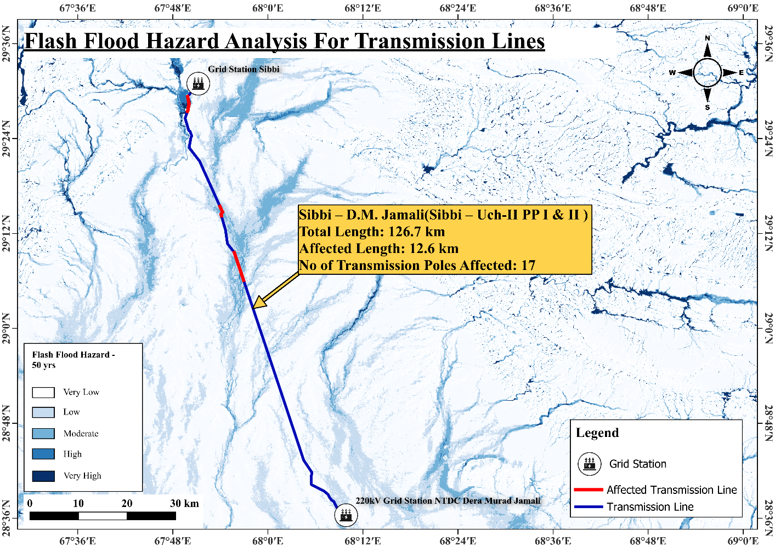

- Dadu – Khuzdar I & II Transmission Line:
The Dadu-Khuzdar I & II Transmission Line is a critical infrastructure component in Pakistan’s power transmission network, connecting the 500kV Grid Station NTDC Dadu in Sindh to the 220kV Grid Station NTDC Khuzdar in Balochistan. Spanning 310.1 km, this 220kV double-circuit line, completed under the Dadu-Khuzdar Transmission System Project, provides an alternative power supply route to Balochistan, addressing the region’s acute power shortages and improving voltage stability. Managed by the National Transmission and Despatch Company (NTDC), or potentially the National Grid Company of Pakistan (NGCP) following the 2025 restructuring, the line supports the electrification of Khuzdar and surrounding areas, where the electrification rate is only 26% compared to the national average of 72% [Source: JICA, Dadu Khuzdar Transmission System Project]. However, its route through flood-prone regions in Sindh and Balochistan exposes it to significant flash flood risks, with 9.9 km (approximately 3.2% of the total length) and 35 transmission poles identified as vulnerable. This assessment details the grid stations, transmission line features, and the flash flood hazards affecting the line, emphasizing the need for mitigation to ensure reliable power supply.
- Kulachi River and Baijah Jhal meeting point near Bajki, Khuzdar Tehsil, Khuzdar District
  - Location: Near the confluence of the Kulachi River and Baijah Jhal (possibly a lake or wetland, potentially a local name for a stream like Chil Jhal or Khanak Jhal) in Khuzdar Tehsil, Khuzdar District, Balochistan [Source: beautyofpakistan.com, Khuzdar].
  - Flood Risk: Confluences of rivers and jhals are natural flood hotspots, where rapid water accumulation can occur during heavy rainfall, threatening infrastructure stability.
  - Impact: Flooding could erode tower foundations, leading to structural damage or collapse of transmission poles, disrupting power supply to Khuzdar.
- Croplands of Mola Tehsil, Khuzdar District
  - Location: Agricultural lands in Mola Tehsil, a subdivision of Khuzdar District, typically located in low-lying areas suitable for cultivation.
  - Flood Risk: Croplands are prone to sheet flooding during heavy rains, especially in areas with poor drainage or near seasonal watercourses.
  - Impact: Water accumulation could destabilize transmission poles, increasing maintenance costs and risking outages.
- Passing through Sain River and Ratodero-Gwadar Motorway
  - Location: The line crosses the Sain River and runs parallel to the Ratodero-Gwadar Motorway (M-8), a major transportation corridor connecting Sindh and Balochistan.
  - Flood Risk: River crossings are highly vulnerable to flooding, particularly during monsoon seasons when rivers swell. The motorway’s proximity may indicate a flood-prone corridor due to altered drainage patterns.
  - Impact: Floodwaters could damage conductors or towers, leading to power disruptions and complicating repair efforts due to the area’s strategic importance.
- Plains of Peer Lakha, Jhal Magsi Tehsil, Jhal Magsi District
  - Location: Flat plains in Jhal Magsi Tehsil, Jhal Magsi District, Balochistan, likely near agricultural or pastoral areas.
  - Flood Risk: Plains are susceptible to sheet flooding, where water spreads across large areas during heavy rainfall, threatening infrastructure stability.
  - Impact: Flooding could undermine tower foundations, causing structural failures and affecting power supply to nearby regions.
- Croplands of Ando Khosa, Qubo Saeed Khan Tehsil, Kambar Shahdadkot District, Sindh
  - Location: Agricultural lands in Qubo Saeed Khan Tehsil, Kambar Shahdadkot District, near the Sindh-Balochistan border.
  - Flood Risk: Croplands in low-lying areas are prone to inundation during flash floods, especially near rivers or seasonal watercourses.
  - Impact: Water accumulation could damage transmission infrastructure, disrupting power supply to downstream areas.
- Near croplands and through Jalipari Dhand, Dadu Tehsil, Dadu District
  - Location: Near Jalipari Dhand, a lake or wetland in Dadu Tehsil, Dadu District, Sindh.
  - Flood Risk: Wetlands and dhands can swell significantly during heavy rainfall, posing a high risk of flooding to nearby infrastructure.
  - Impact: Floodwaters could damage transmission poles, leading to outages and requiring costly repairs in a flood-prone area.
- Croplands near Sobhnari Dhand, Tehsil Dadu, District Dadu
  - Location: Adjacent to Sobhnari Dhand, another lake or wetland in Dadu Tehsil, Dadu District.
  - Flood Risk: Similar to Jalipari Dhand, this area is highly susceptible to flooding due to its proximity to a water body that can overflow during monsoons.
  - Impact: Flooding could disrupt power transmission, affecting consumers in Dadu and beyond.
- Croplands near Johi-Dadu Boundary, Dadu Tehsil, Dadu District
  - Location: Near the boundary between Johi and Dadu Tehsils, likely in a transitional zone with complex drainage patterns.
  - Flood Risk: Boundary areas can experience localized flooding due to varying topography and drainage issues, particularly in croplands.
  - Impact: Flood damage could compromise the transmission line’s integrity, leading to power disruptions and maintenance challenges.
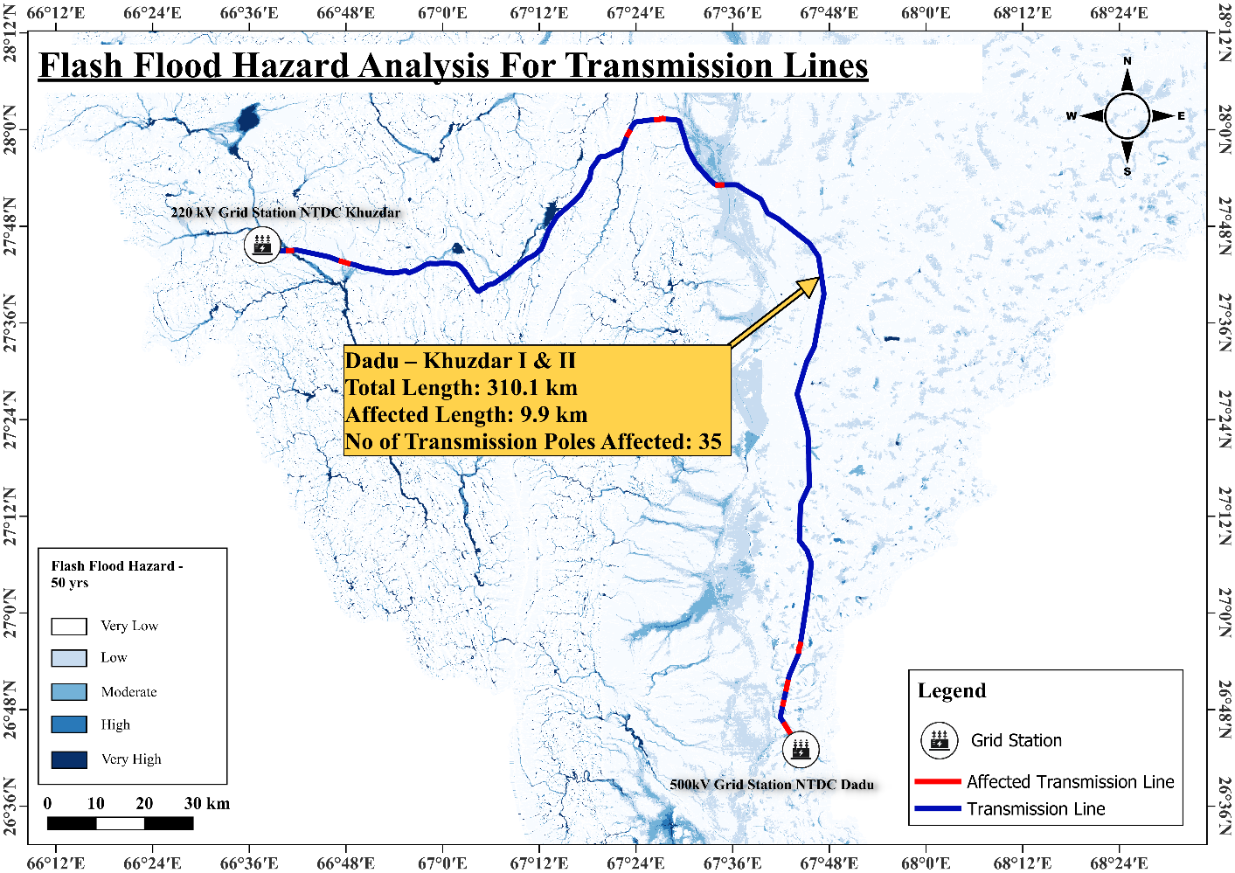

- Shikarpur – Dadu I(Guddi – Dadu I) & Shikarpur – Dadu II(Guddi – Dadu II):
The Shikarpur-Dadu I (Guddu Dadu I) and Shikarpur – Dadu II(Guddi – Dadu II) Transmission Line connects the 500kV Grid Station NTDC Shikarpur to the 500kV Grid Station NTDC Dadu in Sindh, Pakistan. Shikarpur - Dadu I spans 218.2 km whereas Shikarpur - Dadu II spans over a length of 216 km. These 500kV lines, likely part of the broader Dadu-Guddu transmission corridor with Shikarpur as an intermediate point, facilitate the evacuation of power from major generation sources, such as the Guddu Thermal Power Plant, to distribution networks in Sindh and parts of Balochistan. It addresses a significant electricity shortfall estimated at over 600MW in Sindh and Balochistan.
Sindh’s flat topography, seasonal watercourses, and proximity to the Indus River make it highly susceptible to flash floods, particularly during the monsoon season. Shikarpur-Dadu Transmission lines route through flood-prone agricultural areas exposes 3.4 and 3.9 km (approximately 1.56% and 1.8% of the total length) and 29 transmission poles to flash flood risks seven hazardous areas. These areas are detailed below, along with their flood risks and potential impacts.
- Agricultural land around Bhaya in Lakhi Tehsil, District Shikarpur, and cropland around village Booja Napar near Shikarpur-Abdoo Goth Road in Tehsil Shikarpur:
  - Location: Near the boundary of Lakhi and Shikarpur Tehsils, District Shikarpur, Sindh, close to the Shikarpur-Abdoo Goth Road, a key local transportation route.
  - Flood Risk: Low-lying agricultural lands are prone to sheet flooding during heavy rainfall, exacerbated by poor drainage and proximity to seasonal watercourses.
  - Impact: Floodwaters could erode tower foundations, leading to structural damage or pole collapse, disrupting power supply to Shikarpur and nearby areas.
- Agricultural land West of Lakhi Tehsil, District Shikarpur, around Banglo Ghani Abad and North East and South West of Banglo Ghani Abad:
  - Location: West of Lakhi Tehsil, centered around Banglo Ghani Abad, a rural area in Shikarpur District.
  - Flood Risk: Flat agricultural terrain is susceptible to flooding during monsoons, particularly in areas with inadequate drainage systems.
  - Impact: Water accumulation could destabilize transmission poles, increasing maintenance costs and risking outages.
- Croplands of Tehsil Garhi Yasin, District Shikarpur:
  - Location: Agricultural lands in Garhi Yasin Tehsil, Shikarpur District, known for its fertile26. Cropland around Garhi Khuda Baksh in Tehsil Rato Dero, District Larkana:
  - Location: Near Garhi Khuda Baksh, a village in Rato Dero Tehsil, Larkana District, Sindh.
  - Flood Risk: Croplands in this area are vulnerable to flooding due to their low-lying nature and proximity to seasonal watercourses.
  - Impact: Flood damage could compromise transmission infrastructure, affecting power supply to Larkana and surrounding areas.
- Croplands of Tehsil Mehar, District Dadu:
  - Location: Agricultural lands in Mehar Tehsil, Dadu District, Sindh.
  - Flood Risk: Susceptible to sheet flooding during heavy rainfall, particularly in areas with poor drainage.
  - Impact: Flooding could damage transmission poles, leading to potential outages and repair challenges.
- Village Khair Muhammad Baladi in Tehsil Khairpur Nathan Shah, District Dadu:
  - Location: A rural village in Khairpur Nathan Shah Tehsil, Dadu District, Sindh.
  - Flood Risk: Low-lying village areas are prone to flooding during monsoons, especially near seasonal watercourses or irrigation channels.
  - Impact: Floodwaters could undermine tower stability, disrupting power transmission to Dadu and nearby regions.
- Croplands of Tehsil Dadu, District Dadu:
  - Location: Agricultural lands in Dadu Tehsil, Dadu District, Sindh.
  - Flood Risk: Flat croplands are at risk of inundation during heavy rainfall, particularly in areas with inadequate drainage.
  - Impact: Flood damage could affect the transmission line’s reliability, impacting power supply to Dadu and beyond.
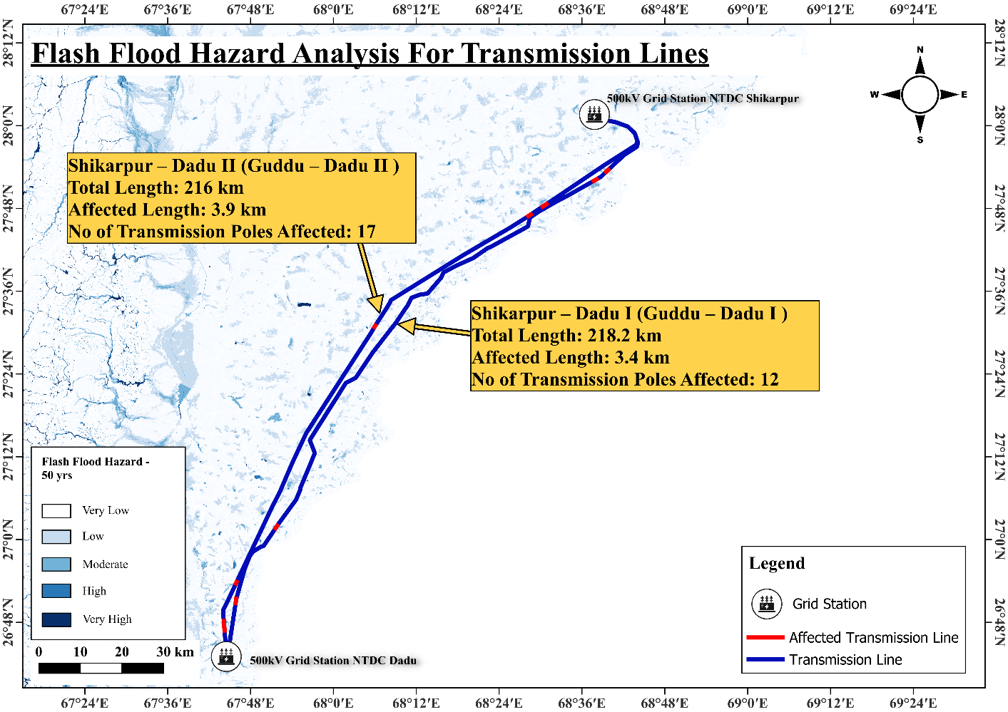

- Dadu – Jamshoro I & II Transmission Line:
The Dadu-Jamshoro I & II Transmission Lines are critical components of Sindh’s power transmission network, connecting the 500kV Grid Station NTDC Dadu to the 500kV Grid Station NTDC Jamshoro. Spanning 176.1 km and 170.8 km respectively, these 500kV lines facilitate the transmission of electricity from major generation sources, such as the Guddu Thermal Power Plant, to distribution networks serving lower Sindh, including Karachi. Managed by the National Transmission and Despatch Company (NTDC), these lines are essential for addressing power shortages in a region with high electricity demand and limited local generation capacity. Their integration into the national grid’s “ring” system enhances reliability and supports economic development. However, their routes through agricultural lands and near significant water bodies expose them to flash flood risks, with 9.4 km of Dadu-Jamshoro I (31 poles) and 11.5 km of Dadu-Jamshoro II (38 poles) identified as vulnerable across four hazardous areas. These areas are detailed below, along with their flood risks and potential impacts.
- Agricultural Land near Indus Highway, South in Tehsil Dadu, District Dadu
  - Location: South of Dadu Tehsil, near the Indus Highway (N-55), which runs parallel to the Indus River.
  - Flood Risk: This area is vulnerable to riverine flooding from the Indus River and flash floods from seasonal tributaries. The proximity to the river increases the risk during high water flow periods, as seen during the 2022 floods when the Indus River swelled significantly [Source: Wikipedia, 2022 Pakistan floods, 2025].
  - Impact: Floodwaters could erode tower foundations and damage conductors, leading to structural failures and power disruptions across Dadu and surrounding areas.
- Croplands in Goth Talpur, Goth Aamra, Goth Haji Paryal Shah, Goth Bakhtiarpur, Goth Haji Sajjawal, near Manchar Lake in Tehsil Sehwan Sharif, District Jamshoro
  - Location: Agricultural lands in multiple villages (Goth Talpur, Goth Aamra, Goth Haji Paryal Shah, Goth Bakhtiarpur, Goth Haji Sajjawal) near Manchar Lake, Pakistan’s largest freshwater lake, in Sehwan Sharif Tehsil, Jamshoro District.
  - Flood Risk: Manchar Lake has a history of overflowing during heavy monsoon rains, as evidenced by the 2022 floods when authorities breached the lake’s banks to protect populated areas, displacing over 100,000 people. The surrounding croplands are highly vulnerable to inundation from lake overflow and sheet flooding [Source: DW, Pakistan floods: Authorities breach largest freshwater lake, 2022].
  - Impact: Floodwaters could submerge transmission towers and conductors, causing structural damage, prolonged outages, and significant repair challenges due to the lake’s proximity.
- Agricultural Land on the Boundary of Tehsil Daulat Pur of District Shaheed Benazirabad and Tehsil Manjhand of District Jamshoro
  - Location: Boundary area between Daulat Pur Tehsil (Shaheed Benazirabad District) and Manjhand Tehsil (Jamshoro District), likely characterized by agricultural lands with complex drainage patterns.
  - Flood Risk: Boundary areas are prone to localized flooding due to varying topography and drainage issues. The 2022 floods severely affected Shaheed Benazirabad, with significant farmland inundation, increasing the vulnerability of this region [Source: Wikipedia, 2022 Pakistan floods, 2025].
  - Impact: Sheet flooding could destabilize transmission poles, leading to infrastructure damage and power disruptions in nearby regions.
- Agricultural Land in Tehsil Manjhand, District Jamshoro
  - Location: Agricultural lands within Manjhand Tehsil, Jamshoro District, typically low-lying and used for cultivation.
  - Flood Risk: Similar to the boundary area, Manjhand Tehsil was affected by the 2022 floods, with agricultural lands experiencing sheet flooding due to poor drainage and proximity to seasonal watercourses [Source: Wikipedia, 2022 Pakistan floods, 2025].
  - Impact: Water accumulation could undermine tower stability, causing structural damage and affecting power supply reliability.
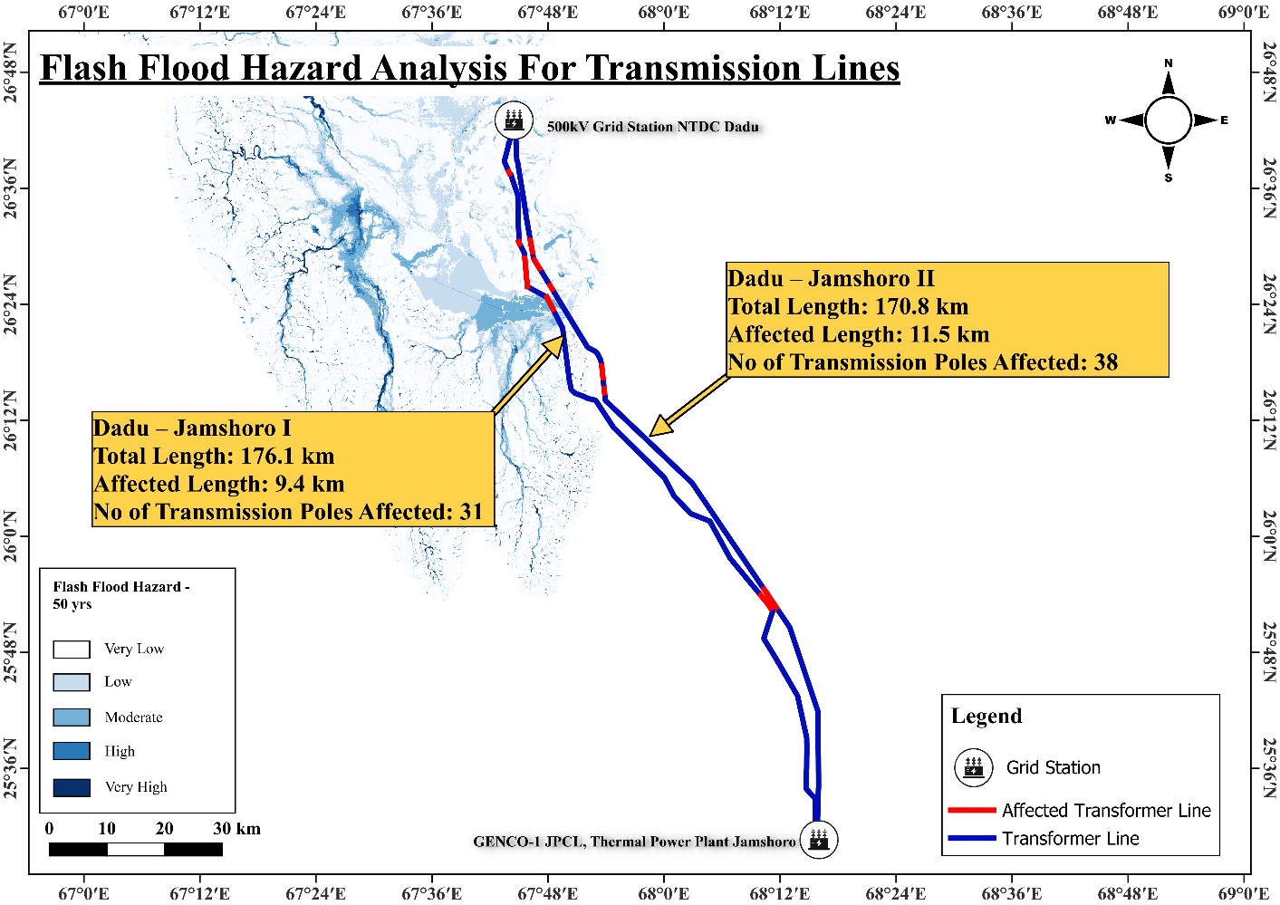

Riverine Flood Hazard Assessment

C-3/C-4 PP - Bannu I & II Transmission Line:
The C-3/C-4 PP - Bannu I & II Transmission Line connects the 220 kV Grid Station Chashma, near the Chashma Nuclear Power Plant in Mianwali, Punjab, to the 220 kV Grid Station Bannu in Khyber Pakhtunkhwa. Spanning 149.5 km. This 220 kV transmission line facilitates the distribution of electricity from the nuclear power plant, which has a total capacity of approximately 1,300 MW from four operating units (C-1, C-2, C-3, C-4), to meet regional power demands. Its route through flood-prone agricultural areas near the Indus River exposes 18 km (approximately 12.04% of the total length) and 32 transmission poles to riverine flood risks, necessitating a detailed hazard assessment to ensure a reliable power supply. This assessment details the grid stations, transmission line features, and flood hazards, emphasizing the need for robust mitigation measures to safeguard this critical infrastructure.
- Agricultural land around Lakki Marwat Chashma Road in Tehsil Isakhel, District Mianwali
  - Location: Near Lakki Marwat Chashma Road, Tehsil Isakhel, District Mianwali, Punjab, a region characterized by agricultural activity and proximity to the Indus River.
  - Flood Risk: This area is highly vulnerable to riverine flooding due to its location near the Indus River and seasonal watercourses. Heavy monsoon rains can cause rapid water level rises, leading to inundation of low-lying agricultural lands, as seen during the 2022 floods that affected Punjab [Source: Wikipedia, 2022 Pakistan floods, 2025].
  - Impact: Floodwaters could erode tower foundations, damage conductors, or cause structural failures, leading to power disruptions in the region.
- Agricultural land in Chashma Kacha, Tehsil Paharpur, District Dera Ismail Khan
  - Location: In Chashma Kacha, Tehsil Paharpur, District Dera Ismail Khan, Khyber Pakhtunkhwa, a low-lying area near the Indus River.
  - Flood Risk: This region is prone to riverine flooding, particularly during monsoon seasons, due to its proximity to the Indus River, which can overflow and inundate surrounding agricultural lands, as evidenced by the 2022 floods that caused significant infrastructure damage [Source: Wikipedia, 2022 Pakistan floods, 2025].
  - Impact: Flooding could submerge transmission towers and conductors, resulting in prolonged outages and costly repairs in a remote area.
- Agricultural land near the bank of the Indus River, Tehsil Piplan, District Mianwali
  - Location: Directly adjacent to the Indus River in Tehsil Piplan, District Mianwali, Punjab.
  - Flood Risk: This area faces a high risk of riverine flooding due to its immediate proximity to the Indus River, which experiences significant water level increases during monsoon seasons, as demonstrated by the 2022 floods that disrupted infrastructure across Punjab [Source: Wikipedia, 2022 Pakistan floods, 2025].
  - Impact: Rapid flooding could destabilize transmission poles, damage electrical components, and disrupt power supply to downstream consumers.
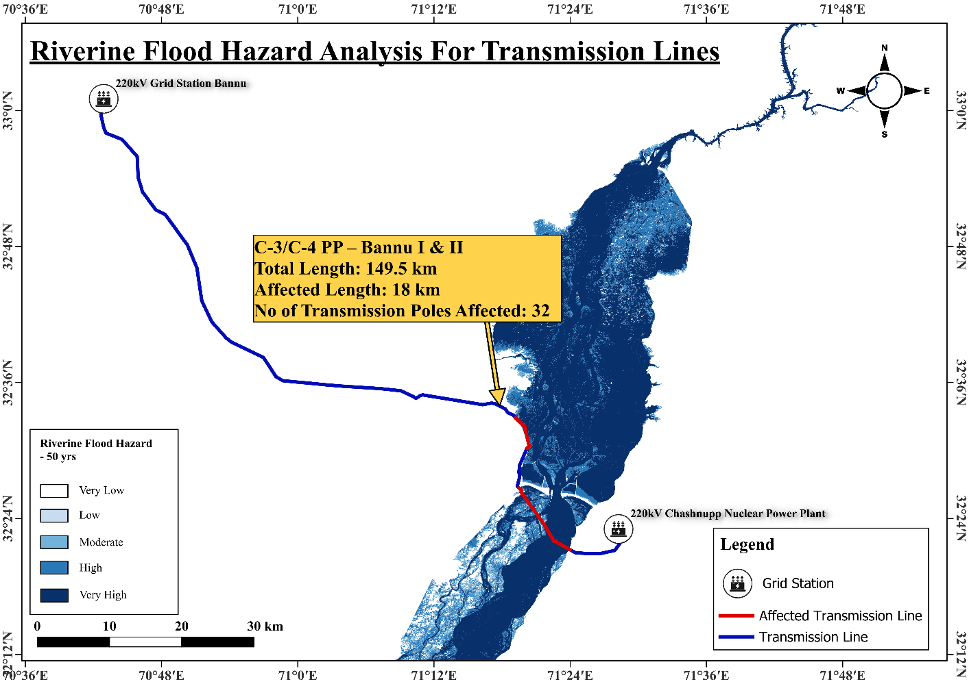

Mangla HPP - Rawat I & II Transmission Line:
The Mangla HPP - Rawat I & II Transmission Line connects the 132kV/220kV Switchyard Mangla, near the Mangla Hydropower Plant in Mirpur, Azad Jammu and Kashmir, to the 500kV Grid Station NTDC Rawat in Rawalpindi, Punjab. Spanning 96.1 km, this 220kV transmission line facilitates the distribution of electricity from the Mangla Hydropower Plant, with a capacity of approximately 1,000 MW, to meet regional power demands in Punjab and beyond. Its route near the Jhelum River exposes 0.9 km (approximately 0.94% of the total length) and 2 transmission poles to riverine flood risks, necessitating a detailed hazard assessment to ensure a reliable power supply. This assessment details the grid stations, transmission line features, and flood hazards, emphasizing the need for robust mitigation measures to safeguard this critical infrastructure.
- Jhelum River on the boundary of Mirpur and Dina:
    - Location: Near the boundary of Mirpur, Azad Jammu and Kashmir, and Dina, District Jhelum, Punjab, where the transmission line crosses or runs parallel to the Jhelum River.
    - Flood Risk: This area is highly vulnerable to riverine flooding due to its proximity to the Jhelum River, which experiences significant water level increases during monsoon seasons. The 2022 floods caused widespread inundation in Punjab, affecting infrastructure near rivers [Source: Wikipedia, 2022 Pakistan floods, 2025].
    - Impact: Floodwaters could erode tower foundations, damage conductors, or cause structural failures, leading to power disruptions in the region.

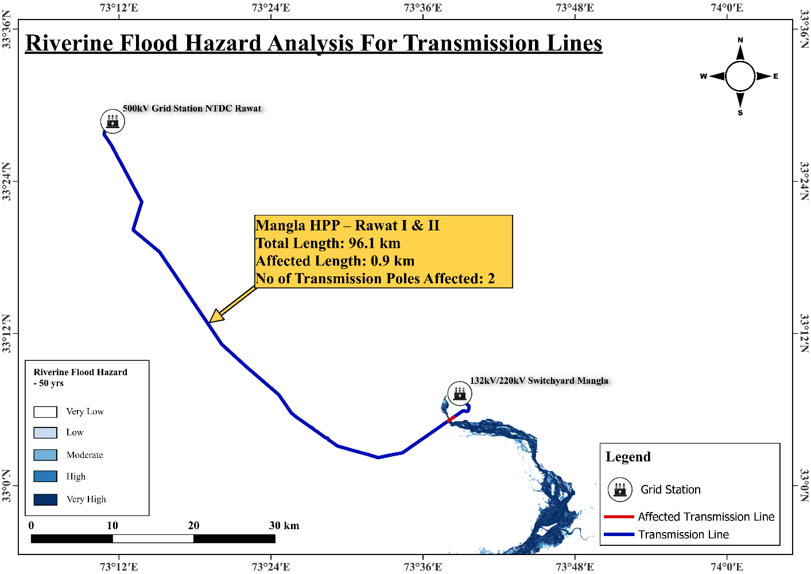

- Rawat - Nokhar II Transmission Line:
The Rawat - Nokhar II Transmission Line connects the 500kV Grid Station NTDC Rawat in Rawalpindi, Punjab, to the 500kV Grid Station NTDC Nokhar in Gujranwala, Punjab. Spanning 230.2 km, this 500kV transmission line facilitates the transmission of electricity across northern Punjab, supporting industrial and urban centers. Its route through agricultural areas near major rivers exposes 14 km (approximately 6.08% of the total length) and 45 transmission poles to riverine flood risks, necessitating a detailed hazard assessment to ensure a reliable power supply. This assessment details the grid stations, transmission line features, and flood hazards, emphasizing the need for robust mitigation measures to safeguard this critical infrastructure.
  - Agricultural land near Rasul Barrage, Jhelum River in Tehsil Mandi Bahauddin, District Mandi Bahauddin:
    - Location: Near Rasul Barrage on the Jhelum River, Tehsil Mandi Bahauddin, District Mandi Bahauddin, Punjab, a region characterized by fertile agricultural lands.
    - Flood Risk: The area is prone to riverine flooding due to its proximity to the Jhelum River, which can overflow during heavy monsoon rains, as seen during the 2022 floods [Source: Wikipedia, 2022 Pakistan floods, 2025].
    - Impact: Floodwaters could erode tower foundations, damage conductors, or cause structural failures, leading to power disruptions in northern Punjab.
  - Agricultural lands near Khanki Barrage, Chenab River in Tehsil Gujrat, District Gujrat:
    - Location: Near Khanki Barrage on the Chenab River, Tehsil Gujrat, District Gujrat, Punjab, a key agricultural region.
    - Flood Risk: The Chenab River’s high water flows during monsoons pose a significant flood risk, with historical flooding events impacting infrastructure [Source: Wikipedia, 2022 Pakistan floods, 2025].
    - Impact: Flooding could submerge transmission towers and conductors, resulting in outages and costly repairs.
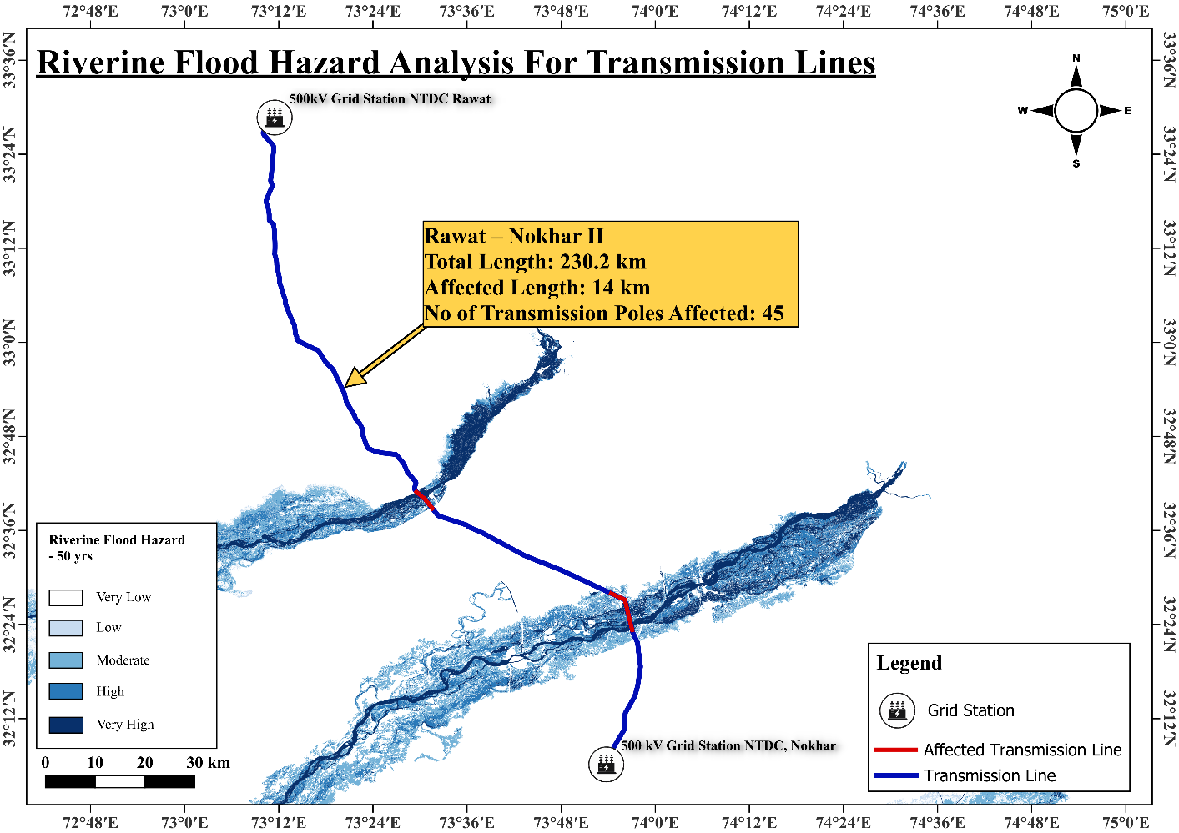

Bund Road - Sheikhupura I & II Transmission Line:
The Bund Road - Sheikhupura I & II Transmission Line connects the NGC 220kV Grid Station Bund Road in Lahore, Punjab, to the 500kV Grid Station Sheikhupura in Sheikhupura, Punjab. Spanning 32.9 km, this 220kV transmission line supports power distribution to Lahore and surrounding areas. Its route through agricultural areas near canals and rivers exposes 2.9 km (approximately 8.81% of the total length) and 9 transmission poles to riverine flood risks, necessitating a detailed hazard assessment to ensure a reliable power supply. This assessment details the grid stations, transmission line features, and flood hazards, emphasizing the need for robust mitigation measures to safeguard this critical infrastructure.
  - Agricultural land near Canal Upper Chenab in Tehsil Sheikhupura, District Sheikhupura:
    - Location: Near the Upper Chenab Canal, Tehsil Sheikhupura, District Sheikhupura, Punjab, a fertile agricultural area.
    - Flood Risk: The area is vulnerable to flooding from canal overflows and seasonal watercourses, exacerbated during the 2022 floods [Source: Wikipedia, 2022 Pakistan floods, 2025].
    - Impact: Floodwaters could destabilize transmission poles, leading to structural damage and power disruptions in Sheikhupura.
  - Agricultural land around Ravi River, Tehsil Lahore City, District Lahore:
    - Location: Near the Ravi River in Tehsil Lahore City, District Lahore, Punjab, a densely populated urban-agricultural area.
    - Flood Risk: The Ravi River is prone to flooding during monsoons, with significant impacts during the 2022 floods [Source: Wikipedia, 2022 Pakistan floods, 2025].
    - Impact: Flooding could damage transmission infrastructure, causing outages in Lahore and surrounding areas.
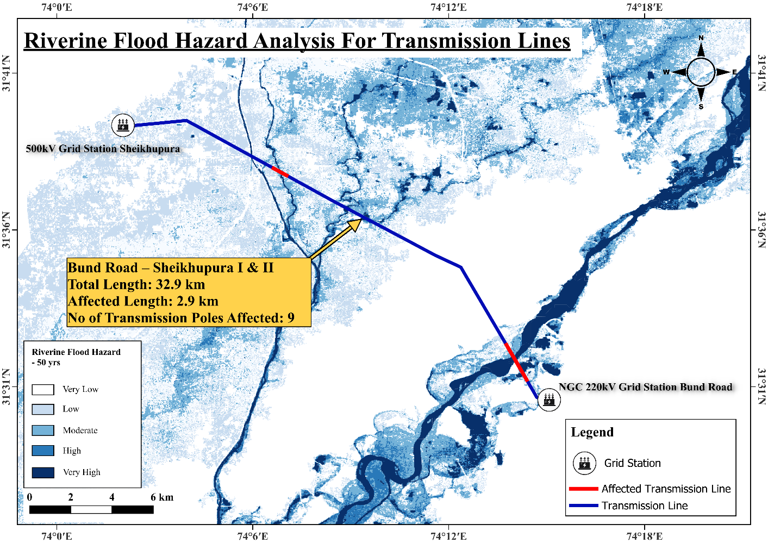

KAPCO PP - Multan V & VI Transmission Line:
The KAPCO PP - Multan V & VI Transmission Line connects the Main Distribution Grid at Kot Addu Power Company (KAPCO) Power Plant in Kot Addu, Punjab, to the Sadiqabad Grid Station in Multan, Punjab. Spanning 89.1 km, this 220kV transmission line evacuates power from the KAPCO plant, with a capacity of 1,600 MW, to meet regional demands. Its route through agricultural areas near the Chenab River exposes 31.8 km (approximately 35.69% of the total length) and 100 transmission poles to riverine flood risks, necessitating a detailed hazard assessment to ensure a reliable power supply. This assessment details the grid stations, transmission line features, and flood hazards, emphasizing the need for robust mitigation measures to safeguard this critical infrastructure.
  - Agricultural land around Chenab River in Tehsil Muzaffargarh, District Muzaffargarh and Tehsil Multan Saddar, District Multan:
    - Location: Agricultural lands along the Chenab River in Tehsil Muzaffargarh, District Muzaffargarh, and Tehsil Multan Saddar, District Multan, Punjab.
    - Flood Risk: The Chenab River is highly prone to flooding during monsoons, with significant inundation during the 2022 floods, affecting agricultural infrastructure [Source: Wikipedia, 2022 Pakistan floods, 2025].
    - Impact: Floodwaters could erode tower foundations, damage conductors, or cause structural failures, leading to widespread power disruptions in Multan and surrounding areas.

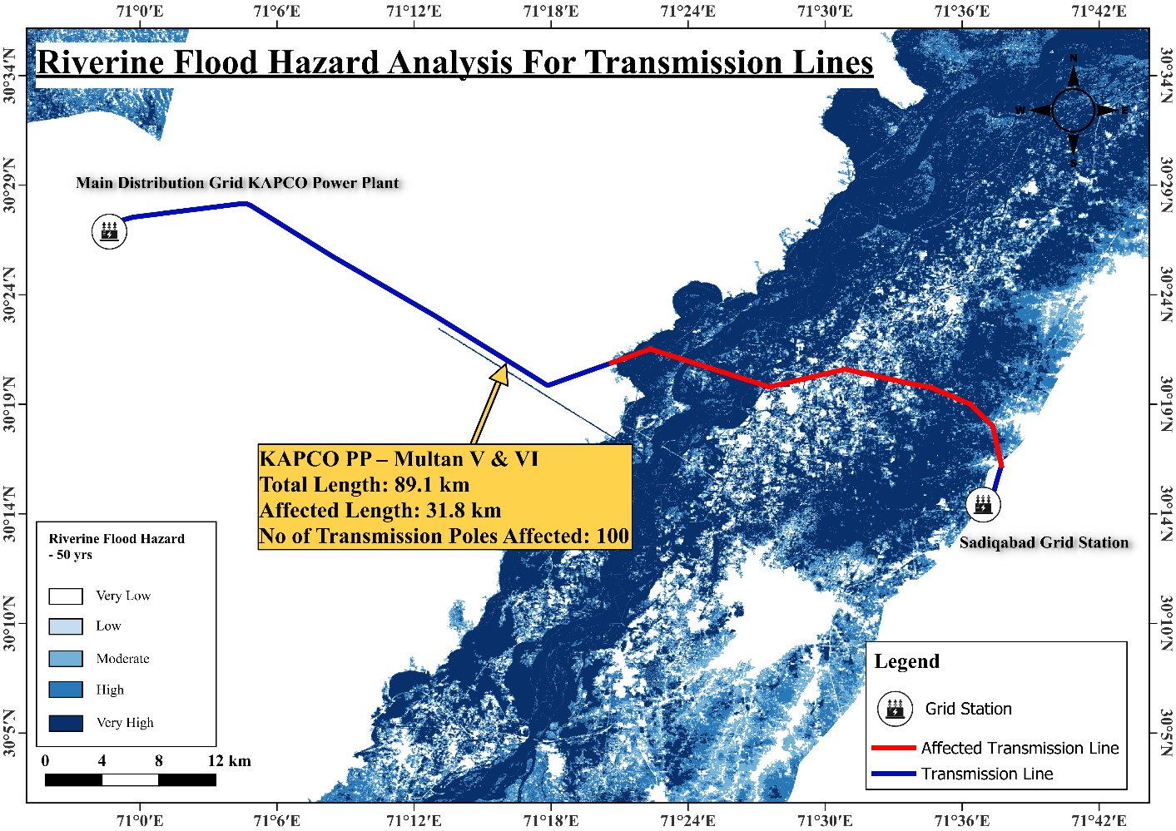

Multan NGPS I & II Transmission Line:
The Multan NGPS I & II Transmission Line connects the Sadiqabad Grid Station in Multan, Punjab, to the Natural Gas Power Station (NGPS) Piran Ghaib in Multan, Punjab. Spanning 11.9 km, this 220kV transmission line supports local power distribution in Multan. Its route through built-up and agricultural areas exposes the entire 11.9 km length and 28 transmission poles to riverine flood risks, necessitating a detailed hazard assessment to ensure a reliable power supply. This assessment details the grid stations, transmission line features, and flood hazards, emphasizing the need for robust mitigation measures to safeguard this critical infrastructure.
  - Majorly built-up and agricultural region across Shahrukh-e-Alam Town, Buland Wala, Green Fort Plus, Sector D, and Sadiqabad region in Tehsil Multan Saddar, District Multan:
    - Location: Urban and agricultural areas in Tehsil Multan Saddar, including Shahrukh-e-Alam Town, Buland Wala, Green Fort Plus, Sector D, and Sadiqabad, near the Chenab River.
    - Flood Risk: The area is vulnerable to flooding from the Chenab River and urban drainage issues, with significant impacts during the 2022 floods [Source: Wikipedia, 2022 Pakistan floods, 2025].
    - Impact: Flooding could submerge transmission infrastructure, leading to outages and safety hazards in densely populated urban areas.

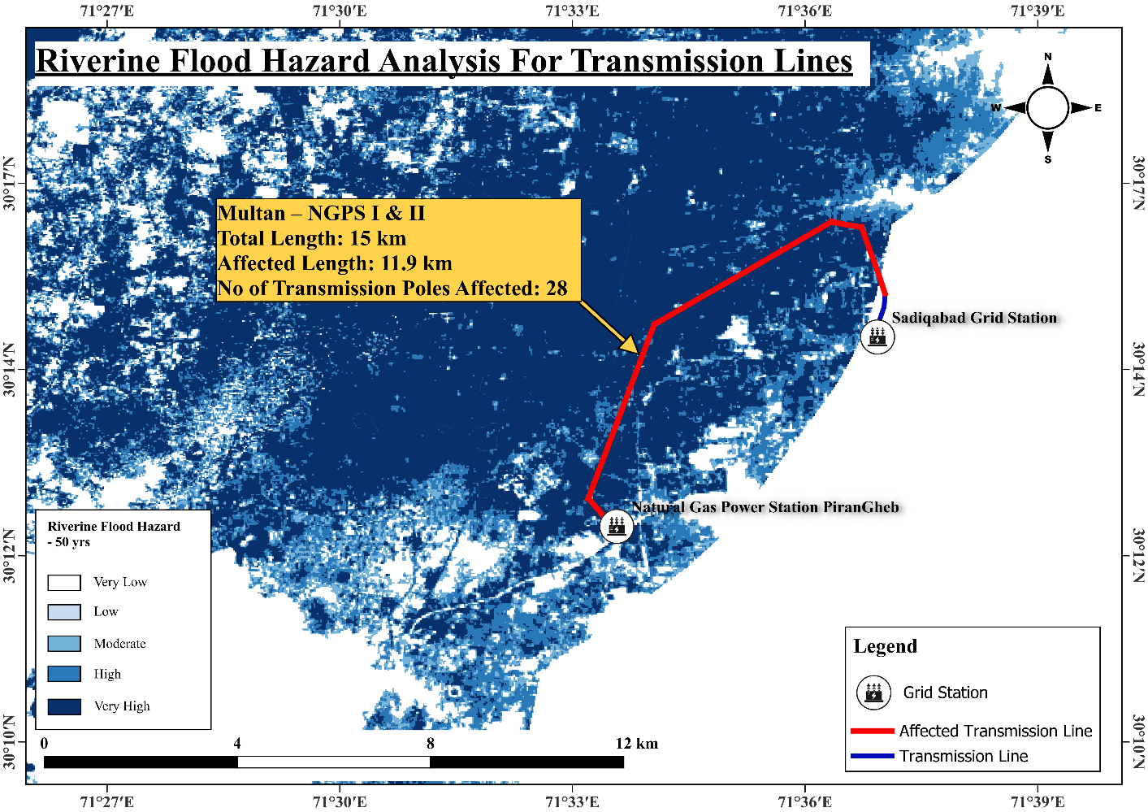

D.G. Khan - Guddu (Multan Guddu III) Transmission Line:
The D.G. Khan - Guddu (Multan Guddu III) Transmission Line connects the 500kV Grid Station NTDC D.G. Khan in Dera Ghazi Khan, Punjab, to the 500kV Grid Station Guddu in Sindh. Spanning 256.6 km, this 500kV transmission line facilitates power transmission from southern Punjab to Sindh. Its route through agricultural and canal-adjacent areas exposes 24.2 km (approximately 9.43% of the total length) and 75 transmission poles to riverine flood risks, necessitating a detailed hazard assessment to ensure a reliable power supply. This assessment details the grid stations, transmission line features, and flood hazards, emphasizing the need for robust mitigation measures to safeguard this critical infrastructure.
  - Agricultural land in Aaliwala, Ghous Abad Road, around Kot Chatta Road, Basti Bhambani, Basti Yaqi, and near Dhegana Lake Road around Dargah Hazrat Peer Fathe Shah Bukhari in Tehsil Kot Chatta, District Dera Ghazi Khan:
    - Location: Agricultural lands in Tehsil Kot Chatta, District Dera Ghazi Khan, Punjab, near seasonal watercourses and Dhegana Lake.
    - Flood Risk: Vulnerable to flooding from seasonal watercourses and lake overflow, exacerbated during the 2022 floods [Source: Wikipedia, 2022 Pakistan floods, 2025].
    - Impact: Floodwaters could destabilize transmission poles, leading to structural damage and power disruptions.
  - Agricultural land in Basti Yaray Wali in Tehsil Jampur, District Rajanpur:
    - Location: Agricultural lands in Basti Yaray Wali, Tehsil Jampur, District Rajanpur, Punjab.
    - Flood Risk: Prone to flooding from seasonal watercourses and the Indus River, with significant impacts during the 2022 floods [Source: Wikipedia, 2022 Pakistan floods, 2025].
    - Impact: Flooding could damage transmission infrastructure, causing outages in Rajanpur.
  - Agricultural land near National Highway 55 in Tehsil Rojhan, District Rajanpur:
    - Location: Near National Highway 55, Tehsil Rojhan, District Rajanpur, Punjab.
    - Flood Risk: Susceptible to riverine flooding from the Indus River, as seen during the 2022 floods [Source: Wikipedia, 2022 Pakistan floods, 2025].
    - Impact: Floodwaters could erode tower foundations, disrupting power supply to downstream areas.
  - Near Pat Feeder Canal, Guddu Barrage, Tehsil Rajanpur (Tribal Area), District Rajanpur:
    - Location: Near the Pat Feeder Canal and Guddu Barrage, Tehsil Rajanpur (Tribal Area), District Rajanpur, Sindh.
    - Flood Risk: High risk of flooding from the Indus River and canal overflow, particularly during monsoons [Source: Wikipedia, 2022 Pakistan floods, 2025].
    - Impact: Flooding could submerge transmission infrastructure, causing significant outages and repair challenges.

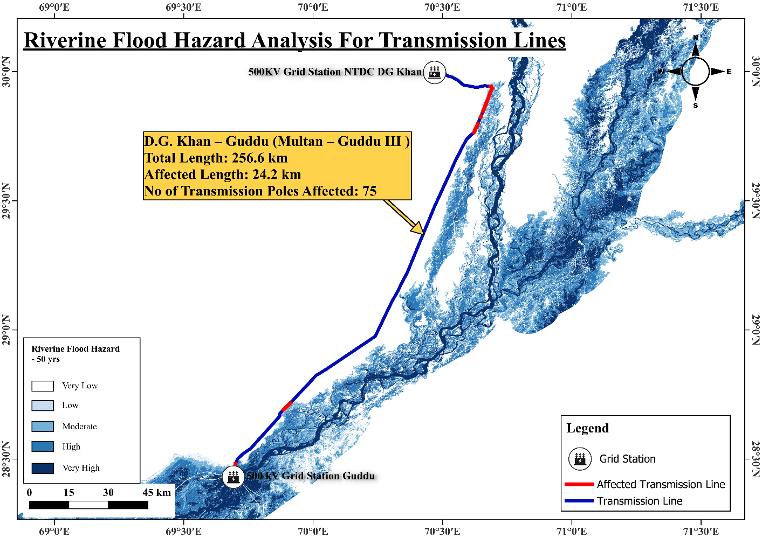

Shikarpur - Dadu I (Guddu - Dadu I) and Shikarpur - Dadu II (Guddu - Dadu II) Transmission Lines:
The Shikarpur - Dadu I & II (Guddu - Dadu I & II) Transmission Lines connect the 500kV Grid Station NTDC Shikarpur to the 500kV Grid Station NTDC Dadu, both in Sindh. Spanning 218.2 km (I) and 216 km (II), these 500kV lines are part of the Dadu-Guddu corridor, evacuating power from the Guddu Thermal Power Plant. Their extensive routes through agricultural areas expose 106.9 km (I) and 129.7 km (II), with 280 and 350 transmission poles respectively, to riverine flood risks, necessitating a detailed hazard assessment to ensure a reliable power supply. This assessment details the grid stations, transmission line features, and flood hazards, emphasizing the need for robust mitigation measures to safeguard this critical infrastructure.
  - Agricultural regions of Tehsil Khanpur, Shikarpur, Lakhi, Garhi Yasin, Rato Dero, Larkana, Baqrani, Nasirabad, Mehar, Khairpur Nathan Shah, and Dadu, all due to Indus River:
    - Location: Multiple tehsils across Shikarpur, Larkana, and Dadu districts, Sindh, near the Indus River.
    - Flood Risk: The Indus River’s high water flows during monsoons, as seen in the 2022 floods, pose a significant flood risk to these agricultural areas [Source: Wikipedia, 2022 Pakistan floods, 2025].
    - Impact: Floodwaters could submerge transmission towers, damage conductors, and cause widespread outages across Sindh.

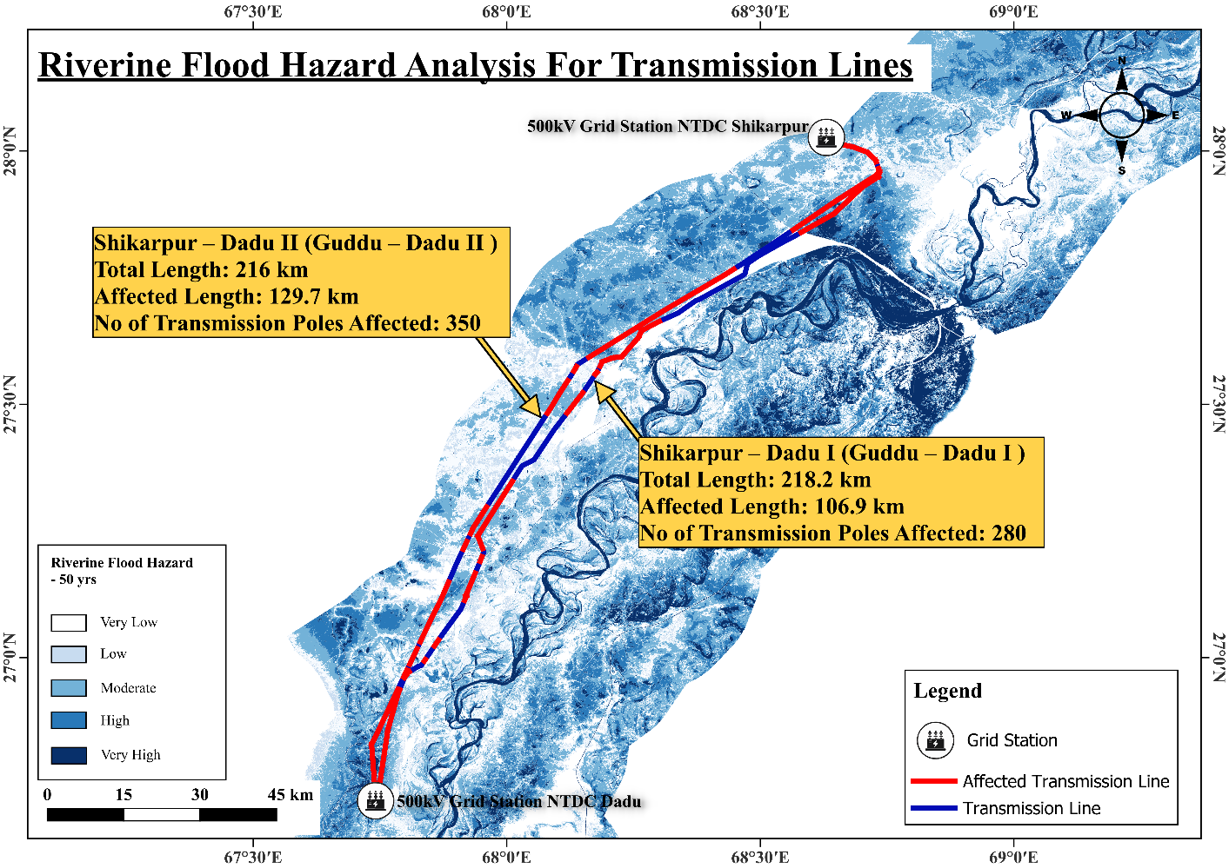

Dadu - Khuzdar I & II Transmission Line:
The Dadu - Khuzdar I & II Transmission Line connects the 220kV Grid Station NTDC Khuzdar in Balochistan to the 500kV Grid Station NTDC Dadu in Sindh. Spanning 310.1 km, this 220kV transmission line provides an alternative power supply route to Balochistan. Its route through agricultural areas exposes 45.8 km (approximately 14.77% of the total length) and 124 transmission poles to riverine flood risks, necessitating a detailed hazard assessment to ensure a reliable power supply. This assessment details the grid stations, transmission line features, and flood hazards, emphasizing the need for robust mitigation measures to safeguard this critical infrastructure.
  - Agricultural lands of Dadu, Johi, Khairpur Nathan Shah, and Mehar along the transmission line:
    - Location: Agricultural lands in Dadu, Johi, Khairpur Nathan Shah, and Mehar tehsils, District Dadu, Sindh, near the Indus River and its tributaries.
    - Flood Risk: These areas are highly vulnerable to riverine flooding from the Indus River, with significant impacts during the 2022 floods [Source: Wikipedia, 2022 Pakistan floods, 2025].
    - Impact: Floodwaters could erode tower foundations, leading to structural damage and power disruptions in Balochistan and Sindh.

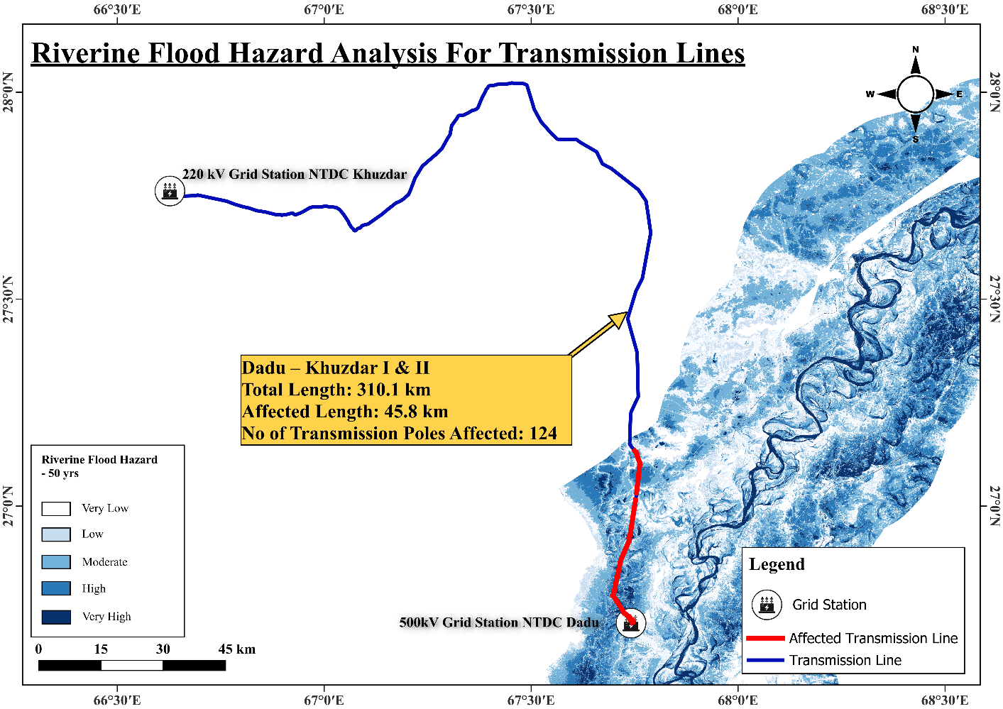

Dadu - Jamshoro I and Dadu - Jamshoro II Transmission Lines:
The Dadu - Jamshoro I & II Transmission Lines connect the 500kV Grid Station NTDC Dadu to the GENCO-I JPCL, Thermal Power Plant Jamshoro, both in Sindh. Spanning 176.1 km (I) and 170.8 km (II), these 500kV lines transmit power to southern Sindh. Their routes through agricultural areas expose 46.4 km (I) and 46.7 km (II), with 117 and 135 transmission poles respectively, to riverine flood risks, necessitating a detailed hazard assessment to ensure a reliable power supply. This assessment details the grid stations, transmission line features, and flood hazards, emphasizing the need for robust mitigation measures to safeguard this critical infrastructure.
  - Agricultural lands of Dadu, Sehwan Sharif, and slight agricultural areas of Manjhand along National Highway 55:
    - Location: Agricultural lands in Dadu, Sehwan Sharif, and Manjhand tehsils, along National Highway 55, Sindh, near the Indus River.
    - Flood Risk: The Indus River and its tributaries pose significant flood risks, as seen during the 2022 floods [Source: Wikipedia, 2022 Pakistan floods, 2025].
    - Impact: Floodwaters could damage transmission infrastructure, leading to outages and repair challenges in Sindh.
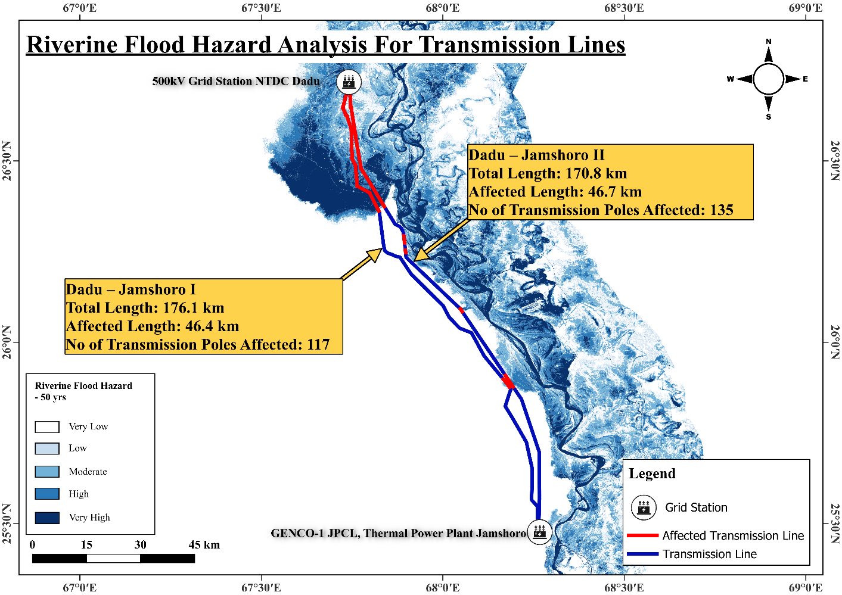

Port Qasim CFPP - Matiari I & II Transmission Line:
The Port Qasim CFPP - Matiari I & II Transmission Line connects the Port Qasim Coal-Fired Power Plant to the 500kV Grid Station Matiari in Sindh. Spanning 176.1 km, this 500kV transmission line evacuates power from the 1,320 MW coal plant to the national grid. Its route through agricultural areas near the Indus River exposes 22.5 km (approximately 12.78% of the total length) and 66 transmission poles to riverine flood risks, necessitating a detailed hazard assessment to ensure a reliable power supply. This assessment details the grid stations, transmission line features, and flood hazards, emphasizing the need for robust mitigation measures to safeguard this critical infrastructure.
  - Agricultural land around Indus River in Matiari and boundary region of Matiari and Kotri:
    - Location: Agricultural lands in Matiari and the boundary region of Matiari and Kotri tehsils, District Matiari, Sindh, near the Indus River.
    - Flood Risk: The Indus River’s high water flows during monsoons, as seen in the 2022 floods, pose significant flood risks to this area [Source: Wikipedia, 2022 Pakistan floods, 2025].
    - Impact: Floodwaters could submerge transmission towers, damage conductors, and disrupt power supply to southern Sindh.

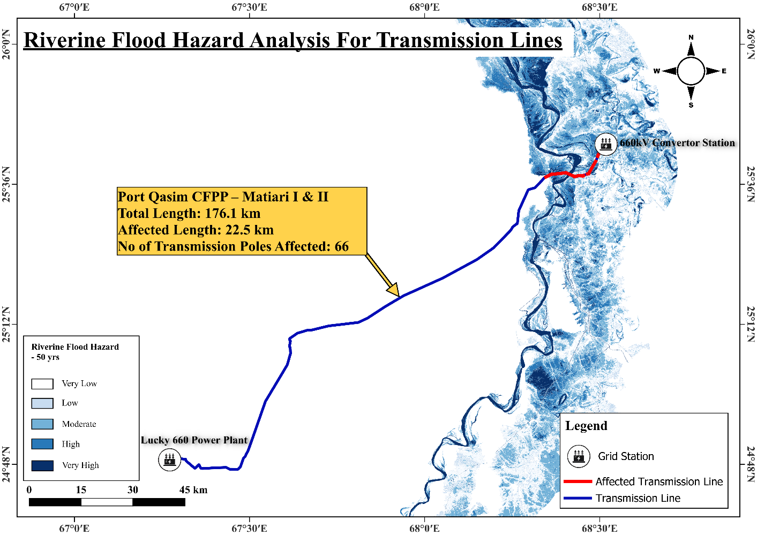

6. Deliverables

- Digitized Data: 35 grid stations and 27 transmission lines as shapefiles, KML files, and a consolidated geodatabase.
- Hazard Assessment Tables: Detailed tables for floods, cyclones, and earthquakes, including severity scores, affected lengths, and locations.
- Maps: Visual representations of NTDC energy infrastructure and hazard zones.
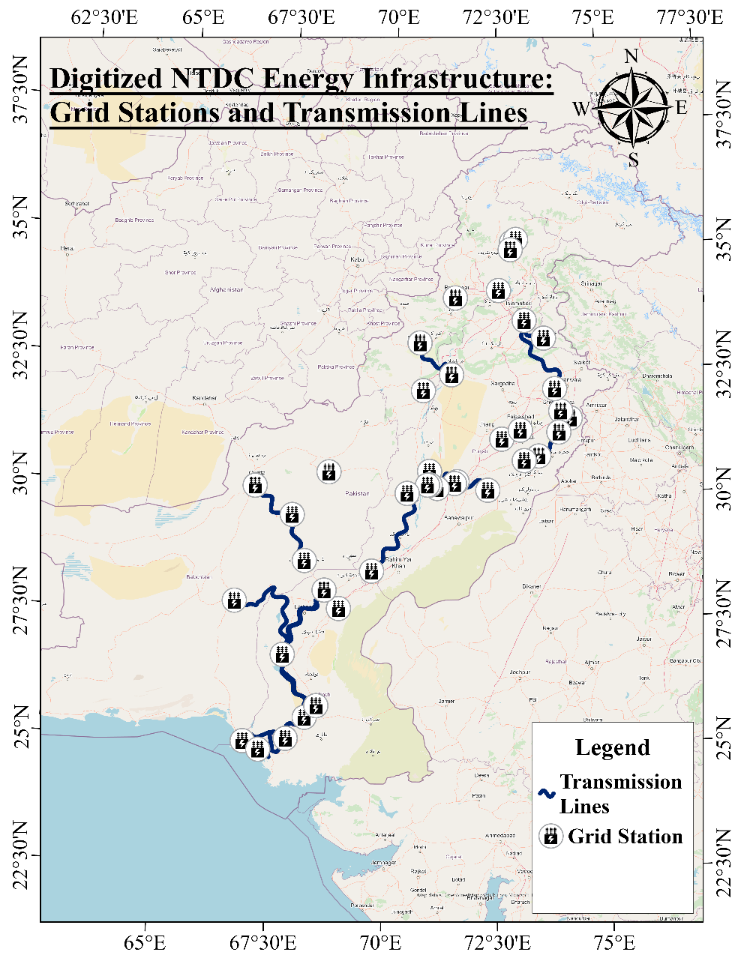
Figure 1 Map of NTDC Energy Infrastructure
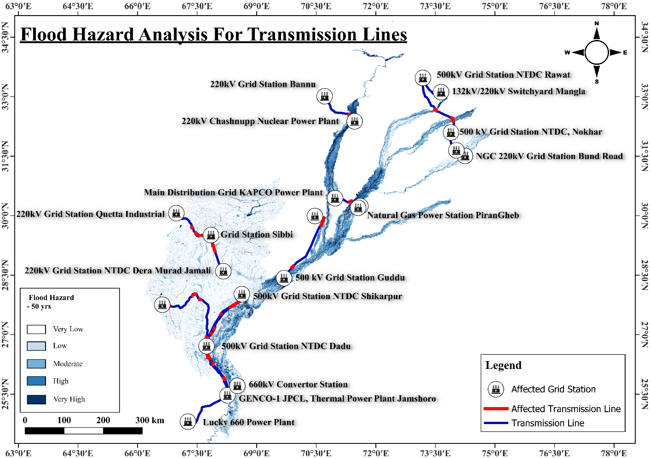

7. Conclusion

The task successfully digitized energy infrastructure data and assessed its vulnerability to natural hazards. The hazard assessment provides critical insights for risk mitigation and infrastructure resilience planning.

