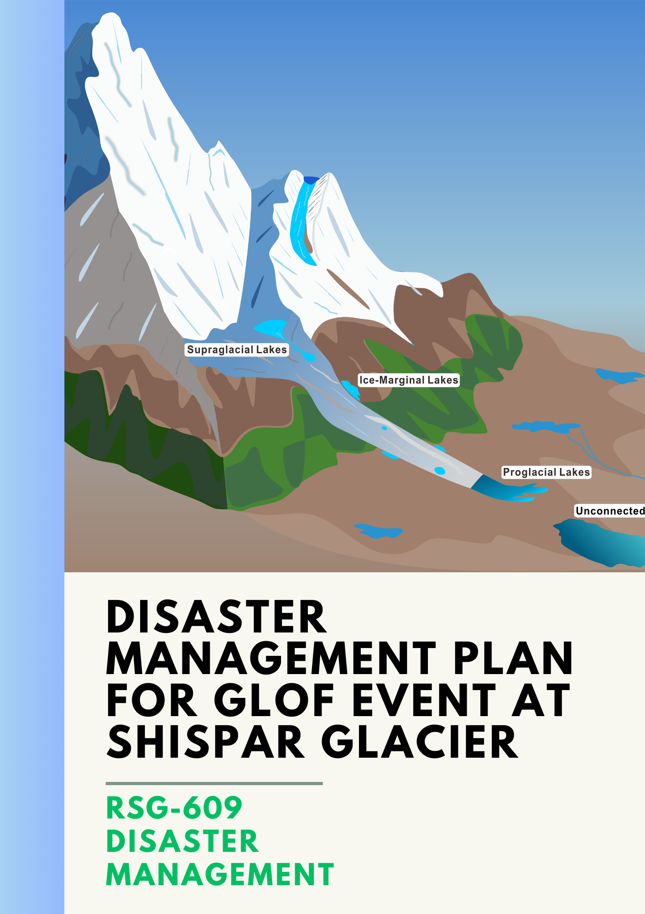
P R O G R E S S R E P O R T
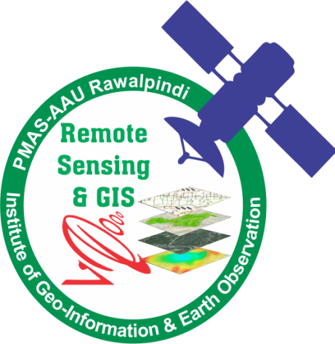

SUBMITTED TO: Dr. Muhammad Usman
SUBMITTED BY: Syeda Rosheen Raza Kazmi(21-ARID-1041) ||
M. Taimoor Ashfaq Malik (21-ARID-10 32) ||
Daniyal Mansoor (21-ARID-1025) ||
Haiqa Noor (21-ARID-1014) ||
Wajahat Hussain (21-ARID-1044) ||
Aleena Imdad (21-ARID-1001) || Fateh Khan (21-ARID-1010)
SUBJECT: GIS for Disaster Management
DISCIPLINE: BS-Geo Informatics
SEMESTER: 7th

PMAS Arid Agriculture University
Rawalpindi
Table of Contents
1. Introduction 4
2. GIS Application in Disaster Management 6
3. History of GLOF Events in Pakistan 6
4. History of GLOF Events in Shishper Glacier: 7
5. Objectives 7
6. Materials and Methods 7
6.1 Study Area: 7
6.2 Data Collection: 8
6.3 Methodology: 11
6.3.1 Accumulation Area Ratio: 11
6.3.2 Normalized Difference Snow Index (NDSI): 11
6.3.3 Normalized Difference Dust Index (NDDI): 11
6.3.4 Normalized Difference Water Index (NDWI): 12
6.3.5 Normalized Difference Turbidity Index (NDTI): 12
6.3.6 Normalized difference chlorophyll index (NDCI): 12
6.3.7 Debris Index (DI) 13
6.3.8 Land Surface Temperature (LST) 13
7.1 Plausible factors triggering breach 16
7.2 After Effects 21
7.3 Disaster Management Responsibilities 22

PROJECT TOPIC
Disaster Management Plan for GLOF in Shishper Glacier

Abstract
Karakoram Himalayas are vulnerable to glacial lake outburst floods (GLOFs), which cause catastrophic floods in the surrounding areas. The increasing natural and anthropogenic activities, especially in the Indo-Gangetic Plains at the southern flank of the towering Himalayas, could be the cause of climate change affecting the fre- quency of the natural hazards in the Himalayas. In the present study, a detailed analysis of the Shisper Lake breach of 7 May 2022 is carried out using satellite remote sensing. A decreasing trend in the glacial mass balance is observed between 2017 and 2021; in this period, frequent GLOF episodes occurred. A pronounced decline in the snow cover and glacial debris (before the cascade) and an abnormal increase in land surface temperature (LST) retrieved from satellite data could be responsible for the enhanced snow/glacial melting prior to the breach. Alteration in glacial mobility (cm/12 days) is observed at the locations where the glacier melts due to an increase in LST with increased debris cover. In the paper, we have studied changes in water quality and land cover along the stream after the GLOF. An increment in normalized dif- ference turbidity index (NDTI) is observed before the flood showing turbulence and sediment load. Increased glacial melt contribution into the stream results in increased flow rate and decreased water quality as observed through normalized difference water index (NDWI) and normalized difference chlorophyll index (NDCI), near the Karakoram Highway Bridge.

Introduction
Glacial lake is a large reservoir of water in, on or near the glacier created by glacial processes as glaciers melts at frontal zone, it creates the empty space which is filled by melt water which eventually become a lake due to gradual accumulation of water. They may be either ice dammed, or moraine dammed. Glacial lakes can be found almost all over the world with glaciated regions. Most theories reveal that glacial lakes began to form with glacier retreat all over the world near the end of last glacial period. Most of the glacial lakes in HKH region are the result of glacier ice and snow melting and deposition of unstable lateral moraines due to increasing temperatures that lead to more glacial lakes in times to come (Rasul et al., 2011).
Glacial Lake Outburst Flood (GLOF) is a sudden release of huge number of debris mix water from the glacial lake flows downstream (ICIMOD, 2011). The GLOF process is supported by the wreckage of glacier ice, the breakdown of moraines due to erosion and gradual leakage of water reduces the strength of lake to contain water, therefore the pressure exerts by the water force led to the outburst and form a debris flow or flash flood. The intensity of possible flood depends on the speed of outflowing water or the discharge rate and the volume of the water which is usually high in cases of GLOF’s, so the higher the volume and discharge rate, maximum would be the severity of flood downstream (Worni et al., 2012).
The GLOF events are catastrophic as huge loads of debris and mud flows in the downstream sweeping the infrastructure, houses and croplands even in scores of life losses if they happen without any alert signal. For mountain population, GLOF is a great hazard which has been reinforced by climate change in terms of frequency and vulnerability in Gilgit Baltistan region. UNDP in 2007 reported that in Gilgit-Baltistan the frequency of glacier lake outburst floods is higher as it has been recorded over 30 disaster events in last two centuries. Such disasters include the GLOF events occurred in Gupis valley during 1994, when a GLOF blocked the Ghizer river and river blockade formed a huge lake, this event took five lives and damaged livelihoods and properties of population living in downstream (PMD, 2016).
There are number of approaches to assess various parameters to understand the nature of glacial lake during field surveys which may include observations by visual records, photography, understand local geology, physical settings of the site, physiography of the lake dimensions and stability of moraines and its composition. Bathymetric data is another critical parameter to consider for GLOF as lake depth is used to estimate the volume of the water released in case of GLOF which can be collected by using advance technology and Boat and Sounder method (Khanal et al., 2015). In general, most of the glacial lakes are found at high altitudes due to which it is difficult to reach physically for detailed assessments, investigations, mapping and monitoring (Anand, 2014). It also needs extensive time, resources in terms of human and financials therefore, the remote sensing data and GIS techniques provide great help. Freely available satellite imagery of Landsat and Sentinel are used to monitor the temporal change of glacial lakes. The normalize water index (NDWI) and modified normalize water index (MNDWI) are frequently used indices to extract lake using satellite data (Huggel et al., 2004). The Geographical Information System (GIS) and remote sensing (RS) tools and techniques supports the detailed study, analysis and monitoring of various features of glaciers and glacier lakes as most of the glacier lakes are located at high altitudes that are difficult to assess physically. The assessments of some critical characteristics of glaciers like snow line, moraine type, lake area etc. can be easily identify on remote data i.e. satellite images. The remote sensing data of high spatial resolution i.e. Digital Terrain Model (DEM) and freely available software’s i.e. HEC-RAS and HEC-GeoRAS can be used to model the possible GLOF and identification of low-lying at-risk features. The results of the remote sensing data coupled with ground truthing can be best approach for GLOF mapping and modelling (Banerjee, 2003).

GIS Application in Disaster Management
The character and magnitude of hazardous events in an area are crucial for natural disaster management. Many types of information needed in this field have an important spatial component, such as maps, aerial photography, satellite imagery, GPS data, rainfall data, and borehole data. These data often have different projections and coordinate systems, requiring standardization to a common map basis for effective superimposition. Remote sensing and Geographic Information Systems (GIS) have proven their usefulness in disaster management. Firstly, remote sensing and GIS provide a database from which evidence of past disasters can be interpreted and combined with other information to create hazard maps, indicating potentially dangerous areas. Hazard zonation is essential for any disaster management project, supplying planners and decision-makers with adequate and understandable information. Remote sensing data, such as satellite images and aerial photos, allow mapping of terrain properties' variabilities, such as vegetation, water, and geology, both in space and time. Satellite images offer a synoptic overview and provide valuable environmental information across various scales, from entire continents to details of a few meters. Additionally, many types of disasters, such as floods, droughts, cyclones, and volcanic eruptions, have certain precursors. Satellites can detect the early stages of these events as anomalies in a time series. Images available at regular short intervals can be used to predict both rapid and slow disasters. When a disaster occurs, the speed of information collection from air and space-borne platforms and the swift dissemination of this information makes it possible to monitor the disaster's occurrence. Many disasters affect large areas, and no other tool than remote sensing can provide matching spatial coverage. Remote sensing also allows monitoring the event during its occurrence while the forces are in full swing. The vantage position of satellites makes it ideal for planning and operationally monitoring the event. GIS is used for planning evacuation routes, designing emergency operation centers, and integrating satellite data with other relevant data in disaster warning systems. In the disaster relief phase, GIS is extremely useful in combination with Global Positioning Systems (GPS) for search and rescue operations in devastated areas where orientation is difficult. The impact and aftermath of the disaster leave behind immense devastation. Remote sensing assists in damage assessment and aftermath monitoring, providing a quantitative base for relief operations. In the disaster rehabilitation phase, GIS organizes damage information and post-disaster census information and evaluates sites for reconstruction. Remote sensing maps the situation and updates the databases used for reconstruction, helping to prevent future disasters (van Westen, 2000).

History of GLOF Events in Pakistan
The Northern Areas of Pakistan, encompassing the Hindukush, Karakoram, and Himalayan Mountain ranges, have experienced intensified glacier surging due to climate warming. Rapid glacier melt increases the risk of ravine blockages and stream discharge obstruction, forming expansive ice-dammed lakes (Ali, 2024). Climate change exacerbates hazards like glacial lake outburst floods (GLOFs), which pose significant risks to communities in the Himalayan region. Over the past 200 years, thirty-five destructive outburst floods have been recorded in the Karakoram Range. Remote sensing and GIS applications have identified approximately 2,420 glacial lakes in the Hindukush-Karakoram-Himalaya (HKH) region of Pakistan, with 52 classified as potentially dangerous (Ashraf et al., 2012). Among these, 62% are End Moraine Dammed, and 25% are Cirque-type lakes. Due to limited resources and management, local communities face challenges in implementing effective GLOF risk mitigation strategies. Increased community awareness, coordination, and capacity-building for preparedness and risk reduction are essential. Regular monitoring using high-resolution satellite data and ground information integration could significantly mitigate future flood risk (Ashraf et al., 2012).

History of GLOF Events in Shishper Glacier:
Shishper Glacier extending over a length of 16.5 km is situated on the Karakoram range more specifically in the Hunza River Raven (Nallah) within the confines of Gilgit-Baltistan, Northern Pakistan (Ali, 2024). The Shishper glacier region experiences an annual precipitation of 125 mm and maintains an average temperature of 11 °C (Khan et al., 2021). Hassanabad village faces susceptibility to Glacial Lake Outburst Floods due to the dynamic movement of the Shishper Glacier, impeding the outlet water flow from the neighboring Muchuwar glacier (Karim et al., 2021). Shishper Glacier Lake from its initiation in November 2018 to the catastrophic GLOF in May 2022. The lake reached a maximum area of 0.32 km² in 2019 and its successive breaches on June 22, 2019, and May 29, 2020, reduced it to 0.018 km². Draining continued until July 2021, shrinking the lake area to 0.009 km². A noteworthy 2.73 °C temperature increase in 2022 correlated with an expansion of the lake area to 0.33 km², culminating in the GLOF on May 7th, 2022. There is critical need for mapping, assessing, and monitoring surging glaciers and glacier-formed lakes in the Karakoram ranges to safeguard downstream communities from potential hazards. (Ali, 2021).

Objectives
The aim of the study is to:
- Study the breach of Shisper glacial lake on May 7, 2022 and investigate the effect of outburst on nearby communities.
- Identify the possible factors responsible for the outburst flood and associated changes after the breach.
- Devise a Disaster Management Plan for Glacial Lake Outburst floods.

6. Materials and Methods

6.1 Study Area:
Shishper Glacier is the western component of the Hassanabad glacier, with the Muchuwar glacier in the east (Muhammad et al. 2021). The glacier belongs to the group of Passu mountain glaciers that lies in the upper Indus basin within the western Karakoram belt of the Himalayan Mountain range. The size of the Shishper Glacier is 54.7 km2 (Bhambri et al., 2020), and the total watershed area drained by the Shishper and the Muchuwar glaciers is 359 km2 (Khan et al., 2021). The western Karakoram region exhibits major topographic, climatic, and geomorphological gradients (Thayyen et al., 2021). The Shishper and the Muchuwar glaciers separated in the 20th century (Bhambri et al., 2017), where western branch is now termed as the Muchuwar glacier, and the eastern as the Shishper glacier. The elevation ranges of Shishper and Muchuwar glacier lies between 2478 and 7737 m, whereas the elevation further reduces in the valley area following the confluence of Hunza Nallah with the Hunza River. The meltwater of Muchuwar and Shishper glaciers flows into the Hunza River. The region has a mean annual temperature of 11 °C and a precipitation of 125 mm (Climate Data, 2022). The region has an arid to semiarid climate and is characterized by two primary seasons, April–September as summer and October–March as winter. The region is dominated by seasonal snow cover in winter, covering approximately 85 % of the area (Shrestha et al., 2015).
Map of Study Area:

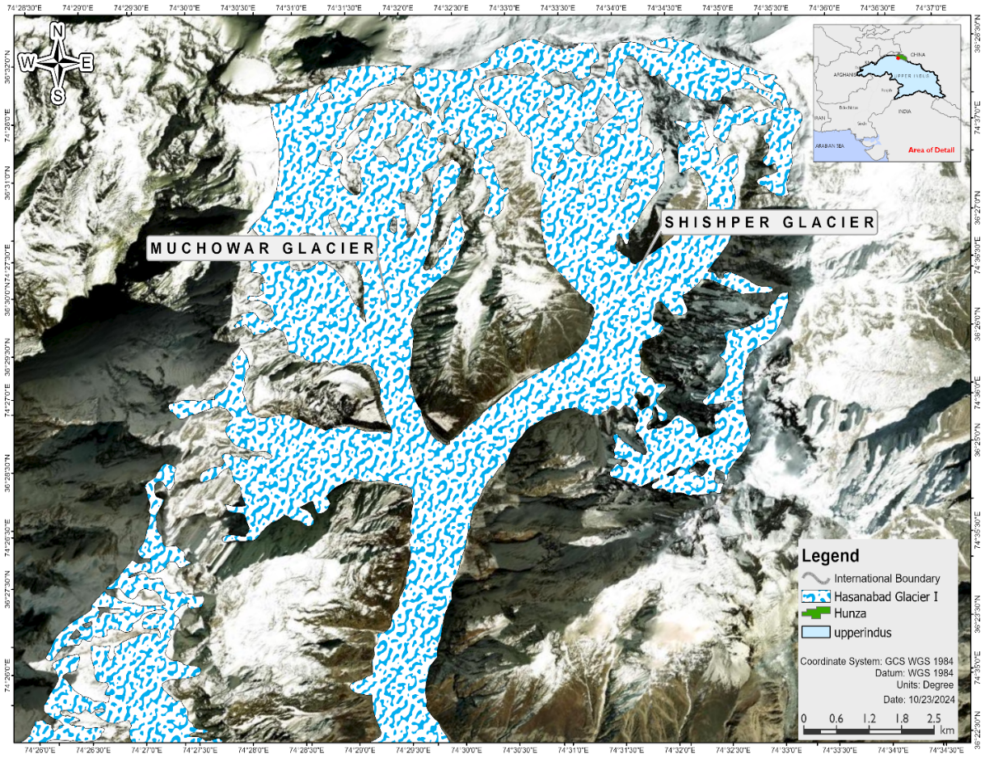

Figure 1: Map of Study Area

6.2 Data Collection:
In this study, an effort has been made to utilize optical and microwave remote sensing data to examine potential triggering mechanisms of the glacial lake breach. Landsat-8/9 Operational Land Imager (OLI), Sentinel-2 Multi-Spectral Instrument (MSI), and Moderate Resolution Imaging Spectroradiometer (MODIS) surface spectral reflectance (MOD09GA) products were employed to analyze anomalies in the region. Landsat-8/9 offers a spatial resolution of 30m across eleven spectral bands, covering the visible, near-infrared (NIR), shortwave infrared (SWIR), and thermal infrared regions of the electromagnetic (EM) spectrum. Sentinel-2, which lacks thermal bands, provides data in thirteen spectral channels ranging from 0.43mm to 2.28mm, covering visible (10m), NIR (20m), and SWIR (60m) wavelengths. Since Landsat-8 and Landsat-9 have identical spectral, spatial, radiometric, and temporal characteristics, combining their datasets enhances the frequency of data acquisition (<16 days), which is particularly beneficial for monitoring natural hazards such as glacier-induced flooding. AIRS skin temperature data from the NASA Giovanni portal was used to assess daily temperature variations for May 2021 and May 2022 over the Shisper Glacier within a 1° × 1° spatial grid. AIRS, an advanced infrared sounder onboard the Earth Observing System (EOS) Aqua satellite, provides high-resolution geophysical parameters. Additionally, a high-resolution (12.5m) digital elevation model (DEM) from the Advanced Land Observing Satellite (ALOS) PALSAR was used to map stream networks in the Hassanabad region of the Hunza River valley. PALSAR, an L-band microwave sensor, enables data acquisition under all weather conditions. The DEM was derived from PALSAR. The boundaries of glaciers in the study area, including the Shisper and Muchuwar glaciers, were obtained from the Randolph Glacier Inventory (RGI 6.0). Using multi-spectral satellite data, several indices were generated to evaluate key parameters associated with the GLOF event. A comprehensive analysis incorporating optical, thermal, and microwave remote sensing data revealed significant variations in multiple snow and water-related parameters.

Data | Data Source | Resolution
DEM | https://search.asf.alaska.edu | 30 m
Sentinel -2 MSI | https://dataspace.copernicus.eu | 10 m
MODIS MOD09GA | https://lpdaac.usgs.gov/ | 500 m
RANDOLPH GLACIER INVENTORY | https://www.glims.org/RGI/rgi60_dl.html | 5.5 km
LANDSAT 8/9 OLI | https://earthexplorer.usgs.gov/ | 10 m

Landsat-8/9 OLI & TIRS Datasets
Pre-GLOF Datasets | Post-GLOF Dataset | Spectral Channel Used Pixel Size | Pixel Depth
17 April 2022 (L-9) | 10 May 2022 (L-9) | Band 3 (Green; 0.53-0.59 lm) 30 m | 16 bit
 |  | Band 4 (Red; 0.64-0.67 lm)
 |  | Band 5 (NIR; 0.85-0.88 lm)
 |  | Band 6 (SWIR-I: 1.57-1.65 mm)
2 May 2022 (L-8) |  | Band 10 (TIR-I; 10.6-11.19 lm) 100 m
Sentinel-2 MSI Datasets
Pre-GLOF Datasets | Post-GLOF Dataset | Spectral Channel Used Pixel Size | Pixel Depth
11 November 2017 | 10 May 2022 | Band 3 (Green; 0.543-0.578 lm) 10 m | 16 bit
8 September 2018 |  | Band 4 (Red; 0.65-0.68 lm)
13 October 2019
22 September 2020
27 September 2021 |  | Band 5 (Red Edge; 0.698-0.713 lm) 20 m
30 April 2022 |  | Band 11 (SWIR-I; 1.565-1.655 lm)
5 May 2022
MOD09GA Datasets
Pre-GLOF Datasets | Post-GLOF Dataset | Spectral Channel Used Pixel Size | Pixel Depth
17 April 2022 | 10 May 2022 | Band 3 (0.469 lm) 500 m | 32 bit
2 May 2022 |  | Band 7 (2.13 lm)
ALOS PALSAR DEM
2 January 2009 |  | Beam Mode/Path Frame/Flight Direction | Polarization
 |  | Fine Beam Single (FBS)/527 710/Ascending | HH

6.3 Methodology:

6.3.1 Accumulation Area Ratio:
The rugged and complex topography and day-to-day variability in the weather conditions restrict scientists to carry out limited ground-based mass balance monitoring to
very few glaciers for a few years. Some discrete data are available which may be of poor quality due to limited logistics and severe climatic conditions. The Accumulation-Area-Ratio (AAR) method was established to compute the mass balance of glaciers through satellite-based observations (Kulkarni 1992). The regression equation for the Karakoram Himalayas is given below:
$Specific Mass Balance in cm = 243.01 x AAR - 120.187$ (1)
NDSI (Normalized Difference Snow Index) threshold of 0.75 0.96 can be used for the extraction of the firn line for the given region (Zhau et al. 2020). Using NDSI and firn line threshold, the accumulation area of the glacier can be extracted during the end of the ablation period i.e. in the month of Mid-September to Early November. The accumulation area ratio is calculated using following equation:
�
$$AAR = \frac{Accumulation Area}{Total area of the glacier} (2)$$

6.3.2 Normalized Difference Snow Index (NDSI):
The Normalized Difference Snow Index (NDSI), as defined by Nolin and Liang (2000), is calculated using the difference between reflectance in the visible (green band) and the shortwave infrared (SWIR) band (1.57–1.65 mm), divided by their sum, as shown in Equation (1)
$$NDSI= \frac{Band 3-Band 6}{Band 3+Band 6}………(3)$$
NDSI is effective in distinguishing snow from clouds and other non-snow surfaces. Additionally, this band ratio helps reduce the impact of atmospheric conditions and viewing geometry (Salomonson & Appel, 2004). A threshold value of 0.4 is applied to differentiate surface snow from other land cover features (Hao et al., 2008).

6.3.3 Normalized Difference Dust Index (NDDI):
The Normalized Difference Dust Index (NDDI), proposed by Qu et al. (2006), is calculated using the difference in reflectance between the 2.13 µm (Band 7) and 0.469 µm (Band 3) bands of MOD09GA, divided by their sum, as expressed in Equation (2):
$$NDDI= \frac{Band 7-Band 3}{Band 7+Band3}………(4)$$
NDDI is useful for distinguishing dust, surface features, and cloud cover. A value of NDDI < 0.0 indicates cloud presence due to lower reflectance in Band 7 and higher reflectance in Band 3. A threshold of 0.28 is applied, where NDDI values below 0.28 correspond to surface features, while values of 0.28 or higher indicate dust presence.

6.3.4 Normalized Difference Water Index (NDWI):
The Normalized Difference Water Index (NDWI), introduced by Gao et al. (1996) for detecting water content using MODIS data and surface water features (McFeeters, 1996), is calculated as follows:
$$NDWI= \frac{Band 3-Band 5}{Band 3+Band 5}…… …(5)$$
During flood events, NDWI utilizes the reflectance of Bands 3 and 5 to assess water quality. Positive pixel values in the NDWI output indicate clear water, while contamination from mud or debris can cause a shift toward negative values (Meena et al., 2021b).

6.3.5 Normalized Difference Turbidity Index (NDTI):
The Normalized Difference Turbidity Index (NDTI), expressed in Equation (4), serves as a complementary band ratio to NDWI. It is calculated as follows:
$NDTI= \frac{Band 4-Band 3}{Band 4+Band 3}………(6)$​
Where Band 3 and Band 4 represent the reflectance in the green and red bands of Landsat-8/9, respectively. Positive NDTI values indicate turbid water, while pixel values ranging between -0.03 and 0.03 correspond to arable land with vegetation (Solovey, 2019). While NDWI effectively differentiates between clear and muddy water following an outburst flood, NDTI specifically utilizes the reflectance in green and red bands to detect turbidity in satellite imagery.

6.3.6 Normalized difference chlorophyll index (NDCI):
In recent years, various algorithms have been developed to estimate chlorophyll-a (Chlo-a) concentration in turbid, highly productive water bodies, particularly using near-infrared (NIR) bands (Mishra & Mishra, 2012). Following a flood event, changes in Chlo-a concentration in river water can be effectively detected using the NDCI formula:
$$NDCI= \frac{Band 5-Band 4}{Band 5+Band 4 }………(7)$$
Where Band 5 and Band 4 represent the reflectance in the red-edge (0.698–0.713 mm) and red (0.65–0.68 mm) bands of Sentinel-2 MSI datasets, respectively. Once NDCI is calculated, Chlo-a concentration (mg/L) can be determined using the following equation (Mishra & Mishra, 2012):
$$Chlo-a Concentration =194.325×NDCI2+86.115×NDCI+14.039………(8)$$
Higher NDCI values indicate increased Chlo-a concentration, signifying lower water quality (USEPA, 2008). An NDCI value of 0.06 corresponds to a Chlo-a concentration of 20 mg/L, which represents the lower contamination threshold. Negative NDCI values indicate overflow conditions with reduced Chlo-a concentration.

6.3.7 Debris Index (DI)
Glaciers are composed of debris especially the Himalayan Glaciers (Hewitt 2009). Debris index (equation 9) is widely used automated algorithms to distinguish debris- covered ice from clean snow/ice is the band ratio technique (Pfeffer et al. 2014).
$$Debris Index= \frac{Band 4}{Band 11 }………(9)$$
where BAND 11 is the reflectance in SWIR (1.565–1.655 μm) band for Sentinel-2 MSI datasets used. The threshold of 1.8 is considered to distinguish clean ice glacier areas from debris-covered areas.

6.3.8 Land Surface Temperature (LST)
In order to understand the impact of sudden increase in temperature (heat waves) resulting in enhanced melting of glacial bodies, it is important to analyse the surface temperature of the glaciers. The thermal infrared bands of Landsat-8/9 are widely used in deriving the LST of an area as shown in Figure 3. The first step involves obtaining top of the atmosphere (TOA) spectral radiance (L_{k}) (equation 10) in watt m⁻² srad⁻¹ mm⁻¹ of the TIR band (band 10).
$$L_{λ}=M × D_{cal}+A ………(10)$$
where M and A represent the multiplicative and additive rescaling factors for Landsat-8/9 datasets as mentioned in Table 2 and D_{cal} represents band 10 digital number (DN) value. The next step involves determining the TOA brightness temperature (BT) which is the microwave radiation radiance from the top of the atmosphere as shown in equation (11).
$$BT (^{0}C)= \frac{K₂}{(\ln{\frac{K^{1}}{L_{λ}}}+1)}-273.15………(11)$$
where K₁ and K₂ are the thermal constants for band 10 given in Table 2.
This study adopted the normalized difference vegetation index (NDVI) threshold method to derive the emissivity (Avdan and Jovanovska 2016). The importance of calculating NDVI (equation 12) is crucial in obtaining the proportion of vegetation (P_{v}) which has a relation to emissivity (e).
$$NDVI= \frac{Band 5-Band 4}{Band 5+Band 4}………(12)$$
P_{v} is calculated using the NDVI threshold for soil (0.5) and vegetation (0.2) as shown in equation 13, (Wang et al. 2015; Avdan and Jovanovska 2016). Further, P_{v} is used to derive the emissivity (equation 14). Finally, the emissivity corrected LST is calculated as shown in equation 15, (Stathopoulou and Cartalis, 2007).
$$P_{V} ={\left(\frac{NDVI- {NDVI}_{S}}{{NDVI}_{V}- {NDVI}_{S}}\right)}^{2}………(13)$$
$$ε=0.004 × P_{V}+0.986 ………(14)$$
$$LST (^{0}C)=\frac{BT (^{0}C)}{\{1+[(\frac{λ × BT (^{0}C)}{ρ})ln⁡(ε)]\}} ………(15)$$
where $λ$ is taken as 10.895 which is the wavelength of emitted radiance for band 10 and $ρ$ is calculated using equation 16
$ρ=h\frac{∁}{σ}=1.438 ×10ˉ² ………(10)$
where $h$ is the Planck’s constant (6.626x10ˉ³⁴ Js), c is the velocity of electromagnetic radiation (2.998x10⁸msˉ¹), and $σ$ is the Boltzmann constant (1.38x10ˉ²³ JKˉ¹).
6.4 Disaster Management Plan:
A Disaster Management Plan (DMP) is a strategic framework designed to prevent, prepare for, respond to, recover from, and mitigate the impacts of disasters, such as Glacial Lake Outburst Floods (GLOFs).
6.4.1 Disaster (GLOF):
The Shisper Glacier, like others in the Hunza Valley, is prone to GLOFs, which are sudden releases of water caused by the failure of a glacial lake dam. These events occur when water accumulates in a lake (ice-dammed, moraine-dammed) and exceeds the capacity of the dam to contain it. Factors such as glacier surging, extreme precipitation, rapid ice melt, or ice calving can trigger the outburst.
Causes of GLOF
- Rapid glacier melting due to climate change, increasing the lake volume.
- Glacier surges that block meltwater, forming unstable ice-dammed lakes.
- Intense precipitation or snowmelt that raises water levels quickly.
- Landslides or avalanches that destabilize the natural dam structure.

6.4.2 Response (Immediate Actions):
The response phase focuses on immediate actions taken after the occurrence of a GLOF to minimize casualties, protect assets, and manage the disaster’s effects. Key response activities should include:
- Evacuation: Immediate evacuation of populations living in the path of the flood, especially in downstream settlements like those along the Hunza River.
- Emergency Communication: Early warning systems (EWS) should notify local populations and authorities via SMS, sirens, and public announcements.
- Rescue Operations: Mobilizing local rescue teams to assist affected communities. Collaboration with the military and local emergency services for rapid deployment.

6.4.3 Recovery (Post-Disaster Reconstruction and Rehabilitation):
The recovery phase includes actions aimed at restoring the affected communities and infrastructure to pre-disaster conditions. Long-term recovery strategies should focus on:
- Infrastructure Reconstruction: Rebuilding essential infrastructure like bridges and water supply systems destroyed by the GLOF.
- Livelihood Support: Providing economic assistance to the affected populations, particularly in sectors such as agriculture and tourism, which are often impacted by GLOF events.
- Psychosocial Support: Offering mental health and counseling services for those affected by the disaster.
- Restoration of Ecosystems: Rehabilitating damaged ecosystems, such as riverbanks, that have been eroded by floodwaters.

6.4.4 Long-Term Considerations:
- Implementing stricter building regulations in vulnerable areas.
- Encouraging sustainable agricultural practices to reduce soil erosion and sedimentation, which can exacerbate future GLOFs.

6.4.5 Preparedness (Preventative Measures for Future GLOF Events)
Preparedness aims to minimize the impact of a future GLOF through early warning systems, community education, and risk assessments.
- Early Warning Systems (EWS): Install and maintain automated EWS to detect rising lake levels and alert authorities and communities in real time.
- Community Training: Conduct regular disaster preparedness drills in local communities, focusing on safe evacuation routes, emergency contacts, and assembly points.
- Glacial Lake Monitoring: Regularly monitor the glacial lake through remote sensing (Sentinel-2) and on-ground surveys to assess changes in lake volume, ice-dam stability, and other indicators of potential GLOF.
- Risk Assessment Maps: Create and disseminate hazard maps identifying areas most at risk of flooding, landslides, and other cascading effects of GLOF events.

6.4.5 Mitigation (Measures to Reduce GLOF Risk)
Description: Mitigation efforts focus on reducing the likelihood of a GLOF event or minimizing its potential damage.
- Lake Drainage Control: Implement structural mitigation measures such as controlled drainage of glacial lakes to reduce water volume and lower GLOF risk.
- Strengthening of Natural Dams: Reinforce weak or unstable moraine dams using engineering solutions like concrete structures or rockfill, which prevent sudden breaches.
- Afforestation and Soil Conservation: Planting trees and other vegetation along riverbanks to prevent erosion and reduce sedimentation in lakes, which can exacerbate flooding.
- Early Climate Adaptation Policies: Develop policies that address the long-term impacts of climate change on glaciers, including reducing greenhouse gas emissions and managing water resources effectively.

7. Results and Discussions

7.1 Plausible factors triggering breach
Investigations into the factors contributing to the Shisper glacial lake outburst (GLOF) revealed critical changes in glacier mass balance and surface conditions. Between 2017 and 2021, the glacier’s accumulation area ratio (AAR) exhibited a declining trend, with annual mass balance values fluctuating from a peak of 0.417 m water equivalent (w.e.) in 2017 to a minimum of 0.172 m w.e. in 2021. This period, marked by two major GLOF events, showed an average mass loss of 0.308 ± 0.098 m w.e., alongside a notable decline in specific mass balance between 2019 and 2021.
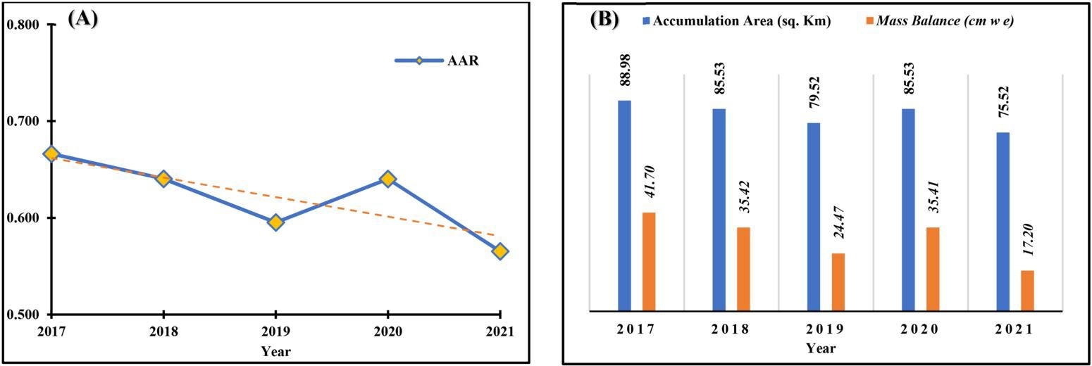
Satellite-derived Normalized Difference Snow Index (NDSI) analyses from Landsat-8/9 highlighted a progressive reduction in snow cover from April to May 2022. Snow-covered area decreased from 59.28% (17 April) to 38.51% (10 May), with a concurrent rise in dust-affected regions (Normalized Difference Dust Index, NDDI) expanding from 671.2 km² to 946.2 km² over the same period. These trends align with documented patterns of dust deposition in the western Himalayas, which accelerate snowmelt by reducing surface albedo.

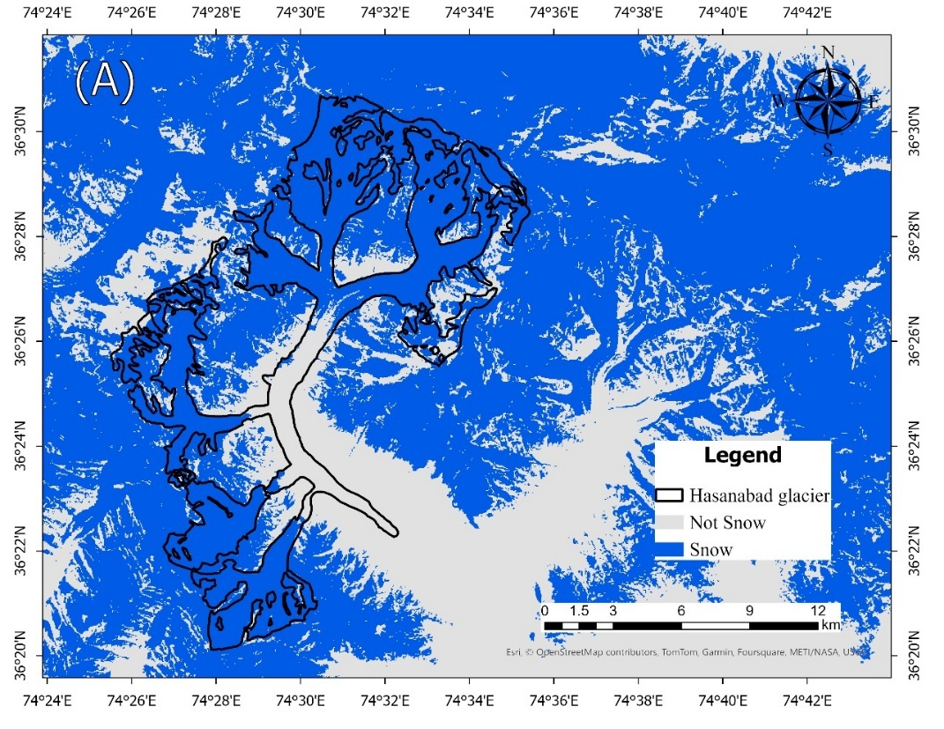
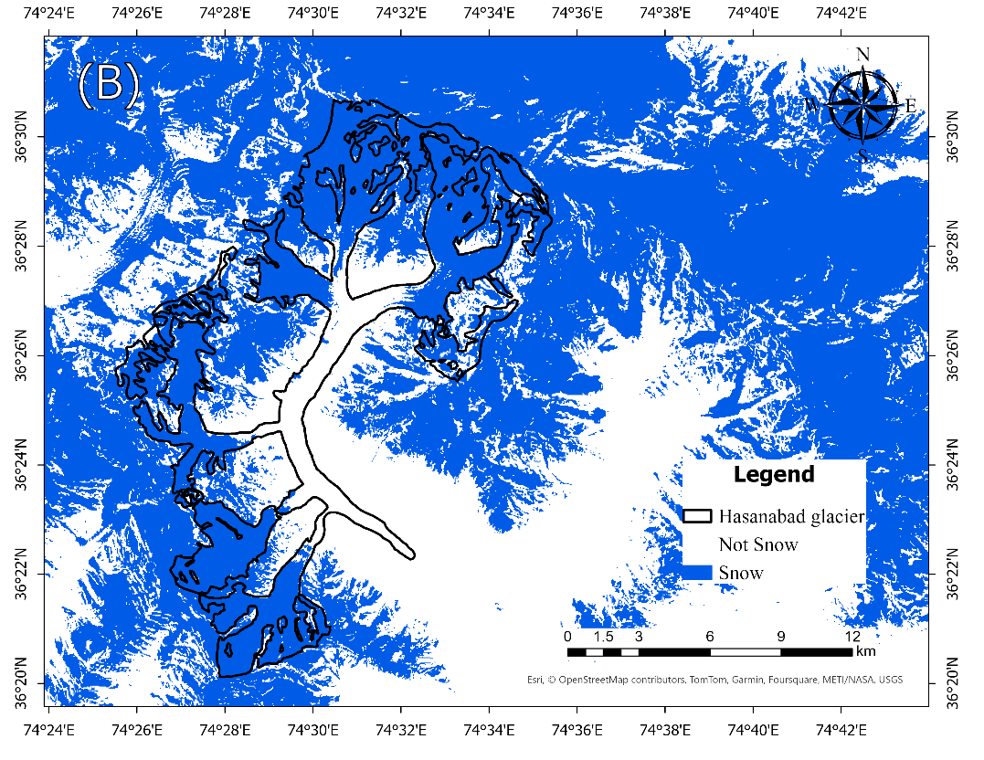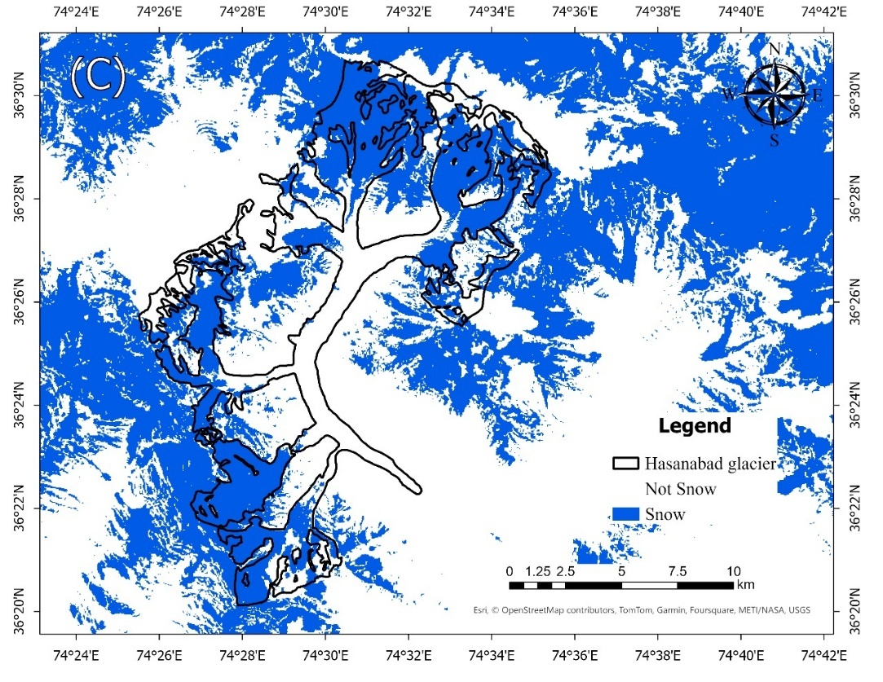
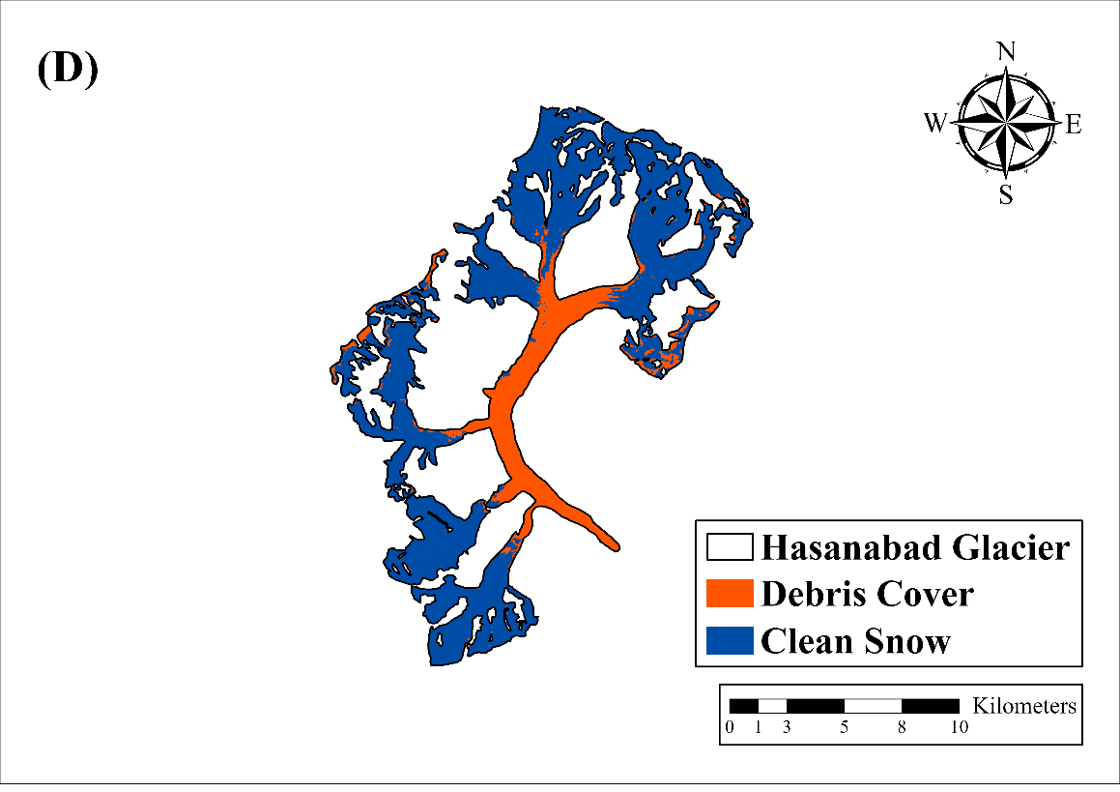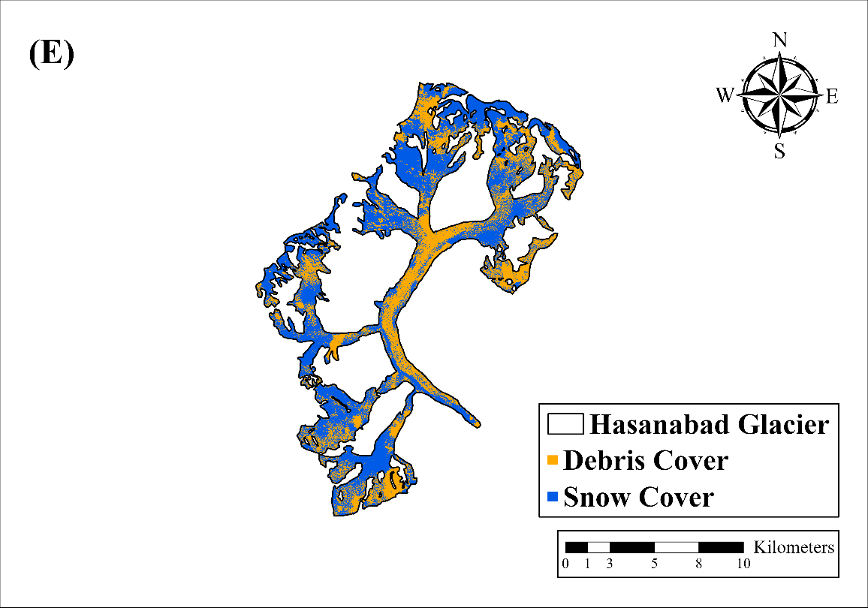
Debris cover mapping using Sentinel-2 data revealed a 5.1% expansion (6.8 km²) of exposed debris on Shisper and Muchowar glaciers between April and May 2022. Enhanced debris coverage lowers albedo, promoting greater solar radiation absorption and localized temperature increases. Land surface temperature (LST) data from Landsat thermal bands corroborated this, showing a sharp rise in surface temperatures from −26.1°C to 32.4°C between mid-April and early May 2022, with anomalies exceeding +12°C in glacier trunk zones. These elevated regions channel meltwater toward the proglacial lake, suggesting that rapid thermal shifts and debris-mediated melting contributed to pre-GLOF instability.
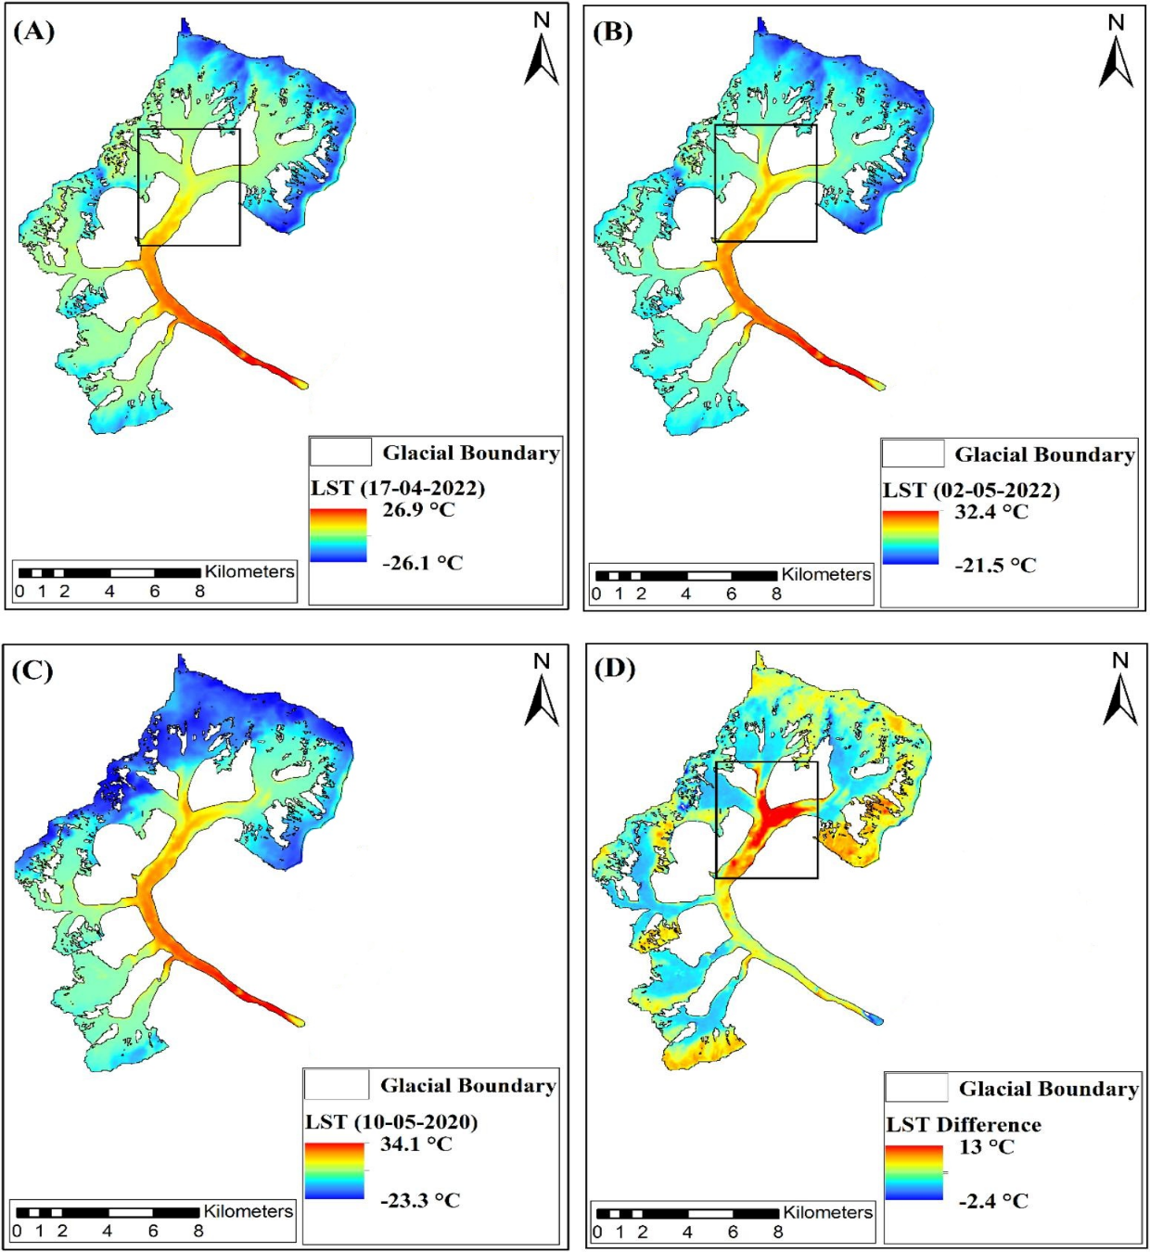
2
Collectively, declining AAR, accelerated snow loss, dust-induced albedo reduction, and abrupt LST increases—particularly during the transition from winter accumulation to ablation phases—likely synergized to trigger the lake outburst. The findings underscore the sensitivity of Karakoram glaciers to coupled climatic and surface processes.

After Effects

The after-effects of a flood event comprise several detectable alterations through satellite remote sensing such as changes in the water quality, flood plains, debris and sediment deposition, etc. Since, the proglacial lake lies close to the human settlements of Hassanabad region, it is essential to conduct a post-event analysis. The first three locations have been considered before the Karakoram highway bridge that collapsed due to the outburst flood. One location has been considered just after the stream crosses the bridge. The last location has been marked at the meltwater stream point of conver- gence with the Hunza river stream.
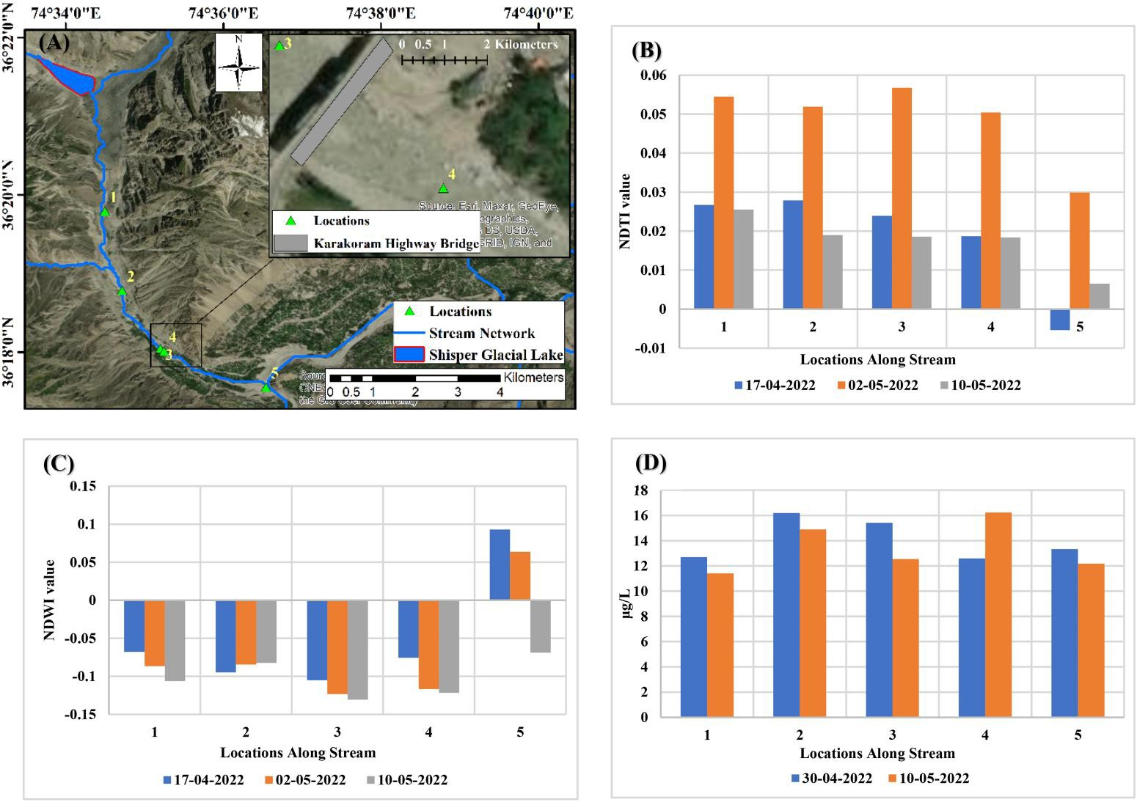
The structural failure of the Karakoram Highway bridge during the glacial lake outburst flood (GLOF) underscores the extreme hydrodynamic forces generated by the event. Pre- and post-flood analysis using the Normalized Difference Turbidity Index (NDTI) revealed significant alterations in stream conditions (Fig. 15B). Prior to the flood, baseline NDTI values along the stream averaged below 0.03, with localized peaks (e.g., at Location 3 upstream of the bridge) reflecting natural sediment dynamics. Post-flood, NDTI values surged across the stream, indicating elevated turbidity linked to increased sediment transport from glacial meltwater and flood-induced erosion. Notably, values stabilized at Location 5, where the stream converges with the Hunza River, suggesting dilution effects.
Concurrent Normalized Difference Water Index (NDWI) data (Fig. 15C) further highlighted water quality degradation. Negative NDWI values upstream (Locations 1–4) prior to the flood indicated sediment-laden flow, transitioning to positive values at Location 5 due to clearer Hunza River contributions. Post-flood, NDWI values at Location 5 shifted to negative, aligning with heightened turbidity observed in NDTI trends. Chlorophyll-a (Chlo-a) concentrations remained below 20 mg/L throughout the stream (Fig. 15D), ruling out biological contamination. Uniformly low Chlo-a levels, coupled with high flow velocities, suggest that sediment load—not organic pollutants—drove water quality decline.
These observations collectively illustrate the flood’s dual impact: intense hydrodynamic forces disrupted sediment equilibrium, while meltwater influx amplified turbidity. The absence of contamination emphasizes the role of physical (rather than chemical) processes in post-GLOF hydrological changes.

Disaster Management Responsibilities

The Geographical Impact of the Shispar Glacier GLOF was most severe in Hassanabad Village, which served as the epicenter of the flood. Karimabad and Central Hunza, located downstream, experienced significant flooding and disruption. While there were no confirmed fatalities, the disaster led to the displacement of families, causing psychological stress and safety concerns. The Loss of Infrastructure was substantial, with the complete destruction of the Hassanabad Bridge, a critical link on the Karakoram Highway (KKH), along with partial damage to connecting roads, hindering transportation. Additionally, irrigation channels were washed away, severely impacting local agriculture. The Economic Damages included the destruction of agricultural lands and orchards, disruption of local trade due to transportation issues, and a decline in tourism, which is a vital economic sector for the Hunza Valley.
To address such disasters, a Disaster Management Cycle is essential. Preparedness measures include installing automated weather and glacier monitoring stations, developing a real-time GLOF alert system, conducting community disaster response drills, and stockpiling emergency supplies while designating evacuation routes and safe zones. During the Response Phase, immediate actions must focus on evacuating affected populations, deploying rescue teams, providing first aid and temporary shelter, and restoring communication networks for efficient coordination. Recovery efforts should include the reconstruction of the Hassanabad Bridge and damaged roads, restoration of irrigation systems, and financial assistance to affected families. Long-term recovery should focus on reestablishing tourism and trade, along with implementing community-based livelihood projects to reduce economic vulnerability. For Mitigation, structural measures such as flood barriers, diversion channels, and climate-resilient infrastructure should be implemented, while non-structural strategies must include glacial and hydrological monitoring, land-use policies for high-risk areas, and afforestation programs to minimize soil erosion and stabilize land.

8. Conclusion:
Based on the detailed analysis, it can be concluded that a noticeable reduction in the snow cover within a short span of time (within weeks) has led to increased expos- ure of debris within the glaciers that might have resulted in increased absorption of solar radiation by the glacial bodies. High absorption of solar radiation could be related to the increase in surface temperature of glaciers, thus leading to enhanced melting. As the meltwater of the Shisper glacier feeds a proglacial lake located at its snout, a sudden increase in the meltwater contribution might have led to increased pressure over the ice-dammed structure confining the lake water and thus breaching.
The May 2022 GLOF event from the Shishper Glacier underscores the urgent need for a proactive disaster management approach. By implementing an effect disaster management plan, Gilgit-Baltistan can enhance its resilience to future GLOFs and protect its communities, infrastructure, and economic stability.

References
- Singh, H., Varade, D., Van Wyk de Vries, M., Adhikari, K., Rawat, M., Awasthi, S., & Rawat, D. (2023). Assessment of potential present and future glacial lake outburst flood hazard in the Hunza valley: A case study of Shisper and Mochowar glacier. Science of the Total Environment, 868, 161717.
- Thompson, I., Shrestha, M., Chhetri, N., & Agusdinata, D. B. (2020). An institutional analysis of glacial floods and disaster risk management in the Nepal Himalaya. International Journal of Disaster Risk Reduction, 47, 101567.
- Frey, H., Huggel, C., Bühler, Y., Buis, D., Burga, M. D., Choquevilca, W., ... & Walser, M. (2016). A robust debris-flow and GLOF risk management strategy for a data-scarce catchment in Santa Teresa, Peru. Landslides, 13, 1493-1507.
- Hewitt, K., Wake, C. P., Young, G. J., & David, C. (1989). Hydrological Investigations at Biafo Glacier, Karakoram Range, Himalaya; an Important Source of Water for the Indus River. Annals of Glaciology, 13, 103–108. doi:10.3189/S0260305500007710
- Khan, G., Ali, S., Xiangke, X., Qureshi, J. A., Ali, M., & Karim, I. (2021). Expansion of Shishper Glacier lake and recent glacier lake outburst flood (GLOF), Gilgit-Baltistan, Pakistan. Environmental Science and Pollution Research, 28, 20290-20298.
- Ali, M. (2024). Assessing climate-driven impacts on Karakoram glacier surge: A geospatial analysis highlighting Shishper Glacial Lake outburst flood events (2019–2022) as a prime example. Heliyon,
- Ashraf, A., Naz, R., & Roohi, R. (2012). Glacial lake outburst flood hazards in Hindukush, Karakoram and Himalayan Ranges of Pakistan: implications and risk analysis. Geomatics, Natural Hazards and Risk, 3(2), 113-132.
- Frantzova, A. (2010, June). Remote sensing, GIS and Disaster management. In Third International Conference on Cartography and GIS. Nessebar, Bulgaria.
- Van Westen, C. J. (2000). Remote sensing for natural disaster management. International archives of photogrammetry and remote sensing, 33(B7/4; PART 7), 1609-1617.

