

Web GIS Lab 04: Getting started with GeoDjango

Name: Muhammad Taimoor Ashfaq Malik
Reg No: 537980
Course: Web GIS
Instructor: Dr. Shahid Nawaz Khan

Part 1: Python and a first Django project

1.1 Check for Python
Python 3.14.7 was already installed from python.org, so no installer was needed. py --list shows one version, 3.14 (64-bit), and where.exe python lists the python.org copy first, ahead of the Microsoft Store alias.
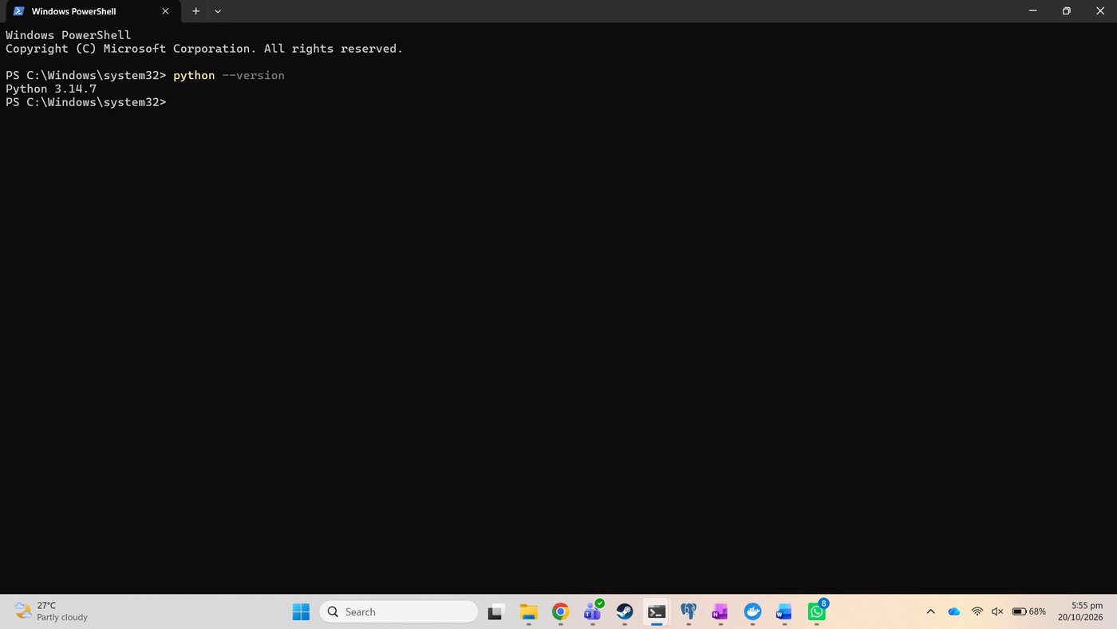
Figure 1. python --version: Python 3.14.7
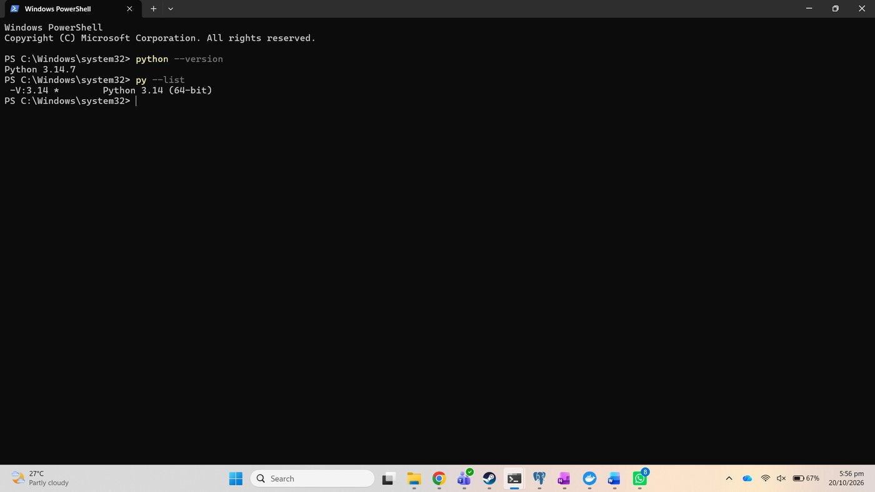
Figure 2. py --list
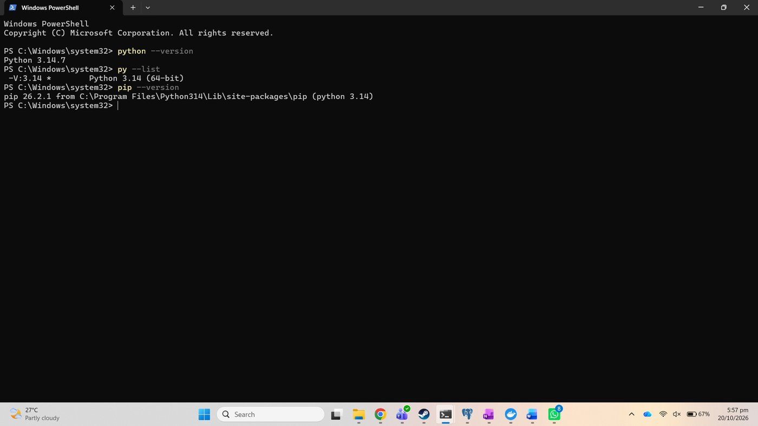
Figure 3. pip --version, from Python 3.14
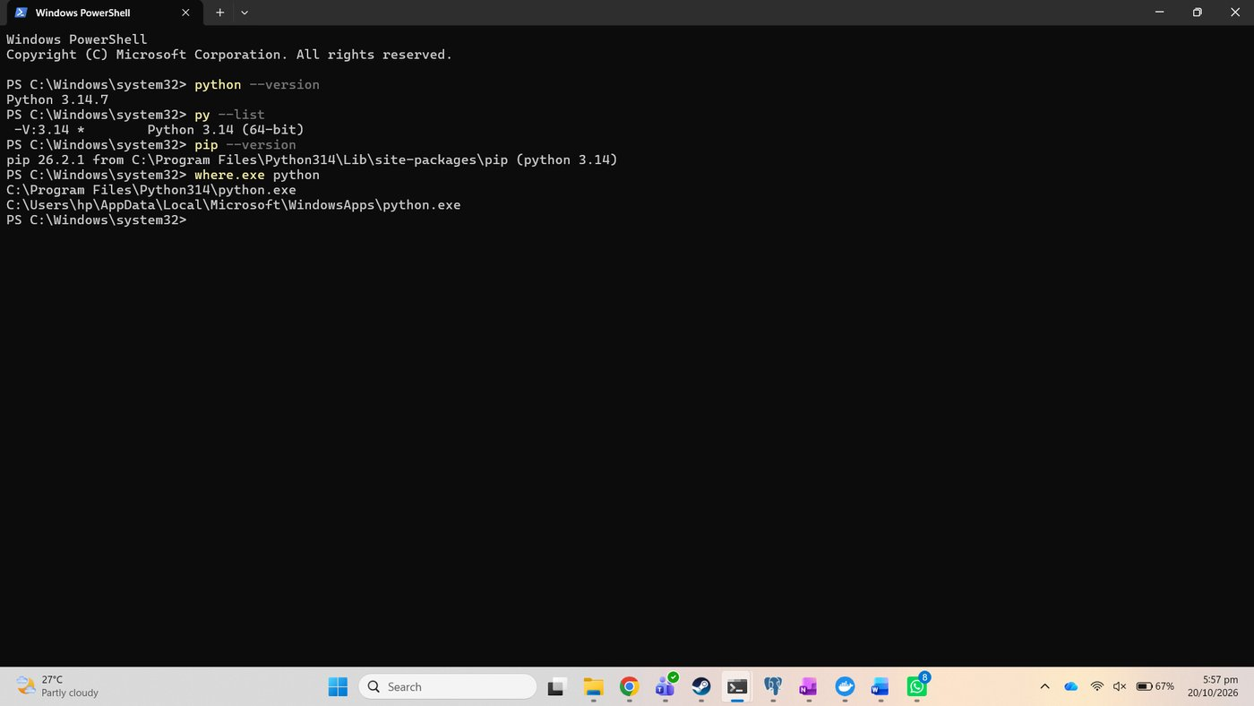
Figure 4. where.exe python: the python.org copy comes first

1.2 Create the project folder and a virtual environment
The project lives in the course folder as Lab 4, next to the earlier labs; the repository copy is the lab4 folder of webgis-lab-537980.
mkdir "Lab 4"
cd "Lab 4"
python -m venv venv
.\venv\Scripts\Activate.ps1

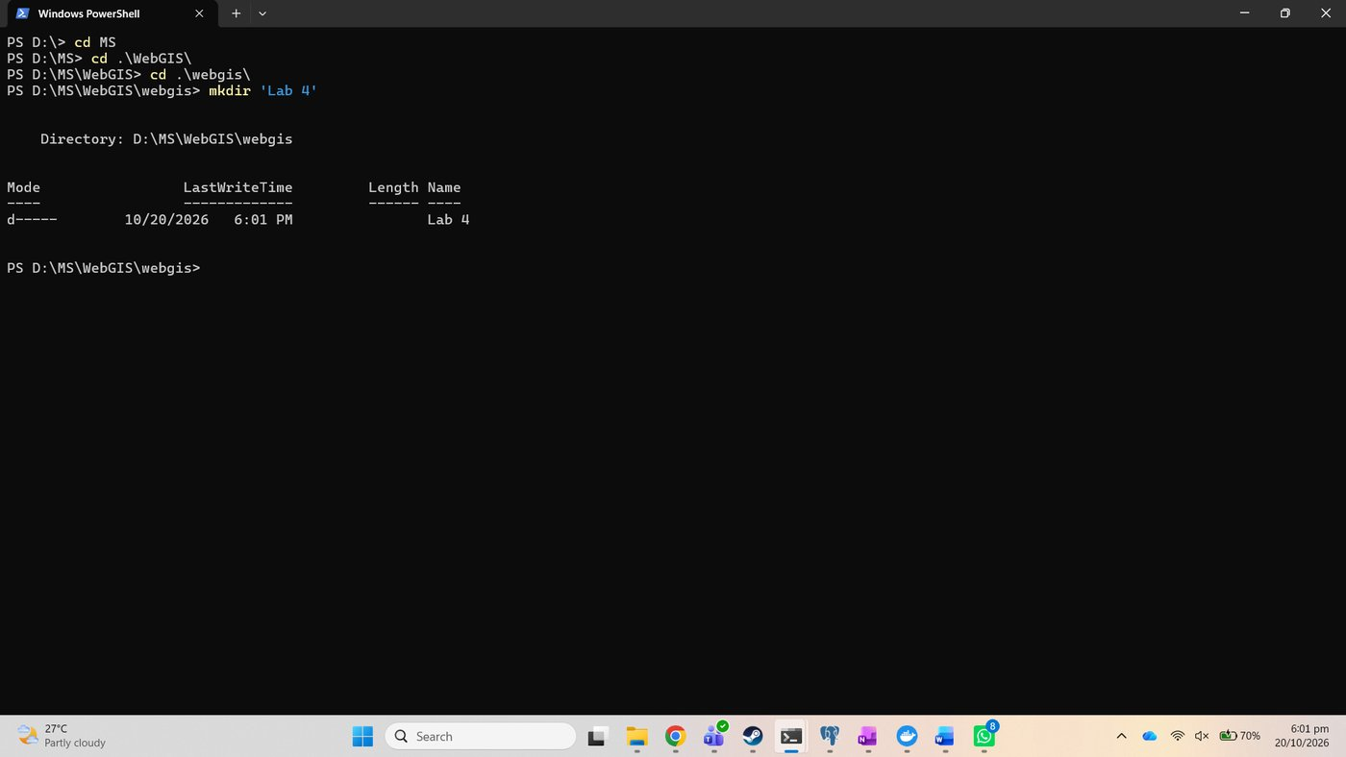
Figure 5. mkdir Lab 4
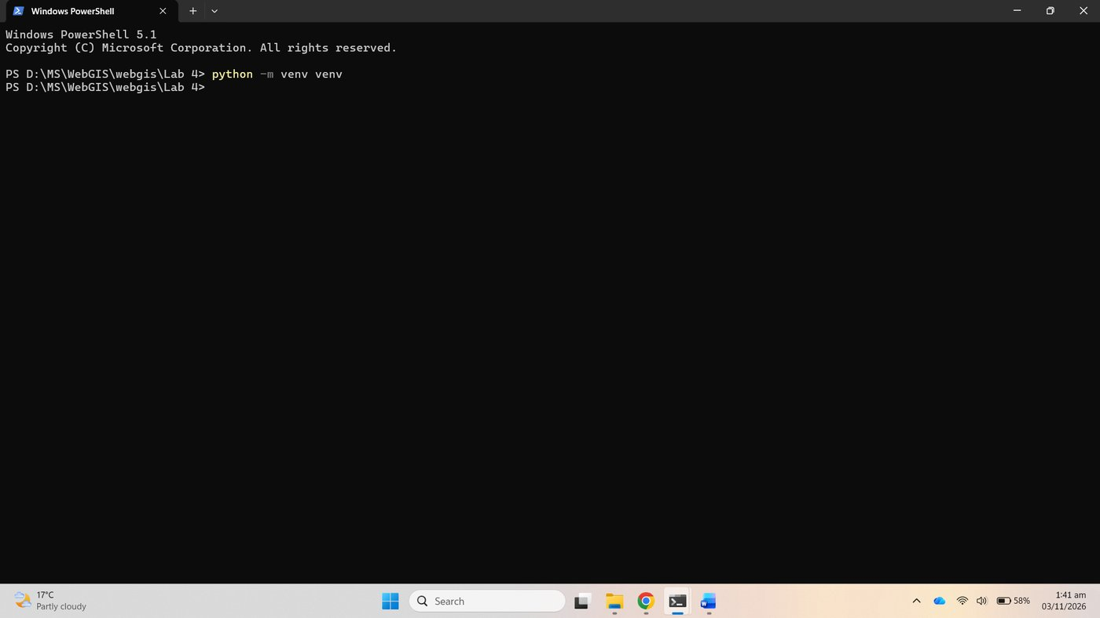
Figure 6. python -m venv venv
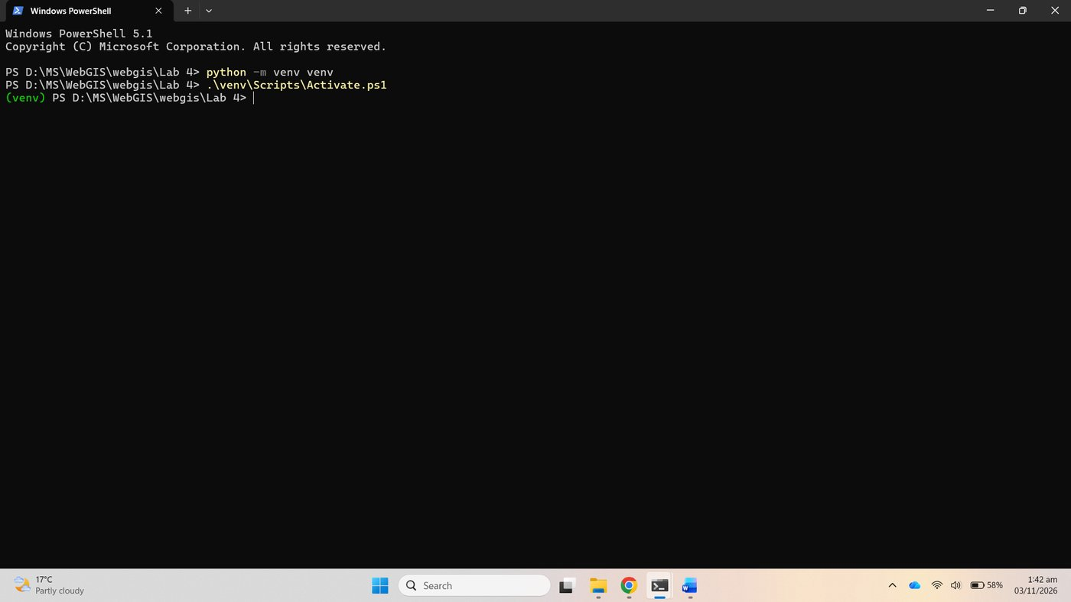
Figure 7. Activate.ps1: the prompt now starts with (venv)

1.3 Install Django and the PostgreSQL driver
pip install django "psycopg[binary]"
pip freeze > requirements.txt
python -m django --version

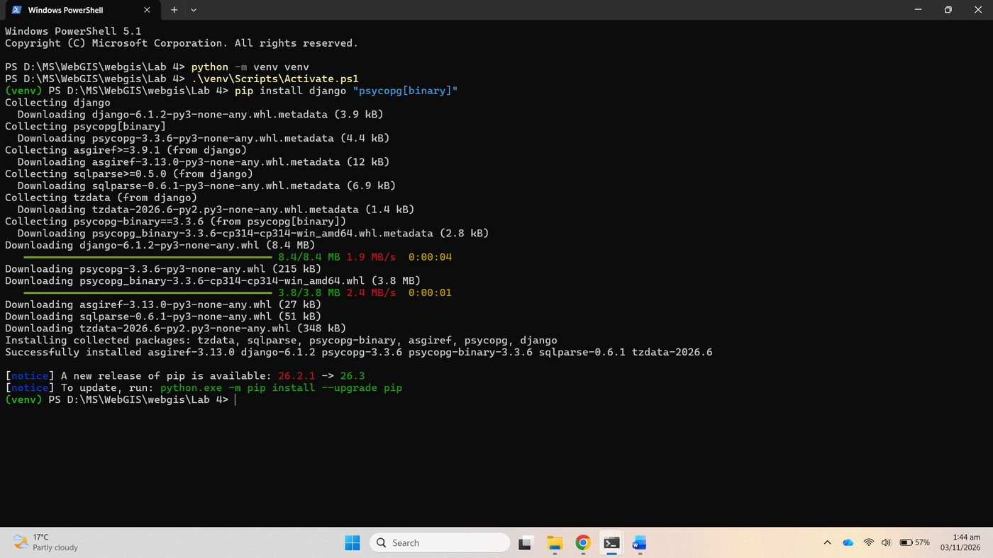
Figure 8. pip install django psycopg[binary]
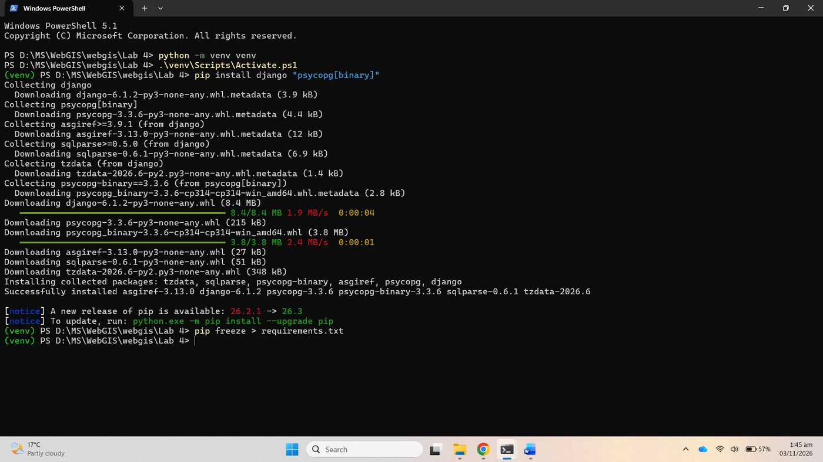
Figure 9. pip freeze > requirements.txt
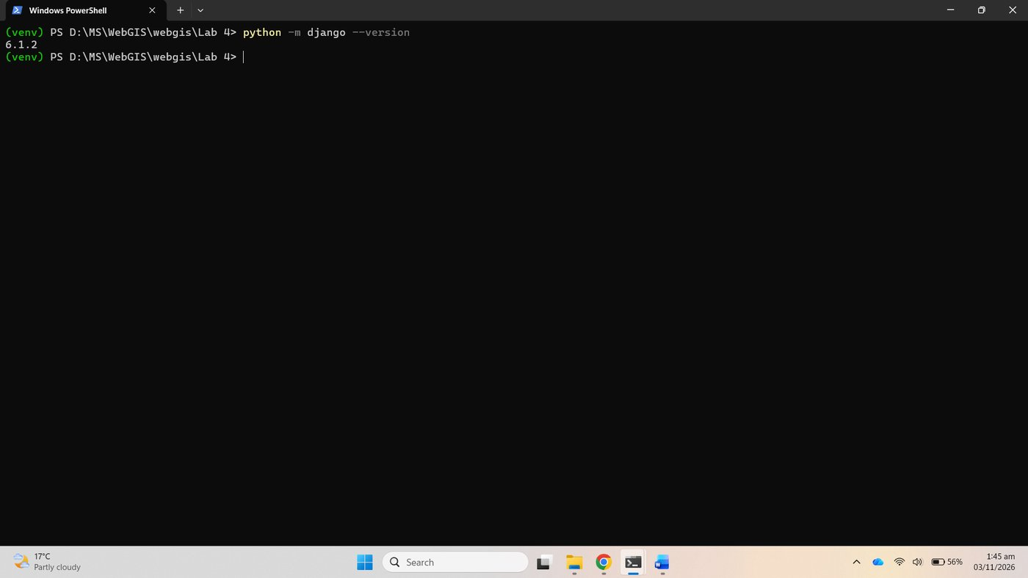
Figure 10. python -m django --version: 6.1.2

1.4 Start a project and an app
django-admin startproject webgis .
python manage.py startapp districts

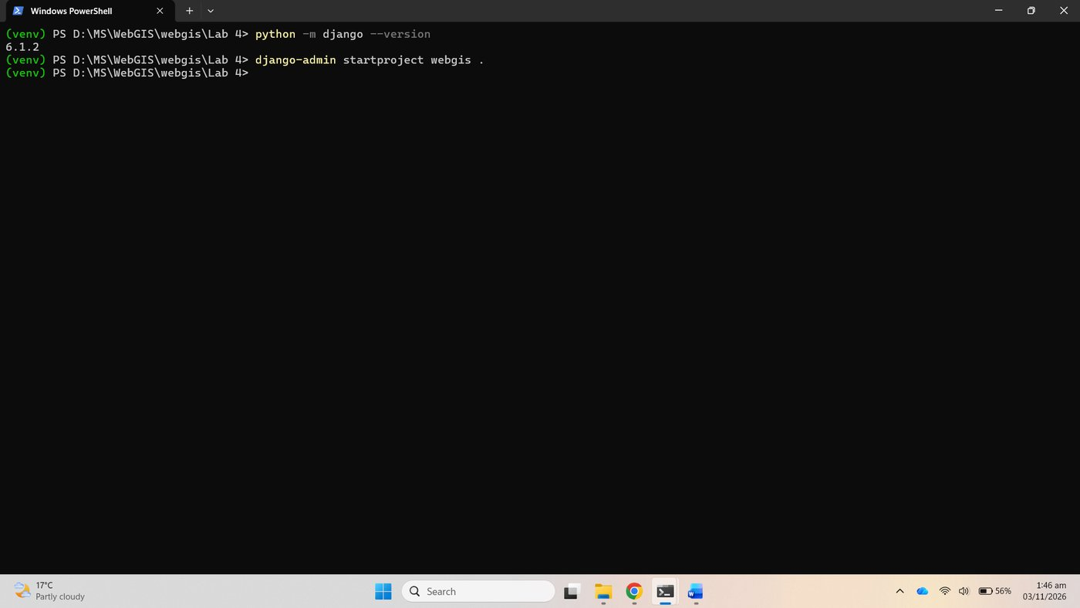
Figure 11. django-admin startproject webgis .
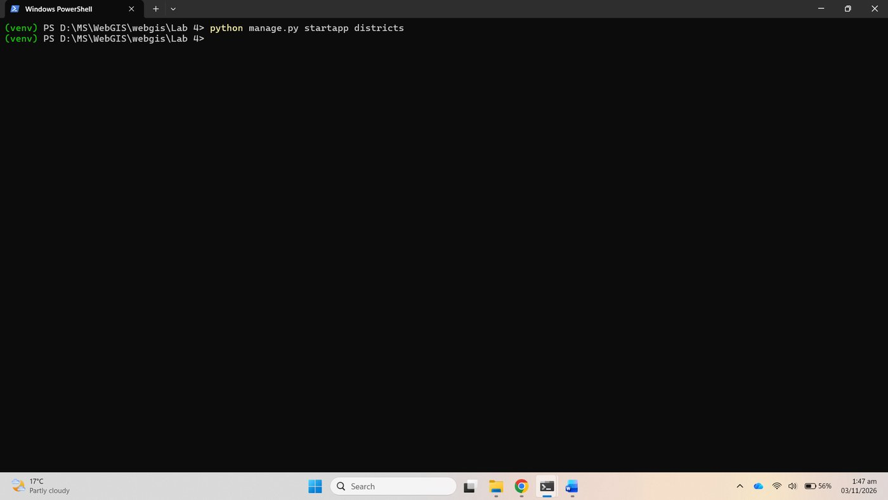
Figure 12. python manage.py startapp districts

1.5 Run it
migrate created the default SQLite database and runserver started the development server on port 8000.
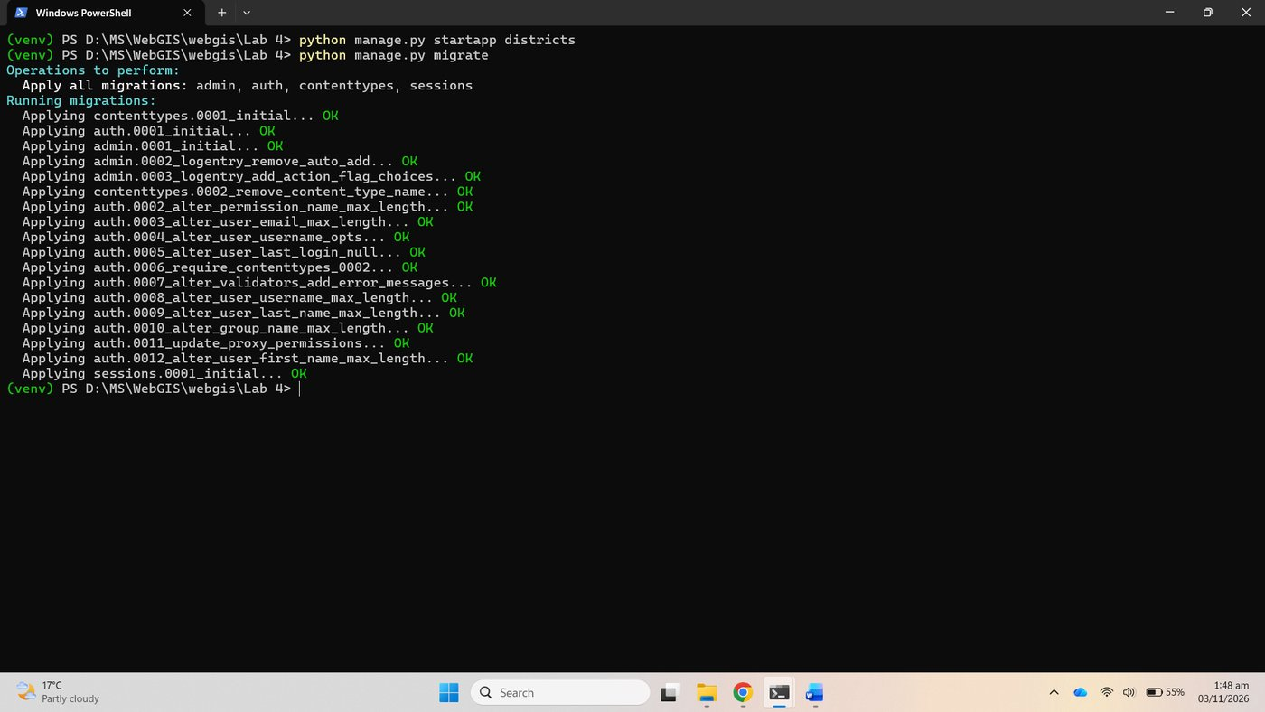
Figure 13. python manage.py migrate, SQLite
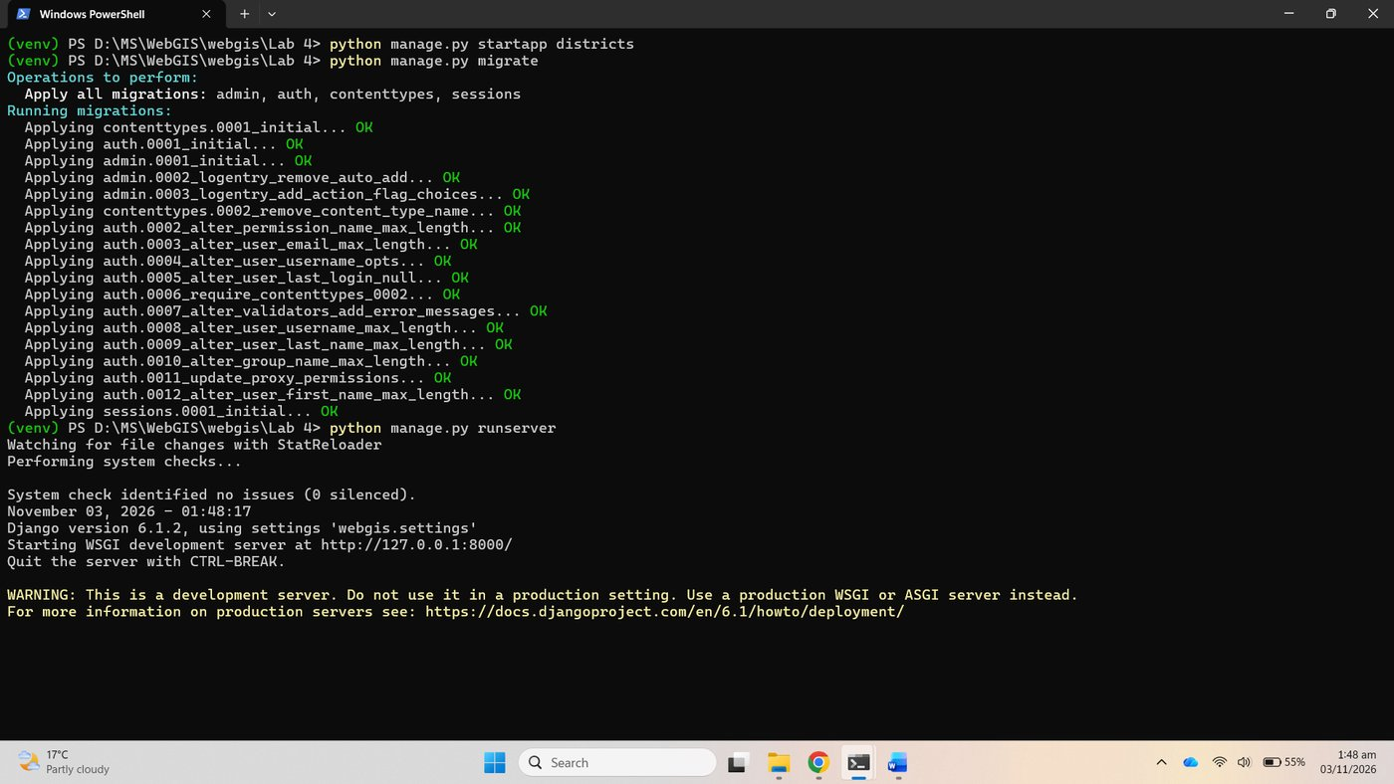
Figure 14. python manage.py runserver

Checkpoint 1
The "install worked" page at 127.0.0.1:8000, with Django 6.1.2 reported by python -m django --version above.
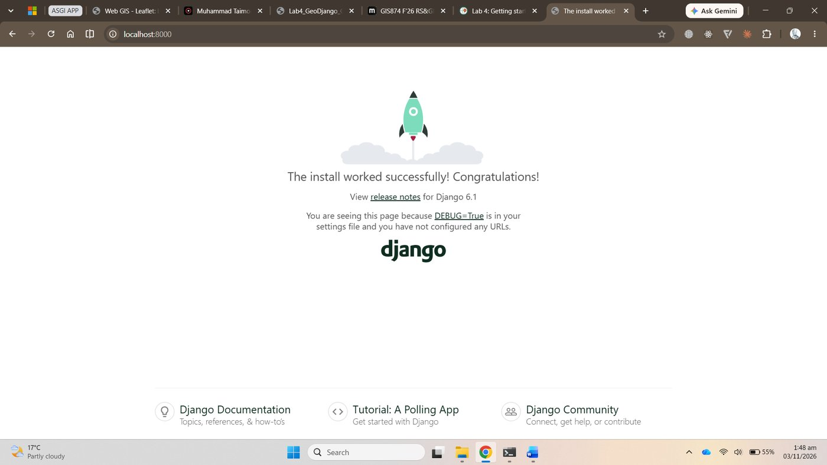
Figure 15. Checkpoint 1: the install worked page
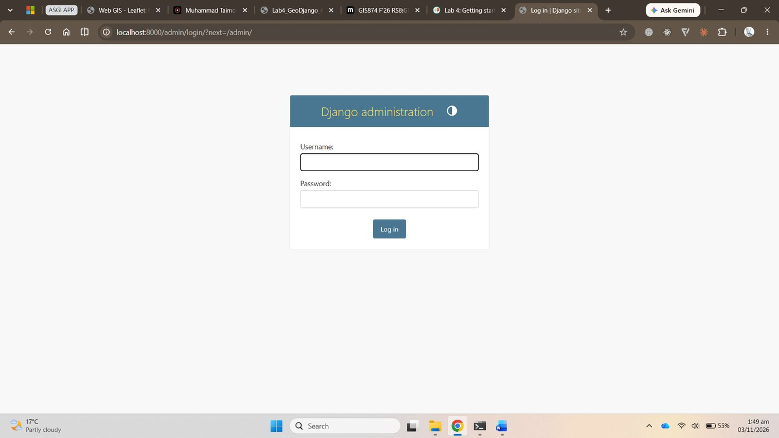
Figure 16. The admin login page at /admin/, no user yet
The server was stopped and db.sqlite3 deleted, because SQLite cannot store geometry properly.
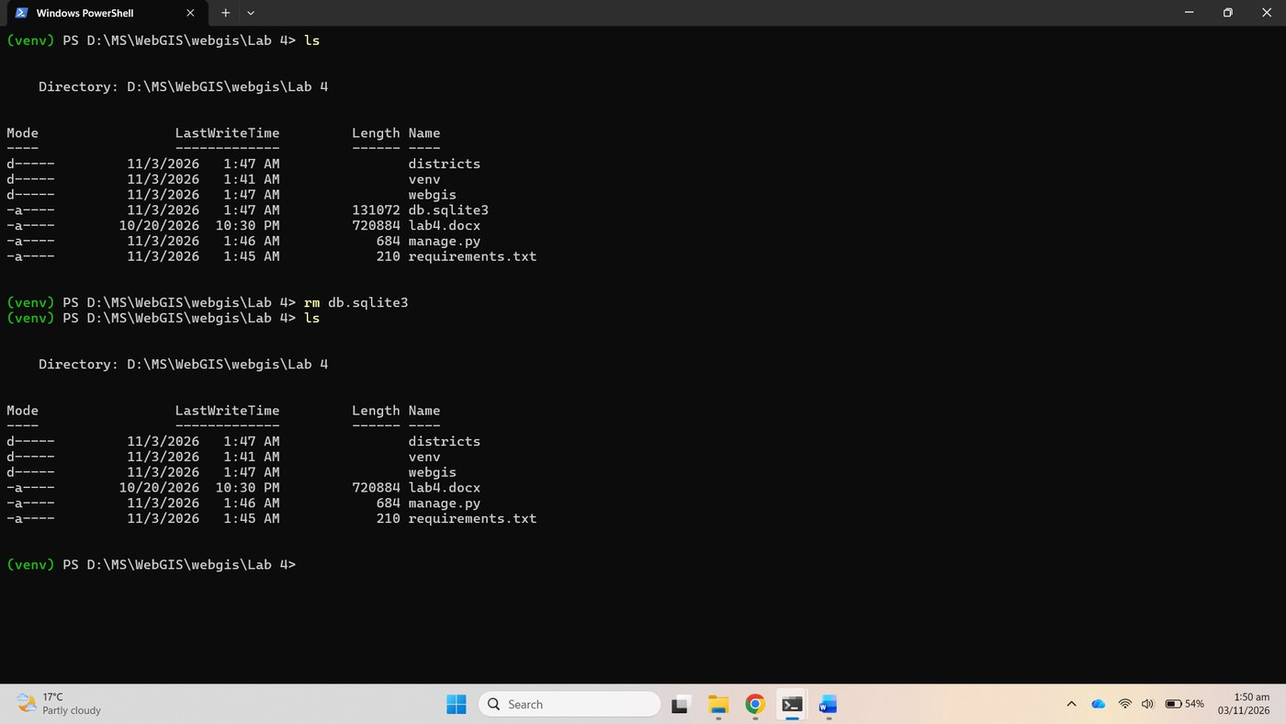
Figure 17. db.sqlite3 removed

Part 2: Install PostgreSQL and PostGIS
PostgreSQL 18 and the PostGIS 3.6 bundle were already installed on this machine from Stack Builder, with pgAdmin 4 and the command-line tools. The service postgresql-x64-18 runs on port 5432.

2.3 Create a spatial database
In pgAdmin, Databases, Create, Database, named webgis; then in the Query Tool:
CREATE EXTENSION postgis;
SELECT postgis_full_version();

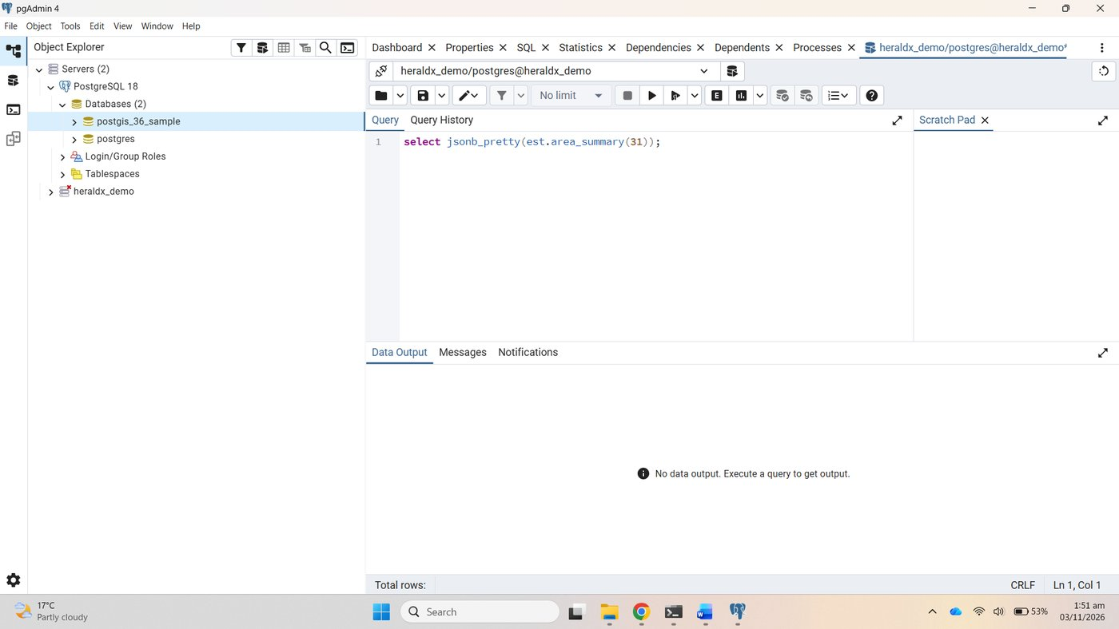
Figure 18. pgAdmin connected to PostgreSQL 18
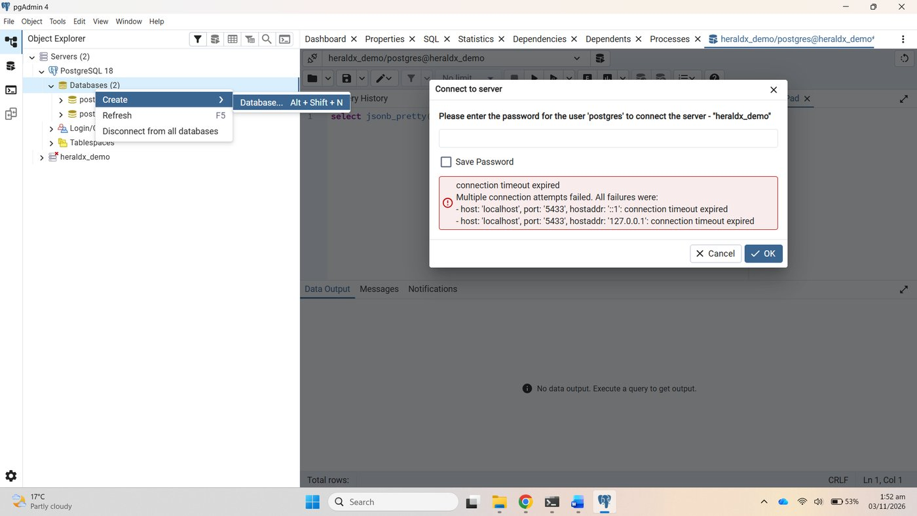
Figure 19. Databases, Create, Database
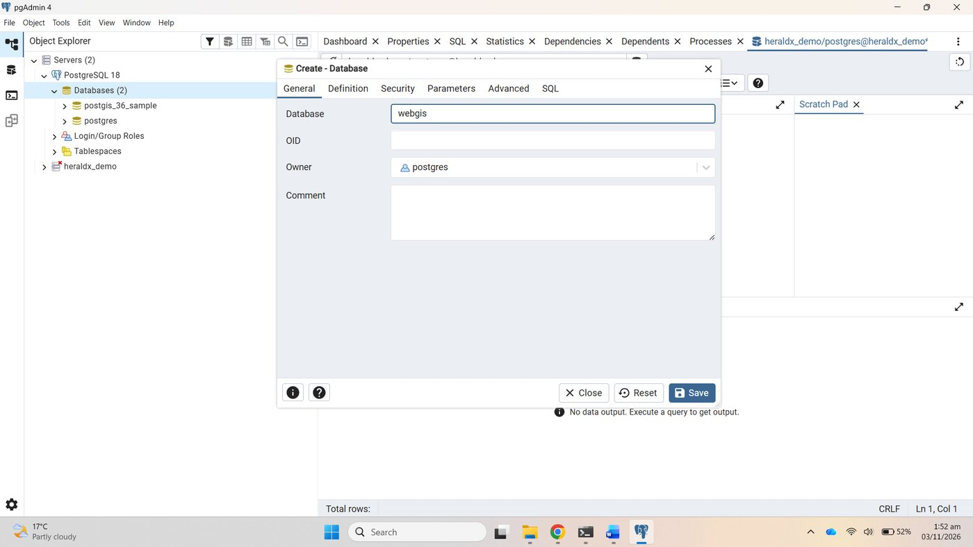
Figure 20. The new database named webgis
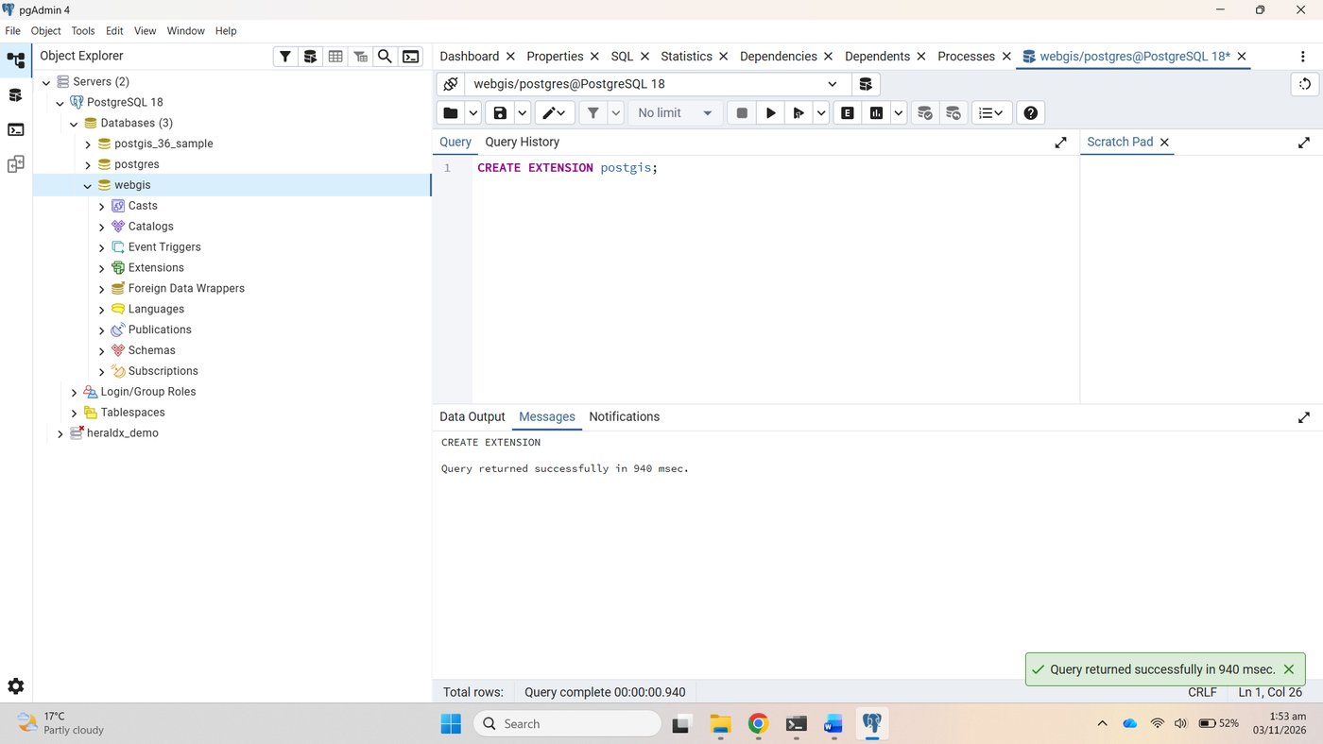
Figure 21. CREATE EXTENSION postgis

Checkpoint 2
postgis_full_version() returns one line listing PostGIS 3.6.2, PostgreSQL 18, GEOS 3.14.1 and PROJ 8.2.1: proof that the database can hold geometry.
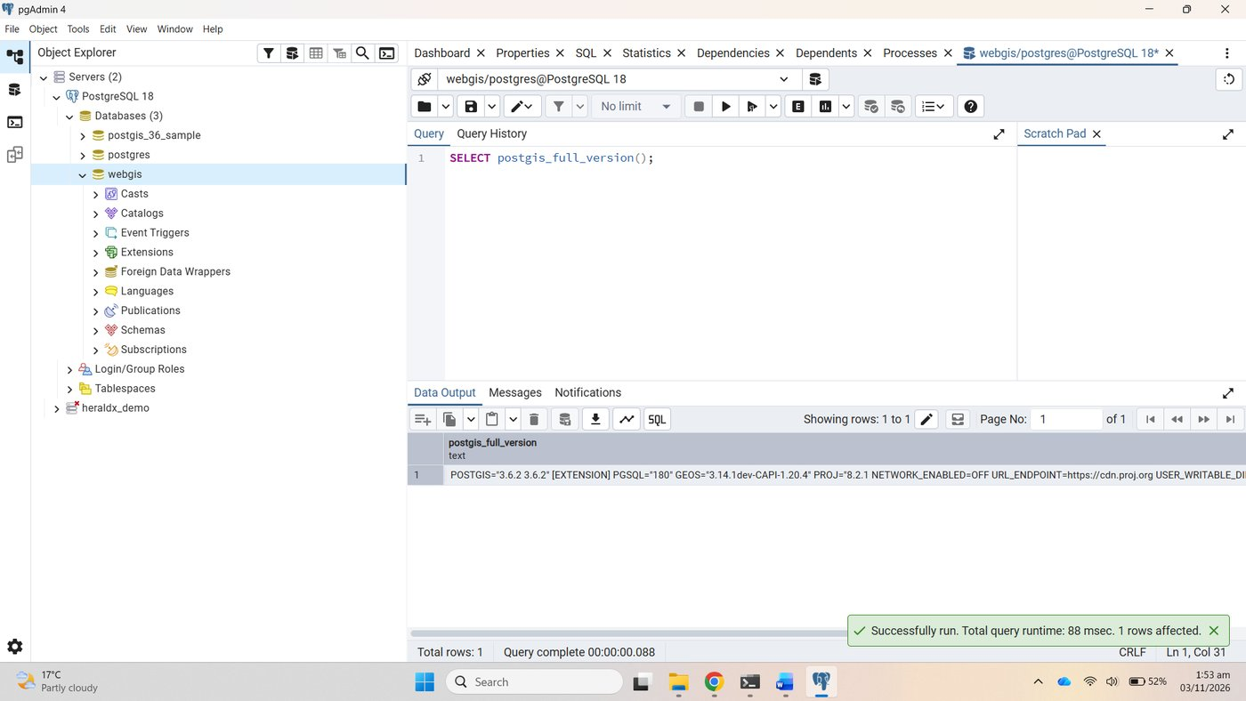
Figure 22. Checkpoint 2: postgis_full_version() in the webgis database

Part 3: Connect Django to PostGIS

3.1 GDAL, GEOS and PROJ
OSGeo4W was already installed at C:\OSGeo4W for Lab 2, with GDAL, so nothing new was needed.

3.2 Store the password outside the code
setx WEBGIS_DB_PASSWORD "..."

The variable is saved for every new window, so the terminal was closed, reopened and the environment activated again.
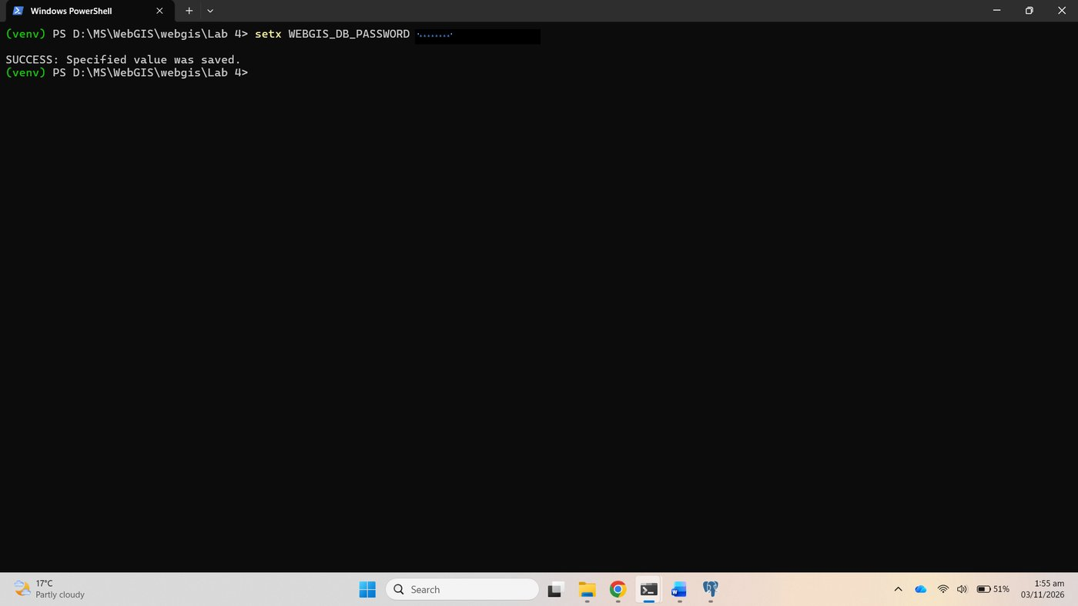
Figure 23. setx WEBGIS_DB_PASSWORD
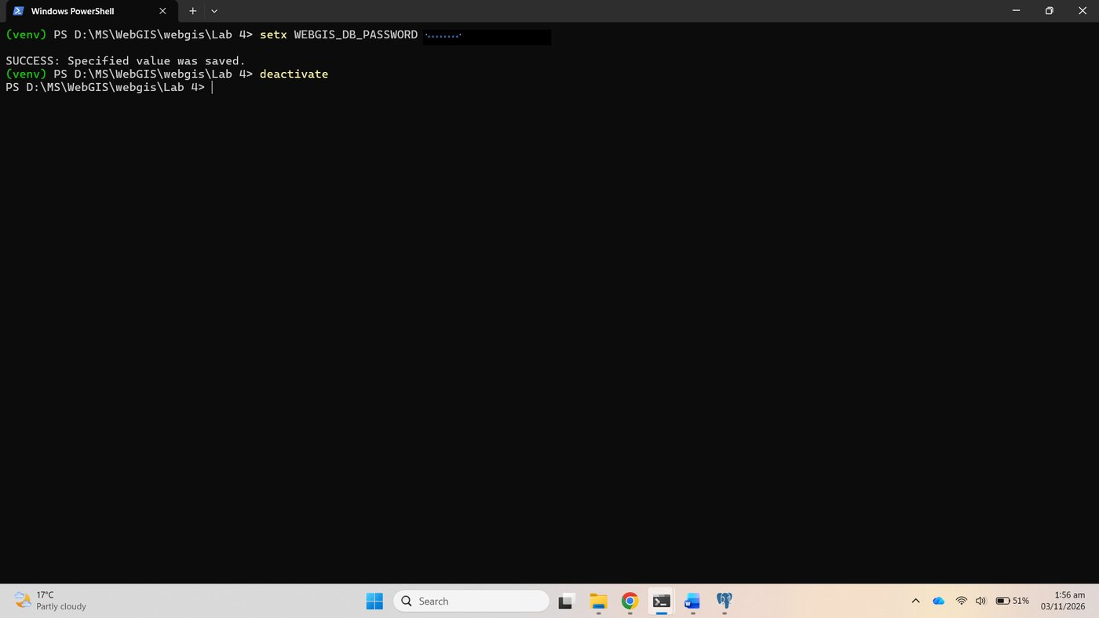
Figure 24. setx confirmed, then deactivate
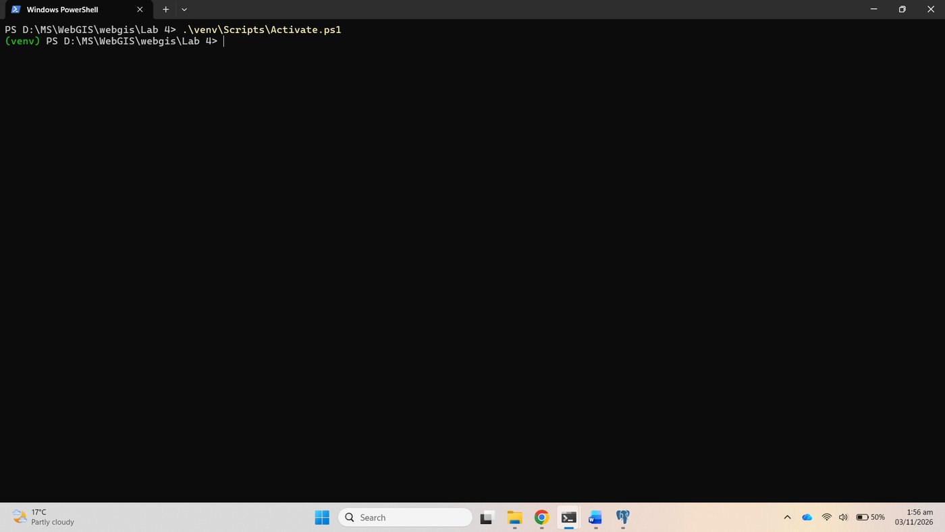
Figure 25. A new window, environment activated again

3.3 Edit the settings
The three changes to webgis/settings.py: the OSGeo4W block below BASE_DIR, django.contrib.gis and districts in INSTALLED_APPS, and the PostGIS DATABASES entry whose password comes from the environment variable.
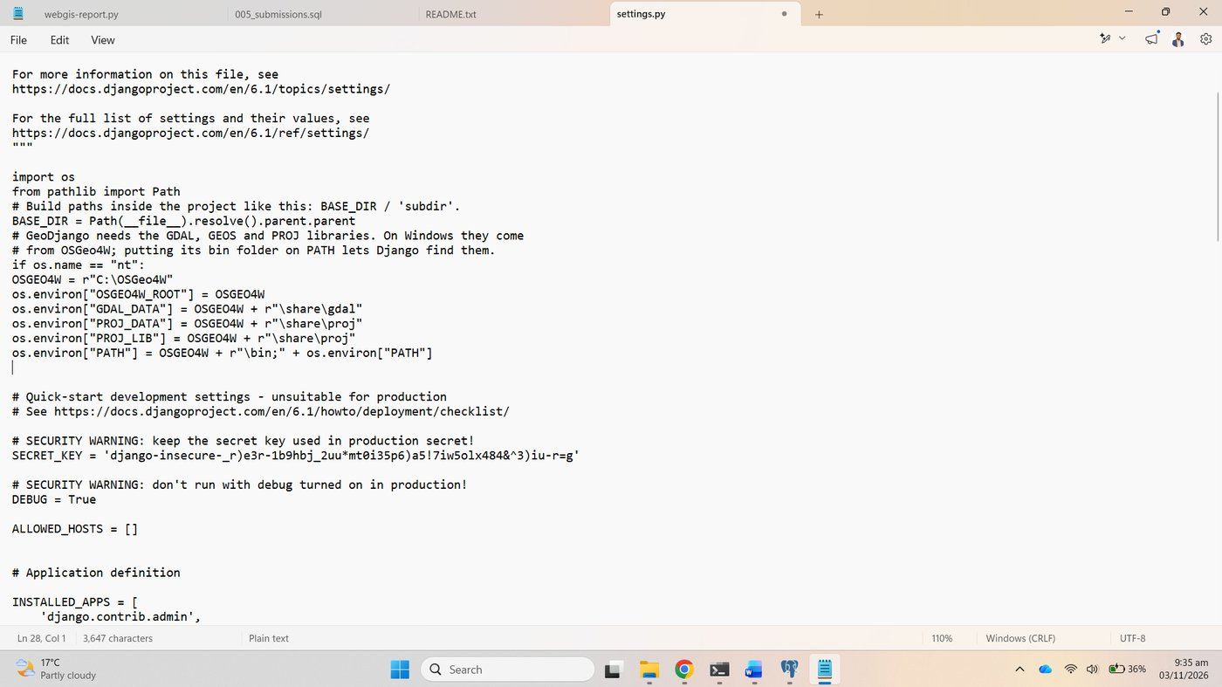
Figure 26. settings.py: OSGeo4W paths
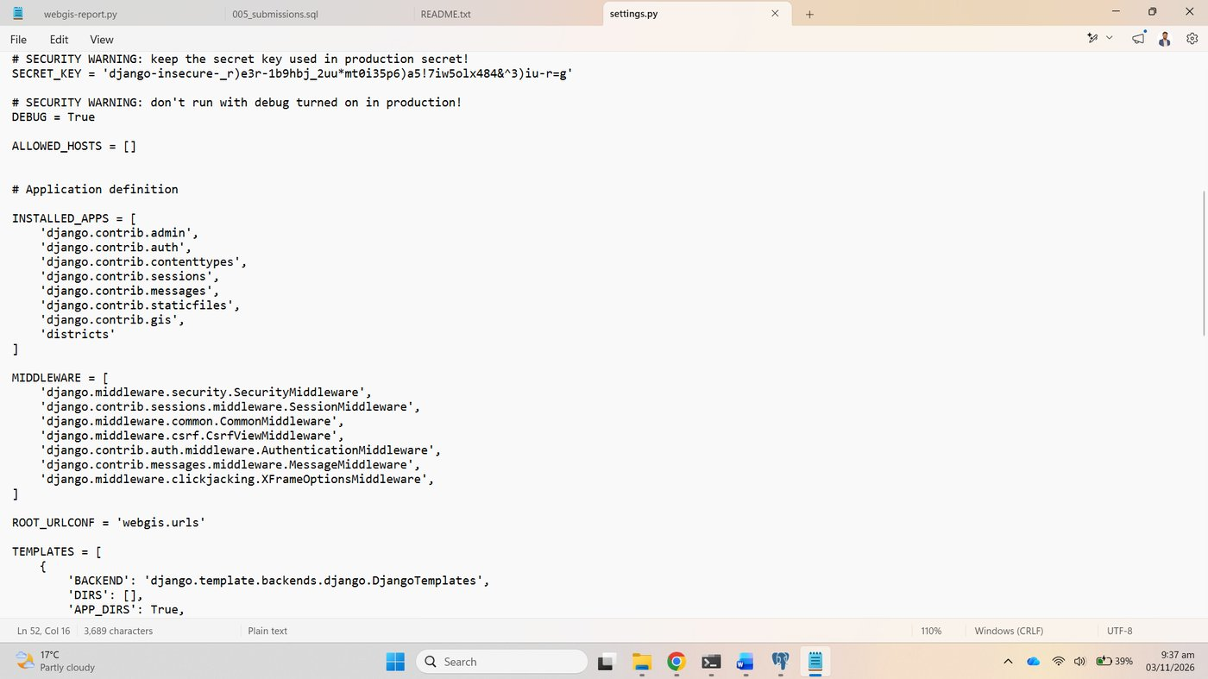
Figure 27. settings.py: INSTALLED_APPS with django.contrib.gis and districts
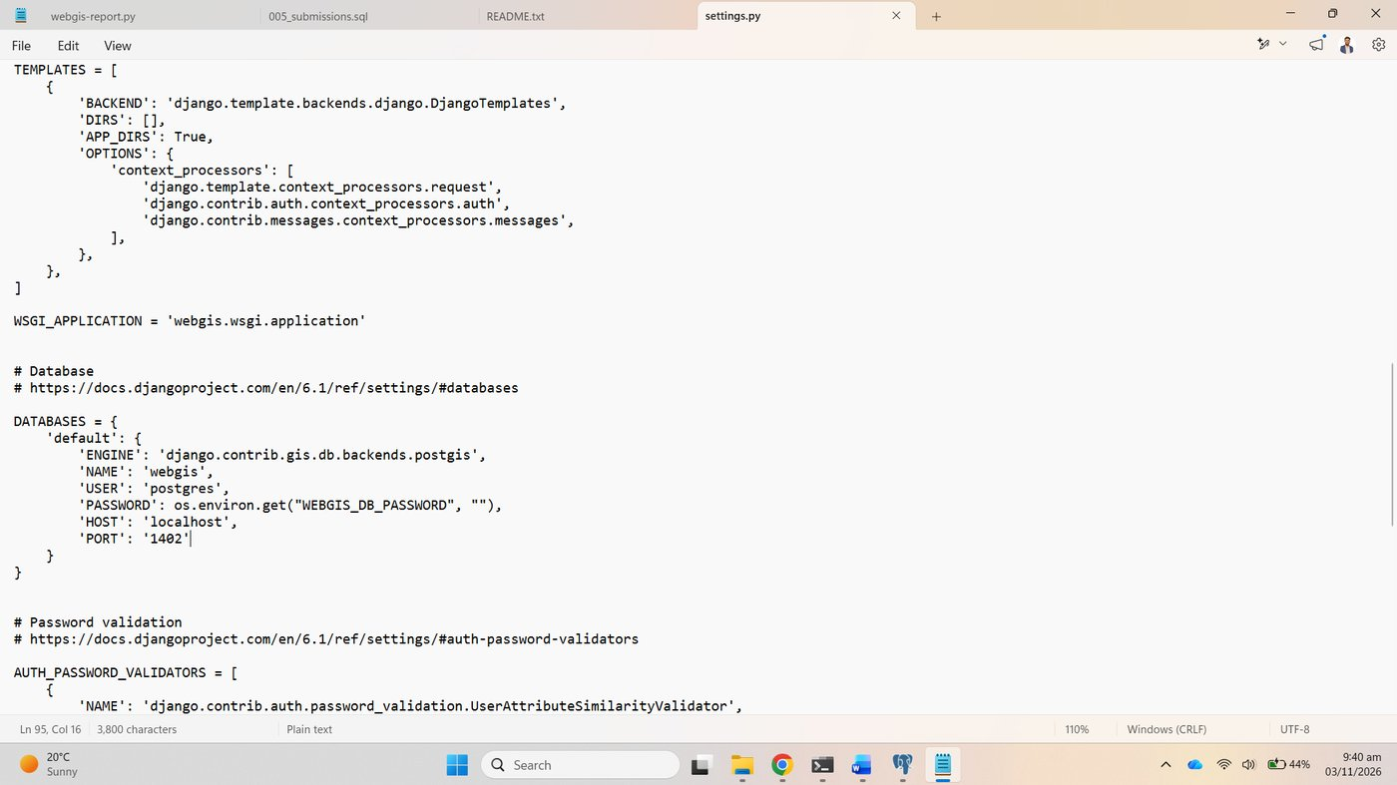
Figure 28. settings.py: DATABASES pointing at PostGIS

3.4 Check each piece separately
python manage.py shell -c "from django.contrib.gis import gdal, geos; print(gdal.gdal_version(), geos.geos_version())"
python manage.py check
python manage.py migrate

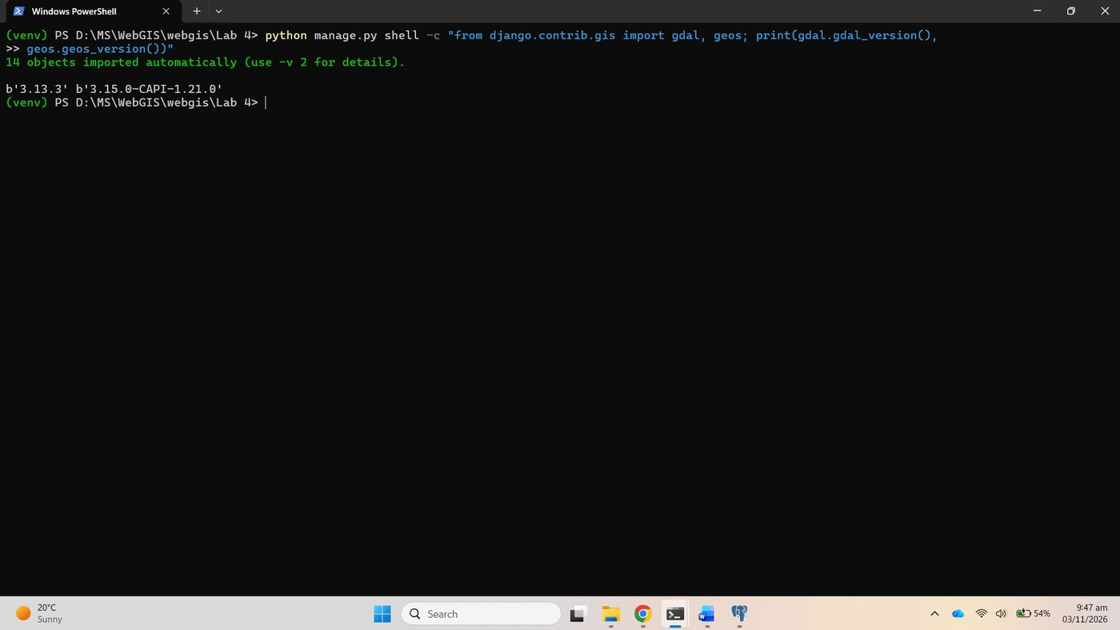
Figure 29. GDAL 3.13.3 and GEOS 3.15.0 loaded by Python
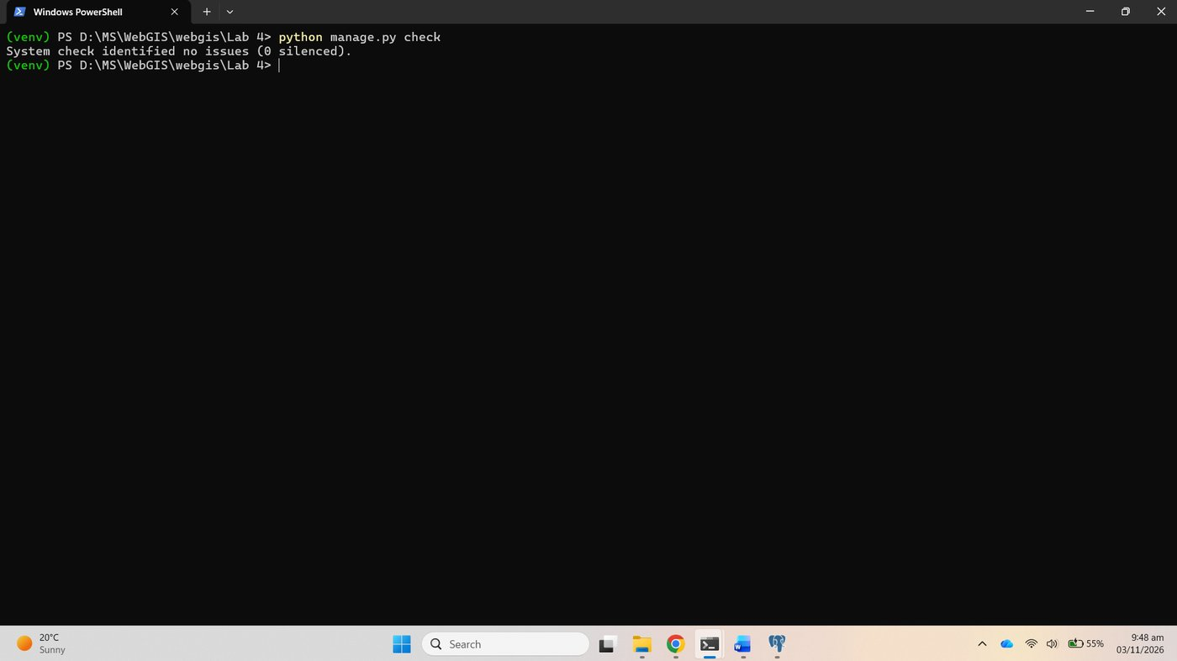
Figure 30. manage.py check: no issues

Checkpoint 3
migrate logged in to PostGIS and created Django's own tables there.
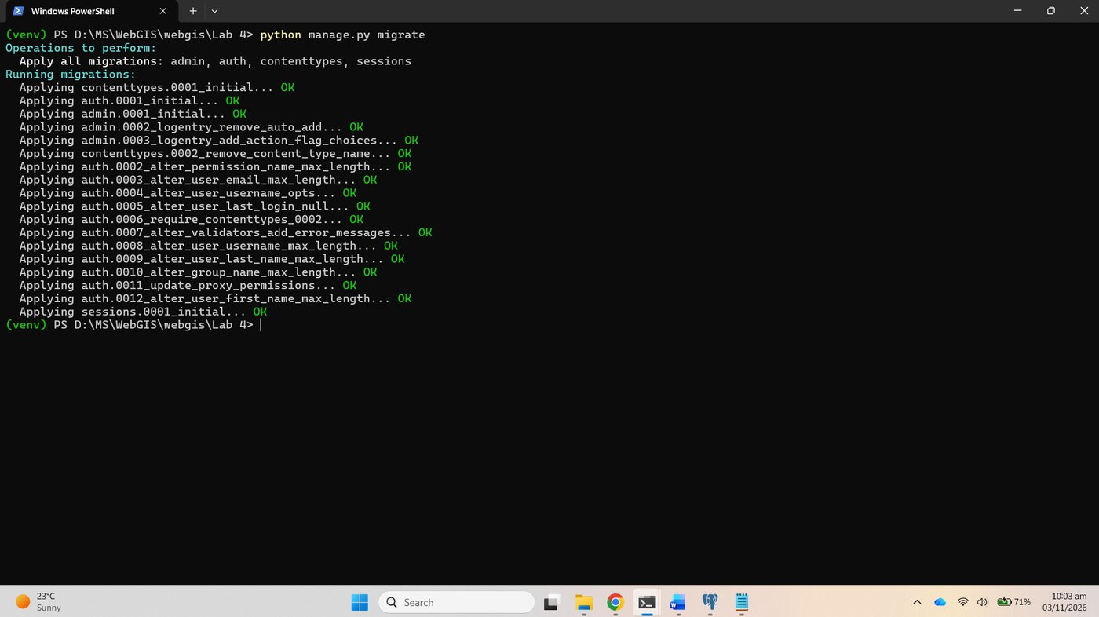
Figure 31. Checkpoint 3: migrate against PostGIS

Part 4: A model with a geometry

4.1 The model
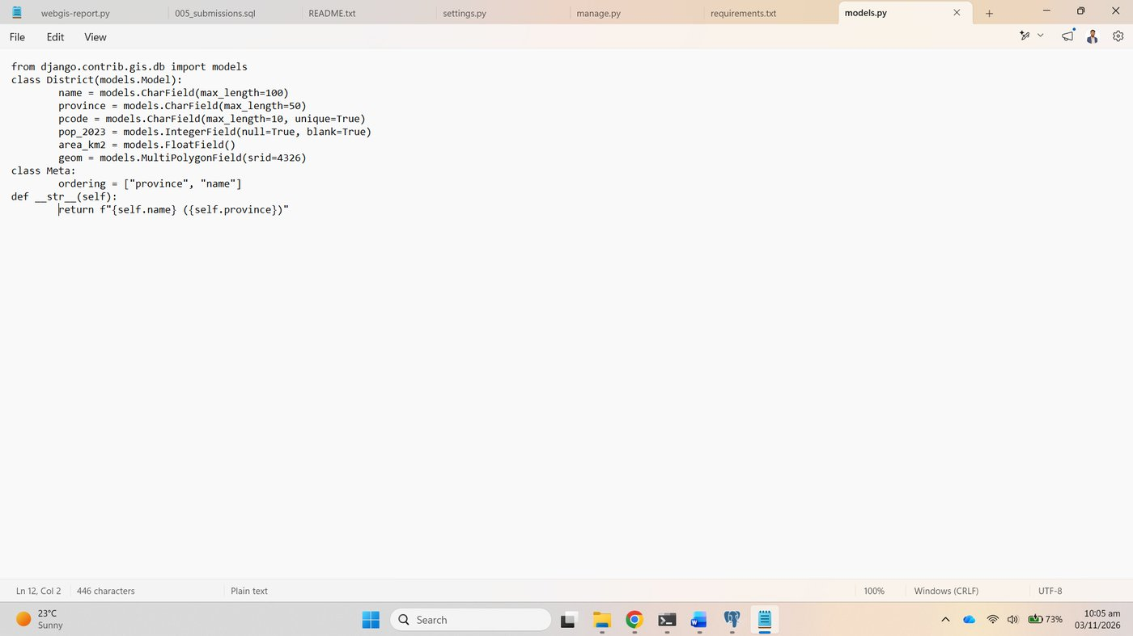
Figure 32. districts/models.py

4.2 From model to table
python manage.py makemigrations districts
python manage.py sqlmigrate districts 0001
python manage.py migrate

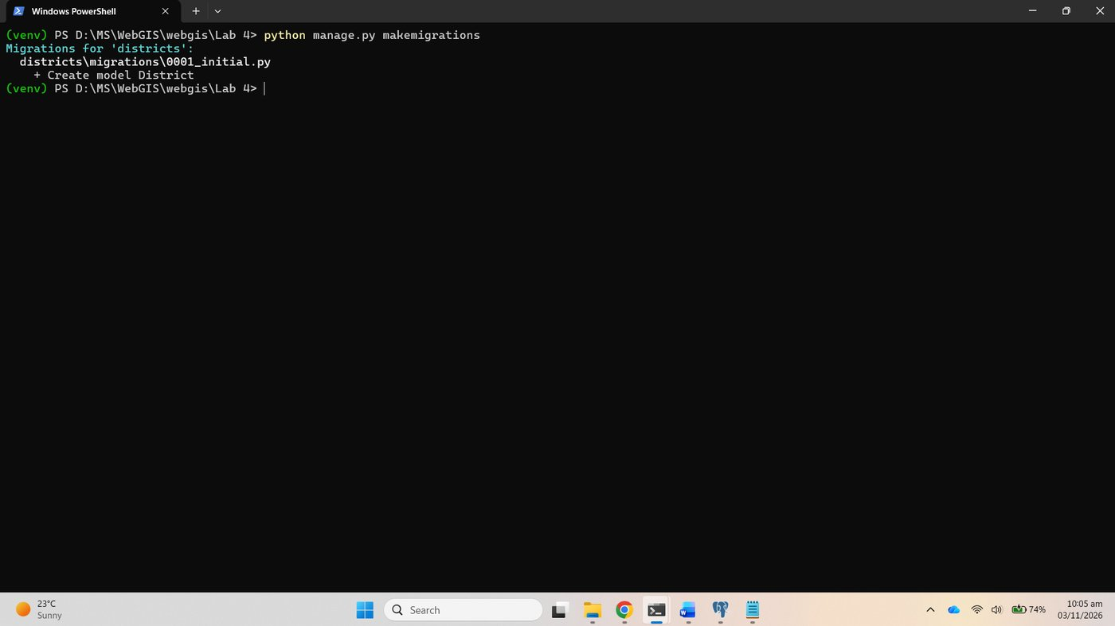
Figure 33. makemigrations districts

Checkpoint 4
The SQL of migration 0001. The two lines that matter: "geom" geometry(MULTIPOLYGON,4326) NOT NULL, a real PostGIS column constrained to multipolygons in EPSG:4326, and CREATE INDEX ... USING GIST ("geom"), the spatial index GeoDjango adds to every geometry field without being asked.
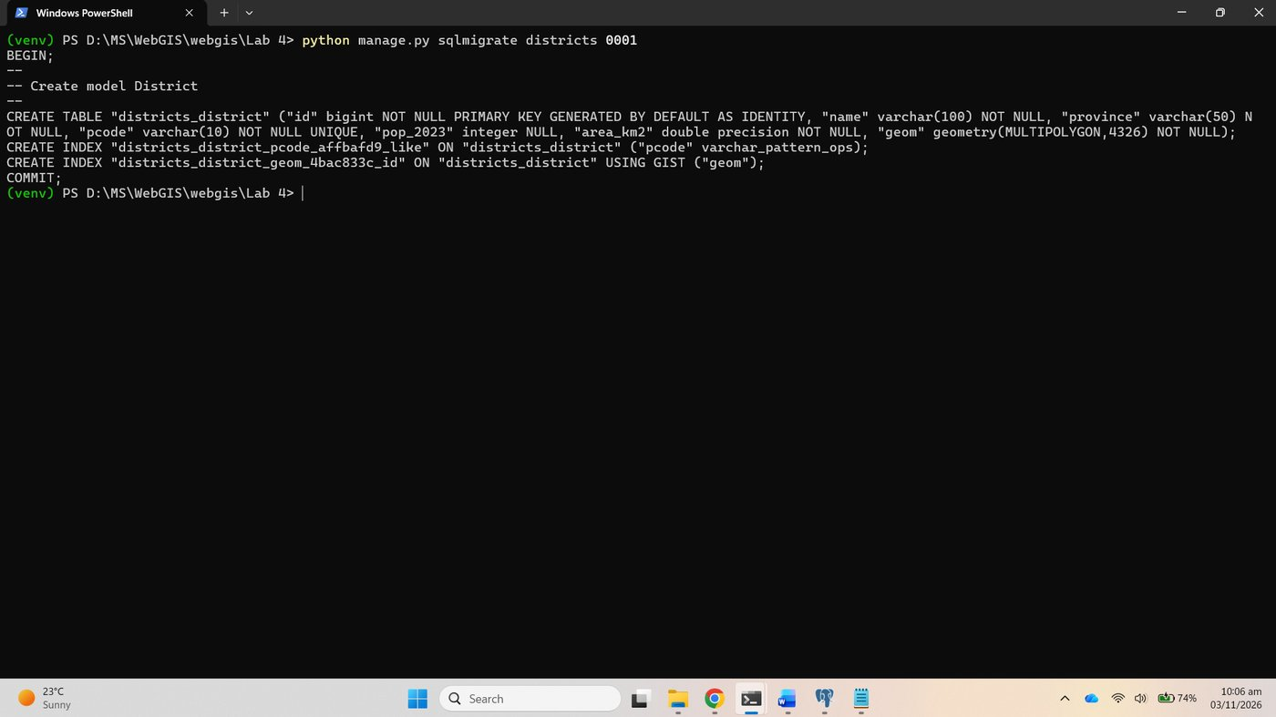
Figure 34. Checkpoint 4: sqlmigrate districts 0001
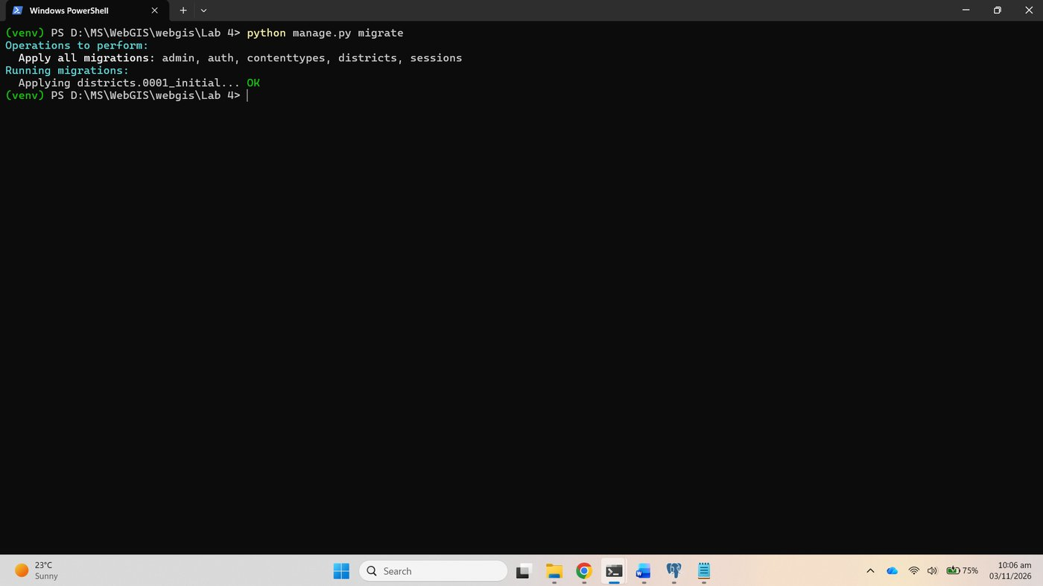
Figure 35. migrate applies districts.0001_initial
ordering in class Meta and __str__ were then added to the model, so makemigrations produced a second migration, 0002_alter_district_options, which migrate applied.
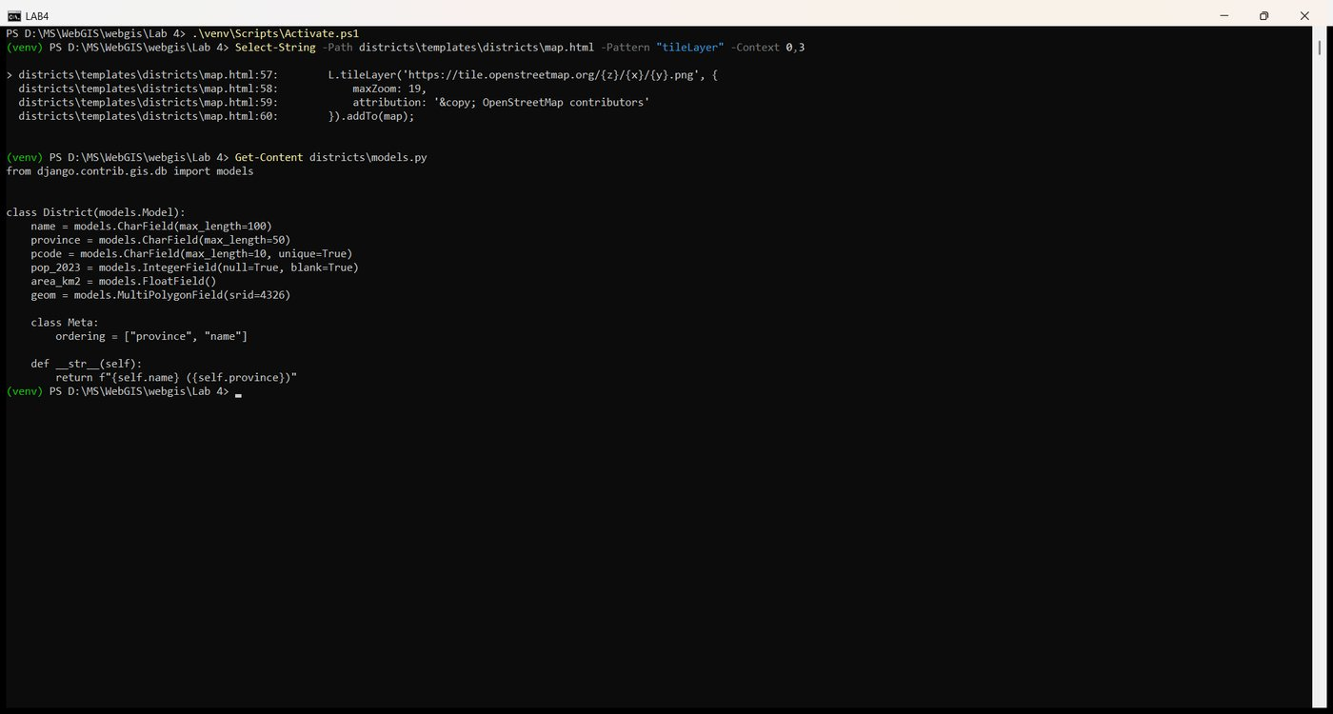
Figure 36. models.py with Meta and __str__
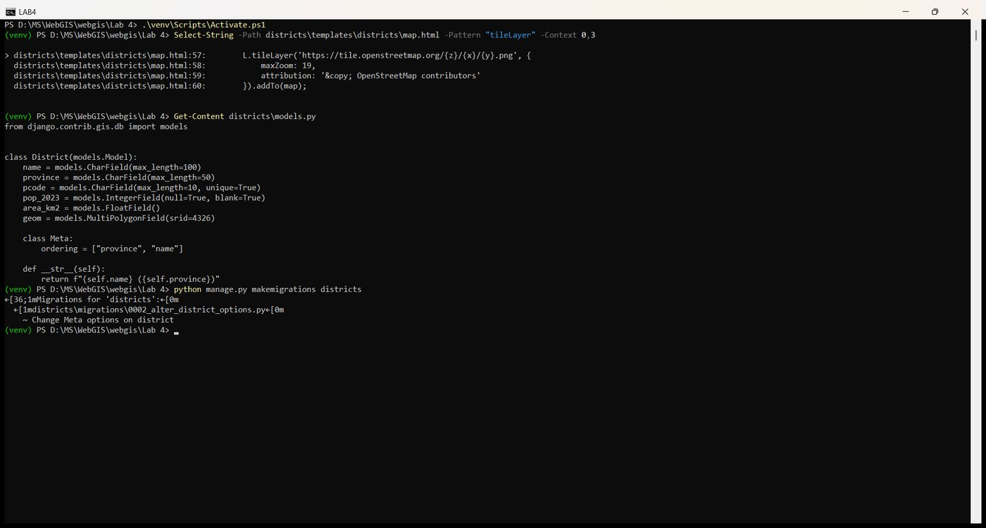
Figure 37. makemigrations: Change Meta options on district
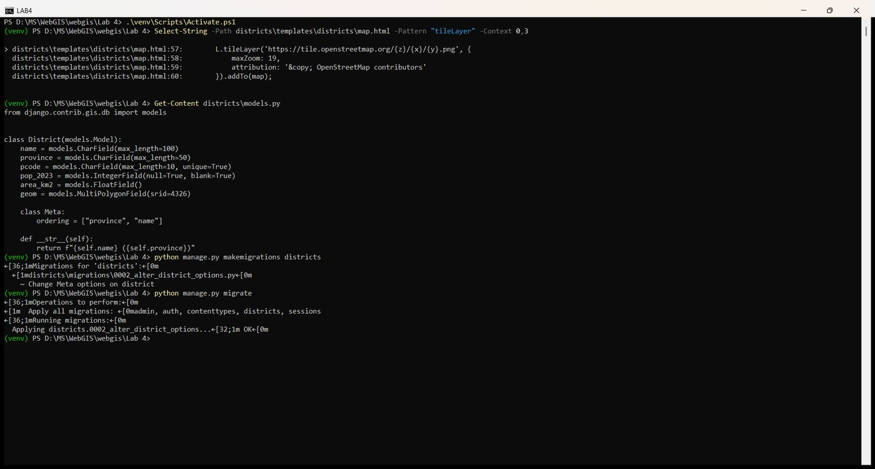
Figure 38. migrate applies 0002
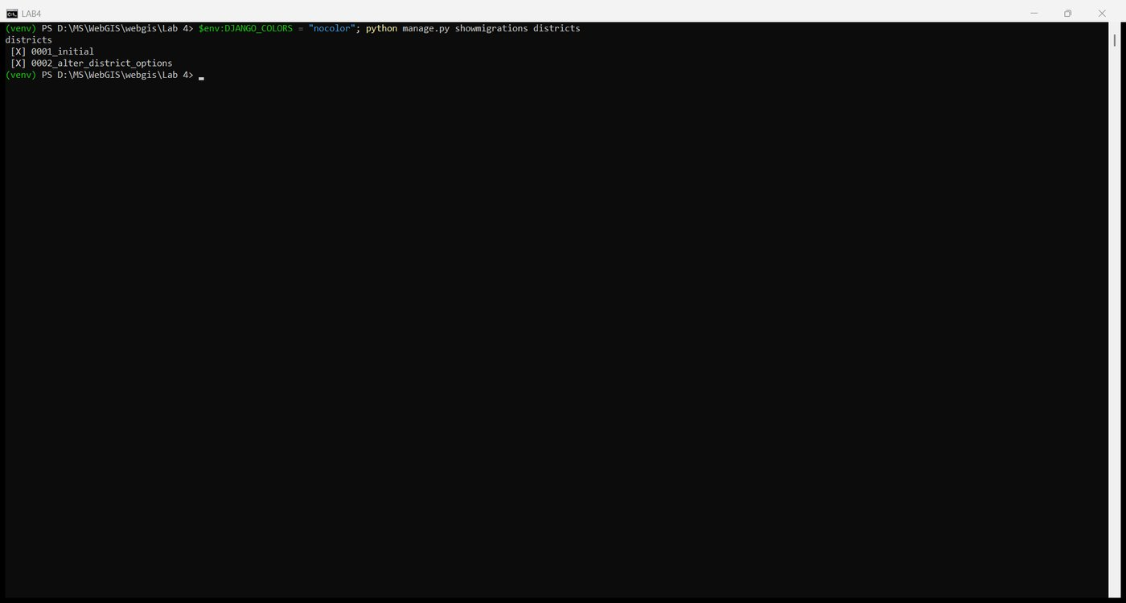
Figure 39. showmigrations districts: both applied

Part 5: Load the districts

5.1 The data file
mkdir data
copy "..\Lab 3\data\districts.geojson" data\districts.geojson

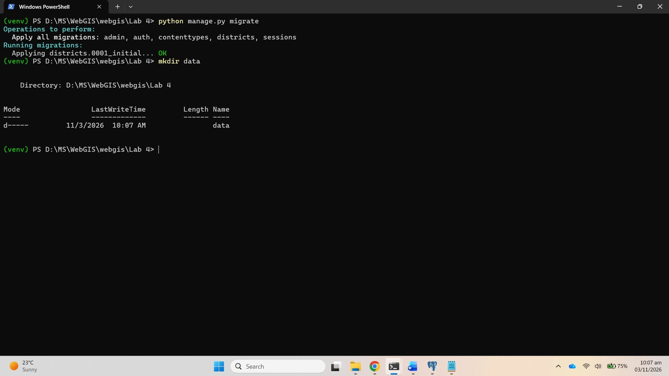
Figure 40. mkdir data
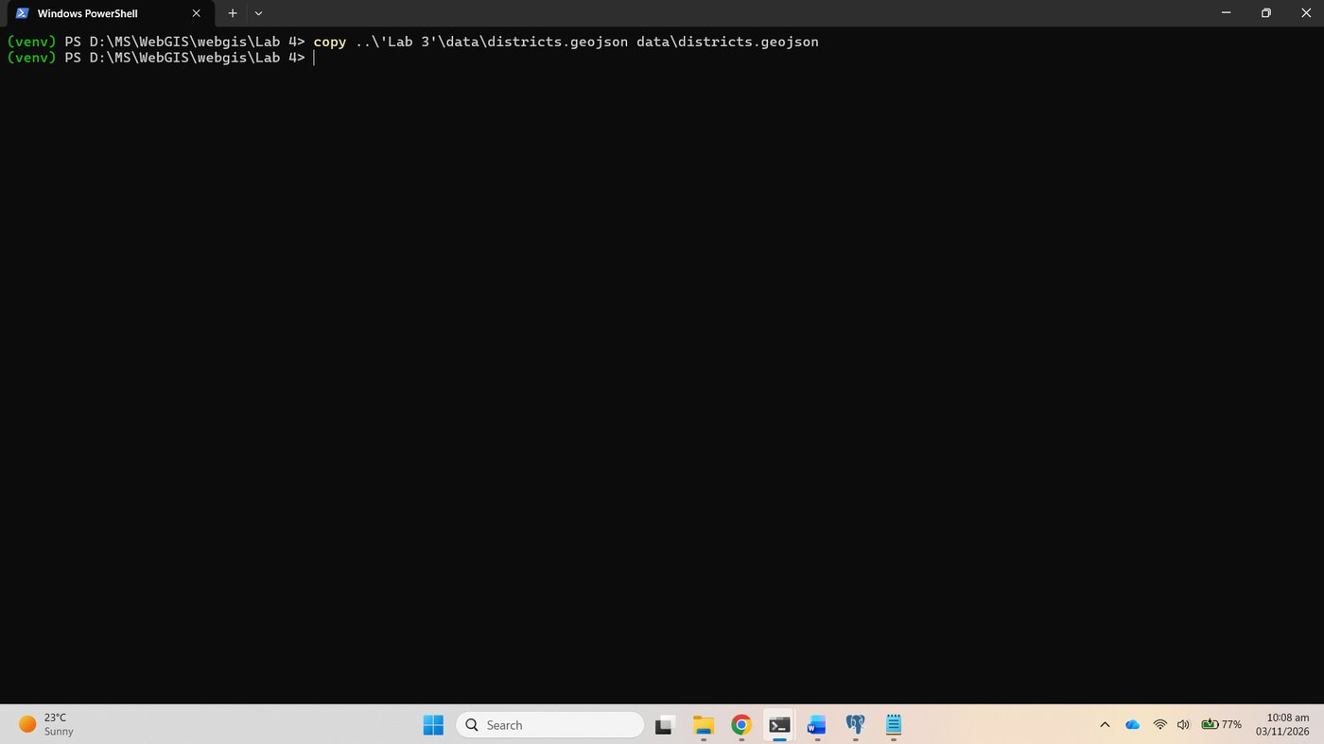
Figure 41. Copy districts.geojson from Lab 3

5.2 A loading script
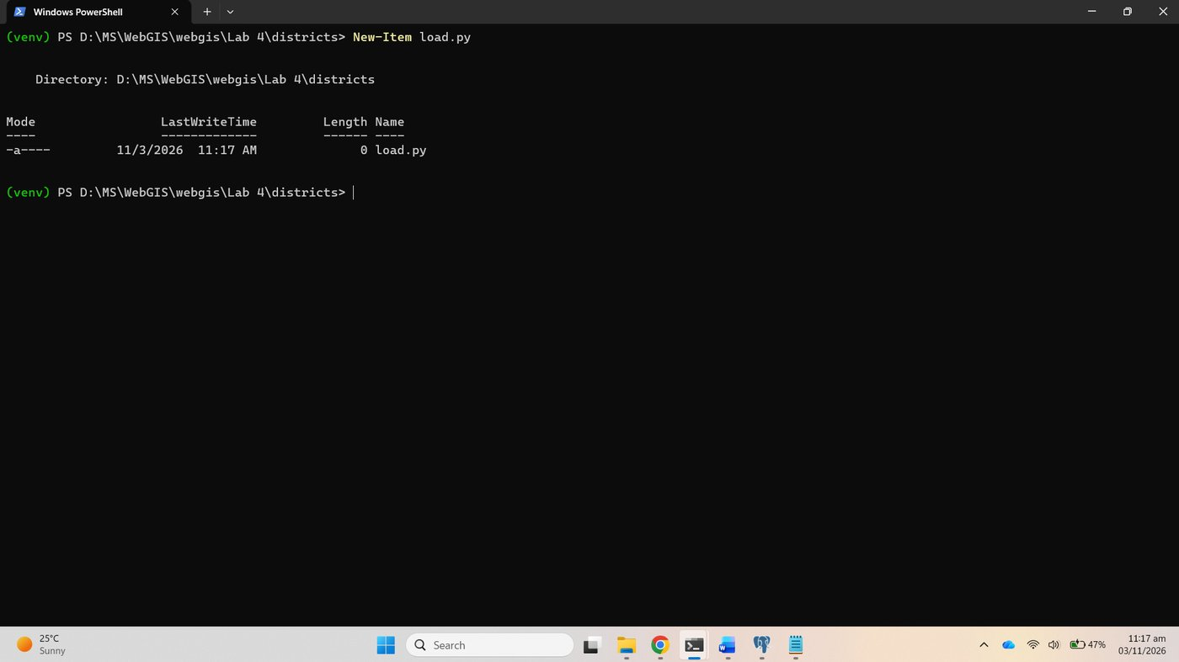
Figure 42. New-Item districts\load.py
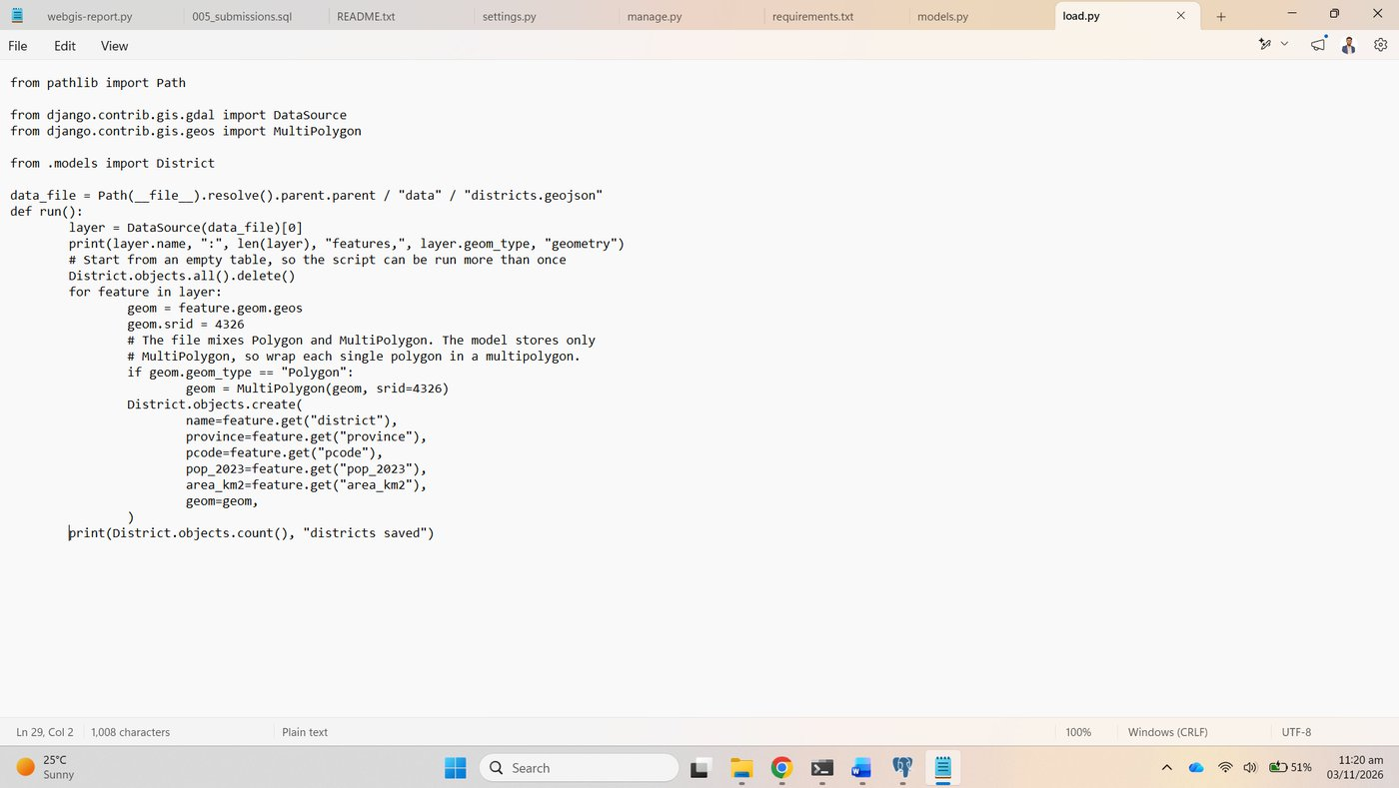
Figure 43. districts/load.py
The script reported the layer as 160 features of Unknown geometry type, because the file mixes 152 Polygon and 8 MultiPolygon features, and saved 160 districts.
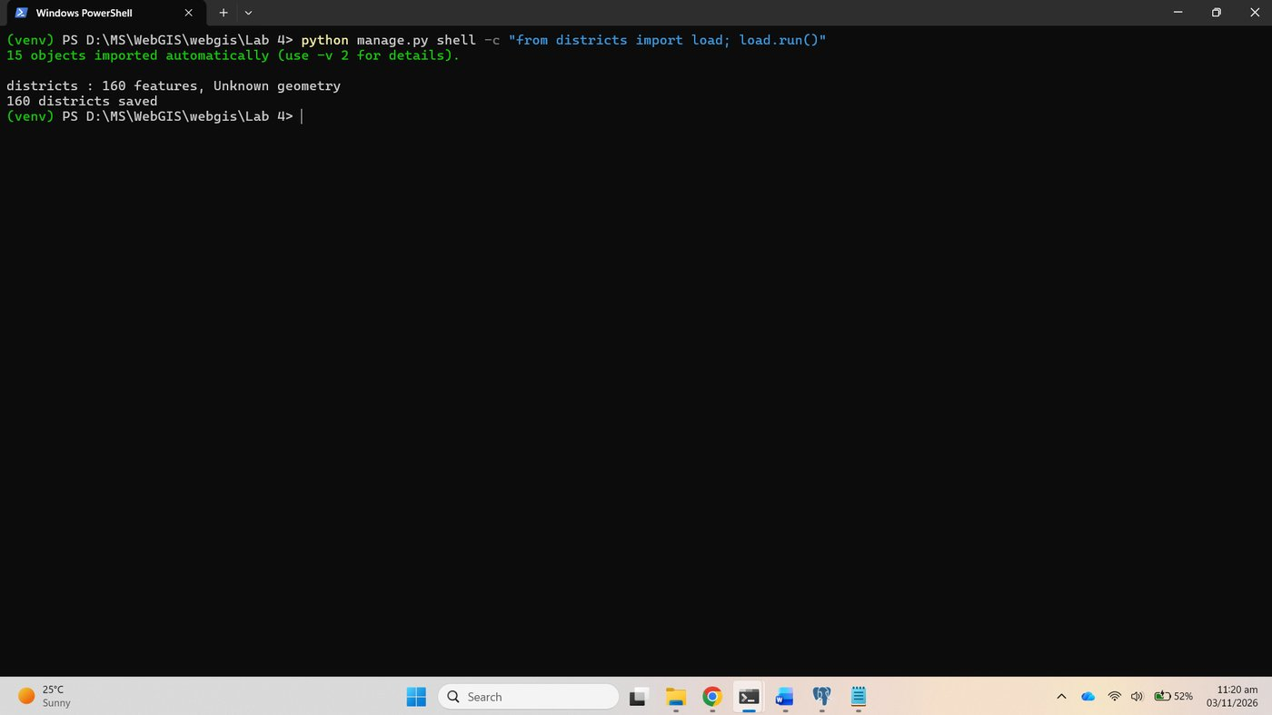
Figure 44. load.run(): 160 features, Unknown geometry, 160 districts saved

5.3 Talk to the data
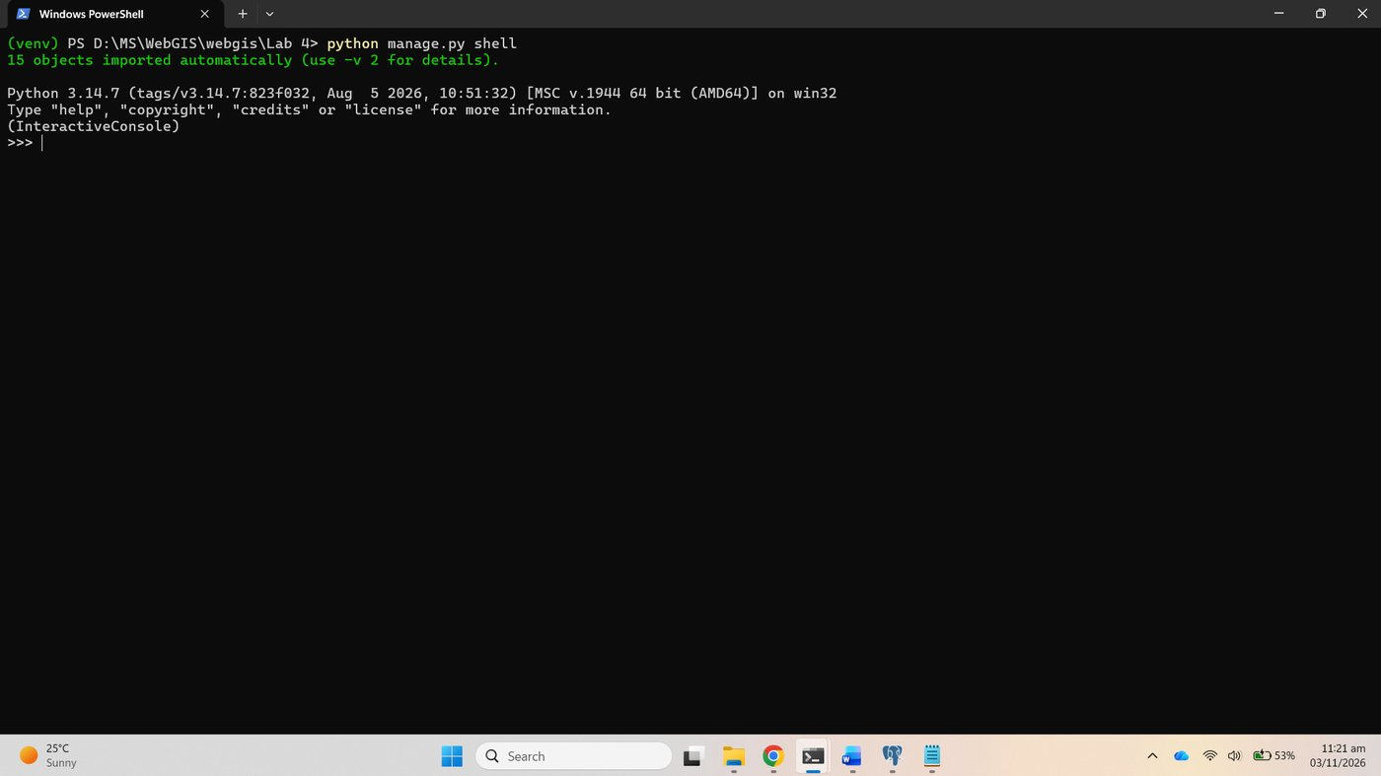
Figure 45. python manage.py shell

Checkpoint 5
The seven ORM lines: 160 districts, 29 in Sindh, 25 with no census figure; Lahore has 13,004,135 people, a MultiPolygon geometry of 238 coordinates.
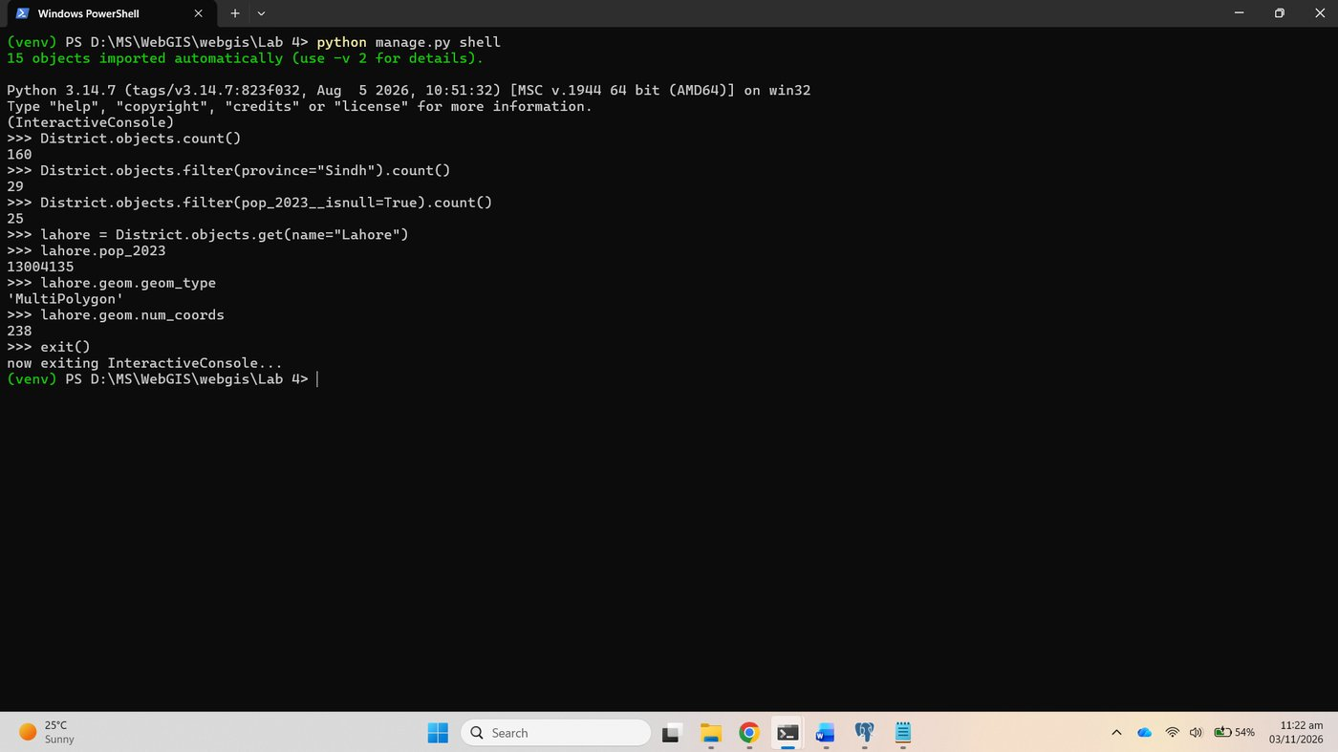
Figure 46. Checkpoint 5: the seven shell lines

Part 6: The admin panel

6.1 Create an administrator, 6.2 register the model
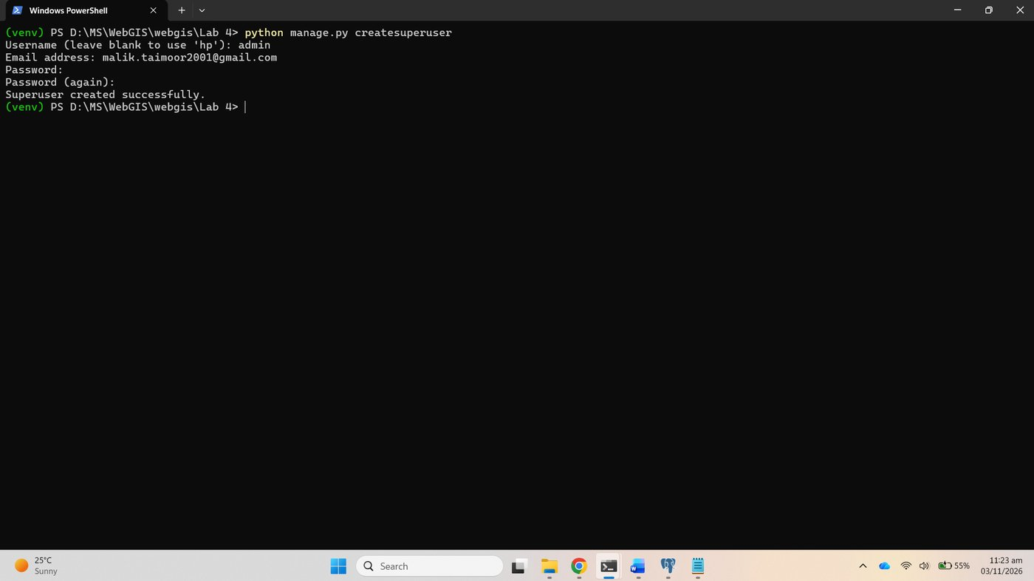
Figure 47. createsuperuser
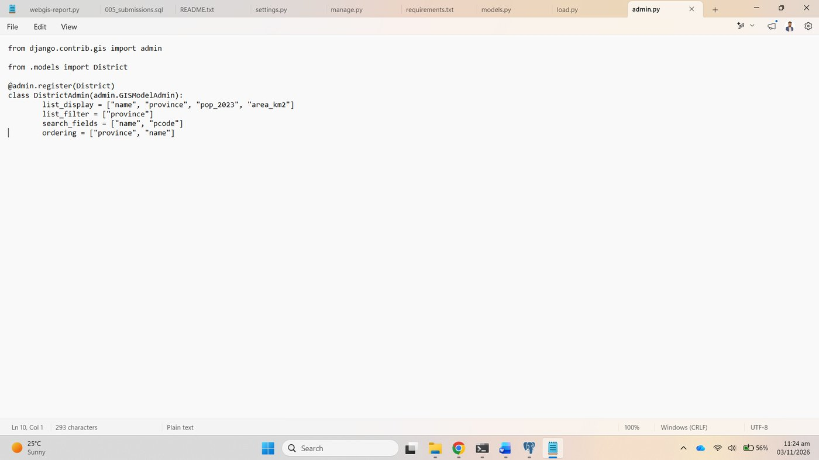
Figure 48. districts/admin.py with GISModelAdmin

6.3 Explore it
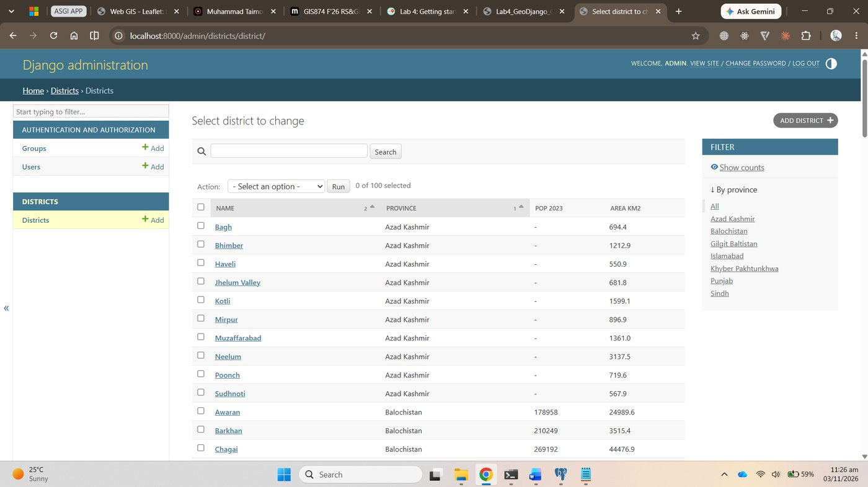
Figure 49. The district list in the admin
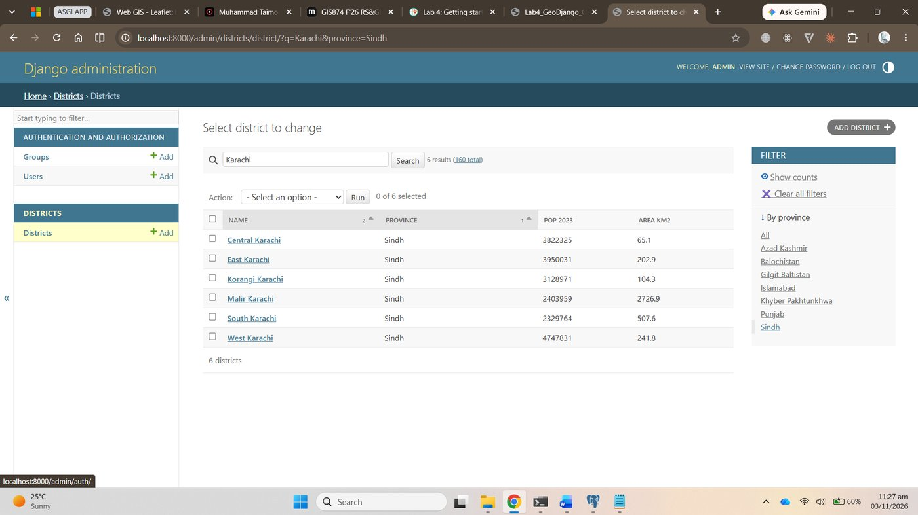
Figure 50. Search for karachi: six districts, all in Sindh
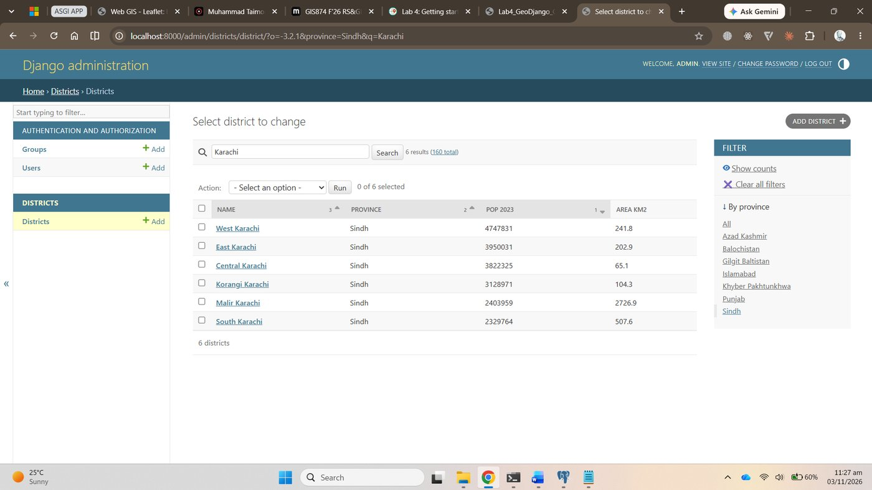
Figure 51. Filtered to Sindh and sorted by population, West Karachi first

Checkpoint 6
The list filtered to one province (Sindh, sorted by population, above); Lahore's page with its geometry on the OpenLayers map; the list after Lahore's population was changed to 1,500,000 and saved, with the admin's success message; and the pgAdmin query confirming the database row had changed.
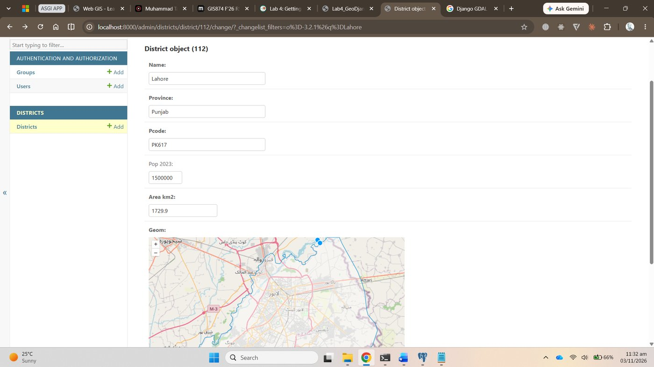
Figure 52. Checkpoint 6: Lahore's page with the map
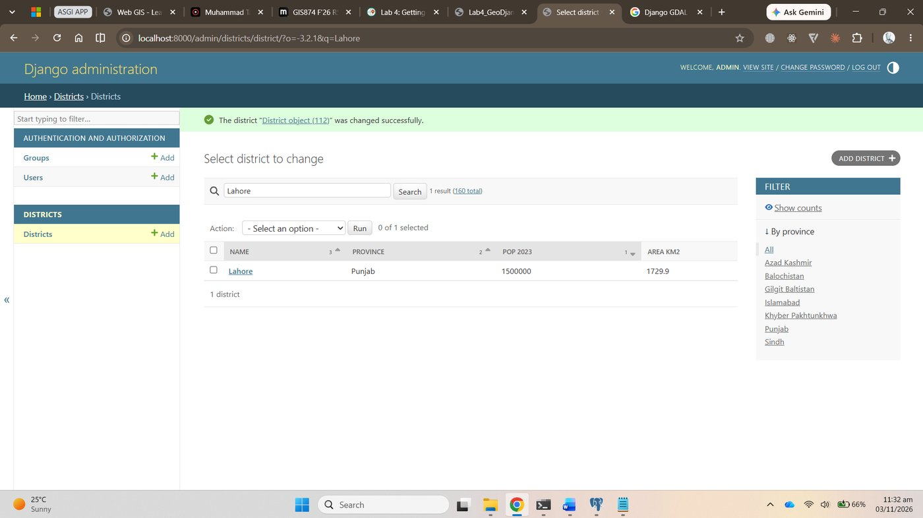
Figure 53. Checkpoint 6: the list after the change was saved, Lahore now 1500000
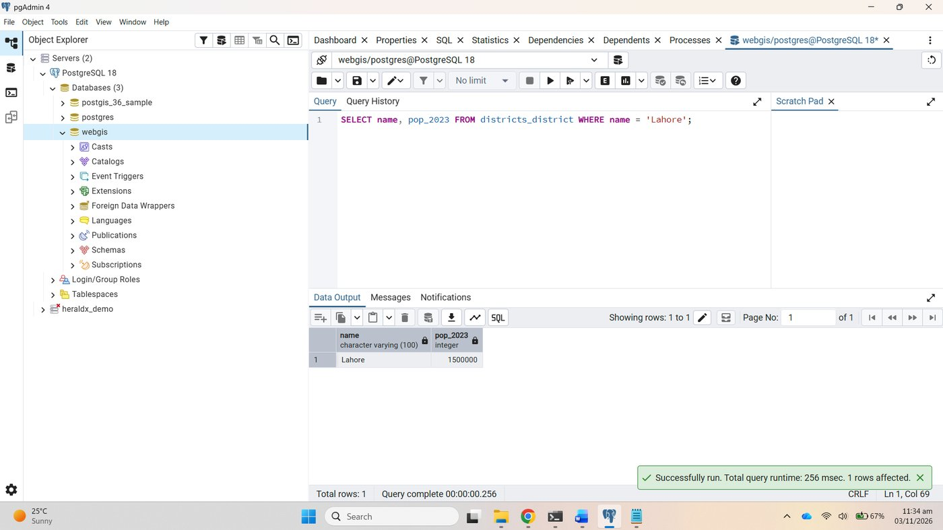
Figure 54. Checkpoint 6: pgAdmin shows pop_2023 = 1500000 for Lahore
The figure was then set back to 13,004,135 and the same query run again in pgAdmin.
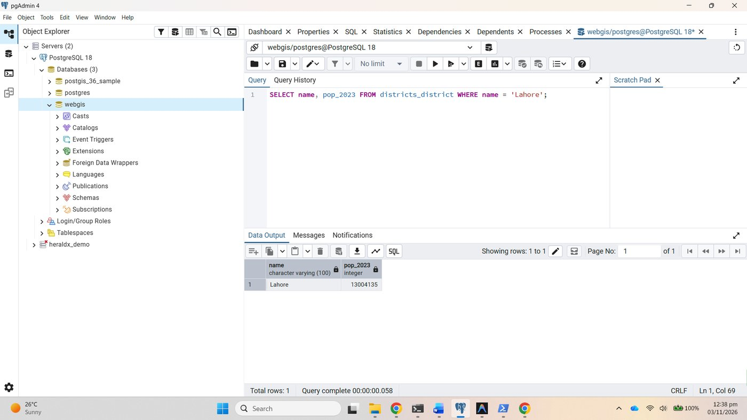
Figure 55. pgAdmin: Lahore restored to 13004135

Part 7: Leaflet, fed by Django

7.1 Two views, 7.2 two URLs
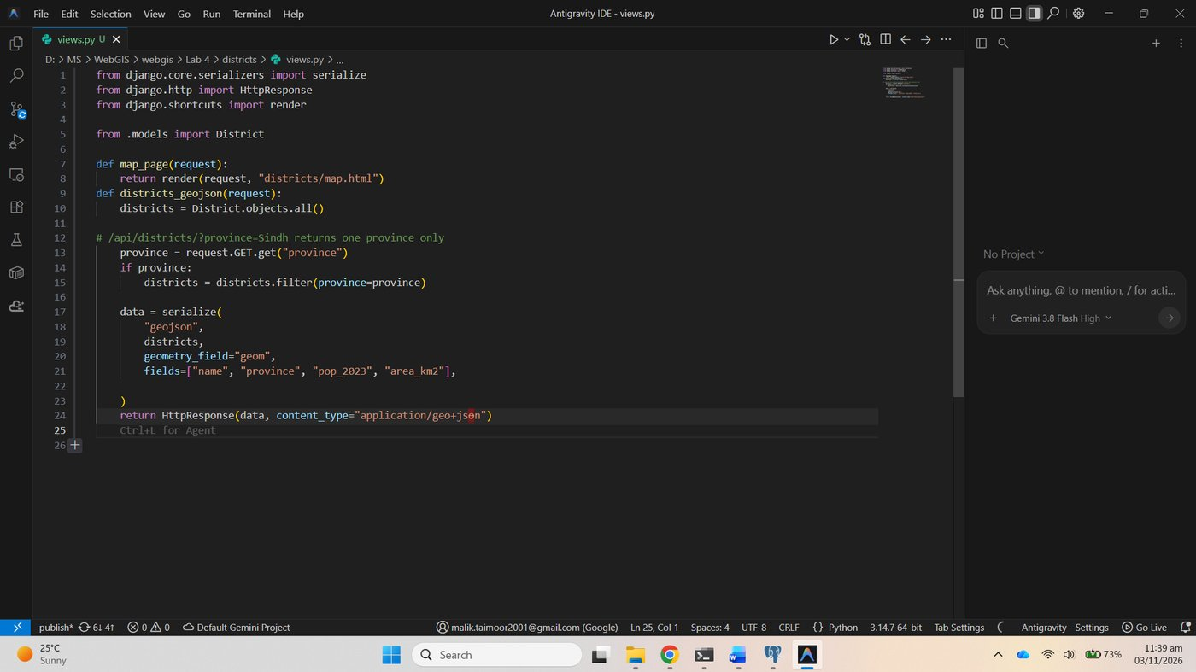
Figure 56. districts/views.py
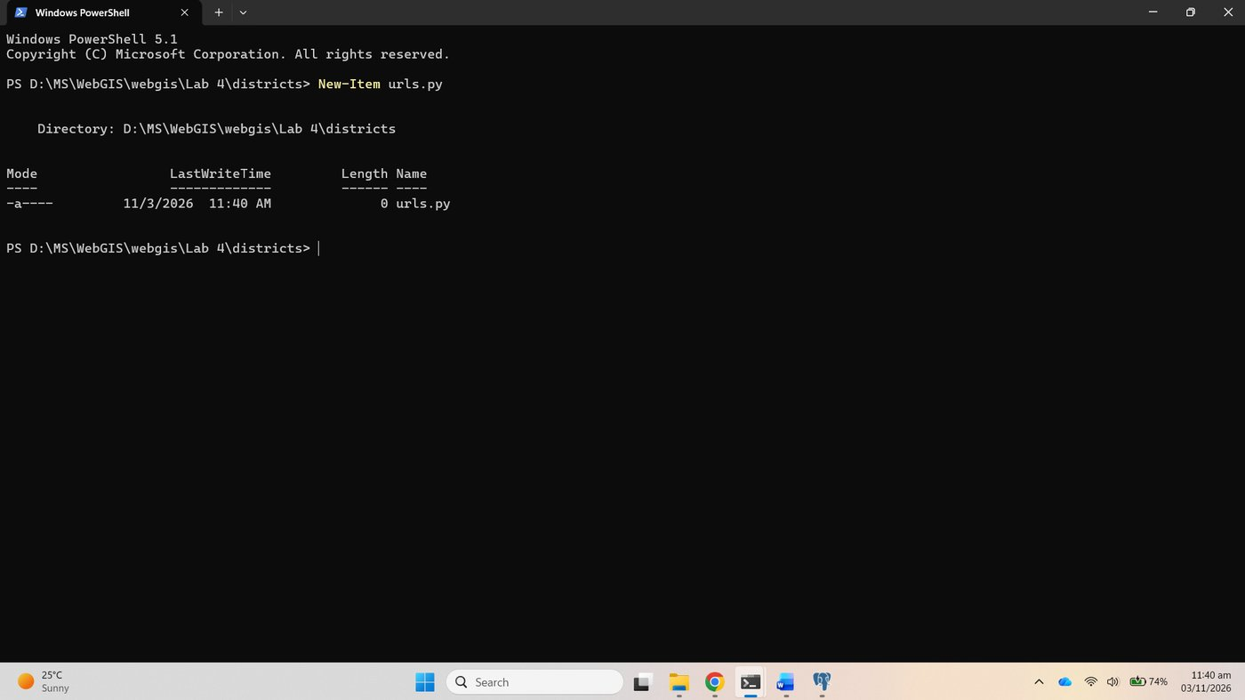
Figure 57. New-Item districts\urls.py
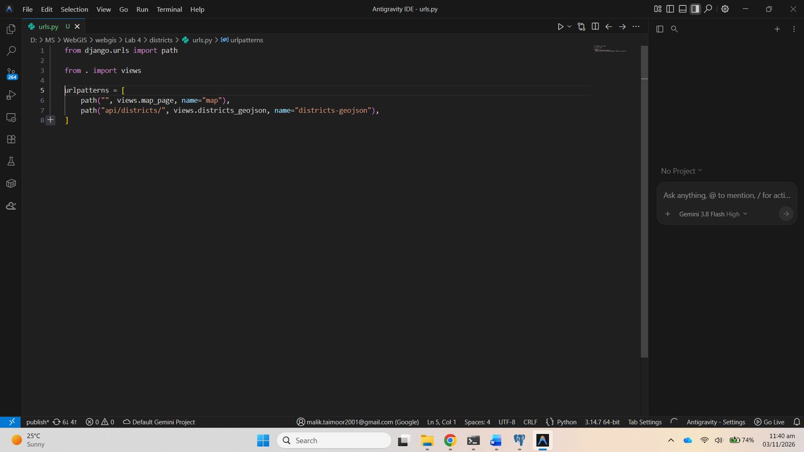
Figure 58. districts/urls.py
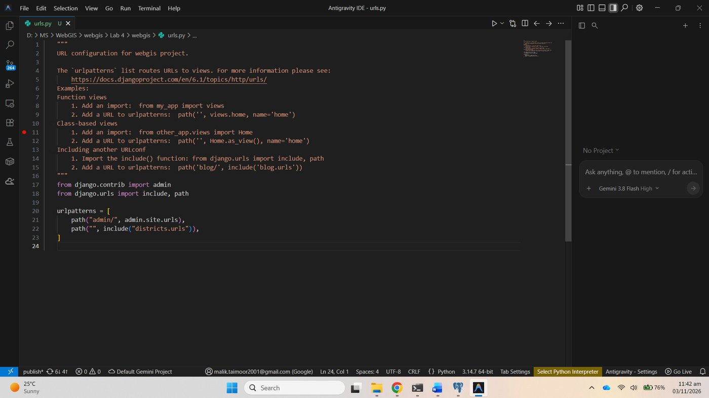
Figure 59. webgis/urls.py includes districts.urls
/api/districts/ returns a GeoJSON FeatureCollection built from PostGIS, and ?province=Sindh returns 29 features instead of 160.
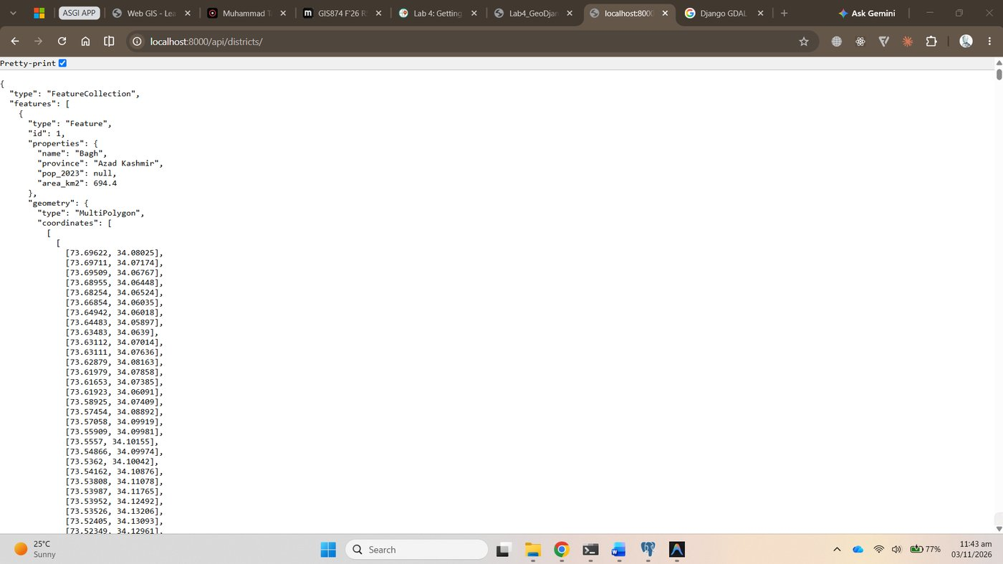
Figure 60. /api/districts/: GeoJSON from the database
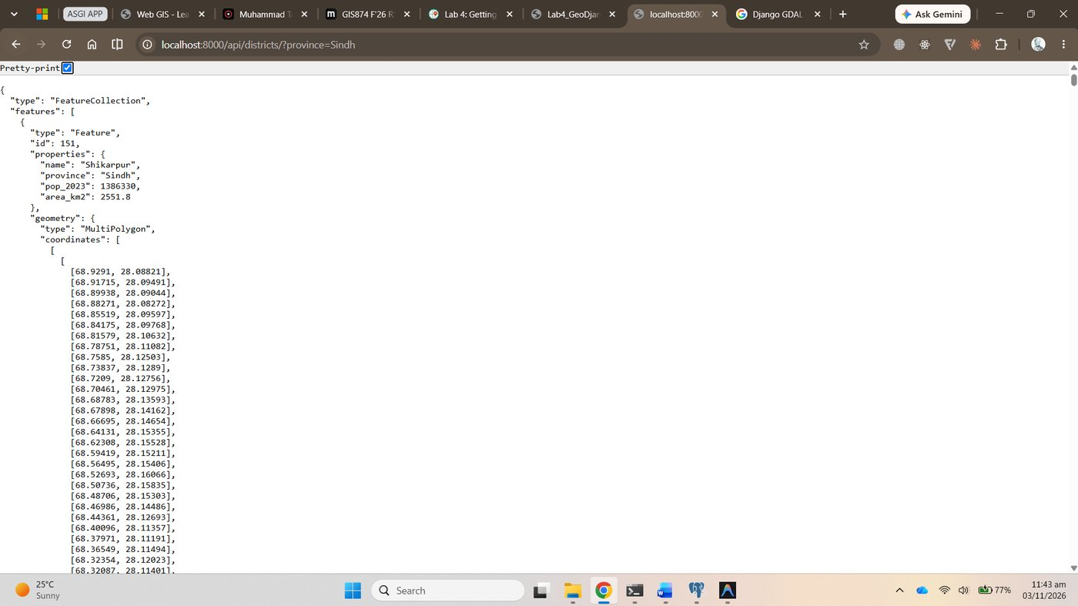
Figure 61. /api/districts/?province=Sindh

7.3 The map page
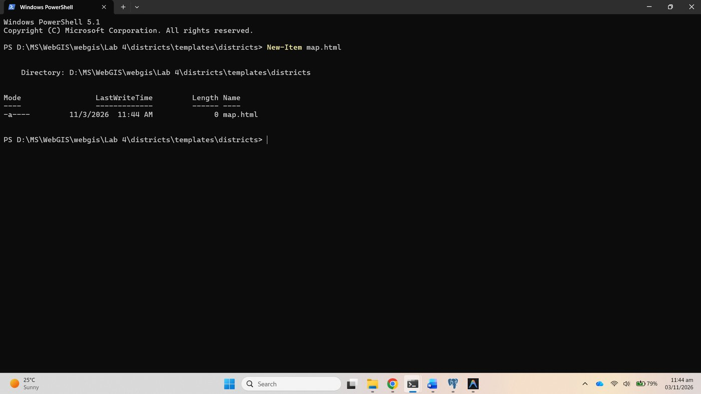
Figure 62. New-Item map.html in districts/templates/districts
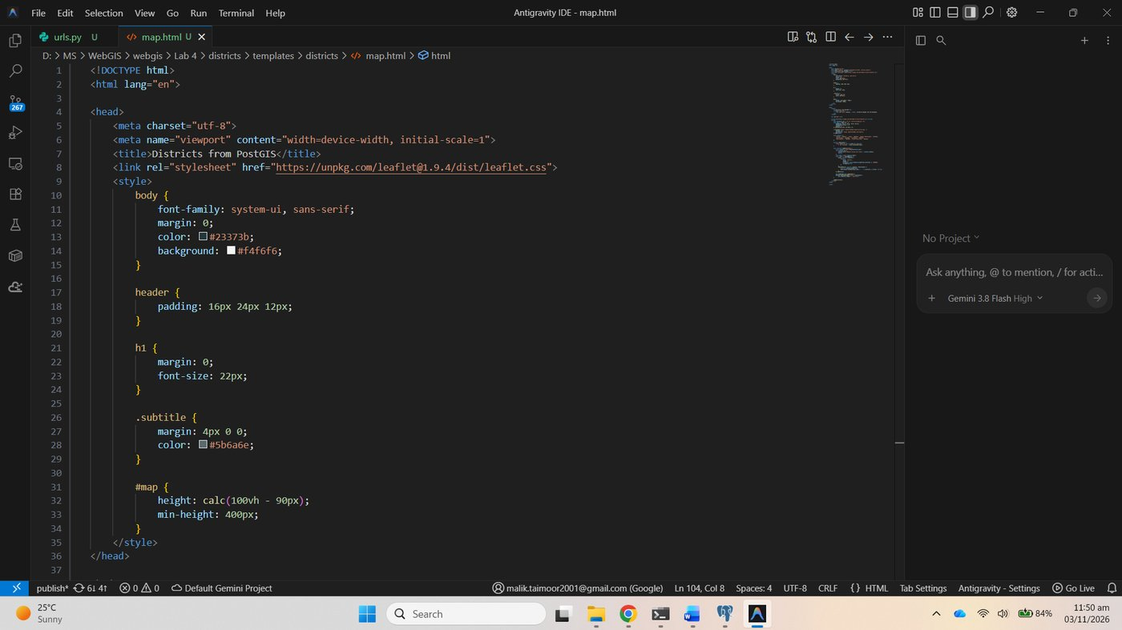
Figure 63. districts/templates/districts/map.html
The basemap is Esri's free Light Gray Canvas, as in Lab 3; its template uses the {z}/{y}/{x} order.
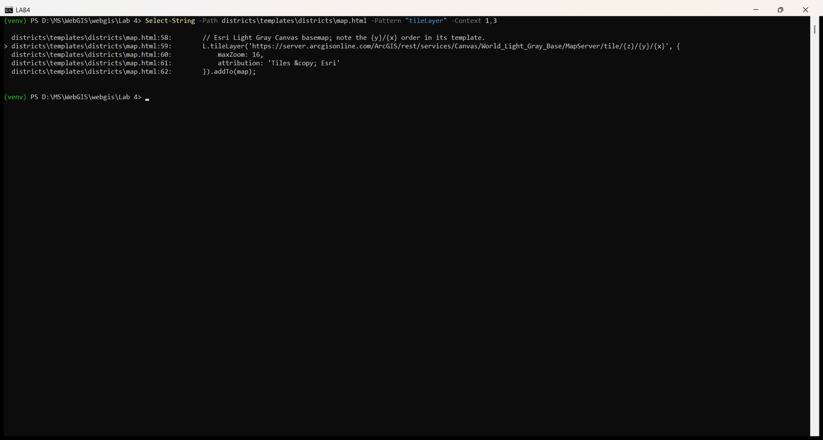
Figure 64. map.html: the tile layer
The server was started in its own window:
.
env\Scripts\Activate.ps1
python manage.py runserver

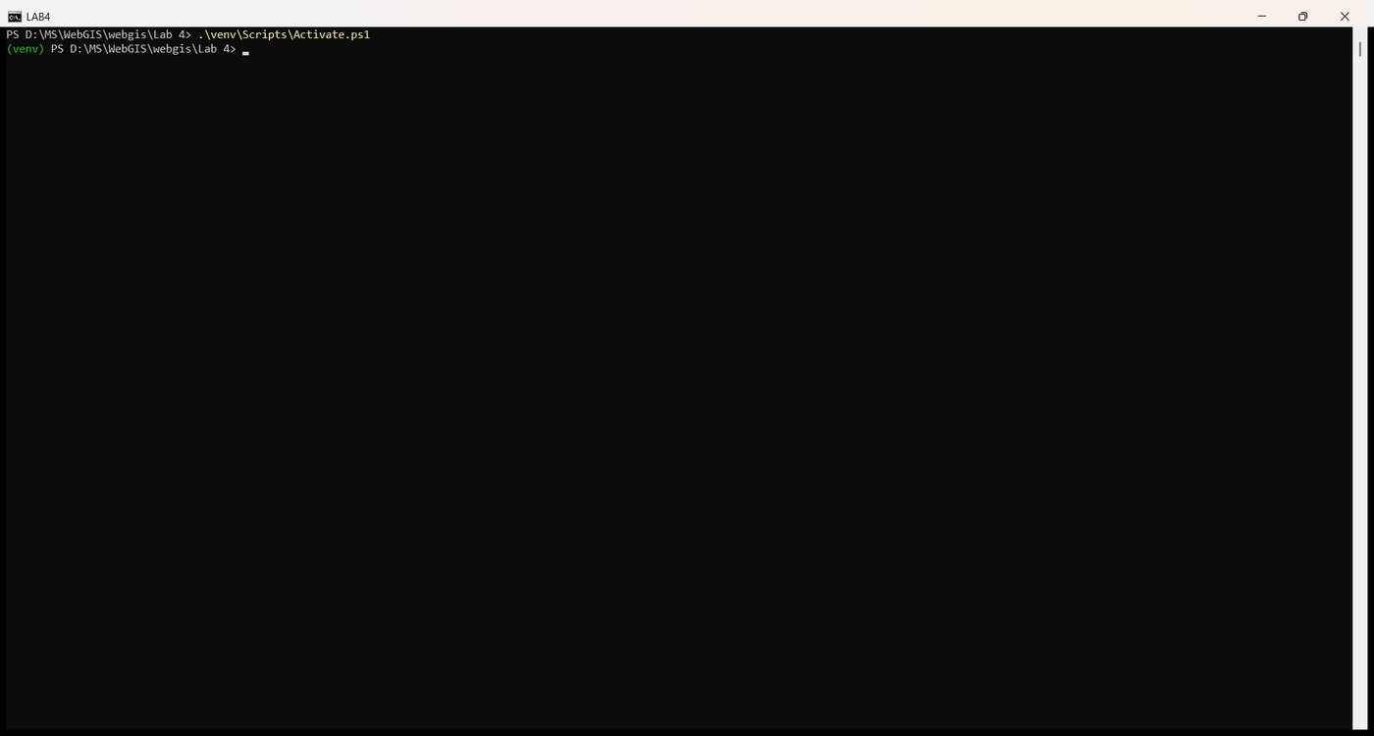
Figure 65. Activate the environment
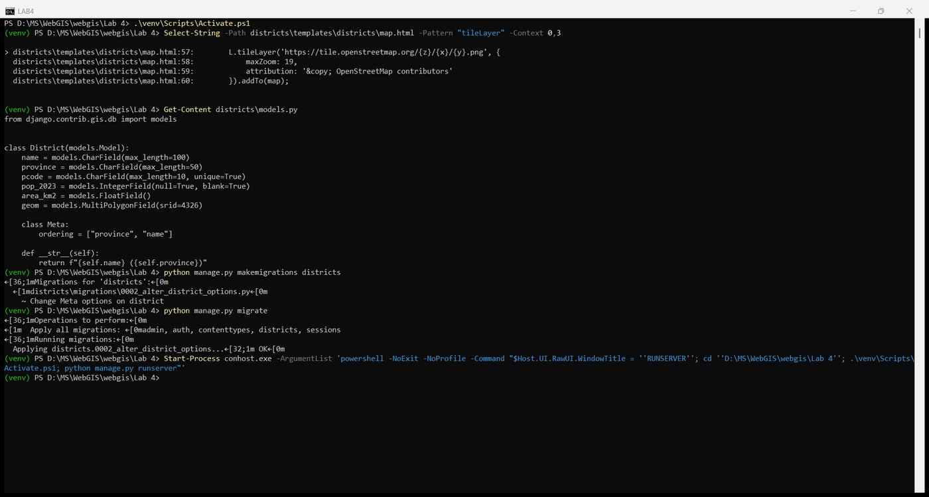
Figure 66. Starting runserver in a second window
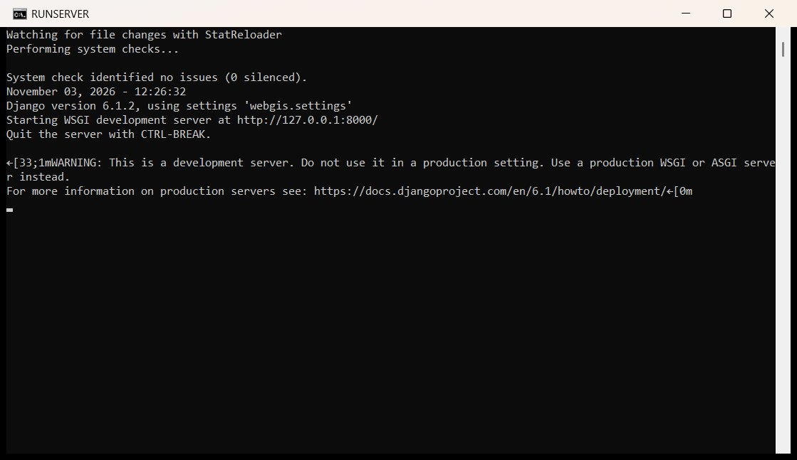
Figure 67. The runserver window answering requests
Ctrl+U shows the page as it arrived from Django: the template tag has been replaced, so the browser reads const DISTRICTS_URL = "/api/districts/";.
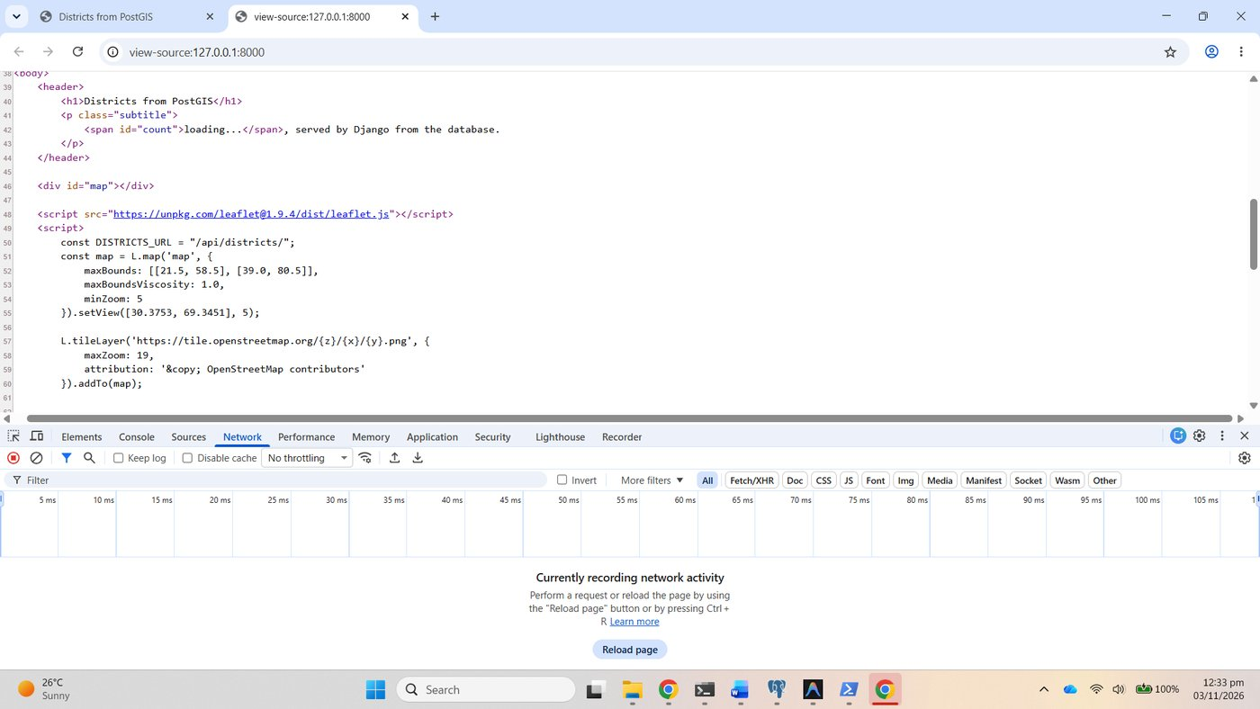
Figure 68. view-source: the url tag rendered as /api/districts/

Checkpoint 7
The map at 127.0.0.1:8000 with the basemap drawn, the 160 districts coloured by province, and the tooltip for Lahore, Punjab.
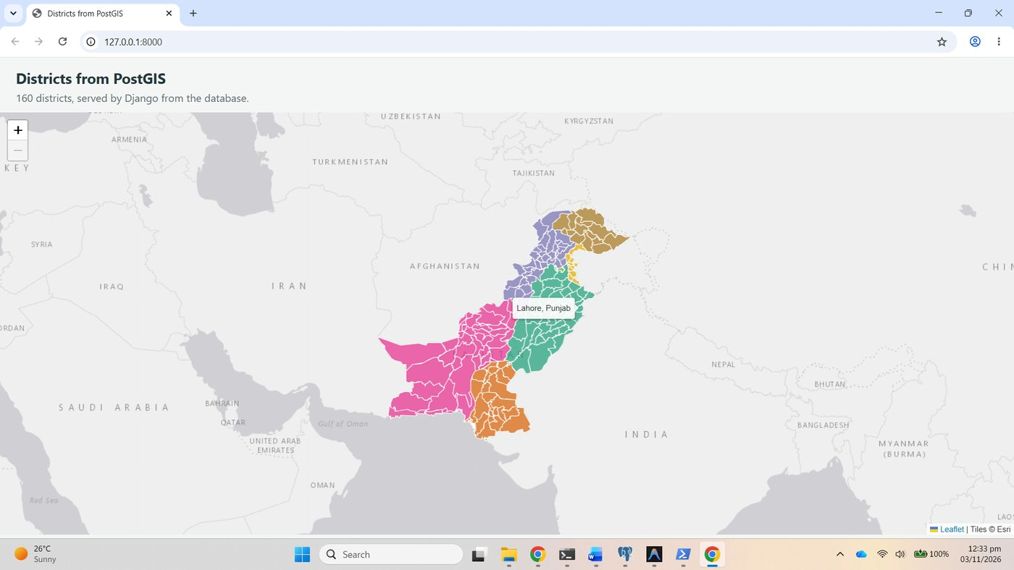
Figure 69. Checkpoint 7: the map with a tooltip
The Network tab with the api/districts/ request selected: status 200, type fetch, 1,027 kB in 317 ms from the Django development server.
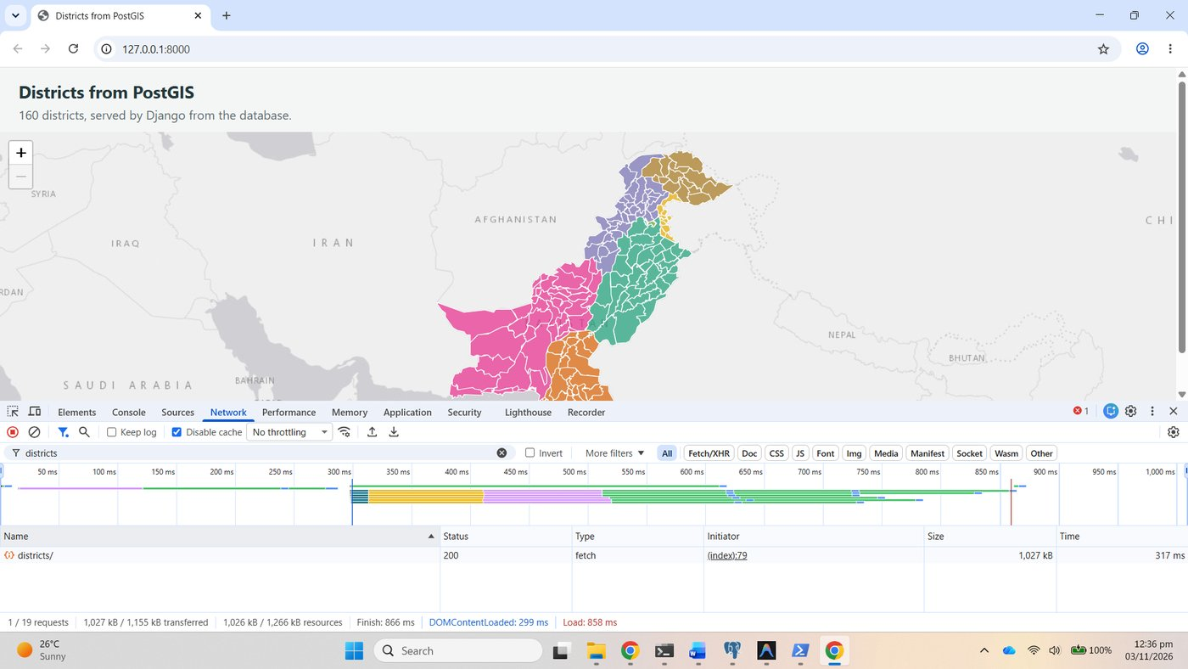
Figure 70. Checkpoint 7: the api/districts/ request, 1,027 kB

Part 8: Ask PostGIS a spatial question (extension)

8.1 The view
district_at reads lat and lng by name, builds Point(lng, lat, srid=4326) and asks for the first district whose geometry contains it; geom__contains becomes ST_Contains in SQL. The URL api/where/ was added to districts/urls.py.
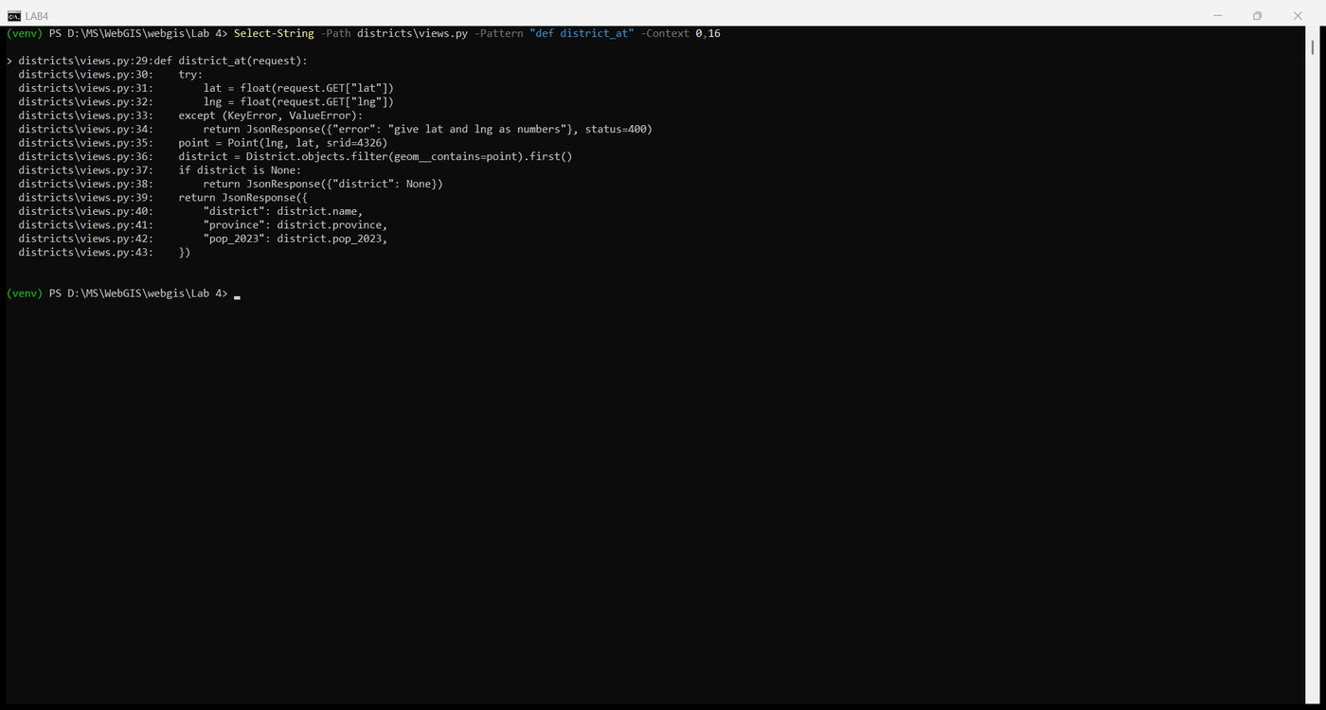
Figure 71. views.py: district_at
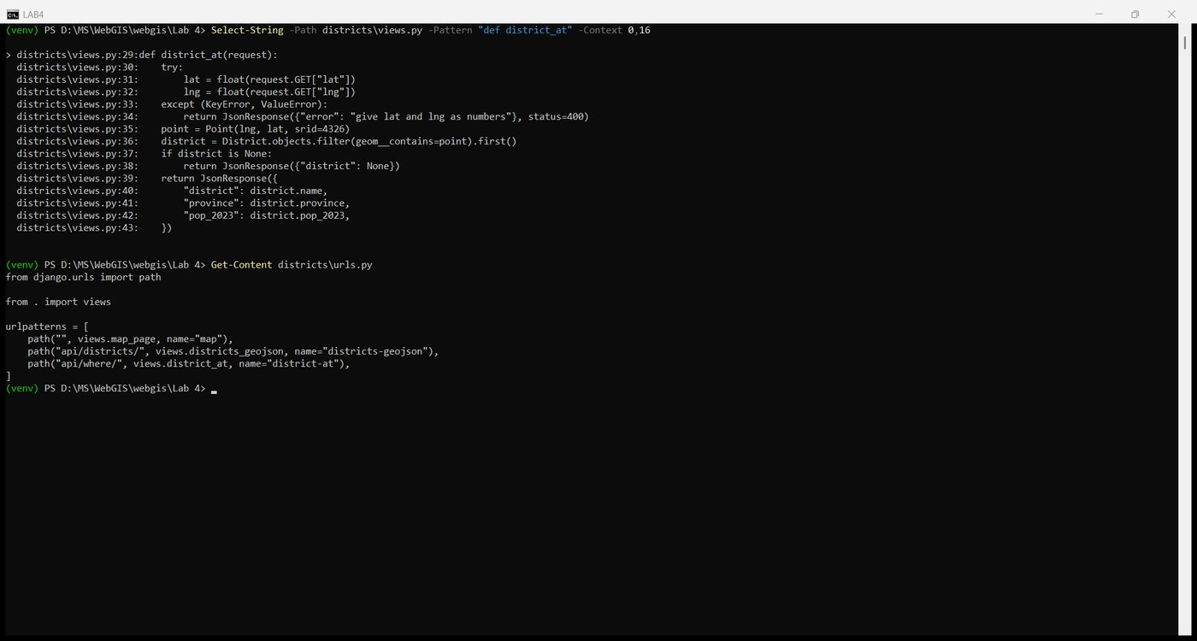
Figure 72. urls.py with api/where/
Tested directly: the NUST coordinates name Islamabad with its population, a point in the sea returns district: null, and a bad argument returns status 400.
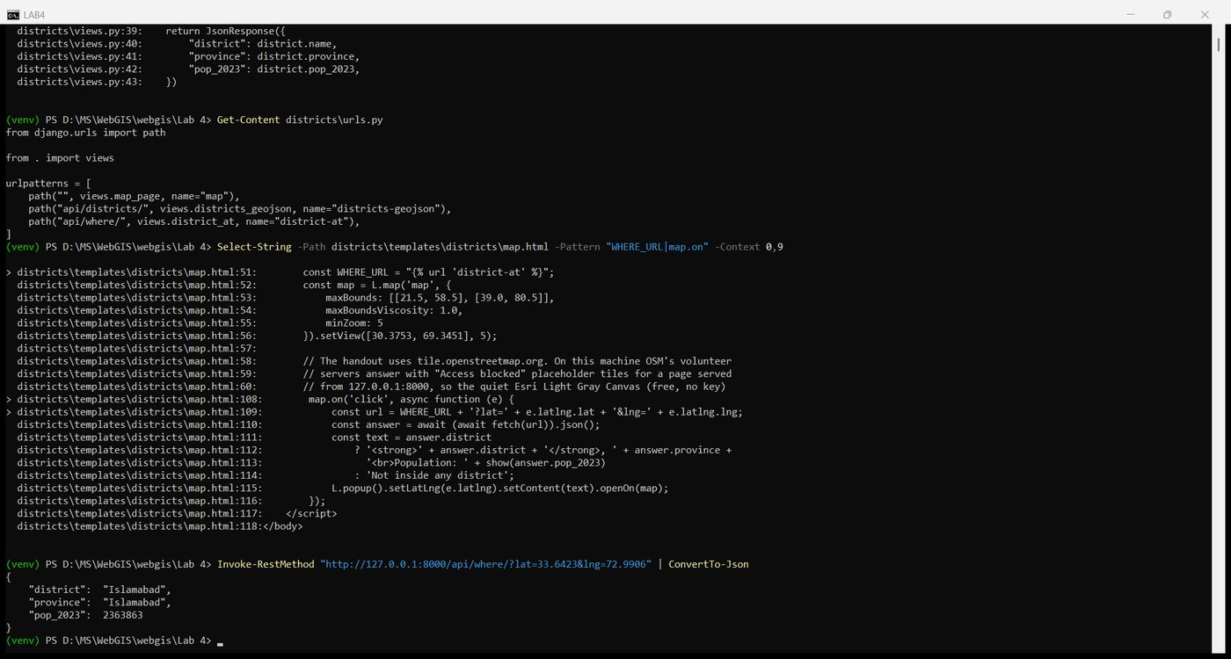
Figure 73. /api/where/?lat=33.6423&lng=72.9906: Islamabad
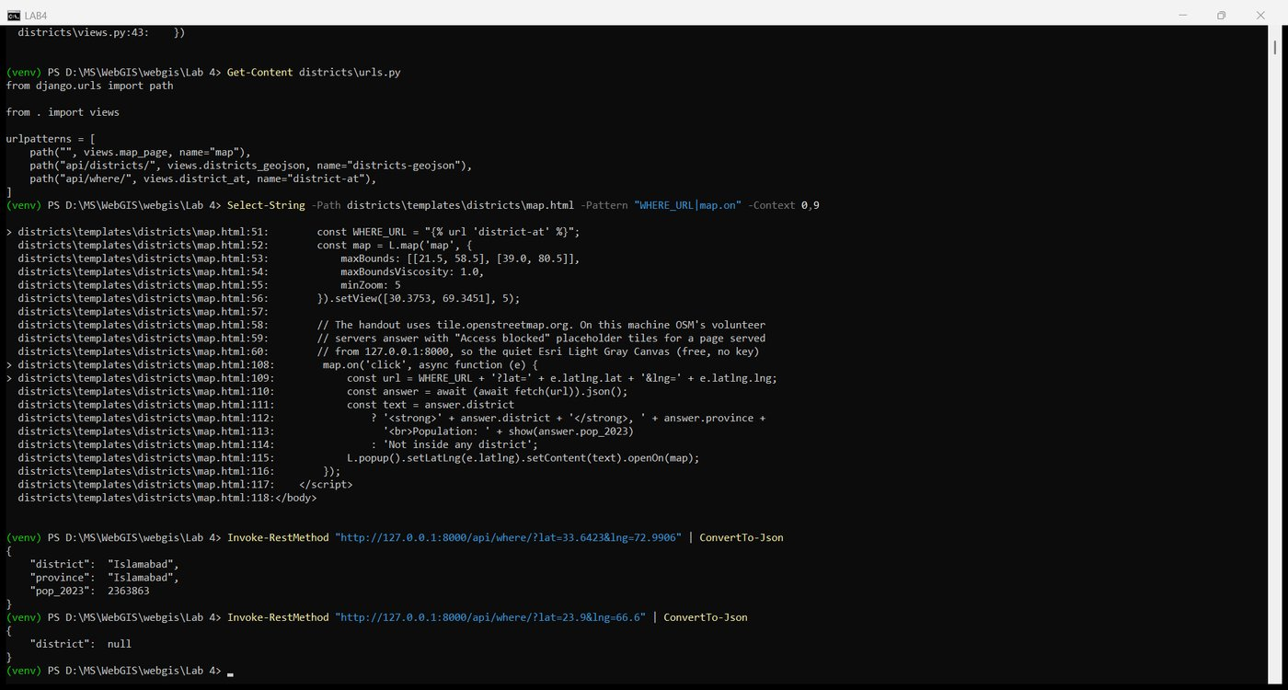
Figure 74. /api/where/ for a point in the sea: null

8.2 Call it from the map
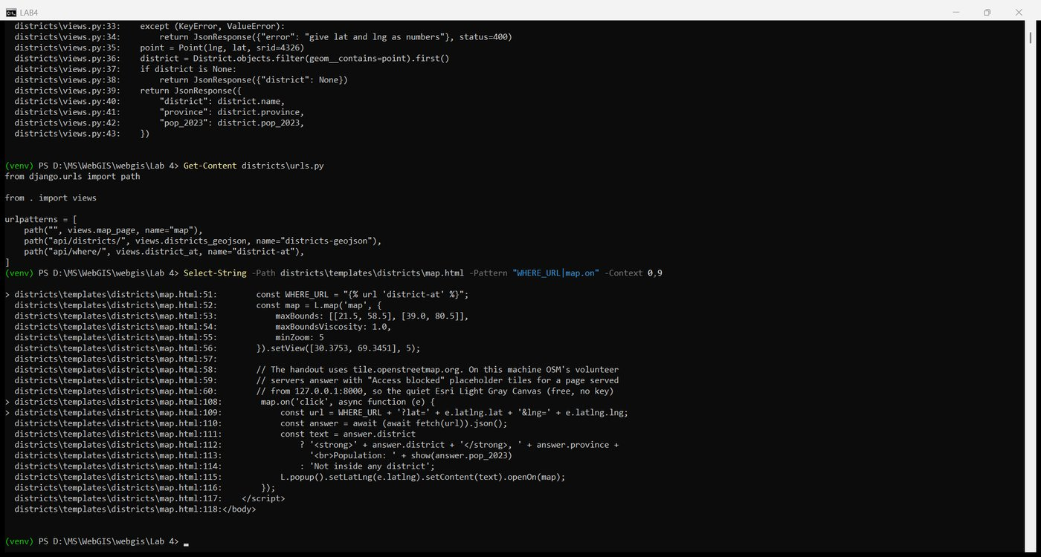
Figure 75. map.html: WHERE_URL and the click handler

Checkpoint 8
A click on Islamabad opens a popup built from PostGIS's answer; a click on the sea south of Karachi reports "Not inside any district".
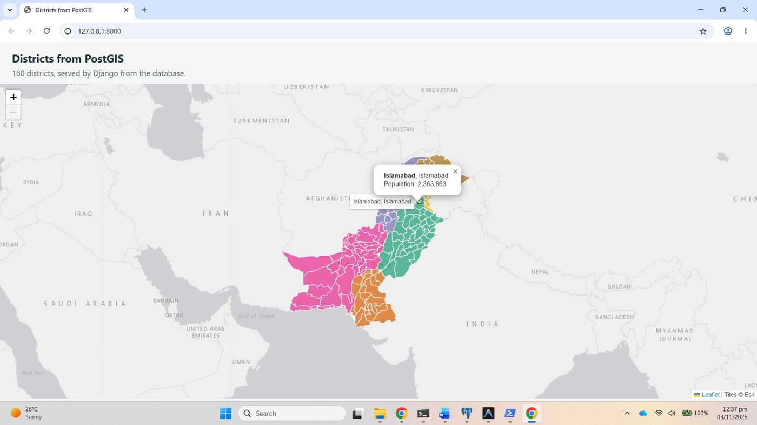
Figure 76. Checkpoint 8: popup from a click, answered by PostGIS
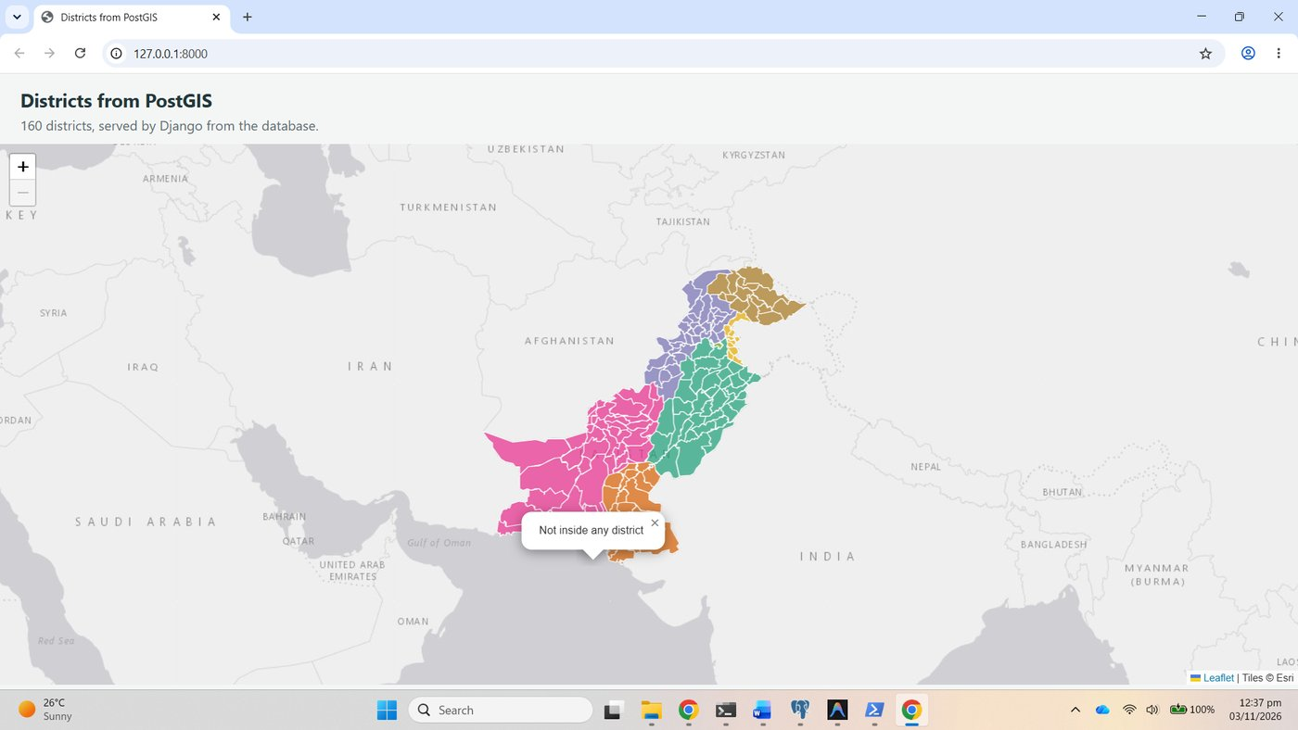
Figure 77. A click on the sea: not inside any district

8.3 The same question in SQL
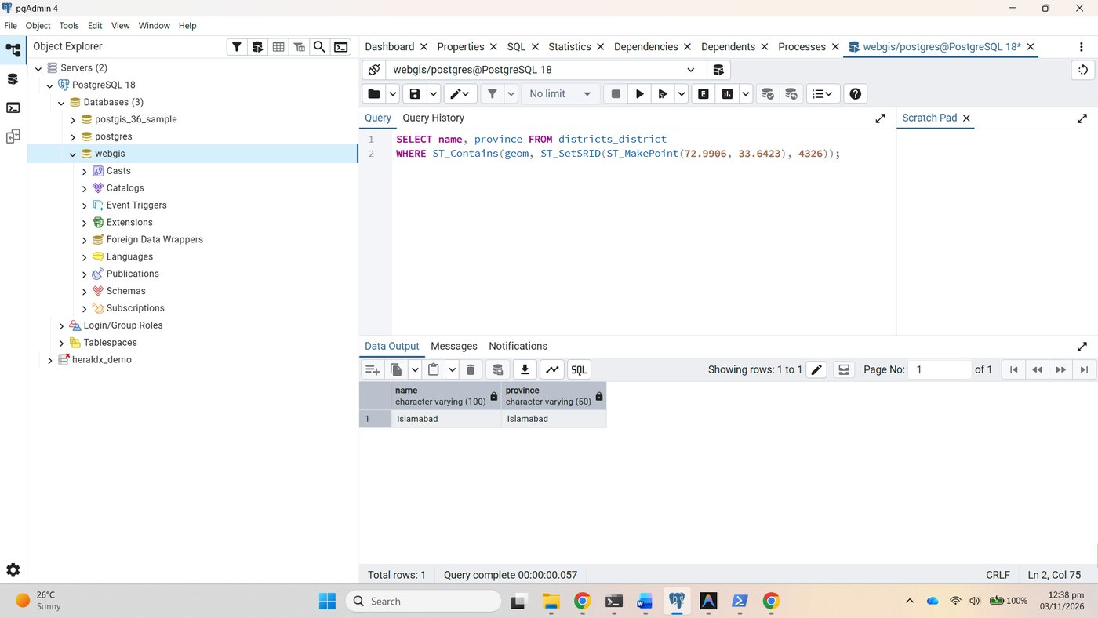
Figure 78. pgAdmin: ST_Contains names Islamabad
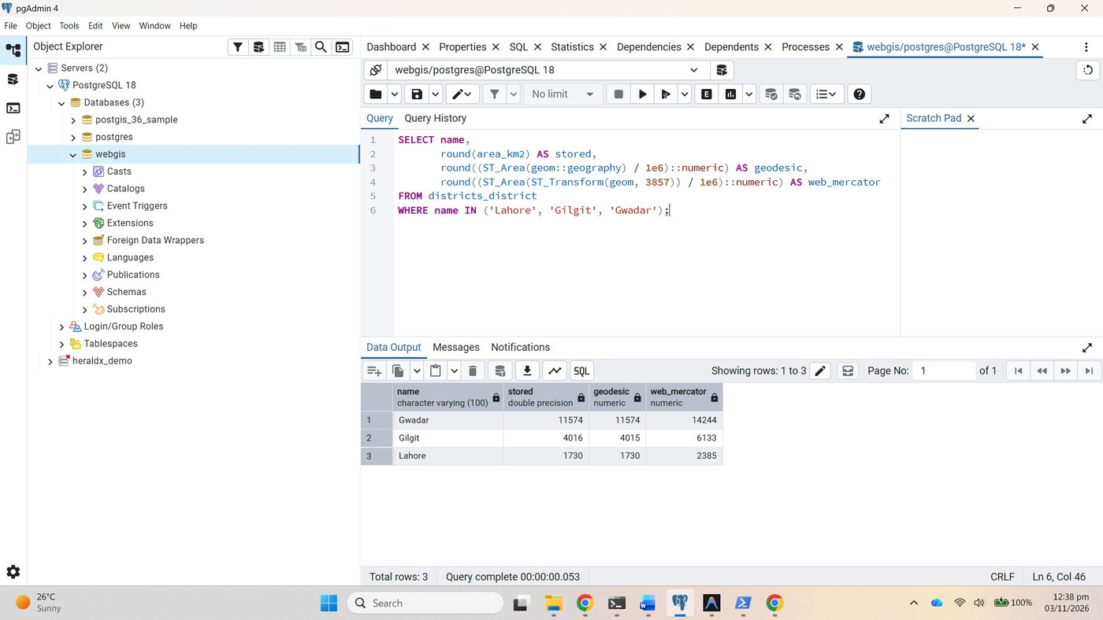
Figure 79. Checkpoint 8: the area query
District | Latitude | stored km² | geodesic km² | web_mercator km² | Mercator / geodesic | 1/cos²(lat)
Gwadar | 25.4 N | 11,574 | 11,574 | 14,244 | 1.23 | 1.23
Lahore | 31.5 N | 1,730 | 1,730 | 2,385 | 1.38 | 1.37
Gilgit | 35.9 N | 4,016 | 4,015 | 6,133 | 1.53 | 1.52

The stored area_km2 and the geodesic area agree to the nearest square kilometre, because the stored figure was itself computed on the ellipsoid. The Web Mercator area is too large by exactly the factor 1/cos²(latitude) predicted in Lab 2: 23 percent at Gwadar on the coast, 38 percent at Lahore, 53 percent at Gilgit in the north. This is Lab 2's Part 9 in one SQL statement, and it says the same thing: never report an area computed in EPSG:3857.

Part 9: Commit and submit

9.1 What not to commit
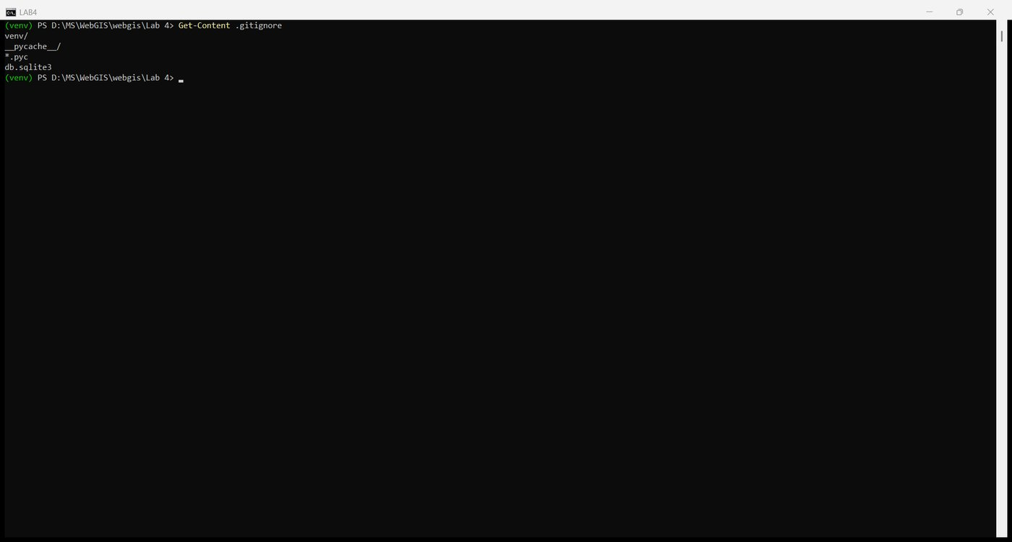
Figure 80. lab4/.gitignore

Versions on this machine
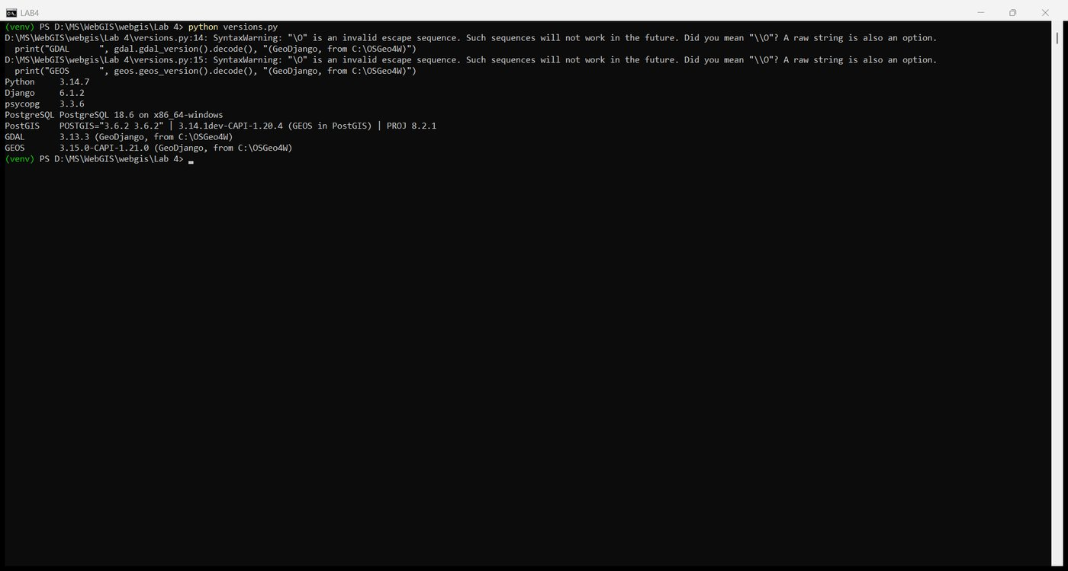
Figure 81. Every version number
Component | Version
Python | 3.14.7 (python.org, 64-bit)
Django | 6.1.2
psycopg | 3.3.6 (binary)
PostgreSQL | 18.6 on x86_64-windows
PostGIS | 3.6.2, with GEOS 3.14.1 and PROJ 8.2.1 inside the database
GDAL (GeoDjango, from C:\OSGeo4W) | 3.13.3
GEOS (GeoDjango, from C:\OSGeo4W) | 3.15.0
OSGeo4W | C:\OSGeo4W, installed for Lab 2
pgAdmin 4 | bundled with PostgreSQL 18

Installation errors met, and what fixed them
1. pgAdmin: "connection timeout expired" when connecting to the server. On first use pgAdmin showed "Multiple connection attempts failed. All failures were: host 'localhost', port 5432 ... connection timeout expired" for both ::1 and 127.0.0.1. The PostgreSQL service had not finished starting after the installer; waiting and retrying the connection succeeded, and the service has run normally since.
2. requirements.txt written as UTF-16. PowerShell's > redirection wrote the file in UTF-16 with a byte-order mark, which pip install -r on another machine may not read. The repository copy was re-encoded to UTF-8; the content is identical.
Nothing else went wrong: Python, OSGeo4W, PostgreSQL and PostGIS were already installed from earlier work, and every manage.py command ran first time. The basemap uses Esri's Light Gray Canvas tiles rather than OpenStreetMap's, because tile.openstreetmap.org answers page requests from this machine with its usage-policy block.

9.2 Commit and push
The project was copied into the course repository as lab4, without venv, and pushed.
cd D:\MS\WebGIS\webgis-lab
git status --short
git add -A
git commit -m "Lab 4: GeoDjango with PostGIS, admin and Leaflet"
git push
git log --oneline

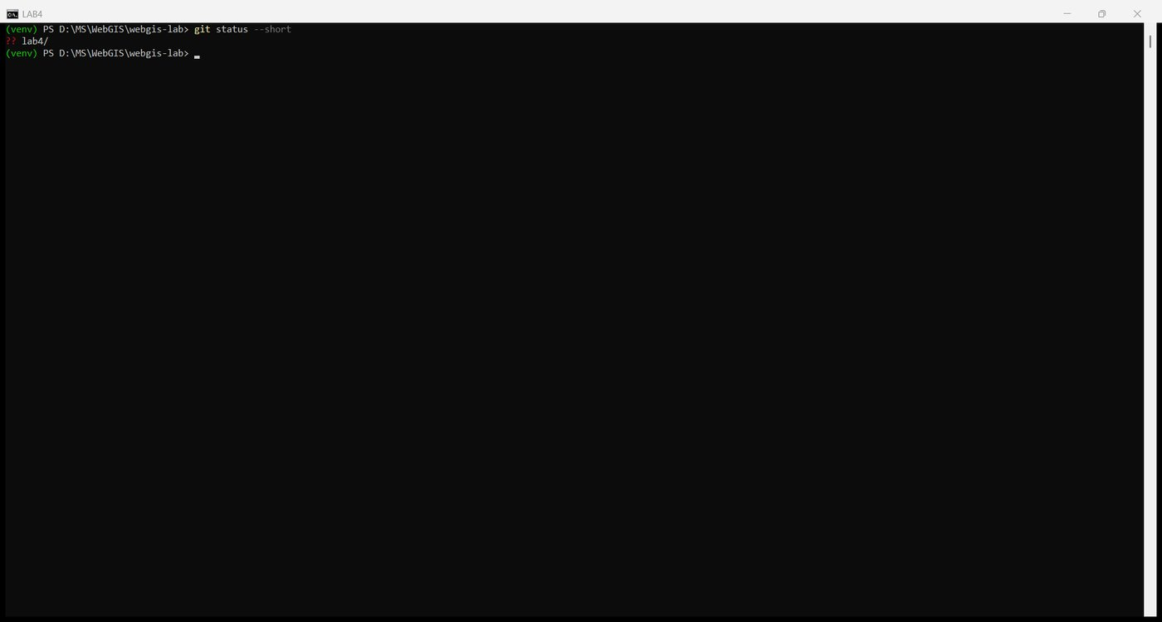
Figure 82. git status: lab4 untracked
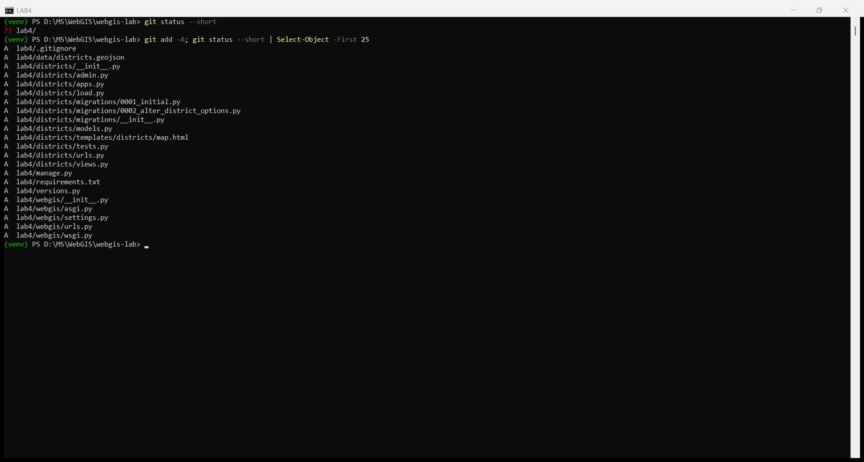
Figure 83. git add -A: 22 files, no venv
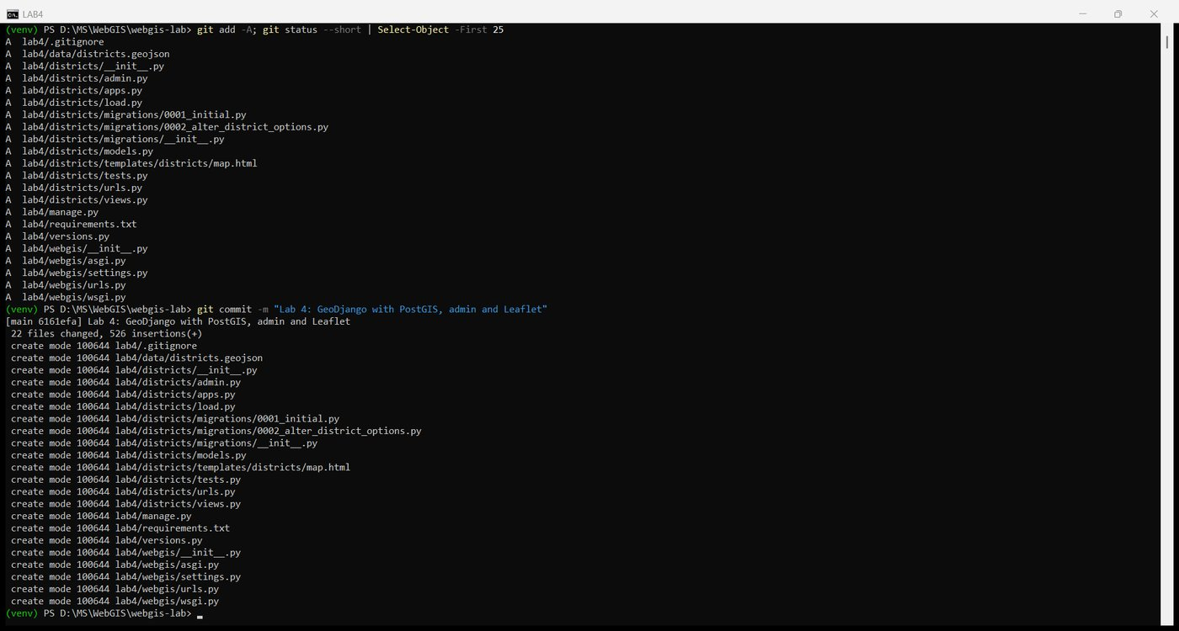
Figure 84. The Lab 4 commit
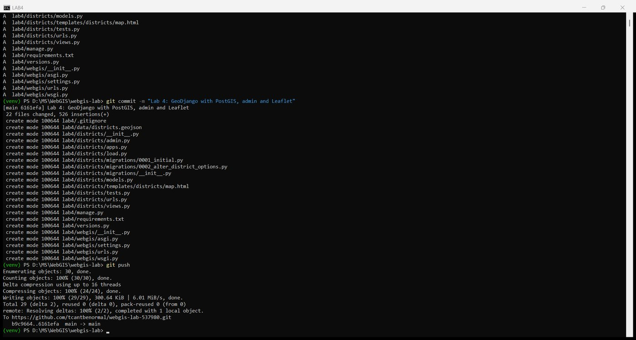
Figure 85. git push
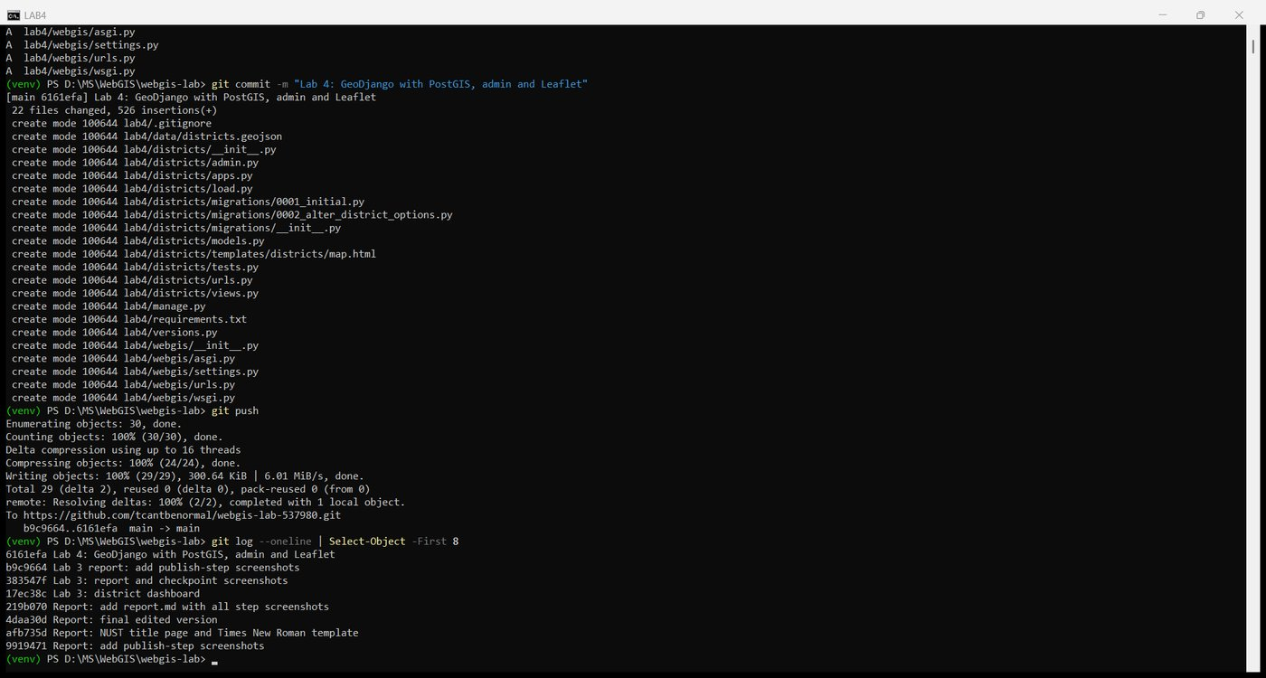
Figure 86. git log
This lab has no live URL: GitHub Pages serves files and cannot run Python or a database, so the project runs only on this machine. The submission is the repository and this report, added to lab4/ as report.md and report.docx in a second commit.
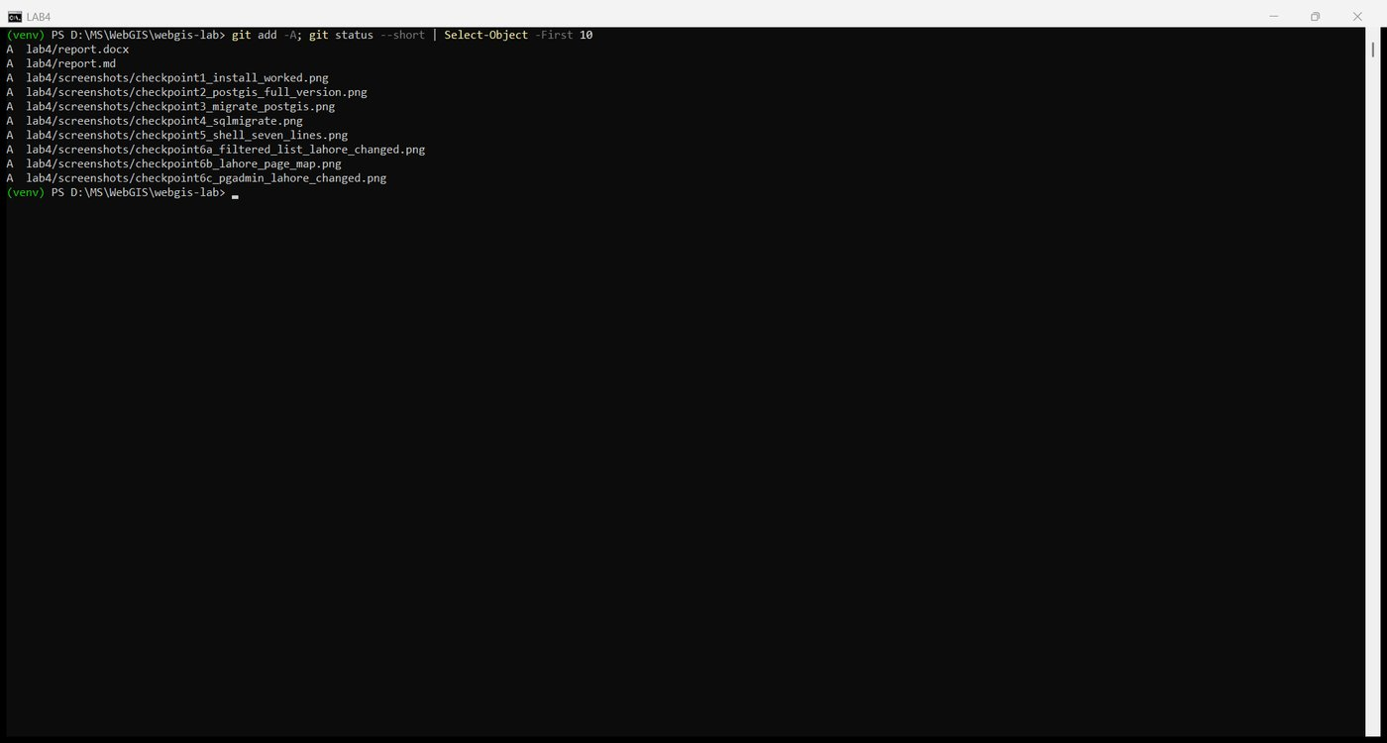
Figure 87. git add -A with the report and screenshots
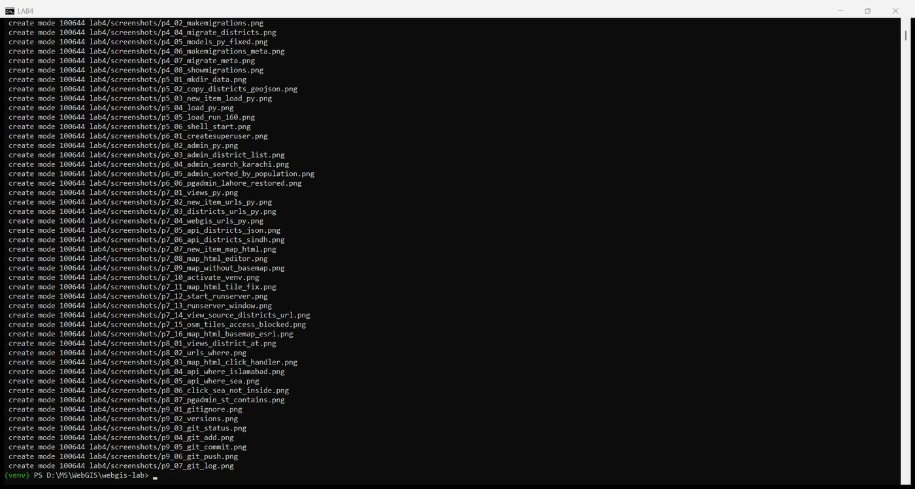
Figure 88. The report commit
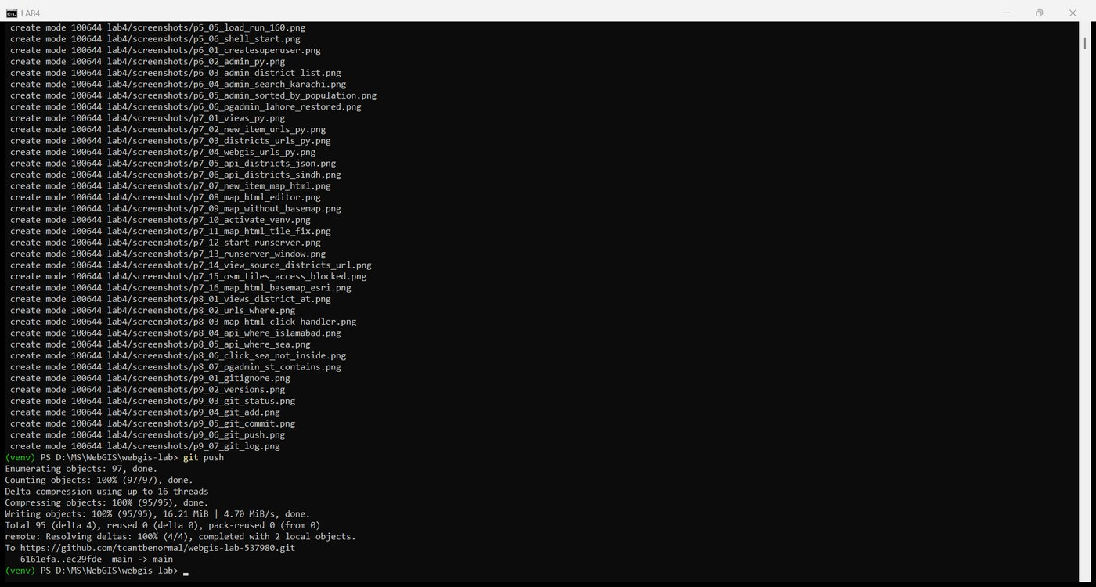
Figure 89. git push
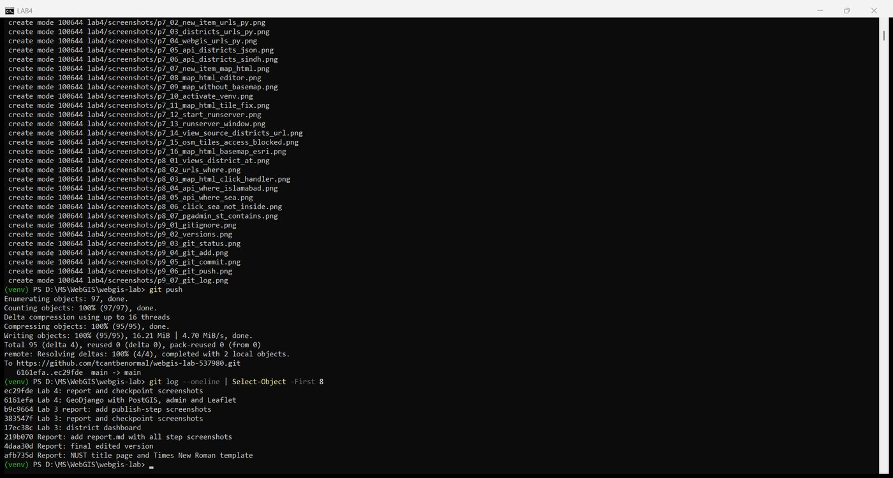
Figure 90. Final git log: both Lab 4 commits on top of Lab 3

Questions
1. In Labs 2 and 3, every visitor downloaded the whole GeoJSON file. What can a page backed by Django and PostGIS do instead? Give two examples from this lab.
It can send only what the visitor asked for, computed at the moment of asking. First, /api/districts/?province=Sindh makes the database do the filtering and returns 29 features rather than 160; the browser never receives the other provinces. Second, /api/where/?lat=...&lng=... sends a single point and gets back one small JSON answer, the district that contains it, instead of downloading every polygon and testing containment in JavaScript. Both answers come from the current table, so an edit in the admin is visible on the next request without anyone re-exporting a file.
2. Why does settings.py read the database password from an environment variable, instead of containing the password itself?
settings.py is committed to a public GitHub repository, and git keeps every version for ever, so a password written there is published and cannot be withdrawn by deleting it later. An environment variable lives only on the machine that runs the project; the committed file contains os.environ.get("WEBGIS_DB_PASSWORD", ""), which is harmless to publish, and each machine supplies its own value. The same pattern is used for any secret, and a server later in the course will have its own variable with its own password.
3. In Part 4, the SQL ends with an index created USING GIST. What does it do, and which query in this lab benefits from it?
A GiST index on the geometry column stores each district's bounding box in a tree, so a spatial query can discard every row whose box cannot possibly match without reading the geometry itself; only the few candidates whose boxes overlap are tested exactly. The query that benefits is Part 8's District.objects.filter(geom__contains=point), which becomes ST_Contains(geom, point) in SQL: with the index PostGIS looks at the handful of districts whose boxes contain the point instead of running the containment test on all 160. GeoDjango creates the index on every geometry field without being asked, because without it every spatial query would be a full scan.
4. The loading script wraps some geometries in a MultiPolygon. What would happen without that step, and why?
The column was declared geometry(MULTIPOLYGON, 4326), so PostGIS enforces the type on every insert. The file holds 152 plain Polygon features and 8 MultiPolygons, and GDAL reports the layer type as Unknown. Without the wrap, the first Polygon feature, Bagh, would be rejected with a geometry-type constraint error and the load would stop with nothing saved; the script's delete at the start would also have emptied the table. Wrapping each Polygon in a MultiPolygon of one part satisfies the column and changes nothing on the map. GeoDjango's LayerMapping shortcut refuses a mixed layer outright, which is why the script reads the features one by one.
5. Who should have an admin login for a district dataset like this, and who should not?
The admin is for the few people who maintain the data: whoever is responsible for keeping names, codes, census figures and boundaries correct, for example a data custodian at the bureau of statistics or the GIS officer who loaded the layer. Anyone who can log in can change or delete every row, and the change is an immediate UPDATE on the table. The public, students, analysts and the map's readers should not have a login; they get the data through the read-only API and the map page. Where someone needs to edit but not delete, the admin's own Users and permissions can grant change without delete, which is still more trust than a casual user should be given.
6. Leaflet takes [lat, lng] and Point takes (lng, lat). Where in this lab is each order used, and how does the extension's URL avoid confusing them?
Latitude first is used wherever Leaflet is given a position by hand: setView([30.3753, 69.3451], 5), maxBounds: [[21.5, 58.5], [39.0, 80.5]], and the e.latlng object of a map click. Longitude first is used by everything that follows the GeoJSON and GEOS convention: the coordinates inside districts.geojson and the API's GeoJSON, Point(lng, lat, srid=4326) in the view, and ST_MakePoint(72.9906, 33.6423) in SQL. The extension's URL names the two numbers, ?lat=33.6423&lng=72.9906, so the order in which they appear carries no meaning; the view reads request.GET["lat"] and request.GET["lng"] by name and puts them into Point(lng, lat) itself. The conversion between the two conventions therefore happens in exactly one place, inside the view, where it is written down.

Submission
- Repository URL: https://github.com/tcantbenormal/webgis-lab-537980 (folder lab4)
- Live URL: none for this lab; the project runs only on the local machine.

