Web GIS Lab 02: District Explorer
Course: Web GIS, MS Remote Sensing and GIS, Batch 2025
Institute: IGIS, SCEE, NUST Islamabad
Instructor: Dr. Shahid Nawaz Khan
Student: tcantbenormal (roll number 537980)
Date: 12 October 2026
Repository: https://github.com/tcantbenormal/webgis-lab-537980
Live page: https://tcantbenormal.github.io/webgis-lab-537980/

How this run differs from the handout
The lab was completed on a personal laptop. Every step of the handout was carried out, but a few tools were substituted. Each substitution is noted again where it applies.
Handout says | What was done here | Why
Project folder C:\webgis-lab | D:\MS\WebGIS\webgis-lab | Kept with the course material. No spaces in the path and not inside OneDrive, so both of the handout's warnings are still respected.
VS Code with Live Server on port 5500 | PowerShell for every command, and Python's built-in server: python -m http.server 5500 --bind 127.0.0.1 | VS Code is not installed on this machine. The page is still served over HTTP at 127.0.0.1:5500, which is what the Live Server step is for.
Shapefile downloaded from LMS, about 24 MB zipped | The original OCHA bundle (25.5 MB) downloaded from the Humanitarian Data Exchange, then the LMS renaming and census join reproduced with a short script | The Lab 2 folder only held the finished districts.geojson. To measure the shapefile and do the four exports honestly, the raw data had to be fetched. Field names and pop_2023 were taken from the supplied file, matched on pcode.
QGIS dialogs for Export, Simplify and the Field Calculator | The same QGIS toolchain from the command line: ogr2ogr for every export (the engine behind Save Features As) and qgis_process run native:simplifygeometries for Simplify. QGIS itself was used for the attribute table and the Checkpoint 2 overlay. | Every operation could then be screenshotted as one command with its output, as requested.
Network throttle preset "Slow 3G" | Preset "3G" | Chrome 155 no longer offers Slow 3G. Its presets are Fast 4G, Slow 4G, 3G and Offline.
Open the live URL on a phone over mobile data | Not done | No second device was available during the run. The live page was verified from the laptop over the public internet instead.

Part 1: Set up the project

1.1 Create the folder
Each handout command was run on its own in a PowerShell window titled LAB2.
cd D:\MS\WebGIS
mkdir webgis-lab
cd D:\MS\WebGIS\webgis-lab
mkdir data

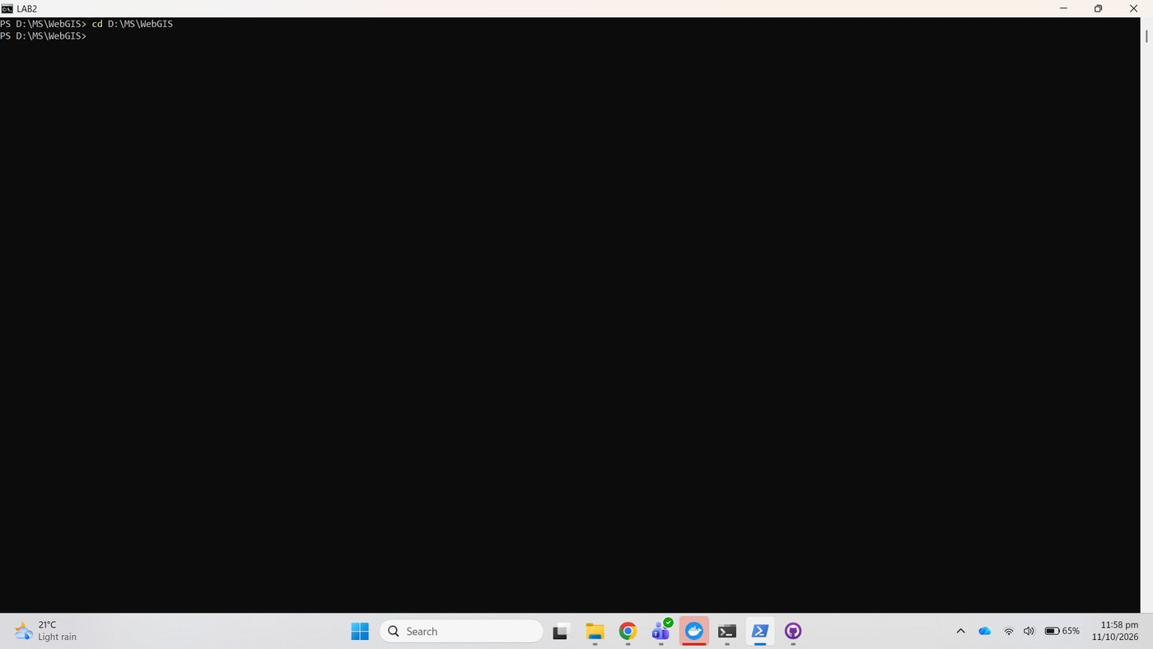
Figure 1. cd to the course folder
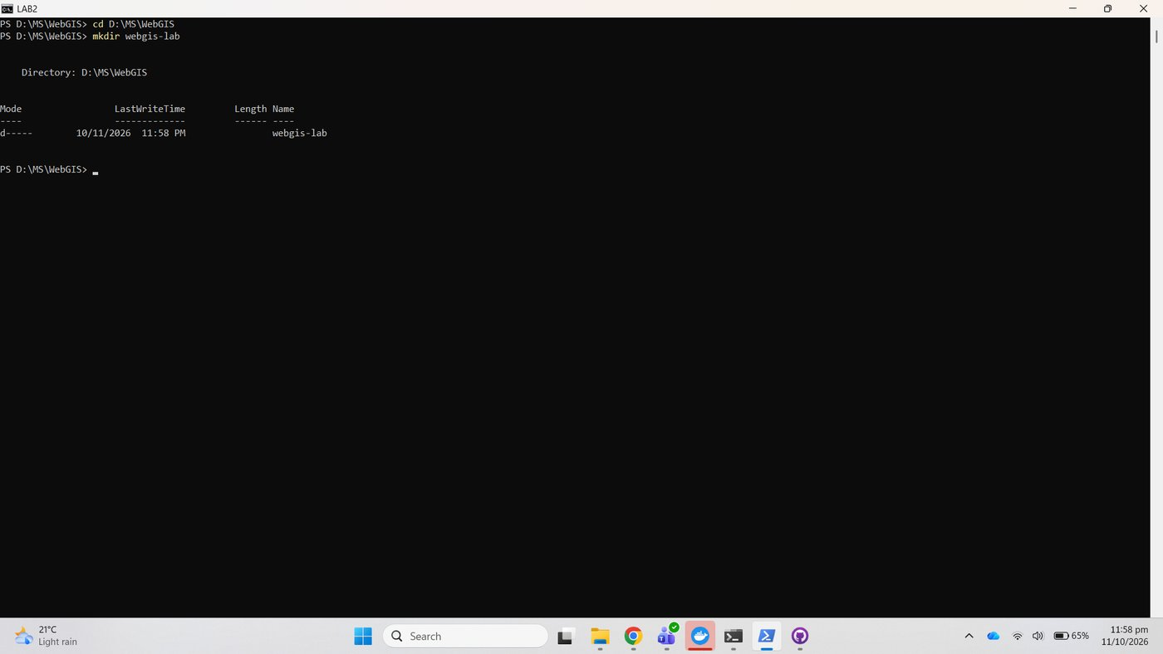
Figure 2. mkdir webgis-lab
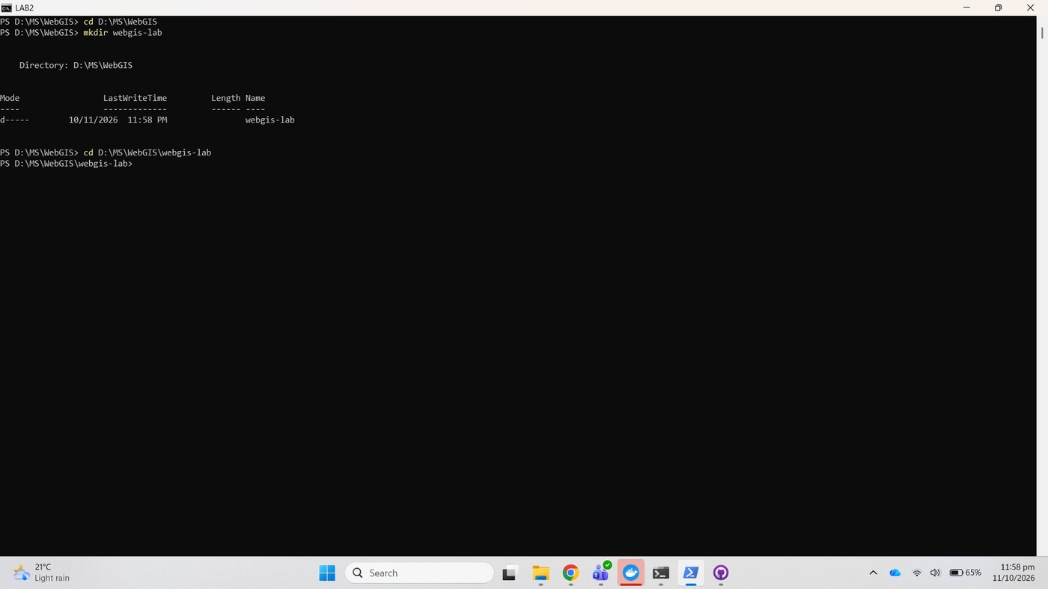
Figure 3. cd into the project folder
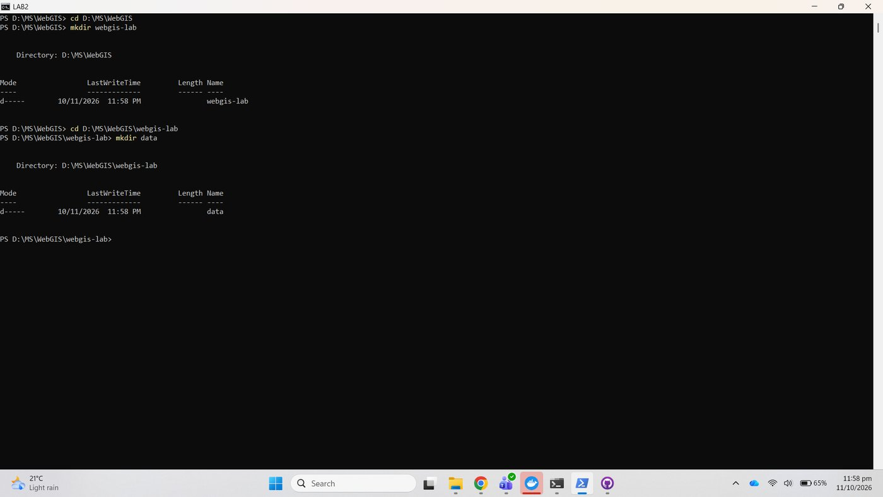
Figure 4. mkdir data

1.2 Create the repository
The GitHub repository webgis-lab-537980 was created public with no README, .gitignore or licence. The folder was then connected to it:
git init
git branch -M main
git remote add origin https://github.com/tcantbenormal/webgis-lab-537980.git

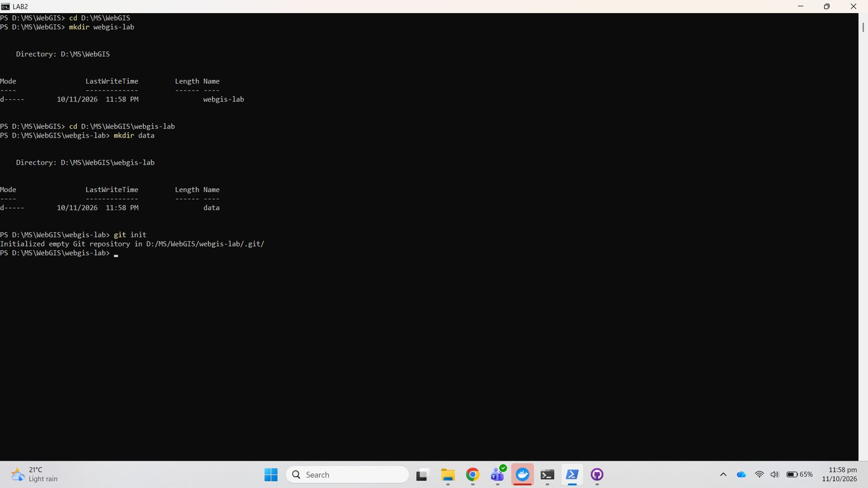
Figure 5. git init
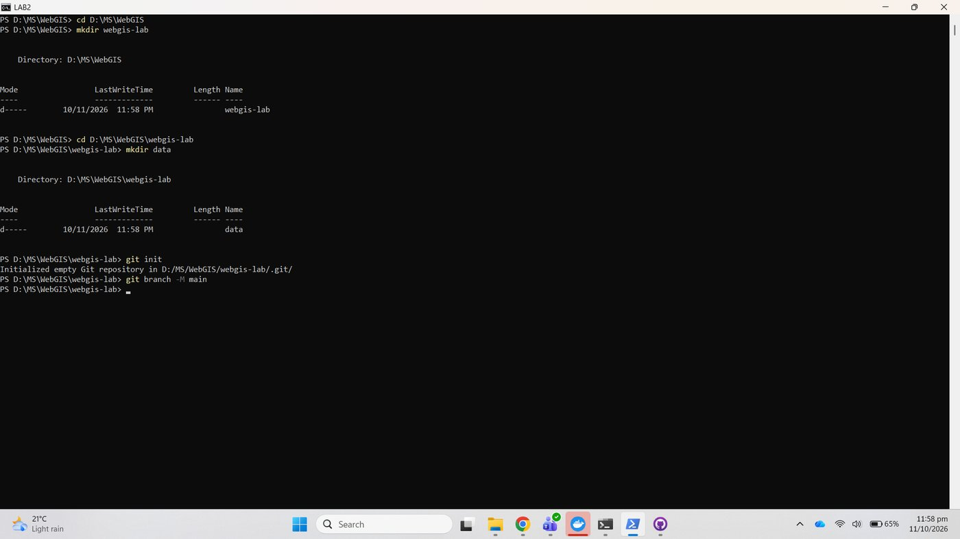
Figure 6. git branch -M main
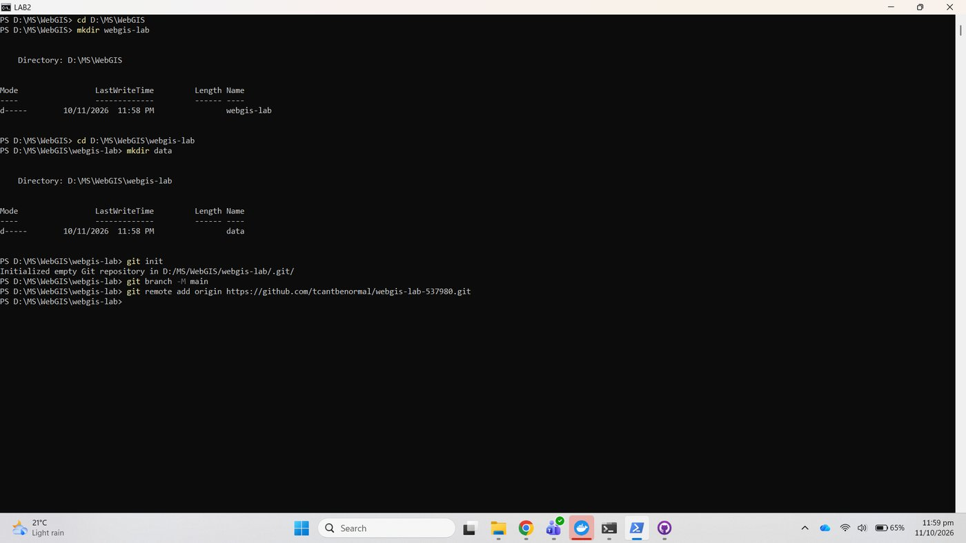
Figure 7. git remote add origin

1.3 Create the three files
Without VS Code, the three empty files were created with one PowerShell command and listed:
New-Item index.html, style.css, app.js -ItemType File
Get-ChildItem

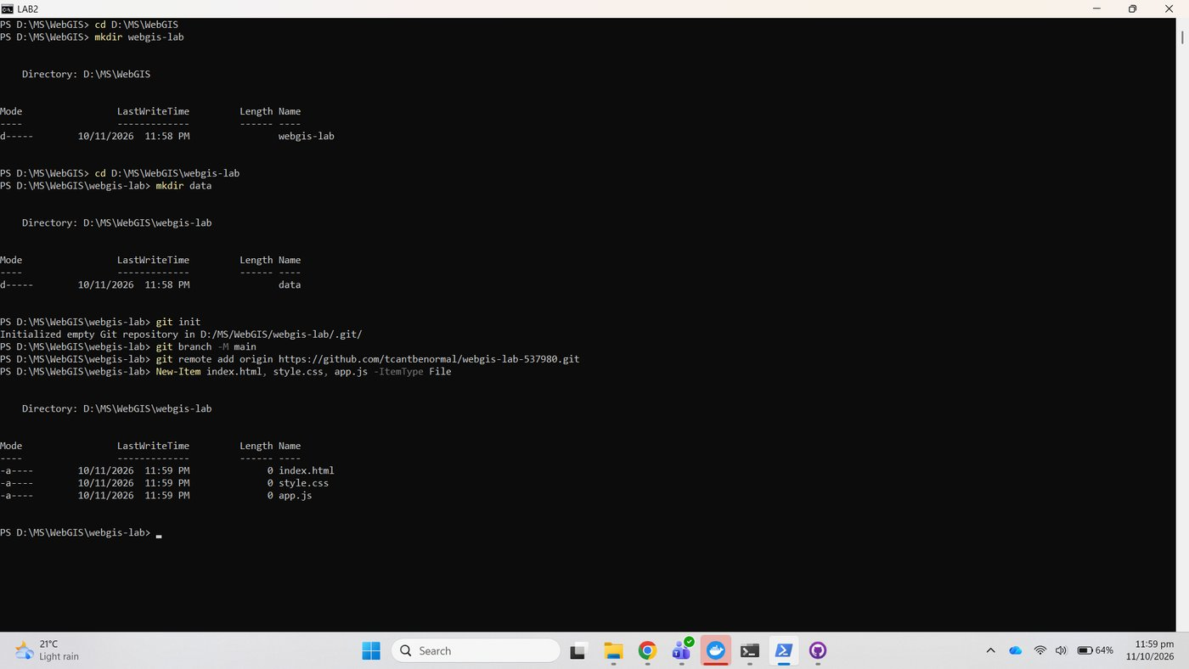
Figure 8. New-Item creates the three files
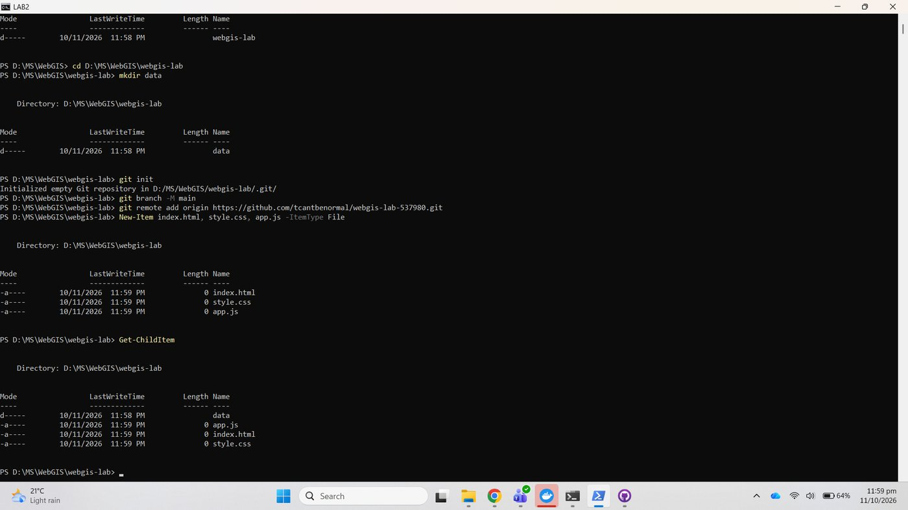
Figure 9. Get-ChildItem shows the four entries

Checkpoint 1
The handout asks for VS Code showing the folder. The stand-in is File Explorer opened from the console with explorer ., showing index.html, style.css, app.js and the empty data folder.
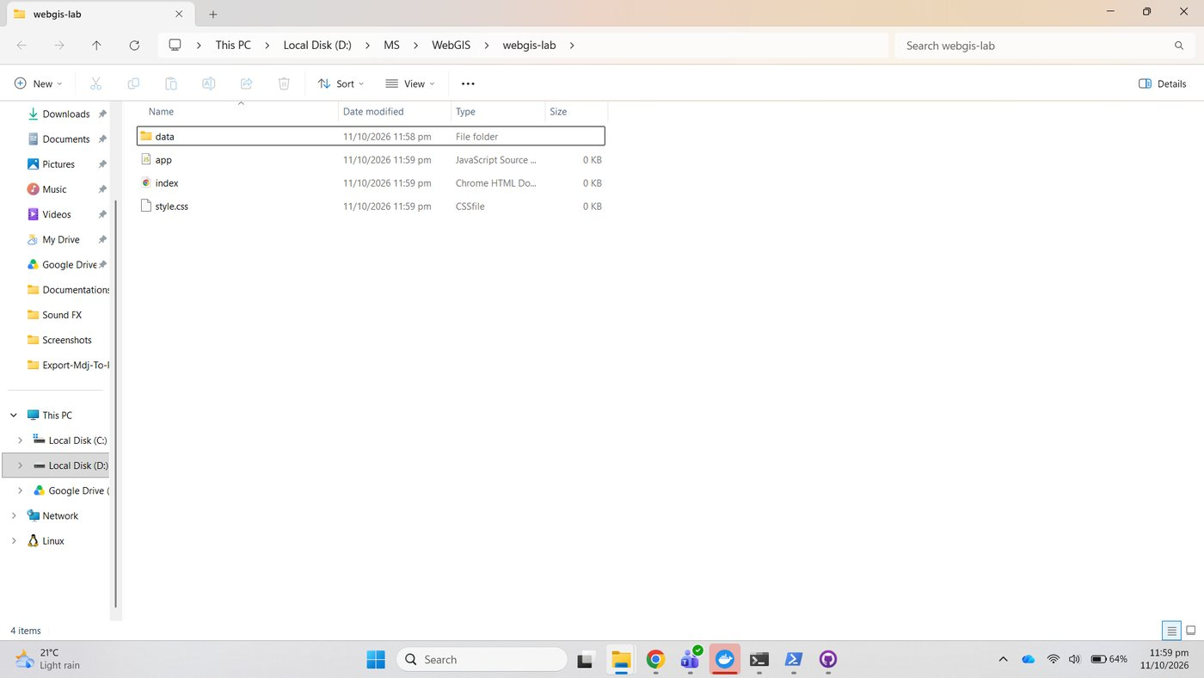
Figure 10. explorer . opens the project folder
Figure 11. Checkpoint 1: project folder with the three files and the data folder

Part 2: Prepare the data

2.0 Tools and the LMS copy of the shapefile
GDAL and QGIS come with OSGeo4W, so their bin folder was added to the console's PATH (appended, not prepended, so that the system Python stays first) and PROJ_LIB was pointed at OSGeo4W's own PROJ database.
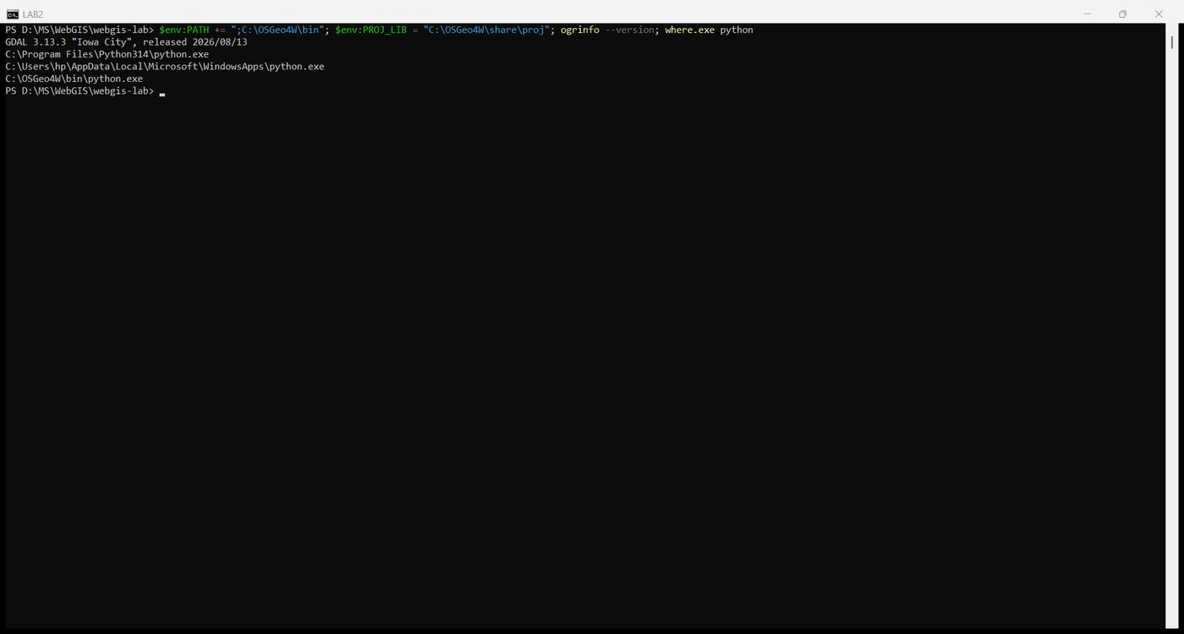
Figure 12. OSGeo4W tools on the PATH, ogrinfo version
The raw OCHA download was unzipped into D:\MS\WebGIS\lab2-data\download\shp, outside the project, so raw data is never committed. The admin level 2 layer pak_admin2 has 160 features and the fields adm2_name, adm1_name, adm2_pcode and area_sqkm, exactly as the handout warns.
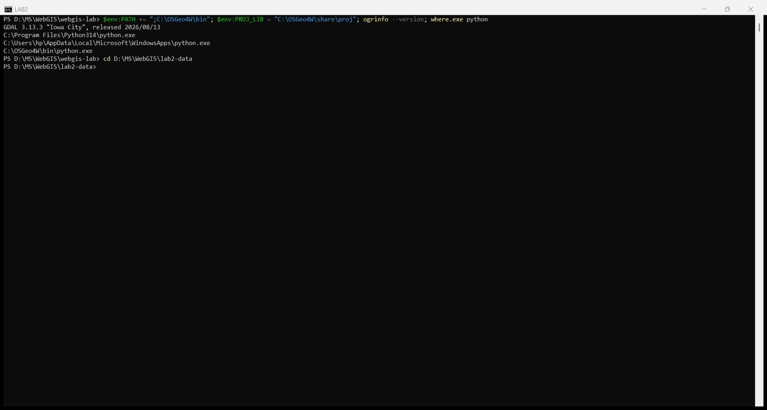
Figure 13. cd to the working folder
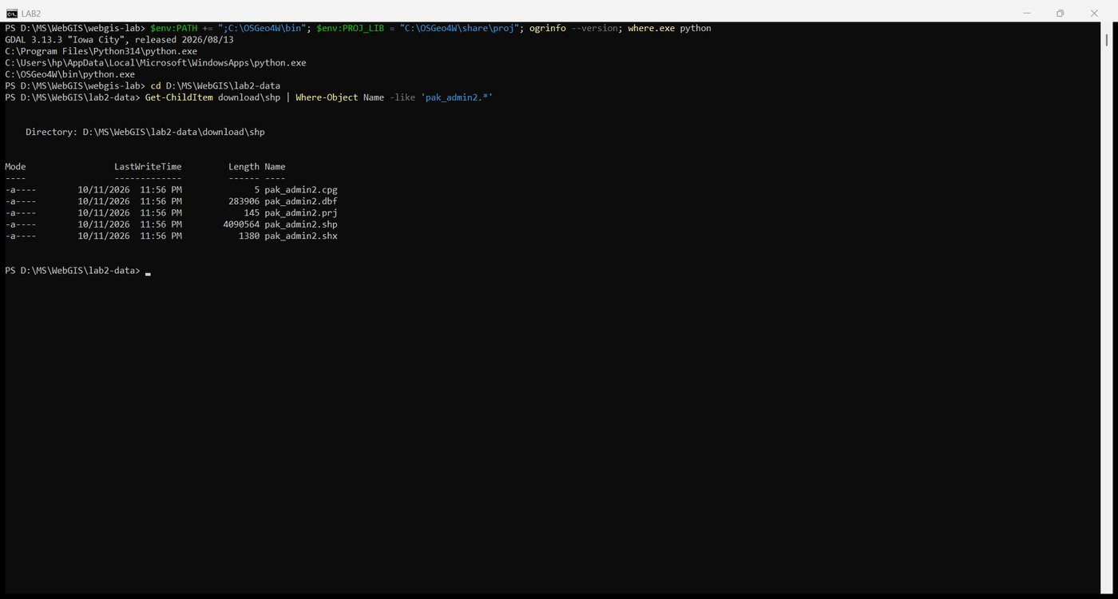
Figure 14. The adm2 components of the download
make_lms_copy.py rebuilds the LMS layer: it renames the four fields to district, province, pcode and area_km2 (one decimal) and joins pop_2023 from the supplied districts.geojson on pcode. 135 districts receive a population and 25 stay empty, matching the handout.
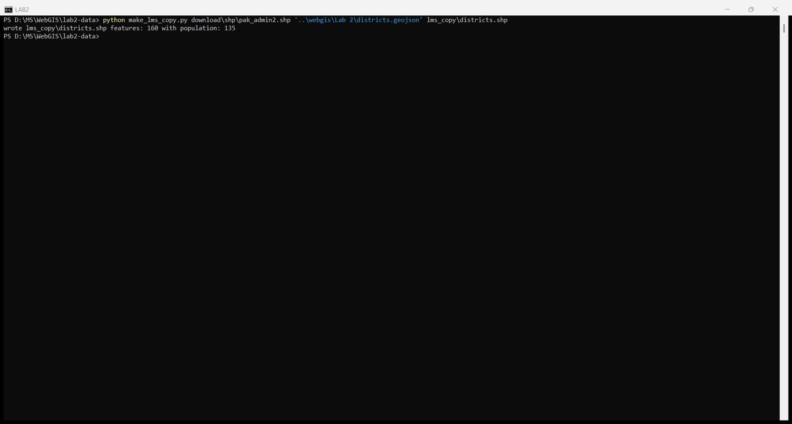
Figure 15. make_lms_copy.py writes lms_copy\districts.shp

2.1 Inspect what you were given
ogrinfo -so is the command-line form of Layer Properties, Information. It reports the geometry type, the feature count (160), the extent, the CRS (WGS 84, EPSG:4326) and the field types: district, province, pcode as String, pop_2023 as Integer64 and area_km2 as Real. The population column is numeric, so classification will work.
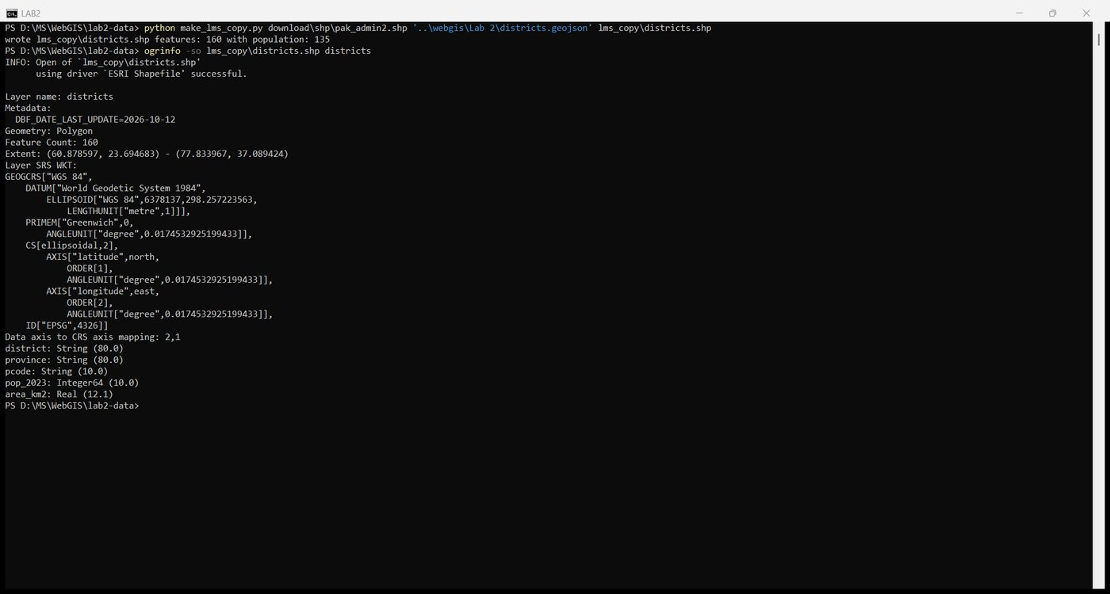
Figure 16. ogrinfo: fields, types, CRS and feature count
The five shapefile components add up to 4,123,167 bytes (4.12 MB).
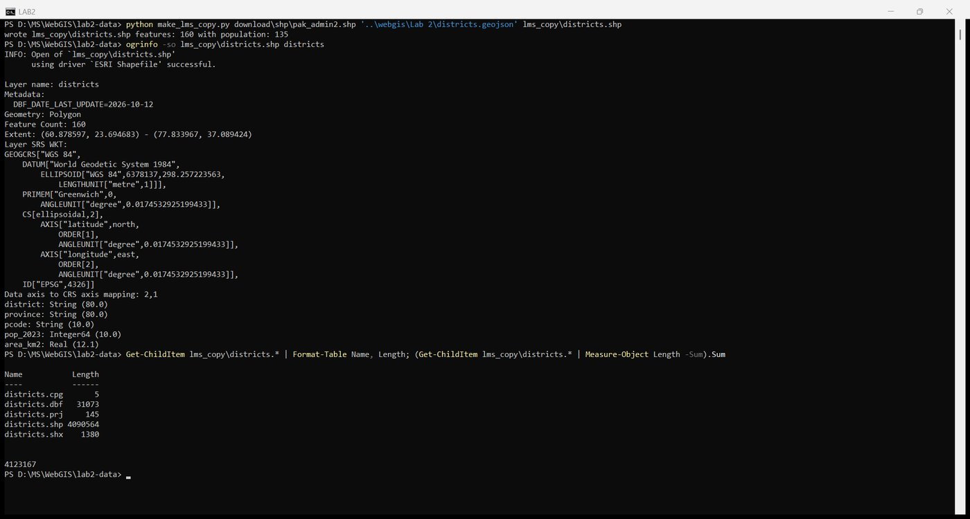
Figure 17. Shapefile component sizes and their sum
The layer was also opened in QGIS and the attribute table inspected with F6. The 24 Azad Kashmir and Gilgit-Baltistan districts show NULL population, as expected.
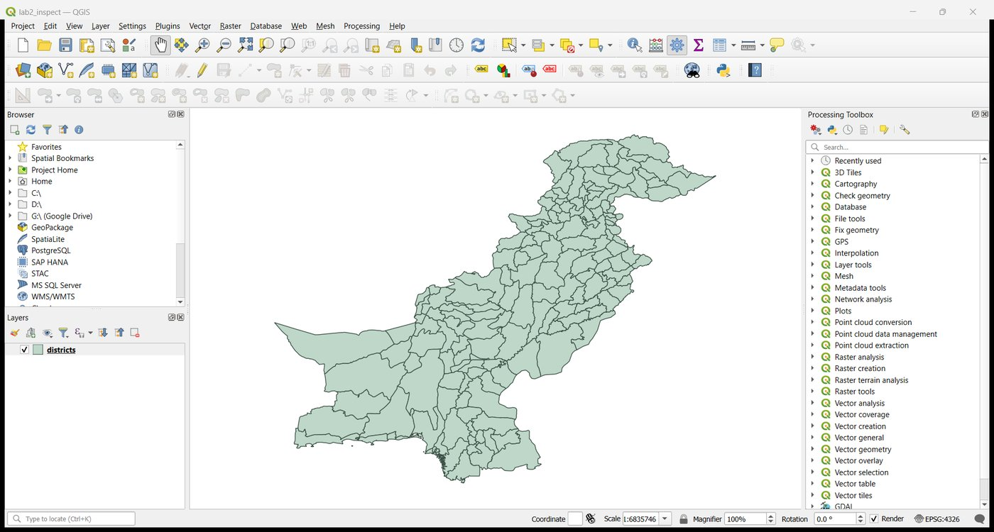
Figure 18. The LMS copy loaded in QGIS
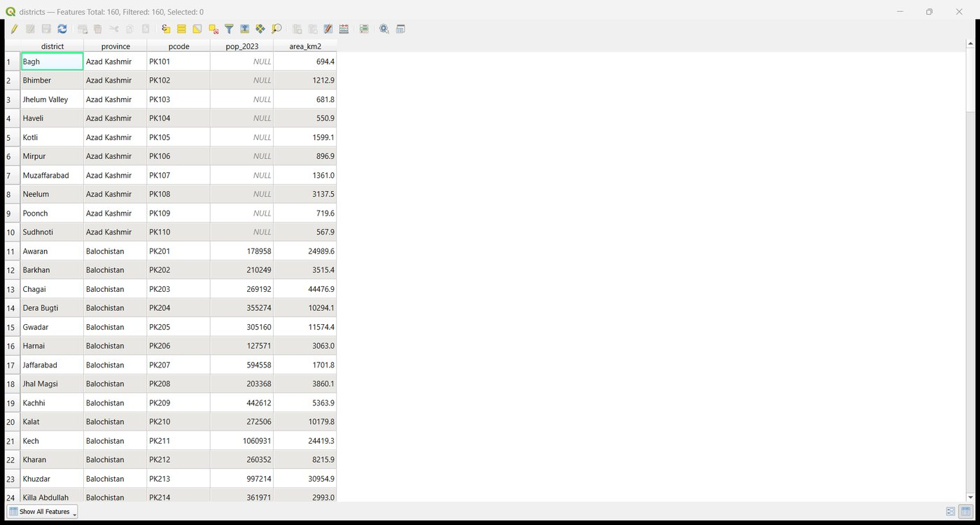
Figure 19. Attribute table in QGIS: 160 features, population NULL in Azad Kashmir

2.2 Version A: a straight conversion
ogr2ogr -f GeoJSON districts_A.geojson lms_copy\districts.shp -t_srs EPSG:4326

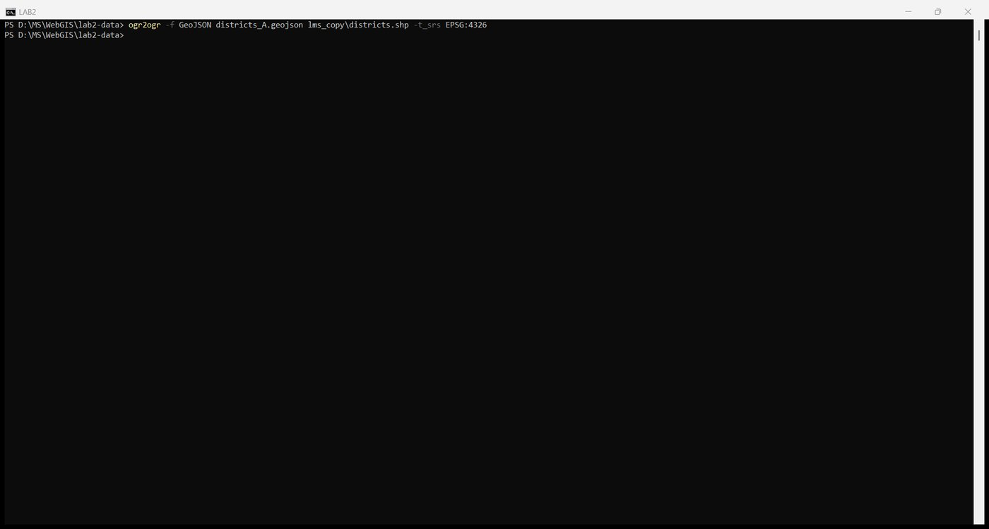
Figure 20. Export A

2.3 Version B: reduced coordinate precision
The COORDINATE_PRECISION layer option is the same setting as in the Save Features As dialog.
ogr2ogr -f GeoJSON districts_B.geojson lms_copy\districts.shp -t_srs EPSG:4326 -lco COORDINATE_PRECISION=5

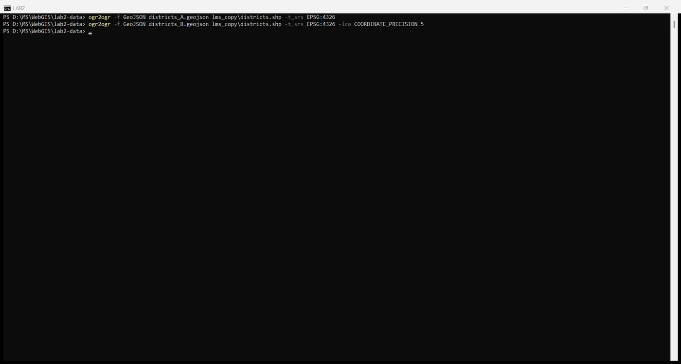
Figure 21. Export B with five decimal places

2.4 Versions C and D: simplified geometry
Simplify was run twice on the original layer with the QGIS processing algorithm (method 0 is Douglas-Peucker, the distance method the dialog uses by default), then each result was exported with precision 5.
qgis_process-qgis-ltr.bat run native:simplifygeometries --INPUT=lms_copy\districts.shp --METHOD=0 --TOLERANCE=0.001 --OUTPUT=simplified_C.geojson
qgis_process-qgis-ltr.bat run native:simplifygeometries --INPUT=lms_copy\districts.shp --METHOD=0 --TOLERANCE=0.01 --OUTPUT=simplified_D.geojson
ogr2ogr -f GeoJSON districts_C.geojson simplified_C.geojson -lco COORDINATE_PRECISION=5
ogr2ogr -f GeoJSON districts_D.geojson simplified_D.geojson -lco COORDINATE_PRECISION=5

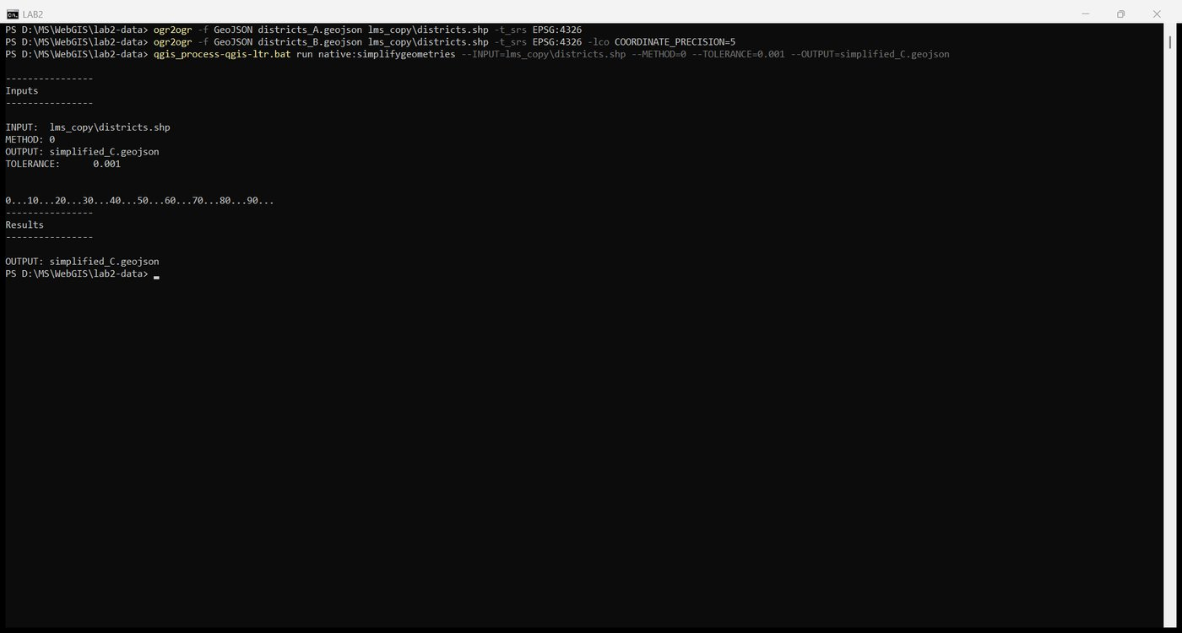
Figure 22. Simplify, tolerance 0.001 degrees
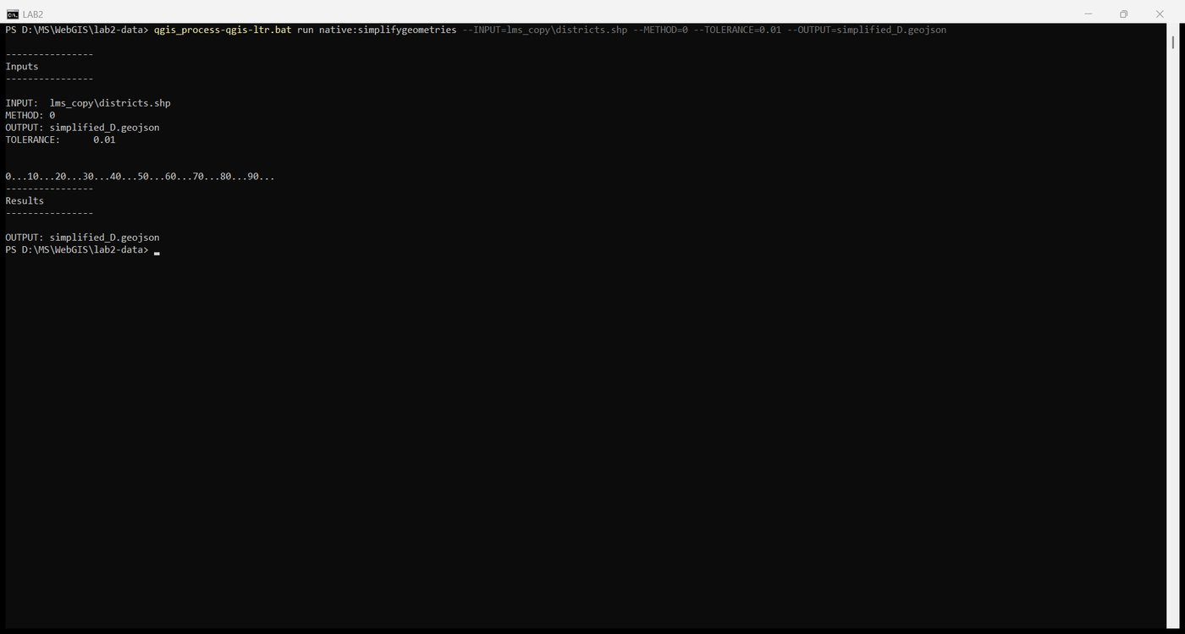
Figure 23. Simplify, tolerance 0.01 degrees
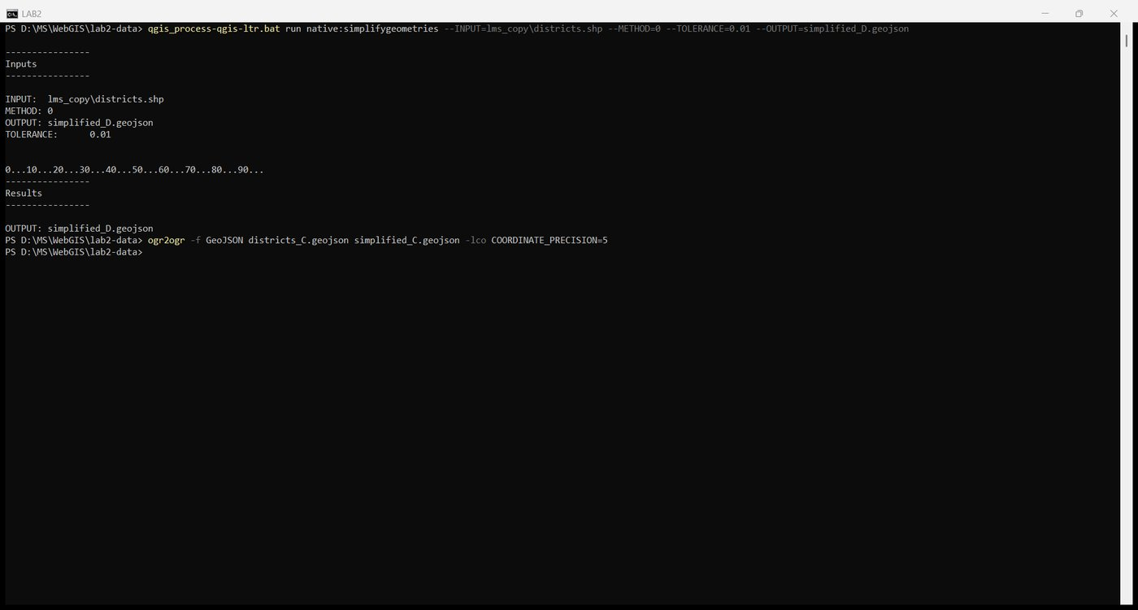
Figure 24. Export C with precision 5
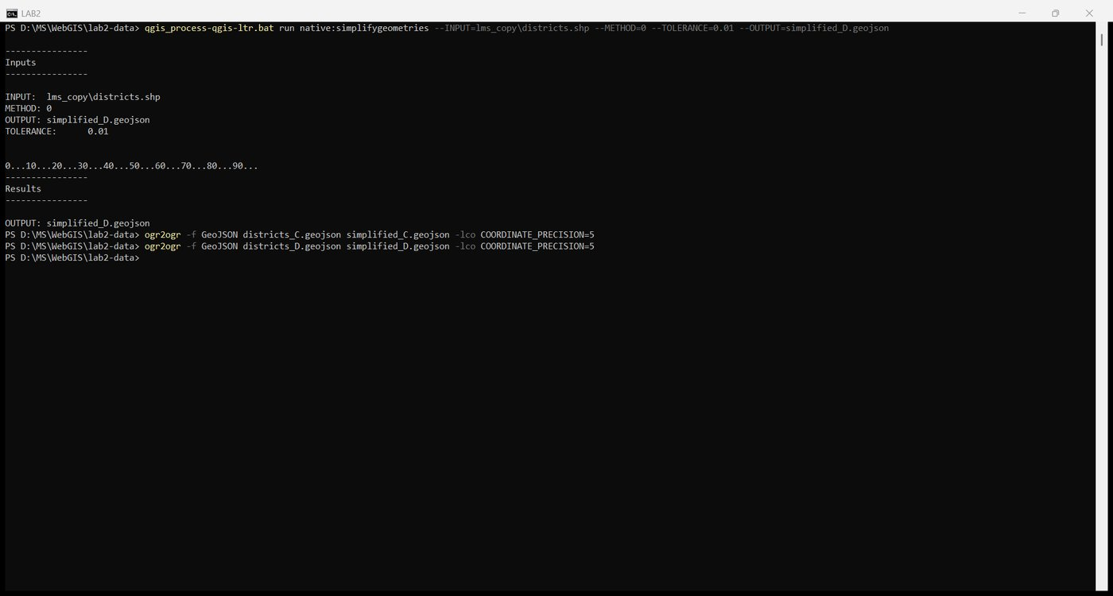
Figure 25. Export D with precision 5

2.5 Record your measurements
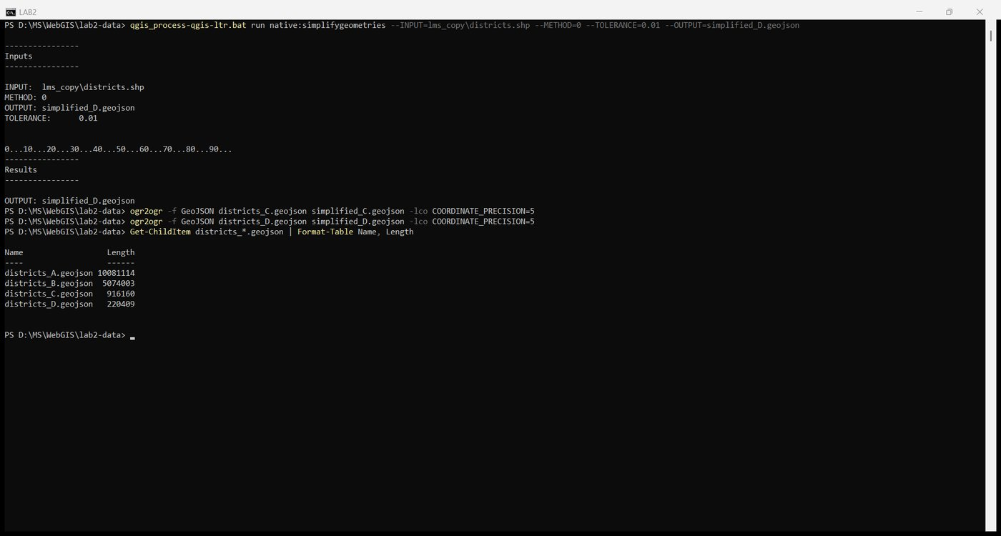
Figure 26. Sizes of the four GeoJSON versions
Version | What was done | Size (bytes) | Size | % of A
Shapefile | .shp + .shx + .dbf + .prj + .cpg of the adm2 layer | 4,123,167 | 4.12 MB | n/a (41%)
A | Straight conversion, default precision | 10,081,114 | 10.08 MB | 100%
B | Precision 5 | 5,074,003 | 5.07 MB | 50.3%
C | Simplified 100 m, precision 5 | 916,160 | 0.92 MB | 9.1%
D | Simplified 1 km, precision 5 | 220,409 | 0.22 MB | 2.2%

For reference, the file supplied in the Lab 2 folder is 933,119 bytes, almost identical to version C, which suggests it was produced the same way.
Why GeoJSON A is larger than the shapefile it came from. A shapefile stores every coordinate as an 8-byte binary double, so 16 bytes per vertex regardless of the value. GeoJSON writes each coordinate as decimal text with up to 15 significant digits plus brackets, commas and spaces, about 40 bytes per vertex, and repeats every property name in every feature. The published download sizes quoted in the handout (24.3 MB shapefile bundle versus 27.7 MB GeoJSON) show the same effect; here the ratio is 2.4 to 1 because the adm2 .dbf is small. Cutting the precision to five decimals halves the file; throwing away vertices the eye cannot see at the map's scale removes another 80 percent.
Version C was copied into the project as the file the map will use:
copy districts_C.geojson D:\MS\WebGIS\webgis-lab\data\districts.geojson

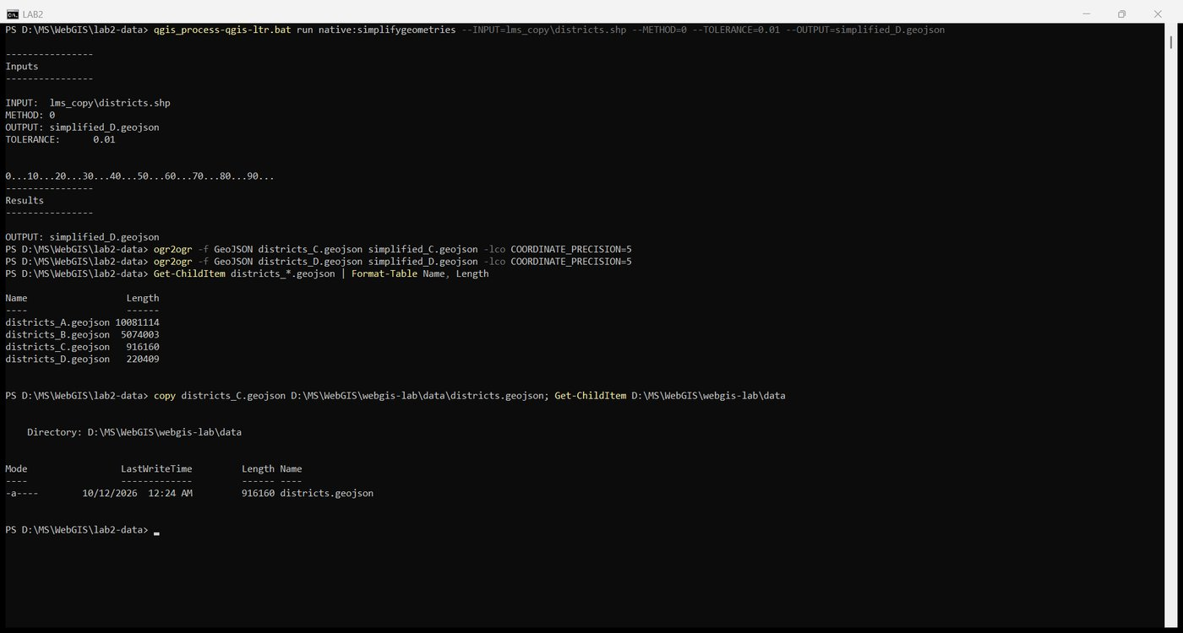
Figure 27. Copy version C into the project's data folder

Checkpoint 2
Versions A (grey fill, dark outline) and D (red outline) drawn together in QGIS, zoomed to the district boundaries around Bagh and Muzaffarabad. The 1 km simplification cuts across every bend of the original line.
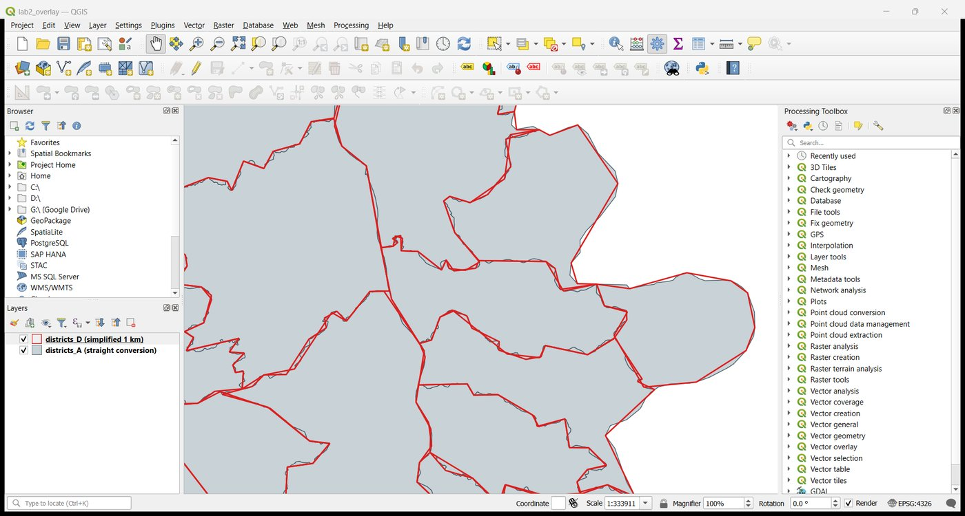
Figure 28. Checkpoint 2: version A and version D together in QGIS

Part 3: Read the data as text

3.1 Open it
Instead of VS Code's formatter, python -m json.tool wrote a formatted copy to a separate file. Formatting put every number on its own line and grew the file from 916,160 to 6,705,645 bytes, more than seven times, which is why the formatted copy is never the one served.
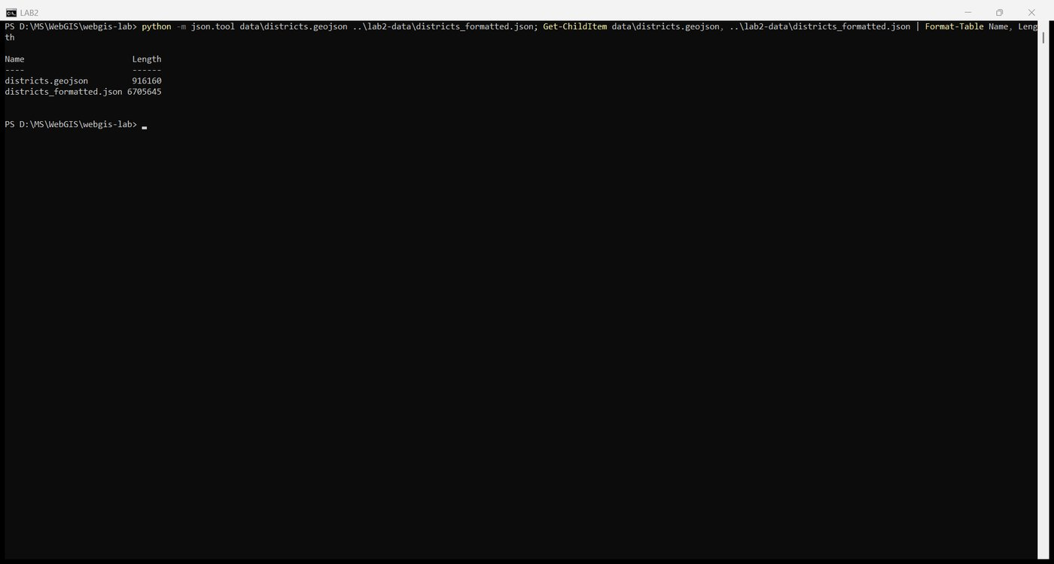
Figure 29. Format a copy and compare sizes
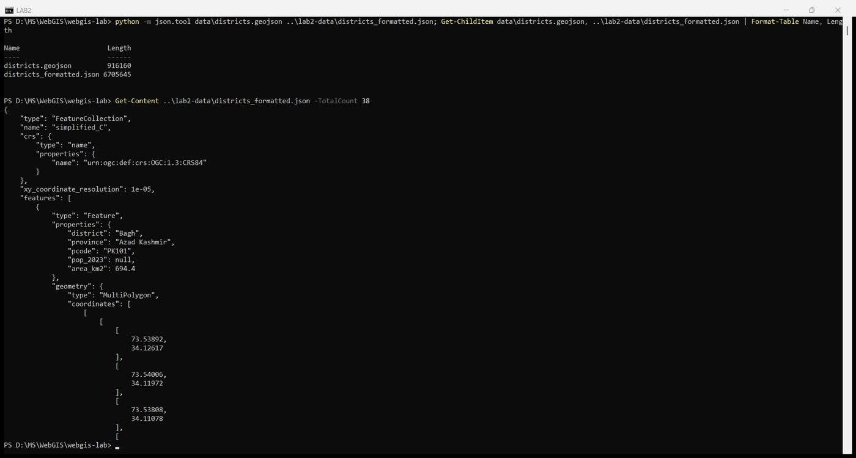
Figure 30. The first 38 lines of the formatted copy

3.2 Find the structure
Each answer was read from the file with a one-line Python command.
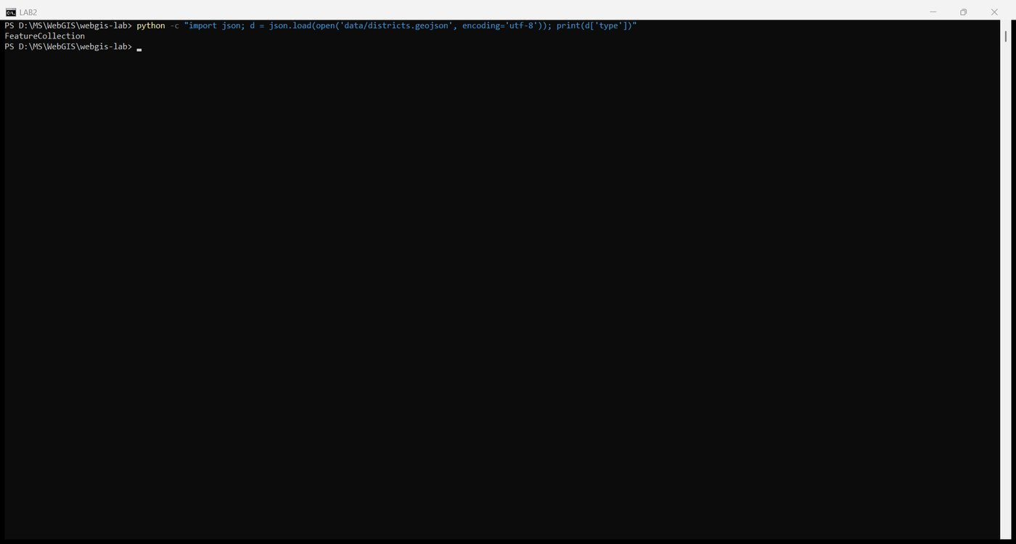
Figure 31. Outer object type
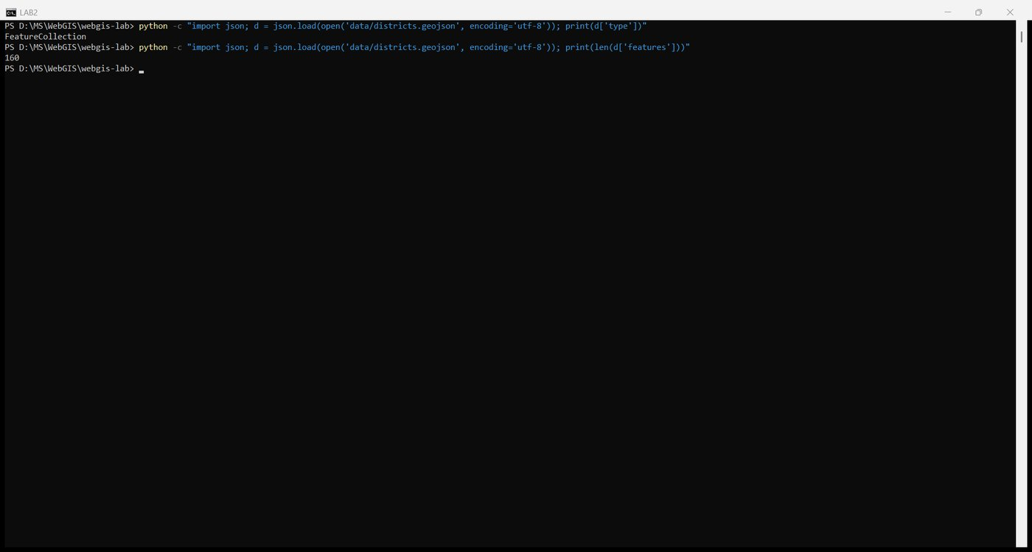
Figure 32. Number of entries in features
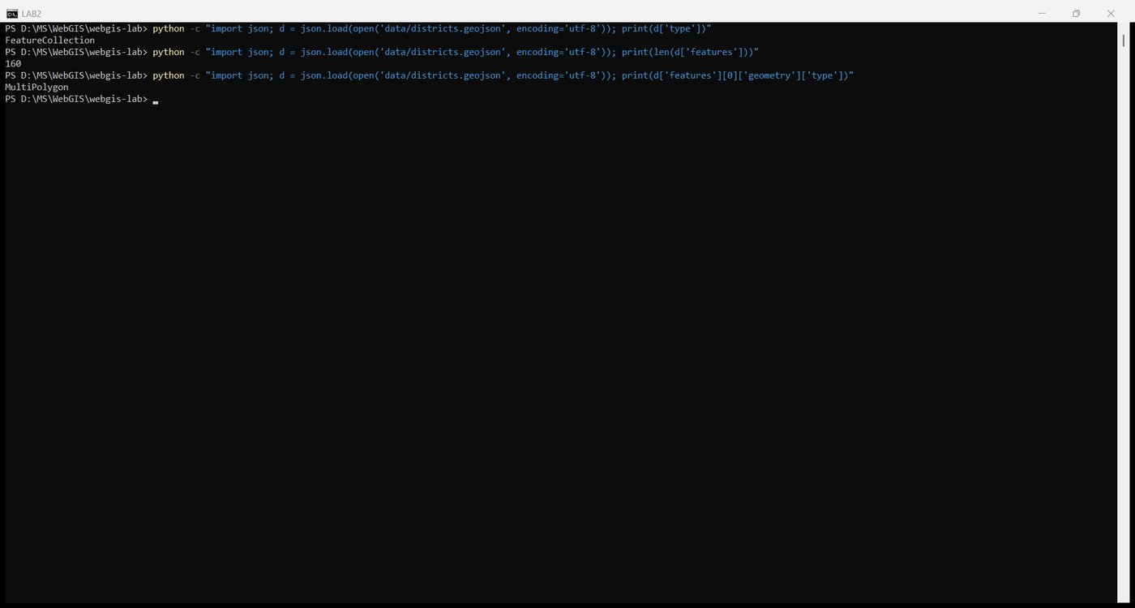
Figure 33. Geometry type of the first feature
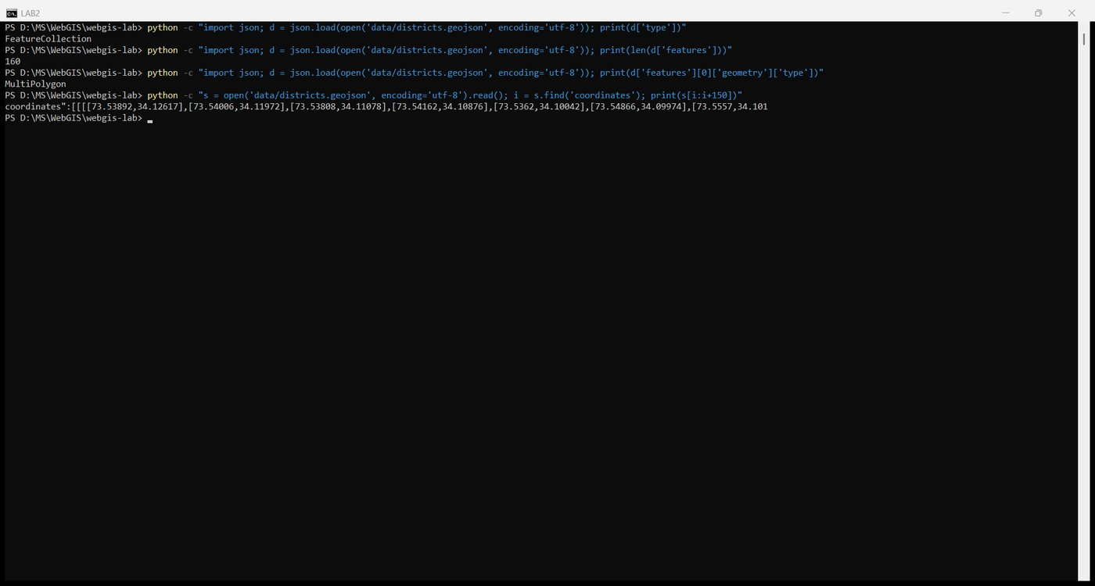
Figure 34. Brackets before the first number
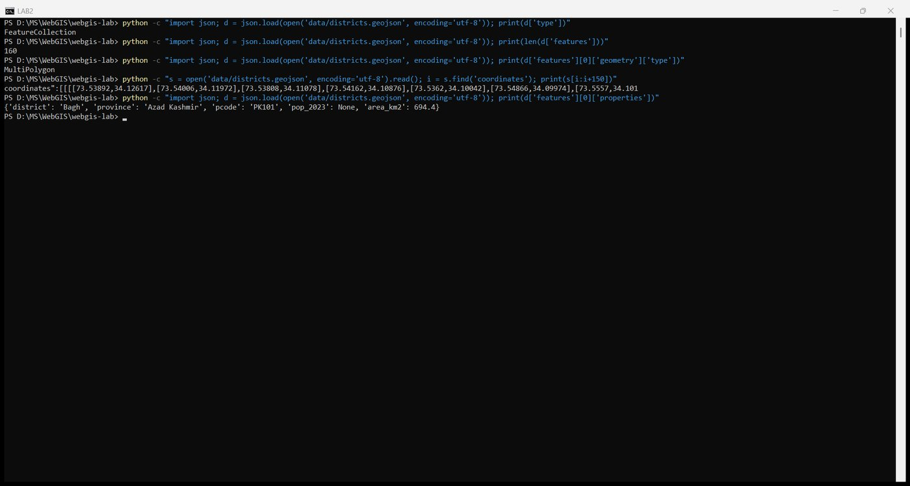
Figure 35. Keys inside properties

3.3 Check the coordinate order and 3.4 that the rings close
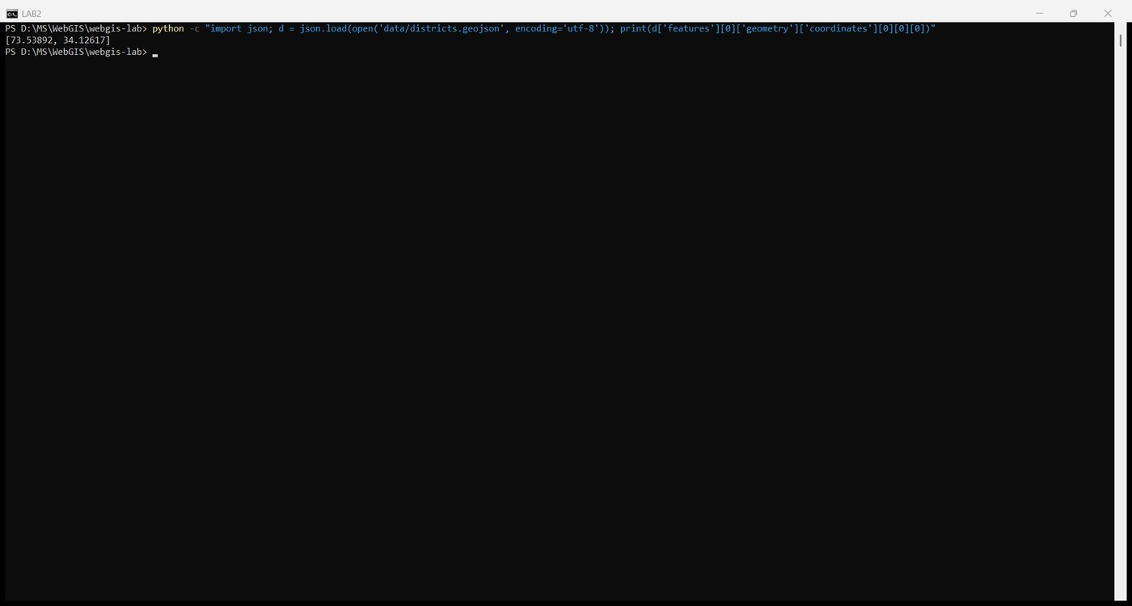
Figure 36. The first coordinate pair
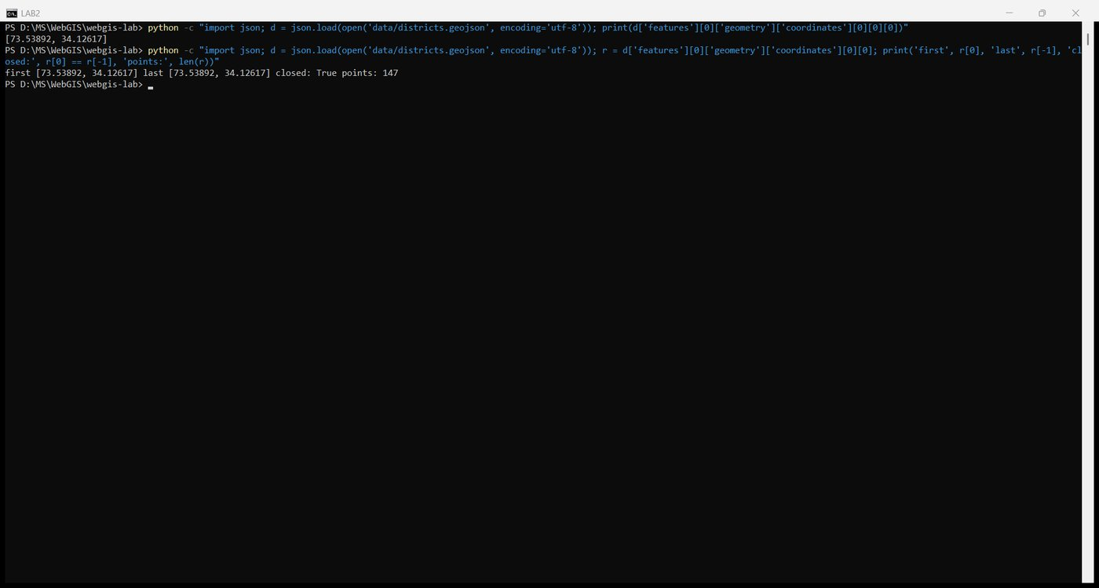
Figure 37. First and last pair of the outer ring

Checkpoint 3
1. Type of the outermost object: FeatureCollection.
2. Entries in the features array: 160, matching the QGIS feature count.
3. Geometry type of the first feature: MultiPolygon. The first feature is Bagh. In the raw shapefile it is a single polygon, but after simplification it is written as a MultiPolygon with one part, because the simplifier emits the general type for the layer.
4. Levels of square bracket before the first number: four, [[[[73.53892, 34.12617], .... A MultiPolygon is a list of polygons, each a list of rings, each a list of positions, each a list of two numbers. For a plain Polygon it would be three.
5. Keys inside properties: district, province, pcode, pop_2023, area_km2.
First coordinate pair: [73.53892, 34.12617]. The first number is in the seventies and the second in the thirties, so the file is longitude first, latitude second, as GeoJSON requires. Ring closure: the outer ring of Bagh has 147 points and its first and last pairs are identical, so the ring is closed and valid.

Part 4: Build the page

4.1 index.html and 4.2 style.css
Both files were written exactly as given in the handout. Their contents were listed from the console.
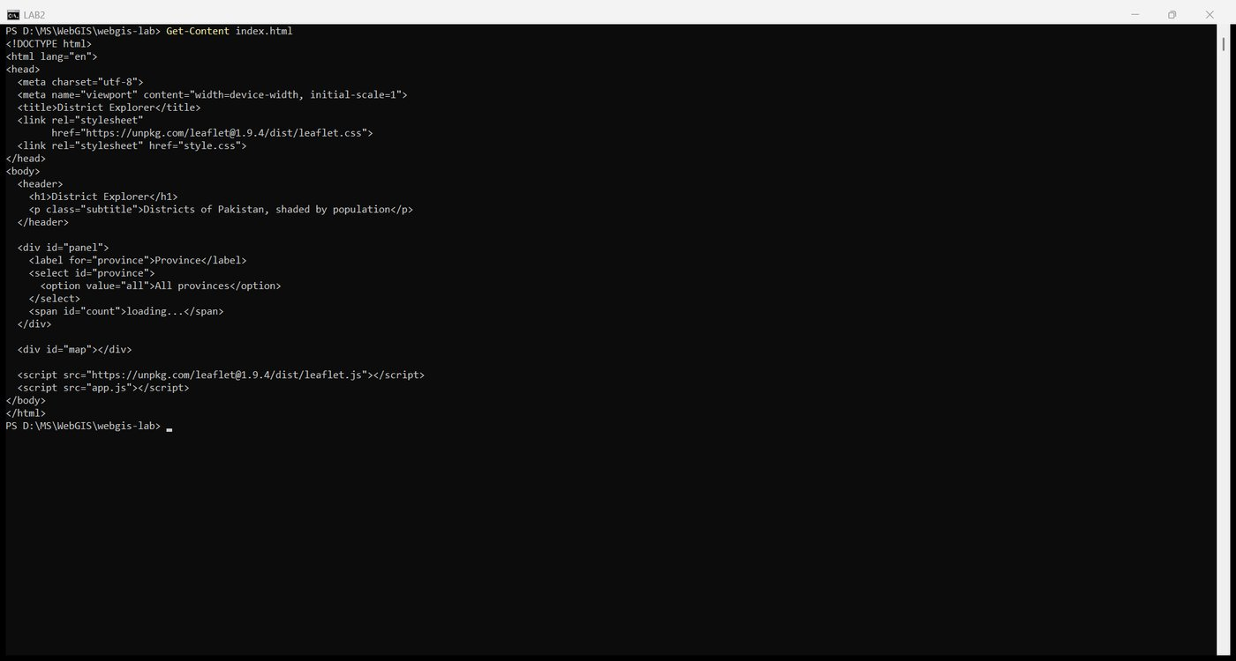
Figure 38. index.html
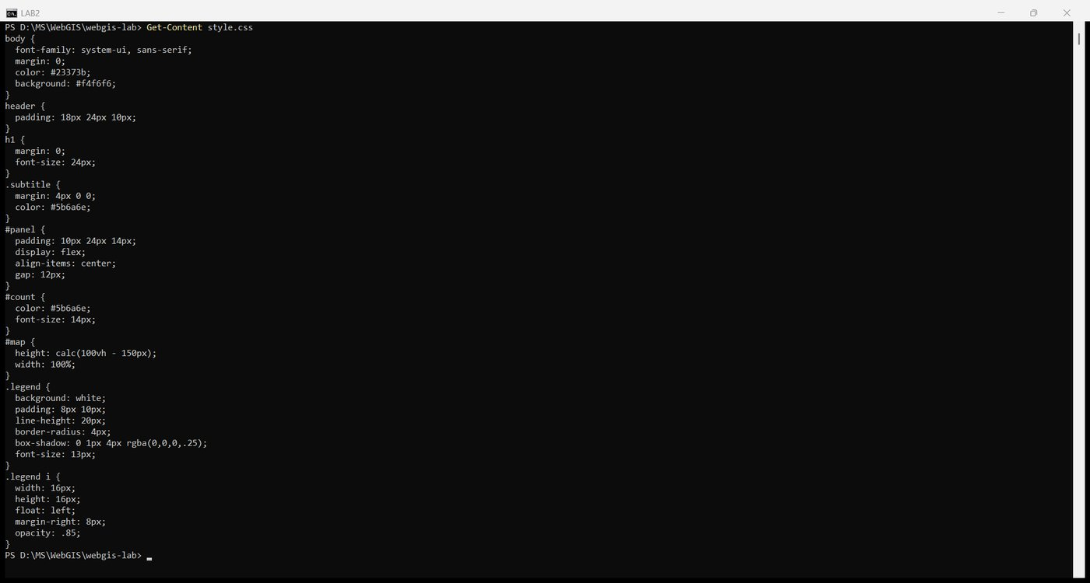
Figure 39. style.css

4.3 View it
The Live Server substitute was started in its own window from the project folder, so that index.html is the root of the site:
python -m http.server 5500 --bind 127.0.0.1

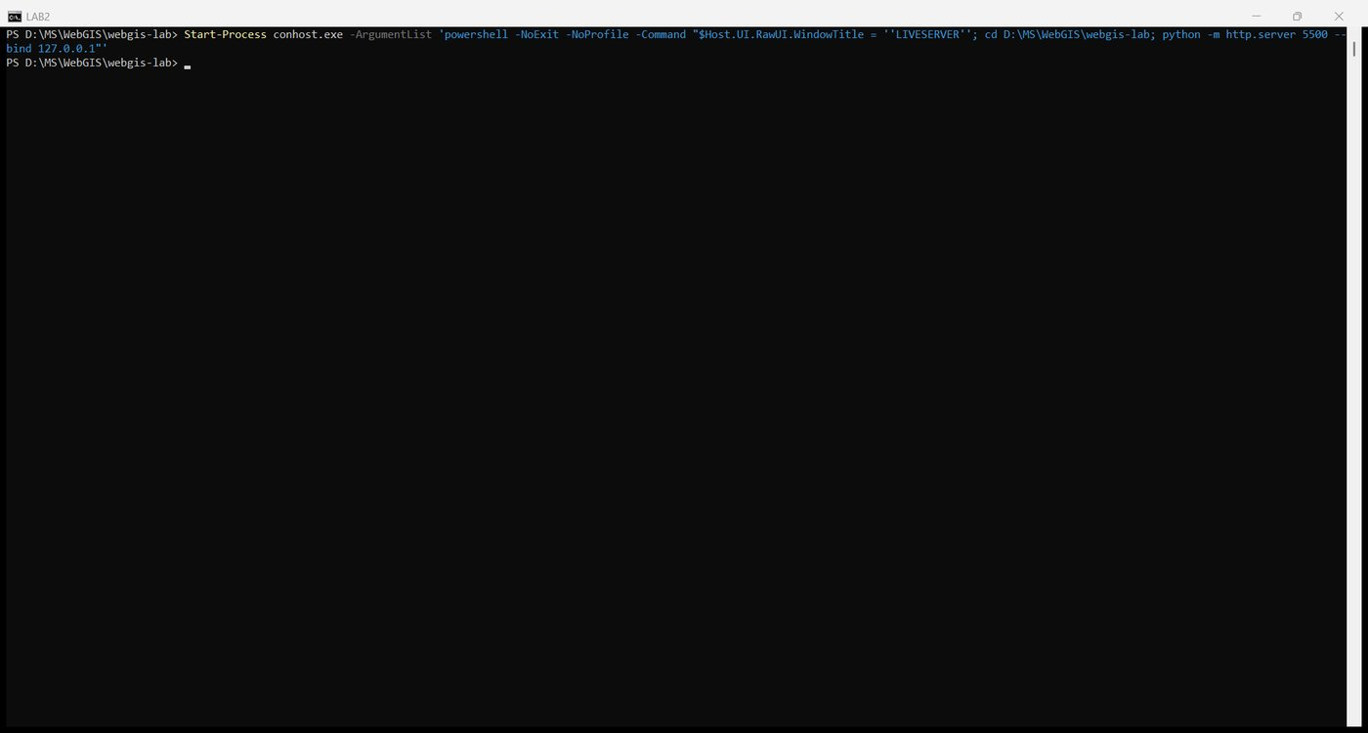
Figure 40. Starting the server in a second console window
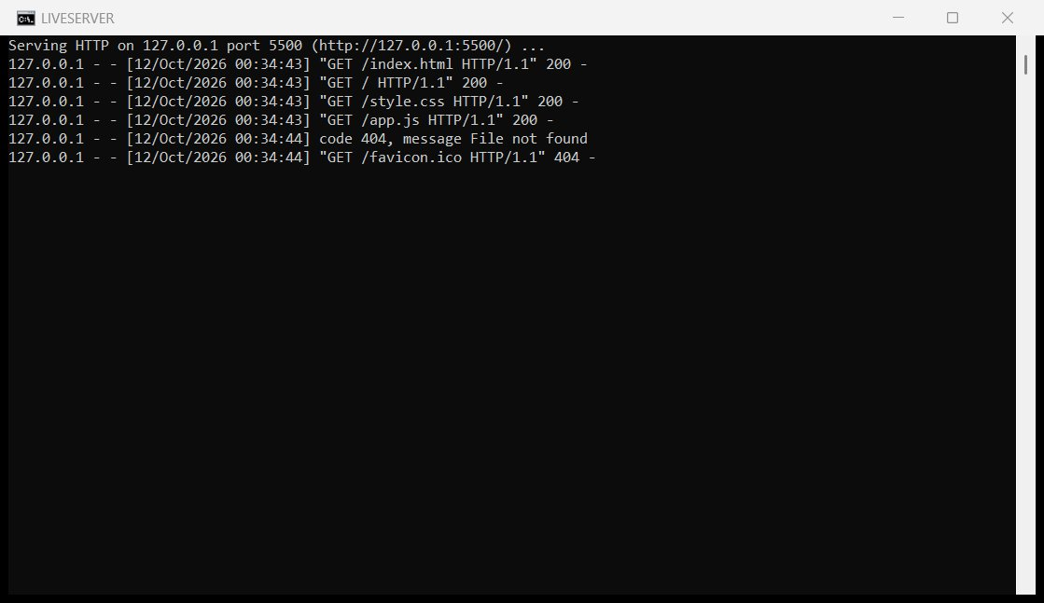
Figure 41. The server log: index.html, style.css and app.js served with status 200

Checkpoint 4
The page open at http://127.0.0.1:5500 with the header, the empty panel reading loading..., and the empty map area. app.js is still empty at this point, so nothing is drawn into the 580 px tall map box.
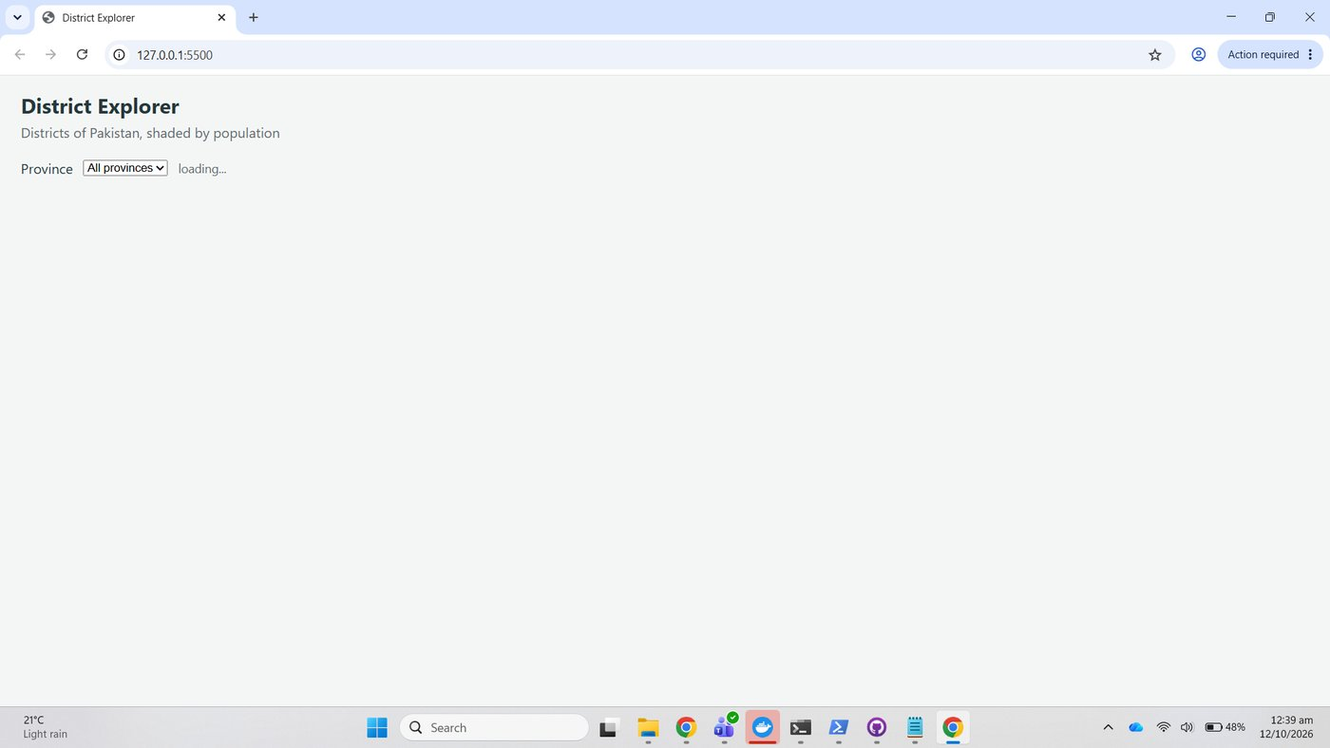
Figure 42. Checkpoint 4: header and empty map area on 127.0.0.1

Part 5: Load the data with JavaScript

5.1 Create the map
The first version of app.js creates the map and the OpenStreetMap tile layer.
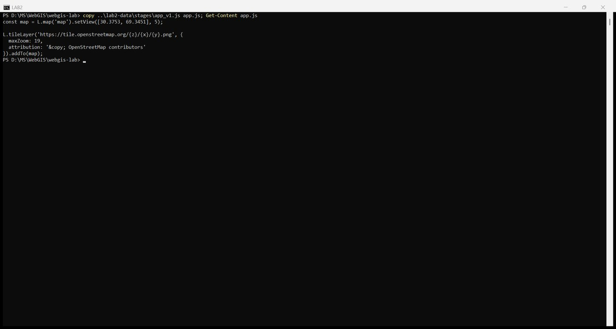
Figure 43. app.js, first version
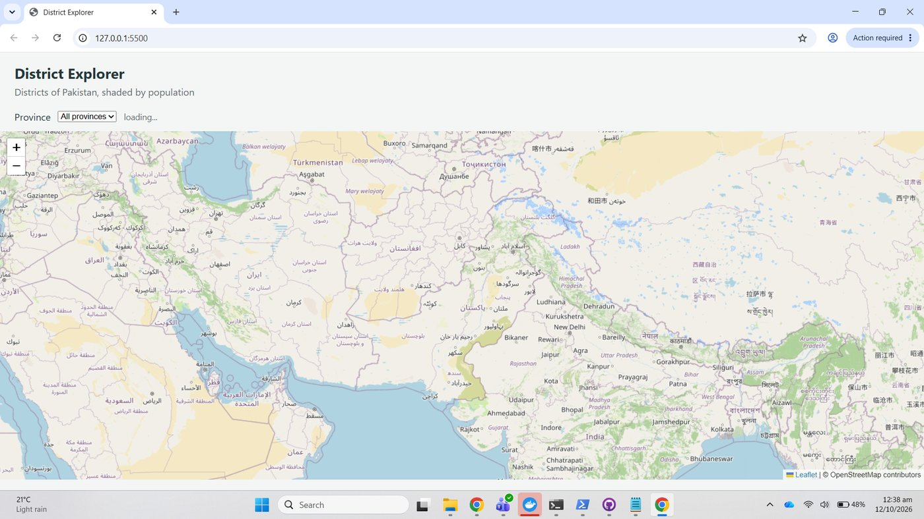
Figure 44. A pannable map centred on Pakistan at zoom 5

5.2 Keep the view on Pakistan
The L.map call was replaced with the version that sets maxBounds, maxBoundsViscosity: 1.0 and minZoom: 5.
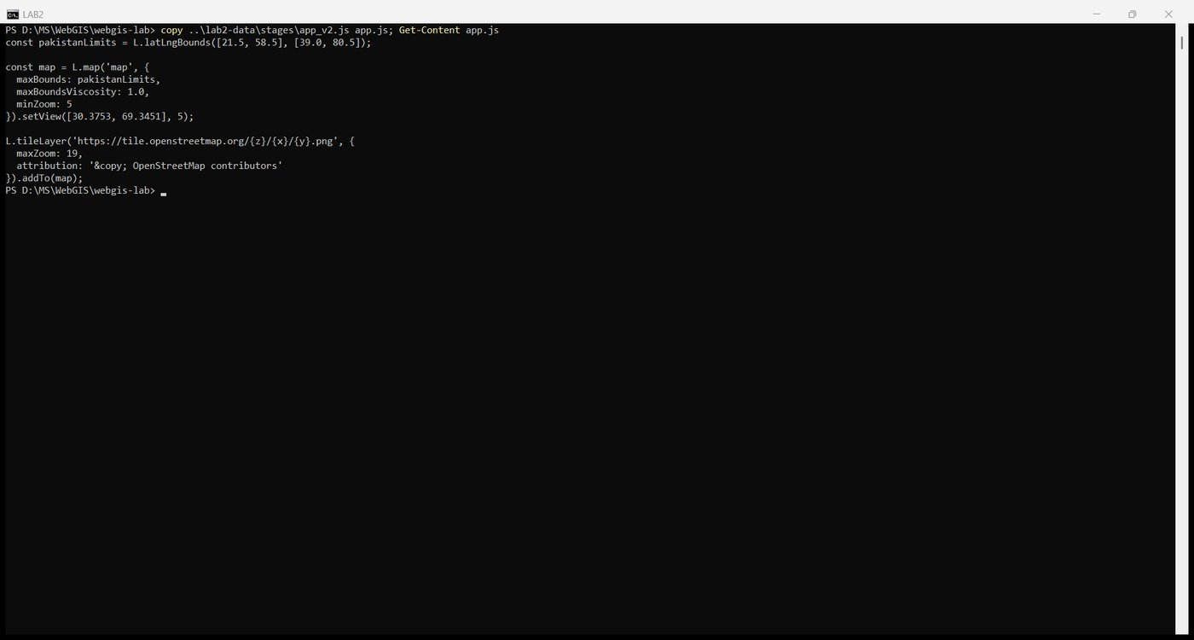
Figure 45. app.js with the Pakistan limits
To test the limits, the map was asked to pan to central Europe (48 N, 10 E). Leaflet refused: the view stayed at 30.6 N, 69.5 E and the zoom-out button is greyed out at zoom 5.
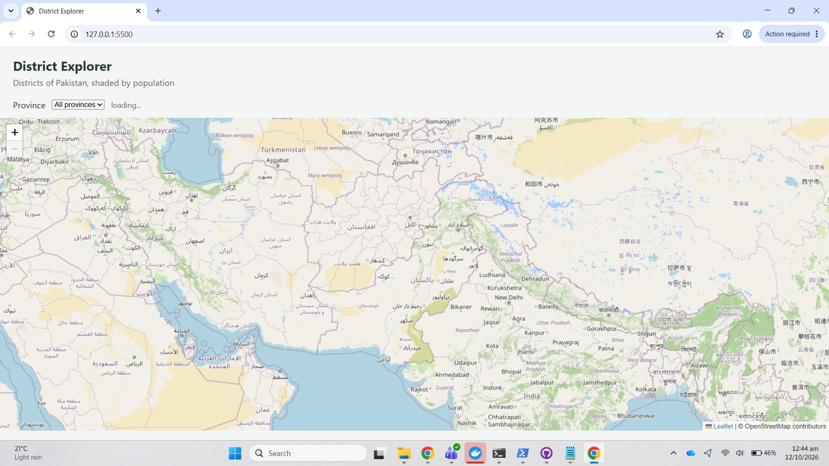
Figure 46. After an attempt to pan to Europe the map is still on Pakistan and cannot zoom out

5.3 Fetch the file
loadData was added with fetch, the response.ok check and the three console.log lines.
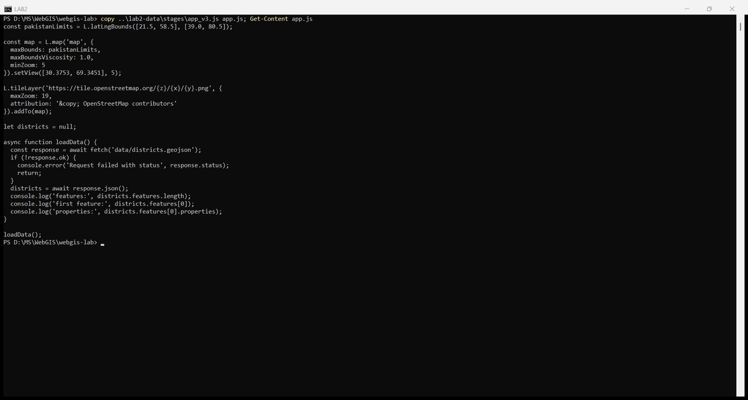
Figure 47. app.js with loadData
The Console shows features: 160, the first feature and its properties. 160 matches the QGIS feature count and the property names match the ones used in the next parts.
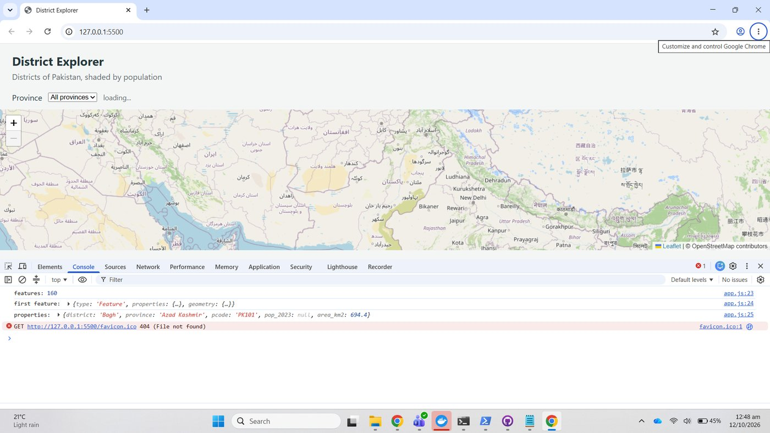
Figure 48. Console after reload: feature count, first feature, properties
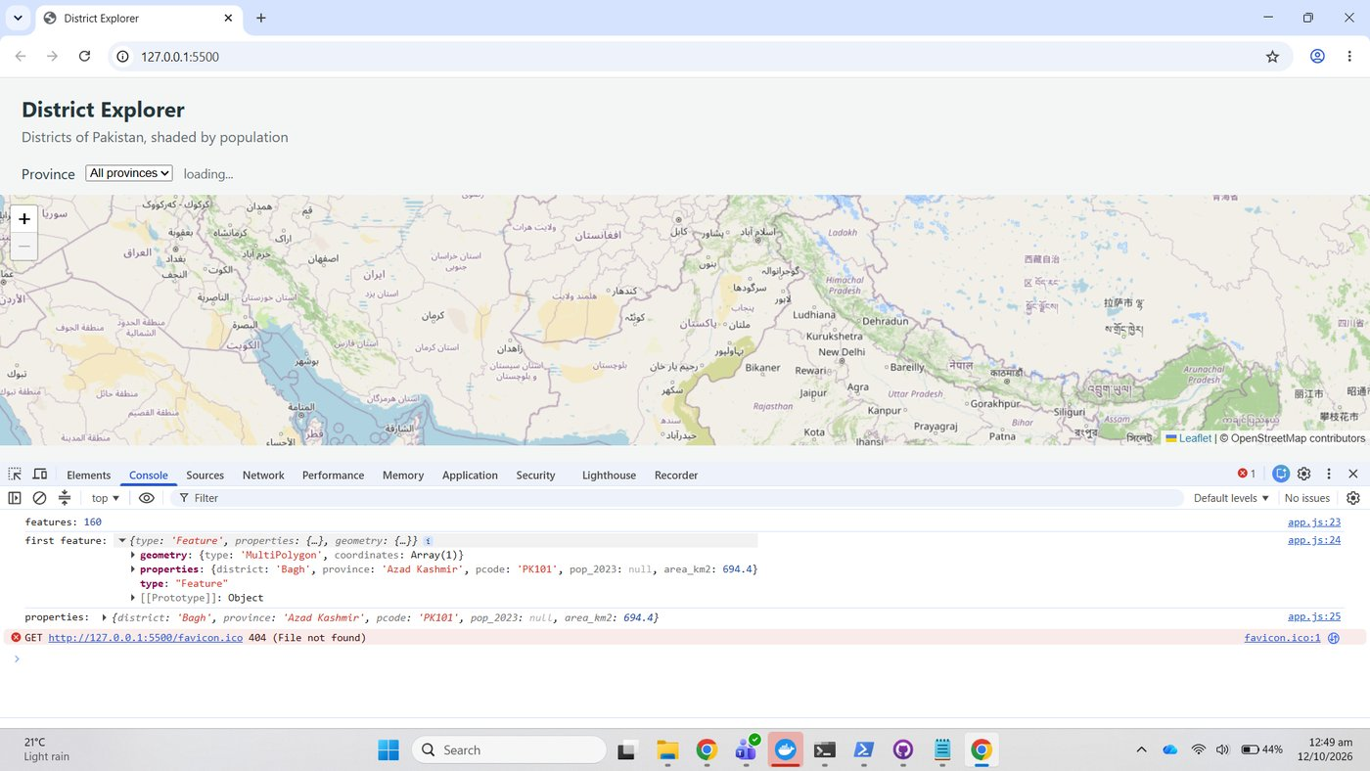
Figure 49. The first feature expanded: geometry, properties, type
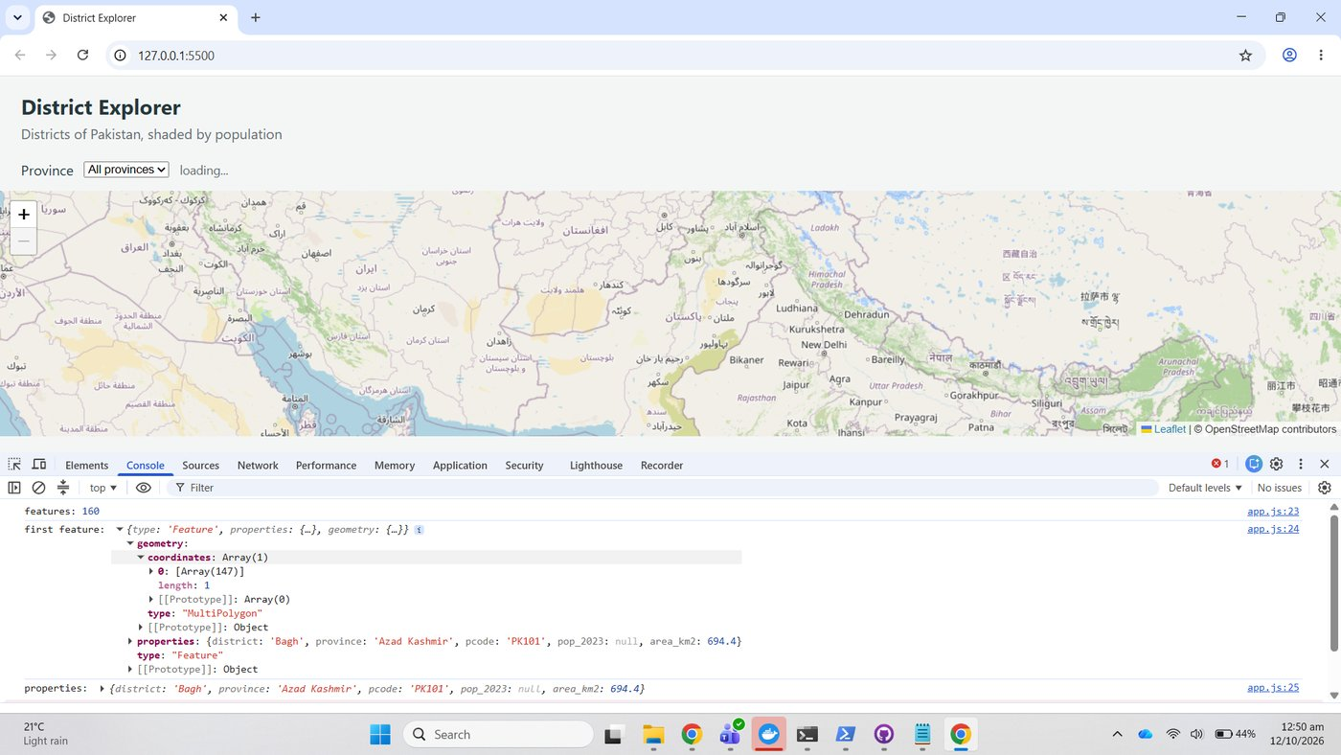
Figure 50. Walking down geometry to coordinates: a MultiPolygon with one part of 147 points

5.4 Try the array methods
The four expressions were typed into the Console one at a time.
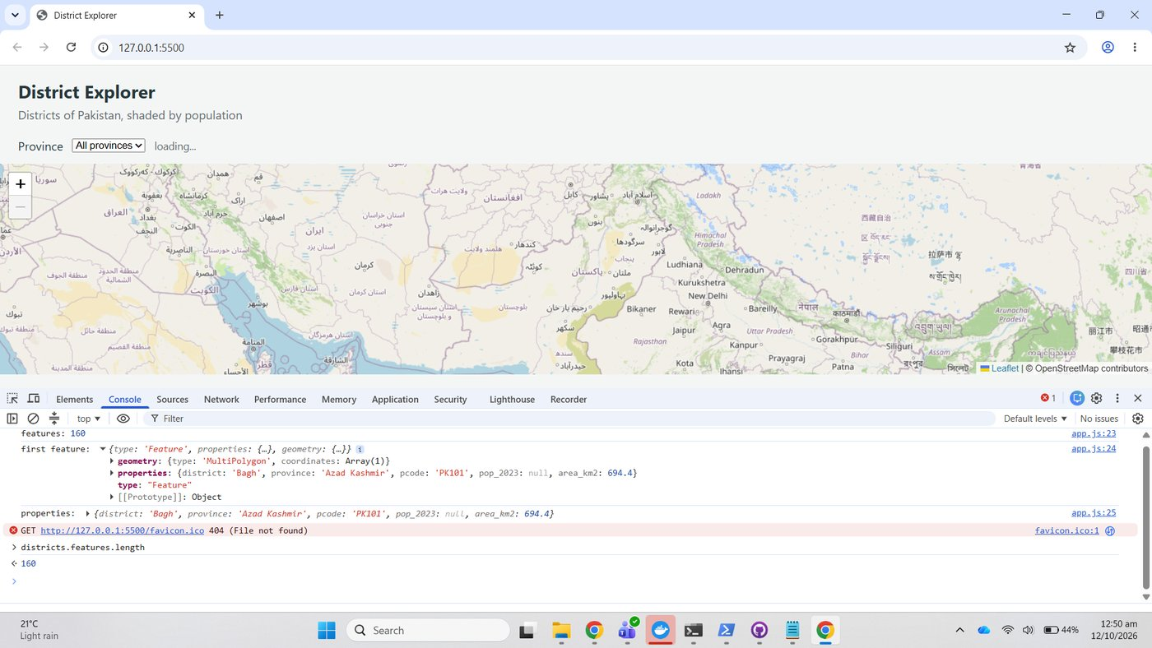
Figure 51. districts.features.length
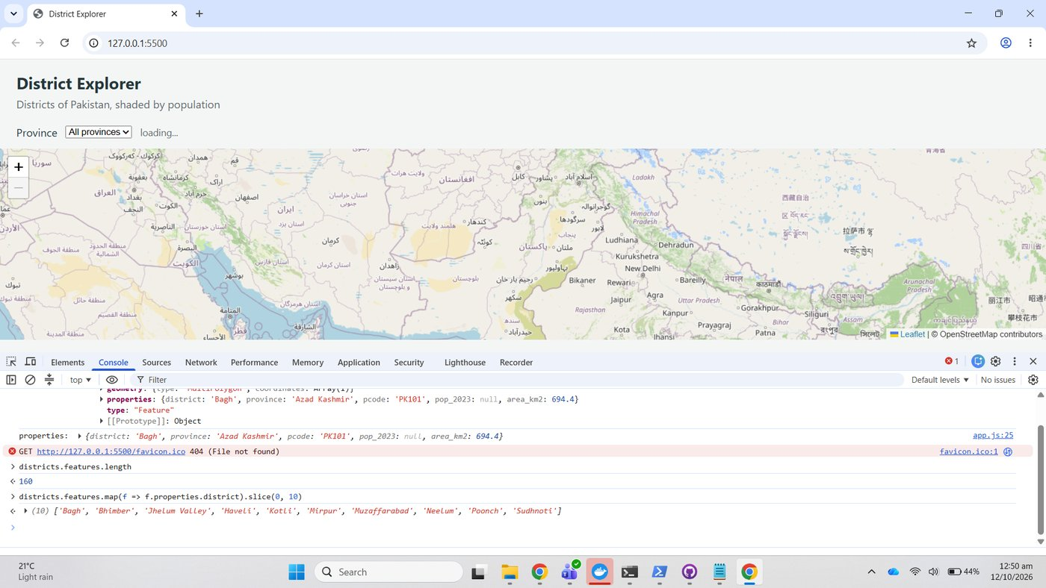
Figure 52. map and slice: the first ten district names
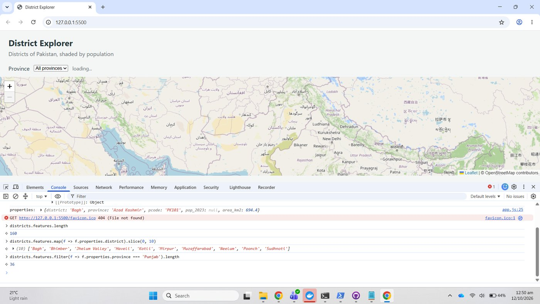
Figure 53. filter: Punjab has 36 districts

Checkpoint 5
Feature count, the expanded first feature, and the distinct province list from [...new Set(...)].sort(): Azad Kashmir, Balochistan, Gilgit Baltistan, Islamabad, Khyber Pakhtunkhwa, Punjab, Sindh. This is the list that fills the drop-down in Part 8.
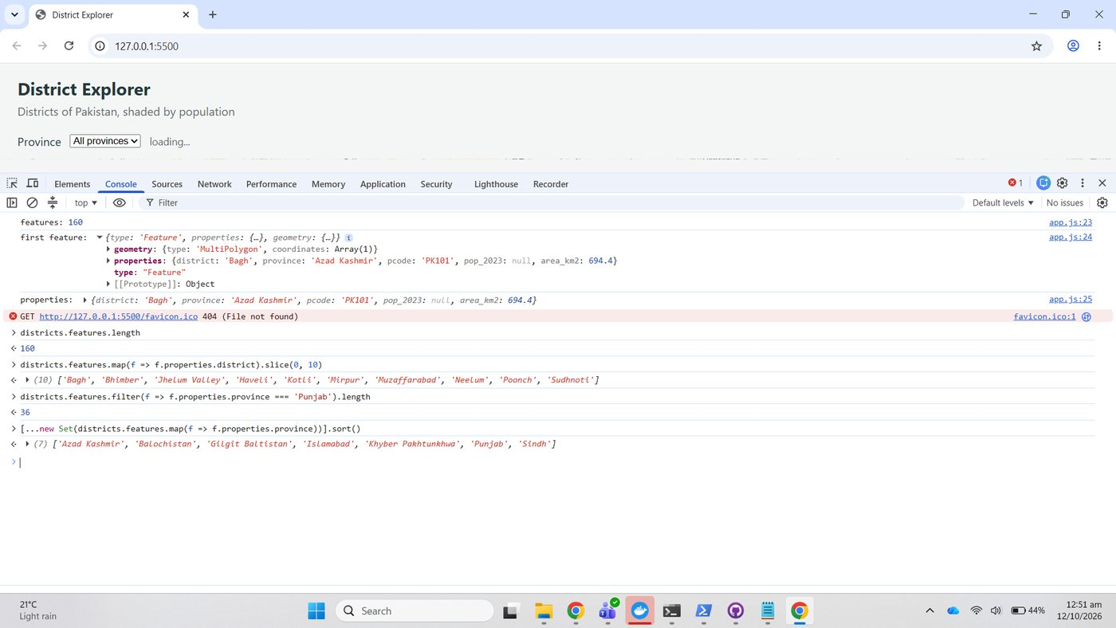
Figure 54. Checkpoint 5: feature count, expanded first feature and the seven provinces

Part 6: Draw it with Leaflet

6.1 Add the layer
draw(features) was added with the two guards, and draw(districts.features) called at the end of loadData.
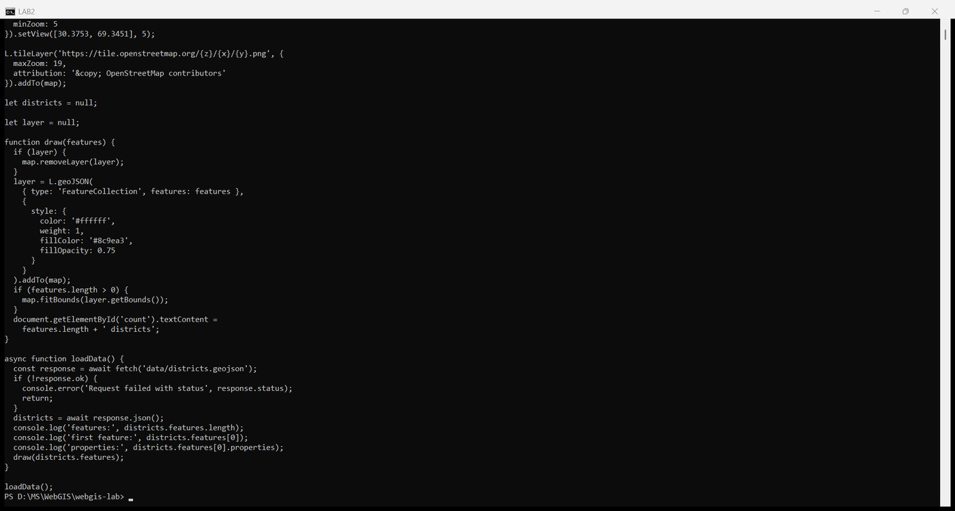
Figure 55. app.js with draw
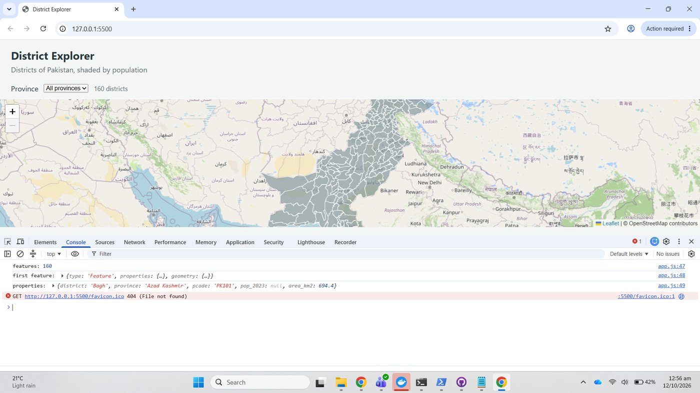
Figure 56. 160 districts drawn in grey, the count label updated

6.2 Check the network activity
With Disable cache ticked and the page reloaded, the Network tab lists 22 requests and 1.3 MB transferred. The GeoJSON request is 916 kB and took 10 ms from the local server. Fifteen requests end in .png: the map tiles for zoom 5.
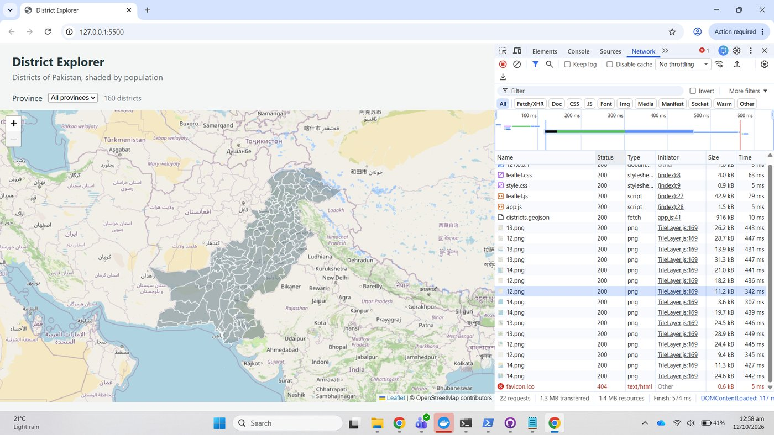
Figure 57. Network tab, all requests, with districts.geojson at 916 kB in 10 ms
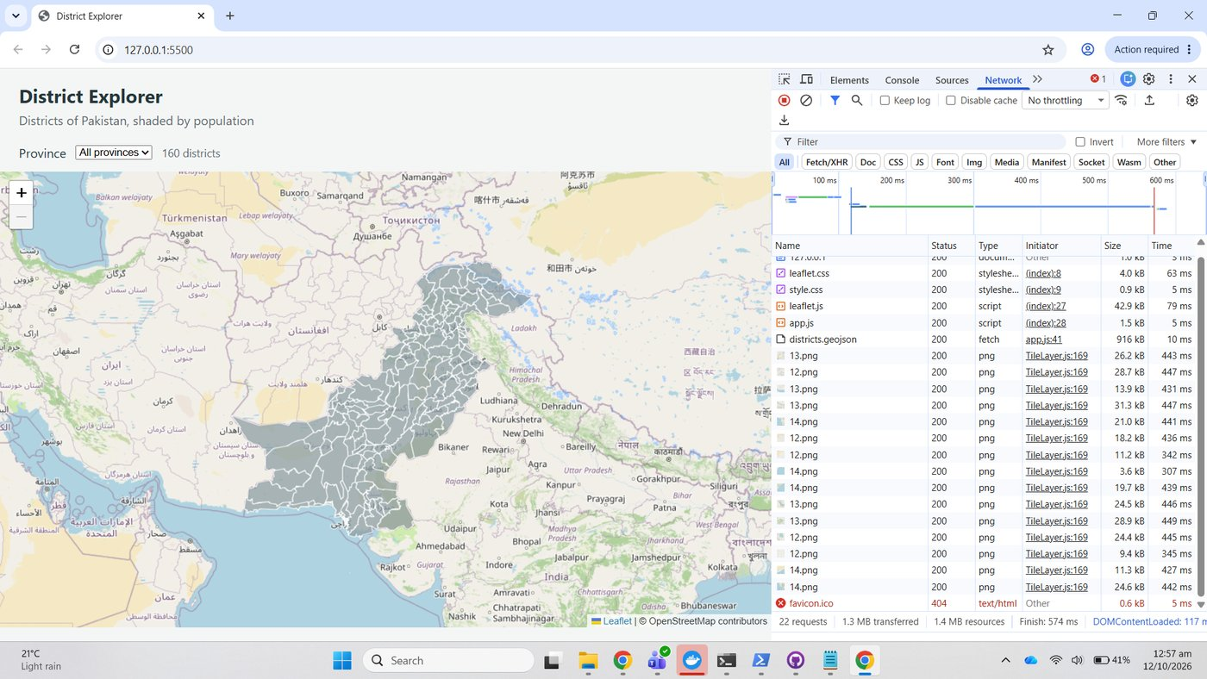
Figure 58. Fetch/XHR filter: the single GeoJSON request
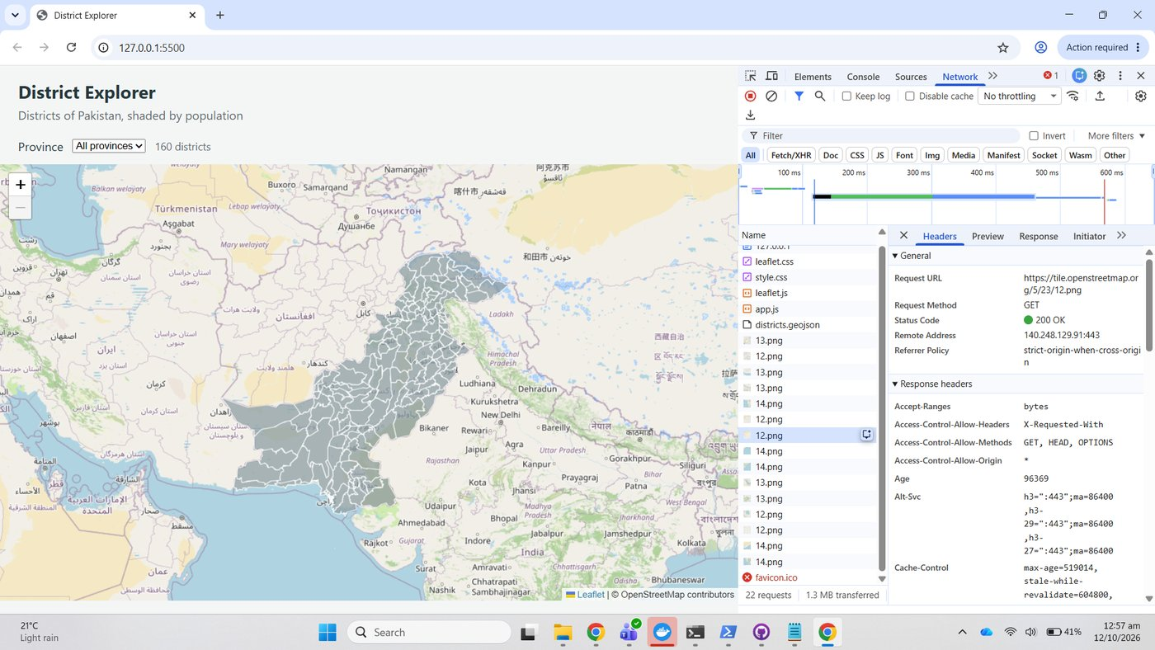
Figure 59. Img filter: the tile requests
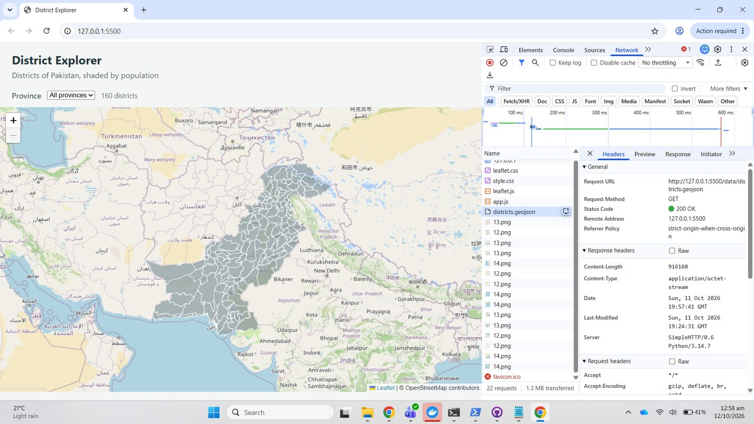
Figure 60. districts.geojson selected

Checkpoint 6
One tile selected with its Preview open: a single 256 by 256 image/png, 25.8 kB. Its URL is https://tile.openstreetmap.org/5/23/12.png. The three numbers are zoom 5, column 23 and row 12; the first is the zoom level.
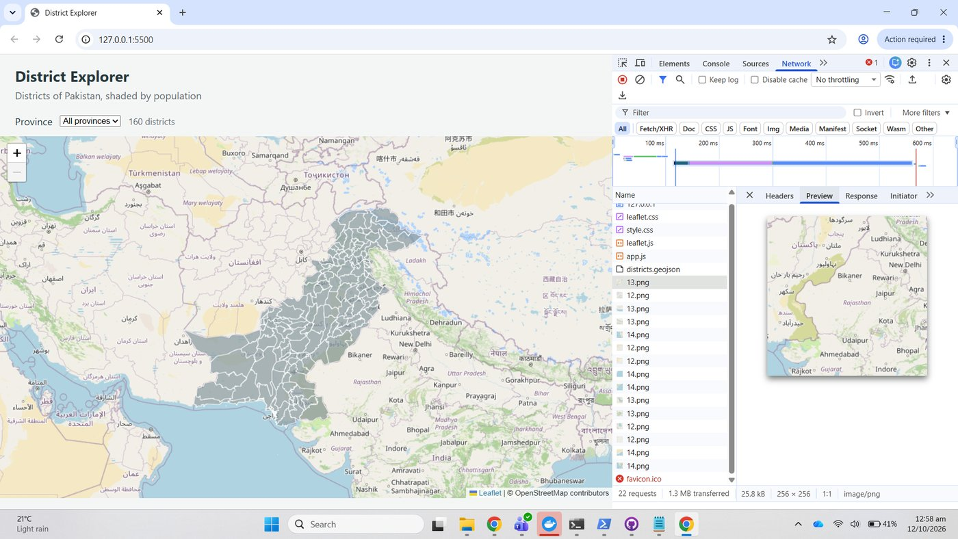
Figure 61. Checkpoint 6: a selected tile request with its Preview
Panning the map made six new tile requests arrive; the count of .png requests rose from 15 to 21.
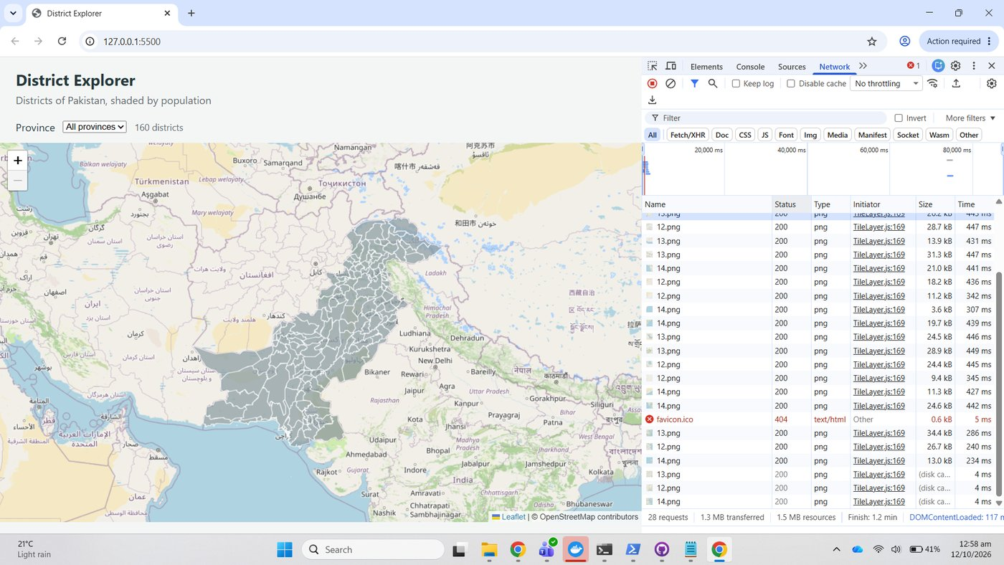
Figure 62. After a pan: new tile requests at the bottom of the list

Throttling the connection
The throttle was set to 3G and the page reloaded. The GeoJSON now takes 26.6 s instead of 10 ms and the page finishes after 31.7 s.
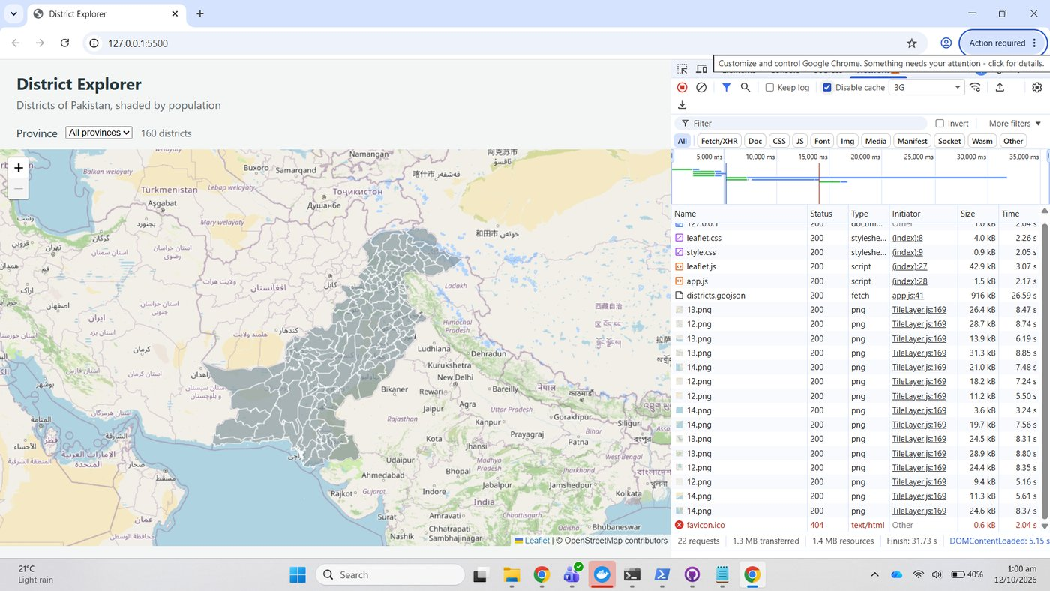
Figure 63. 3G throttle: districts.geojson in 26.59 s, finish 31.73 s
Version A was then copied over data/districts.geojson and the throttled reload repeated. The 10 MB file took 3.5 minutes. Version C was restored afterwards and the throttle set back to No throttling.
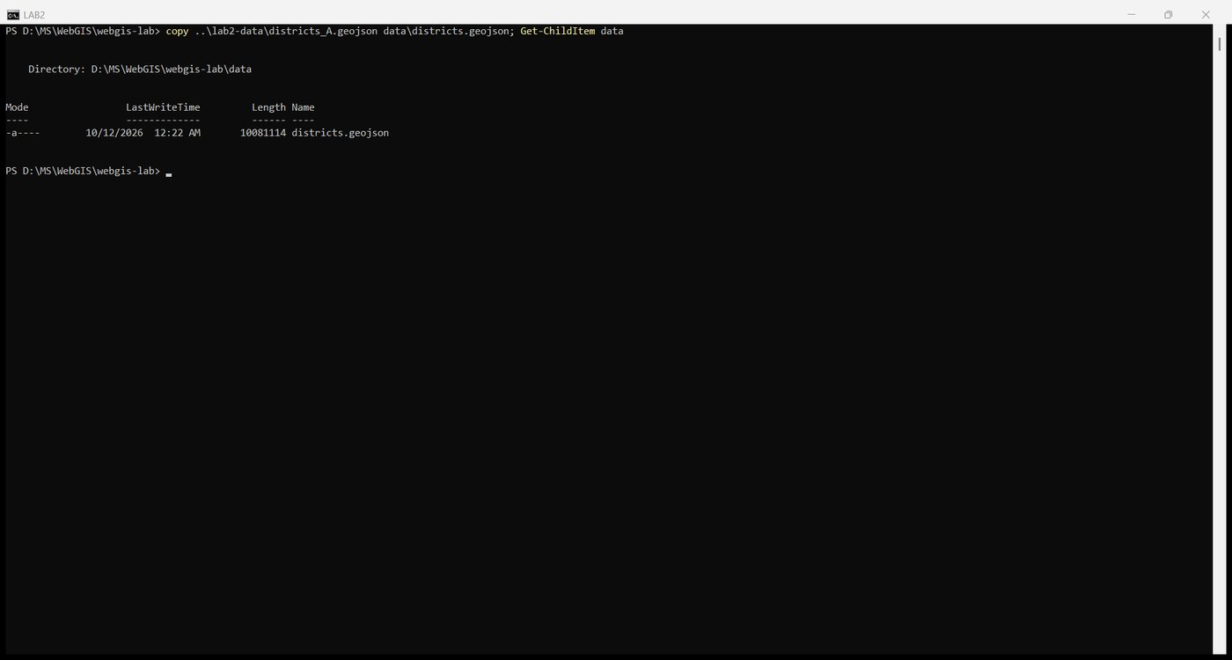
Figure 64. Substituting version A
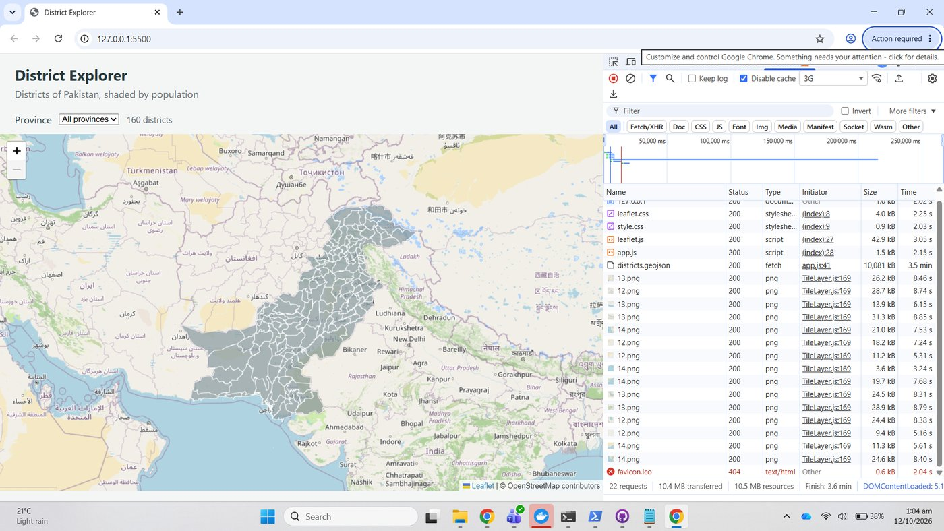
Figure 65. 3G throttle with version A: 10,081 kB in 3.5 minutes
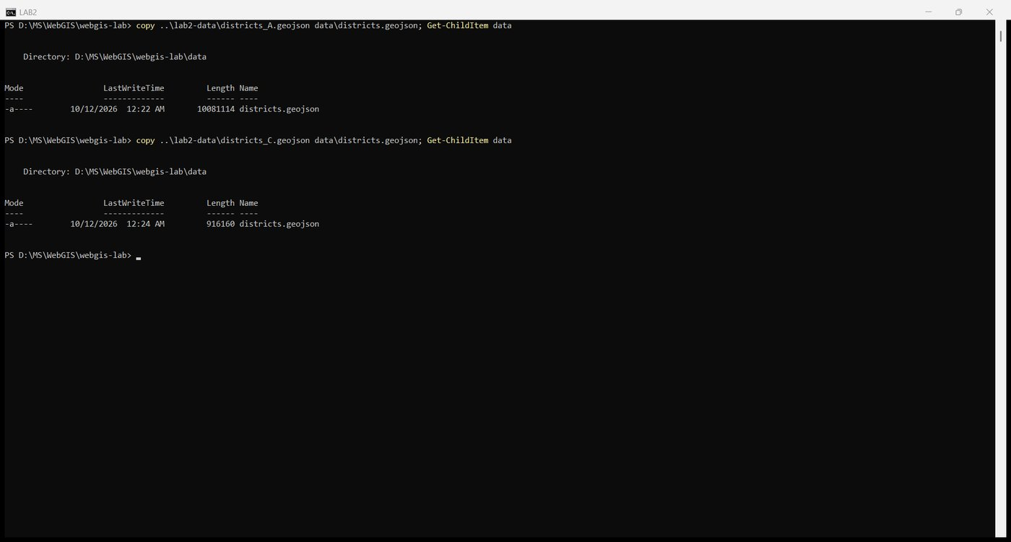
Figure 66. Restoring version C
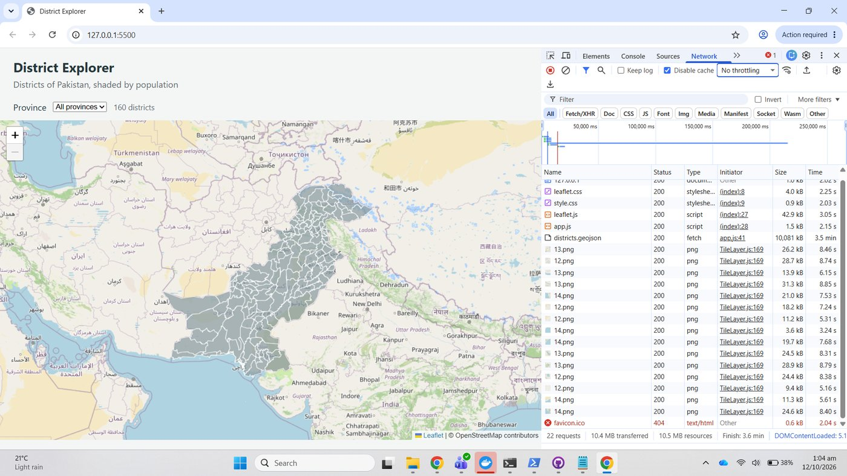
Figure 67. Throttle back to No throttling
Load time table
Condition | File served | Transfer size | districts.geojson time | Page finish
No throttling, cache disabled | Version C | 916 kB | 10 ms | 574 ms
3G preset | Version C | 916 kB | 26.59 s | 31.73 s
3G preset | Version A | 10,081 kB | 3.5 min (209.9 s) | 3.6 min

On a 3G connection the straight conversion takes seven times longer than the simplified file; everything else on the page (CSS, JavaScript, fifteen tiles) is finished within the first 9 s in both cases.

Part 7: Classify and add a popup

7.1 Shade by population, 7.2 Add a popup, 7.3 Add a legend
show, colourFor and styleFor were added above draw; the fixed fillColor was replaced with style: styleFor; onEachFeature binds the popup through show; and the legend control was appended at the end of the file.
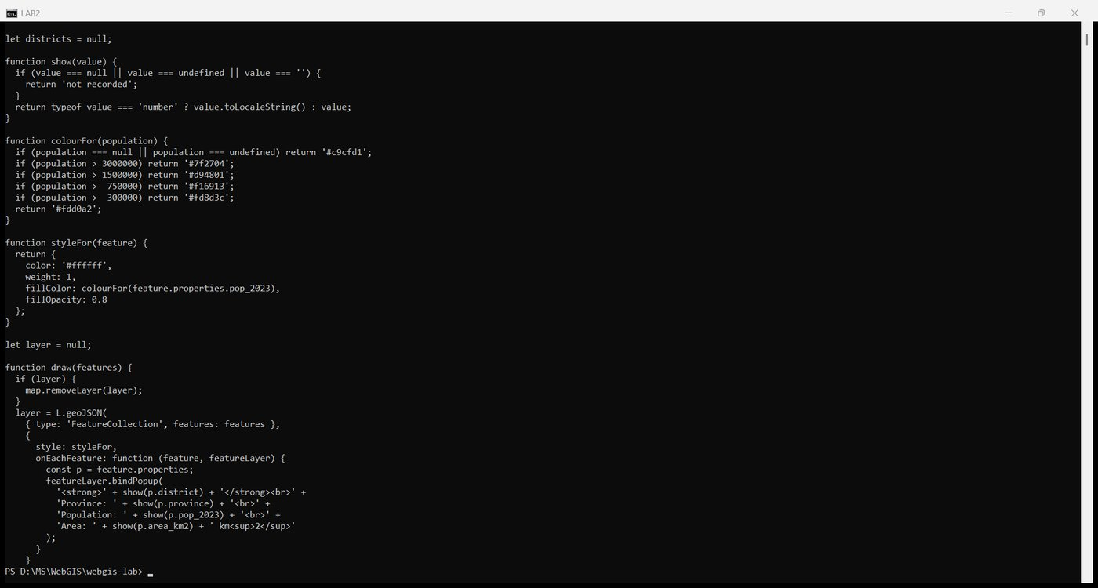
Figure 68. app.js with the classification, popup and legend code
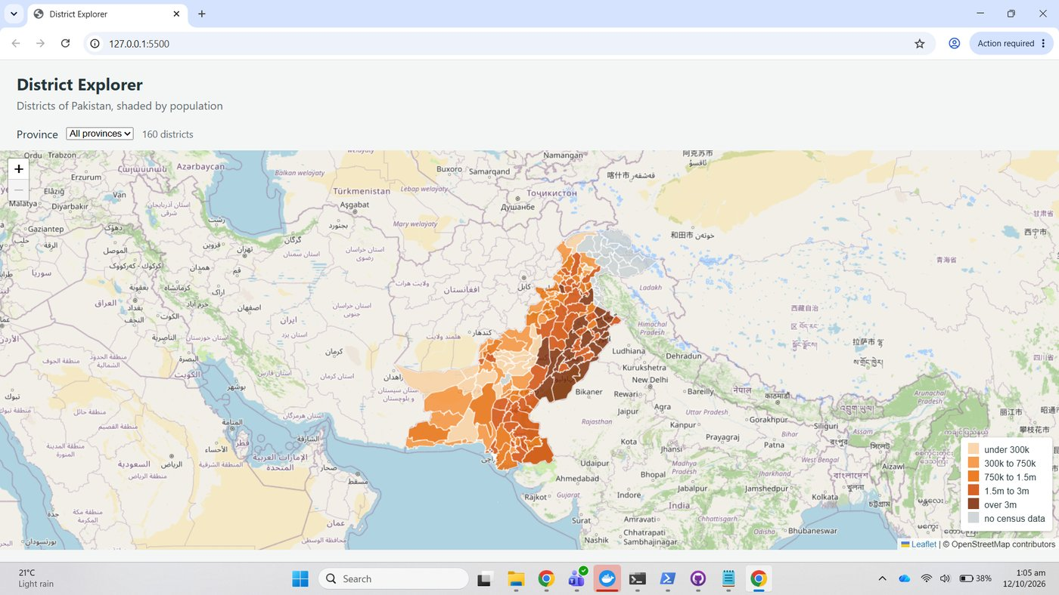
Figure 69. The map shaded by population with the legend
Classification breaks: five classes with breaks at 300,000, 750,000, 1,500,000 and 3,000,000, plus a grey class for districts with no census value. The breaks roughly double at each step, so each class is visually distinct across a range that runs from a few tens of thousands (Hunza, Awaran) to thirteen million (Lahore); equal intervals would put all but a handful of districts in the lowest class. The 25 districts without a census figure are drawn grey rather than falling into the lowest class, so "no data" is never mistaken for "sparsely populated".

Checkpoint 7
The shaded map with the legend and the popup for Lahore open: Province Punjab, Population 13,004,135, Area 1,729.9 km².
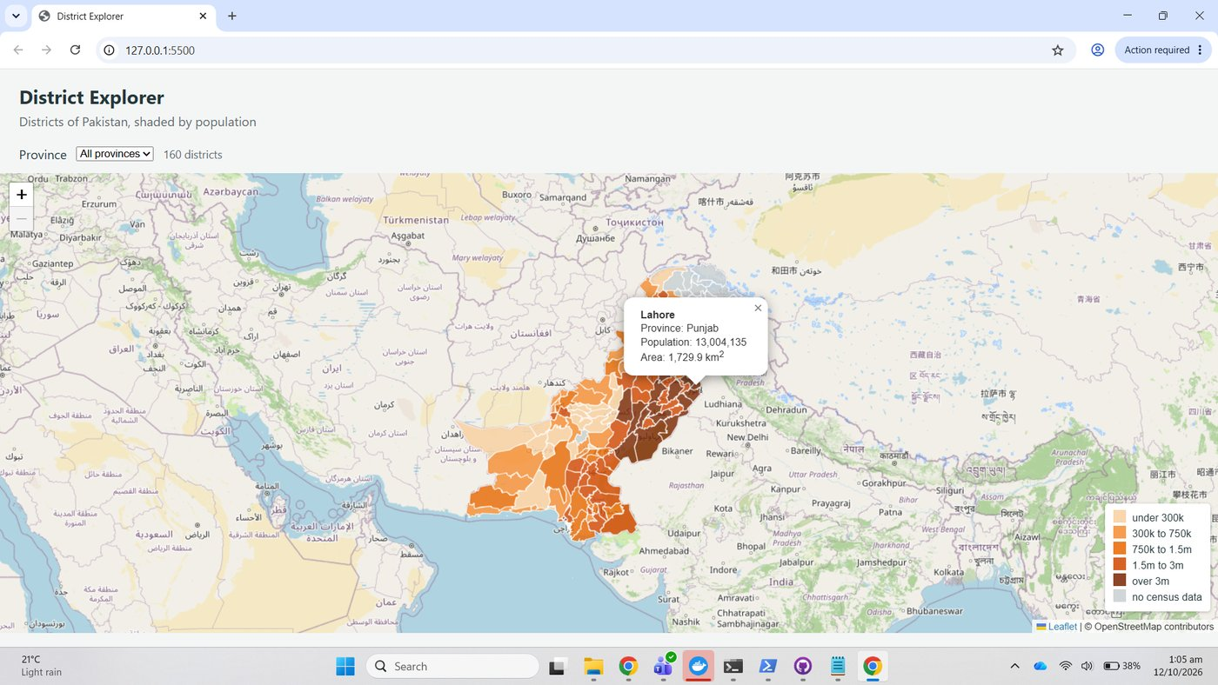
Figure 70. Checkpoint 7: shaded map, legend and one popup

Part 8: Filter with a control (extension)
fillProvinceList() builds the options from the data and is called before draw in loadData; the change listener filters the features and redraws.
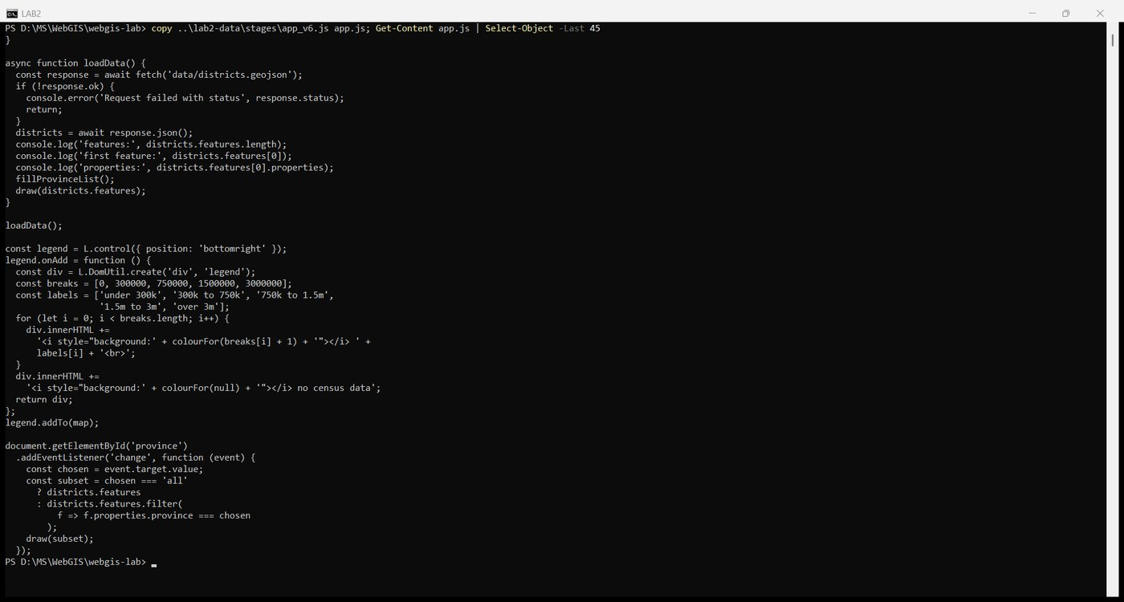
Figure 71. app.js with fillProvinceList and the change listener

Checkpoint 8
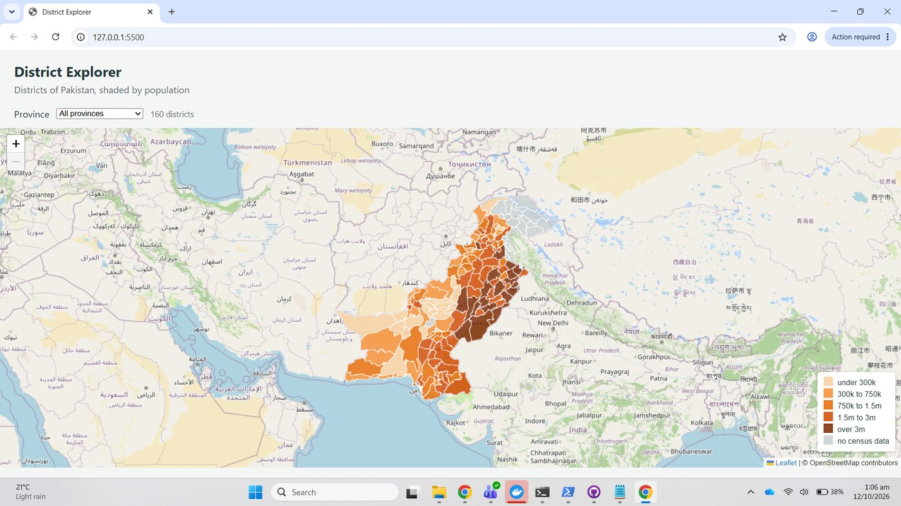
Figure 72. Checkpoint 8a: all provinces, 160 districts
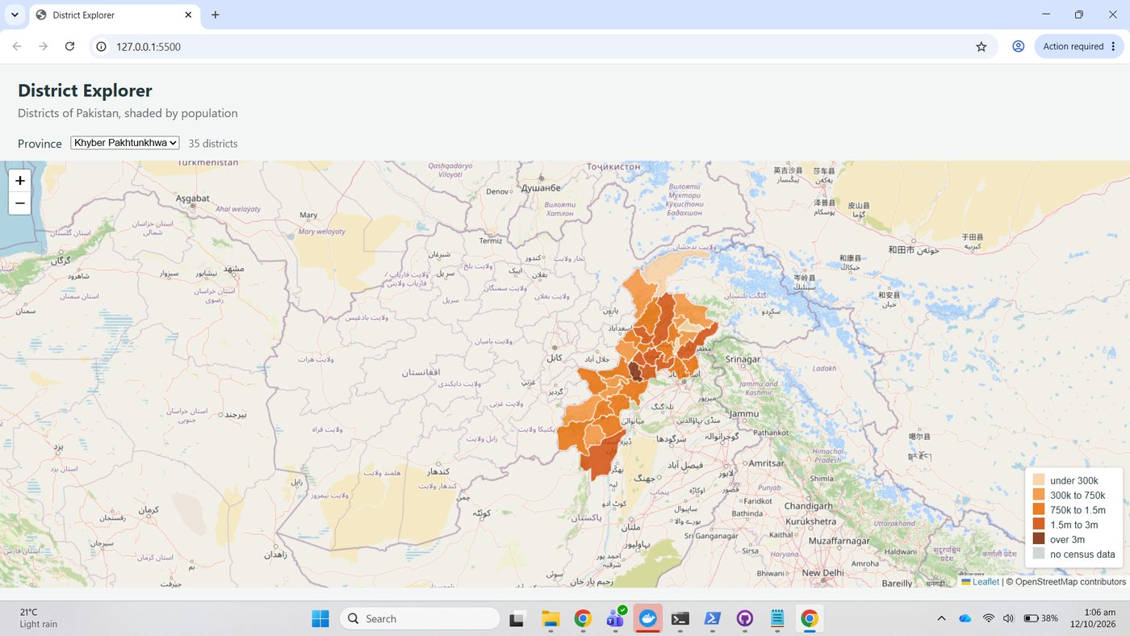
Figure 73. Checkpoint 8b: Khyber Pakhtunkhwa selected, 35 districts, map zoomed to the province

Part 9: Measure the coordinate systems (extension)

9.1 Produce two projected copies
ogr2ogr -f GeoJSON d_3857.geojson lms_copy\districts.shp -t_srs EPSG:3857
ogr2ogr -f GeoJSON d_32643.geojson lms_copy\districts.shp -t_srs EPSG:32643

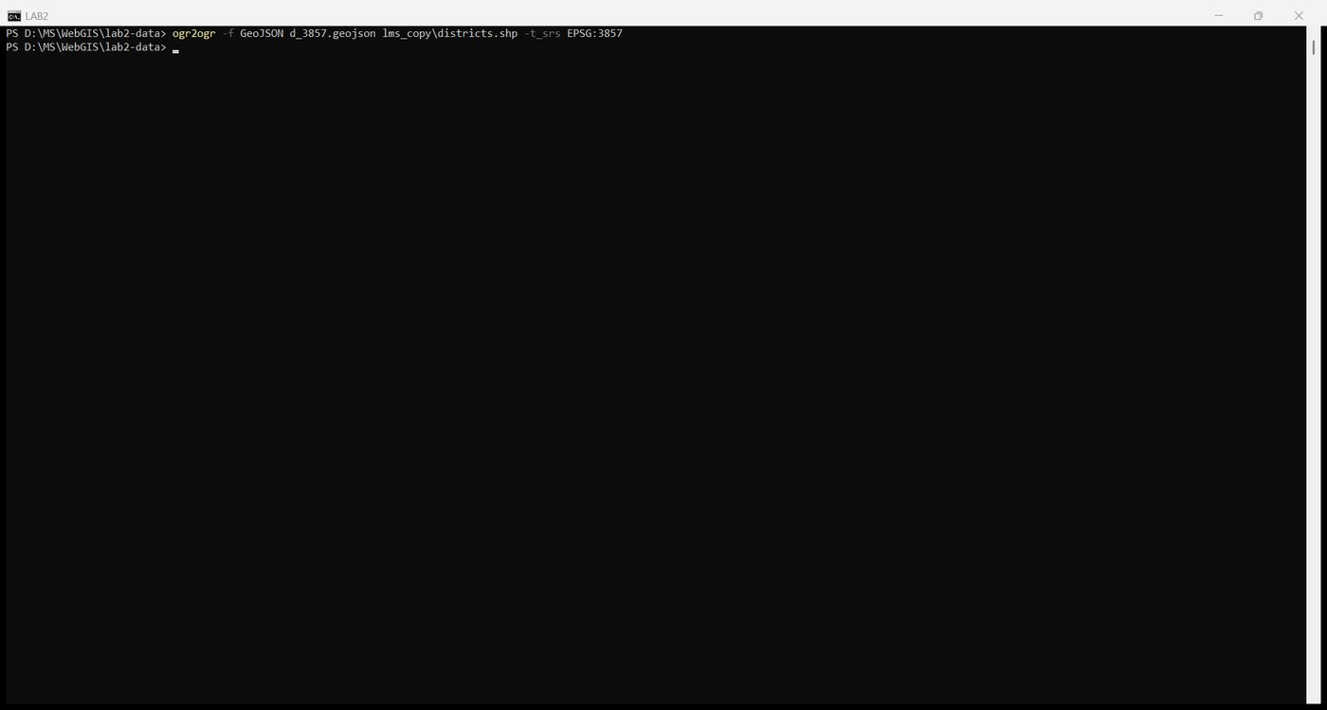
Figure 74. Export in EPSG:3857, Web Mercator
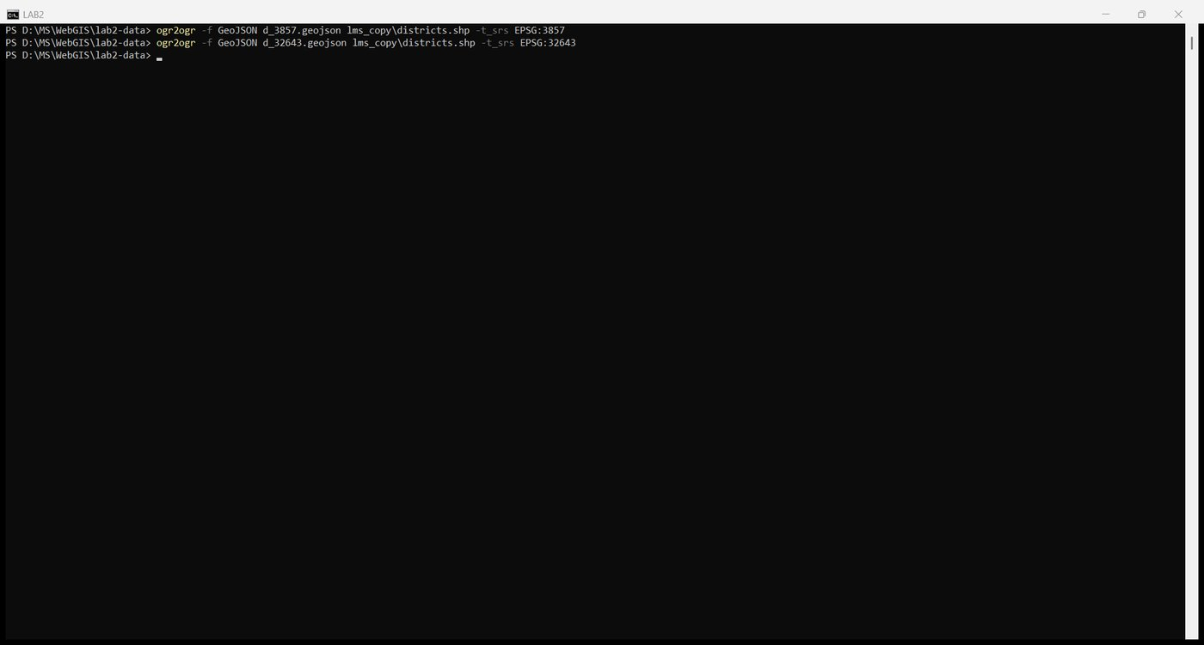
Figure 75. Export in EPSG:32643, UTM zone 43N

9.2 Compute areas in each
The Field Calculator step was done with OGR SQL. OGR_GEOM_AREA is the planar area in the layer's own coordinate system, the same quantity QGIS's $area gives when the project ellipsoid is set to None, so the two layers give different numbers for the same district.
ogr2ogr -f GeoJSON d_3857_area.geojson d_3857.geojson -sql "SELECT *, OGR_GEOM_AREA / 1000000 AS area_calc FROM districts"
ogr2ogr -f GeoJSON d_32643_area.geojson d_32643.geojson -sql "SELECT *, OGR_GEOM_AREA / 1000000 AS area_calc FROM districts"

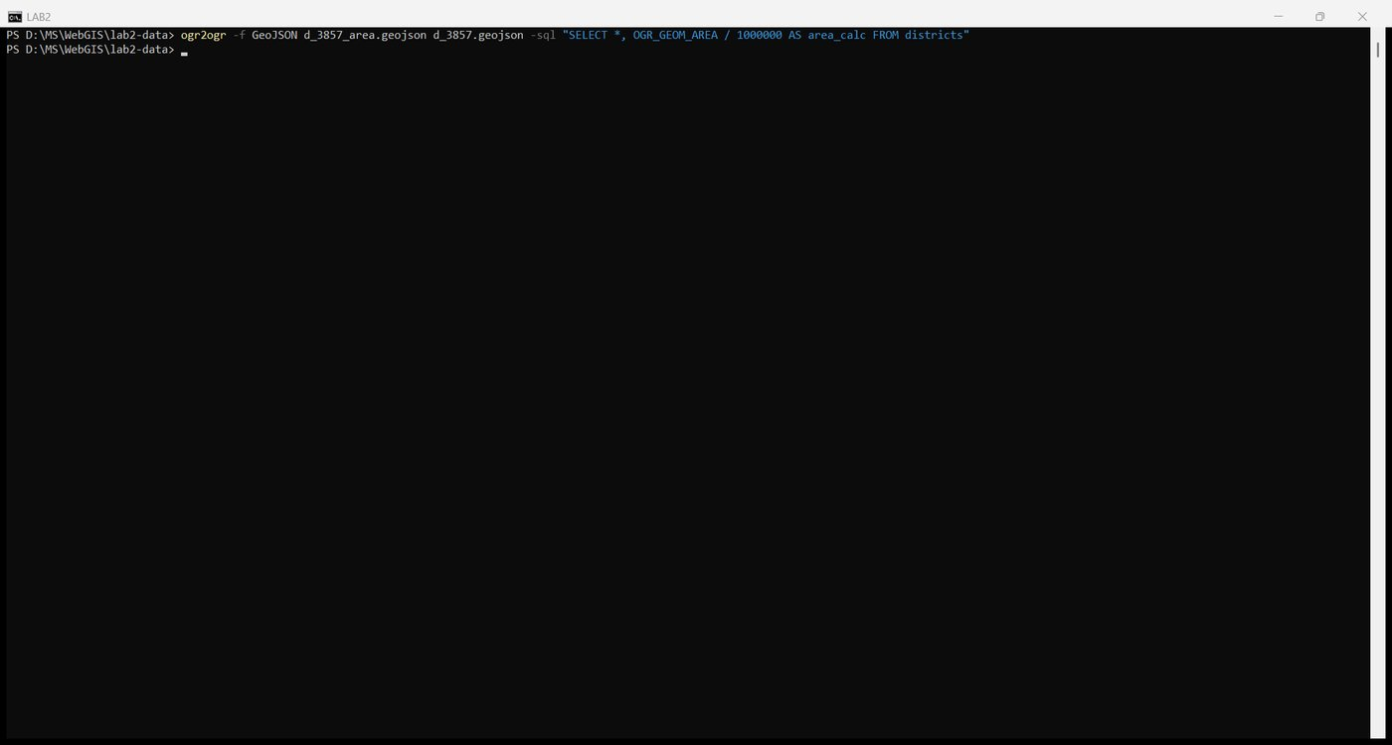
Figure 76. area_calc added to the Web Mercator copy
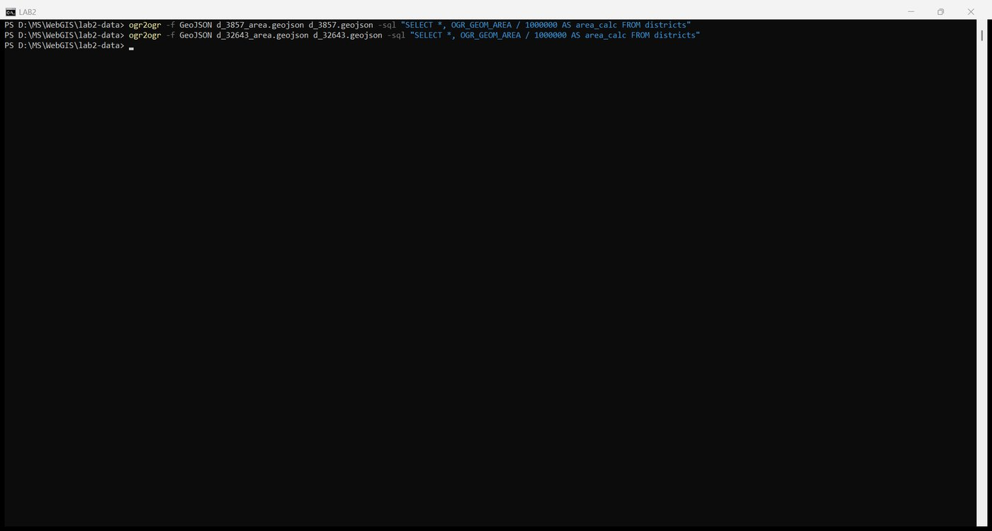
Figure 77. area_calc added to the UTM copy
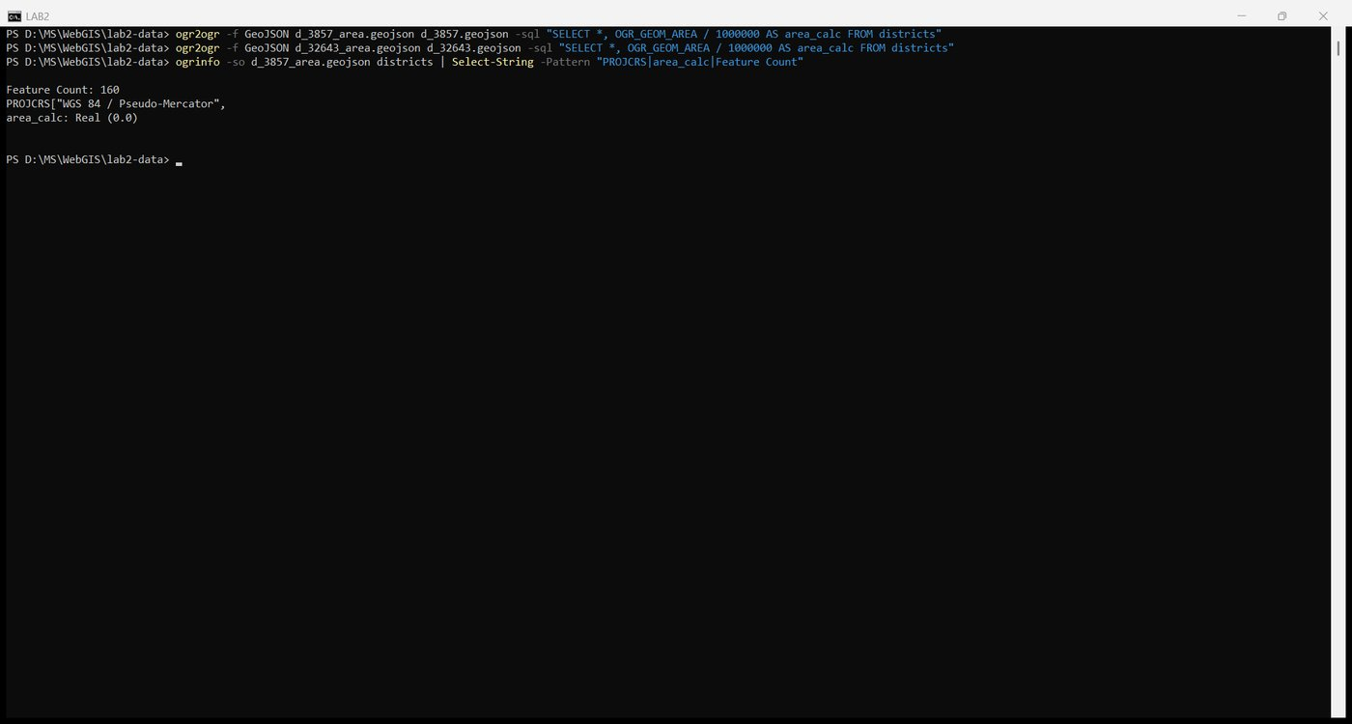
Figure 78. The new field and the CRS confirmed with ogrinfo

9.3 Compare
Five districts from the south coast to the far north, compared with compare_crs.py:
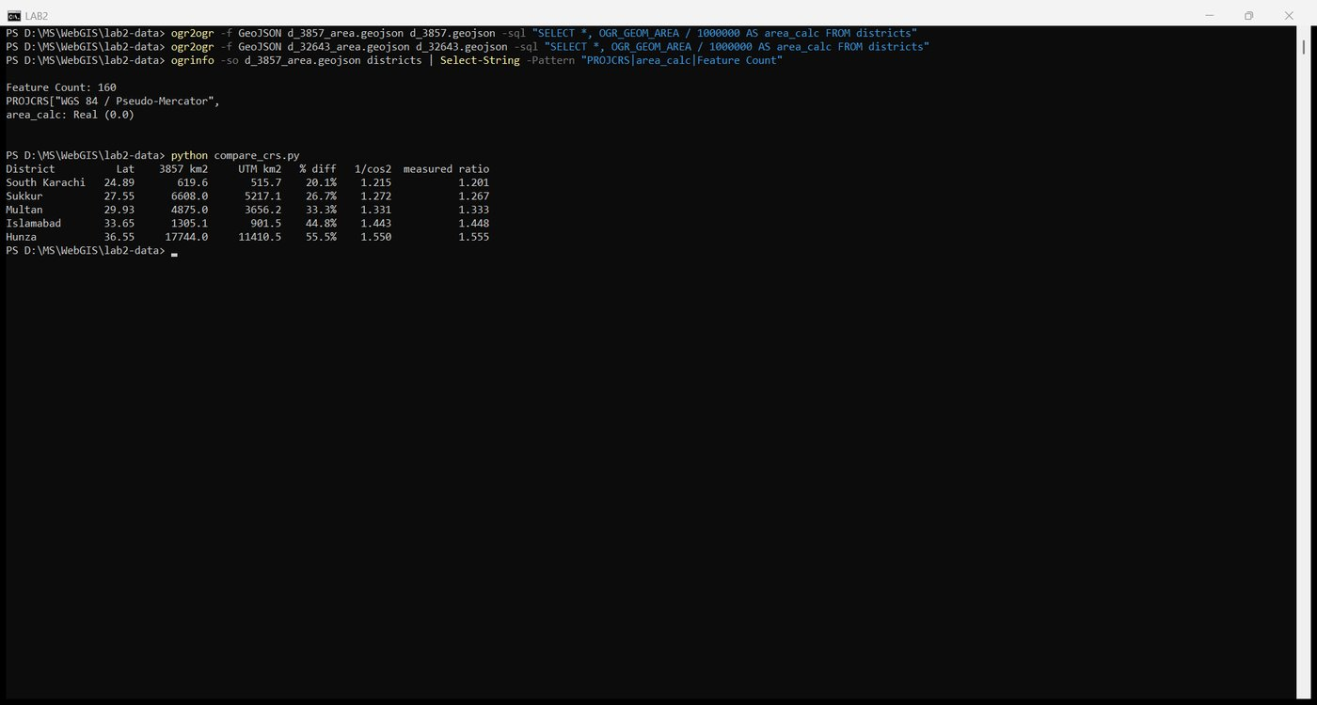
Figure 79. The comparison table
District | Latitude | 3857 km² | UTM km² | % difference | 1/cos²(lat) | Measured ratio
South Karachi | 24.89 | 619.6 | 515.7 | 20.1% | 1.215 | 1.201
Sukkur | 27.55 | 6,608.0 | 5,217.1 | 26.7% | 1.272 | 1.267
Multan | 29.93 | 4,875.0 | 3,656.2 | 33.3% | 1.331 | 1.333
Islamabad | 33.65 | 1,305.1 | 901.5 | 44.8% | 1.443 | 1.448
Hunza | 36.55 | 17,744.0 | 11,410.5 | 55.5% | 1.550 | 1.555

Checkpoint 9: answers
1. Does the difference grow or shrink northwards? It grows, from 20 percent at Karachi to 55 percent at Hunza. Web Mercator stretches both axes by 1/cos(latitude), so the error increases steadily with latitude.
2. Predicted inflation factor. For Islamabad at 33.65 N, 1/cos²(33.65°) = 1.443. The measured ratio of the two areas is 1,305.1 / 901.5 = 1.448. The prediction is within 0.4 percent of the measurement; the small residual is because a district spans a range of latitudes and the UTM figure itself carries a scale factor of up to 0.9996 to 1.0010 away from the zone's central meridian. The lecture's "about 40 percent too large" at this latitude is confirmed.
3. Which figure goes in a report? The UTM zone 43N value. It is computed in a conformal projection designed for this longitude band, with distortion below 0.1 percent, so the number is a real area in square kilometres. The Web Mercator figure is only a measure of how much screen the district covers; it is never a quantity to report. Store in EPSG:4326, display in EPSG:3857, measure in EPSG:32642 or 32643.

Part 10: Publish and submit

10.1 Commit and push
git status
git add -A
git commit -m "District Explorer: map, classification, filter"
git push -u origin main

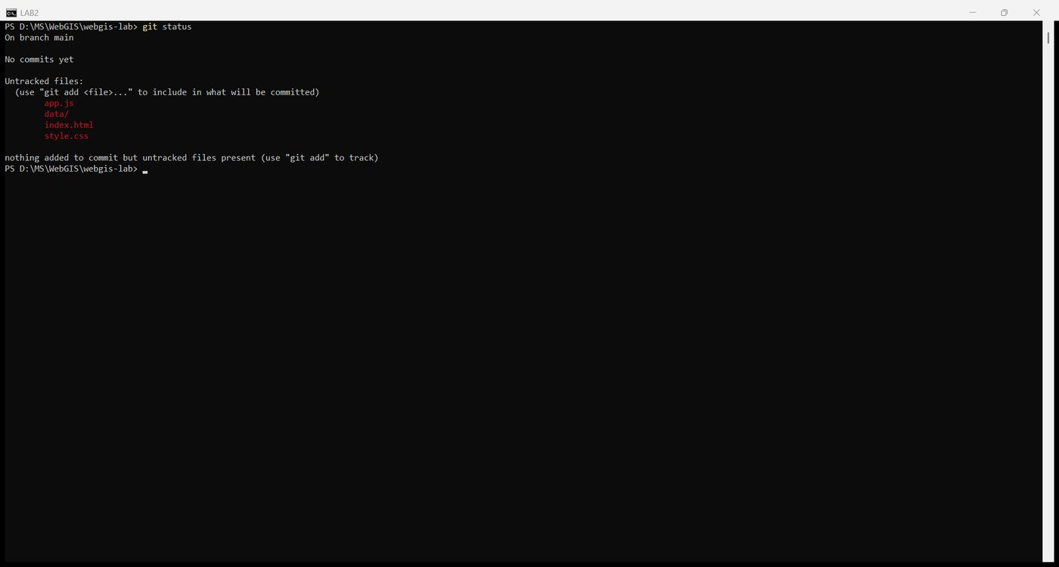
Figure 80. git status before staging
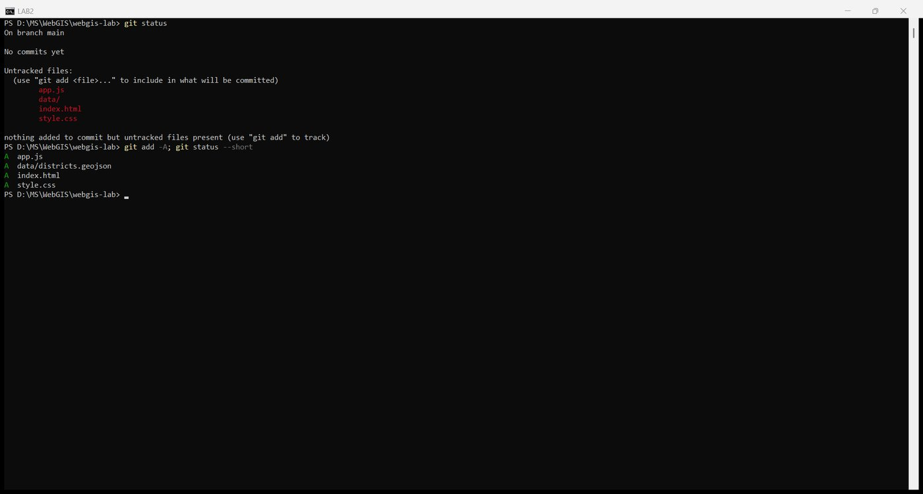
Figure 81. git add -A
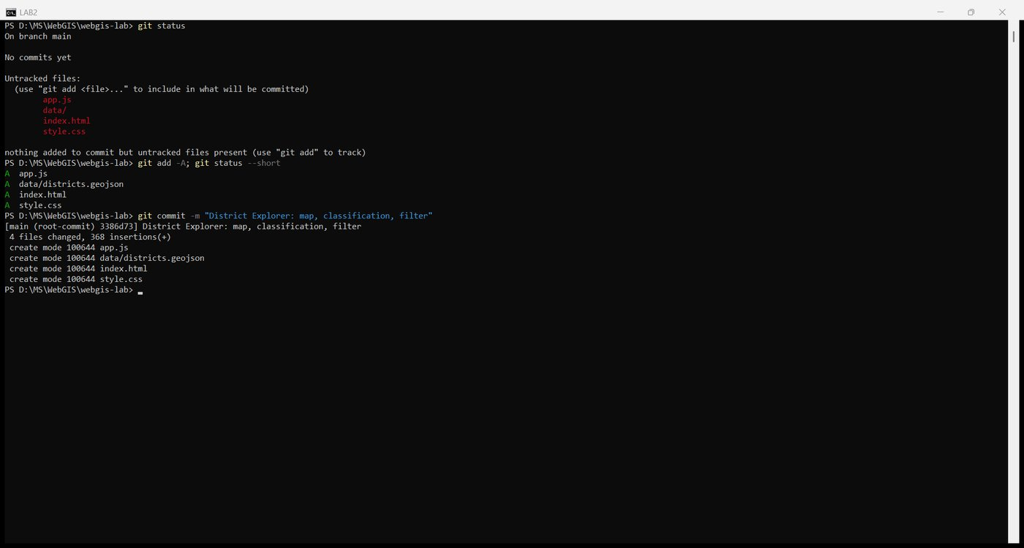
Figure 82. The first commit
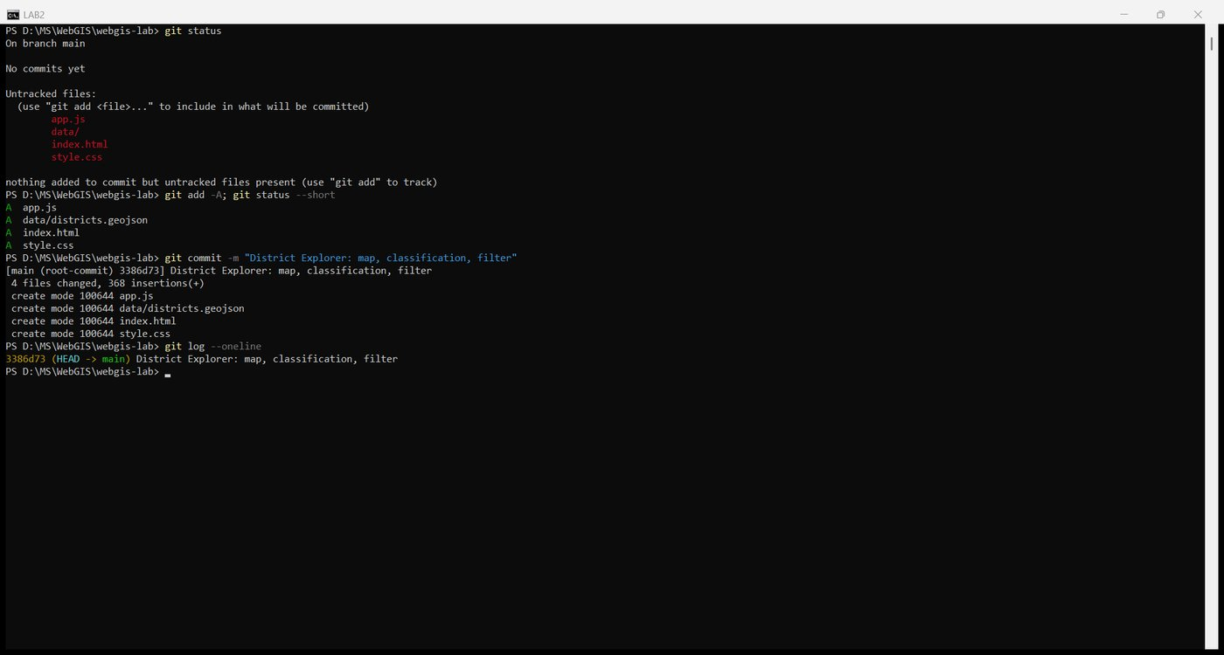
Figure 83. git log
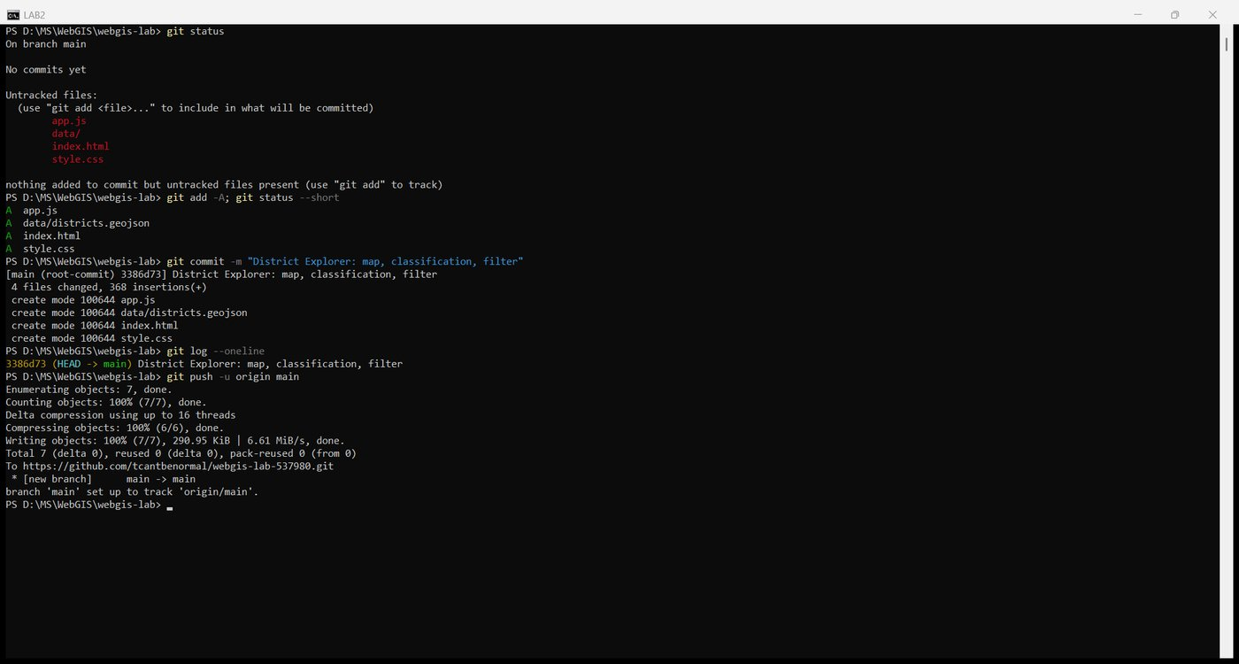
Figure 84. git push -u origin main

10.2 Turn on hosting
GitHub Pages was enabled from the main branch, root folder. The site returned 404 while it was being built and then 200.
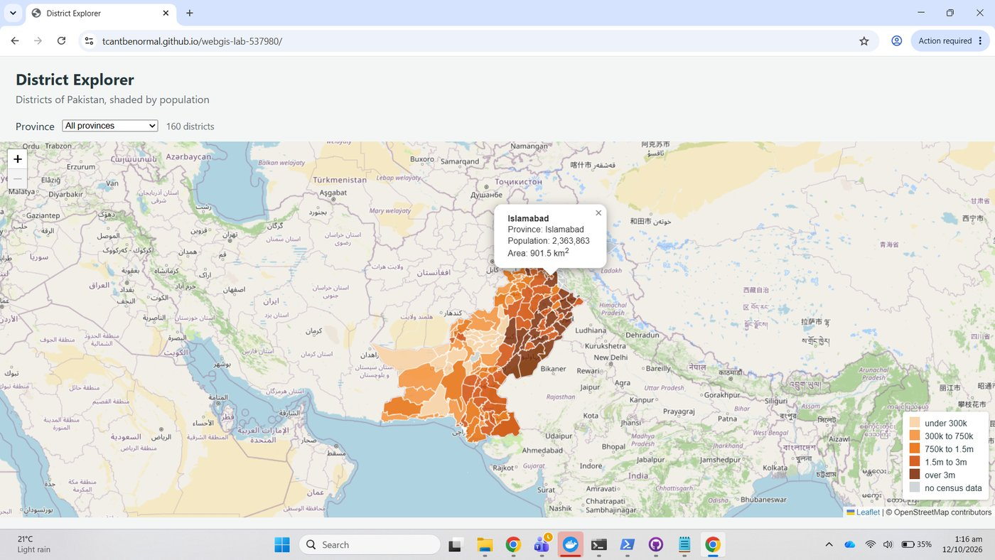
Figure 85. The live page served by GitHub Pages

10.3 Report
The report, the checkpoint screenshots and the measurement tables were then committed and pushed as a second commit, so the repository history reads: page, map and data first; report second.
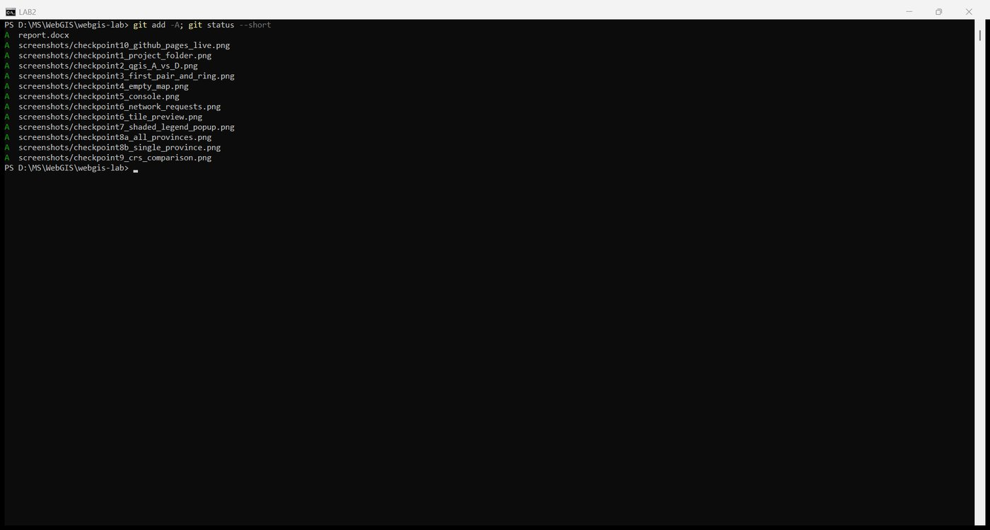
Figure 86. git add -A with the report and screenshots
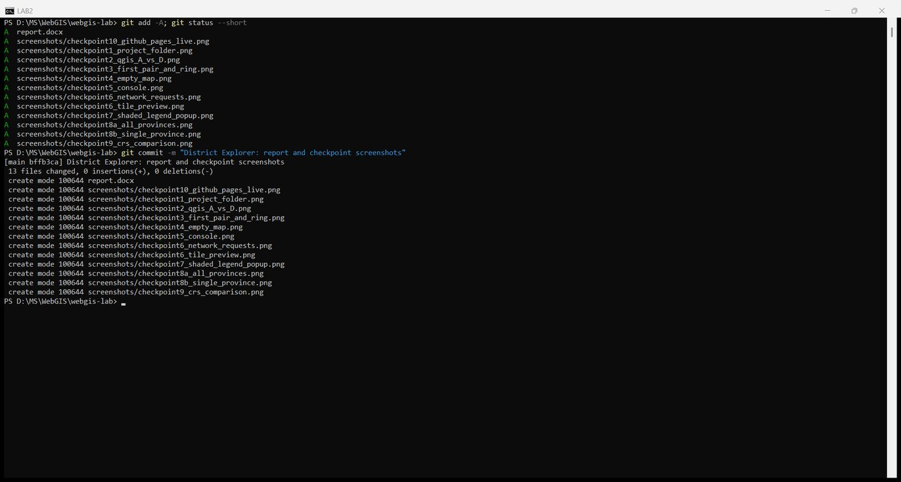
Figure 87. The report commit
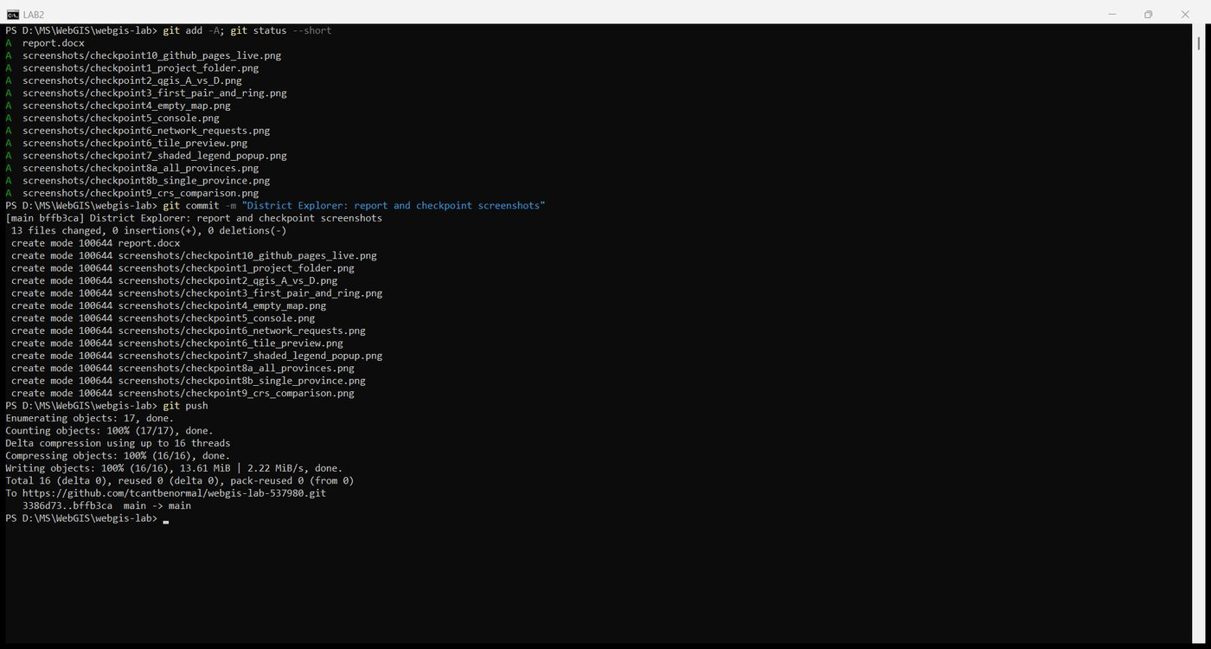
Figure 88. git push
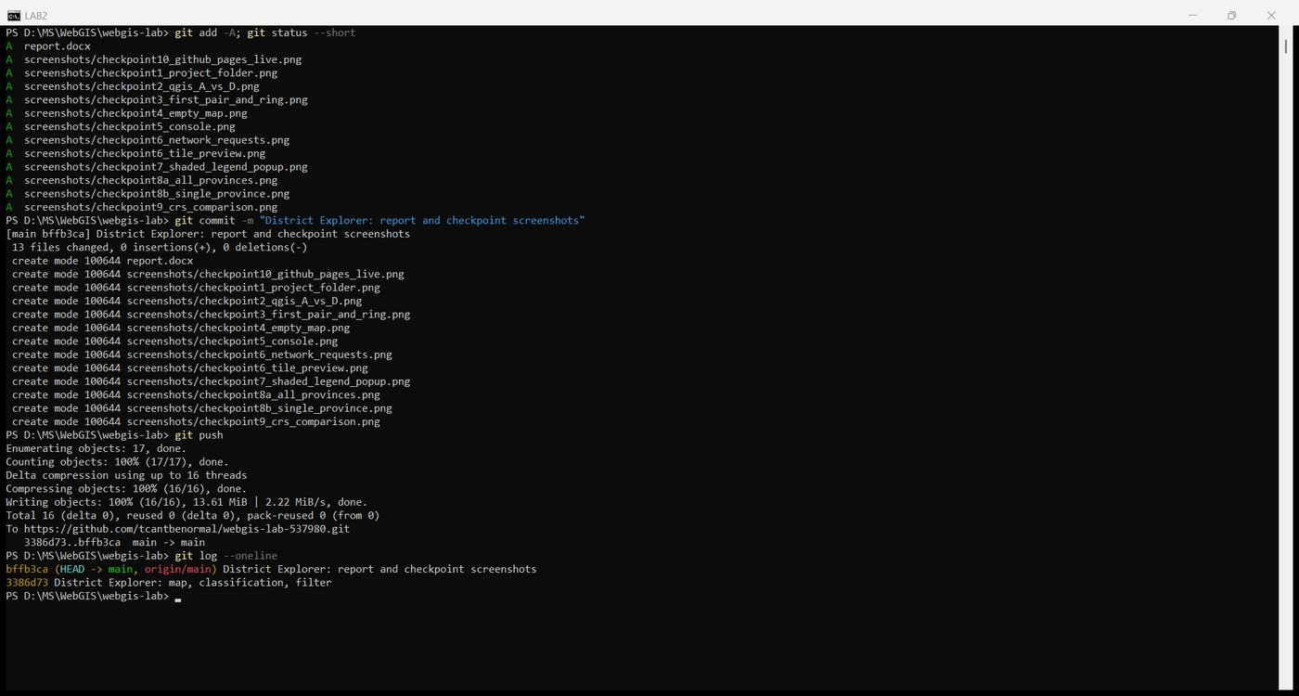
Figure 89. Final git log

Questions
1. Version D is far smaller than version A. Give one situation in which version D would be the wrong choice.
Any map where the user zooms in to a single district or a city. At tolerance 0.01 degrees, about 1 km, a boundary is reduced to a few dozen straight segments; at zoom 10 or closer those segments are visibly wrong, shared borders may open into slivers, and a point that is really inside a district can fall outside its simplified polygon. Version D is right for a thumbnail or a country overview and wrong for anything that will be inspected or queried locally.
2. The page makes one request for your GeoJSON file and dozens for tiles. Explain the difference in how those two kinds of data reach the browser.
The GeoJSON is vector data: one file holding every coordinate of every district, fetched once by fetch, parsed into JavaScript objects, and drawn by Leaflet in the browser. After that one transfer, panning, zooming, filtering and styling cost no further requests. The tiles are raster data: the basemap is pre-rendered by the server into 256 by 256 pixel images for every zoom level, and the browser only asks for the squares that cover the current view at the current zoom. Each square is its own HTTP request, so the number of tile requests grows every time the view changes, while the vector layer is still the single file loaded at the start.
3. Why does the map container need a height when the heading does not?
An h1 contains text, and a block element's default height grows to fit its content. The map div is empty, so its natural height is zero. Leaflet draws into whatever box it is given and does not enlarge it, so without the height: calc(100vh - 150px) rule it would render a map zero pixels tall, with no error and a clean console.
4. `draw` removes the existing layer before adding a new one. What would go wrong if it did not?
L.geoJSON(...).addTo(map) adds a layer; it never replaces one. Without map.removeLayer(layer), each change of the drop-down would stack a new layer on top of the old ones: the previously drawn provinces would still be visible under the new selection, popups from several layers would overlap, and the map would slow down with every change as the number of polygons kept growing. The count label would also lie, because it reports the new subset while the old features are still drawn.
5. A classmate's districts all appear in the same colour. List two possible causes and how you would tell them apart.
Cause one: the population values cannot be read as numbers, for example "1,500,000" with a thousands separator, " 95000" with a stray space, or a placeholder like "NA". Every comparison in colourFor is then false and each feature falls through to the lowest class. Cause two: the property name in the code does not match the data, for example pop2023 or Pop_2023, so feature.properties.pop_2023 is undefined for every district and the first line of colourFor paints them all grey. To tell them apart: look at the colour. All grey means the value is undefined or null, so check the property name in the Console with districts.features[0].properties. All the palest orange means the values exist but failed the numeric comparisons, so check typeof districts.features[0].properties.pop_2023 and look at the attribute table for separators or text.
6. You open the page by double-clicking `index.html` instead of using Live Server. The basemap appears but the districts do not. Explain why.
Opened from the file system, the page has a file:/// address and no proper web origin. Leaflet, its CSS and the OpenStreetMap tiles all come from https:// servers, which the browser is happy to load from any page, so the basemap appears. fetch('data/districts.geojson'), however, is a request from a file:// page to another local file, which the browser blocks under its security rules; the promise rejects or returns a failed response, districts stays null, and draw never runs. Served from http://127.0.0.1:5500, the same relative URL is an ordinary same-origin request and works.

Marking checklist
Item | Where
Published map with shading, legend and popups | https://tcantbenormal.github.io/webgis-lab-537980/
File size table with method | Part 2.5
Network measurements including throttled figures | Part 6, load time table
Nine checkpoint screenshots | Checkpoints 1 to 9 above
Answers to the six questions | Questions section
Repository with readable history | https://github.com/tcantbenormal/webgis-lab-537980
Extensions | Parts 8 and 9 completed

