

Web GIS Lab 03: District Dashboard

Name: Muhammad Taimoor Ashfaq Malik
Reg No: 537980
Course: Web GIS
Instructor: Dr. Shahid Nawaz Khan

Part 1: Set up the project
The lab was done in the same repository as Lab 2, webgis-lab-537980, so that Lab 2 stays published. As in Lab 2, VS Code is not installed on this machine: every command was run in a PowerShell window, the page was served with Python's built-in server from the repository root so that the address ends in /lab3/index.html, and the QGIS toolchain was driven from the command line with QGIS itself used for the Checkpoint 2 view. Each command was run on its own and screenshotted.

1.1 Create the folder
cd D:\MS\WebGIS\webgis-lab
mkdir lab3
mkdir lab3\data
copy data\districts.geojson lab3\data\districts.geojson

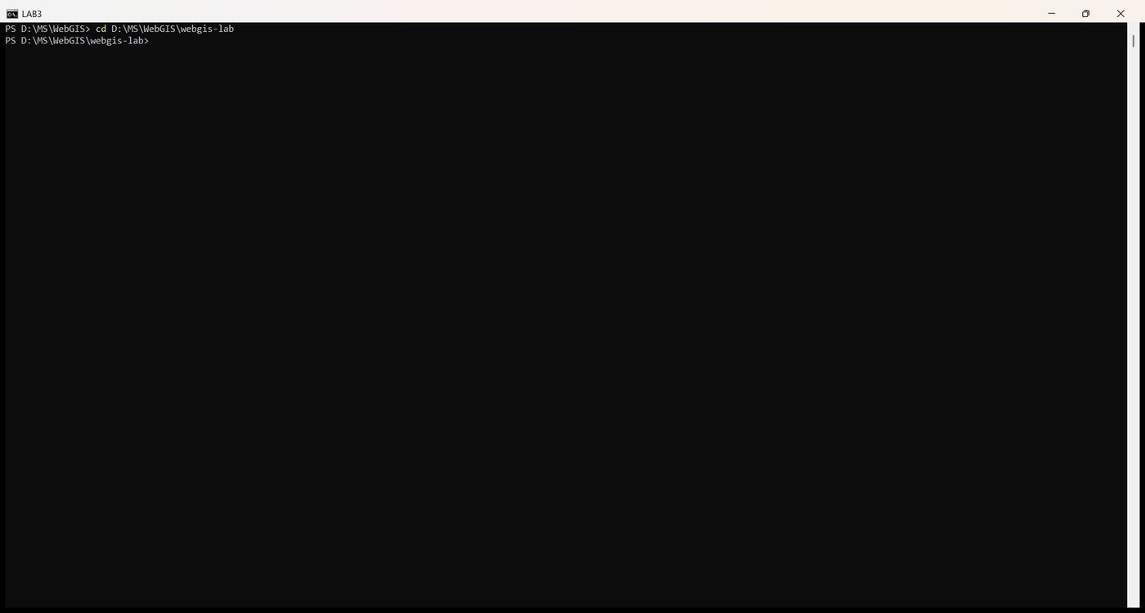
Figure 1. cd to the Lab 2 repository
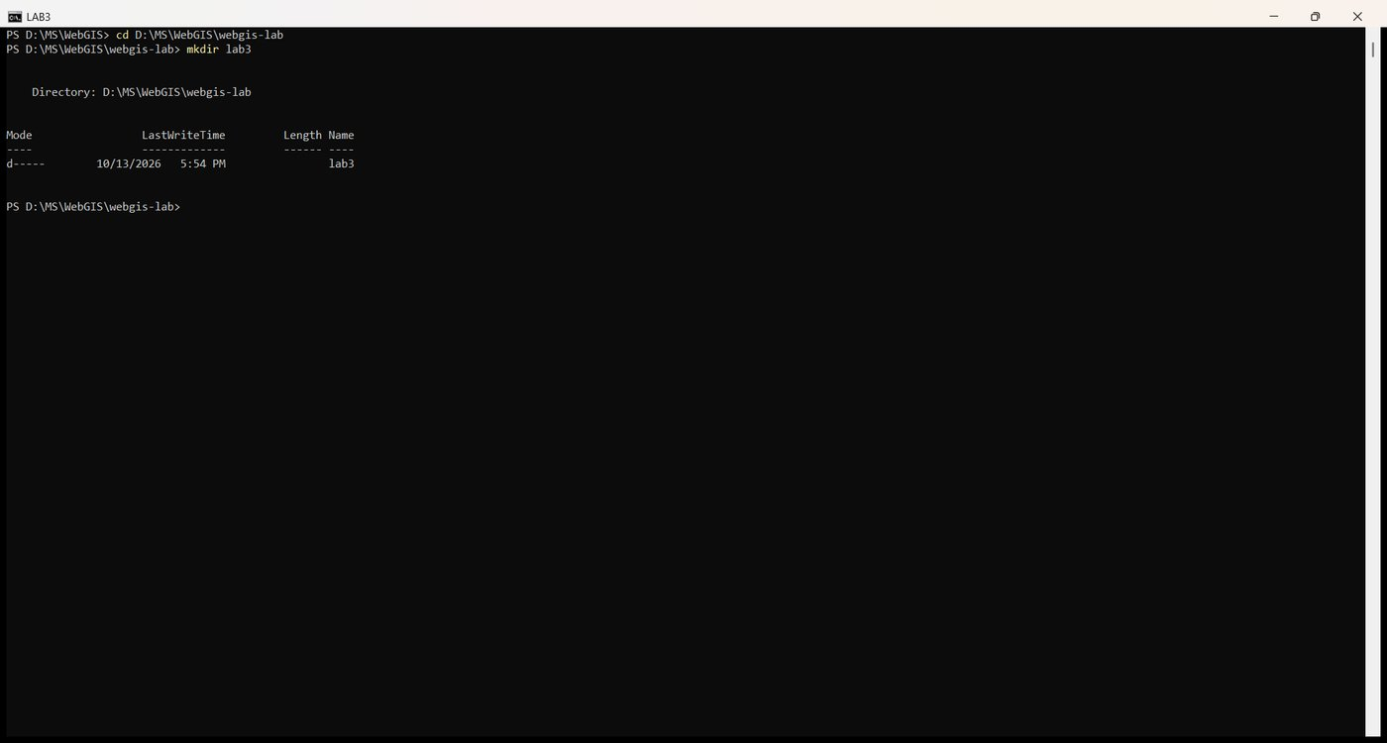
Figure 2. mkdir lab3
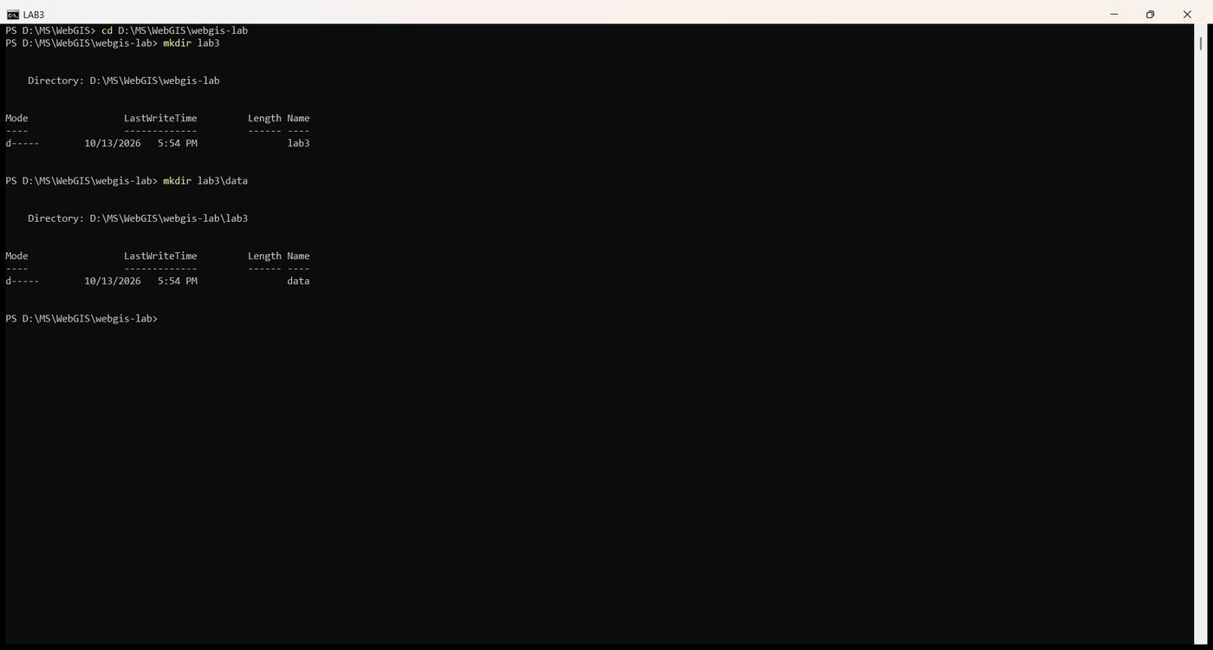
Figure 3. mkdir lab3\data
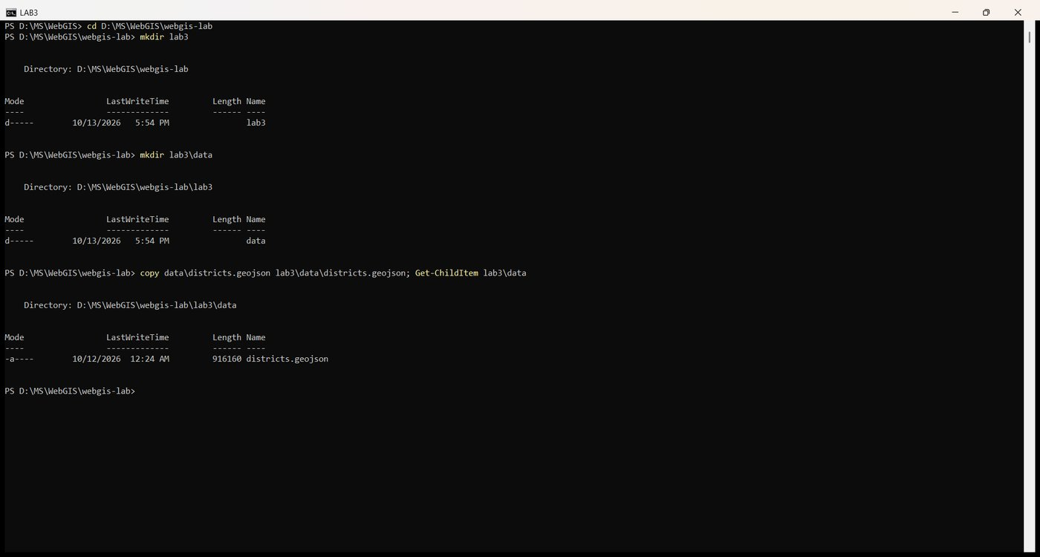
Figure 4. Copy the Lab 2 districts.geojson into lab3\data
The three files were created with one PowerShell command and listed:
New-Item lab3\index.html, lab3\style.css, lab3\app.js -ItemType File
Get-ChildItem lab3

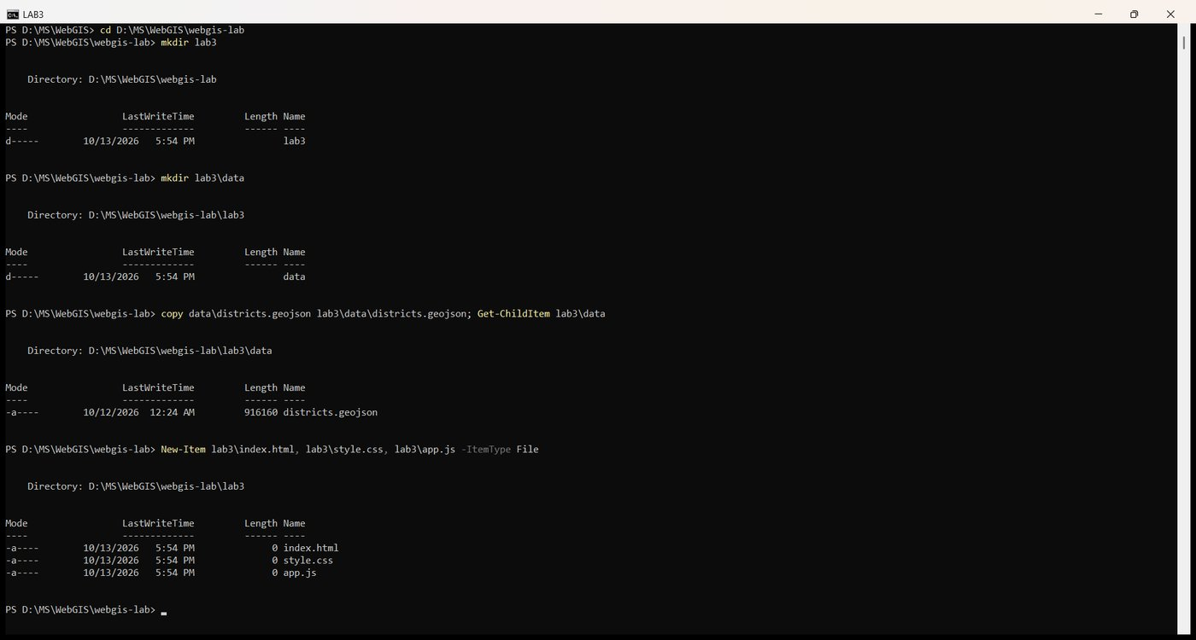
Figure 5. New-Item creates index.html, style.css and app.js
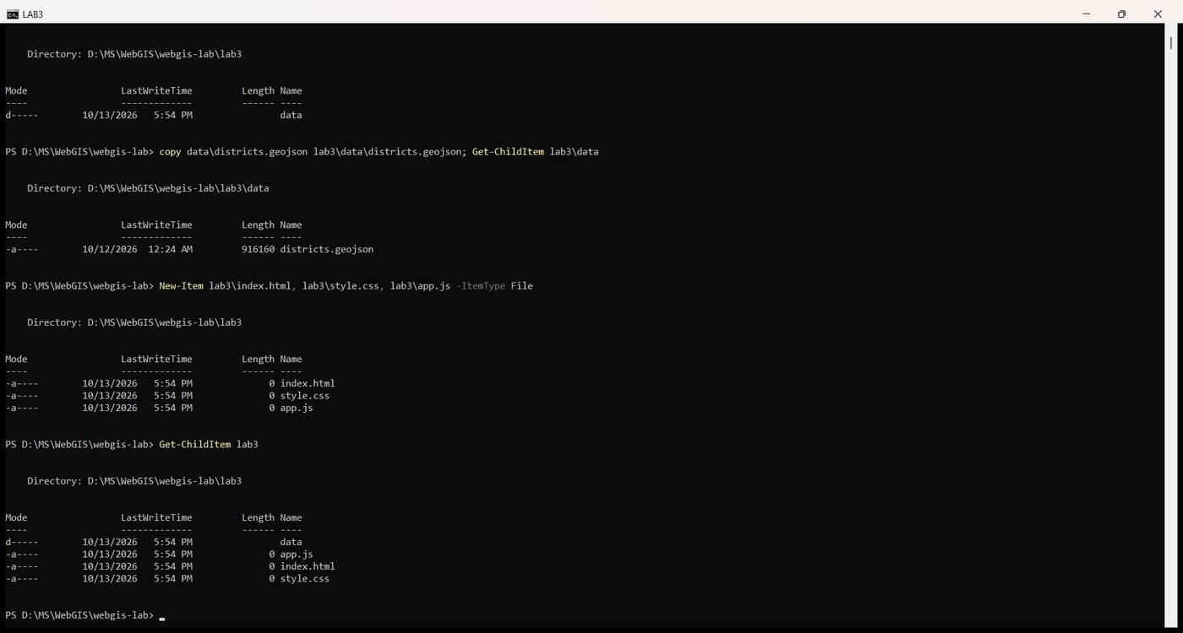
Figure 6. Get-ChildItem lab3

Checkpoint 1
The lab3 folder with its three files and data\districts.geojson, shown in File Explorer opened from the console.
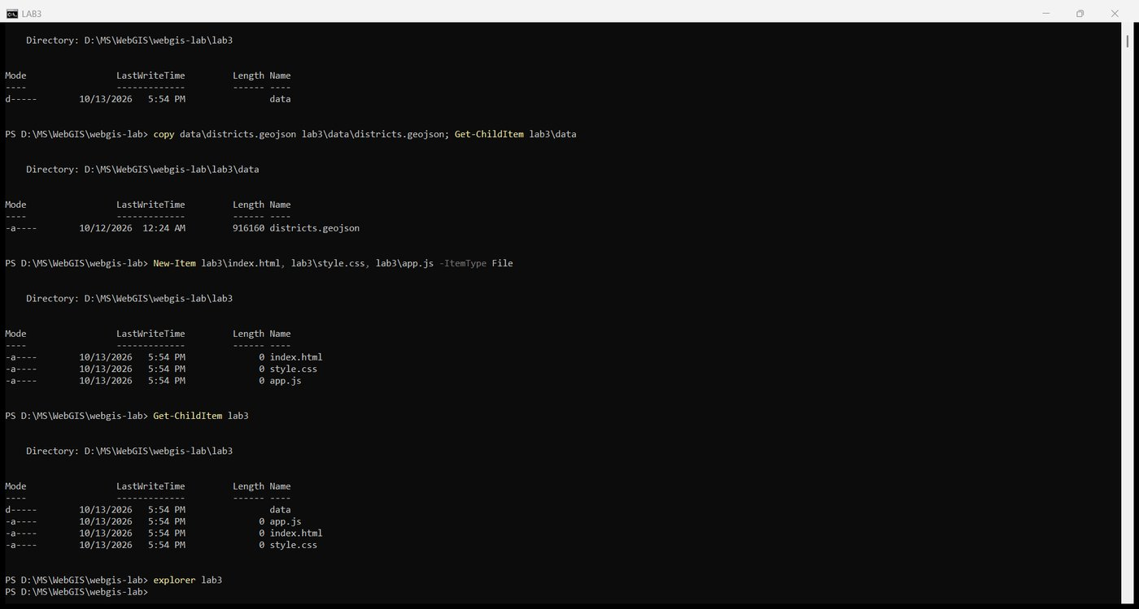
Figure 7. explorer lab3
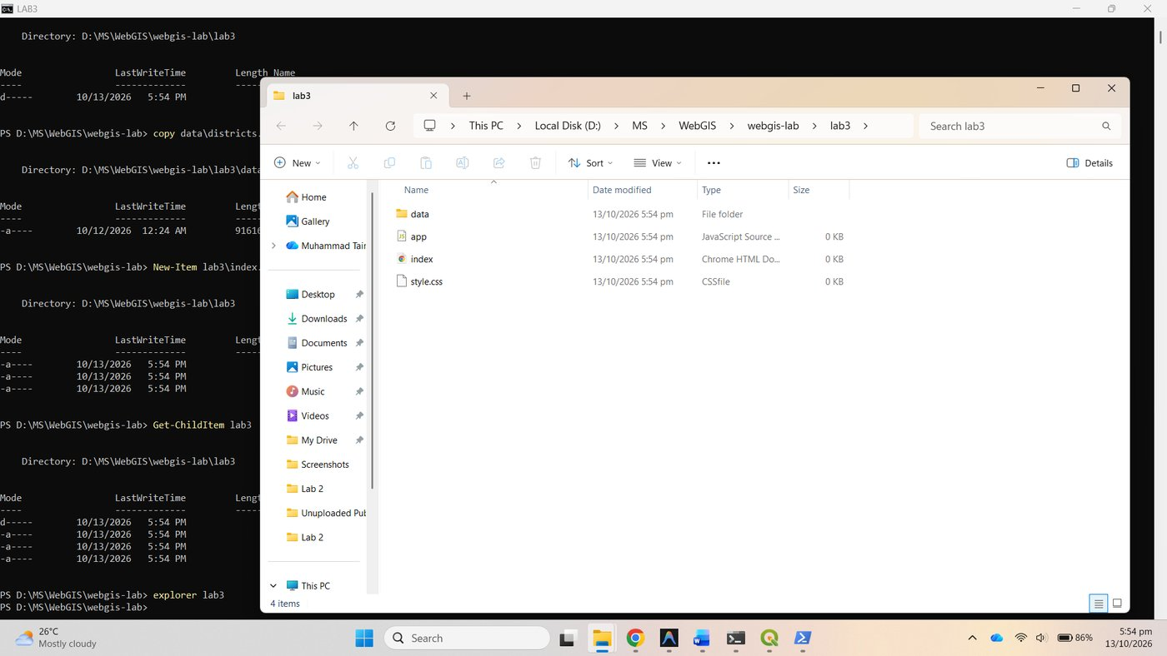
Figure 8. Checkpoint 1: lab3 with index.html, style.css, app.js and data

Part 2: Make a point layer in QGIS

2.1 Point on surface, not centroid
Both tools from Vector, Geometry Tools were run on lab3/data/districts.geojson through qgis_process, the same algorithms the menu runs.
qgis_process-qgis-ltr.bat run native:centroids --INPUT=lab3\data\districts.geojson --ALL_PARTS=false --OUTPUT=..\lab3-data\centroids.geojson
qgis_process-qgis-ltr.bat run native:pointonsurface --INPUT=lab3\data\districts.geojson --ALL_PARTS=false --OUTPUT=..\lab3-data\point_on_surface.geojson

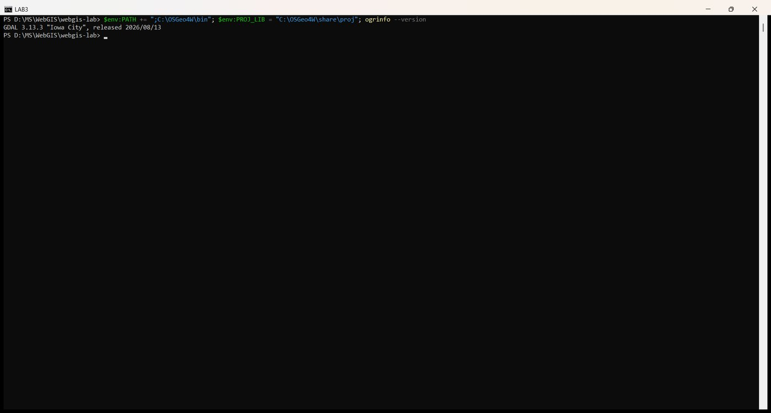
Figure 9. OSGeo4W tools on the PATH
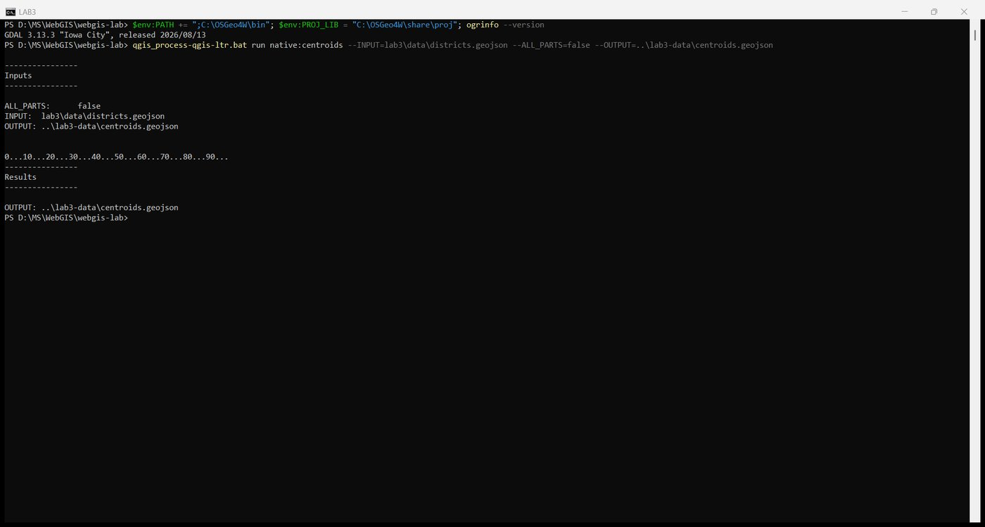
Figure 10. Centroids
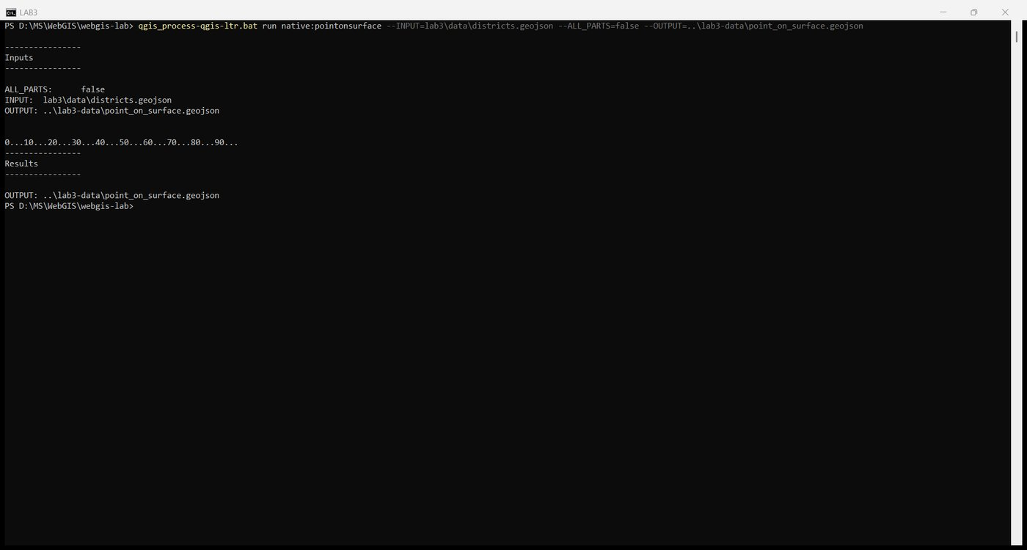
Figure 11. Point on Surface
The district whose centroid falls outside it is Sibi, in Balochistan. Sibi is a MultiPolygon in two parts joined by a narrow neck, so its centre of mass (67.9447 E, 29.7615 N) lands in the gap between the parts, inside the neighbouring district. Point on Surface places the point at 68.2501 E, 29.7271 N, inside the larger eastern part. A symbol drawn at the centroid would be read as belonging to the neighbour.

2.2 Export
The Point on Surface result was exported with precision 5 in EPSG:4326, exactly as the Save Features As dialog does:
ogr2ogr -f GeoJSON lab3\data\district_points.geojson ..\lab3-data\point_on_surface.geojson -t_srs EPSG:4326 -lco COORDINATE_PRECISION=5

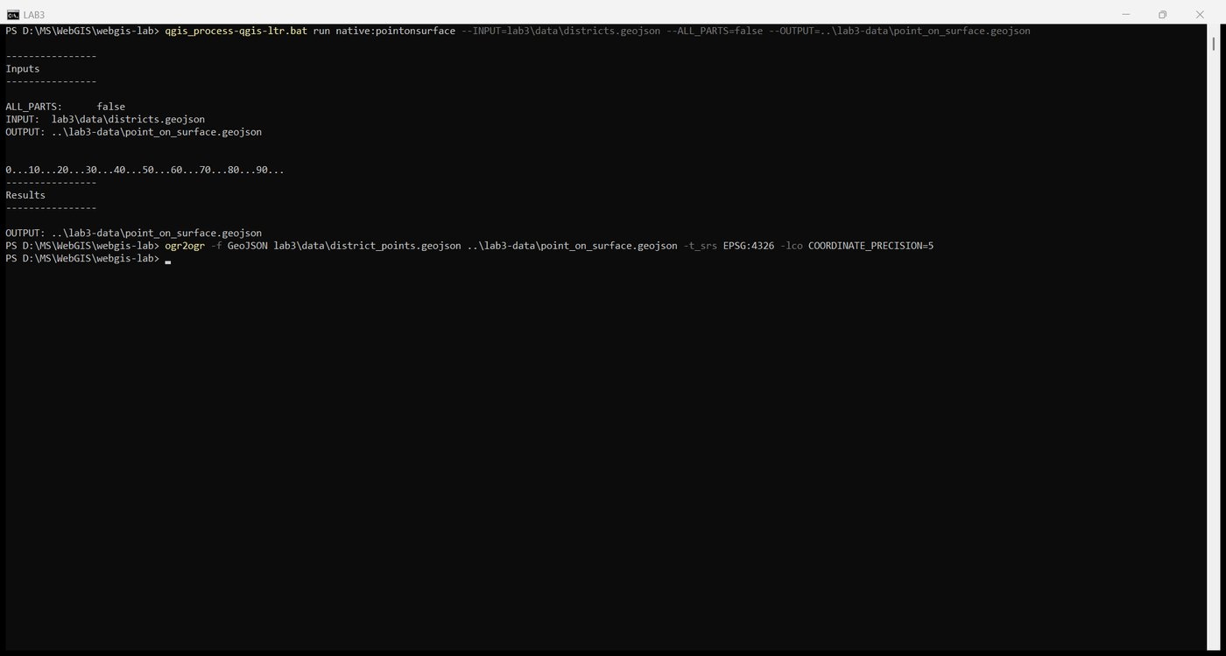
Figure 12. Export district_points.geojson
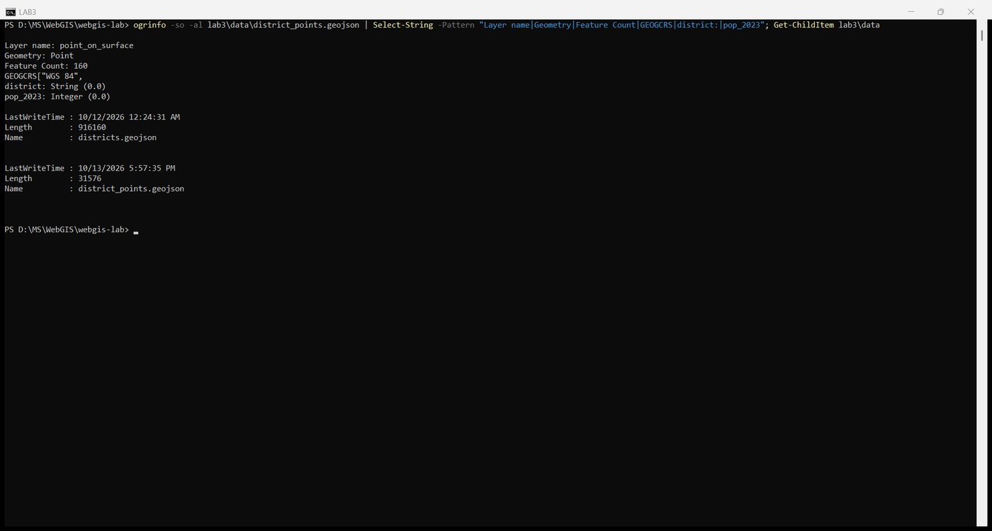
Figure 13. ogrinfo: 160 point features, WGS 84, pop_2023 carried over; file size 31,576 bytes
district_points.geojson | Value
Size | 31,576 bytes (31 kB)
Feature count | 160
Geometry | Point, EPSG:4326, five decimal places
Attributes | district, province, pcode, pop_2023, area_km2 (inherited from the districts)
Districts with no population | 25

The attribute table in QGIS confirms 160 features with the inherited attributes:
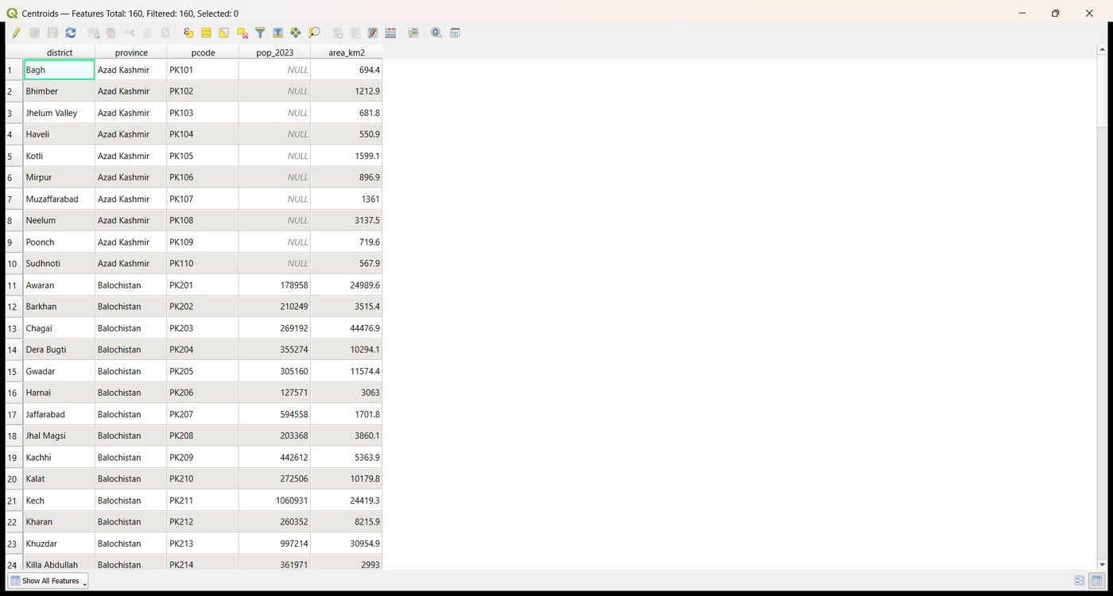
Figure 14. Attribute table of the point layer: 160 features

Checkpoint 2
Sibi zoomed in QGIS with the districts, the centroids (red circles) and the points on surface (green triangles). The red Sibi centroid sits in the narrow neck outside the polygon; the green Sibi point is inside the eastern part.
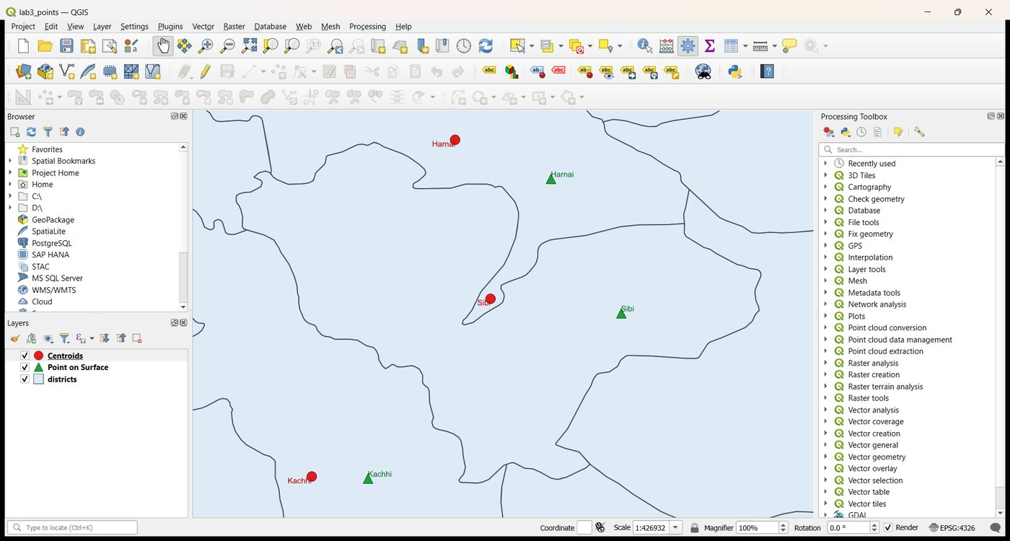
Figure 15. Checkpoint 2: Sibi, centroid outside the district, point on surface inside

Part 3: The page, the map and its basemaps

3.1 index.html and 3.2 style.css
Both files were written exactly as given in the handout.
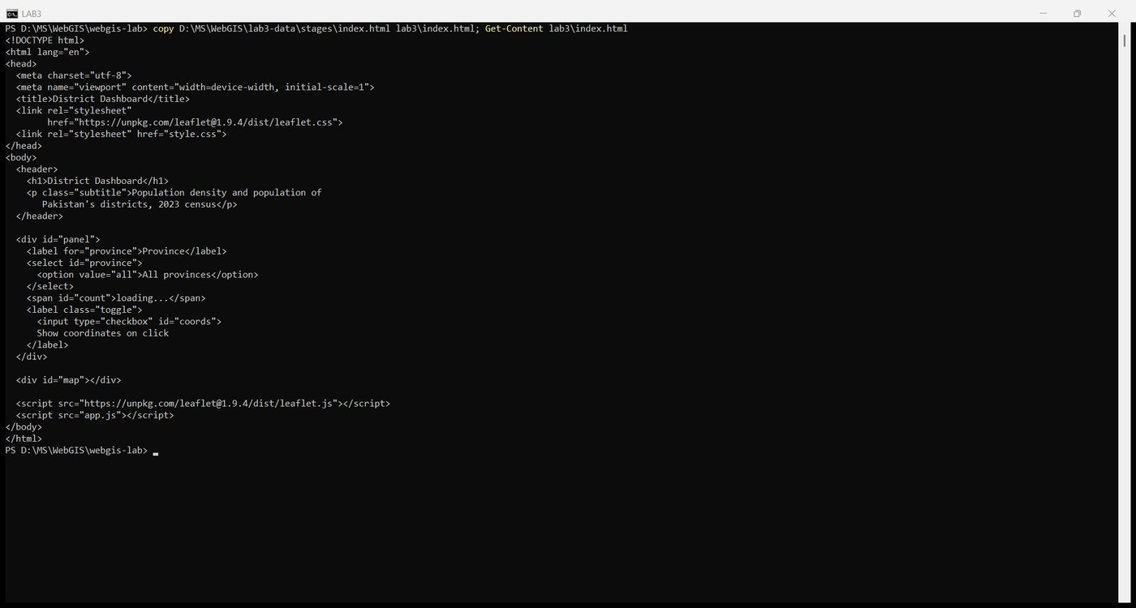
Figure 16. index.html
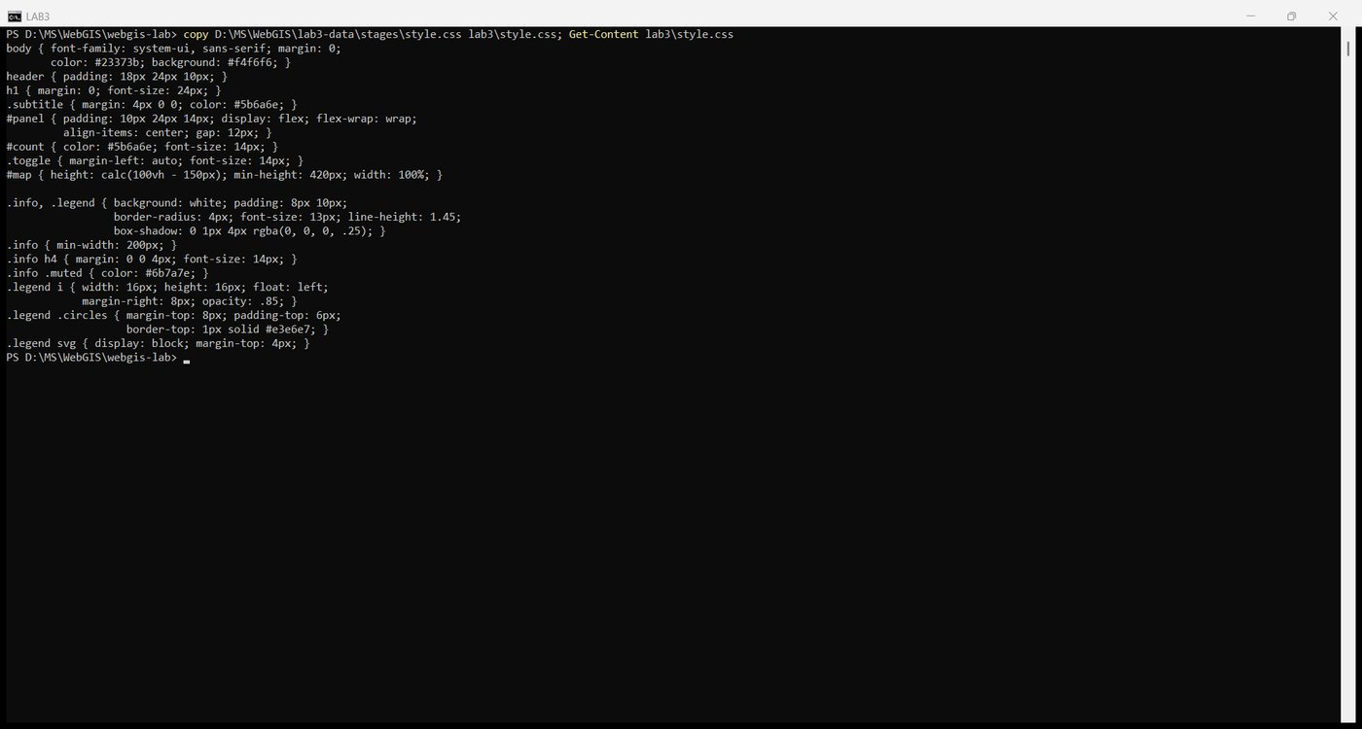
Figure 17. style.css

3.3 The map, through its options, and 3.4 three basemaps and a layer control
The first block of app.js creates the map with center, zoom, minZoom: 5, maxZoom: 14, maxBounds and maxBoundsViscosity: 1.0 in the options object, then the three tile layers, the layer control with collapsed: false, and the metric scale bar.
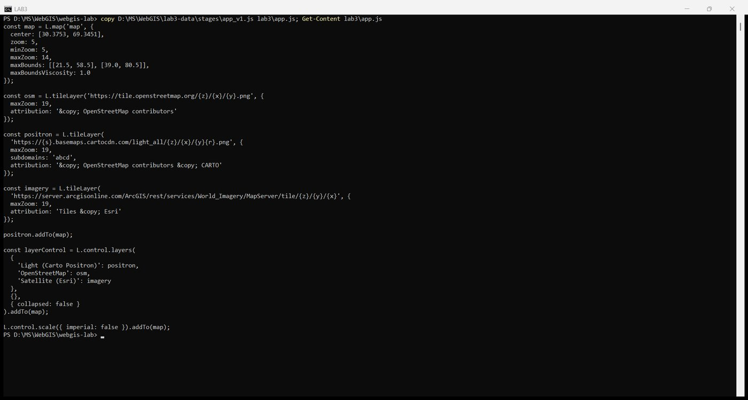
Figure 18. app.js: map options, basemaps, layer control, scale
The server was started from the repository root so that lab3/index.html is reached at http://127.0.0.1:5500/lab3/index.html and the data paths resolve relative to it.
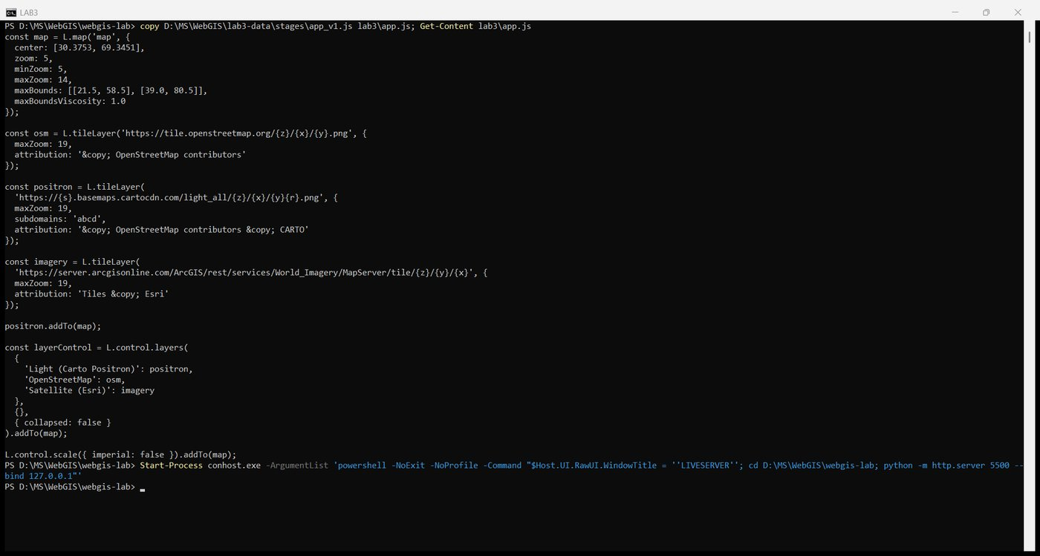
Figure 19. Starting the server from the repository root
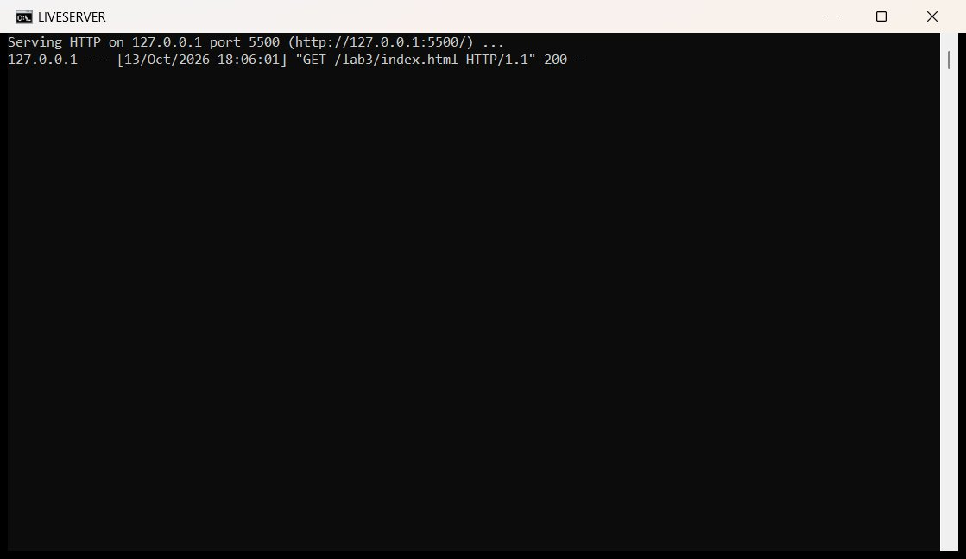
Figure 20. The server log serving lab3
A substitution that had to be made. The handout's default basemap, Carto Positron at basemaps.cartocdn.com, now returns placeholder tiles stamped "API KEY REQUIRED" instead of map tiles, because CARTO has put its free basemaps behind an API key. The page as written therefore opened on a grid of watermark tiles:
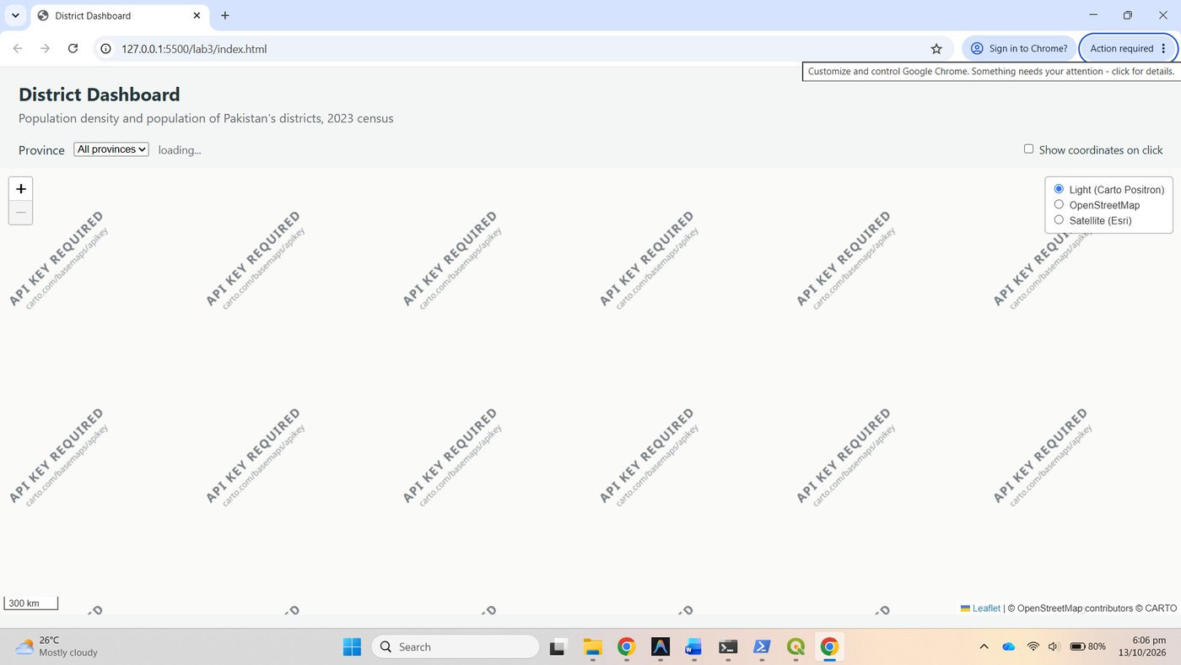
Figure 21. Carto Positron tiles now require an API key
The quiet grey default was replaced with Esri's free Light Gray Canvas service, which serves the same purpose (a basemap that does not compete with a thematic layer) and uses the same {z}/{y}/{x} order as the Esri imagery template, so the handout's lesson about reading templates closely still applies. The attribution string credits Esri.
const light = L.tileLayer(
'https://server.arcgisonline.com/ArcGis/rest/services/Canvas/World_Light_Gray_Base/MapServer/tile/{z}/{y}/{x}', {
maxZoom: 16,
attribution: 'Tiles &copy; Esri'
});

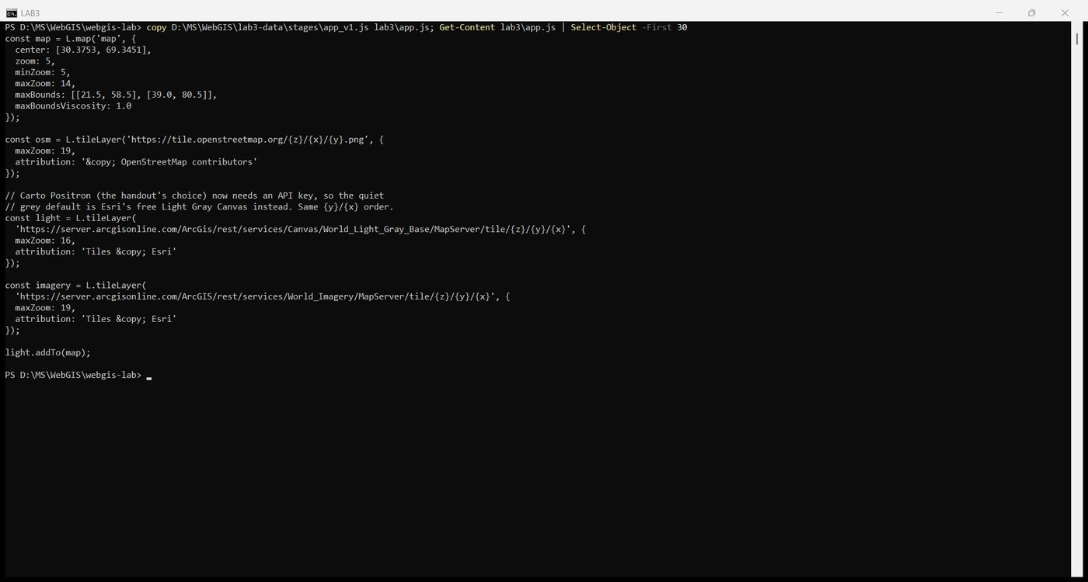
Figure 22. app.js with the Light Gray Canvas default

Checkpoint 3
The Network tab with the Satellite (Esri) basemap selected and one tile request opened. Its URL is https://server.arcgisonline.com/ArcGIS/rest/services/World_Imagery/MapServer/tile/5/13/22.
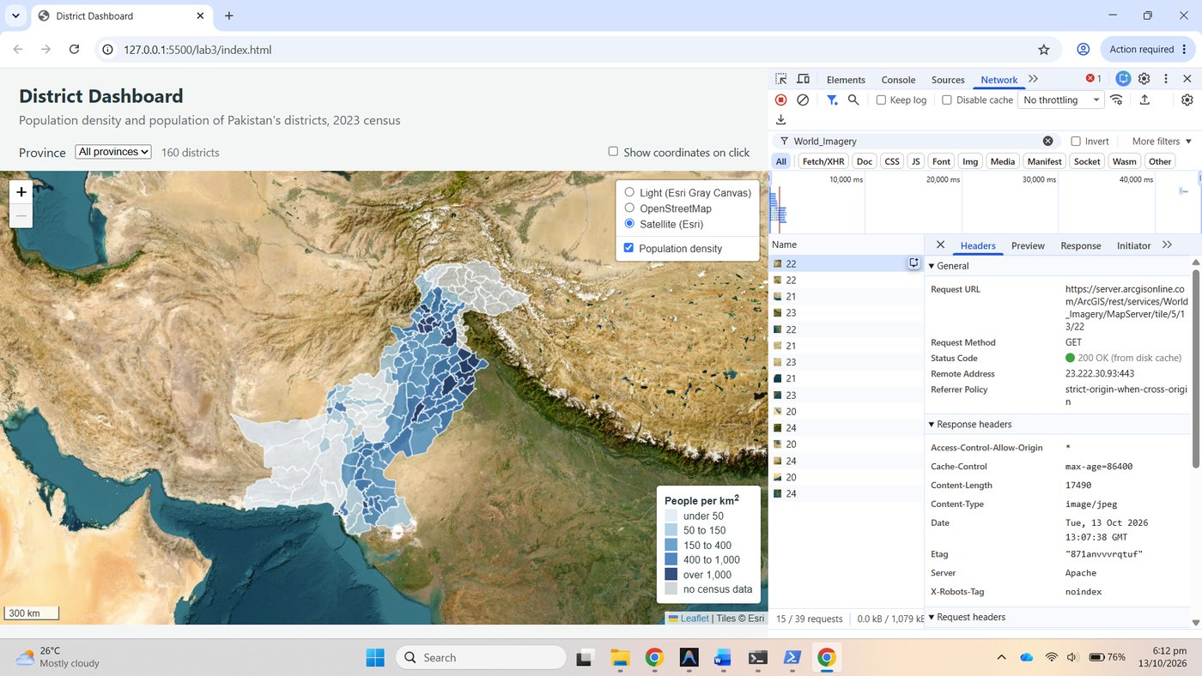
Figure 23. Checkpoint 3: an Esri tile request with its URL
Row and column in the Esri URL. The Esri template ends {z}/{y}/{x}, so in /tile/5/13/22 the numbers are zoom 5, row 13, column 22. OpenStreetMap's template ends {z}/{x}/{y}, so the equivalent OSM tile is /5/22/13.png, column first. Leaflet fills in whichever placeholders the template contains in the order they appear, which is why each provider's template must be copied exactly.

Part 4: A thematic layer, done properly

4.1 Why density, not population
Lab 2 shaded districts by population, which largely repeats their areas: a large district holds many people simply because it is large. A choropleth colours areas, so the value behind the colour must not grow with area. The dashboard therefore shades by density, pop_2023 / area_km2, computed by densityOf from two stored attributes every time a district is styled, and shows the population count a second way in Part 6, as proportional symbols.

4.2 to 4.5 Style by density, the feature group, loading, drawing and the legend
show, densityOf, colourFor and styleFor were added; districtGroup is a L.featureGroup registered with the layer control as the overlay "Population density"; draw(province) uses the filter hook with keep, clears and refills the group and updates the count; loadJSON and loadData fetch both files with Promise.all; and the legend lists the five density classes plus the no-data class.
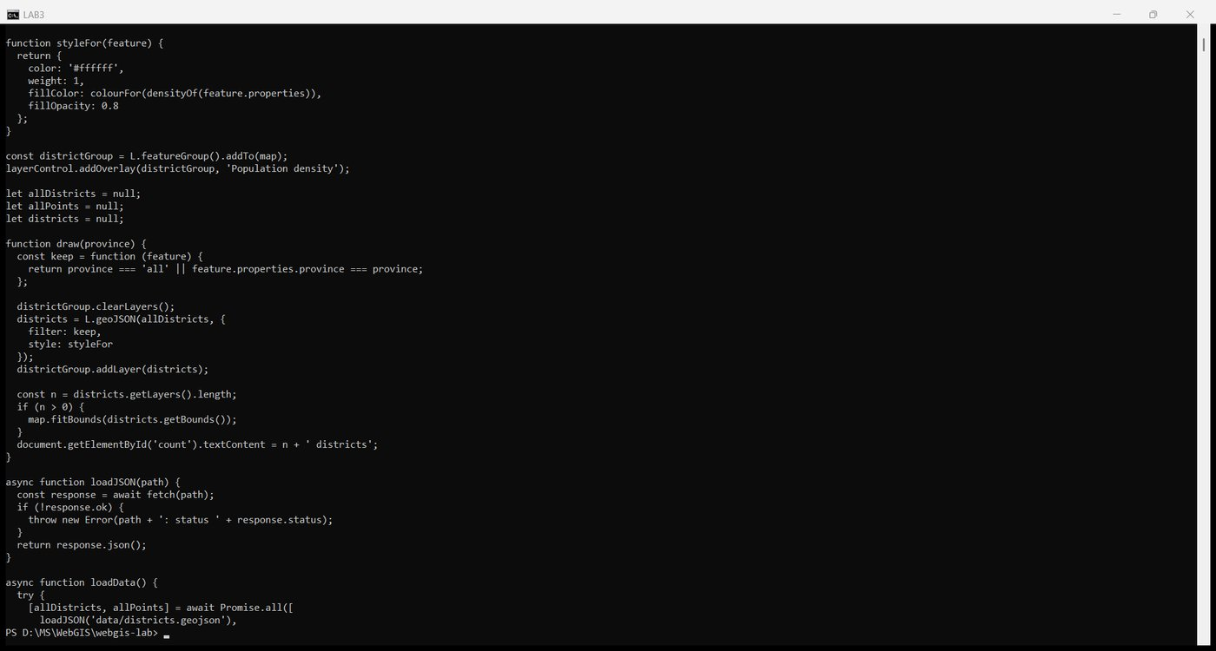
Figure 24. app.js: density functions, group, draw, loadData
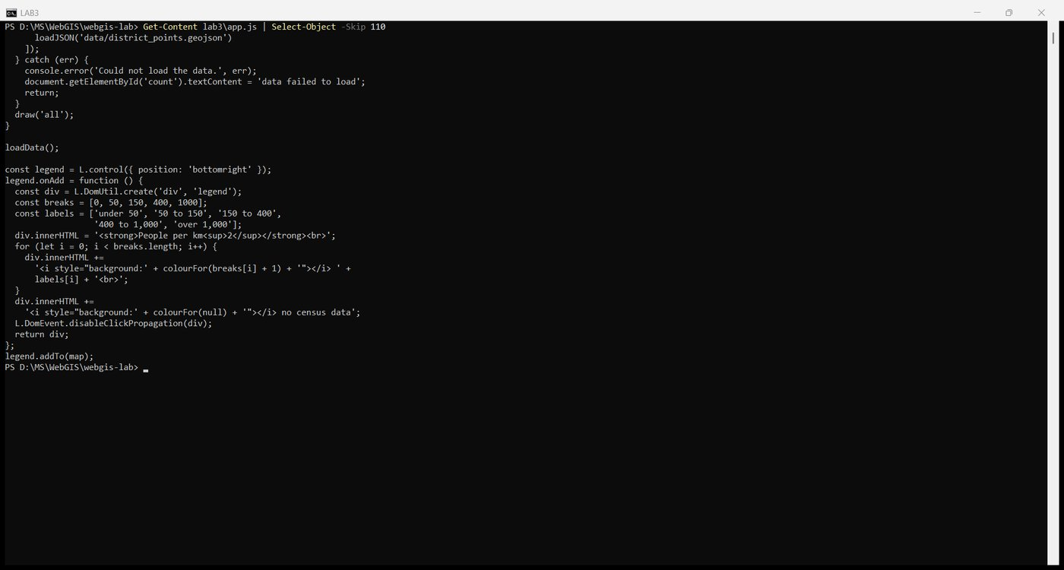
Figure 25. app.js: the legend
With these breaks the 135 districts with census data fall 20, 18, 34, 41 and 22 into the five classes, exactly as the handout states, and 25 are grey.

Checkpoint 4
The density map with its legend, and the layer control open showing the three basemaps and the one overlay.
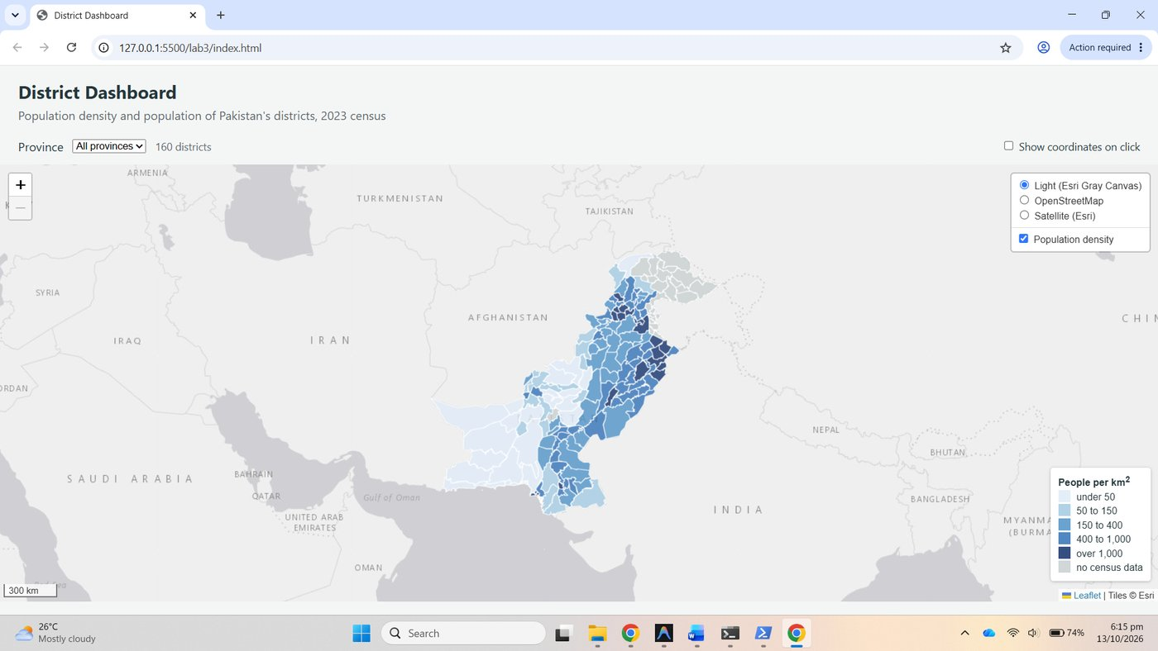
Figure 26. Checkpoint 4: density map, legend, layer control with three basemaps and one overlay

Part 5: Interaction: highlight and an info panel
The info control was added with onAdd and the custom update method; highlight, unhighlight and zoomToDistrict were written; bindDistrict binds a sticky tooltip and the three handlers; and onEachFeature: bindDistrict was handed to L.geoJSON inside draw.
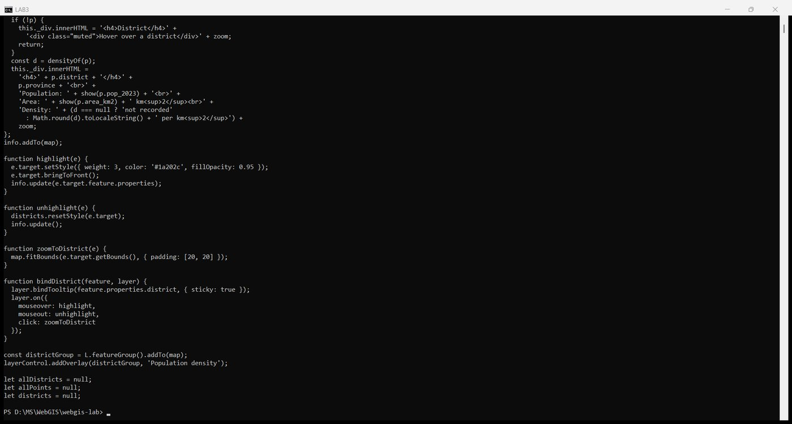
Figure 27. app.js: info control, highlight, unhighlight, zoomToDistrict, bindDistrict

Checkpoint 5
Lahore under the pointer: the thick dark outline brought to the front, the tooltip, and the info panel reporting Punjab, population 13,004,135, area 1,729.9 km², density 7,517 per km², zoom level 5.
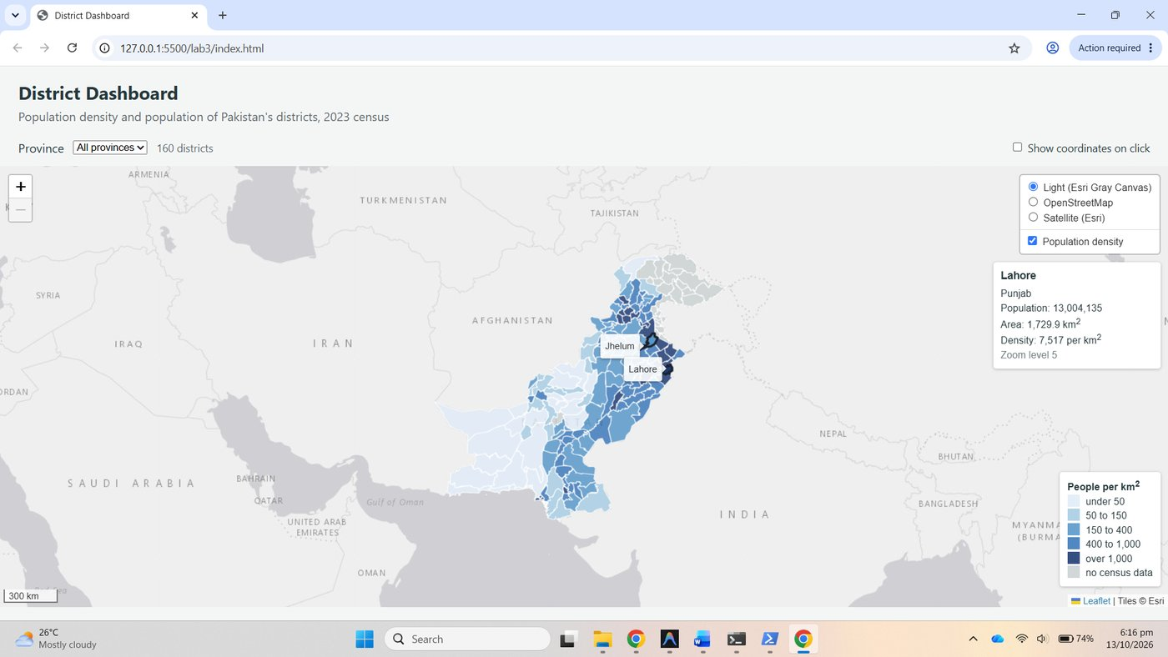
Figure 28. Checkpoint 5: Lahore highlighted with tooltip and info panel

Part 6: Proportional symbols in their own pane

6.1 to 6.5
The symbols pane was created with z-index 450, between overlayPane (400) and markerPane (600). radiusFor takes the square root of the population divided by 160, so that the area of each circle, not its radius, follows the count; Lahore at 13.0 million gets a radius of 22.5 px. circleFor builds a circleMarker in the symbols pane with a tooltip; hasPopulation drops the 25 districts without a census value before circleFor can meet a null; circleGroup is the second overlay, "Population", filled inside draw with filter and pointToLayer together; three reference circles drawn with the same radiusFor were added to the legend; and the NUST overlay pairs a L.circle of 25,000 m with a L.circleMarker of 6 px.
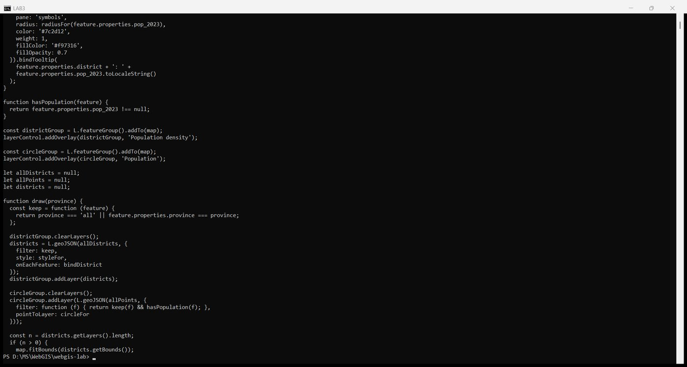
Figure 29. app.js: pane, radiusFor, circleFor, hasPopulation, circleGroup
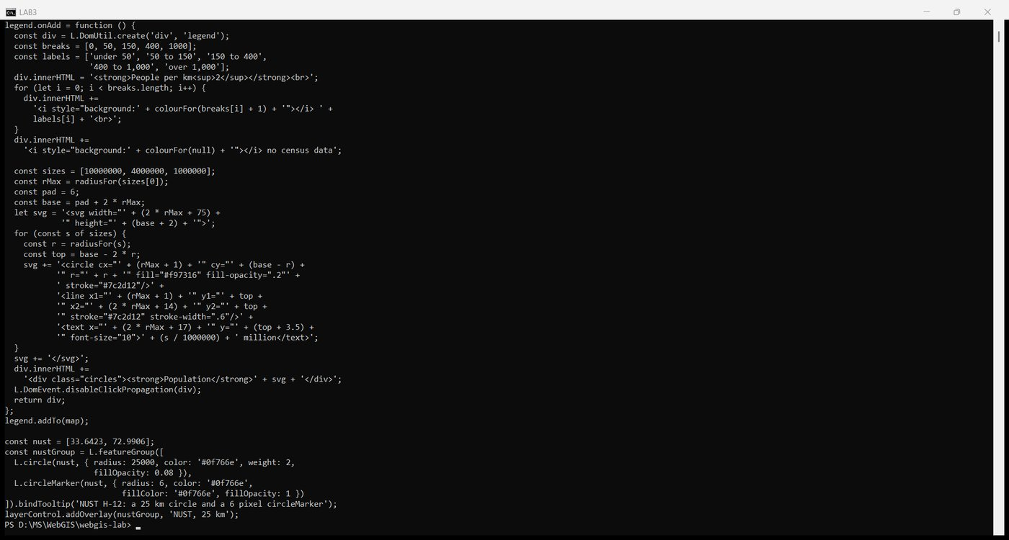
Figure 30. app.js: legend circles and the NUST overlay

Checkpoint 6
The full dashboard: 135 circles above the density shading, and the legend showing both the density classes and the circle sizes.
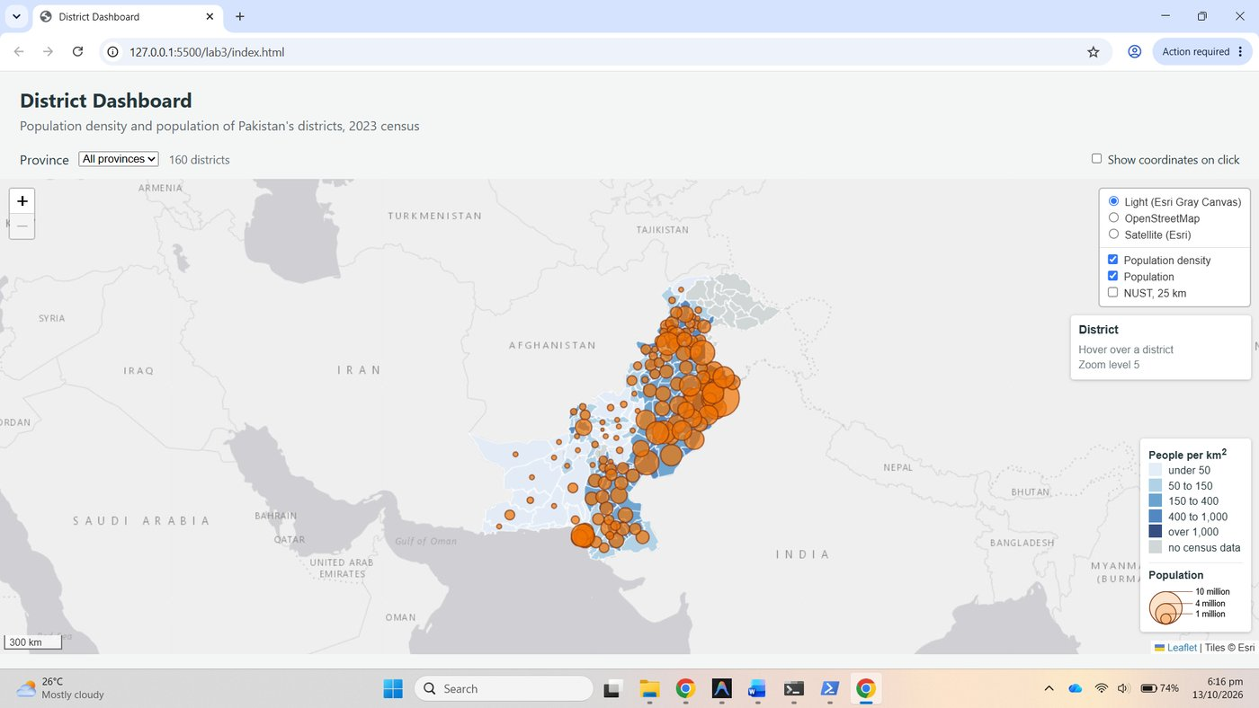
Figure 31. Checkpoint 6a: circles above the density shading, legend with both parts
The NUST overlay at zoom 5 and zoom 10. At zoom 5 the 25 km L.circle is about 6 px across on screen, the same size as the 6 px circleMarker, so the two coincide. At zoom 10 the L.circle has grown to a radius of about 196 px while the circleMarker is still 6 px. Measured against the scale bar at zoom 10, 10 km is 79 px, so 25 km should be 197 px: the metre circle is drawn to scale.
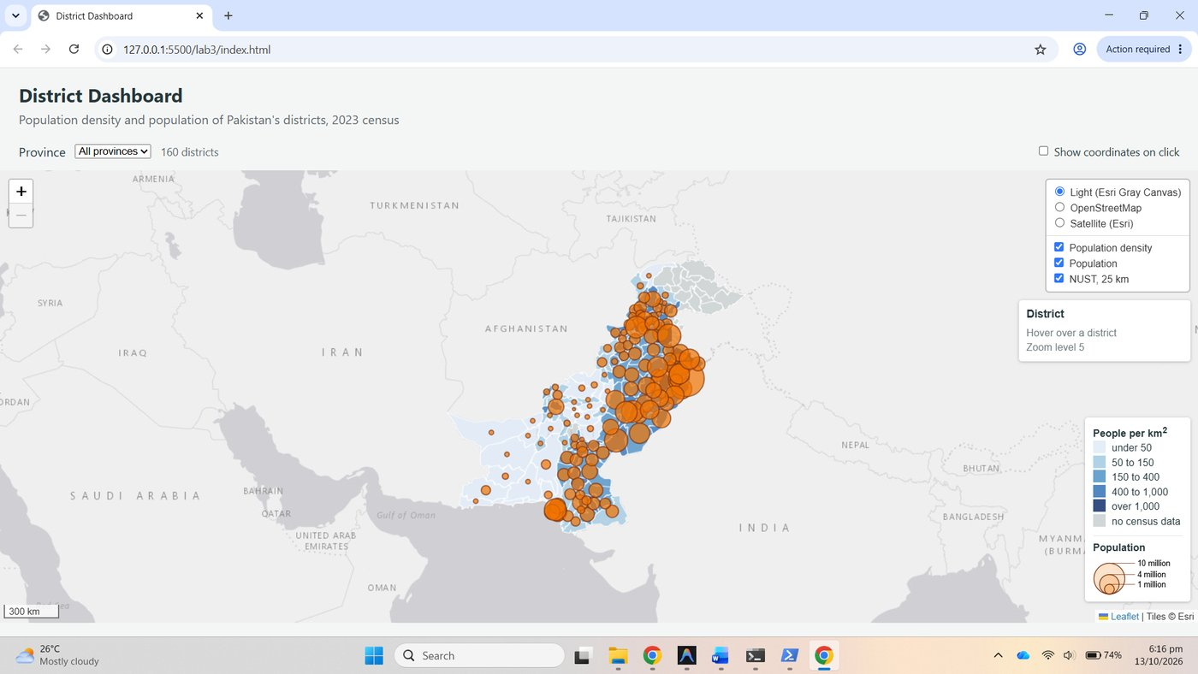
Figure 32. Checkpoint 6b: NUST overlay at zoom 5
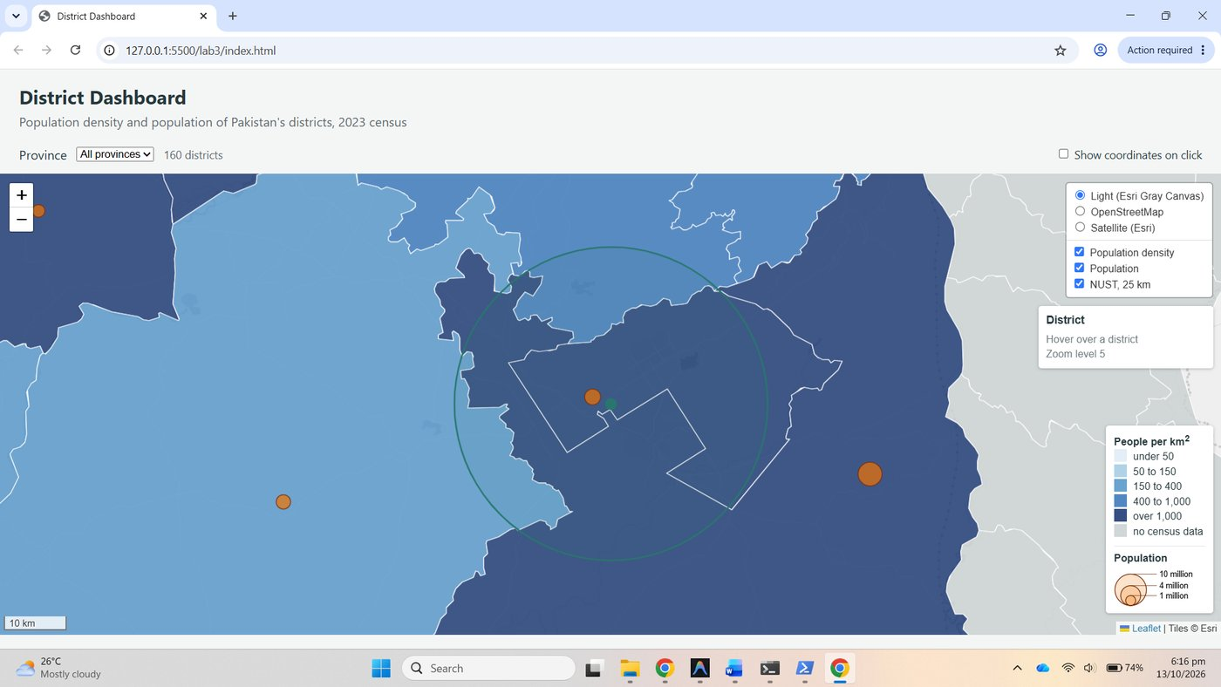
Figure 33. Checkpoint 6c: NUST overlay at zoom 10, the 25 km circle against the 10 km scale bar

Part 7: Map events, on and off
showCoordinates is a named function so that map.off('click', showCoordinates) can find the very function map.on registered. The checkbox's change listener switches it on and off, and a zoomend handler keeps the info panel's zoom level current.
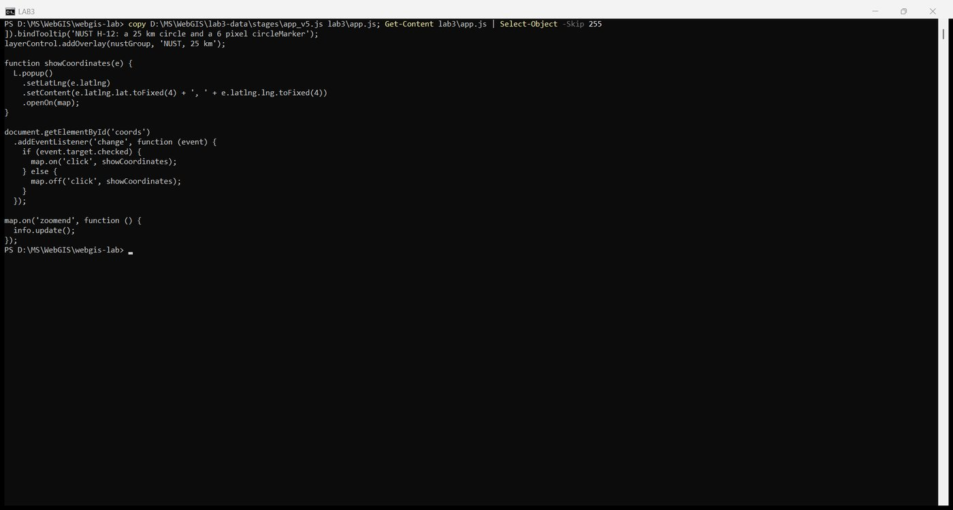
Figure 34. app.js: showCoordinates, the checkbox listener, zoomend

Checkpoint 7
With the checkbox ticked, a click on the sea south of Karachi opens a popup reading 23.8810, 66.6211.
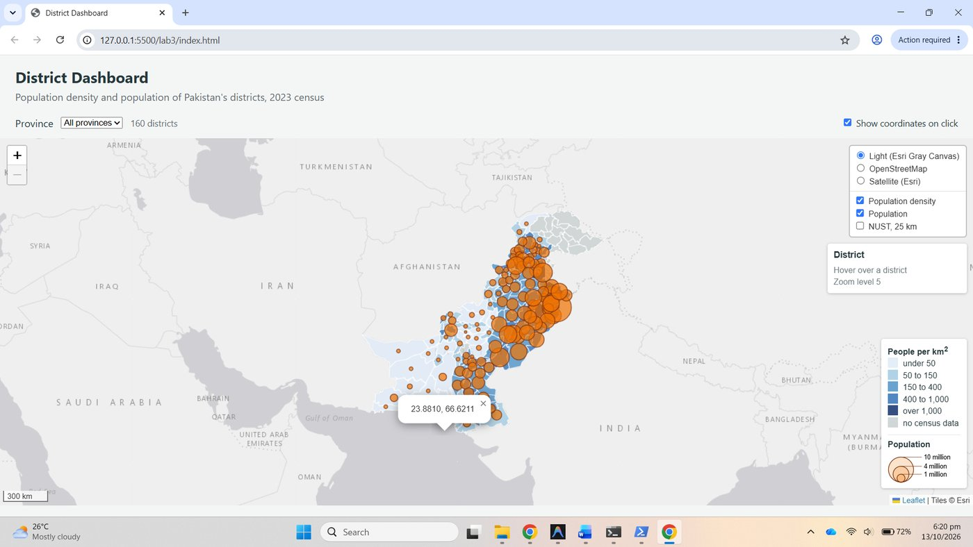
Figure 35. Checkpoint 7: coordinate popup on the sea
Notes from the three steps
1. Sea, then a district. The sea click gave only the coordinate popup and the zoom stayed at 5, because no district layer was under the pointer. Clicking a district in western Balochistan ran both handlers: Leaflet fired the layer's click first, so zoomToDistrict zoomed the map to level 8 around the district, and the event then bubbled to the map, so showCoordinates opened a popup reading 28.3415, 65.0830 at the clicked point. The panel briefly showed the district's figures while the pointer was over it.
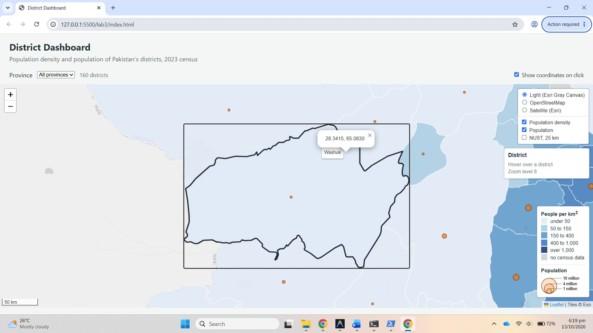
Figure 36. Step 1: district click runs both handlers, zoom to 8 and a coordinate popup
2. The legend. With the checkbox ticked, clicking the legend produced no popup, because L.DomEvent.disableClickPropagation(div) stops the click reaching the map. With that one line removed and the page reloaded, the same click opened a coordinate popup, 28.4575, 98.6572, the location under the legend in the bottom-right corner. The line was then put back.
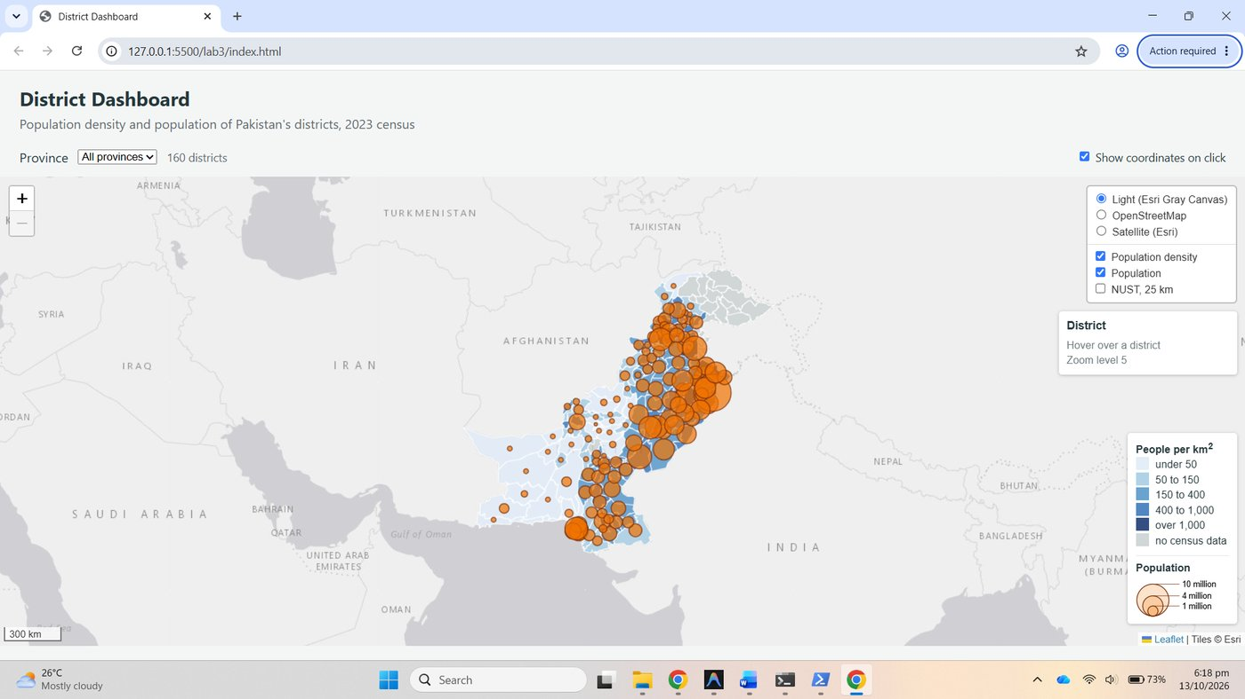
Figure 37. Step 2: legend click with disableClickPropagation, no popup
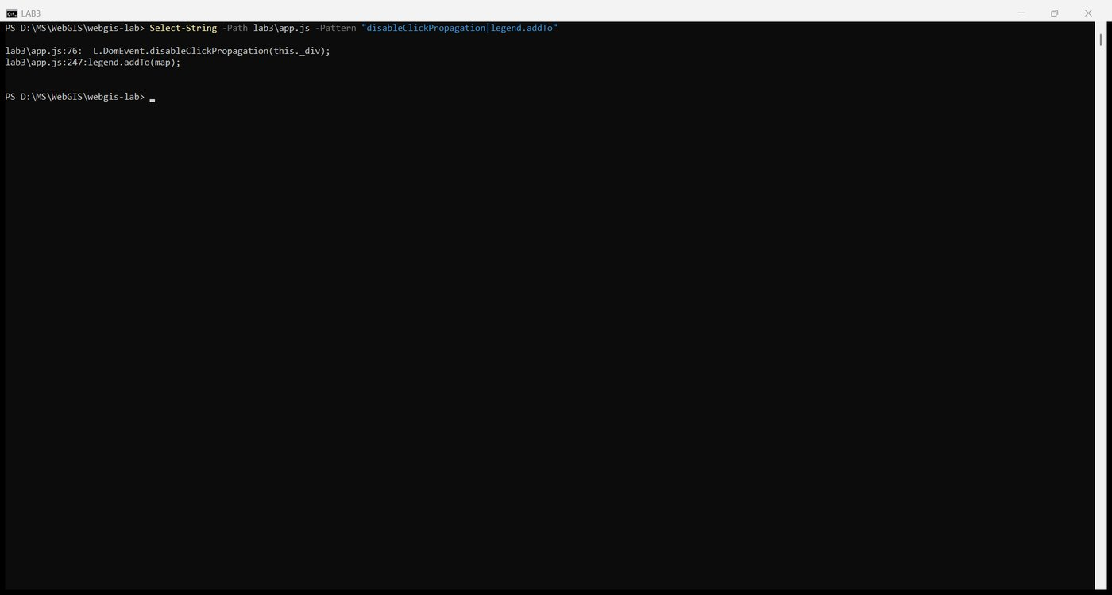
Figure 38. Step 2: the line removed from app.js
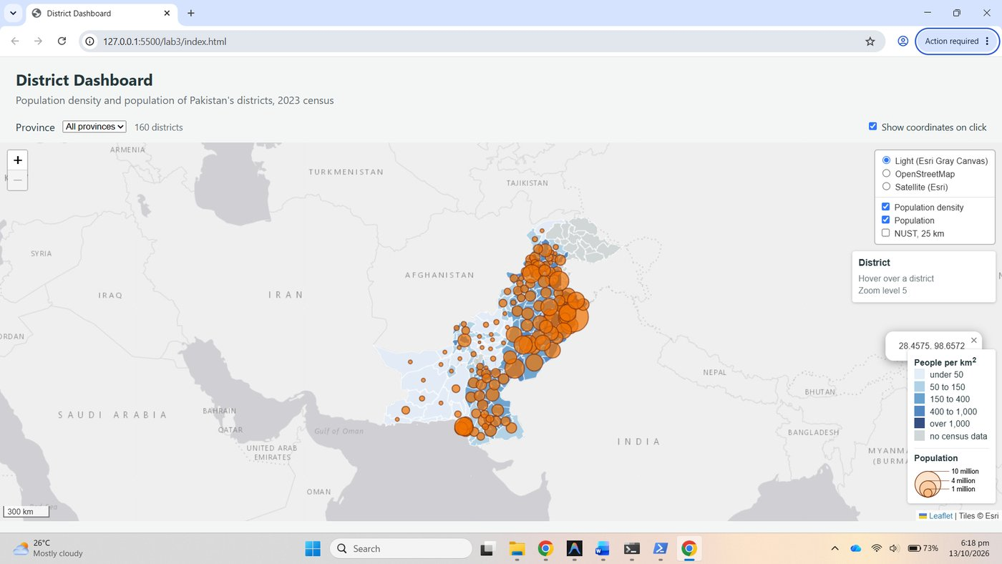
Figure 39. Step 2: the same click without disableClickPropagation opens a popup
3. Unticked. After unticking the checkbox, map.off had removed the handler and clicks on the sea did nothing.
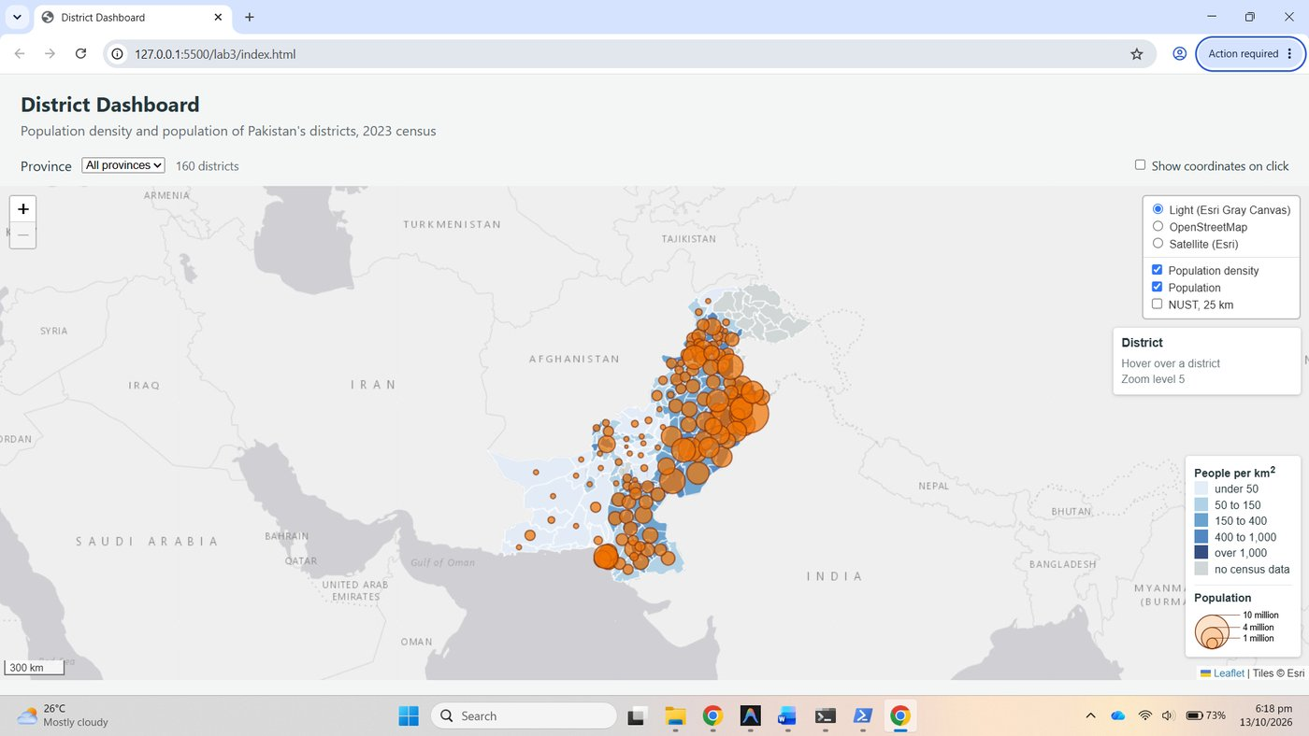
Figure 40. Step 3: checkbox unticked, a sea click opens nothing

Part 8: Filter by province (extension)
fillProvinceList builds the drop-down from the data and the change listener calls draw(event.target.value), which already filters through the keep hook.
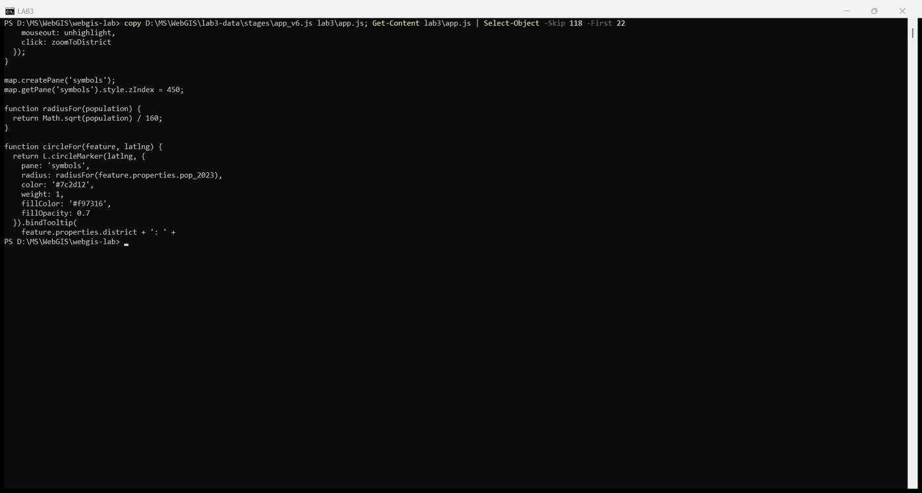
Figure 41. app.js: fillProvinceList and the change listener

Checkpoint 8
Gilgit Baltistan selected: the count reads 14 districts, the map has zoomed to the province, the layer control is open and its overlays still switch the rebuilt layers because they point at the two feature groups, not at the L.geoJSON layers inside them.
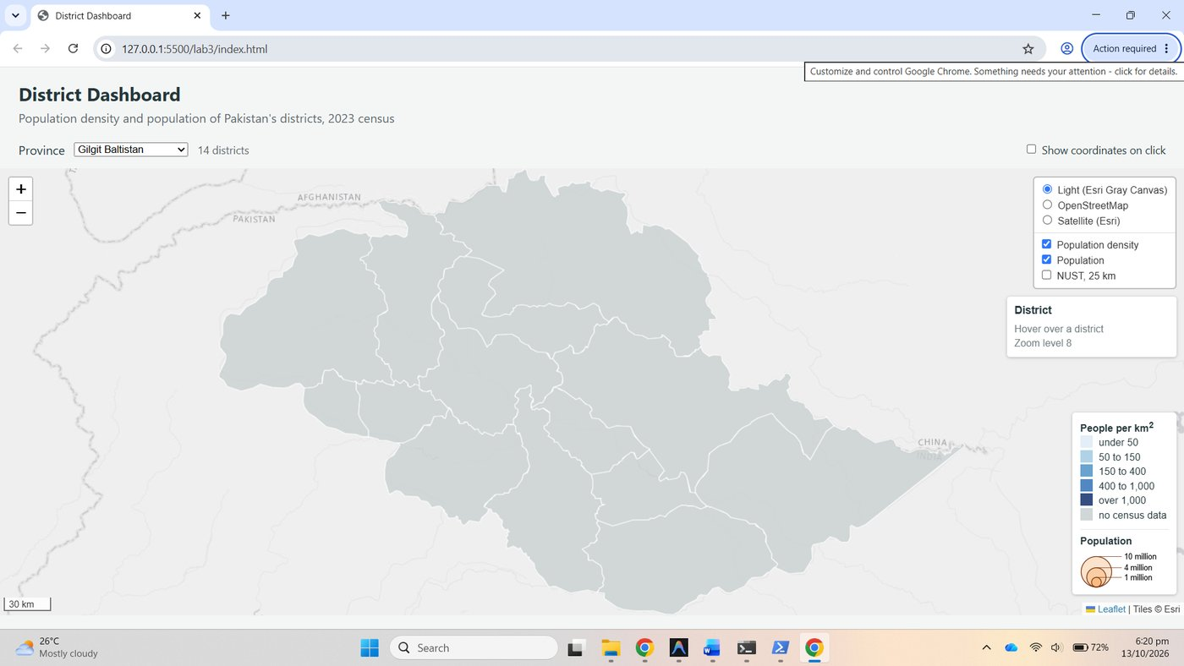
Figure 42. Checkpoint 8: Gilgit Baltistan, 14 districts, layer control open
Why no circles appear. The 2023 census did not cover Gilgit-Baltistan, so all 14 districts have pop_2023: null. hasPopulation filters them out before circleFor runs, so the circle layer is rebuilt empty, while the districts are drawn grey as "no census data". The dashboard should say so: a silent empty layer reads as "nobody lives here". A one-line note in the count label, such as "14 districts, no census data", or a legend entry stating that circles are drawn only where a census value exists, would make the absence an explicit statement rather than an apparent fact.

Part 9: SVG or canvas (extension)
useCanvas is read from the query string on the first line of app.js, preferCanvas: useCanvas was added to the map options, and draw now times itself and logs the result.
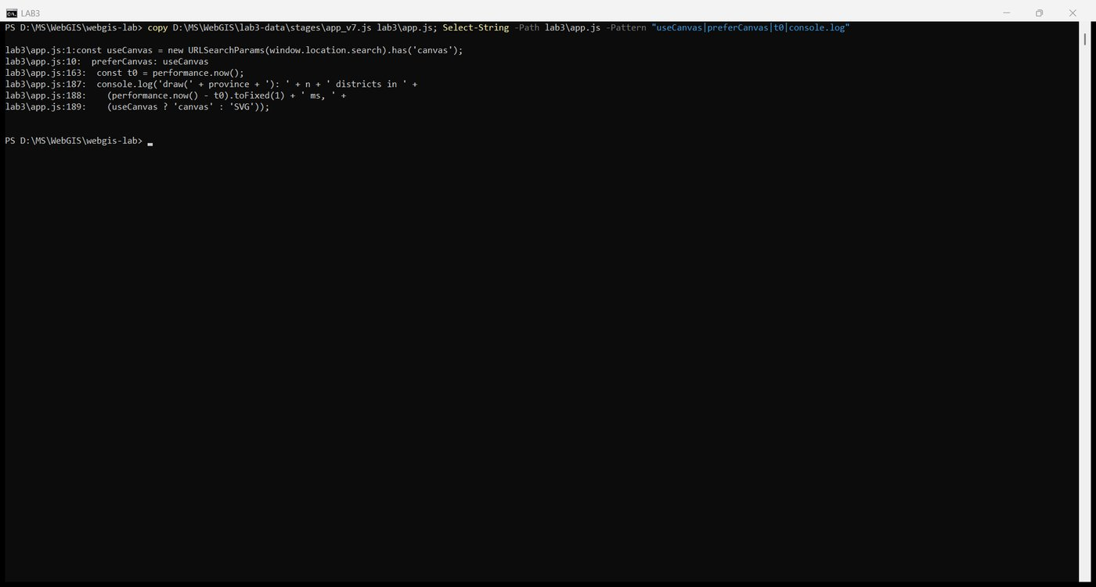
Figure 43. app.js: useCanvas, preferCanvas and the timing in draw

Measurements
Each renderer was reloaded five times with the cache disabled and the time printed for draw(all) recorded.
 | SVG (index.html) | Canvas (index.html?canvas)
draw(all), five runs, ms | 30.3, 32.1, 35.5, 35.8, 37.2 | 21.1, 21.6, 22.7, 22.9, 30.9
draw(all), median of five, ms | 35.5 | 22.7
Elements inside leaflet-overlay-pane | one svg holding 162 elements: a g and 160 paths plus the NUST circle | one canvas, nothing inside it
Elements inside the symbols pane | one svg holding 136 elements: a g and 135 circle paths | one canvas
Hover highlight still works? | Yes | Not on the districts while the circles are shown; see below
Can you inspect one district in Elements? | Yes, each district is a path with its own attributes | No, the canvas is a single element with pixels inside

Checkpoint 9
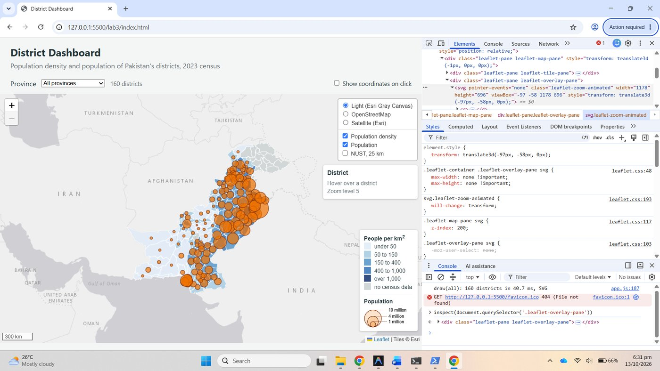
Figure 44. Checkpoint 9a: Elements tab in SVG mode, the overlay pane holds an svg of paths
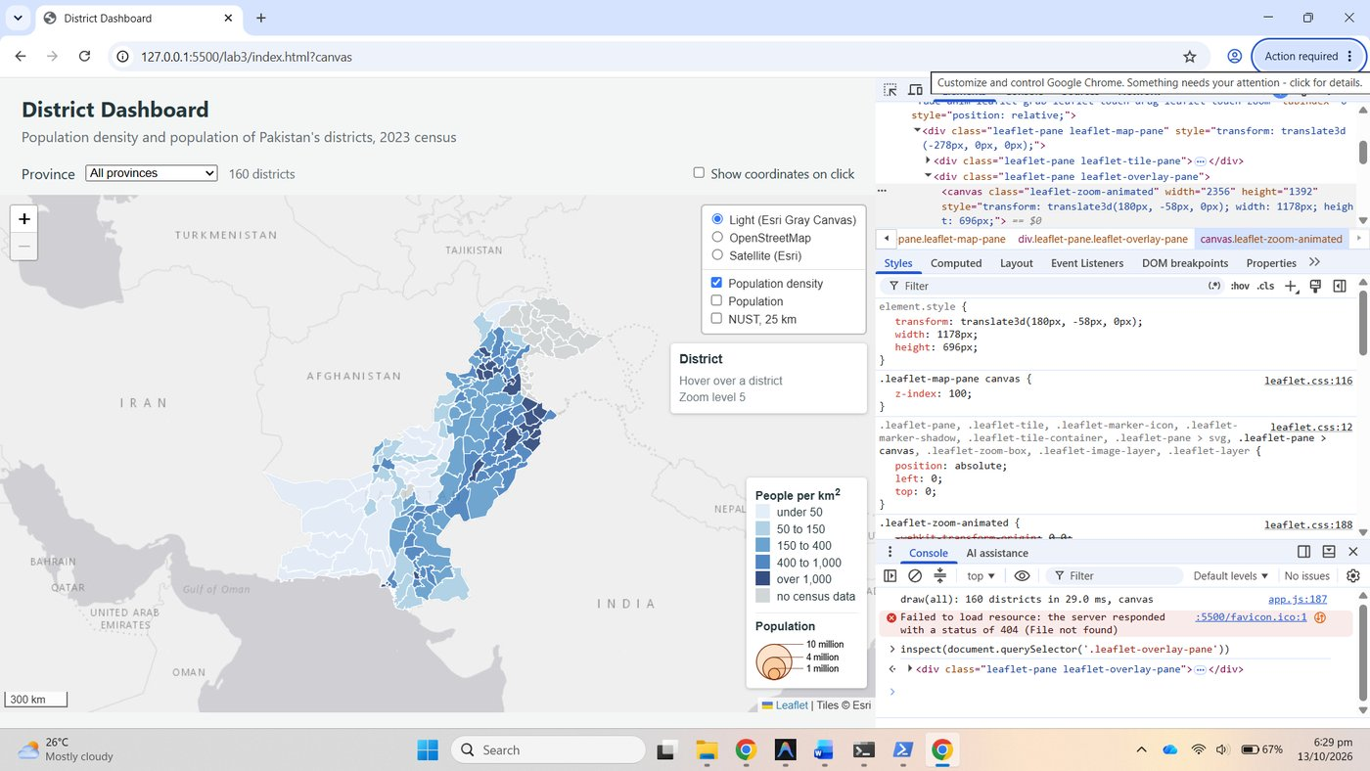
Figure 45. Checkpoint 9b: Elements tab in canvas mode, the overlay pane holds one canvas
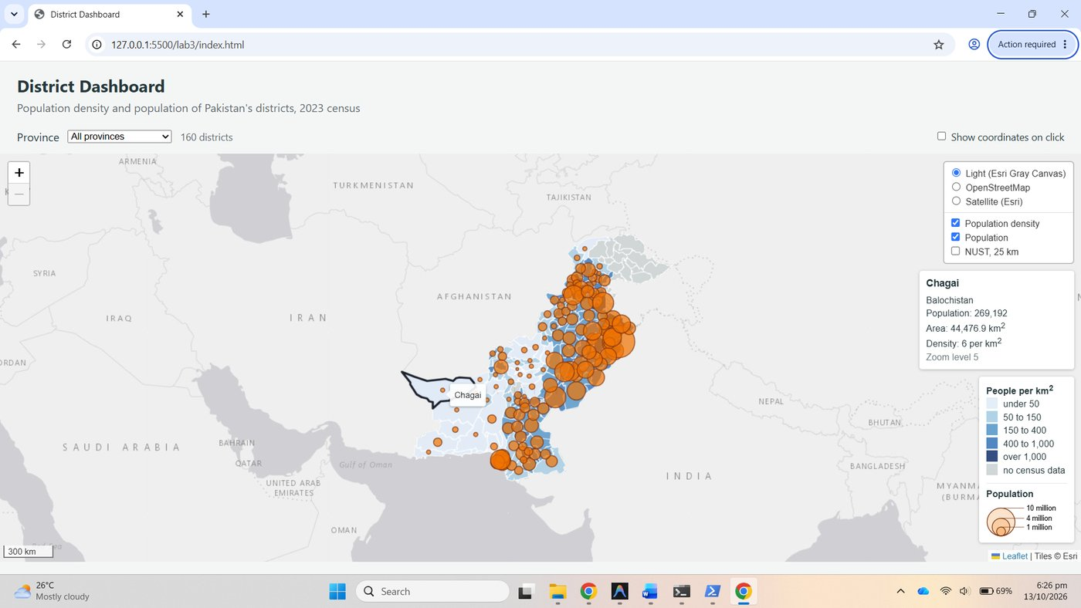
Figure 46. Hover highlight in SVG mode
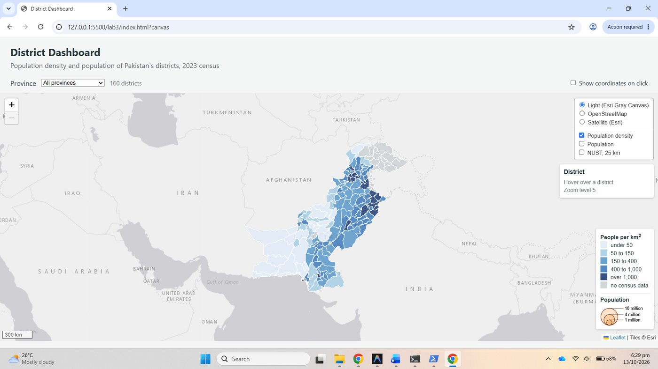
Figure 47. Canvas mode: the pointer over a district does not highlight it while the circles' canvas lies above
The hover result, explained. In canvas mode each pane gets its own canvas element that covers the whole map. The symbols pane sits at z-index 450 above the overlay pane, so every mouse move lands on the circles' canvas, whose renderer hit-tests only its own circles and never passes the event down to the districts' canvas underneath. The circle tooltips therefore still work, but the district highlight does not, even when the "Population" overlay is switched off, because the empty canvas is still there. Hiding the symbols pane altogether brings the district highlight back, which confirms the cause. In SVG mode the upper svg only captures the pointer where it has painted content, so the districts beneath remain reachable. The pane that solved the draw-order problem in Part 6 creates a pointer problem in canvas mode.
Reading the result. With 160 districts and 135 circles canvas was faster here, 22.7 against 35.5 ms, but both are well under a frame of perceptible delay and the difference is not what decides the choice. The lecture's guidance is that canvas starts to pay at a few thousand features. For the tehsil layer, administrative level 3, with several times as many features and more vertices each, the gap would widen in canvas's favour: SVG would have to create and keep thousands of path nodes in the DOM, each restyled on hover and each re-laid-out on every pan and zoom, while canvas repaints one bitmap. The cost of canvas is what this table shows: no per-feature element to inspect, and hit-testing that must be done by the renderer, with the pane interaction above as a consequence.

Part 10: Publish and submit

10.1 Commit and push
cd D:\MS\WebGIS\webgis-lab
git status --short
git add -A
git commit -m "Lab 3: district dashboard"
git push
git log --oneline

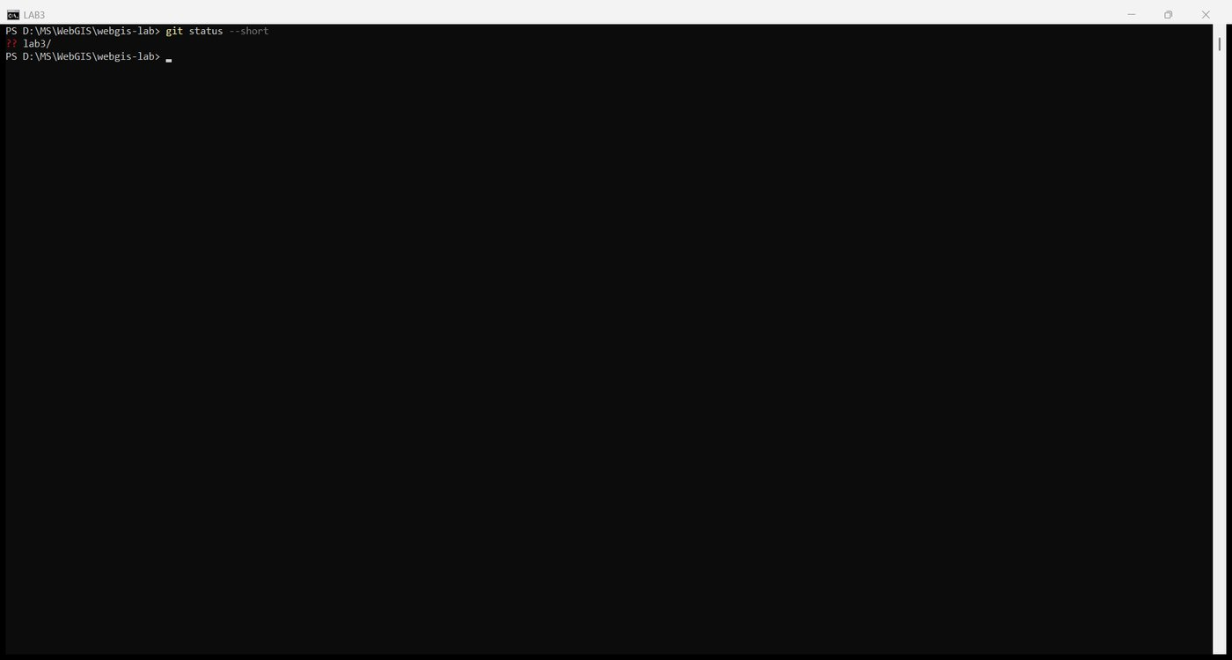
Figure 48. git status
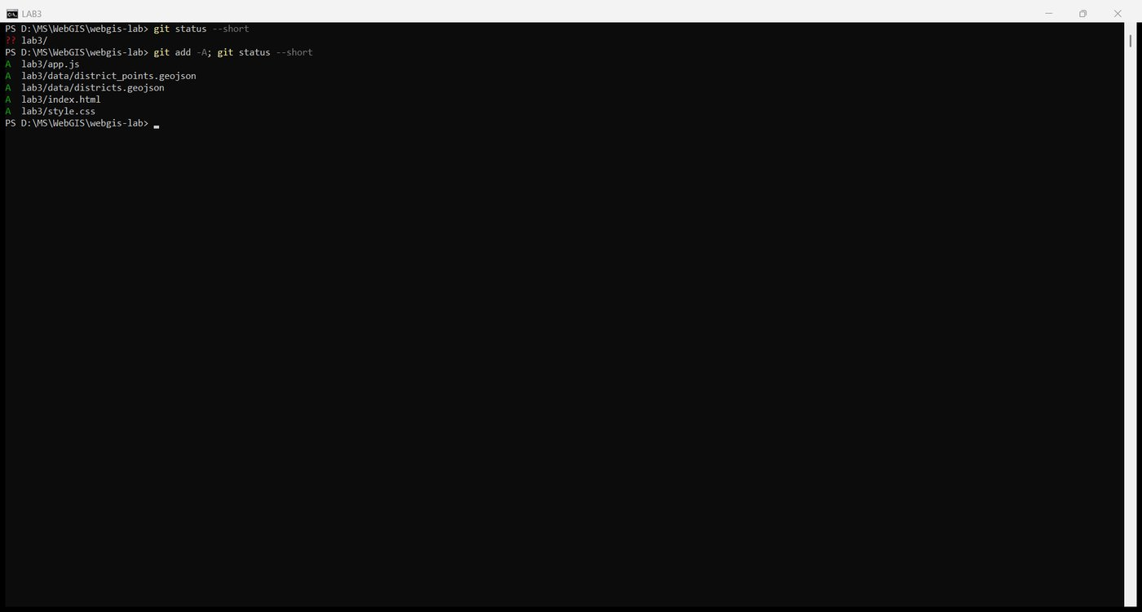
Figure 49. git add -A
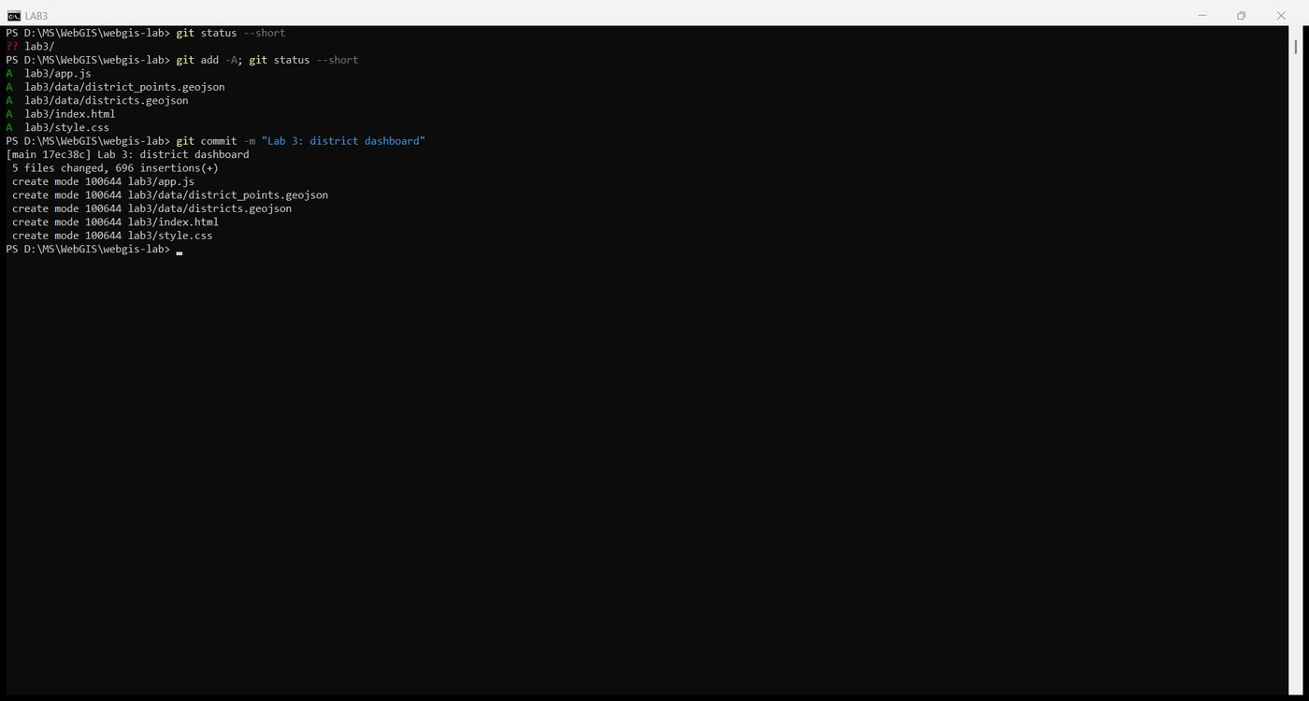
Figure 50. The Lab 3 commit
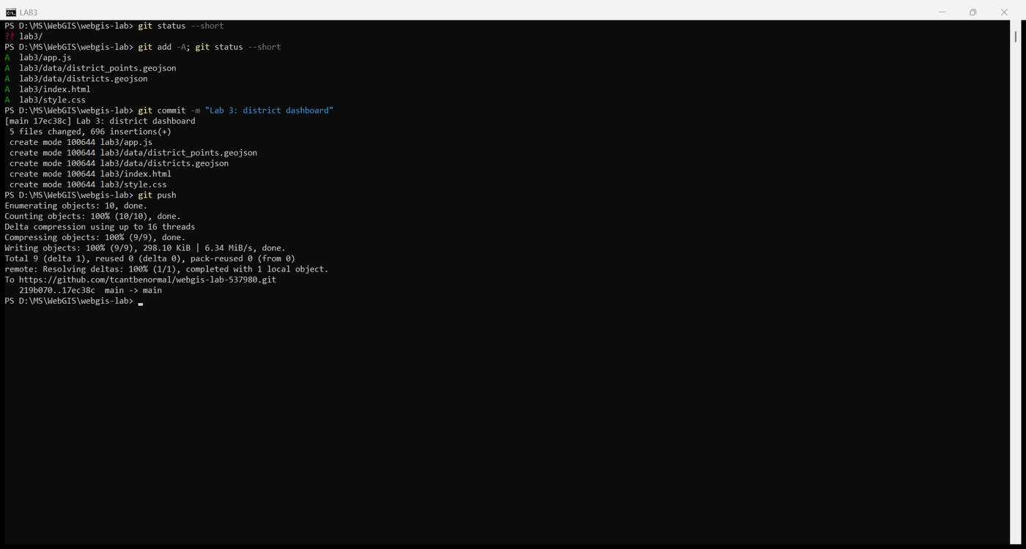
Figure 51. git push
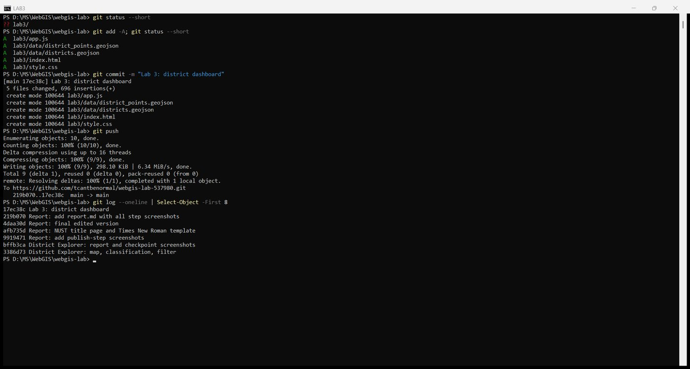
Figure 52. git log: Lab 3 on top of the Lab 2 history
GitHub Pages rebuilt the site from the existing configuration. The dashboard is live at https://tcantbenormal.github.io/webgis-lab-537980/lab3/ and Lab 2 still works at its old address.
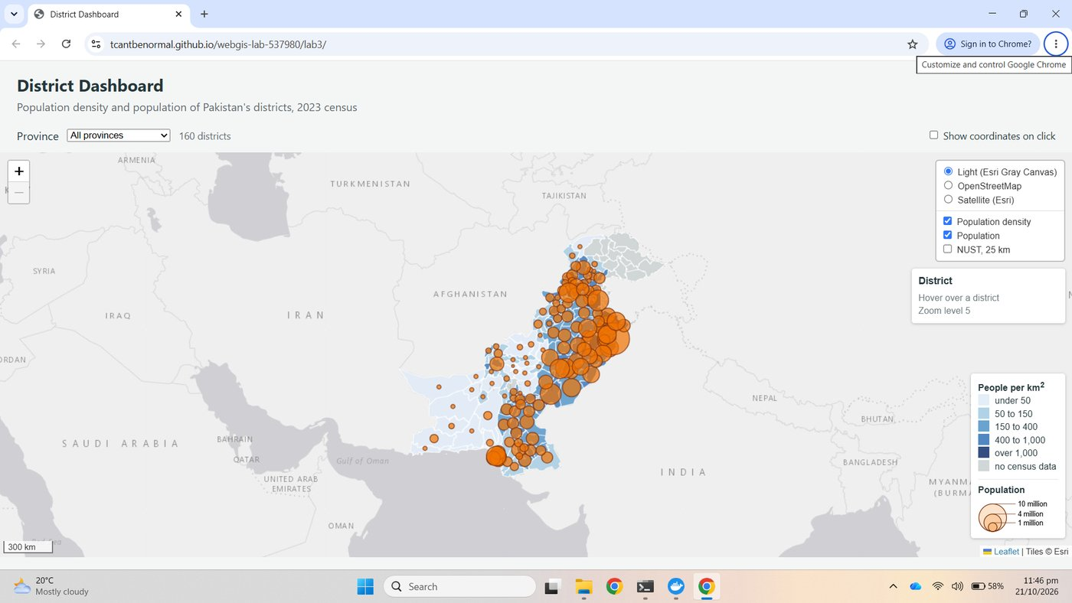
Figure 53. The live lab3 page served by GitHub Pages
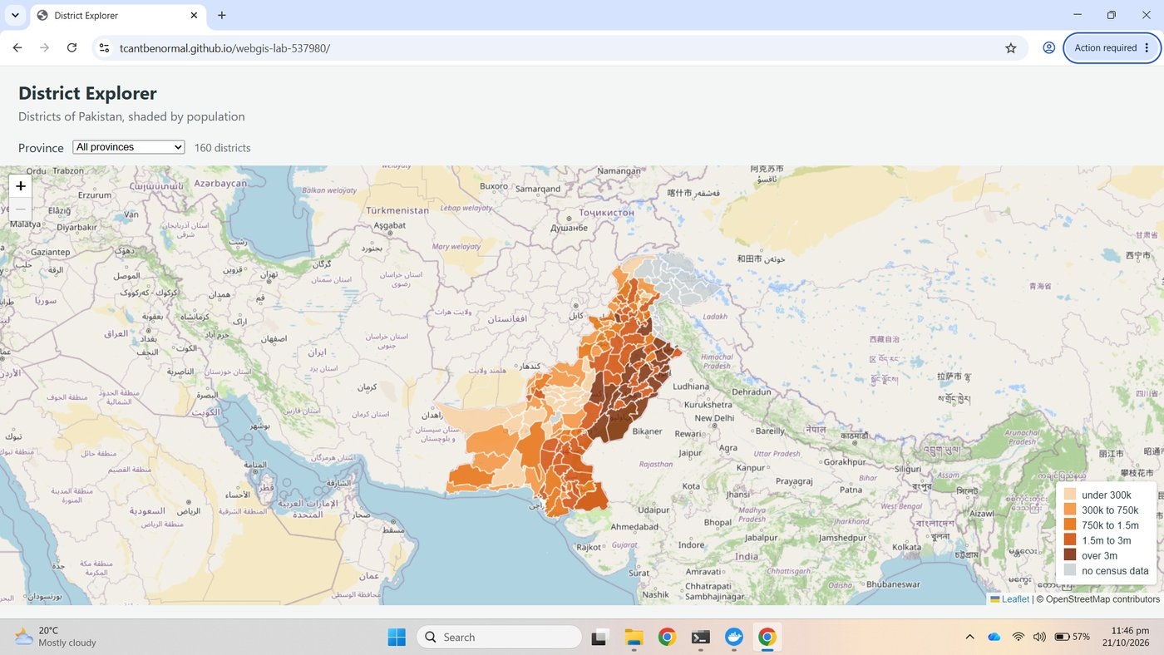
Figure 54. Lab 2 still live at the root address

10.2 Report
This report, with the screenshots, was added as lab3/report.md and lab3/report.docx in a second commit, so the history reads: dashboard first, report second.
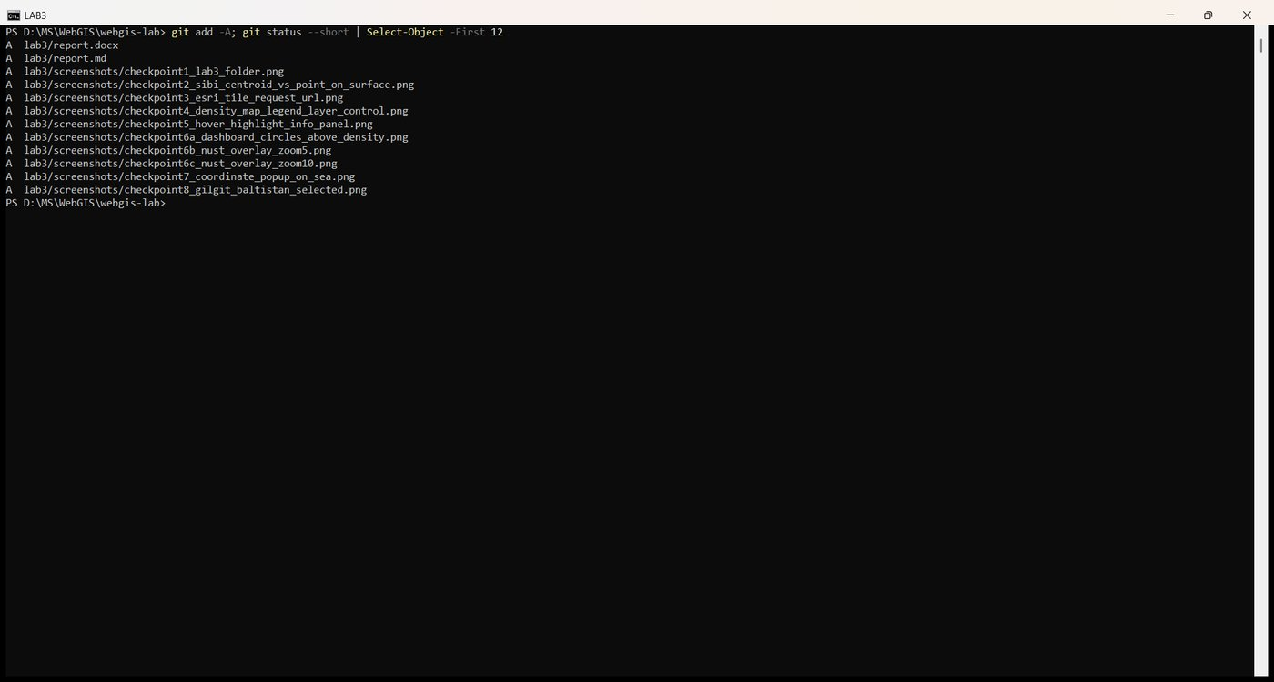
Figure 55. git add -A with the report and screenshots
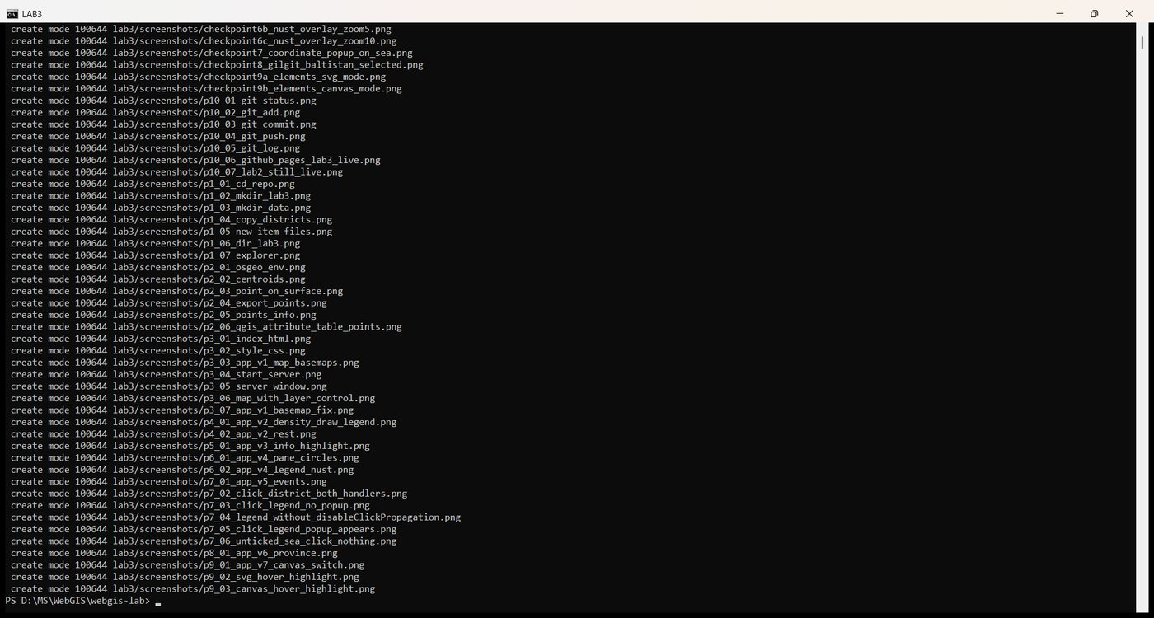
Figure 56. The report commit
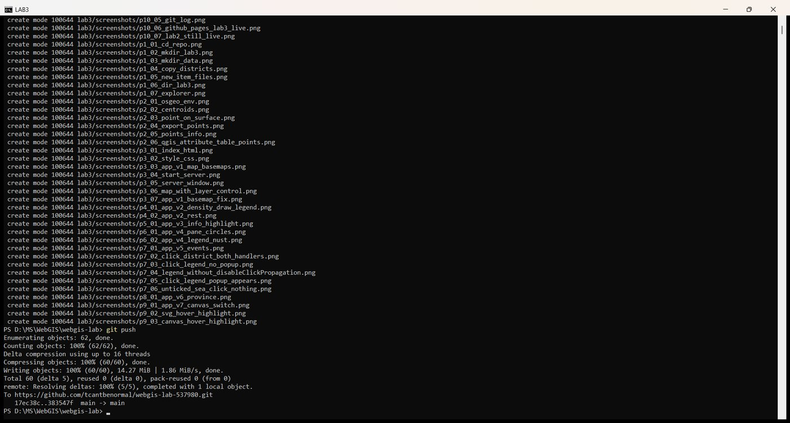
Figure 57. git push
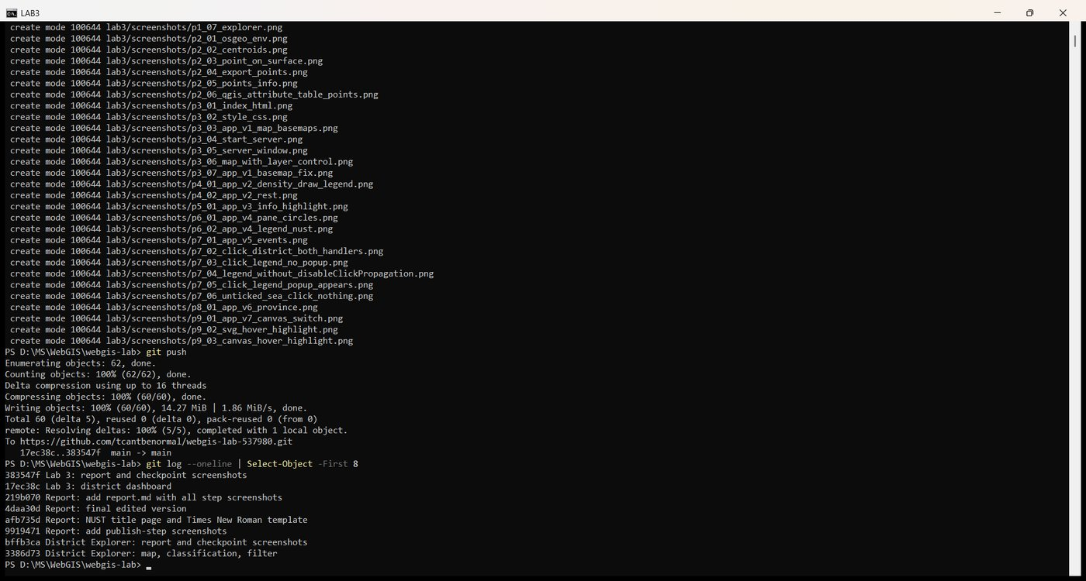
Figure 58. Final git log

Questions
1. Lab 2 shaded districts by population. Name one large, thinly populated district and one small, crowded one, and explain how each would mislead on the Lab 2 map.
Chagai in Balochistan covers about 44,500 km² with 269,000 people, a density of about 6 per km²; on the Lab 2 map it sat in the lowest population class and looked unremarkable, when in fact it is one of the emptiest places in the country, and its sheer size gave that pale colour a large visual weight. Lahore covers 1,730 km² with 13.0 million people, about 7,500 per km²; on the Lab 2 map it was in the darkest class, correctly, but so were several large rural districts whose counts are high only because they are big, so the reader could not tell a crowded district from a large one. Shading by density separates the two: Chagai drops to the palest class and Lahore stays the darkest, and the colour now says something about the place rather than about the size of the polygon.
2. radiusFor takes a square root. What would the map suggest about Lahore against a district of 3 million if it did not?
The eye compares the areas of circles, and area grows with the square of the radius. If the radius followed population directly, Lahore at 13 million would have a radius 4.3 times that of a 3-million district and therefore an area about 19 times larger, suggesting Lahore held nineteen times as many people rather than four. With the square root, the radii are in the ratio 2.1 and the areas in the ratio 4.3, which is the true ratio of the populations.
3. Why does the layer control hold districtGroup rather than the L.geoJSON layer itself?
Because draw throws the L.geoJSON layer away and builds a new one every time the province changes. A control that pointed at the old layer would switch on and off something that is no longer on the map, and would never see the new one. The feature group stays put while its contents change: draw clears it and adds the new layer inside it, so the control's checkbox keeps working after every rebuild, which Checkpoint 8 shows.
4. What would go wrong if the circles were drawn in overlayPane instead of the symbols pane? Describe what the user would see when hovering.
Polygons and circle markers are both vector paths, so in one pane whichever is drawn later covers the other; the circles, drawn after the districts, would start on top. But highlight calls bringToFront on the hovered district, which lifts it above everything else in the same pane. The user would see the circles over that district disappear under the highlighted polygon, then reappear when the pointer left, with the symbols flickering in and out as the mouse moved across the map. A pane with a higher z-index settles the order once, and bringToFront can only reorder within the polygons' own pane.
5. Why can map.off remove showCoordinates, when it could not remove an anonymous function passed to map.on?
map.off removes a handler by identity: it searches the registered handlers for the very function object you pass in. showCoordinates is a named function stored in a variable, so the same object can be passed to on and later to off, and the two match. An anonymous function written inline in map.on('click', function (e) { ... }) has no name and no variable holding it; once the call returns there is no way to refer to that object again, and anything you passed to off would be a different function that matches nothing. The handler could never be removed.
6. On the NUST overlay, which circle would you use to show a 25 km evacuation zone, and which to mark the campus on a national map? Why?
The evacuation zone needs L.circle with a radius in metres: it represents a real distance on the ground, so it must grow and shrink with the zoom and measure 25 km against the scale bar at every level, as Checkpoint 6 shows. The campus marker on a national map needs L.circleMarker with a radius in pixels: it marks a location, not an extent, and it should stay a visible 6 px dot at zoom 5 rather than shrinking to nothing, which a 25 km L.circle does at that zoom, where it was about 6 px across and indistinguishable from the marker.

Submission
- Repository URL: https://github.com/tcantbenormal/webgis-lab-537980 (folder lab3)
- Live lab3 page: https://tcantbenormal.github.io/webgis-lab-537980/lab3/

