# Directions & Deliverable – Tim Capehart

Complete the following exercises in a single document. Label each question and/or letter clearly. For each excercise, provide screen shot(s) that demonstrate your code is correct and working. Submit your work electronically to Blackboard by the due date specified.

**Part 1 (60 pts)**

Create a script that builds the following database (named MovieDB) using SQL DDL statements. Define the necessary primary keys, foreign keys, and constraints based on the schema. The table primary key(s) is/are signified by the underlined attributes in the table. Choose appropriate data types for each attribute. Lastly, insert at least 5 records into each table to verify the constraints have been fulfilled.

**Customers**

|  |  |  |
| --- | --- | --- |
| CustID | LastName | FirstName |

**Inventory**

|  |  |
| --- | --- |
| MediaID | MovieID |

**Movies**

|  |  |
| --- | --- |
| MovieID | MovieName |

**MovieSupplier**

|  |  |  |
| --- | --- | --- |
| SupplierID | MovieID | Price |

**Orders**

|  |  |  |  |
| --- | --- | --- | --- |
| OrderID | SupplierID | MovieID | Copies |

**Rentals**

|  |  |  |  |
| --- | --- | --- | --- |
| CustomerID | MediaID | CkoutDate | Duration |

**Suppliers**

|  |  |
| --- | --- |
| SupplierID | SupplierName |

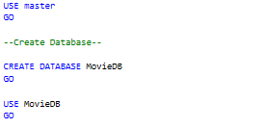

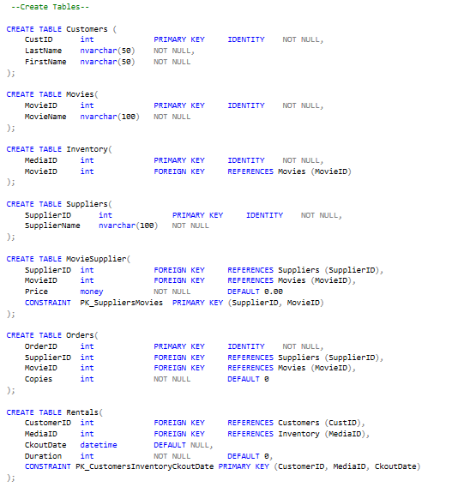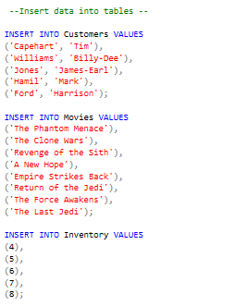

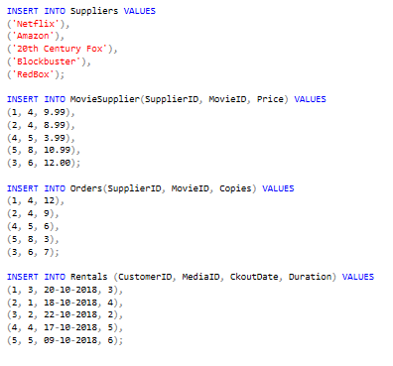

**Part 2 (10 pts ea.)**

1. Write a script that implements the following design in a database named MyWebDB:

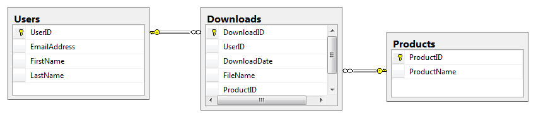

In the Downloads table, the UserID and ProductID columns are the foreign keys.

Include a statement to drop the database if it already exists.

Include statements to create and select the database.

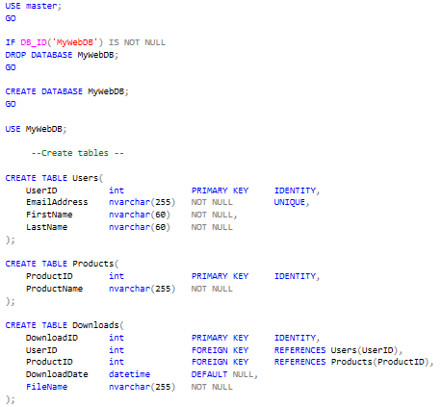

1. Write a script that adds rows to the database tables that you created.

Add two rows to the Users and Products tables.

Add three rows to the Downloads table: one row for user 1 and product 2; one for user 2 and product 1; and one for user 2 and product 2. Use the GETDATE function to insert the current date and time into the DownloadDate column.

Write a SELECT statement that joins the three tables and retrieves the data from these tables like this:

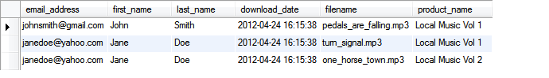

Sort the results by the email address in descending order and the product name in ascending order.

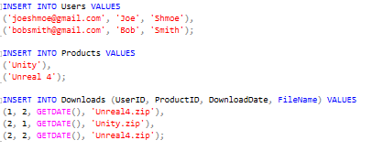

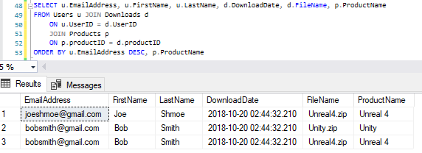

1. Write an ALTER TABLE statement that adds two new columns to the Products table.

Add one column for product price that provides for three digits to the left of the decimal point and two to the right. This column should have a default value of 9.99.



Add one column for the date and time that the product was added to the database.



1. Write an ALTER TABLE statement that modifies the Users table so the FirstName column cannot store null values and can store a maximum of 20 characters.



Code an UPDATE statement that attempts to insert a null value into this column. It should fail due to the not null constraint.

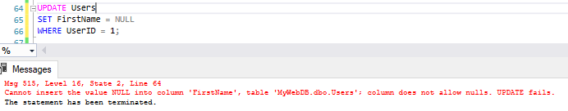

Code another UPDATE statement that attempts to insert a first name that’s longer than 20 characters. It should fail due to the length of the column.

