# Directions & Deliverable (3.7 pts ea) – Tim Capehart

Execute the CreateMyGuitarShop.sql in a new query window. Then, complete the following exercises in a single document. Label each question and/or letter clearly. For each query, provide a screen shot of your output. Submit your work electronically to Blackboard by the due date specified.

# Retrieve data from a single table

1. Write a SELECT statement that returns four columns from the Products table: ProductCode, ProductName, ListPrice, and DiscountPercent. Then, run this statement to make sure it works correctly.

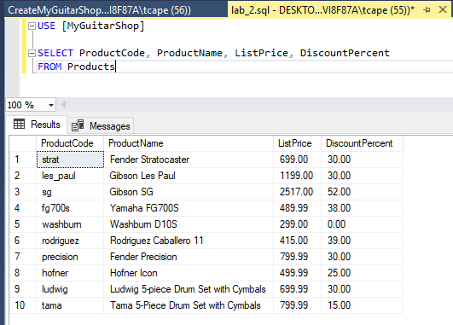

Add an ORDER BY clause to this statement that sorts the result set by list price in descending sequence. Then, run this statement again to make sure it works correctly. This is a good way to build and test a statement, one clause at a time.

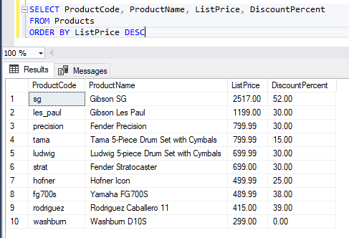

1. Write a SELECT statement that returns one column from the Customers table named FullName that joins the LastName and FirstName columns.

Format this column with the last name, a comma, a space, and the first name like this:

Doe, John

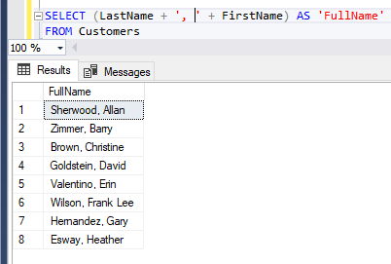

Sort the result set by last name in ascending sequence.

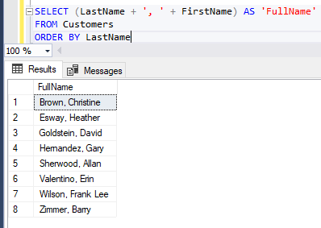

Return only the contacts whose last name begins with a letter from M to Z.

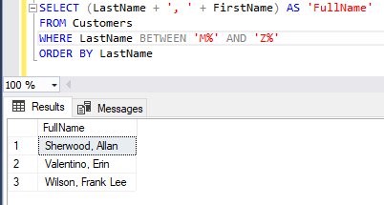

1. Write a SELECT statement that returns these column names and data from the Products table:

ProductName The ProductName column

ListPrice The ListPrice column

DateAdded The DateAdded column

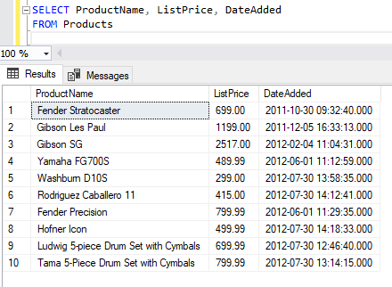

Return only the rows with a list price that’s greater than 500 and less than 2000.

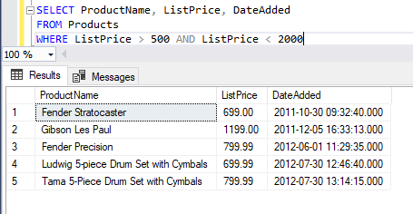

Sort the result set in descending sequence by the DateAdded column.

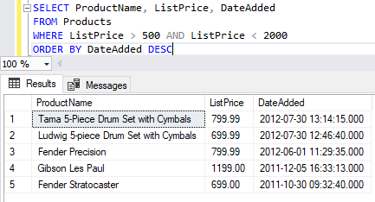

1. Write a SELECT statement that returns these column names and data from the Products table:

ProductName The ProductName column

ListPrice The ListPrice column

DiscountPercent The DiscountPercent column

DiscountAmount A column that’s calculated from the previous two columns

DiscountPrice A column that’s calculated from the previous three columns

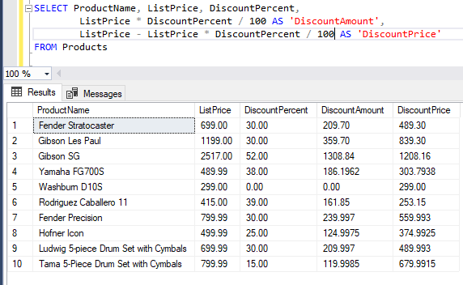

Sort the result set by discount price in descending sequence.

1. 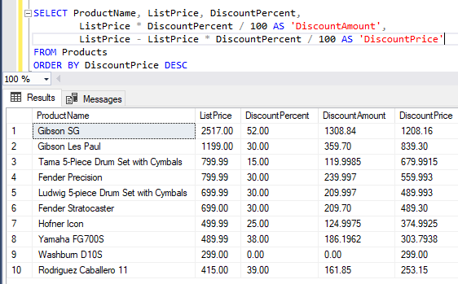Write a SELECT statement that returns these column names and data from the OrderItems table:

ItemID The ItemID column

ItemPrice The ItemPrice column

DiscountAmount The DiscountAmount column

Quantity The Quantity column

PriceTotal A column that’s calculated by multiplying the item price by the quantity

DiscountTotal A column that’s calculated by multiplying the discount amount by the quantity

ItemTotal A column that’s calculated by subtracting the discount amount from the item price and then multiplying by the quantity

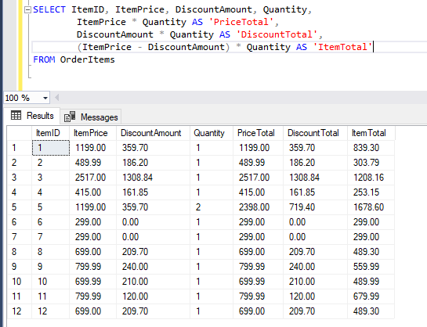

Only return rows where the ItemTotal is greater than 500.

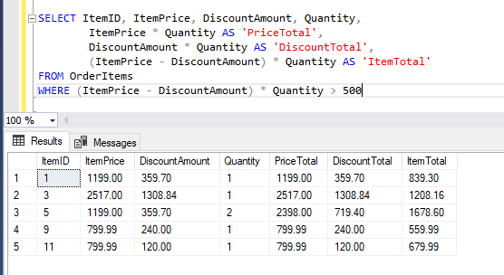

Sort the result set by item total in descending sequence.

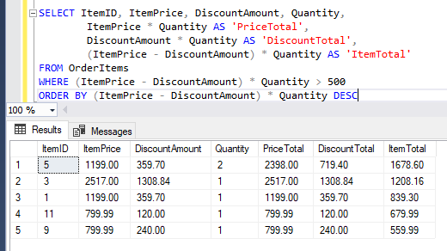

Work with nulls and test expressions

1. Write a SELECT statement that returns these columns from the Orders table:

OrderID The OrderID column

OrderDate The OrderDate column

ShipDate The ShipDate column

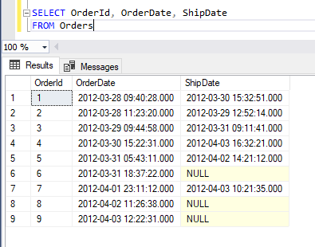

Return only the rows where the ShipDate column contains a null value.

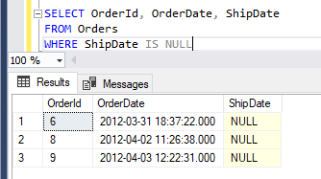

1. Write a SELECT statement without a FROM clause that creates a row with these columns:

Price 100 (dollars)

TaxRate .07 (7 percent)

TaxAmount The price multiplied by the tax rate

Total The price plus tax

To calculate the fourth column, add the expressions you used for the first and third columns.

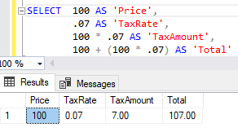

# Retrieve data from two or more tables

1. Write a SELECT statement that joins the Categories table to the Products table and returns these columns: CategoryName, ProductName, ListPrice.

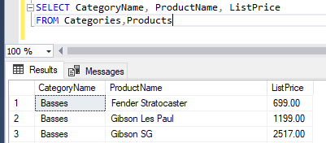

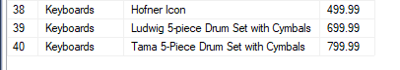

Sort the result set by CategoryName and then by ProductName in ascending order.

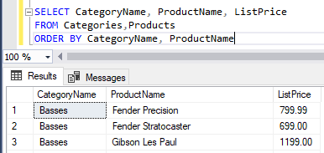

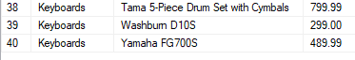

1. Write a SELECT statement that joins the Customers table to the Addresses table and returns these columns: FirstName, LastName, Line1, City, State, ZipCode.

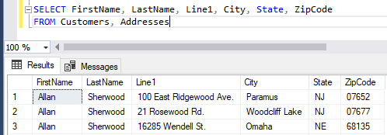

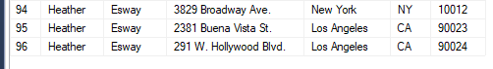

Return one row for each address for the customer with an email address of [allan.sherwood@yahoo.com](mailto:allan.sherwood@yahoo.com).

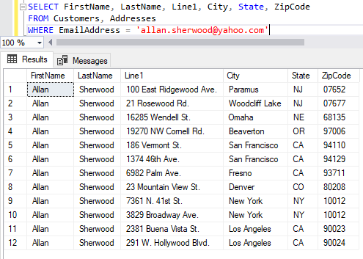

1. Write a SELECT statement that joins the Customers table to the Addresses table and returns these columns: FirstName, LastName, Line1, City, State, ZipCode.

“Same as 9.”

Return one row for each customer, but only return addresses that are the shipping address for a customer.

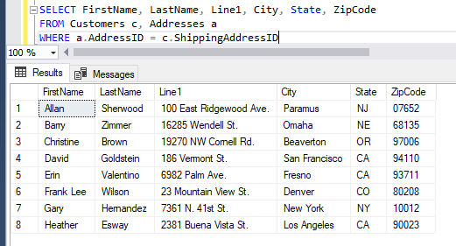

1. Write a SELECT statement that joins the Customers, Orders, OrderItems, and Products tables. This statement should return these columns: LastName, FirstName, OrderDate, ProductName, ItemPrice, DiscountAmount, and Quantity.

Use aliases for the tables.

Sort the final result set by LastName, OrderDate, and ProductName.

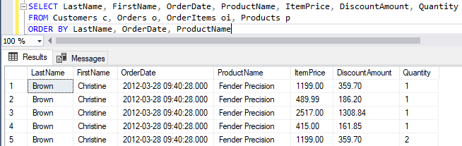

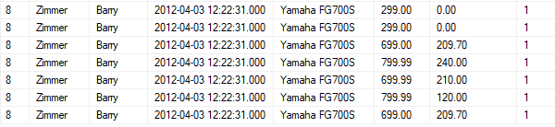

1. Write a SELECT statement that returns the ProductName and ListPrice columns from the Products table.

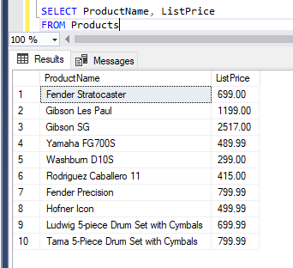

Return one row for each product that has the same list price as another product. *(Hint: Use a self-join to check that the ProductID columns aren’t equal but the ListPrice column is equal.)*

Sort the result set by ProductName.

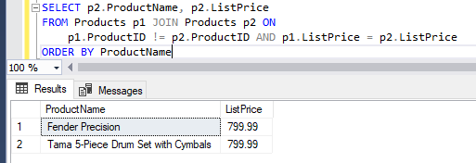

1. Write a SELECT statement that returns these two columns:

CategoryName The CategoryName column from the Categories table

ProductID The ProductID column from the Products table

Return one row for each category that has never been used. *(Hint: Use an outer join and only return rows where the ProductID column contains a null value.)*

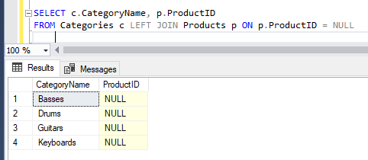

1. Use the UNION operator to generate a result set consisting of three columns from the Orders table:

ShipStatus A calculated column that contains a value of SHIPPED or NOT SHIPPED

OrderID The OrderID column

OrderDate The OrderDate column

If the order has a value in the ShipDate column, the ShipStatus column should contain a value of SHIPPED. Otherwise, it should contain a value of NOT SHIPPED.

Sort the final result set by OrderDate.

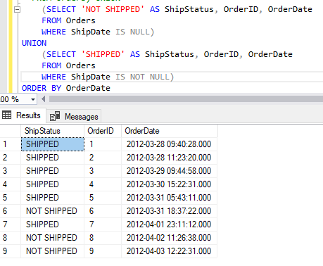

# Summary queries

1. Write a SELECT statement that returns these columns:

The count of the number of orders in the Orders table

The sum of the TaxAmount columns in the Orders table

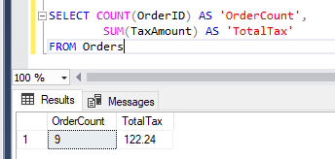

1. Write a SELECT statement that returns one row for each category that has products with these columns:

The CategoryName column from the Categories table

The count of the products in the Products table

The list price of the most expensive product in the Products table

Sort the result set so the category with the most products appears first.

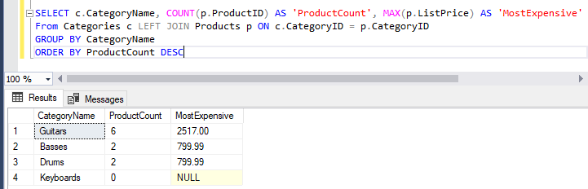

1. Write a SELECT statement that returns one row for each customer that has orders with these columns:

The EmailAddress column from the Customers table

The sum of the item price in the OrderItems table multiplied by the quantiy in the OrderItems table

The sum of the discount amount column in the OrderItems table multiplied by the quantiy in the OrderItems table

Sort the result set in descending sequence by the item price total for each customer.

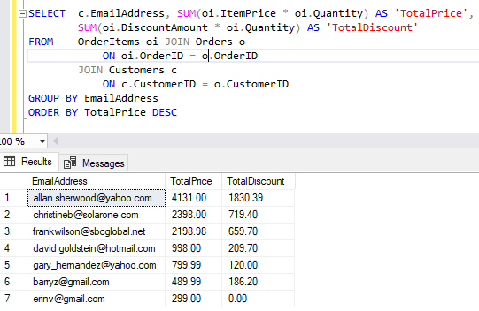

1. Write a SELECT statement that returns one row for each customer that has orders with these columns:

The EmailAddress column from the Customers table

A count of the number of orders

The total amount for those orders (*Hint: First, subtract the discount amount from the price. Then, multiply by the quantity.*)

Return only those rows where the customer has more than than 1 order.

Sort the result set in descending sequence by the sum of the line item amounts.

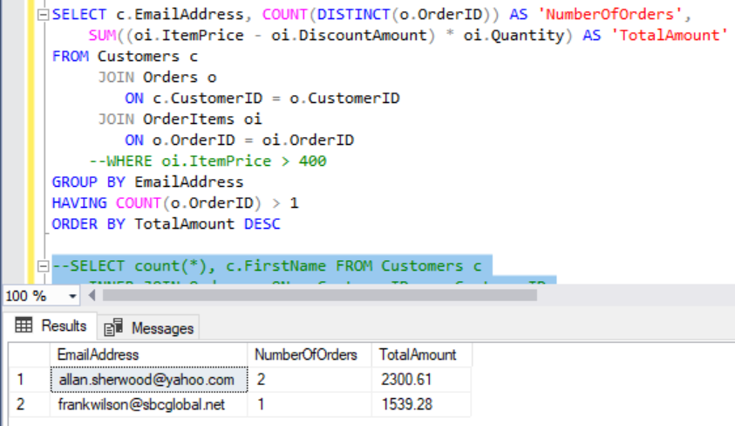

1. Modify the solution to exercise 4 so it only counts and totals line items that have an ItemPrice value that’s greater than 400.

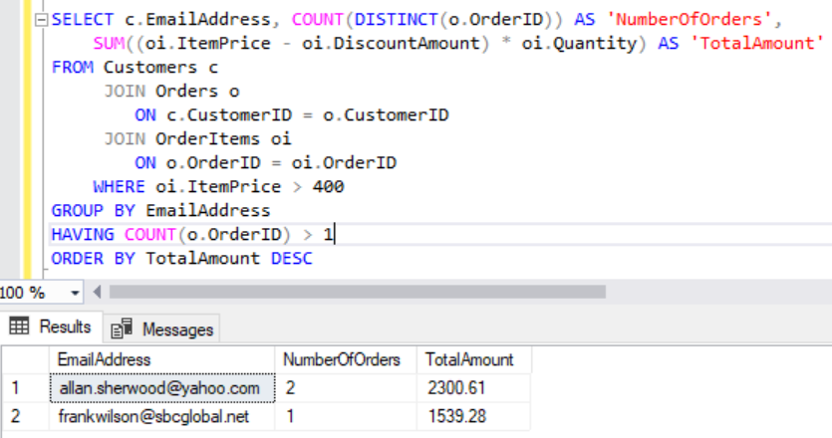

1. Write a SELECT statement that answers this question: What is the total amount ordered for each product? Return these columns:

The product name from the Products table

The total amount for each product in the OrderItems table (*Hint: You can calculate the total amount by subtracting the discount amount from the item price and then multiplying it by the quantity*)

Use the WITH ROLLUP operator to include a row that gives the grand total.

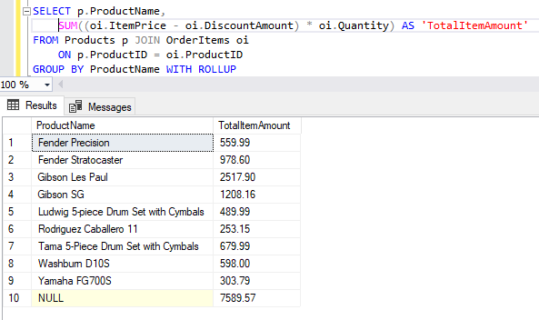

1. Write a SELECT statement that answers this question: Which customers have ordered more than one product? Return these columns:

The email address from the Customers table

The count of distinct products from the customer’s orders

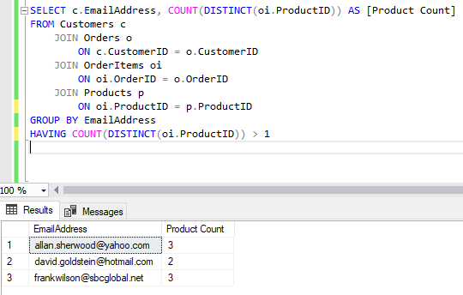

# Code subqueries

1. Write a SELECT statement that returns the same result set as this SELECT statement, but don’t use a join. Instead, use a subquery in a WHERE clause that uses the IN keyword.

SELECT DISTINCT CategoryName

FROM Categories c JOIN Products p

ON c.CategoryID = p.CategoryID

ORDER BY CategoryName

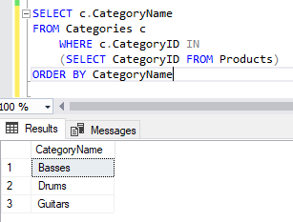

1. Write a SELECT statement that answers this question: Which products have a list price that’s greater than the average list price for all products?

Return the ProductName and ListPrice columns for each product.

Sort the results by the ListPrice column in descending sequence.

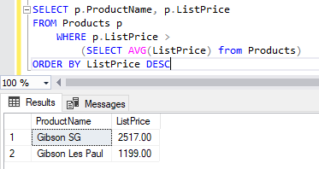

1. Write a SELECT statement that returns the CategoryName column from the Categories table.

Return one row for each category that has never been assigned to any product in the Products table. To do that, use a subquery introduced with the NOT EXISTS operator.

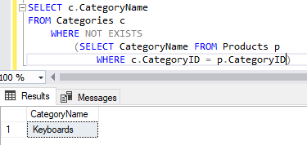

1. Write a SELECT statement that returns three columns: EmailAddress, OrderID, and the order total for each customer. To do this, you can group the result set by the EmailAddress and OrderID columns. In addition, you must calculate the order total from the columns in the OrderItems table.

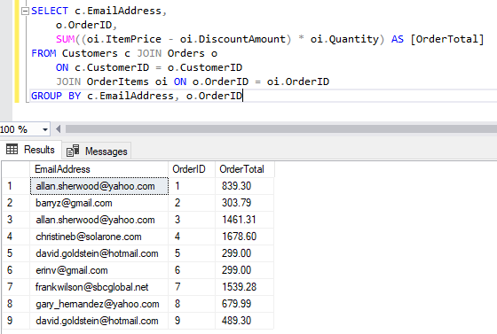

Write a second SELECT statement that uses the first SELECT statement in its FROM clause. The main query should return two columns: the customer’s email address and the largest order for that customer. To do this, you can group the result set by the EmailAddress column. 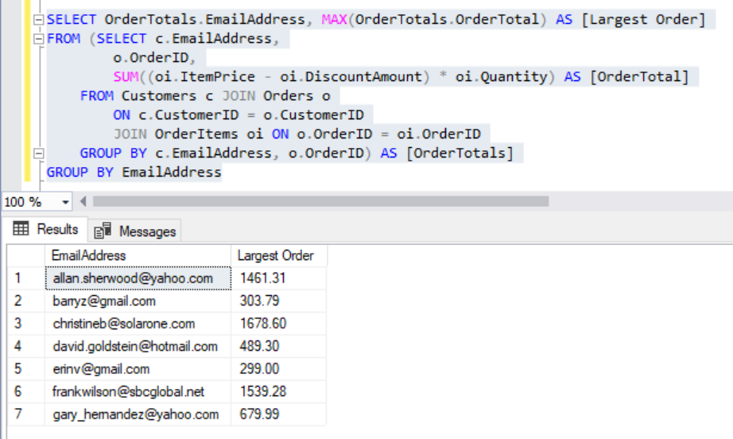

1. Write a SELECT statement that returns the name and discount percent of each product that has a unique discount percent. In other words, don’t include products that have the same discount percent as another product.

Sort the results by the ProductName column.

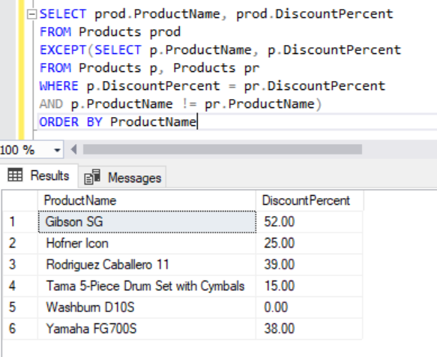

1. Use a correlated subquery to return one row per customer, representing the customer’s oldest order (the one with the earliest date). Each row should include these three columns: EmailAddress, OrderID, and OrderDate.

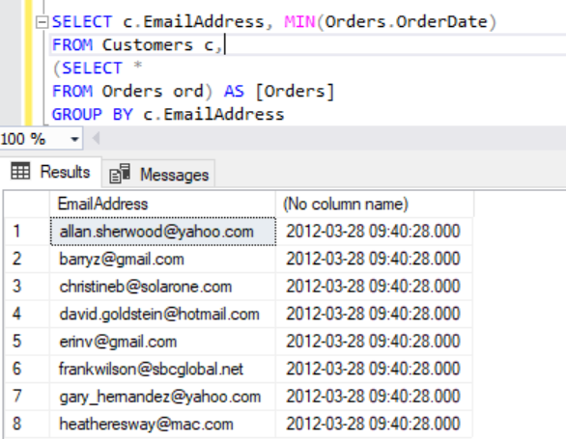

# Insert, Update, and Delete Statements

To test whether a table has been modified correctly as you do these exercises, you can write and run an appropriate SELECT statement.

1. Write an INSERT statement that adds this row to the Categories table:

CategoryName: Brass

Code the INSERT statement so SQL Server automatically generates the value for the CategoryID column.

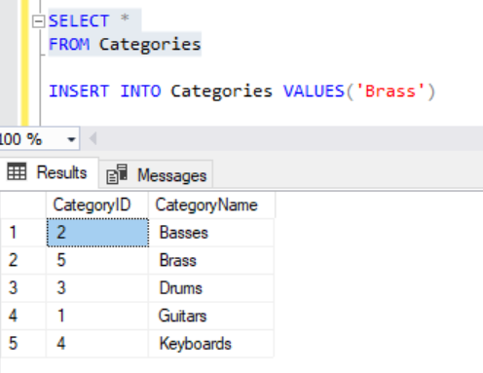

1. Write an UPDATE statement that modifies the row you just added to the Categories table. This statement should change the CategoryName column to “Woodwinds”, and it should use the CategoryID column to identify the row.

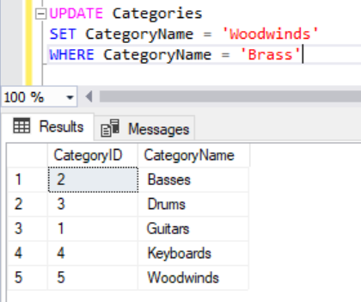

1. Write a DELETE statement that deletes the row you added to the Categories table in exercise 1. This statement should use the CategoryID column to identify the row.

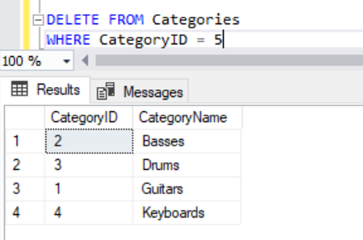

1. Write an INSERT statement that adds this row to the Products table:

ProductID: The next automatically generated ID   
CategoryID: 4  
ProductCode: dgx_640  
ProductName: Yamaha DGX 640 88-Key Digital Piano  
Description: Long description to come.  
ListPrice: 799.99  
DiscountPercent: 0  
DateAdded: Today’s date/time.

Use a column list for this statement.

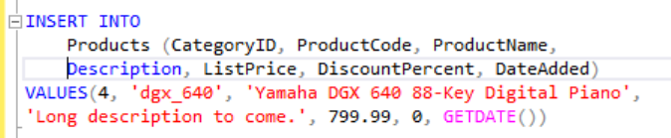

1. Write an UPDATE statement that modifies the product you added in exercise 4. This statement should change the DiscountPercent column from 0% to 35%.

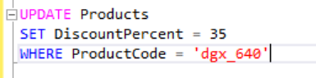

1. Write a DELETE statement that deletes the row in the Categories table that has an ID of 4. When you execute this statement, it will produce an error since the category has related rows in the Products table. To fix that, precede the DELETE statement with another DELETE statement that deletes all products in this category.

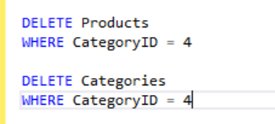

1. Write an INSERT statement that adds this row to the Customers table:

EmailAddress: rick@raven.com  
Password: (empty string)  
FirstName: Rick  
LastName: Raven

Use a column list for this statement.



1. Write an UPDATE statement that modifies the Customers table. Change the password column to “secret” for the customer with an email address of [rick@raven.com](mailto:rick@raven.com).

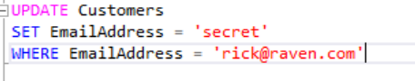

1. Write an UPDATE statement that modifies the Customers table. Change the password column to “reset” for every customer in the table.



1. Open the script named CreateMyGuitarShop.sql that’s in the Exercise Starts directory. Then, run this script. That should restore the data that’s in the database.