# Directions & Deliverable (10 pts ea) – Tim Capehart

Execute the NewEmployeeProjects.sql in a new query window. Then, complete the following exercises in a single document. Label each question and/or letter clearly. For each exercise, provide screen shot(s) of your output. Submit your work electronically to Blackboard by the due date specified.

1. Write a SQL statement to create a table Users with the following requirements.
   1. Users should have username, password, full name and last login time.
   2. Choose appropriate data types for the table fields.
   3. Define a primary key column with a primary key constraint.
   4. Define the primary key column as identity to facilitate inserting records.
   5. Define unique constraint to avoid repeating usernames.
   6. Define a check constraint to ensure the password is at least 5 characters long.

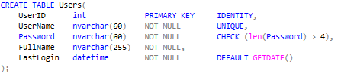

1. Write a SQL statement to create a view that displays the users from the Users table that have been in the system today. Test if the view works correctly.

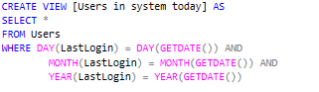

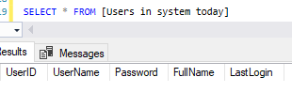

1. Write a SQL statement to create a table Groups with the following requirements.
   1. Groups should have unique name (use unique constraint).
   2. Define primary key and identity column.



1. Write a SQL statement to add a column GroupID to the table Users.



* 1. Fill some data in this new column and as well in the Groups table.

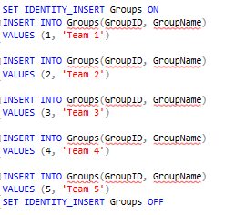

* 1. Write a SQL statement to add a foreign key constraint between tables Users and Groups tables.



1. Write SQL statements to insert at least 5 records into the Groups table and at least 10 records into the Users table. For any date entries, insert any dates between 1999 and today.

See above for inserts into Groups table.

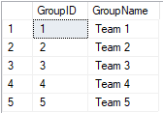

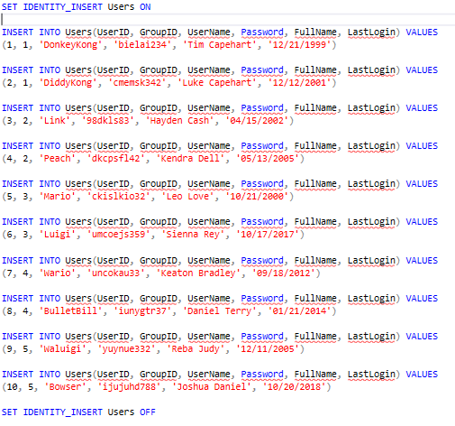

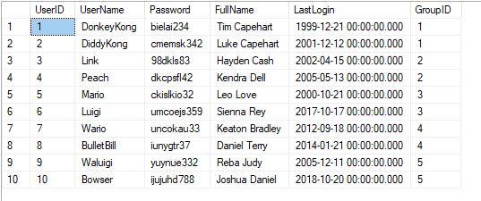

1. Write a SQL statement that changes the password to NULL for all users that have not been in the system since 10.03.2010.



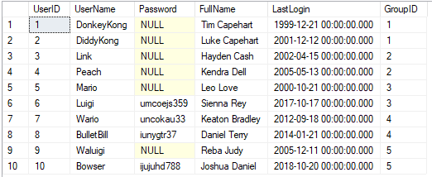

1. Write a SQL to create table WorkHours to store work reports for each employee (employee id, date, task, hours, comments). Define the appropriate identity, primary key and foreign key constraints.

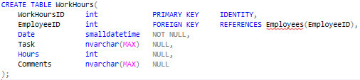

1. Write SQL statements to insert at least 5 records into the WorkHours table.

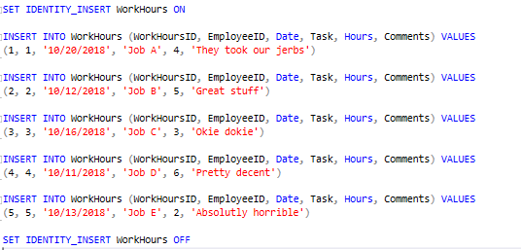

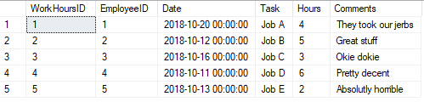

1. Start a database transaction, delete all employees from the 'Sales' department along with all dependent records from the other tables. At the end rollback the transaction.

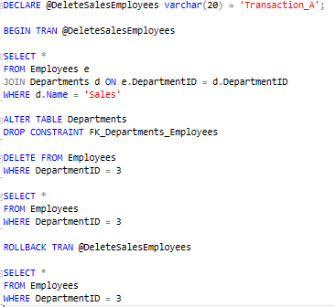

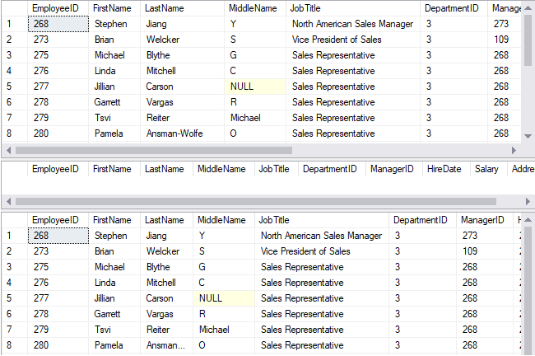

1. Find how to use temporary tables in SQL Server. Using temporary tables backup all records from EmployeesProjects and restore them back after dropping and re-creating the table.

