Triana Carmenate
Project 2, Oct. 18, 2015
COP 5725- Principles of Database Management Systems

I have first attached corrections for project 1 along with the graded version of the project. I then attached project 2 which has constraints indicated using the following symbols:

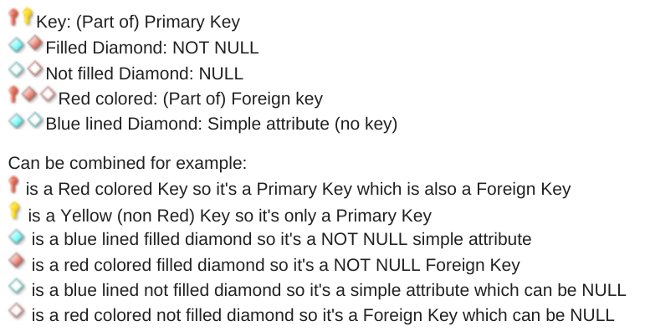
The records are the last page.

