**QUESTION 1**

4,000*6 bits=24,000 bits

24,000 bits= 3,000 bytes

30,000/3,000=10

Final answer: 10 seconds[1]

**QUESTION 2**

Generally speaking a Virtual Local Area Network (VLAN) a way of splitting up a Local Area network into separate domains. By doing so you are able to separate broadcasts and this helps to alleviate network congestion by splitting up network traffic.[2] In addition, VLANs also provide a layer of security to a network by making communication more private.[2] If you had three departments in a corporation such as accounting, engineering, and marketing, a VLAN could be used to separate their communications and make it so that employees of each branch could only access data from follow coworkers on their branch of the network. Below is a pictorial representation of this: 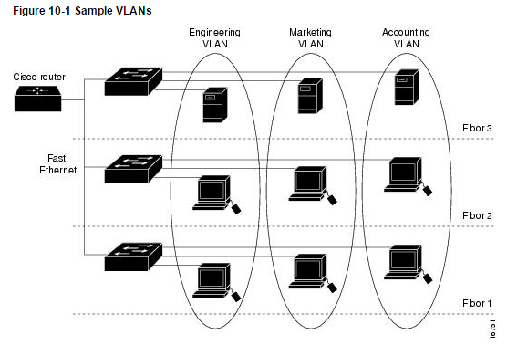[3]

**QUESTION 3 (Max: 120 words).**

The answer to this question is entirely situational and thus will change on a case by case basis. Both topologies have their advantages and disadvantages. For starters the token ring eliminates the possibility of data collision, but is also slower than the star topology with Fast Ethernet which operates at 100mbps [4]. I think that the LAN called Gandalf will perform better due to its utilization of Fast Ethernet which results in fast speed and the ability to keep operating even if one of the nodes on the network goes down. [5]

**QUESTION 4**

**a) What is the source address (sender) in the Ethernet frame that you have captured?**

08 24 F5 CE D3 AC. In Ethernet frames, the Source address follows immediately after the delivery address. [6]

**b) Who is the receiver of the frame?**

Every computer on the network will receive this frame. This is shown by the address FF FF FF FF FF FF which signifies that this message is to be broadcasted on the network. [6] [7]

**c) What type of message does the frame carry in its payload?**

The frame carries an ARP. This is shown by the 08 06 sequence in the frame. [8]

**QUESTION 5**

**Question 5.1:**

a) Wolverine (N1), Storm (N2), Cyclops (N3), Beast (N4) Iceman (N5), and Rogue (N6)

Since the frame is being sent to the network for the first time, it will send to every node on the network until it reaches its destination Beast (N4). The reason for this is that the bridge has not located any of the other nods on the network besides that of the sender. [9] Then once the bridge learns the location of the receiver, it will stop sending the message to all the other nods. [10]

b) The Physical addresses Wolverine (N1), Storm (N2), and Cyclops (N3) would receive the message. This is because the hubs on the 2nd floor will send the message to every node on the network in order to find the one intended receiver. [10]

c) The message would be received by the Physical addresses Wolverine (N1) and Cyclops (N3). This is again due to the hubs which will just send the message to every node again in order to locate the intended receiver. [10]

**Question 5.2:**

The frame would be the same in both case that being IcemanWolverine because the receiver Iceman does not send anything back to sender wolverine.

**Question 5.3:**

80,480 Kilobytes = 80,480,000 Bytes

80,480,000 Bytes/ 1,514 Byte= 53,157.19947159841

Final Answer: 53,158

Note: 1,514 bytes is the number of bytes in an Ethernet frame. [11]

Note 2: Final answer is rounded up.

**QUESTION 6**

-What is your budget?

- How many users are will be on your network?

-will your users be sending large amounts of data?

-How would you rank the following in order of importance for your network? Speed, privacy, security, reliability, and easy maintenance.

-Would the ability to easily add nodes (laptops, desktops, cellphones, printers, etc.) to the network be an important feature for you?

[1] L. Frenzel, "What’s The Difference Between Bit Rate And Baud Rate?", *Electronic design*, 2012. [Online]. Available: http://www.rpi.edu/dept/ecse/mps/Bit_&_Baud_Rate.pdf. [Accessed: 13- Apr- 2016].

[2] S. Varadarajan, "Virtual Local Area Networks", *Cse.wustl.edu*, 1997. [Online]. Available: http://www.cse.wustl.edu/~jain/cis788-97/ftp/virtual_lans/#WhatVLAN. [Accessed: 13- Apr- 2016].

[3] "Catalyst 4500 Series Switch Cisco IOS Software Configuration Guide, 12.2(25)EW - Understanding and Configuring VLANs [Cisco Catalyst 4500 Series Switches]", *Cisco*, 2016. [Online]. Available: http://www.cisco.com/c/en/us/td/docs/switches/lan/catalyst4500/12-2/25ew/configuration/guide/conf/vlans.html. [Accessed: 13- Apr- 2016].

[4]V. Moorthy, "Gigabit Ethernet", *Cs.wustl.edu*, 1997. [Online]. Available: http://www.cs.wustl.edu/~jain/cis788-97/ftp/gigabit_ethernet/. [Accessed: 14- Apr- 2016].

[5]"Fast Ethernet vs FDDI", *Courses.cs.washington.edu*, 1997. [Online]. Available: https://courses.cs.washington.edu/courses/csep561/97sp/paper1/paper13/. [Accessed: 14- Apr- 2016].

[6]P. Buis, "Ethernet Frames & Frame Types", *Cs.bsu.edu*, 1996. [Online]. Available: http://www.cs.bsu.edu/~peb/cs637/ethernet/frames.htm. [Accessed: 14- Apr- 2016].

[7]"Cisco IOS Bridging and IBM Networking Command Reference Volume 1 of 2", *http://www.cisco.com/*, 2006. [Online]. Available: http://www.cisco.com/c/en/us/td/docs/ios/12_2/ibm/vol1/command/reference/fibm_r1.pdf. [Accessed: 13- Apr- 2016].

[8] C. Easwaran, "Address Resolution Protocol (ARP)", *http://www.cs.newpaltz.edu*, 2006. [Online]. Available: http://www.cs.newpaltz.edu/~easwaran/CCN/Week13/ARP.pdf. [Accessed: 13- Apr- 2016].

[9]B. Ku and C. Chu, "Tutorial on Networks", *Cs.umd.edu*, 2005. [Online]. Available: https://www.cs.umd.edu/class/fall2001/cmsc411/proj01/pub/nine.html. [Accessed: 14- Apr- 2016].

[10]J. Rexford, COS 461: Computer Networks. Topic: "Switches and Bridges", Computer Science Department, Princeton University, Princeton, NJ, 2009.

[11]D. Comer, *Computer networks and internets*, 5th ed. Upper Saddle River, N.J.: Pearson/Prentice Hall, 2009, p. 285.