**Evaluating Web Sources: A Brief Overview**

Theodore Sullivan Cassidy

Table of Contents

**Abstract** 1

**Introduction** 2

**How to Evaluate Web Sources** 2

**Evaluating the Future of Children Website** 3

**Conclusion** 4

**References** 5

**Appendix** 6

# **Abstract**

This report explores the often understudied process of evaluating web sources for credibility. It provides an overview of some of the key factors that should be kept in mind when looking for sources online. An evaluation of the website [www.princeton.edu/futureofchildren/](http://www.princeton.edu/futureofchildren/) is also used to demonstrate how one can use these factors to determine the validity of a website. Through these means, it is anticipated that a person will become more apt at analyzing web sources moving forward.

# **Introduction**

With the emergence of computers into public life, locating information online has become a trivial task. In one search you can find information on everything spanning from the population of Greece to campaign maps from the Napoleonic Wars. Yet even though there is now virtually an infinite amount of information available at our fingertips; it does not mean that all of it is necessarily reliable or for that matter even true at all. Someone knowledgeable or world renown in their field has the same ability to post information online as any other person with internet access.

Due to this openness it can sometimes be difficult to determine the validity of a website when it comes time to find reliable sources. Fortunately, there are some clues that a person can look out for to help determine the validity of a website and other online sources. This report aims to provide an overview of these clues and demonstrate how they can be used to evaluate a website. With this in mind, the

# **How to Evaluate Web Sources**

A website’s domain is one of the first factors that a person should keep in mind when evaluating a website. This is because it denotes exactly what kind of entity a website is associated with. Two types of reliable domains are .gov and .edu which are used for the websites of governmental agencies and institutions of higher education respectively. [1] Occasionally .org sites can be fine as well since they denote a non for profit. However, it is safer to just avoid them since they are often advocacy websites, which almost always tend to be biased. Yet this is not to say that domains such as .gov and .edu could not be biased or inaccurate too. Thus it is important to examine other variables as well.

Just like the author of a book, the author(s) of a website should be checked to make sure that they are credible in the subject they are discussing. One way to do this is to look for a biography or ‘about us’ section on the website. [2] This should list their experience and purpose for publishing the material along with any institution or organization that the website is associated with. [3] There should also be some form of contact information given for the author(s). If a website lacks this, it could be a warning sign that there is no system or authority in place to prevent false information from being published. [1] So if the author(s) make it through this initial assessment, it is worth continuing on to review the information given on the website itself.

One of the easiest ways to initially verify the credibility of information on a website is to look for the sources it has cited. This can tell you not only if the author has done appropriate research, but also if they are biased in the stance they take. [2] If they are biased, it can often be ascertained from the sources they used. For example, if someone wrote an investigative report on the effects of greenhouse gas on the environment, but only referenced sources from major fuel companies, this would show their bias. You can check the accuracy of a website not only by checking its references, but by searching for other sources which have cited it if any. [3] After confirming that the author(s)’ are impartial in their position and that their information is truthful, it should then be determined if the information on the website is still relevant today.

Sometimes a person may find an article or website online which at first seems to fit their needs perfectly. It is from a credible source and is related to the topic they want to cite it for. Unfortunately, just because the information is from a reliable source does not necessarily mean that it is valid. It could be long out of date which can diminish its value or even make it obsolete as a source. The age of a source is critical to keep in mind when it comes to fields such as science and technology which are constantly progressing. [4] Yet the age of a source in some cases might not discredit it. This exception mainly occurs when it comes citing to more solid facts, like historical events or documents. [5] So it is necessary to keep in mind the subject you are using the source for because it will usually determine the age of the sources you can use.

By following these guidelines, a person can be more confident that the sources they use are legitimate. Although even if a source is found to be reliable and meet all of the above criteria, it does not mean that it is a perfect source. One example of a reliable, but flawed website is [www.princeton.edu/futureofchildren/](http://www.princeton.edu/futureofchildren/)

# **Evaluating the Future of Children Website**

The Future of Children is a website run jointly by Princeton University’s Woodrow Wilson School of Public and International Affairs and The Brookings Institution. It aims to make research about children more understandable to people who are involved in either researching or making educational policies for adolescents. [6] As such, its purpose is directly tied to this specific audience. This may explain why the website’s user interface is not the best. It is not intended for popular use. What is important to the people who are most likely to use the website is the research and documents it provides and not its appeal to the eye. In other words, as long as it works, it does not need to look pretty. Fortunately, when it comes to the credibility of the website and the quality of its information, it does not disappoint.

Being operated and maintain by Princeton University means that the website is held to the rigorous standard that are used by Ivy League schools. This can be seen in the transparency of the site and the proof of validity it provides. On the side bar there are links not only to a thorough ‘about’ section, but also to a section fully dedicated to the appearance of Future of Children information, in the media. In the ‘about’ section, there is a staff members list which provides the names and qualifications of each member. Then in the media section, the information is broken up into three sections in which to find publications mentioning the site.

At the bottom of the website is a footer that shows Princeton University and The Brookings Institution as the publishers and owners of the website. It contains a link to the website’s contact section, which displays a mailing address, email, and phone number to reach them through. A link to a Copyright and Terms of Use section is also included. This footer remains present on every webpage you visit throughout the site. As a result, the website instills the user with a sense of confidence that the information provided is reliable because it proves that Princeton University and The Brookings Institution are taking responsibility and ownership of the website and its contents.

When it comes to referencing, the journal articles on the site use an incredible amount of them. From browsing through a few articles, it becomes apparent that on average, at least 40 unique sources are cited per article. Such thorough referencing shows that the authors writing for *The Future of* *Children,* invest a large amount of energy towards producing high quality work for publication in its journal. For this reason, a link to purchase copies of *The Future of* *Children* journal is included on the website’s information bar. This further proves the validity of websites and its content, by showing that the information provided is considered suitable enough to be sold to its rather educated audience.

All of these features demonstrate that the *Future of Children* is not only a reliable source, but an extraordinarily high quality one as well. Unfortunately, the same cannot be said for the quality of the website’s layout.

When someone first connects to the Future of Children website, they are presented with a poorly formatted homepage. All of the text is crammed on to the left hand side of the screen resulting in a large portion of the webpage being blank. Combined with the highly contrasting colors, this format can strain a user’s eyes and make it difficult for them to read the information contained on the webpage. In addition, the website has no search bar present at the top of the page like is typically the case. Instead, a link must be click on either the menu bar or at the top of the page, which brings you to a black page with the search bar. To make matters worse, this search bar is of rather low quality because it does not include an advance search function. So a user is unable to filter their search results with anything besides the term they enter. These poor aesthetic and functionality choices, make using the website a particularly unpleasant experience. However, at the end of the day, this does not truly detract from its credibility as a source or of the information contained within it.

# **Conclusion**

When it comes to finding information, The internet has become an unprecedented (tool) medium through which (to do so)to find information.

This report aimed to act as a guide for evaluating websites and other sources of information that you find online. By providing evaluation techniques and ___ing an example of a website evaluation, it was ____ that

# **References**

[1] <http://depts.washington.edu/trio/trioquest/resources/web/assess.php>

[2] <http://www.lib.berkeley.edu/TeachingLib/Guides/Internet/Evaluate.html>

[3] <http://www.lib.vt.edu/instruct/evaluate/>

[4] <http://isites.harvard.edu/icb/icb.do?keyword=k70847&pageid=icb.page346375>

[5] <http://www.lib.umd.edu/tl/guides/evaluating-web>

[6] <https://www.princeton.edu/futureofchildren/about/>

# **Appendix**

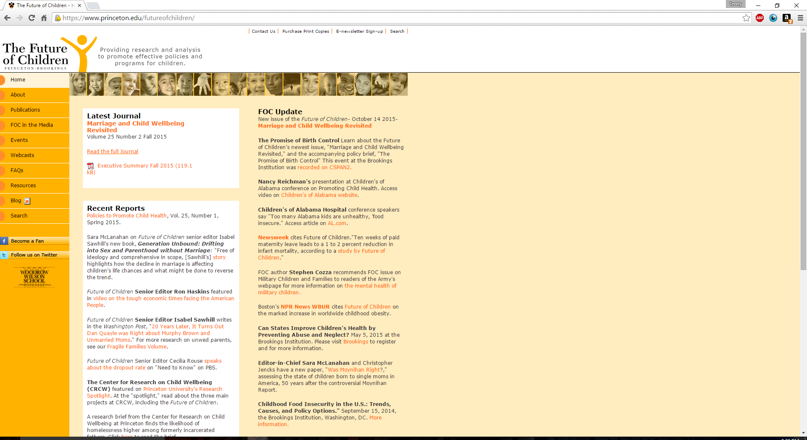

A screenshot of the starting page of The Future of Children’s website.