PLAYCE — Design & Furniture Placement Rules
The rulebook for the AI designer and the 3D generation: every rule the app follows today, per room, plus the draft notes (translated), as a plan to build them in.
Version 1 · 4 Nov 2026 · prepared for Nini to review and edit · source: the app's code and docs (lib/design/rules.ts, catalog.ts, autoLayout.ts, docs/design-studio/design-rules.md) and the draft "დრაფტი კლოდისთვის".

1. How to use this document
Every rule is one row. Read the rule, then write in the last column: keep, change (and how), or drop. Add new rows anywhere: give them the next number in that room (e.g. K-40) and status "New". Numbers in centimetres, areas in m².
Status colours:
Status | Meaning
In app | The app already does this today (engine or AI designer). Change it only if it is wrong.
New (draft) | From the draft; the app does not do it yet. To build.
Change (draft) | The app does something here already, but the draft asks for it differently. The new behaviour replaces the old.
Fix (bug) | The app should do this already but the draft shows it going wrong (screenshot).
Unclear: Nini? | I was not sure what the draft meant, or there is a choice to make. My reading is written; please confirm or correct.
Needs product | The rule needs a 3D model or catalogue product we do not have yet.

Room codes: G = global (whole flat) · E = entrance / hall · L = living room · K = kitchen · D = dining · B = bedroom · BA = bathroom · WC = separate toilet · O = office · BL = balcony · S = storage / closet · ST = studio (open kitchen + living) · P = plan board (2D) · Y = styles.
The column "Where it lives" is for the developers (me): the file or part of the app that holds the rule today, or how it would be built. Nini can ignore it.

2. How to give rules to the AI designer (suggestions)
The goal: after these rules, a generated flat is furnished, lit and decorated with everything it needs. The rules reach the result through four different "ears", and a rule works best when it is written for the right one:
Who follows it | What kind of rule | Example | How to write it
The layout engine (code, exact) | Measurable placement: distances, heights, which wall, which room, "never", "always", sizes, area limits. | "Kitchen island: at least 120 cm of free floor on every side." | A number, a condition and a priority. The engine follows it every time, without an API key.
The AI designer (Claude, judgement) | Taste and choice: which products go together, style, colours, mood, decor, what the room "needs". | "Scandinavian: one big pendant in the middle, spots around it; warm light." | Plain words, with the reason. Photos of good examples help it most.
The catalogue / models (products) | Things that must exist to be placed: a dryer, a door mat, a vanity made to measure. | "A coat rack model in each of the 4 styles." | A list of the products and a reference picture or link for each.
The checks (warnings) | Rules a person may break by hand but should be told about. | "Warn when a TV is in sight of the entrance." | Say "warn" instead of "never".

A template for one rule
Writing each rule with these six parts makes it buildable without questions:
Part | Fill in | Example
Room | which room type(s), or "all" | Bathroom
Strength | MUST · PREFER · NEVER · WARN | MUST
When | the condition: size, style, budget, what else is there | if the bathroom is 6 m² or more
Rule | what to do, with numbers in cm | a towel shelf on a free wall, 30 cm deep, beside the basin
Style | all styles, or which | all except Vintage
Why / picture | the reason, and a screenshot with the project number | project #412: the big wall stayed empty

Good habits
- One rule per row; one idea per rule. "Island not against a wall" and "hood over the island" are two rules.
- Always a number: "near" → "within 50 cm"; "big room" → "12 m² or more"; "high" → "top at 90 cm".
- Say what happens when the rule cannot be met: "…otherwise put the table against the kitchen run" (the draft does this well for the dining table).
- Mark the strength. MUST rules the engine never breaks; PREFER rules it follows when there is room; WARN rules show a warning in the studio.
- When something looks wrong, a screenshot with the project number and one line "wrong: … / right: …" is the fastest way — I can open the same project and see the plan.
- Style rules go in the style section (Y), not in every room: "in Scandinavian, …".
- Products we lack go in section 15 so the team can source the models while the rules are built.

Where the rules should live (proposal)
- Now: this Word file is the master list. When Nini finishes a round, I build it in stages (like the two earlier rounds), each one tested on the reference plans and pushed.
- Next: the numbers already live in one code file (rules.ts). We can move the numbers Nini edits most (heights, gaps, area limits, which rooms get what, how often decor appears) to an admin page "Design rules", so she changes a number and the next generation uses it, no developer needed.
- Then: the AI designer's instructions are generated from the same rulebook, so the engine and the AI never disagree; the AI's room check reads the same list and reports which rules a room breaks.
- Always: a set of 10–15 reference plans (the uploaded ones) that every change is generated on, so we see a rule fixed in one flat did not break another.

3. Global rules (the whole flat)
# | Rule (edit freely) | Status | Where it lives / how we build it | Nini's notes: keep / change / drop
G-1 | One floor through the flat: the largest living room's floor (else the largest room's) is laid in every room except bathrooms, toilets, the balcony and a closed kitchen (tiled). A room finished by hand keeps its own. | In app | surfaces.ts withFlatFinish
G-2 | Walls consistent: the same wall finish, or tones of one colour family, through the flat. | In app | surfaces.ts; AI brief | keep
G-3 | One palette: 2–3 main colours + 1 accent, materials repeated across rooms; at most 3–4 colour families per room. | In app | AI designer brief | keep
G-4 | Every object is a real product with a price and a shop; one product per kind per room (6 identical dining chairs); the next room gets a different one of the same kind. | In app | matcher.ts | keep
G-5 | Generation is random: the same plan generated twice gives two different flats; the style's own products are 10× as likely. | In app | random.ts, matcher | keep
G-6 | The product must fit: a product bigger than its spot gives way to the next that fits; nothing stands through a wall; nothing tall stands across a window. | In app | matcher placeFitting, blocksWindow | keep
G-7 | Room to walk: a bed, sofa or wardrobe should not leave 15–60 cm to a wall (a gap you cannot use); paths 100 cm; warning when a big piece is under 60 cm from a wall or 30 cm from a doorway. | In app | clearance.ts tightSpots | keep
G-8 | Light colour: 2700–3000 K in living rooms and bedrooms, 3500–4000 K in kitchens and offices, ~3500 K in bathrooms. Light in three layers: ambient, task, accent. | In app | rules.ts roomLightK | keep
G-9 | One main-light fixture per room: all main lights in one room are the same model; do not mix different main lights in a room. (main lights are rials spots small pendants but big chandelier wall or floor lights no) | New (draft) | Draft note 32 (entrance screenshot). Matcher: one product per kind per room already, but spots/ceiling lights are drawn separately — to unify. | keep
G-10 | Doors: room doors 80 cm, bathroom/toilet 70 cm, front door 90 cm. (can be changed by user when they build tho) | In app | rules.ts doorWidthFor | keep
G-11 | Front door only at the entrance, interior doors only between rooms — never an entrance-type door inside the flat. | New (draft) | Draft note 36. Openings: product chosen by exterior flag. | keep
G-12 | No glass doors into bedrooms or bathrooms. | New (draft) | Draft note 7. Door product filter by room. | keep
G-13 | Switches at 105 cm, 20 cm from the door opening on the handle side; two-way in bedrooms (door + each bed side) and in hallways 4 m or longer. | In app | rules.ts, electrical.ts | keep
G-14 | Sockets: general 45 cm; TV 110 cm (+ high ones at 170); desk 10 cm over the top; bedside 10 cm over the nightstand (45–75 cm), 35 cm with no nightstand; none within 60 cm of a shower or bath. | In app | rules.ts, electrical.ts | keep
G-15 | Radiators: under the window, bottom 12 cm off the floor, 4 cm off the wall, top ≥10 cm under the sill; a floor-length window's radiator beside it on the same wall; no furniture in the 30 cm strip in front. | In app | radiators.ts, ruleChecks | keep
G-16 | Boiler: in the hall by the entrance in a technical cupboard; else on the balcony in a cupboard; else in the bathroom (never in the shower or by the bath). Ventilated cabinet = boiler + 10 cm round. | In app | autoTechnical.ts, boilerCabinet.ts | keep
G-17 | Water: cold + hot at every basin, sink, shower, bath; cold only at WC, washer, dishwasher; hot left, cold right; WC, kitchen sink and washer within 2 m of the plumbing shaft (else warning). | In app | rules.ts WATER_NEEDS | keep
G-18 | Ceilings: a plasterboard ceiling lowers the room 10 cm, a stretch ceiling 3 cm; LED cove 12 cm drop, 15 cm from the wall. No false ceiling on the balcony. | In app | ceiling.ts | keep
G-19 | Windows: roller blinds in Modern and Industrial flats and in every kitchen, bathroom and toilet; floor-length curtains from just under the ceiling in Scandinavian and Vintage. A blind is 5 cm wider each side, cassette 10 cm over the window. | In app | rules.ts windowDressing | keep
G-20 | Every window that should have curtains gets them (not by chance): today a curtain appears in 90 % of rooms, a blind in 95 %. The draft shows living-room windows left bare. | Change (draft) | Draft notes 30, 34. autoLayout OPTIONAL_DECOR → 100 % when the room has a window. | Keep – every window has to have curtains
G-21 | Pictures at gallery height: middle at 150 cm on a free wall; bottom 25 cm over a bed or sofa. Never in an opening or over a window. | In app | catalog artwork rule | keep
G-22 | Wall sconces hang on the wall (never stand on the floor or a table). | New (draft) | Draft note 12. Need a wall-light kind in the layout (today only bedside wall lights). | keep
G-23 | Wall panels — whole wall or none: never one small panel alone. When a wall is panelled, a door in that wall is built into the panel (a hidden door, same finish), and a door groove follows the panel lines. | Change (draft) | Draft note 24. Today: panels only in Modern (kept). decor/ panels family + openings. | Keep – they have to be dragged as they are now to be able to change manually dimensions
G-24 | Cornice runs continuously through a room-to-room opening (an archway or open passage): no break where two rooms meet. | Fix (bug) | Draft note 33 (screenshot 6). trims.ts. | (screenshot) - keep
G-25 | No visible seams in floor and wall materials: tiles of a texture must not show a light stripe where they repeat. | Fix (bug) | Draft notes 19, 33 (screenshot 1). Texture edges / WebP; check per finish. | (screenshot) - keep
G-26 | Partitions at generation: a front door opening into a living room or studio gets a screen 1.3 m in; an en-suite bathroom opening into a bedroom (12 m²+) gets a 1.1 m lobby. A screen runs on to a wall if it would leave under 90 cm. | In app | autoPartitions.ts | keep
G-27 | Built to measure where it pays: when a standard product does not fill a space well, use a made-to-measure piece in the chosen material (kitchen, wardrobe, vanity, washer column, mirror panel) stretched to the wall, with internal sections the width the person chose. | New (draft) | Draft notes 25, 35, 37. Generalise the kitchen maker (kitchen.ts) into "joinery". | keep
G-28 | Don't double up: if a piece already does a job, don't add another for it — a bed with its own headboard gets no panel behind it; a basin sold with its tap gets no extra tap; a full-wall wardrobe means no extra chest of drawers in that room. | New (draft) | Draft notes 16, 18, 25. Needs product attributes (has headboard, includes tap). | keep
G-29 | Budget decides extras: optional upgrades (a dryer over the washer, built-in units, bigger shower) appear when the budget level is high. | New (draft) | Draft note 14. Budget tier already in matcher. | keep

4. Entrance / hall (E)
# | Rule (edit freely) | Status | Where it lives / how we build it | Nini's notes: keep / change / drop
E-1 | Program today: console table, shoe cabinet, mirror over the console (middle at 155 cm), a pendant, a plant from 8 m². | In app | catalog ROOM_PROGRAMS.hallway | keep
E-2 | Hallway lights: one every 3 m or nearer, evenly down the middle (an L-shaped hall's arm too); no floor lamp at its start. | In app | electrical hallLightSpots | keep
E-3 | Two-way switches at both ends of a hallway 4 m or longer. | In app | electrical | keep
E-4 | The boiler's technical cupboard goes in the hall by the entrance when the hall is 1.4 m wide and has 80 cm of free wall. | In app | rules.ts BOILER_HALL_* | Change – A made-to-measure cabinet should be installed next to the hallway wardrobe to conceal the boiler. The cabinet should extend to the ceiling, matching the full height of the existing wardrobe. Its dimensions should be designed around the boiler to ensure it is fully enclosed, while allowing sufficient space for maintenance and ventilation. The material and finish should be selected to complement the overall interior style chosen by the client, creating a seamless and cohesive design throughout the apartment.
E-5 | Washing machine fallback: if no bathroom has room, the hall takes it (built into a cupboard — see BA-12). | In app | autoLayout WASHER_FALLBACK_ROOMS | keep
E-6 | Coat storage by the door: a coat rack or a wardrobe for jackets right where you come in (from the 3D models). | New (draft) | Draft note 31. New kind "coat_rack"; wardrobe allowed in hall. | Keep – A made-to-measure cabinet should be installed next to the hallway wardrobe and next to it can be the boiler. Both cabinets should be designed as one continuous, built-in wardrobe with separate internal sections, creating the appearance of a single, unified piece of furniture. The cabinetry should extend to the ceiling, maintaining a consistent height and depth throughout.
E-7 | Shoe cabinet / shelf right next to the coats. If there is no model fitting | Change (draft) | Draft note 31. Shoe cabinet exists; make it stand beside the coat storage. | Keep – do the same as for washing machine, coat and boiler
E-8 | Full-height mirror on the opposite wall: about 60 cm wide, from the floor to door height. In all styles it can be a made-to-measure mirror panel. | Change (draft) | Draft note 31. Today: small mirror over the console. Make mirror panel (decor) or tall mirror. | keep
E-9 | Door mat only at the front door (inside), never at other doors. | New (draft) | Draft note 8. New kind "door_mat"; needs product. | keep
E-10 | Name the room "Hall / entrance" as well as "hallway", so the app knows which hall the front door is in and which doors are interior. | New (draft) | Draft note 22. Room type label; plan reader. | keep
E-11 | Hidden storage in the entrance (closed cupboards rather than open shelves). | In app | AI designer brief | keep
E-12 | Hall lighting: all the hall's main lights the same model (see G-9). | Fix (bug) | Draft note 32 (screenshot 5). | keep

5. Living room (L)
# | Rule (edit freely) | Status | Where it lives / how we build it | Nini's notes: keep / change / drop
L-1 | Program today: sofa (corner sofa from 22 m²), coffee table, TV unit + TV, armchair from 16 m², bookshelf from 15 m², rug, floor lamp from 11 m², pendant, picture, plant from 12 m², curtains, dining table + chairs from 26 m². | In app | ROOM_PROGRAMS.living_room | keep
L-2 | Sofa faces the TV, 2.5–3.5 m away, never faces a window wall. | In app | autoLayout, rules.ts SOFA_TV_M | keep
L-3 | Coffee table 42 cm from the sofa's front; TV unit leaves 60 cm before the coffee table (else no TV unit). | In app | rules.ts | keep
L-4 | TV over its unit, centre at 105 cm, up to 65"; kept clear of windows up to 1.5 m high. | In app | autoLayout tv | keep
L-5 | TV on a blank wall, out of the entrance's path: never where you walk in front of it to come in or go out; from the very first generation. Turn the sofa/TV group if needed. | New (draft) | Draft note 34 (screenshot 7). Score TV walls by doorway sight bands. | Keep – do not make main passageway in front of tv to enter to other rooms
L-6 | Armchair beside the sofa, turned 45° towards the TV; 80 cm from the dining table. | In app | autoLayout placeRelative | Change – Leave everything as it is, except for the dining table. An 80 cm table is too small, so increase its size to at least 1.2 m. If space allows, consider a larger table and position it centrally within the remaining open area of the living room.
L-7 | Bookcase / cabinets beside or behind the sofa, never on the TV wall. On a free wall that does not run into a window. | Change (draft) | Draft note 9 adds: "on a free wall, not hitting a window" — and in the office too. | keep
L-8 | Dining table in a living room: 4–6 seats minimum, never a 2-person table; set away from the sofa with a clear way between. | New (draft) | Draft note 34. Today table size from the room; add a minimum. | keep
L-9 | Wider passages: the app leaves walkways too narrow in living rooms; keep 90–100 cm free routes between doors and between groups. | Change (draft) | Draft note 34. Today paths 100 cm only as a warning; make it a layout rule. | Keep
L-10 | Use the whole room: don't leave a large empty area on one side while pieces crowd the other; spread the groups (seating, dining, storage). | New (draft) | Draft note 34. Score empty area in layout. | keep
L-11 | Curtains at every living-room window (see G-20). | Change (draft) | Draft note 34. | keep
L-12 | Chandelier / prominent pendant where the room is big enough; more floor lamps (95 % of rooms that fit one). | In app | electrical, OPTIONAL_DECOR | keep
L-13 | Entrance screen: a front door opening straight into the living room gets a partition 1.3 m in. | In app | autoPartitions | Change – for industrial style do not do it and for studio apartments when there is not much space
L-14 | Full-wall empty side → offer a made-to-measure cabinet wall (see B-9). | New (draft) | Draft note 25. | keep

6. Kitchen (K)
# | Rule (edit freely) | Status | Where it lives / how we build it | Nini's notes: keep / change / drop
K-1 | Program today: kitchen run, fridge, wall cabinets, island from 17 m², dining table + chairs from 10 m², pendant, roller blind. | In app | ROOM_PROGRAMS.kitchen | keep
K-2 | The run: on the longest wall without a window (2.2 m+), near the water point, out of the front door's line of sight (warning if no other wall works). A small kitchen goes on one wall: run, fridge at its end, wall cabinets over the run. | In app | autoLayout placeWallRun | keep
K-3 | Run order: sink at the end nearer the water, dishwasher beside it (only if the run is 2.1 m+), prep zone, hob towards the middle with the oven under it, hood over the hob. | In app | rules.ts kitchenRunZones | keep
K-4 | Wall cabinets 55 cm over the worktop (bottom at 145 cm), as long as the run, shortened round a window or door. | In app | autoLayout placeAbove | keep
K-5 | 1.2 m of working floor in front of the run before the table and chairs. | In app | rules.ts KITCHEN_CIRCULATION_M | keep
K-6 | Island never against a wall: at least 1.2 m of free floor on every side of it. | Change (draft) | Draft note 13. Today only 1.2 m from the run. | keep
K-7 | Hood: if the kitchen has no hood, put one centred over the hob — usually a round cylindrical one, otherwise a thick rectangular one. (An island hob: a hood hanging over the island.) | New (draft) | Draft note 13. Need hood products in the kitchen (equipment). | keep
K-8 | No extra hob or oven: never add a separate hob or oven when the kitchen run already has them. Add a separate oven only when the kitchen model is a sink unit only. | Fix (bug) | Draft note 27 (screenshot 3). | keep
K-9 | Missing hob or tap: if the kitchen has no hob or no tap, add one on top automatically. | New (draft) | Draft note 17. Needs "includes hob/tap" on kitchen products. | keep
K-10 | Dining table: at least 4 chairs, never a small table with one chair in a large kitchen. Leave a way round it; do not push it to the wall if there is 1.2 m between the seats and the kitchen run. | Change (draft) | Draft note 27. Today: table size from the space; one chair possible. | keep
K-11 | Not enough room for a free table (under 1.2 m to the run): put the table against the kitchen (a breakfast bar / counter extension) instead. | New (draft) | Draft note 27. | keep
K-12 | Long kitchen → long rectangular table. | New (draft) | Draft note 27. Table shape by room proportion. | keep
K-13 | Kitchen lighting, three layers: a pendant centred over the dining table (never over the hob); ceiling spots across the middle of the room — not hugging the kitchen run; LED under the wall cabinets onto the worktop. | Change (draft) | Draft note 28. Today: spots every 90 cm, 10 cm in front of the worktop → move towards the room centre. | keep
K-14 | LED under wall cabinets must not show: the strip is hidden, flush with the cabinets' underside, only the light is seen. | Fix (bug) | Draft note 29 (screenshot 4). 3D: strip position. | keep
K-15 | Kitchen strictly in the flat's style: a Scandinavian flat gets a Scandinavian kitchen (light, wood, handleless/simple), not another style's. | Fix (bug) | Draft note 37. Kitchen material choice by style tag. | keep
K-16 | Fill the wall: when a standard kitchen does not fit, build it to measure, adding cabinet sections to run the whole wall. | Change (draft) | Draft note 37. Made-to-measure exists ~2/3 of the time; prefer full wall. | keep
K-17 | Roller blind at every kitchen window. | In app | rules.ts BLIND_ROOMS | keep
K-18 | Sockets: worktop 105 cm (three doubles, off the sink and hob), 30 cm behind dishwasher/oven, hood 215 cm, fridge 40 cm, one inside the wall cabinets for the LED. | In app | rules.ts, electrical | keep
K-19 | Closed kitchen floor tiled; open kitchen takes the flat's floor. | In app | surfaces.ts isClosedKitchen | keep

7. Bedroom (B)
# | Rule (edit freely) | Status | Where it lives / how we build it | Nini's notes: keep / change / drop
B-1 | Program today: double bed (single under 9 m²), 2 nightstands, wardrobe (always), chest of drawers from 13 m², rug under the bed, pendant, picture, curtains, plant and floor lamp from 12 m². | In app | ROOM_PROGRAMS.bedroom | keep
B-2 | Bed: middle of the wall furthest from the door, out of the door's line of sight when possible, 60 cm free each side of a double bed. | In app | autoLayout, rules.ts | keep
B-3 | Nightstands both sides, 4 cm off the bed, the same product both sides. | In app | matcher pairsAlike | keep
B-4 | Wardrobe beside the bed, never facing it from its foot; into a niche when there is one (60 cm deep, or 38 cm in a shallow niche). | In app | autoLayout placeInNiche | keep
B-5 | Bedroom storage set: wardrobe, nightstands and a clothes shelf / rack. | Change (draft) | Draft note 10. Clothes shelf is new. | keep
B-6 | Headboard: if the bed has its own headboard panel, add no wall panel behind it. | New (draft) | Draft note 18. Needs "has headboard" on bed products; decor check. | keep
B-7 | Wall sconces by the bed hang on the wall (see G-22). | In app | Today the bedside lights are wall lights over the nightstands. | keep
B-8 | Stool / small chair in a bedroom when there is free space (e.g. at a dresser or the window). | New (draft) | Draft note 11. New kind "stool". | keep
B-9 | Full-wall built-in wardrobe: when an empty wall takes a whole side (or a niche), offer a made-to-measure wardrobe filling it in the chosen style and material, with internal sections the width of the shelf the person picked (or sections added outside). | New (draft) | Draft note 25. Joinery like kitchen.ts. | keep
B-10 | No extra chest when a full-length wardrobe was added at generation. | New (draft) | Draft note 25 ("ტუმბო" read as chest of drawers / extra cabinet — Nini?). | keep
B-11 | Lighting: one large light, or the main light + bedside light each side; Industrial a track of three cylinder spots square to the bed; Scandinavian a large central light and bedside pendants. Two-way switches by the bed. | In app | electrical | keep
B-12 | En-suite lobby: a bathroom opening into a bedroom of 12 m²+ gets a 1.1 m lobby screen. | In app | autoPartitions | keep
B-13 | No glass door into a bedroom (G-12). | New (draft) | Draft note 7. | keep

8. Bathroom (BA)
# | Rule (edit freely) | Status | Where it lives / how we build it | Nini's notes: keep / change / drop
BA-1 | Program today: WC, basin, bath from 7.5 m², shower, washing machine from 4.5 m², mirror, roller blind. | In app | ROOM_PROGRAMS.bathroom | keep
BA-2 | Free floor in front of every fixture: 60 cm where possible, never under 40 cm; fixtures do not stand in each other's way. Several orders are tried and the best kept. | In app | autoLayout wetOrders | keep
BA-3 | WC: never facing the door if another spot fits; centre 40 cm from a side wall; wall-hung with a 20 cm gypsum box behind (half height with a shelf, or to the ceiling). | In app | rules.ts, decor box | keep
BA-4 | Every WC gets its box, including WCs added by hand later and black square wall-hung WCs. | Fix (bug) | Draft note 5. Known gap: a WC added after generating gets no box. | keep
BA-5 | Centre the WC on its wall when it stands on the side away from the other fixtures; use the large free area by the door. | New (draft) | Draft note 35 (screenshot 8). | keep
BA-6 | Basin: what the door opens onto; top at 85 cm; on a long wall. | In app | autoLayout, rules.ts | keep
BA-7 | Vanity built to measure: the basin cabinet is made like a panel / cabinet — width adjustable up to the wall's length, height never over 90 cm. A rectangular (non-freestanding) basin model can be resized from standard. | New (draft) | Draft note 35. Joinery; needs vanity material. | Keep – Generate this for all available styles except Vintage. The dimensions should automatically adjust to suit each selected style, and every version must include a sink and a matching faucet.
BA-8 | Basin + tap always complete: if the vanity does not include a basin and tap, add them. A freestanding basin always gets a tap; a basin sold with its tap gets none extra. | New (draft) | Draft notes 16, 35. Needs tap products and "includes tap". | keep
BA-9 | Built-in (wall) taps and shower heads: boxed in the same way as the WC (a gypsum wall around the concealed part). | New (draft) | Draft note 5. Decor box family. | keep
BA-10 | Mirror: over the basin only. Standard mirror made as a panel: a rectangular one sized exactly like a panel (to the vanity), a round one scaled in proportion. | Change (draft) | Draft note 35. Today: product mirror over the basin. | keep
BA-11 | Shower: an area of 80×80 minimum (90×90, 100×90, 120×90 when the room allows, 5 m²+), in a corner, with transparent glass walls in every style. If there is more room, lengthen it along the room's direction. Must not block the tap, WC, the way through or the door. | Change (draft) | Draft note 3. Glass exists; "lengthen along the room" and "never block" to add. | keep
BA-12 | Washing machine never freestanding at generation (except Vintage): built into a 65 cm-deep cabinet, wrapped exactly to its height and shape so the machine does not stick out. The person may still choose freestanding. | New (draft) | Draft notes 4, 35. Joinery around the washer. | keep
BA-13 | Dryer over the washer when there is room and budget: built in the same column above the washer. | New (draft) | Draft notes 14, 35. Needs dryer product. | yes
BA-14 | Washer column at the end of the wall, never in the middle: the last section at the wall's end, so its door opens freely and it does not get in the way of sitting on the WC or reaching the shower. | New (draft) | Draft note 35. | keep
BA-15 | Washer + vanity in one run: in a big bathroom with no washer, build tap/basin, then the washer and dryer column in the same made-to-measure run. | New (draft) | Draft note 35. | keep
BA-16 | Built-in bath: rectangular ceramic bath, boxed in (enclosed all round) and then painted or tiled. | New (draft) | Draft note 1. Decor box + bath product. | keep
BA-17 | Bath mixer at the head of the bath (freestanding or built-in), added with the bath. | New (draft) | Draft note 2. Needs tap products. | keep
BA-18 | Bath / shower by style: Scandinavian — shower with glass walls; Modern — freestanding bath; Vintage — bath built in with tiles (and freestanding pieces inside — Nini?); Industrial — shower with glass walls like Scandinavian. Shower head chosen by style. | Unclear: Nini? | Draft note 35. Please check my reading of the Vintage part. | For the Vintage style, create a tiled built-in bathtub enclosure with a freestanding rectangular bathtub placed inside. The dimensions of the tiled structure should automatically adapt to the wall dimensions and the available space. Apply the same design approach to the toilet area, including built-in wall panels, and to the sinks, with integrated wall-mounted faucets. All built-in elements should be proportionally adjusted to the room dimensions while maintaining a consistent Vintage style throughout the bathroom.
BA-19 | Towel shelf when the bathroom/toilet is 6 m² or more: a towel rack/shelf or other shelves by the size of the wall and corner; a corner shelf where a corner is free. | New (draft) | Draft note 6. New kind "bath_shelf". | Change – if there is space and extra budget add it there if not towels will be on the wall, above toilet seat on heated toilet radiator.
BA-20 | Stool near the basin or in a free spot when there is room. | New (draft) | Draft note 11. | keep
BA-21 | Bathroom lighting: never a single light; spots evenly spaced like the kitchen, at least 3 — over the shower, the basin and the WC. | Change (draft) | Draft note 35. Today one ceiling light. | keep
BA-22 | Heated towel rail on the wall (48×120 cm, bottom at 60 cm) instead of a radiator. | In app | rules.ts TOWEL_RAIL_* | keep – show in 3d too
BA-23 | Sockets IP44, none within 60 cm of the shower or bath. | In app | ruleChecks socket_in_splash | keep
BA-24 | Use the model "shower door" as the example shower enclosure for now. | Needs product | Draft note 15. Find the product in the catalogue. | Drop – meaning remove – use built up for bathrooms
BA-25 | No glass door into a bathroom (G-12). | New (draft) | Draft note 7. | Keep – when u enter the bathroom

9. Separate toilet (WC)
# | Rule (edit freely) | Status | Where it lives / how we build it | Nini's notes: keep / change / drop
WC-1 | Program today: WC, small basin, mirror over the basin; door 70 cm; roller blind at a window. | In app | ROOM_PROGRAMS.toilet | keep
WC-2 | WC rules as BA-3/BA-4 (not facing the door, 40 cm to the side, wall-hung with box). | In app |  | keep
WC-3 | Towel shelf if 6 m²+ (BA-19); spots rather than one light (BA-21 — at least 2 in a toilet? Nini). | Unclear: Nini? | Draft notes 6, 35. | Change - For larger bathrooms, provide at least three main lighting points, evenly distributed according to the room's layout, similar to the lighting arrangement used in kitchens. One light should illuminate the sink area, one the toilet area, and one the shower area. All lighting fixtures should have a consistent design and light color, with the fixture style selected to complement the overall interior style. The main ceiling light should be positioned centrally in the room, while ensuring that none of the fixtures interfere with the opening of doors, cabinets, or wardrobes.

10. Office (O)
# | Rule (edit freely) | Status | Where it lives / how we build it | Nini's notes: keep / change / drop
O-1 | Program today: desk, office chair (seat under the desk), bookshelf, armchair from 14 m², rug, pendant, floor lamp from 9 m², picture, curtains. | In app | ROOM_PROGRAMS.office | keep
O-2 | Light 3500–4000 K; desk socket 10 cm over the desktop. | In app | rules.ts | keep
O-3 | Cabinets on a free wall that does not run into a window (L-7). | Change (draft) | Draft note 9. | keep
O-4 | Full-wall built-in cabinet with sections when a wall is empty (B-9). | New (draft) | Draft note 25. | keep

11. Balcony (BL), storage and closet (S)
# | Rule (edit freely) | Status | Where it lives / how we build it | Nini's notes: keep / change / drop
BL-1 | Balcony: an armchair from 4 m², two plants; no false ceiling; the boiler may go here in a cupboard. | In app | ROOM_PROGRAMS.balcony | keep
S-1 | Storage room: two storage shelves, a pendant. | In app | ROOM_PROGRAMS.storage | keep
S-2 | Walk-in closet: two wardrobes, a mirror, a pendant. | In app | ROOM_PROGRAMS.closet | Change – no mirror on a balcony closet if there are corners of at least 30-60cm depth
S-3 | Closet: made-to-measure shelving along the walls instead of two wardrobes? | Unclear: Nini? | Suggestion from G-27; not in the draft. | Drop - remove

12. Studio — open kitchen + living (ST)
# | Rule (edit freely) | Status | Where it lives / how we build it | Nini's notes: keep / change / drop
ST-1 | A studio is furnished half by half: the kitchen's program in the kitchen half, the living room's in the other; nothing stands against or hangs on the line between them. | In app | studio.ts partRoom | keep
ST-2 | Every kitchen (K-) and living room (L-) rule applies to its half; the front-door screen applies (L-13). | In app |  | keep

13. Plan board — 2D (P)
# | Rule (edit freely) | Status | Where it lives / how we build it | Nini's notes: keep / change / drop
P-1 | Interior walls show their length too (not only the outside chains) when a wall stands alone. | New (draft) | Draft note 20 (screenshot 2). plan board dimensions. | keep
P-2 | Beam = "რიგელი": move the beam and label it "rigel" (რიგელი). | Unclear: Nini? | Draft note 21. Which beam / where — Nini, a screenshot? | Change – name in Georgian რიგელი because it is ძელი - leave beam in English
P-3 | Windows and doors show their distances from wall to wall, so they can be placed exactly. | New (draft) | Draft note 23. | keep
P-4 | Opposite windows align: two windows facing each other on opposite walls snap into line; the same for doors, walls and the rigel. | New (draft) | Draft note 23. Snapping. | keep
P-5 | Hall / entrance naming (E-10): front door in the hall, interior doors elsewhere. | New (draft) | Draft note 22. | keep

14. Styles (Y)
# | Rule (edit freely) | Status | Where it lives / how we build it | Nini's notes: keep / change / drop
Y-1 | Four styles: Scandinavian, Modern ("minimalist"), Industrial, Vintage, each with a guide (look, palette, materials, lighting, furniture, kitchen, walls) and sub-styles. Products of the style 10× as likely. | In app | styleGuide.ts | keep
Y-2 | Scandinavian: no product whose main colour is black/very dark; light colours; no wall mouldings or decorative wall treatments (at most slats, a niche); plants and floor lamps; no LED strips. | In app | styleRejects, STYLE_DECOR_FAMILIES | keep
Y-3 | Scandinavian lighting: one large-volume main light per room plus spots / point lights around it — in every room. | Change (draft) | Draft note 26. Nini will send a sketch for all rooms. | keep
Y-4 | Modern: clean; the only style with wall panels, mouldingsand LED (lines, coves, lit niches); decor used selectively. | In app |  | Keep - one large-volume main light per room plus spots /pendant, point lights around it — in every room.
Y-5 | Industrial: no mouldings, no cornices, no hidden/LED light; cylindrical fixtures; track lights. | In app |  | keep
Y-6 | Vintage: the most decor and characterful detail; no LED or panels; the only style where freestanding washers/vanities are allowed at generation. | Change (draft) | Draft note 35 adds the freestanding exception. | Keep – add also with mouldings,. one large-volume main light per room plus spots /pendant, point lights around it — in every room.
Y-7 | Strict style matching for big pieces (kitchen, sofa, bed, bath): never another style's product when the style has its own. | Fix (bug) | Draft note 37. | keep
Y-8 | Bath / shower per style — see BA-18. | Unclear: Nini? |  | Drop - remove

15. Products and 3D models we need
# | Rule (edit freely) | Status | Where it lives / how we build it | Nini's notes: keep / change / drop
M-1 | Coat rack / hall wardrobe (4 styles) | Needs product | E-6 | keep
M-2 | Door mat | Needs product | E-9 | keep
M-3 | Tall / full-height mirror, mirror panel (rectangular + round) | Needs product | E-8, BA-10 | keep
M-4 | Range hoods: round cylindrical, thick rectangular, island hood | Needs product | K-7 | keep
M-5 | Kitchen products marked "includes hob / tap / oven" | Needs product | K-8, K-9 | keep
M-6 | Long rectangular dining table (6–8 seats) | Needs product | K-12, L-8 | keep
M-7 | Clothes rack / open clothes shelf | Needs product | B-5 | keep
M-8 | Stool / small chair (bathroom, bedroom) | Needs product | B-8, BA-20 | keep
M-9 | Wall sconces (more than the bedside ones) | Needs product | G-22 | keep
M-10 | Bed products marked "has headboard" | Needs product | B-6 | keep
M-11 | Vanity materials (made to measure, ≤90 cm high) + separate basins | Needs product | BA-7 | keep
M-12 | Basin taps, wall-mounted taps, bath mixers, shower heads per style | Needs product | BA-8, BA-9, BA-17, BA-18 | keep
M-13 | Tumble dryer | Needs product | BA-13 | keep
M-14 | Rectangular built-in ceramic bath; freestanding bath | Needs product | BA-16, BA-18 | keep
M-15 | Black square wall-hung WC (check it gets its box) | Needs product | BA-4 | keep
M-16 | Towel shelf / IKEA-type rack; corner shelf | Needs product | BA-19 | keep
M-17 | Shower glass door (the "shower door" model as the example) | Needs product | BA-24 | keep
M-18 | Interior doors without glass; one front-door model per style | Needs product | G-11, G-12 | keep
M-19 | Dressing table and stool (already waiting from the last round) | Needs product | Earlier gap | keep

16. Integration plan
Built in stages, as in the last two rounds: each stage built, tested on the reference plans, documented and pushed on its own. Nini's edits to this file decide what goes in; the order can change.
Stage | What | Rules | Needs first
1 — Bathrooms | Made-to-measure vanity and washer/dryer column at the wall end, built-in bath, taps and mixers, built-in tap boxes, every WC boxed, WC centred, shower lengthened and never blocking, towel shelf, stool, 3+ spots, bath/shower by style | BA-4…BA-21, WC-3, Y-6 | M-11…M-17; answer BA-18
2 — Kitchen | No duplicate hob/oven, missing hob/tap added, island 1.2 m all round + hood, table ≥4 chairs or against the run, long table, lighting moved to the room centre, hidden LED, kitchen strictly in style and run along the whole wall | K-6…K-16, Y-7 | M-4…M-6
3 — Entrance & living room | Coat storage + shoe cabinet + full mirror + door mat, TV out of the entrance path, dining 4–6 seats away from the sofa, wider passages, using the whole room, curtains always | E-6…E-12, L-5…L-11, G-20 | M-1…M-3, M-6
4 — Bedrooms & storage | Full-wall built-in wardrobe with sections, no extra chest, headboard check, clothes shelf, stool, sconces | B-5…B-10, O-3, O-4, G-22, G-28 | M-7…M-10
5 — Whole flat | One main fixture per room, Scandinavian lighting (after Nini's sketch), panels whole wall with hidden doors, continuous cornice, invisible seams, door types by place, budget-driven extras | G-9, G-11, G-12, G-23…G-29, Y-3 | Nini's lighting sketch; M-18
6 — Plan board | Interior wall lengths, window/door distances, opposite windows aligned, rigel, hall naming | P-1…P-5 | Answer P-2
7 — Rules in admin | The numbers Nini edits most on an admin page; the AI designer's brief built from the same list | All | After stages 1–6

Open questions for Nini
- BA-18: Vintage bathroom — "built in with tiles and a freestanding bath inside": is the bath built in (tiled box) or freestanding? And what does Scandinavian get — a shower with glass only, no bath? – see the answer above
- P-2: which beam should move and be called "რიგელი"? A screenshot of the plan helps. – see the answer above
- B-10 / note 25: "ტუმბო" after a full-wall wardrobe — a chest of drawers, a nightstand, or any extra cabinet? – cabinet can be if it is for work or for make up with mirror
- G-9 / note 32: is the rule "all main lights in one room are the same model", or "the same model through the whole flat"? see the answer above
- WC-3: how many spots in a small separate toilet — 2, or one over the WC and one over the basin? See the answer above – at least 3 lights in the same distances from each other and from the walls as u were starting to do
- Y-3: the Scandinavian lighting sketch for every room (promised in the draft). Use the ones that are in the style assigned
- Budget (G-29): which extras appear only at the high budget level — the dryer only, or also built-in joinery? – dryer on the upper part joinery can be close to the sink to be one whole piece of furniture with different openings

Appendix — the draft, translated
Each note of "დრაფტი კლოდისთვის" with its English translation and the rule numbers it became. Where the meaning was unclear, my reading is marked (?).
# | Draft note (English) | Became rules | Picture
1 | Built-in bath: box it in all round, then paint it or tile it. For a built-in bath use a rectangular shape — a rectangular built-in ceramic bath. | BA-16
2 | Bath mixer: put the bath tap at the head of the bath, freestanding or built-in, together with the bath. | BA-17
3 | Shower: give it transparent glass walls automatically, at least 80×80; if the area is large, lengthen it along the room's direction; it must not get in the way of the tap, the WC, the passage or the door. | BA-11
4 | Washing machine: don't place it freestanding. Offer that it can be freestanding, but always build it into a 65 cm cabinet wrapped exactly to its height and shape, so the model does not stick out. | BA-12
5 | Built-in taps and shower heads (a wall-mounted basin tap) — always in the bathroom — need the same principle as the built-in WC: a wall built around them. Some built-in WCs did not get their wall: add it, also on the black square wall-hung WC. | BA-4, BA-9
6 | If the bathroom/toilet is at least 6 m², put a towel shelf (IKEA-type) or other shelves by size and corner; if there is a large empty long wall, or a corner, a corner shelf. Depends on the room size. | BA-19
7 | No glass doors at bedroom entrances or bathroom entrances. | G-12
8 | Door mat only at the front door. | E-9
9 | Cabinets in the living room or the office on a free wall where they don't run into a window. | L-7, O-3
10 | Wardrobe, nightstand and clothes shelf in bedrooms. | B-5
11 | Stool / small chair in the bathroom if there is room, near the basin or in empty space, or in the bedroom. | B-8, BA-20
12 | Hang wall lights on the wall. | G-22
13 | Kitchen island: not against a wall; leave at least 1.2 m to move around it. If there is no hood, put a hood over the hob in the middle — usually round, cylindrical; otherwise rectangular but thick. | K-6, K-7
14 | With the washing machine, if there is room, a dryer is needed: build the dryer in on top of the washer, also built-in. *By the budget: if there is a lot of money, build in the dryer too. | BA-13, G-29
15 | Use the model "shower door" for now as the example for the shower. | BA-24
16 | Always add a tap to a freestanding basin; if the basin comes with a tap, don't add one (bathroom). | BA-8, G-28
17 | If the kitchen lacks a hob or a tap, add one on top automatically. | K-9
18 | If the bed has its own headboard panel, don't add another behind it. | B-6, G-28
19 | Some materials show a seam when laid, e.g. here [screenshot 1]. Fix them all so this stripe does not appear when laying. | G-25 | screenshot below
20 | Interior walls should show their size too, e.g. here [screenshot 2] — when it is just a wall. | P-1 | screenshot below
21 | Move the beam and label it "რიგელი" (rigel). | P-2 (?)
22 | Where you place the hallway, it is a hallway but also label it "Hall" — the entrance — so you understand where the outer door and the inner doors go. | E-10, P-5
23 | When placing windows, show the distances from wall to wall so they sit exactly. If two windows face each other on opposite walls, align them. The same for doors, walls and the rigel. | P-3, P-4
24 | Don't use panels pointlessly in just one place: if you do, the whole wall, and the door too with this panel; a door groove or a door is set into it the same way. | G-23
25 | If an empty wall takes a whole side, also offer a cabinet (material) that fits the whole niche and is assembled to those sizes — stretched over the whole wall in that style, with internal dividers exactly the width of the shelf the person chose, or sections added outside. If a large full-length cabinet is added at generation, don't add an extra chest (ტუმბო). | B-9, B-10, L-14, O-4
26 | Lighting is placed badly: in Scandinavian, hang one large-volume light and spots / point lights. *I will make a sketch — for all rooms. | Y-3
27 | [Screenshot 3] Here you put an extra hob and oven when they were not needed. Use an oven only when the kitchen model has only a sink. Never put a small table and one chair in a large kitchen: plan at least 4 chairs and leave room to walk round; don't push it to the wall if there is 1.2 m between the seating and the kitchen; if not, you may only set it against the kitchen. With a long kitchen like this, use a long table. | K-8, K-10, K-11, K-12 | screenshot below
28 | The pendant should be centred over the table, not by the hob; put the spots in the room's centre, not so close to the kitchen — the direction and the spacing are good. And LED from the kitchen: light from under the upper cabinets. | K-13
29 | [Screenshot 4] This is how you stuck it on. The LED must not show; it must always be flush with the upper cabinet. | K-14 | screenshot below
30 | Also put blinds at windows like these. | G-20, K-17
31 | In the entrance, plan a hanger or a cabinet to hang jackets as you come in (from the 3D models), and close to it a shelf / cabinet, as you usually do. On the opposite side a full-length mirror; the mirror can come as a panel in every style since it is made to order — standard: door height from the floor, about 60 cm wide. | E-6, E-7, E-8
32 | Here the entrance lighting is all different: always hang the same in a room, don't mix during the main lighting. | G-9, E-12 (?) | screenshot below
33 | Here was a crossing between rooms: always run the cornice through as one. And as you see the floor has seams showing badly as white stripes: make the seams invisible in every floor and wall material. | G-24, G-25 | screenshot below
34 | Here the TV stands in sight right from the entrance. You could have turned it: you should not walk in front of the TV all the time. The TV must be on a blank wall from the very first generation; and the table not for 2 people, not in the living room either: at least 4/6, and away from the sofa. Here the entrance is wrong already, but other times too you leave passages this close; put the table away from the sofa; on the right there is unused space. This window also wants curtains. | L-5, L-8, L-9, L-10, L-11 | screenshot below
35 | [Bathroom screenshot] Where is the shower cabin? The biggest area as you come in is unused. Centre the WC when you put it on the other side. The basin vanity is made like a panel and cabinet, as explained: grow its sides, since length and height are made to order — *not higher than 90 cm; the width can go up to the wall's length. If the basin is not freestanding and the model is rectangular, we can change it from standard. If they don't come with a basin and tap, add a basin and tap. Make the standard mirror like a panel: a rectangular and a round version — the round scaled in proportion, the rectangle exactly like a panel. There is no washing machine here and there is a lot of room by the basin: except Vintage, I would not use freestanding at generation — make the tap, then build in the washing machine and the dryer above it, but the dryer never in the middle: always the last section at the end of the wall, so it can be opened, you have no problem sitting on the WC, and it is not out of reach; the shower likewise. Give the shower glass all round in every style and give me a shower in every style: *Scandinavian; a freestanding bath in Modern; Vintage built in with tiles and a freestanding bath inside (?); Industrial a shower with a glass wall as in Scandinavian. Choose the shower head by style. There is only one light here: like the kitchen, put lights at equal spacing, at least 3 spots — at the shower, the basin and the WC. | BA-5, BA-7, BA-8, BA-10, BA-11, BA-12…BA-15, BA-18, BA-21 | screenshot below
36 | Leave the front door only at the entrance, and interior doors only in the rooms. | G-11
37 | This kitchen you put in was not Scandinavian: check the styles strictly. If the kitchen does not fit, do exactly what already worked with the panels: add sections, i.e. cabinets, to kitchens — but try to do the whole wall. | K-15, K-16, Y-7

Screenshots from the draft
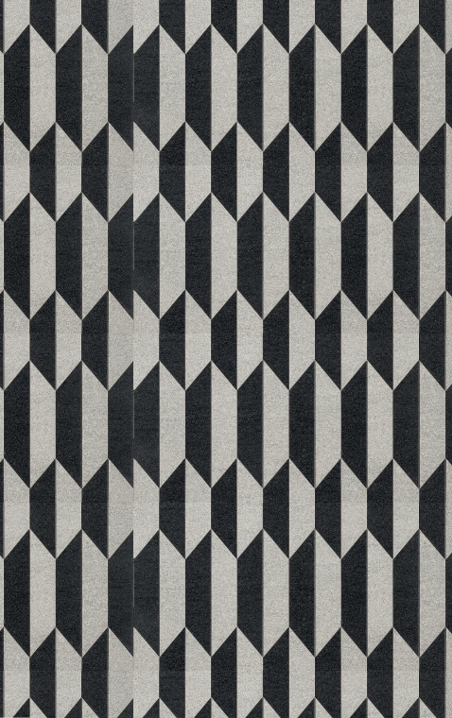
Screenshot 1 — a seam stripe where a material repeats (G-25)
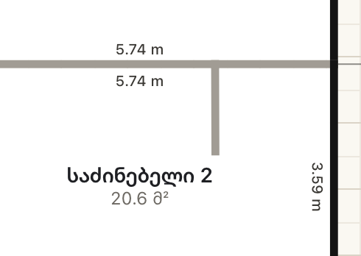
Screenshot 2 — an interior wall without its length (P-1)
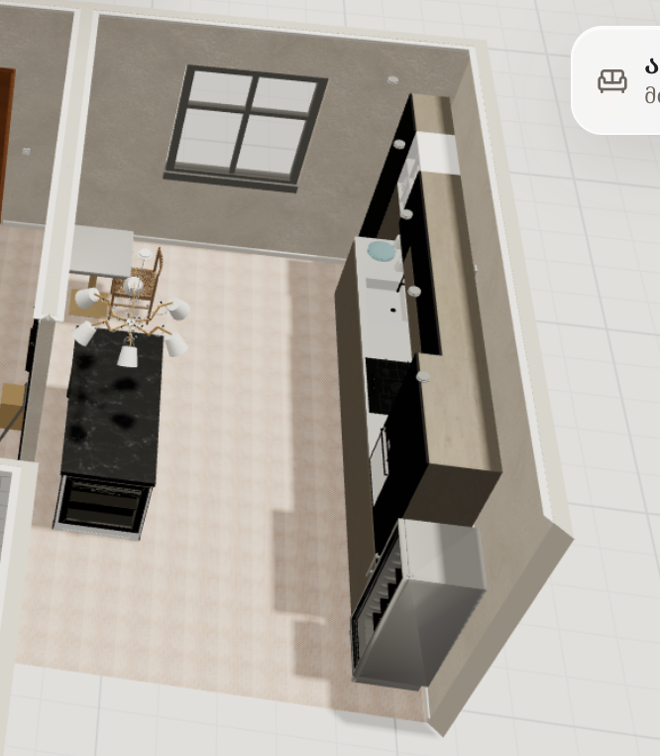
Screenshot 3 — extra hob and oven; small table in a large kitchen (K-8, K-10)
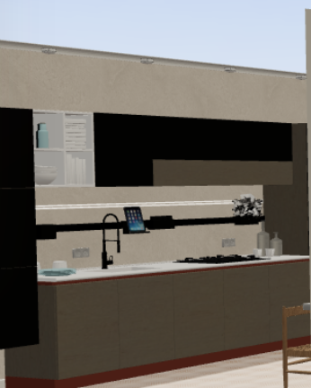
Screenshot 4 — the LED strip showing under the wall cabinets (K-14)
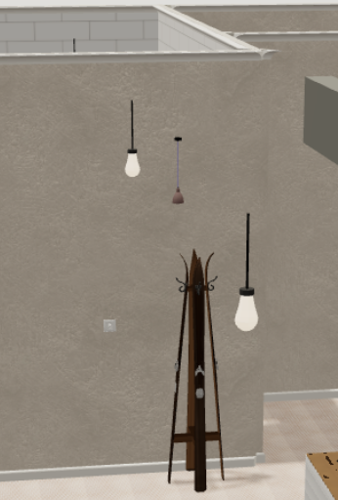
Screenshot 5 — mixed main lights in the entrance (G-9, E-12)
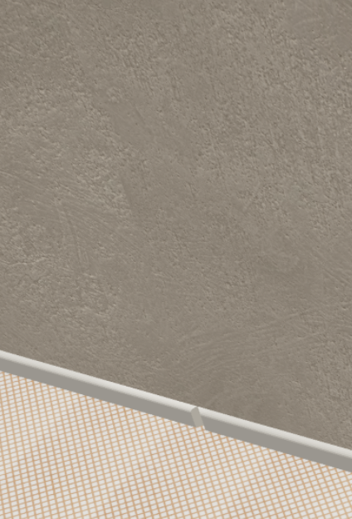
Screenshot 6 — cornice broken where two rooms meet (G-24)
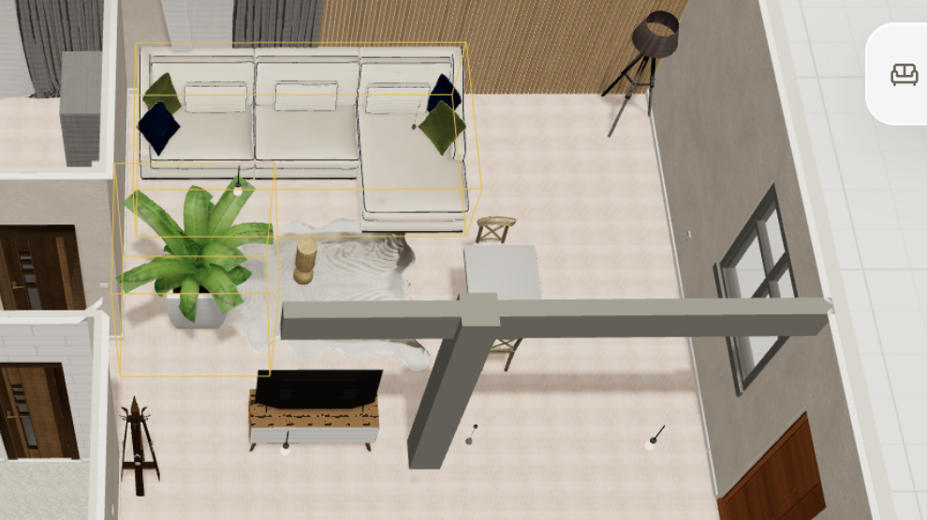
Screenshot 7 — the living room: TV in sight of the entrance, small table, unused space (L-5…L-11)
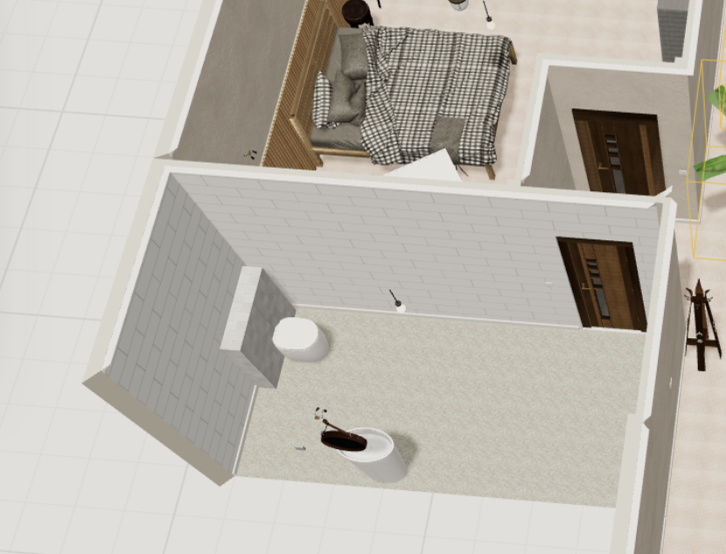
Screenshot 8 — the bathroom: no shower, big unused area by the door, one light (BA-5…BA-21)

