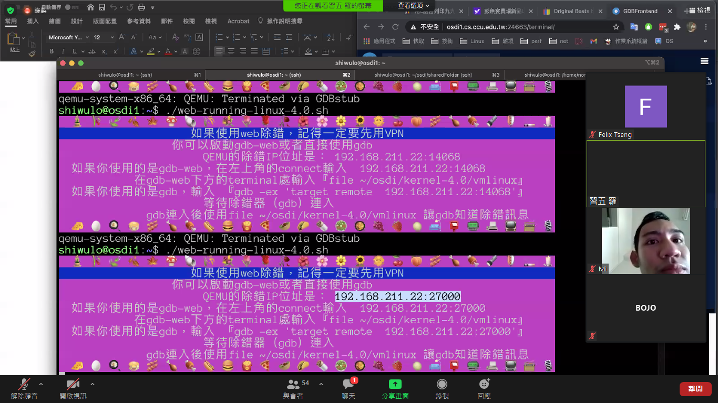

File vmkernel-4.0

(b start)

b 550(trap)

c

s

b divide_error

b system_call

b int3

c

ni

d (取消所有b)



