**系統程式設計**

**Lab4 File Attributes**

**學號: 407210013**

**姓名: 曾峻麒**

1. **How do you modify fig4_22.c?**

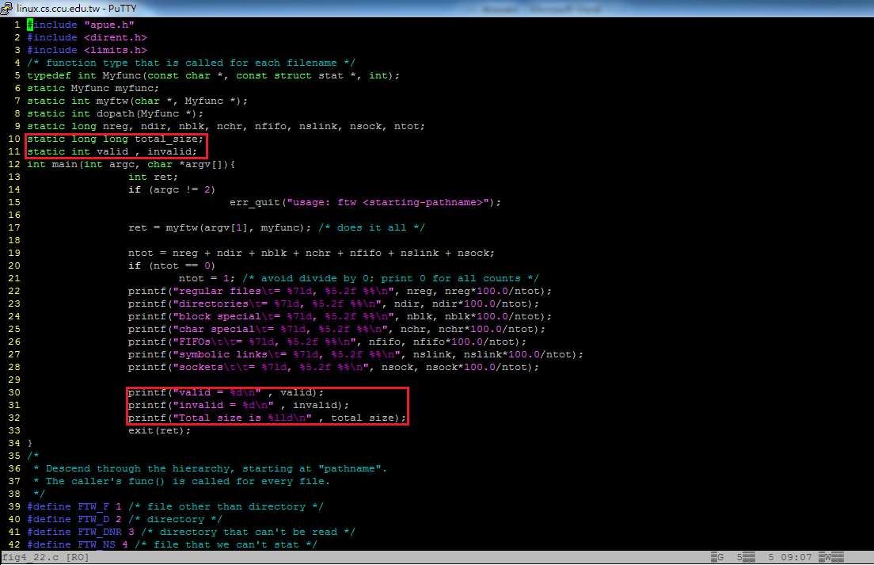

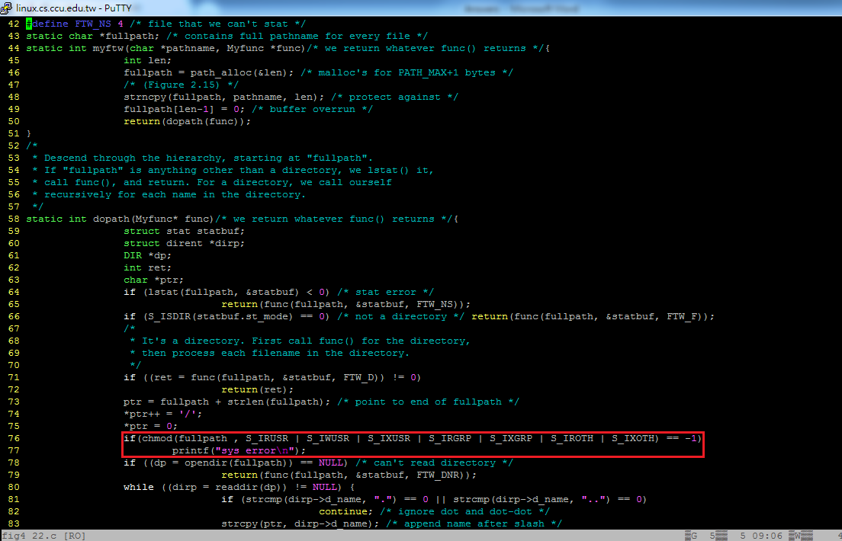

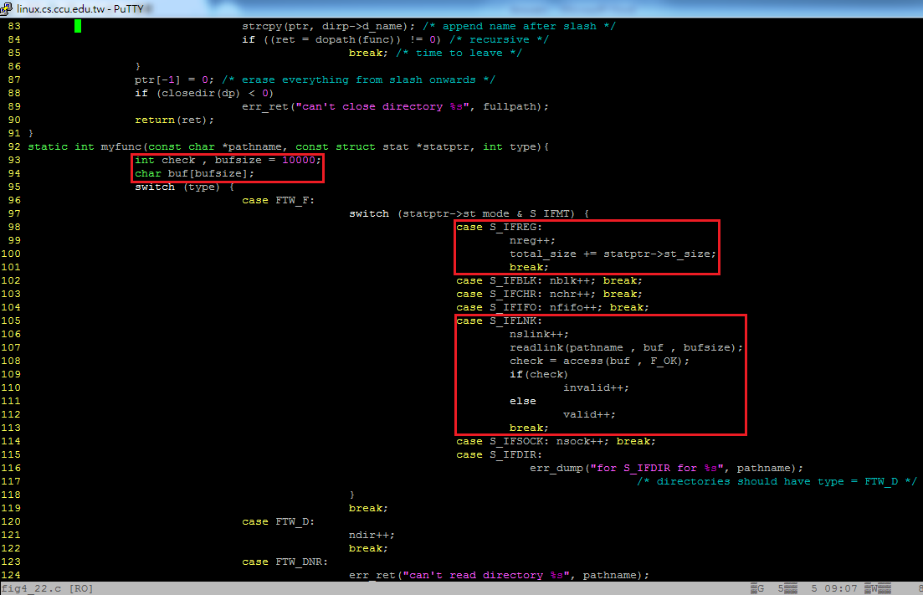

1. **The count of the various types of files?**

**Ex: File type = Count, Percentage**

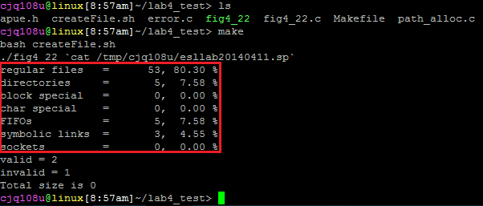

1. **The count of total files size?**

**Ex: Total size = Size**

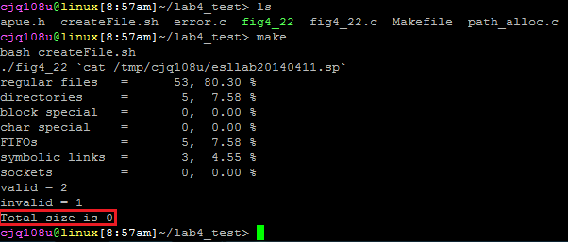

1. **(Bonus) The count of valid and invalid link?**

**Ex:**

**Valid link = Count**

**Invalid link = Count**

