**系統程式設計**

**Lab5 Stdio Compare**

**學號:407210013**

**姓名:曾峻麒**

1. **Where is the counter you add?   
   (請註明在程式碼的第幾行，最好加上截圖)**

**Fig5_4.c: (第7、9行)**

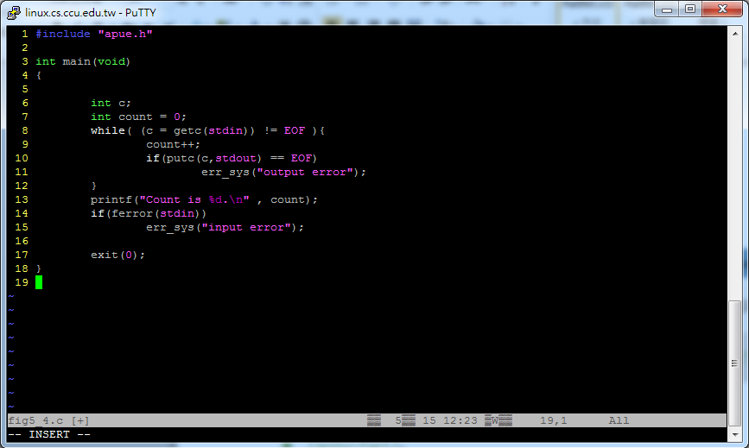

**Fig5_5.c: (第6、9行)**

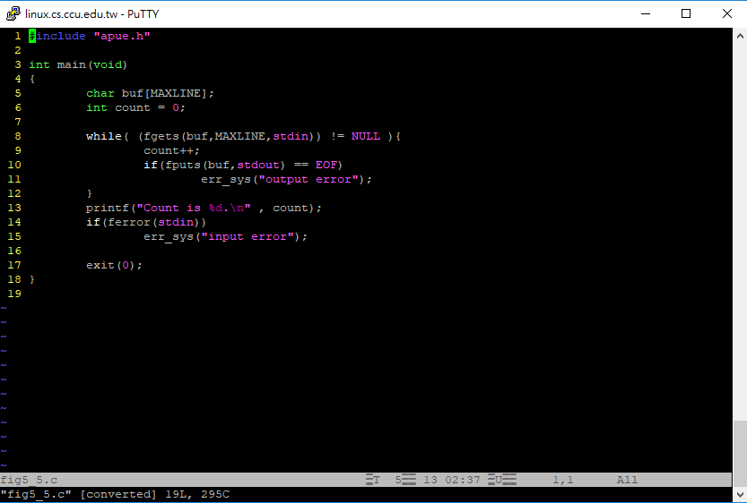

1. **Screen shot for Table1  
   (提供每個執行後的截圖，並說明每張截圖是屬於哪種function)**

**Fig5_4.c: (getc , putc)**

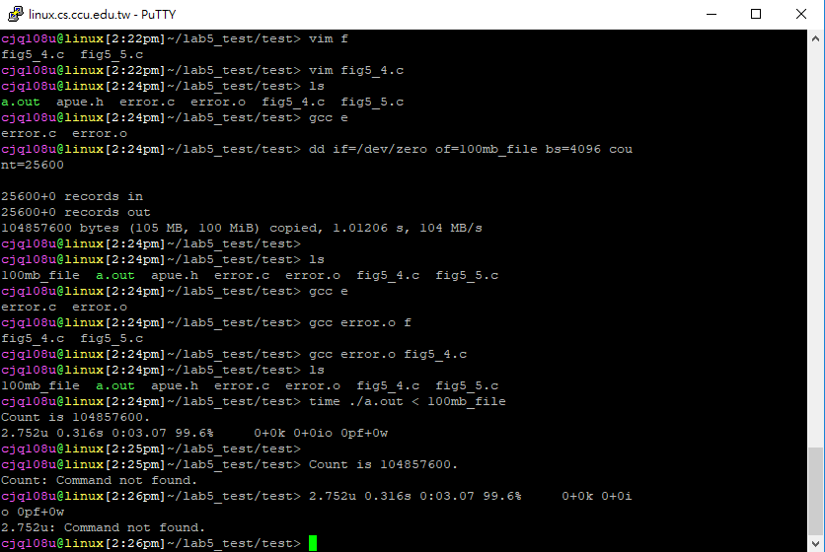

**Fig5_5.c: (fgets , fputs)**

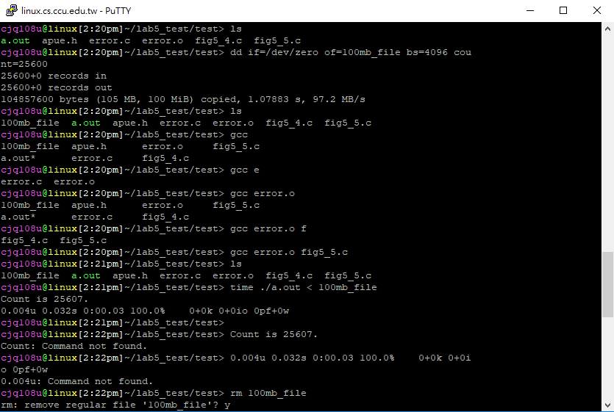

1. **Screen shot for Table2  
   (提供每個執行後的截圖，並說明每張截圖是屬於哪種mode)**

**Fully buffered: ( _IOFBF )**

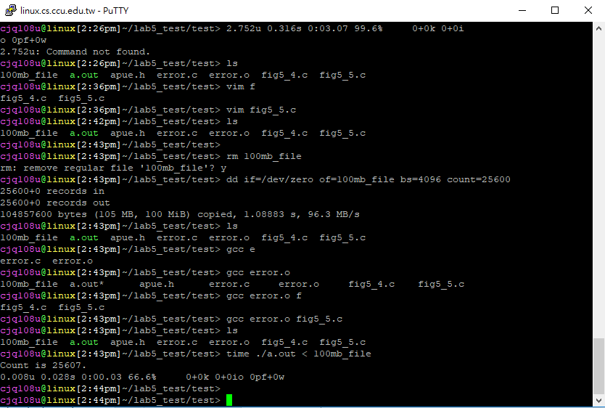

**Line buffered: ( _IOLBF )**

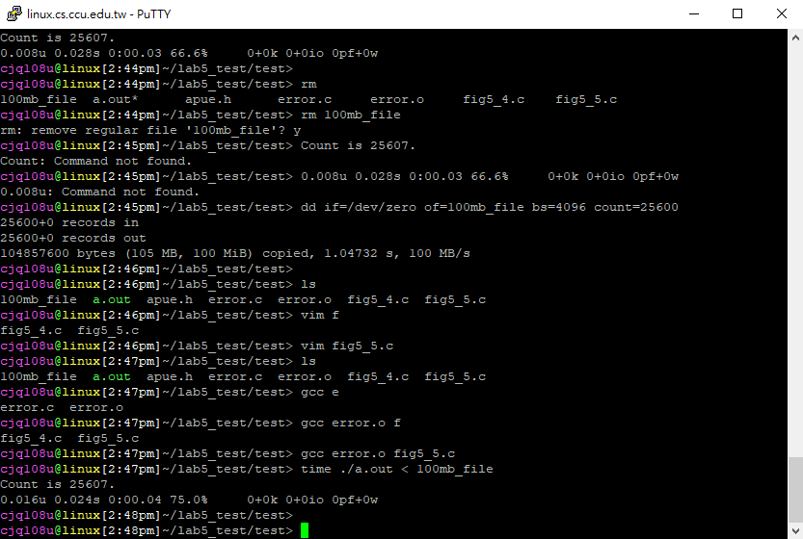

**Unbuffered: ( _IONBF )**

