**系統程式設計**

**Lab8 Race condition**

**學號 : 407210013**

**姓名 : 曾峻麒**

1. **How did you implement the processes?**

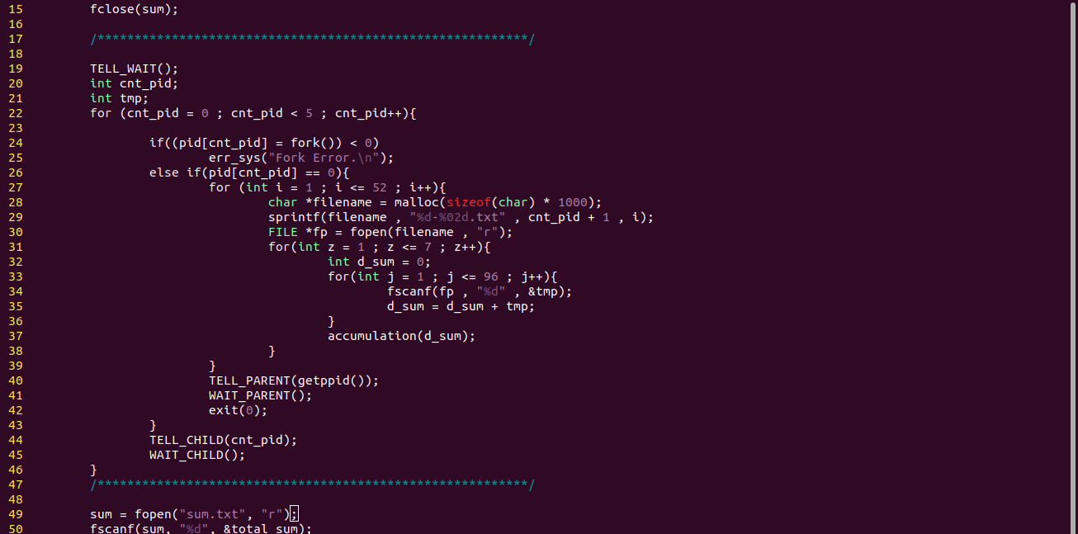**第一步驟：先用malloc開一個動態配置的空間存取各txt檔的檔名 , 再分別讀取 , 將檔案裡一週的96筆以及一週共有七天的數值去做相加 , 寫入到sum.txt檔。**

**第二步驟：設置cnt_pid，透過TELL_PARENT(gettpid()) , WAIT_PARENT() , TELL_CHILD(cnt_pid) , TELL_CHILD()函式產生五個子父程序，相互等待計算，再印出最終sum之結果。**

1. **How did you update the file "sum.txt**

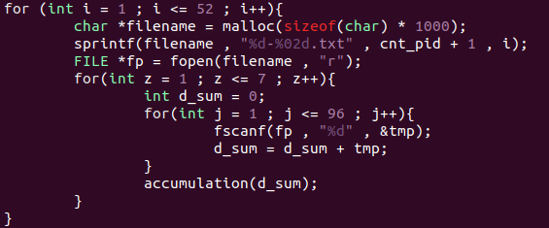 **方法：透過fopen , 去讀取各檔名下的txt檔 , 做完運算之後 將結果存到d_sum , 並呼叫accumulation（d_sum）函式將 此值寫進sum.txt , 重複此步驟直到所有子父程序皆運行完 畢。**

1. **How did you solve the race condition?  
   運用TELL_PARENT(gettpid()) , WAIT_PARENT() , TELL_CHILD(cnt_pid) , TELL_CHILD()函式產生五個子父程序，他們會計算並相互等待。**
2. **What is the average daily power consumption over the 5 years? (daily means for one day)  
   Please attach screenshot !**

