**Chan Dat Thai**

**COSC 4328 Programming Assignment 2**

**Time: 12 hours**

1. **PART 1**
2. **PART 2**

My card is an NVIDIA GTX-950M and it can run OpenGL 4.4

1. **PART 3**

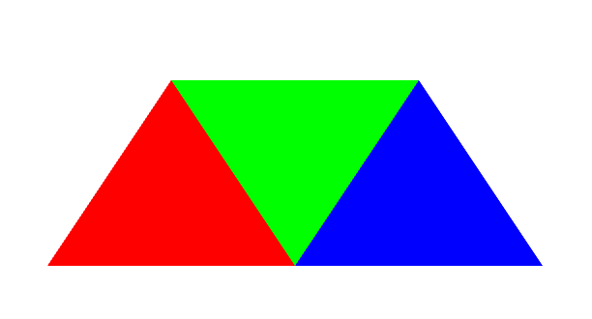

Figure

Here is my initial triangles, and I used the tutorial from opengl-tutorial.org (the first link in sources) and also part A in assignment 3.

1. **PART 4**

For extra credit, I also implement these things:

* Add more triangles (as in Figure 1)
* When the mouse cursor is clicked within any triangle, colors of each vertices in that triangle will be changed randomly. This includes:
  + - Mouse interaction using GLFW
    - Varying color (as in Figure 2)
    - Color is changed dynamically based on interaction

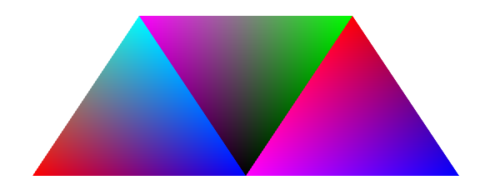

Figure

1. **DISCUSSION**

Some problems I ran into:

1. LNK2019, LNK1112: linker problem with glewInit. This was due to the incompatibility of the library version (x64) with target machine type (x86). Now I’m using x86 library.
2. Illegal character when reading shader source (problem with line ending). I changed from Windows-style to Unix and everything works fine.
3. Weird result when drawing with glDrawArrays. It turned out that I passed wrong number of vertices, couldn’t realize this until I switched the background color to white.
4. Problem with loading dlls (last link in sources)
5. **SOURCES**

* <http://www.opengl-tutorial.org/beginners-tutorials/tutorial-2-the-first-triangle/>
* <https://www.glfw.org/docs/latest/input_guide.html#input_mouse> (GLFW mouse callback)
* <https://stackoverflow.com/questions/2049582/how-to-determine-if-a-point-is-in-a-2d-triangle> (determine if a point is in triangle)
* <https://stackoverflow.com/questions/949959/why-do-64-bit-dlls-go-to-system32-and-32-bit-dlls-to-syswow64-on-64-bit-windows> (problem with dll)