**MULTI-BRANCH VETERINARY CLINIC MANAGEMENT SYSTEM**

A CAPSTONE PROJECT

Presented to the Faculty of the

College of Information Technology

Tagoloan Community College

Tagoloan Misamis Oriental

In Partial Fulfillment

Of the Requirements of the Degree

Bachelor of Science in Information Technology

By

CABACTULAN, KAREL

CANDELANSA, MECHELLE

CANTERO, HUMPREY

OBSIOMA, IRISH MAY

PELAGO, RICA MAE

PREQUENCIA, JANE (New Member)

MAY 2025

**TABLE OF CONTENTS**

**Page**

**TITLE PAGE** 1

**TABLE OF CONTENTS** 2

**CHAPTER**

1. **THE PROBLEM**

Background of the Study 4

Purpose of the Study 8

Conceptual Framework 9

Objectives of the Study 10

Scope and Limitation 11

Definition of Terms 13

1. **REVIEW OF RELATED LITERATURE**

Comparative Review of Related Studies 18

Synthesis 23

1. **RESEARCH METHODOLOGY**

Research Methodology 25

Requirements 26

Design 26

Development 28

Testing 32

Deployment 34

Review 35

**REFERENCES**

Journal 37

Academic Repositories 38

Websites 39

**APPENDICES**

Received Letter of the Client 42

Interview Guide Questions43

Paper forms / reports from Client44

**Chapter 1**

**BACKGROUND OF THE STUDY**

# Project Context

Nowadays, with the advancement in the world of technology, such as the internet, wireless network, communication technology, many business parties have incorporated these technologies in their daily business operation, as they believed that the advancement of technology will surely bring good if they can appropriately have incorporated them into business. Veterinary clinics are no exception, as modern technology offers significant improvements and customer service.

One of those high technology is web-based systems, it was essential for modern businesses to remain competitive and to reach their target client. It enables veterinary clinics to create customized software solutions that simplify the processes. Web-based system offered users a userfriendly interface, where they can access from any devices with an internet connection (Jain, V., 2024). It will helped manage their records, allowing easy access storage retrieval.

Scheduling appointments was also be integrated into a web-based system making it easier to manage appointments as well as the services such as grooming, vaccinations, deworming, surgery, treatment, confinement, consultation, and home for pets. It can also enhanced sales and inventory processes which enable veterinary clinics to track and manage their product sales, monitor stock levels, as well as generate reports for their inventory management (Larkin, M., & Lefebvre, S. 2023).

However, despite these advancements, veterinary clinics still rely on manual operations for managing their daily transactions, which can lead to inefficiencies in record-keeping, inventory tracking, and appointments. The absence of an efficient system in veterinary clinics often results in poor management of patient records, scheduling conflicts, and ineffective resource utilization.

(Mustafa, H., Salih, J., Mustafa, Y., Hamad, Y., Supervised, A., Lect, A., Chiman, H., & Salih., 2023).

The implementation of a multi-branch veterinary clinic management system addresses a range of responsibilities that ensure smooth operations and pet care. By developing a web-based system, it can enhance the daily task, such as appointments schedules, pet record management, referral management, inventory, billing and multi-branch access. This approach benefits the veterinary clinic and improves the overall experience for customers (Leong, V. K., 2023).

The study was conducted at a veterinary clinic located in Bulua, and Elsalvador, Misamis Oriental. It has ten staff members across its branches, each employee fulfilling various roles, including administrative tasks and veterinary services. Through interviews and observations, the veterinary clinic's existing operations and challenges were assessed. This veterinary clinic was chosen as the study site due to its growing operational needs and evident limitations in its current manual operation.

As the clinic expanded, a digital solution becomes crucial to support its increasing workload, reduce errors, and provide better service to pet owners. The implementation of the proposed system in this clinic made the tasks easier and faster. Veterinary clinic faces several operational challenges due to its reliance on manual record-keeping, such as tracking inventory and sales, accessing and retrieving pet records using spreadsheets which is time consuming, it might loss of records, as well as limited capacity to handle large amounts of data, causing inconsistencies in pet and customer information (Sunbase, 2024).

The clinic performs inventory checks every day, where they manually count all their products. If a discrepancy is found between the actual count and the recorded inventory, they manually subtract the missing items from their records, which is both time-consuming and prone to errors. Additionally, many pet owners prefer to continue with their pet’s previous doctor, even if that doctor has been reassigned to a different branch.

Often results in clients visiting other branches, in such cases, retrieving the pet's medical records takes a long time especially during referrals between branches. The entire file must be sent to the specific doctor, who then manually searches for the pet's records, leading to delays in retrieving pet records due to the lack of a centralized system. Pet records are stored in spreadsheets and must be manually located and shared between branches, significantly slowing down the referral process.

Each pet’s history is recorded by consultation date rather than in a single file, making it difficult to track ongoing medical issues. As a result, staff often spend extra time searching for information. Moreover, due to the time-consuming nature of these manual processes, the clinic owner sometimes forgets to record important information during busy periods, further impacting the accuracy and completeness of pet records.

For follow-up appointments, pet owners sometimes fail to visit the clinic due to forgetting their appointment or not being properly informed. As a result, no appointments happened. The clinic does not offer online booking due to pet owners may arrive late or require extended consultation times especially in the presence of walk-in clients where it becomes difficult to determine who should be attended first, leading to scheduling conflicts.

The limited coordination between branches makes it difficult to access pet records across other branches, resulting in delays in referrals and consultations. These challenges really impact on the overall operation of a veterinary clinic and hinder the clinic’s ability to expand its services.

The proposed system served as a centralized platform for managing clinical operations across multiple branches as well as providing detailed records that are easy to retrieve and will minimize all paperwork and manual record keeping. It facilitated the smooth referral of pet cases between branches. This allowed the clinic to keeping track of pet records and increasing the number of customers to serve. Furthermore, it incorporated SMS alert functions enabling clinics to send timely customer notifications for follow up appointment schedules (Sinch, 2025).

The proposed system was developed using Visual Studio Code for text editor, Laravel as the backend framework and MySQL for database management, with a centralized database to ensure seamless data access across all branches. TailwindCSS or the frontend design, provides a modern, flexible, responsive, and user-friendly interface. It also used HTML, and JavaScript languages as well as SMS API to handle notifications, keeping pet owners to get updated with their follow up appointments.

These tools provide fast and scalable architecture, ensuring data integrity and security. The system’s contribution eliminated redundancy and errors in record-keeping, automates the manual processes, SMS notifications for updates, enable data sharing between branches through a centralized database, it was designed to support future expansion for additional branches. Integrating these technologies, the proposed system enhanced clinic performance, administrative tasks, and improve its overall services.

# PURPOSE AND DESCRIPTION

Veterinary clinics with multiple branches often face administrative inefficiencies due to manual record-keeping, inconsistent medical histories, scheduling conflicts, and poor inventory management. These challenges result in delays, long waiting times, and potential risks to pet health. As clinics expanded, adopting a centralized digital solution is essential to improved operations and service quality.

The proposed system enhanced medical record management, follow up appointment scheduling, and sales and inventory tracking. Automates the veterinarians access to pet records, manage referrals and consultations between branches (Webcode Genie, 2024). The proposed system allowed only authorized personnels to set follow-up appointments.

Pet owners received SMS notifications for appointment reminders, medication schedules, and vaccinations, eliminating the need for manual follow-ups (AmeriVet, 2023). A centralized database ensured accurate and accessible pet history across all branches (Pawtrack, 2024). Additionally, inventory tracking notify staff when supplies are low, preventing shortages of essential veterinary products (Pokar, H., 2023).

The proposed system provided significant benefits to various stakeholders in the veterinary clinics and reduced administrative workload, improved record management, and better coordination between branches. Personnels benefited from easy access to medical records, follow up appointment scheduling, and improved inter-branch communication (Ahmad, M. S., & Salamat, M. A., 2023).

Pet owners received SMS notifications, keeping them informed about their pet’s follow up appointments, while pets received better care due to accurate records and organize workflows.

Additionally, veterinary clinic owners would have access to multi-branch operations and daily transactions. By integrating modern technology, it optimized administrative processes, reduced errors, and enhanced overall service quality, ensuring a more efficient multi-branch veterinary service. (Grosman-Rimon, L., Li, D. H. Y., Collins, B. E., & Wegier, P., 2023).

# CONCEPTUAL FRAMEWORK

The proposed system was designed based on the Input-Process-Output (IPO) model, providing a structured approach to managing veterinary clinic operations. This model helped define the essential inputs, processes, and expected outputs, ensuring a clear flow of data and organized system functionality. The system was expected to include storage capabilities within the processing phase, allowing data management and retrieval.

The input phase consists of collected data and materials necessary for system operations. The processing phase involves tasks required to transform these inputs into the desired results. The output phase delivers processed data and reports generated by the system.

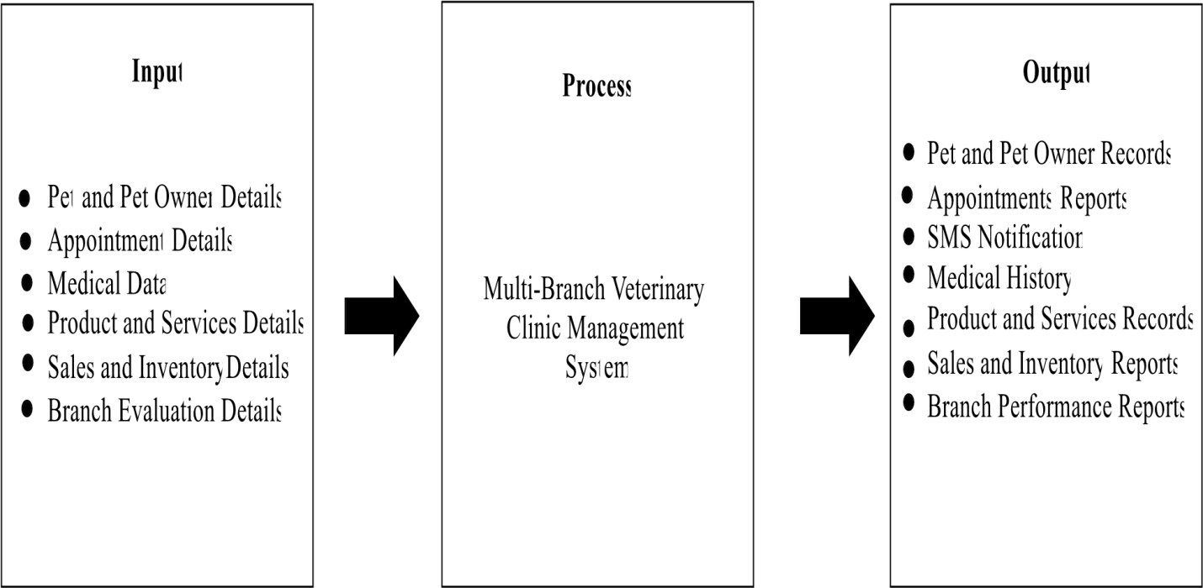

# Figure 1.0 Conceptual Framework of the Study

The input phase collecting essential data such as pet and pet owner details, appointment details, medical data, product and services details, sales and inventory details, and branch evaluation details. These inputs served as the foundation for handling veterinary clinic operations across multiple locations. The process phase focused on the development of a Multi-Branch Veterinary Clinic Management System, which facilitating the management of customer and patient records, appointment scheduling, SMS notifications, and branch data syncing.

Additionally, the system includes features for updating pet medical records and transactions to ensure organized operations across all branches. The output phase generated organized pet and pet owner records, medical history reports, appointment records, SMS notifications, product and services reports, sales and inventory reports, as well as branch performances reports. These outputs contributed to improved record management, timely notifications, and provided a well-organized veterinary clinic.

# OBJECTIVES OF THE STUDY

The general objective of the study was to create and develop a management system that provides precise and secure record-keeping, implementing multi-branches access to its multiple branches as well as the upcoming branches. The proposed system specifically aimed to:

1. To develop a web-based system that enhances branch management, allowing the super admin to easily manage multiple branches
2. To design a centralized database system that ensures secure and organize storage of patient records, inventory, and appointments across all branches.
3. To implement and develop a system within the veterinary clinic to replace manual processes and enhance operational efficiency.
4. To evaluate the system’s functionality to ensure the system functions as expected.
5. To evaluate the usability and effectiveness of the system thought client and staff feedback using the System Usability Scale (SUS).
6. To assess the system’s performance evaluating speed, reliability, and scalability as new branches are added.
7. To integrate an SMS alert functionality that sends timely notifications to pet owners regarding appointments and reminders.

# SCOPE & LIMITATIONS

The proposed system aimed to enhance veterinary clinic operations by improving patient record management, appointment, and inventory tracking across multiple branches. It centralized medical history for easy access, offering a dashboard for scheduling and supply monitoring. The system supported multiple user roles, including Super Admin, receptionist, and veterinarians, allowing structured control over clinic operations.

Features like SMS notification, branch data syncing to ensure all locations stay updated with pet and owner records, and referral records, as well as inventory tracking will help make operations smoother and improve service quality. Despite its benefits, the system had certain limitations. It required an internet connection, as offline functionality is not supported. Automated diagnoses and direct integration with third-party laboratories are not available, requiring manual input of lab results.

Pet owners don’t have any interaction with the system. SMS notifications used fixed templates with limited customization. The system is accessible only via a web browser, with no mobile app available, and does not support for online payments. Additionally, Only the Bulua and El Salvador branches were fully supported by the proposed system with potential expansion to other locations in the future.

# DEFINITION OF TERMS

* Tailwind CSS – A utility-first CSS framework that provides ready-to-use classes for fast and responsive web design without writing much custom CSS. In this study, it helps create a clean and user-friendly interface for the veterinary clinic system, making it easy for staff to navigate and manage tasks efficiently.
* Centralized Platform – It is a system architecture where all data and functionalities are managed in a single, unified database accessible to all branches. In this study, it is a unified system that manages data and operations across multiple veterinary branches from a single database, ensuring efficiency and consistency.
* Cloud-Based System – Refers to a software system hosted on remote servers, providing on-demand access via the internet without requiring local installations. In this study, it allows veterinary clinics to access patient records, appointments, and inventory data securely from any location, ensuring seamless multi-branch operations.
* Customization – Refers to a process of making minor modifications to a system while maintaining its core structure, allowing limited adjustments within a fixed template. In this study, it applies to minor changes in the SMS template, enabling veterinary clinics to adjust specific details like names, dates, or messages while keeping the overall format intact.
* Computerized System – A digital system that automates data processing, storage, and management using software and databases, minimizing errors and improving efficiency. In this study, it streamlines appointment scheduling, patient record management, billing, and inventory tracking, ensuring accuracy and real-time coordination across branches.

Dashboard – A visual interface that displays key data and system metrics using charts, tables, and widgets, providing real-time insights and quick access to important functions. In this study, it helps veterinary staff monitor appointments, patient records, inventory levels, and clinic performance briefly, improving decision-making and efficiency.

* Data Syncing – It refers to the process of updating and maintaining consistent data across multiple locations in real-time using cloud databases or APIs. In this study, it ensures that patient records, inventory, and appointments are updated across all veterinary branches, preventing discrepancies and ensuring accuracy.
* Frontend – refers to visible part of a website or application that users interact with, It handles UI/UX design, responsiveness, and user interactions while communicating with the backend. In this study, it provides a user-friendly interface for staff to manage appointments, patient records, and inventory, ensuring seamless experience.
* High Technology – It refers to the latest and most advanced technological developments, especially in computing. In this study, it enhances veterinary clinic efficiency by automating processes, improving service delivery, and optimizing decision-making for better patient care.
* HTML – It is a markup language used for structuring and displaying content on web pages. In this study, it defines the layout and elements of the veterinary clinic management system, ensuring proper organization and readability of information across multiple branches.
* Interface – It refers to the visual layout and interactive elements that allow users to navigate and interact with a system. In this study, it provides veterinary staff with an organized and user-friendly platform to manage appointments, patient records, and inventory efficiently.

Laravel – It is an open-source PHP framework designed for building web applications with elegant syntax and robust features. In this study, it provides a secure and scalable structure for developing the veterinary clinic management system, ensuring efficient data handling and smooth system operations.

* MySQL – It is an open-source relational database management system (RDBMS) used for storing and managing structured data efficiently. In this study, it stores patient records, appointments, billing details, and inventory data, ensuring fast and reliable access across multiple veterinary branches.
* SMS API – It refers to an application programming interface (API) that allows software systems to send and receive SMS messages programmatically. In this study, it automates appointment reminders, medication alerts, and important notifications for pet owners, improving communication and reducing missed visits.
* Super Admin – It refers to a system role with the highest level of access, capable of managing system configurations, user roles, and branch-wide settings. In this study, it oversees multiple branches, monitors staff activities, and ensures the smooth operation of the multi-branch veterinary clinic management system.
* System Usability Scale (SUS) – A standardized 10-item questionnaire used to measure the usability of a system, scoring from 0 to 100, with higher scores indicating better user experience. In this study, SUS evaluates how easily veterinary staff can navigate and use the platform, helping improve efficiency in appointment scheduling, record management, and multi-branch operations.

Third-Party – It refers to external services or software that are integrated into a system to provide additional functionality. In this study, it specifically refers to the SMS service provider used to send automated appointment reminders and notifications to pet owners.

* Visual Studio Code – It is a lightweight, open-source code editor offering features like debugging, syntax highlighting, and extensions for various programming languages. In this study, it serves as the primary tool for developing and maintaining the veterinary clinic management system, ensuring efficient coding and system development.
* Web-Based System – It refers to software that operates over the internet, accessible through a web browser. In this study, it enables veterinary clinics to manage appointments, records, and reports remotely, ensuring seamless operations across multiple branches.
* Wireless Network – Refers to a communication system that transmits data over radio waves instead of physical cables, enabling devices to connect to the internet or other networks wirelessly. In this study, it allows staff to access patient records, appointments, and inventory on connected devices.

**Chapter 2**

# REVIEW OF RELATED WORKS

This chapter presents a comparative analysis of related studies for both local and foreign studies focusing on the development of technological solutions for pet care services and veterinary clinic management. Some of these studies were originally written in different languages and were analyzed as related literature after being translated into English using Google Translate for better understanding.

It helped the researchers to understand how the past systems were made, what tools and methods were used and what features they had. The studies are grouped based on their methodology, system features, and tools/technology approach to allow a more structured evaluation. Each group is analyzed in terms of similarities and differences among the systems. A synthesis was also be provided at the end to connect these insights to the proposed system.

This review supports the study by showing what is already done and what needs to be improved, helping the researchers to make a more useful system. The reviewed studies revolve around digital platforms to improve veterinary services. Utilizing various types of technology to support each major functionality, reflecting a preference for full-stack web and mobile development.

These tools were chosen for their flexibility, scalability, and capability to support real-time data handling. Common development methodologies were used to facilitate the system development, and user feedback. The technologies being used were proven effective in research systems as well as in enhancing operational efficiency. However, challenges like real-time data synchronization and system scalability issues persist.

# Comparative Review of Related Studies

Pet Care Management System by Yeow Jing and Hazalila (2023) and Model View

Controller Method for Animal Care (Petcare) Information System at Niz Petcare Lawang by Mukhlis et al. (2023) both adopted a prototyping model, emphasizing iterative development based on continuous user feedback. Yeow Jing and Hazalila used Entity Relationship Diagrams (ERDs) and Data Flow Diagrams (DFDs) to design a PHP-MySQL system that supported login/logout, user registration, service management, and reservations.

They noted that “the system aims to systematically process reservations and use the database for data storage” (p. 1). Similarly, Mukhlis et al. (2023) used the CodeIgniter 4.0 PHP framework and MVC architecture to create a structured application with features like notifications and data management, they stated that “this framework adopts Model, View and Controller including being faster and easier” (p. 108).

Both studies used User Acceptance Testing (UAT), but they extended their evaluation by including Usability Testing based on ISO/IEC 9126 standards and Functional testing using BlackBox. While both systems demonstrated functional success, limitations were acknowledged such as Yeow Jing and Hazalila (2023) mention of needed enhancements like notification features, and Mukhlis et al. (2023) focus on improving user convenience through better interface design.

On the other hand, Vet Assistant, an online clinic management system by Varca (2021) used a RAD model to developed Vet Assistant, an integrated clinic management system. This model facilitated rapid development and delivery while incorporating features like SMS appointment reminders, inventory tracking, and report generation. The system was evaluated using McCall’s software quality criteria and stated that “the system was of good quality” (p. 3) and stated that “the system has provided the aid of managing the business in an automated approach” (p. 5).

Compared to prototyping studies, which prioritized iterative design refinement. Varca (2021) system focused on quick deployment with broader automation capabilities. However, the study lacked details on user feedback mechanisms or limitations in usability, suggesting a potential trade-off between speed and long-term user adaptation. In contrast, Android mobile Application System for Pet Care by Putri et al. (2023) followed the Waterfall model, applying a structured phase-by-phase development process.

Their Android-based system used MVVM (Model-View-View-Model) architecture and combined technologies such as Kotlin, Python, HTML, CSS, JavaScript, and Django. The application supported veterinary services, grooming, pet hotel bookings, and user account management. Their objective was to “increase customer satisfaction and attract new customers with exclusive offers available only through the application” (p. 2).

While the Waterfall model allowed for comprehensive planning and execution, it lacks the flexibility found in prototyping and RAD. As a result, system feedback and adaptability were less emphasized, and the study does not mention post-deployment testing like UAT, which limits insights into actual user experience. While The Development of Veterinary Clinic Management System Using Structured Approach by Nurnajlaa and Nur Ariffin (2021) adopted an iterative model with a structured system design to tackle issues such as lost or duplicated customer data common in traditional paper-based systems.

Their PHP-based system allowed online booking and digital record management. They stated that “the main problems are most of the veterinary clinic are still using the traditional paperbased management system” (p. 9), and claimed their system effectively addressed this. Despite using an iterative method, the study emphasized system structure over user-centered adaptability. Unlike the prototyping and RAD models, this approach focused more on eliminating legacy system flaws rather than innovating with new features. They did recognize limitations, suggesting improvements such as a booking calendar and notification reminders features which already present in the systems developed by Varca (2021) and Mukhlis et al. (2023).

These five studies aimed to improve pet care and clinic management by digitizing tasks like booking, user management, and notifications. They use different methods and technologies but share the goal of making operations more efficient. However, limitations such as basic interfaces, lack of advanced features like calendars or reminders, and system scalability were noted, highlighting areas for future improvement.

Implementation of a Pet Care Management System by Gunaratne et al. (2022) and Dogs Health Care Management System by Balasooriya et al. (2022) both utilized the MERN stack (MongoDB, ExpressJS, ReactJS, NodeJS), yet their implementations differ in scope and integration. Gunaratne et al. focused on a feature such as pet activity management, in-app product purchases, and admin monitoring, highlighting that their system “allows users to browse through a catalog of such items and purchase them within the application itself” (p. 157).

In contrast, Balasooriya et al. they expanded beyond pet care to include dog adoption services and include additional tools like Bootstrap for frontend styling, RabbitMQ for messaging, and AWS for hosting. They stated that “this system mainly provides efficient service to dog owners, veterinaries, animal pharmaceuticals, and animals” (p. 1), and that “The dog adoption management part mainly focuses on connecting with dog requesters and rehoming rescued puppies” (p. 5). De Guzman et al. (2021), they developed a VetConnect, an e-commerce portal for veterinary services during the pandemic.

Unlike the other two systems, they conducted situational analysis using flowcharts to analyze existing clinic workflows and emphasized convenience and cost-efficiency through online transactions, they stated that “using e-commerce for online buying and selling of products is very convenient since there is no need for physical interaction and it is also cost-efficient for both buyers and sellers” (p. 1).

Meanwhile, Gallaza, J., Mary J., and Niña Ethel (2024) introduced PetCare Plus with a strong focus on optimizing clinic operations through real-time chat and data analytics using agile method. Their system highlights the absence of capabilities related to inventory and billing features.

They also emphasized its benefits, as they stated that “This system is designed to enhance the workflow of the clinic, including managing patient records, scheduling appointments, managing staff schedules, and other administrative tasks” (p. 10), and “The Veterinary Doctor proclaimed that the proposed system is deemed beneficial and very promising for the Veterinarian Clinic” (p. 46).

This set of studies highlights the shift toward more integrated and digital pet care management systems, using modern technologies like MERN stack. Some systems not only offer core features like appointment scheduling and notifications but also expand into areas like ecommerce, dog adoption, and real-time communication. These innovations aimed to improve convenience, efficiency, and connectivity among users, veterinarians, and service providers.

However, limitations remained, such as the lack of features like inventory and billing in some systems, or reliance on future hardware integrations. Overall, while these systems enhanced clinic operations and user interaction, further development was needed to address current gaps and expand system capabilities.

Shivani et al. (2021) developed a Java-based web application using MongoDB, React.js, and Node.js. They aimed to enable pet owners to book appointments based on the doctors’ availability and specialization. They emphasized that “this web-based application effectively addresses the challenges of managing and booking appointments according to pet owners' preferences and needs” (p. 4).

Similarly, Design and Development of Website and Mobile-Based Veterinary Clinic Information System by Devi Yanti and Bonda Sisephaputra (2024) created a system with both website and mobile interfaces, using PHP with the Laravel framework and Dart with Flutter. Unlike Shivani et al., their solution placed additional emphasis on the transition from a manual to a digital system.

They emphasized that the previous manual recording system led to several challenges, including the difficulty of accessing or searching for data, and the risk of data loss if the paper is damaged or lost due to the lack of an organized appointment system, they stated that, "the system facilitates the running of the clinic by providing medical record recording and appointment arrangements" (p. 1).

In contrast, Veterinary Clinic Management System of Azhari (2020) focused specifically on replacing physical vaccination cards with electronic records through a mobile and web-based application, thereby streamlining data accessibility and enhancing user convenience. Their goal was to “bring more convenient and meet the users’ requirement” (p. 23), while Muhamad Dicky et al. (2025) took a broader approach, integrating user management, pet profiles, appointment scheduling, service listings, educational content, feedback, and notifications in a web-based system for Terrapeto Pet Care using the Laravel framework and MySQL database.

The system was informed by a detailed needs analysis involving interviews and observations, which highlighted that “the commonly used manual recording system was

inadequate for supporting the fast, accurate, and efficient service required by the clinic” (p. 1309). Their results demonstrated a quantifiable impact, stating that the system “succeeded in increasing work efficiency by up to 40% and reducing the error rate of manual recording by 20%” (p. 1308).

These studies demonstrated how digital systems are transforming veterinary clinic operations by improving appointment scheduling, record management, and overall service efficiency. Whether developed with Java and MERN stack, Laravel and Flutter, or other web technologies, the systems consistently address common issues found in manual processes such as data loss, slow access, and overcrowded queues.

While these systems significantly enhance user experience and clinical productivity, limitations still exist, including the exclusion of certain features like inventory tracking or broader integration across platforms, where continues development is necessary to create more comprehensive and adaptable solutions for modern veterinary care.

# Synthesis

The reviewed existing studies reveal several limitations, particularly in their ability to support multi-branch operations. The researchers identified that most studies like Gunaratne et al. (2022) and Yeow Jing & Hazalila (2023), didn’t mention any centralized control across branches. They often fall short in integrating essential features like patient records, appointment scheduling, and inventory tracking within a platform.

The proposed Multi-Branch Veterinary Clinic Management System addresses these limitations by offering a centralized solution that synchronizes data across all branches in real time. Unlike previous systems, it consolidates patient management, appointments, sales and inventory tracking, and SMS notifications into a single unified platform. Although it has some limitations like fixed

SMS templates it still represents a significant improvement in terms of automation and efficiency.

The proposed system was not a duplication of earlier works but rather, it combined their strengths while addressing critical gaps. It integrated appointment features from Shivani et al.

(2021) but limited only for follow-up appointments. Inventory functions from Balasooriya et al. (2022). Its relevance was underscored by the growing digital transformation in healthcare and the increasing number of multiple branch clinics.

Additionally, the various methodologies used in the related studies such as prototyping

(Yeow Jing & Hazalila, 2023), iterative development (Nurnajlaa & Nur Ariffin, 2021), and Rapid Application Development (Varca, 2021). Among these, Gallaza et al. (2024) adopted the Agile methodology, emphasizing collaboration, adaptability, and iterative delivery to enhance clinic operations through real-time chat and administrative tools.

Their approach demonstrated how Agile enables systems to evolve based on real-time feedback and stakeholder involvement. Inspired by this, the proposed system adopted the Agile methodology due to its flexibility, responsiveness to change, and ability to deliver working software incrementally. Agile was particularly suitable for systems like this, where evolving requirements, feature refinement, and user involvement are critical to success.

Unlike other models such as the traditional Waterfall, Agile promotes continuous collaboration with stakeholders ensuring that the system remains aligned with user needs throughout the development lifecycle. While Agile development could be demanding in terms of communication and coordination, its advantages in adaptability, faster feedback loops, and early delivery of functional modules make it ideal for this project.

This approach helped ensure that key features such as follow up scheduling, sales and inventory, pet and pet owner records which are validated quickly and adjusted based on actual user feedback.

**Chapter 3**

# RESEARCH METHODOLOGY

In this chapter, the researchers utilized the Agile Software Development Life Cycle (SDLC) methodology, ensuring that the system aligned with the requirements and addressed the specific needs of the Veterinary Clinic. The Agile model emphasized flexibility and responsiveness by incorporating iterative development and continuous feedback, allowed for adjustments based on evolving needs and testing outcomes. This adaptive approach facilitated early detection and resolution of issues, contributing to improved system quality. (Ahmad, Miza S. & Salamat, Mohamad A. 2024).

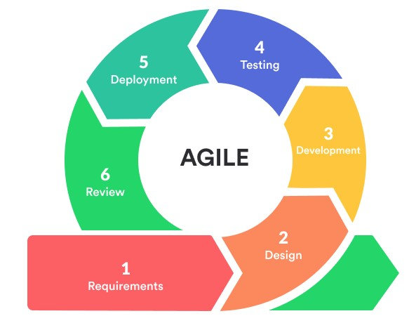

Figure 2.0 Agile Software Development Life Cycle (SDLC) methodology

Adopted from Pet Health Management system for Gebuu Veterinary Clinic

(Ahmad, Miza S. & Salamat, Mohamad A. 2024)

The SDLC phases in this study are as follows: requirements, design, development, testing, deployment and review, all conducted in iterative cycles to support continuous improvement and stakeholder involvement throughout the process.

# Requirements

In this phase, the researchers gathered all the data that helped the development of the

System. During this phase, all necessary requirements for the proposed system were documented. According to Gallaza et al. (2024) This phase involves detailed planning of the project, including brainstorming sessions conducted by the researchers.

A letter of intent was sent to the Veterinary clinic owner indicating their willingness to cooperate. The researchers also prepared twenty (20) guide questions for the Clinic’s Owner and these questions addressed a range of topics as the researchers aimed to gather significant insights into the challenges that they are facing by collecting information. It's important to interview the Clinic Owner to understand the main problems and the challenges they are facing.

The identified problems were discussed clearly to help ensure the proposed system is implemented smoothly. At this phase, the needs of the Veterinary Clinic become clearer that leads to a specific solution within a Veterinary Clinic. The output made in this phase is important because it establishes a strong foundation for the next phase of development.

# Design

In this phase, the researchers incorporated the agreed system requirements into visual and technological models that served as the foundation for future development of the proposed system.

A diagramming tool and modeling approaches were used to ensure a complete understanding of how the proposed system was design to its function. ClickCharts was used to create all the diagrams, including the wireframe for user interface design.

It is an ideal tool for presenting data and information in a meaningful and organized way (NCH Software, n.d.). Also, TechRadar highlights that ClickCharts is an inexpensive diagramming tool capable of producing flowcharts, wireframes, and more, making it suitable for teams needing basic functionality without a steep learning curve. Cawley, C. (2024).

ClickCharts was utilized to create process flow diagrams, as it is a user-friendly tool for creating clear and effective flowcharts (VamienMcKalin 2022), unlike others, this is a robust and user-friendly flowchart software that offers a comprehensive set of features for creating professional-looking diagrams (Technology Evaluation 2025), that provides valuable insights into the clinic’s operations.

The researchers was utilizing various types of diagrams commonly demonstrated in reviewed studies, including the Manual Process flow, it was created to illustrate how each operation within the veterinary clinic is carried out without a system. This process flow is created based on observations and interviews, and it served as a foundational reference for identifying inefficiencies and opportunities for system enhancement.

Logical Entity Relationship Diagram (LERD), it shows the database's structure by emphasizing key entities, attributes, and how they interact with one another. This diagram ensures a well-structured database design. At the same time, the Data Flow Diagram (DFD), ensures the movement of data throughout the system, showing how input turns into output through various processes, resulting in more accurate and efficient system concept design.

Yeow, J. R., & Kamaludin, H., (2023), used Logical Entity Relationship Diagram (LERD) to build a database system to store and manage data inserted by users into the system, while Data Flow Diagram (DFD) shows the information flow for each process or system. (p. 3). Use Case Diagram was utilized, as it emphasizes the system's several features through the perspective of the user, helping in defining the user roles and interactions.

Use case diagram was used in Neoh, Howe Yik (2024) to visually represent different ways that users can interact with the system. It also helps to illustrate the functional requirements of the system from a user’s perspective. (p. 24). And lastly, Physical database design helps transform the logical data model into an efficient structure for data storage and retrieval. It ensures data integrity, supports performance optimization, and aligns with system requirements. According to Coronel & Morris (2022), the physical design phase defines the storage structures, access methods, and relationships necessary for implementing the database effectively (p.15).

Each of these models have a vital role in determining the system architecture. All this information and visual representation is important because it establishes a strong foundation for the next phase of development, where actual system development and implementation planning took place.

# Development

In the development phase, the information collected from the previous phases was thoroughly used in this phase. The researchers performed the actual implementation of the system based on the data and design collected from the previous phases. This involves translating the design into a functional system using a Three-tier Architecture, consisting of the Presentation Layer, Application Layer, and Database Layer.

The specific tasks include front-end development, back-end development as well as database design and management. These tasks are crucial for building a responsive and secure system that meets the intended functionalities. The purpose of performing these activities is to ensure the proper implementation of the system features. Utilizing this three-tier allows for a modular development approach, where each layer can be independently developed and maintained. This structure is effective in managing complexity and promoting scalability. The proposed system was designed as a web-based platform, which allows user to access and manage clinic operations through a browser interface without the need for software installation on individual devices.

GeeksforGeeks, stated that the Three-tier Architecture is one of the most effective models in developing modern database-driven systems, which supports the implementation strategy of the researchers.



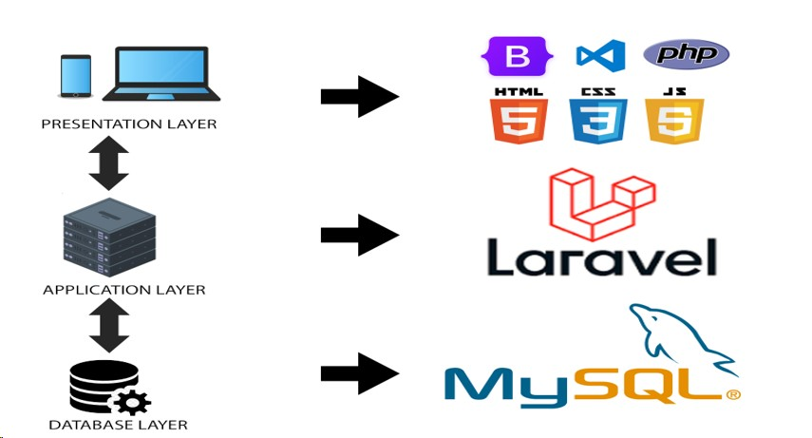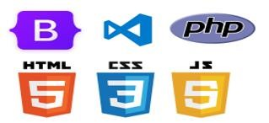

Figure

3

.

0

Three

-

Tier Architectural Design

The researchers were using various tools and technologies that are suitable to each layer of the system. For the Presentation Layer, front-end development was carried out using Visual Studio Code as the development environment. The researchers used VS Code to write, organize, and manage all the HTML, CSS, JavaScript, and TailwindCSS files for the user interface. The user interface had been structured with Hypertext Markup Language (HTML) for content structure, HTML was used to create the actual content of each page such as referral forms, pet registration forms, appointment lists, dashboards, and buttons.

Cascade Style sheet (CSS) for design customization, CSS was used to style pages with custom colors, spacing, fonts, and layout so each branch and user role has a professional and userfriendly experience. JavaScript for interactivity, used for features like interactive calendars for appointments, validation of forms (checking if referral fields are complete), dynamic dropdowns (selecting branches or pets), and page behavior. and Bootstrap for responsive design, helped design pages that adjust automatically to screen size especially important for staff working on tablets or phones. Forms, modals, and tables was designed using Bootstrap components.

Onyekani (2024) emphasized the usefulness of HTML in organizing and presenting data, while MDN Web Docs described how CSS enhances user experience through design control. JavaScript, as highlighted in the study of Putri et al. (2023), supports real-time user interactions, such as registration and scheduling. Bootstrap, referenced in the study by Gunaratne et al. (2022), Balasooriya et al. and explained by Alexandrea (2025), enables the development of responsive, mobile-first interfaces.

The user interface includes modules for Pet registration forms, Appointment calendar views, Inventory product listings, Dashboards for users. These interfaces enable efficient task management for user accounts, appointments, sales, consultations, and referrals. These technologies helped build a user-friendly interface for staff to manage users, pets, appointments, consultations, sales, inventory, and

referrals.

For the Application Layer, the Laravel framework was utilized. As mentioned in the study by Muhamad Dicky et al. (2025) Devi Yante (2024), Laravel is well-suited for developing dynamic web applications due to its intuitive syntax and robust feature set. Elizabeth (2024) supported this by highlighting Laravel’s built-in features such as authentication, which the researchers will implement to secure sensitive data like pet medical records.

Laravel controlled everything from processing login/authentication, handling referral submissions and status updates, sending appointment SMS notifications, assigning user roles per branch, managing appointment conflicts, sales logic, and consultation flows. Laravel also routed requests between the interface and database and use middleware to secure access based on roles as well as ending text message reminders to pet owners when an appointment is booked, rescheduled, or canceled. Laravel will call Twilio’s API automatically without needing staff to do it manually. This means that when an appointment is created or updated, the system automatically triggered and send an SMS message to the pet owner, eliminating the need for manual action by the staff. Each module represented by its own set of controllers, services, and middleware components to ensure a clear separation of responsibilities and reusability.

Additionally, the study of Leong, V. K., 2023 introduces Twilio, stating that “it uses on the appointment module so that the staff can use it to notify the pet owner remind them the appointment they make” (p58). Twilio’s SMS API had been integrated to provide SMS notifications, which according to Twilio.com, allows applications to send short messages through a software interface.

For the Database Layer, MySQL were used to design and implement a normalized relational database. A database was created with tables such us users, pets, appointments, referrals, sales, branches, and pet owners, MySQL handles data relationships using foreign keys like which pet belongs to which owner, or which referral goes to which branch. Laravel communicates with MySQL to insert, retrieve, update, and delete data securely and efficiently.

The schema included tables for users, branches, pet owners, pets, appointments, services, products, sales, and referrals. Relationships were managed using foreign keys, and pivot tables handled many-to-many associations, such as users with multiple roles as well as to manage and store structured data.

MySQL is known for its reliability and compatibility with Hypertext Preprocessor (PHP) frameworks like Laravel, making it a logical choice for data handling in this system mentioned in the study of Muhammad Dicky (2025). The expected outcome of this phase is a functional version of the proposed system included the key features such as a user-friendly interface, important system functions like user login, and data processing, a connected database, and SMS notifications.

This phase is crucial because it served as the foundation for the next phase.

# Testing

In this Phase, it focuses on evaluating the system’s functionality, readiness for real-world use from the end-user's perspective and usability to ensure that it operates as intended and delivers satisfactory user experience. The researchers performed two key activities in this phase, such as Black Box Testing, and Usability Testing. The study of Mukhlis et al. (2023) stated that, Black Box Testing is a method that evaluates whether all functions and features of the system work correctly by testing inputs and outputs without any knowledge of the internal code.

This technique, as supported by GeeksforGeeks, is ideal for verifying the software’s external behavior and ensuring it performs as expected from the user's perspective. Mukhlis et al. (2023) also highlighted the importance of usability tests involving real users performing specific tasks, where their interactions are observed and recorded to identify pain points and areas for improvement.

To measure usability, the System Usability Scale (SUS) were employed. According to Thomas N. SUS is one of the most efficient and statistically reliable tools for collecting feedback on system usability. It provides a quantitative score that reflects the users’ overall satisfaction and perception of the system’s ease of use. The SUS questionnaire gathered user feedback on factors such as navigation, interface design, and general usability.

This method enables the researchers to evaluate how intuitive the system is and identify any adjustments needed to improved user experience. For these testing activities, the primary tools and methods including test cases for functional testing and the SUS questionnaire for usability testing. These tools are appropriate because they focus on two critical aspects of system quality, reliability and user satisfaction.

SUS allows for the quick collection of consistent and actionable feedback across multiple users. During this phase, relevant documents and models was developed to support testing efforts. These include Test Case Documents, which list the inputs, actions, and expected which capture pass/fail outcomes for each feature tested. and SUS Score Reports, which compile and analyze feedback gathered through the SUS survey.

These activities served to document the testing process and justify the decisions made concerning final improvements. The expected output of the Testing Phase is a verified and userapproved version of the system. This includes a fully functional system that meets predefined requirements, resolves critical issues, and documents usability scores. Achieving a high level of user satisfaction and stable system performance confirms that the system is ready for deployment.

This output is important because it served as the final quality gate before the system is released. The testing results inform necessary refinements and validation that the system is both usable and dependable in real-world scenarios. The significance of this output is further supported by Thomas N. who emphasized that SUS enables system developers to capture users' experiences in a statistically valid manner, which is essential for understanding whether the product is ready for launch or requires further iteration.

# Deployment

During the Deployment phase, the researchers performed specific tasks such as installing the finalized system on the Veterinary Clinic's infrastructure, which involves configuring the server and setting up the database. The researchers conducted user training sessions aiming to equip the clinic staff with the necessary skills to effectively used the system. The purpose of these activities was to ensure the system’s fully functionality, accessibility, and readiness for real-world use.

According to Deloitte, resistance to change is a major barrier during implementation, making user training essential to encourage adoption and boost user confidence, as also highlighted by Meij S., who emphasized that training increases employee readiness before going live. To complete this phase, the researchers will use appropriate tools such as deployment software for server configuration, database management systems, and user training platforms, which are essential for ensuring proper system installation and knowledge transfer.

Similar deployment activities and tools have been documented in studies focused on system implementation in clinical settings, demonstrating their effectiveness in minimizing downtime and improving user experience.

These outputs were important because they confirmed that the system was operational and accessible to end-users, with live data handling and error monitoring capabilities. As noted by Nextra (2024), a successful deployment reduces performance issues and supports a positive user experience, thereby ensuring the system meets its intended purpose and is ready for subsequent phases such as maintenance and evaluation.

# Review

This phase represented the official launch of the fully tested and deployed system for daily use at the veterinary clinic. During this phase, the researchers performed several specific tasks, including comprehensive code and design evaluations to ensure the system aligned with the project objectives. The purpose of these activities was to verify that the system met all functional and security requirements and operated efficiently within the clinic’s environment.

This phase also involved presenting the system to the Veterinary Clinic owner and users through face-to-face demonstrations and collecting their feedback via audio recordings to identify and address any gaps or usability issues prior to final deployment. To facilitate these activities, the proponents used tools such as integrated development environments (IDEs) like Visual Studio Code for code inspection, and presentation software such as Microsoft PowerPoint to support faceto-face demonstrations.

These tools were appropriate because they enabled detailed examination of code quality and provided clear visual aids during in-person stakeholder communication and feedback sessions. The expected output of this phase was a thoroughly reviewed and validated system prototype, together with documented feedback and a list of identified improvements. This output was critical because it ensured that the system was functionally complete, secure, and user-approved—laying a solid foundation for the subsequent final testing and deployment phases.

**References**

# Journal

Ahmad, M. S., & Salamat, M. A. (2023). Pet Health Management System for Gebuu Veterinary Clinic. *Applied Information Technology and Computer Science, 4(2)*, 1016–1033. <http://publisher.uthm.edu.my/periodicals/index.php/aitcs/article/view/11996>

B.m.d.d, B., R.m.s.y, R., M.g.s.u, D., K.s.c, P., Silva, D. I. D., & Samarasekara, H. M. P. K. (2022).

*Dogs Health Care Management System*. International Journal of Engineering and Management Research, 12(5), 99–103. <https://doi.org/10.31033/ijemr.12.5.12>

D.M.M.P Gunaratne et al. (2022). *Implementation of a Pet Care Management System*. International Journal of Engineering and Management Research, 12(5), 157–163. <https://doi.org/10.31033/ijemr.12.5.19>

Daisy-Ann Ylarde Santos. (2024). *Cloud-Based Veterinary Clinic Integrated Management System*. IJFMR. <https://www.ijfmr.com/papers/2024/2/19095.pdf>

Devi, & Bonda Sisephaputra. (2024). *Design and Development of a Website and Mobile Based*

*Animal Clinic Information System*. Journal of Emerging Information Systems and Business Intelligence, 5(3), 121–128. <https://doi.org/10.26740/jeisbi.v5i3.62362>

Grosman-Rimon, L., et al. (2023). *Can we improve healthcare with centralized management systems...?* Medicine, 102(45), e35769. <https://doi.org/10.1097/MD.0000000000035769>

Iqbal, N., Hermansyah, N. D., & Hariyanti, N. T. A. (2023). *Model View Controller Method for*

*Animal Care*. JEECS, 8(2), 103–122. <https://doi.org/10.54732/jeecs.v8i2.2>

Jaffar, N. B., & Zin, N. A. M. (2021). *The Development of Veterinary Clinic Management System*

*Using Structured Approach*. Applied Information Technology and Computer Science, 2(2), 1555–1567. <https://publisher.uthm.edu.my/periodicals/index.php/aitcs/article/view/2339>

Varca, B. M. (2021). *Vet Assistant: An Online Integrated Clinic Management System*. <https://doi.org/10.47310/iarjals.2021.v02i04.004>

Yeow, J. R., & Kamaludin, H. (2023). *Pet Care Management System*. Applied Information

Technology and Computer Science, 4(2), 2019–2038.

<https://publisher.uthm.edu.my/periodicals/index.php/aitcs/article/view/11969>

**Academic Repositories**

Ainin Sofea, A. (2020). *Veterinary Clinic Management System*. Ir.unimas.my.

<https://ir.unimas.my/id/eprint/33985/>

Leong, V. K. (2023, January 1). *Veterinary clinic management system*. Eprints.utar.edu.my. <http://eprints.utar.edu.my/id/eprint/5562>

Mustafa, H., et al. (2023). *Veterinary Clinic Management System - Graduation Project*. LFU. <https://lfu.edu.krd/wp-content/uploads/2023/06/lastt-2-compressed.pdf>

Neoh, Howe Yik. (2024). *Smart mobile pet tracking system*. Final Year Project, UTAR. <http://eprints.utar.edu.my/id/eprint/6496>

Nur A., Abd Hamid. (2020). *I-vet Veterinary Clinic Management System*. Scribd.

<https://www.scribd.com/document/586176229/050705-pdf>

**Websites**

AmeriVet. (2023, September 29). *Veterinary Appointment Scheduling*.

<https://amerivet.com/blog/veterinary-appointment-scheduling>

Cawley, C. (2024, July 24). *ClickCharts Review*. TechRadar.

<https://www.techradar.com/reviews/clickcharts>

“ClickCharts Reviews, Pricing and Features - 2025.” (2021, April 14). *Technologyevaluation.com*. <https://www3.technologyevaluation.com/solutions/53715/clickcharts>

Course Hero. (2024). *Enhance Veterinary Clinic Efficiency with Web-Based Management*. <https://www.coursehero.com/file/230497747/Veterinary-Clinic-Management>

De Guzman, D., et al. (n.d.). *Vetconnect: E-Commerce Portal for Veterinary Health Care Providers*. <https://www.ieomsociety.org/brazil2020/papers/776.pdf>

Elizabeth. (2024, September 6). *Why Use Laravel Framework for Web centralizement?* A2 Design. <https://www.a2design.biz/blog/why-use-laravel-framework-for-web-development>

FreeCodeCamp. (2024, May 7). *HTML for Beginners – Code Examples*.

<https://www.freecodecamp.org/news/introduction-to-html-basics>

GeeksforGeeks. (2016). *Introduction of 3-Tier Architecture in DBMS*.

<https://www.geeksforgeeks.org/introduction-of-3-tier-architecture-in-dbms-set-2>

GeeksforGeeks. (2018). *Black Box Testing*. [https://www.geeksforgeeks.org/software-engineeringblack-box-testing/](https://www.geeksforgeeks.org/software-engineering-black-box-testing/)

How to Enhance Customer Experience in Your Veterinary Clinic. (2025, January 20). *Wavetec*.

<https://www.wavetec.com/blog/enhance-customer-experience-in-veterinary-clinic/>

Jain, V. (2024, July 21). *Why Your Business Needs Web-Based Applications*. Appicial.

[https://www.appicial.com/blog/why-your-business-needs-web-based-applications-keybenefits-and-features.html](https://www.appicial.com/blog/why-your-business-needs-web-based-applications-key-benefits-and-features.html)

Meij, S. (2019). *End User Training: How to Get It Right*. GoSkills.

<https://www.goskills.com/Resources/End-user-training>

NCH Software. (n.d.). *ClickCharts Diagram & Flowchart Software*.

<https://www.nchsoftware.com/chart/index.html>

Onyekani, C. (2024). *HTML Basics With Code Examples*. FreeCodeCamp.

<https://www.freecodecamp.org/news/introduction-to-html-basics/>

Pawtrackapp. (2024). *Sharing Pet Medical Records*. [https://www.pawtrackapp.com/blog/petmedical-records](https://www.pawtrackapp.com/blog/pet-medical-records)

Petcare PLUS. (2024). *Petcare PLUS - Eastern Veterinarians Clinic*. Studocu.

[https://www.studocu.com/ph/document/eastern-visayas-state-university/bachelor-ofscience-in-information-technology/petcare-plus-this-is-an-example-of-a-capstoneproject/112772068](https://www.studocu.com/ph/document/eastern-visayas-state-university/bachelor-of-science-in-information-technology/petcare-plus-this-is-an-example-of-a-capstone-project/112772068)

Pokar, H. (2023). *Vet Clinic Management System: Types & Best Software*. Bigscal. <https://www.bigscal.com/blogs/healthcare-industry/vet-clinic-management-system/>

SDLC Deployment Phase - A Smooth Launch. (n.d.). Teachingagile.com.

<https://teachingagile.com/sdlc/deployment>

Shirole, S., et al. (n.d.). *Smart Veterinary Management System*. IRJET.

<https://www.irjet.net/archives/V8/i3/IRJET-V8I3505.pdf>

Sinch. (2025, February 27). *What’s 10DLC messaging?*<https://sinch.com/blog/what-is-10dlc/>

Sunbasedata. (2024, January 12). *Disadvantages of Spreadsheets*.

[https://www.sunbasedata.com/blog/understanding-disadvantages-of-spreadsheet-itslimitations](https://www.sunbasedata.com/blog/understanding-disadvantages-of-spreadsheet-its-limitations)

Twilio. (2010). *What is an SMS API?* [https://www.twilio.com/docs/glossary/what-is-sms-apishort-messaging-service](https://www.twilio.com/docs/glossary/what-is-sms-api-short-messaging-service)

WebCodeGenie Technology Pvt Ltd. (2025). *Veterinary Software Case Study*.

<https://webcodegenie.com/casestudy/veterinary-software>

What is CSS? (2024, December 19). *MDN Web Docs*. [https://developer.mozilla.org/en-](https://developer.mozilla.org/en-US/docs/Learn_web_development/Core/Styling_basics/What_is_CSS)

[US/docs/Learn_web_development/Core/Styling_basics/What_is_CSS](https://developer.mozilla.org/en-US/docs/Learn_web_development/Core/Styling_basics/What_is_CSS)

WOAH. (n.d.). *Challenges Faced by Veterinary Services in Trade*.

<https://www.woah.org/app/uploads/2021/03/oie-technical-item-part-iii.pdf>

# APPENDIX – A

Scanned Copy of the Received Letter of the Client

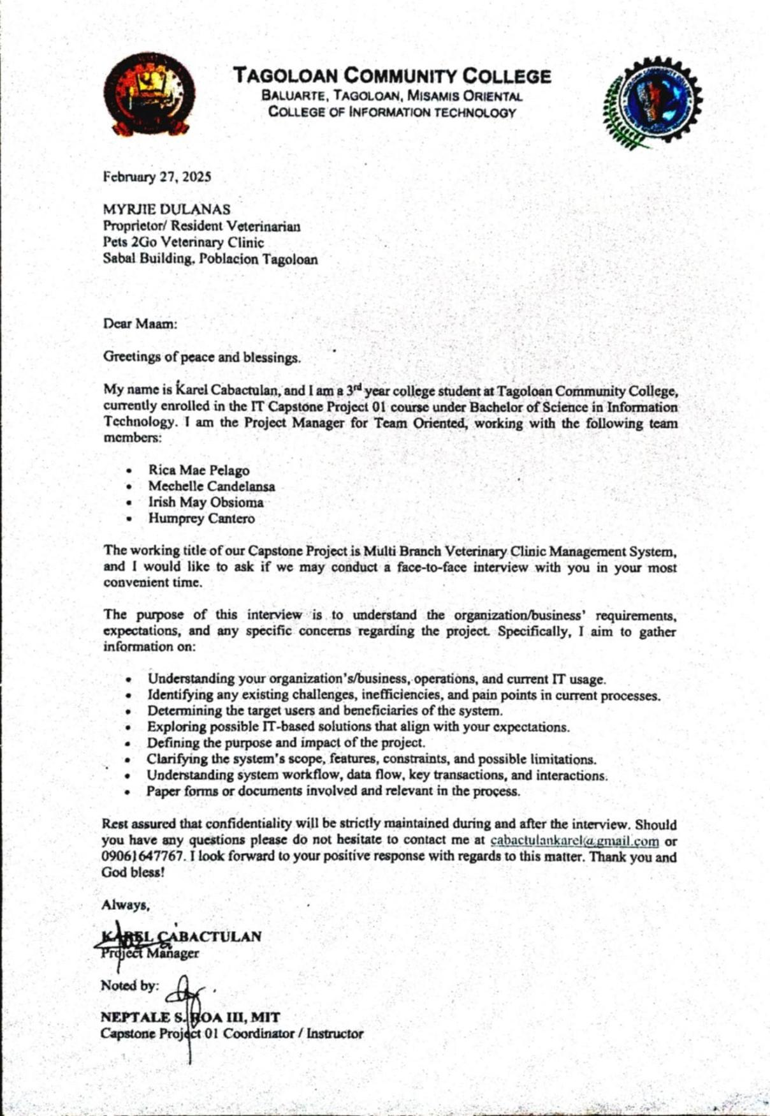

# APPENDIX – B\

Scanned Copy of the Interview Guide Questions

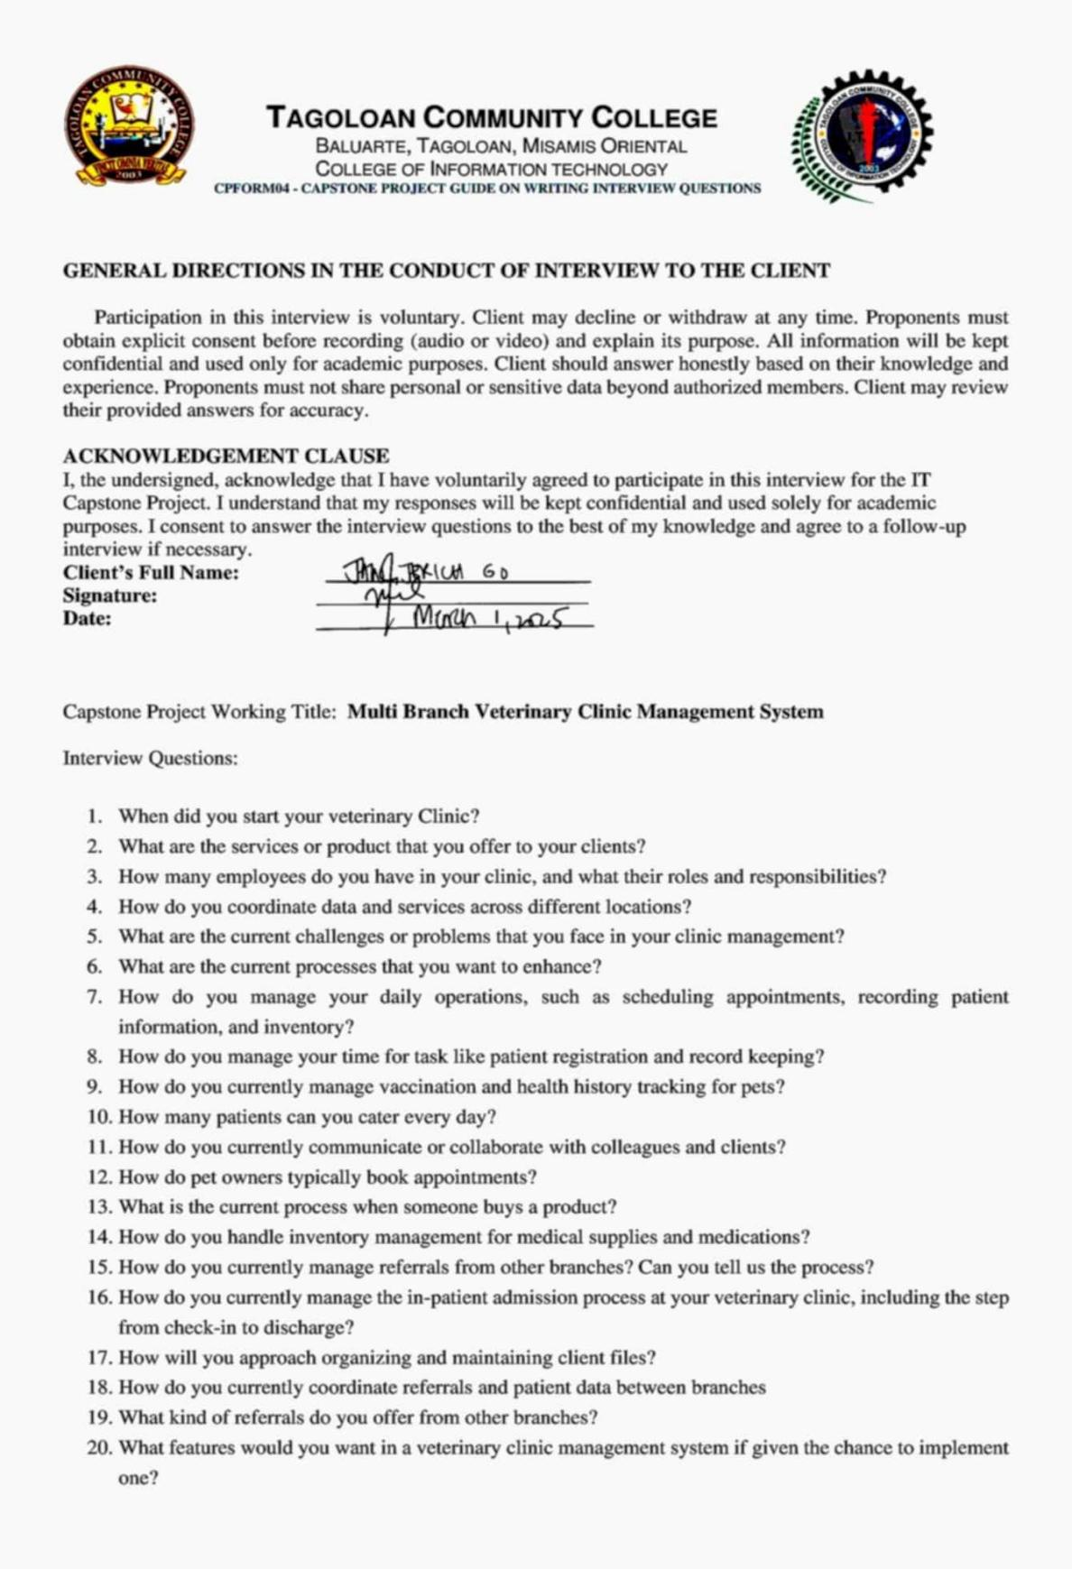

# APPENDIX – C

Scanned Copy of Paper forms / reports from Client

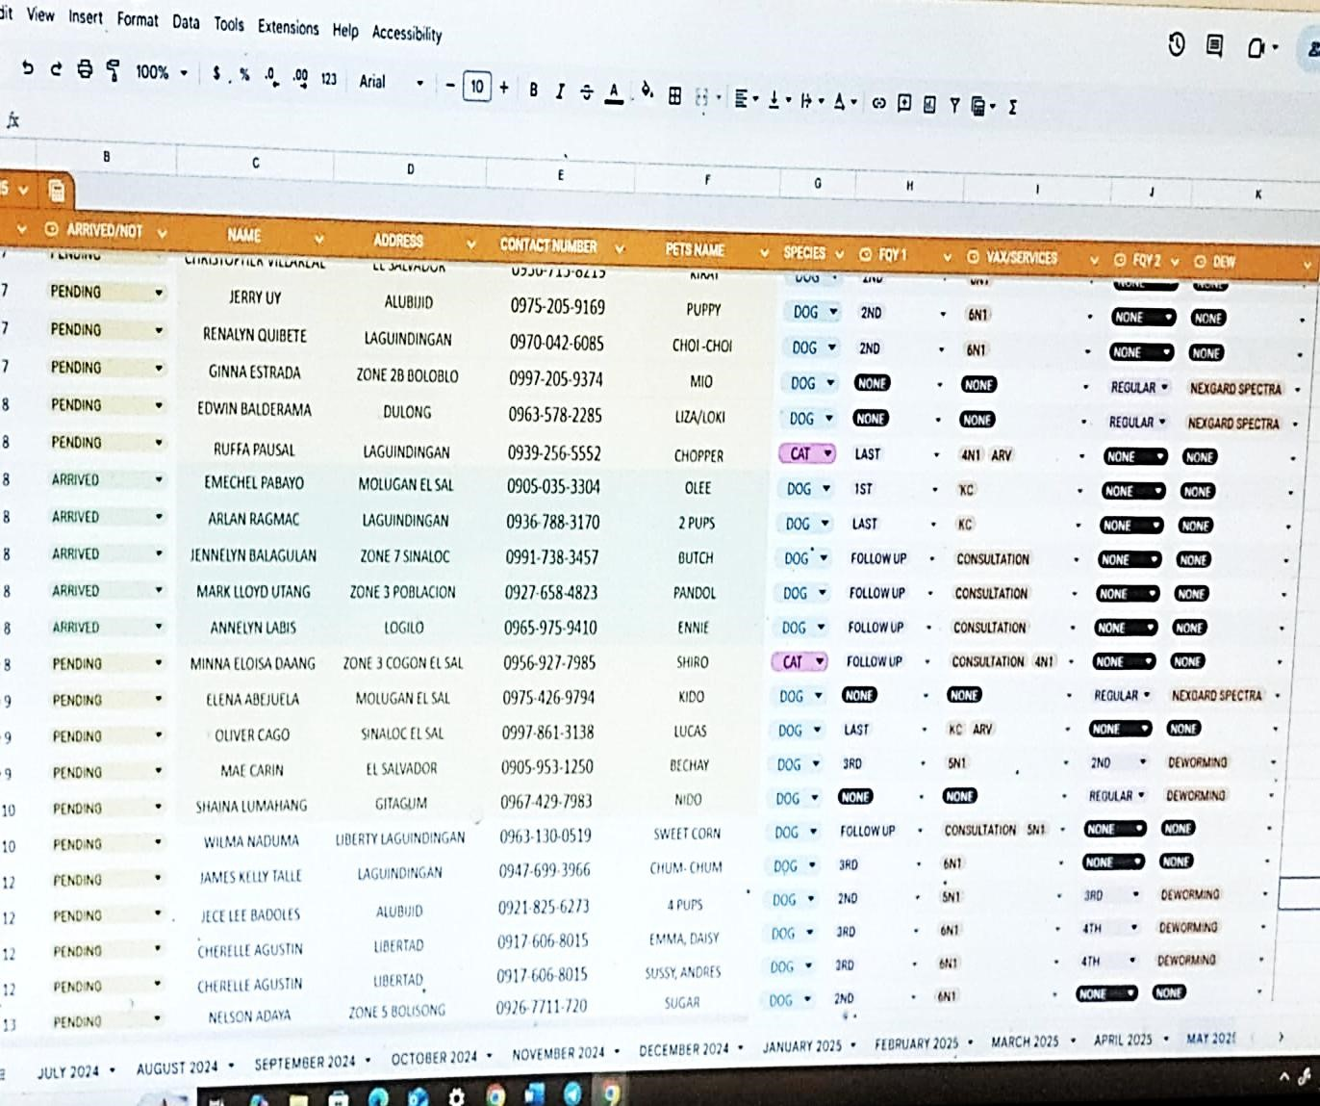

Vaccination Records

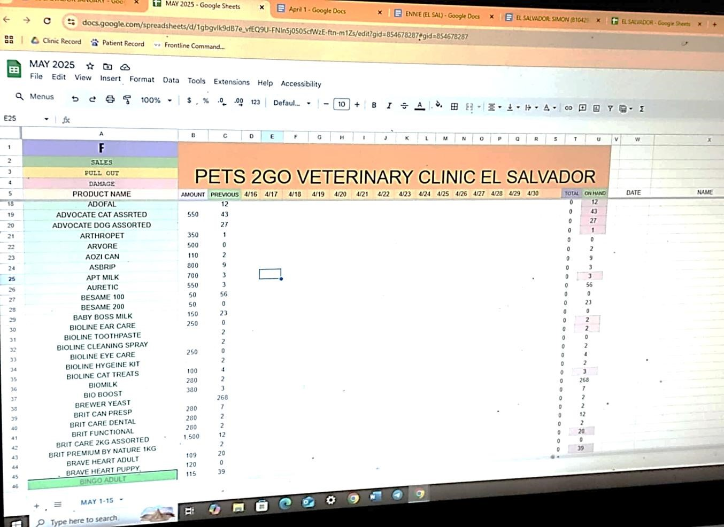

Inventory Records

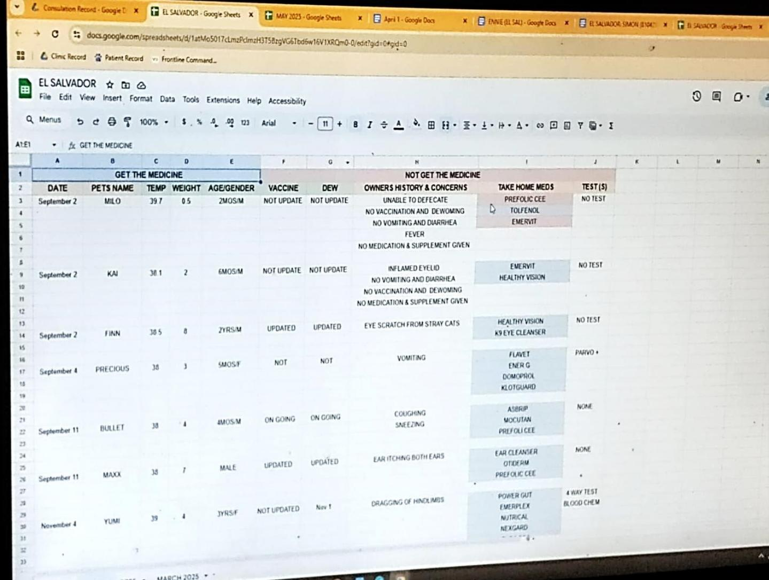

Pet History Records

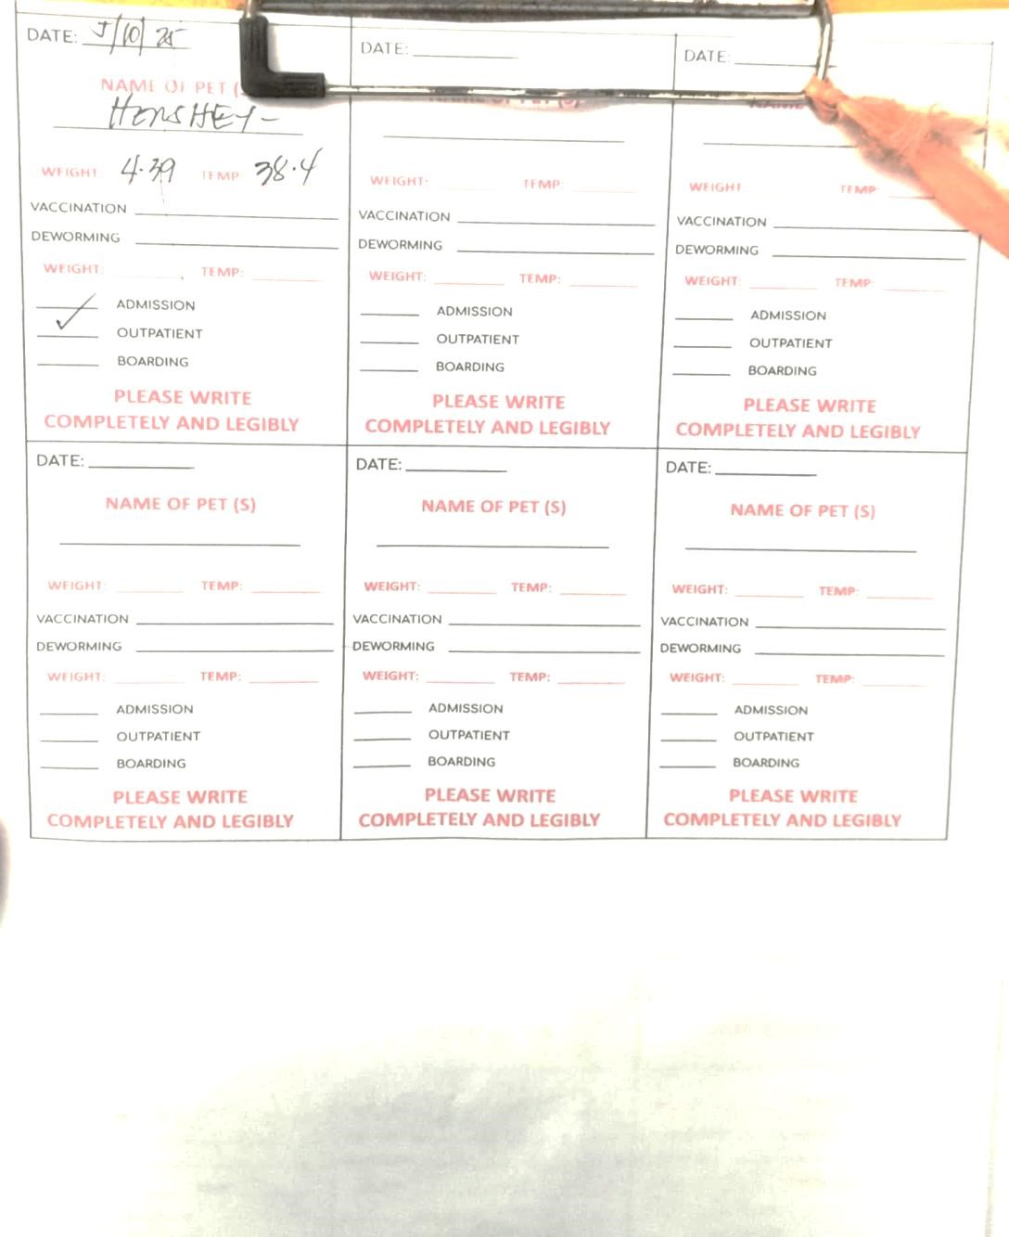

Consultation Form

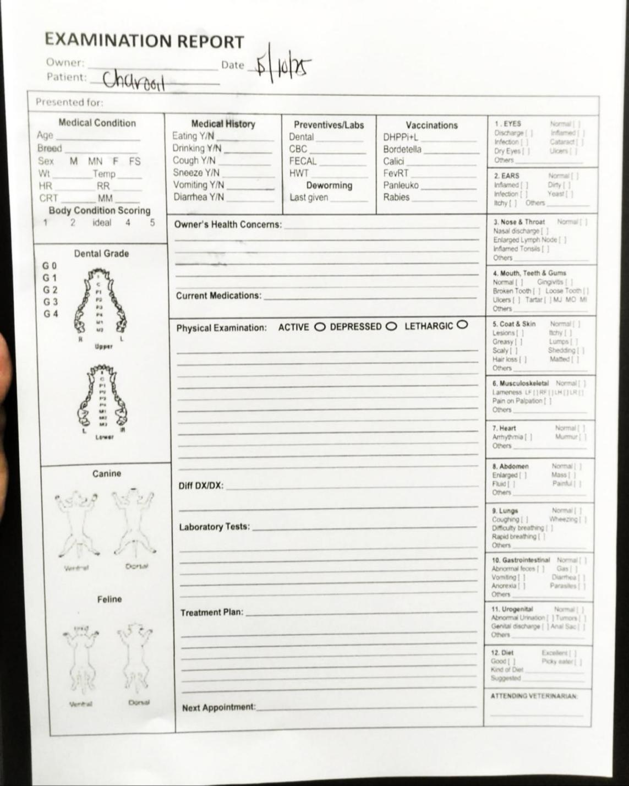

Examination Form

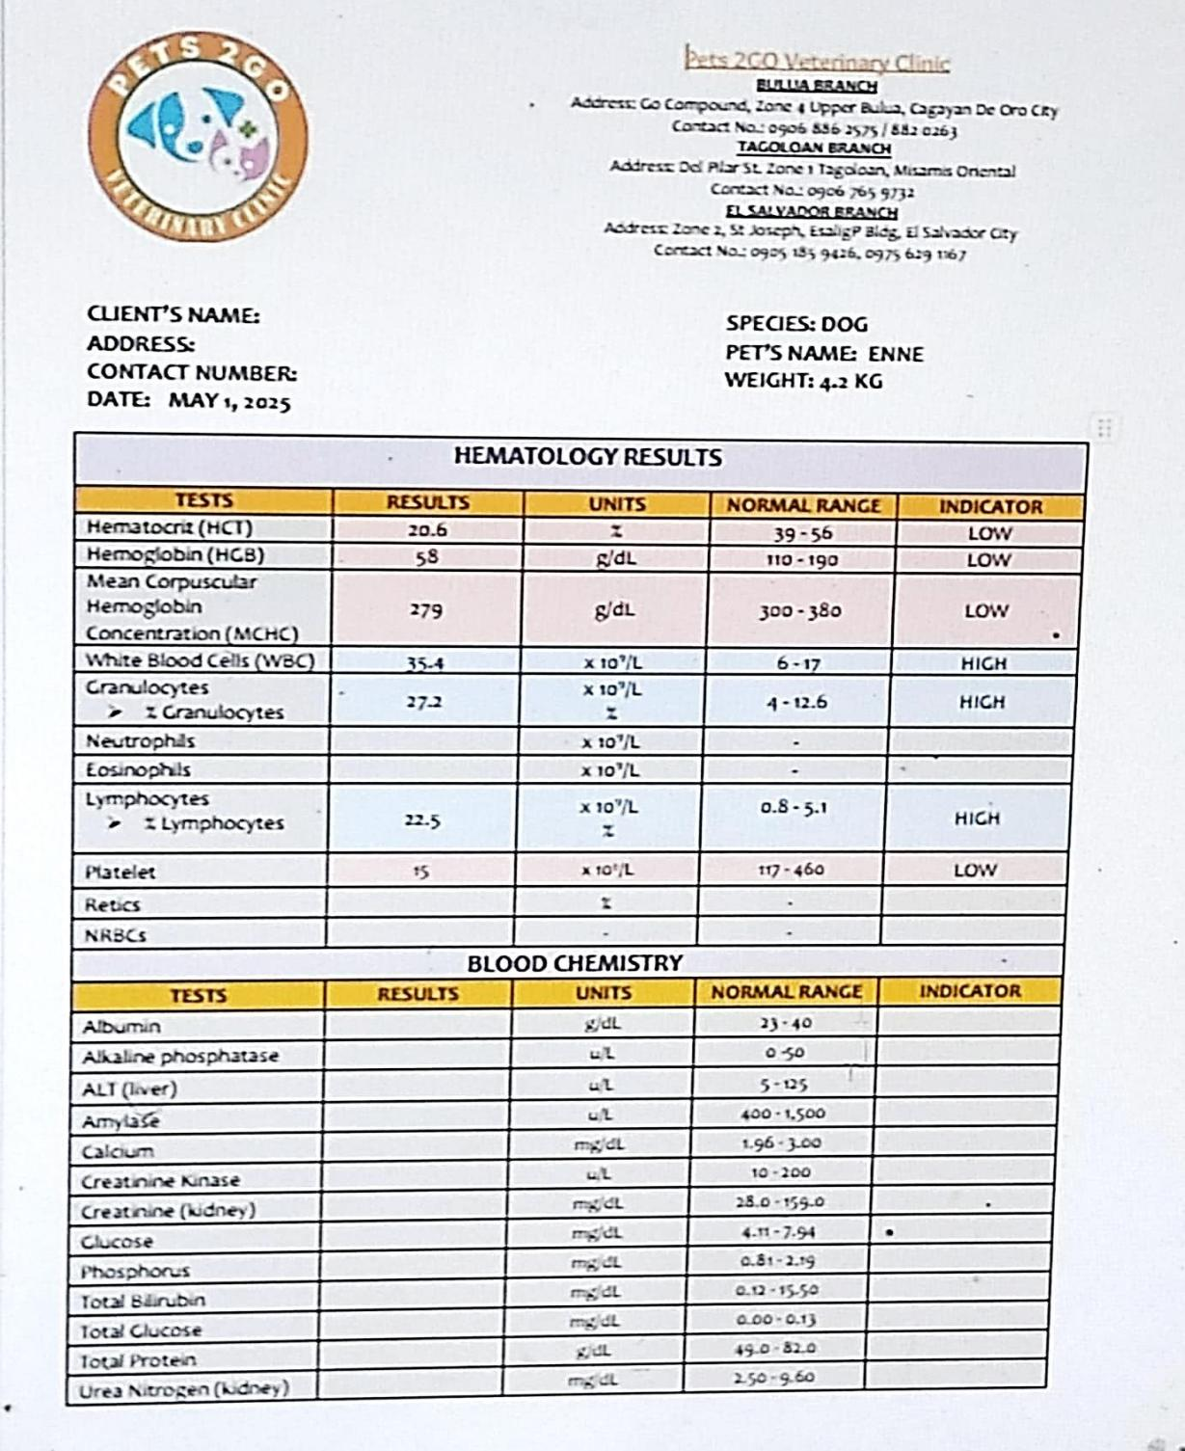

Laboratory Template form