hoBoard | All Boards
Subject | English Language
Grade | 5,6
Chapter | NA
TP Name | Paragraph Writing
TP ID | NA

Learning Objective | Arrange jumbled sentences in logical order to form a coherent paragraph.
Brief description | User sees 4-6 jumbled sentences displayed as draggable cards on screen.  User drags and drops sentence cards into numbered slots to arrange them in correct order.  Visual cues (discourse markers, pronouns, time sequences) help guide the arrangement.  Each correct placement is immediately confirmed with green highlighting and the sentence locks in place.  Incorrect placements show a red border but remain unlocked for rearrangement.  When paragraph is complete, user sees an illustrated image depicting the paragraph content with annotations.

Widget Title | Build a Paragraph
Instruction | Tap the sentences in the correct order to create a meaningful paragraph.

Functionality, Wireframe and Graphic Treatment
Functionality | Wireframe | Graphic Treatment Suggestions
Screen 1:  Instruction Screen  Display Instruction.  A box appears for the complete paragraph to appear.  Below this, 4-6 jumbled sentences are displayed in coloured boxes. | I-text –  Tap the sentences in the correct order to create a meaningful paragraph.  A paragraph with jumbled sentences appears on the screen.  ______________  Jumbled Sentences  This hard work helps plants grow and gives us delicious honey.  A honeybee's day starts early in the morning.  After collecting enough, it returns to the hive.  There, it stores the nectar, which later becomes honey.  It flies from flower to flower, gathering sweet nectar. | The jumbled sentences are displayed in coloured boxes (yellow, pink, blue, green, orange, lavender).  The paragraph box displays faint gridlines with numbered positions. When a correct sentence is tapped, it appears in the corresponding position.  Show answer button is required for all questions.
Screen 2:  User taps sentences in the correct order. | Instruction –  Tap the sentences in the correct order to create a meaningful paragraph.  Arrange your paragraph here!  A honeybee's day starts early in the morning.  Jumbled Sentences  This hard work helps plants grow and gives us delicious honey.  After collecting enough, it returns to the hive.  There, it stores the nectar, which later becomes honey.  It flies from flower to flower, gathering sweet nectar. | Correct placement:  - The sentence appears in light green highlight in the paragraph box.  - Soft "ting" sound/similar.  Incorrect placement:  - Red border glows briefly.  - Gentle shake animation (1 second).  - Box remains in place.
Screen 3:  Once all sentences are correctly arranged and locked in green, the previous screen clears and new one appears.  User sees the completed paragraph with markings and annotations. Paragraph should not appear like individual sentences one below the other here.  Provide ‘NEXT’ button to continue. | 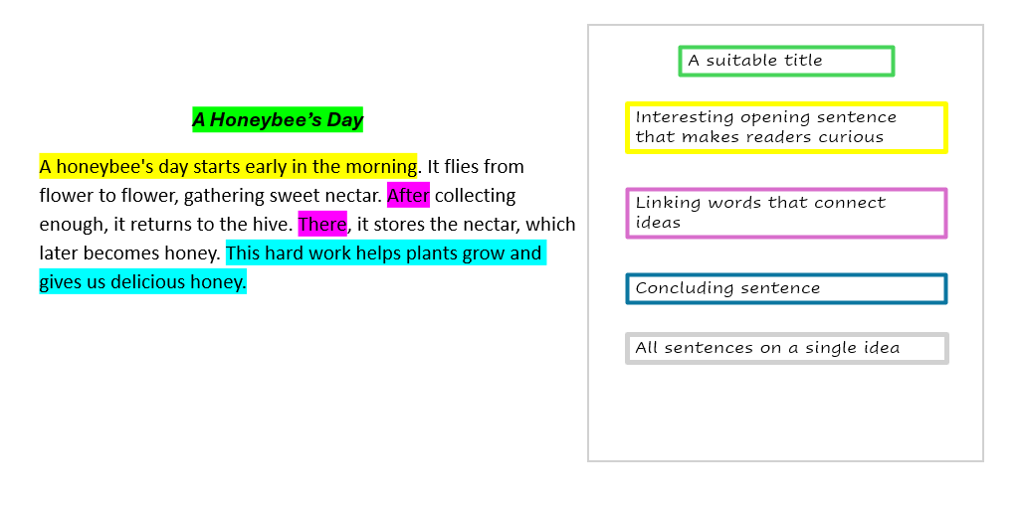  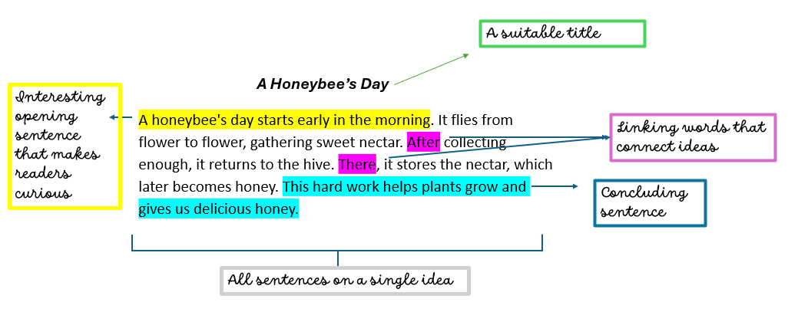  Option 1 layout:  Option 2 layout: | Provide ‘NEXT’ button to continue.  Provide ‘FINISH’ button at the last slide to stop.

Build a Paragraph
No | Topic | Jumbled Sentences | Correct Order | Annotations/Grammar Concepts
1. | A Honeybee’s Day | 1. This hard work helps plants grow and gives us delicious honey.  2. A honeybee's day starts early in the morning.  3. After collecting enough, it returns to the hive.  4. There, it stores the nectar, which later becomes honey.  5. It flies from flower to flower, gathering sweet nectar. | 2,5,3,4,1 | Annotation 1 – Interesting opening sentence that makes readers curious  Annotation 2 – Linking words that connect ideas  Annotation 3 – Concluding sentence  Summary Annotation – All sentences on a single idea.  A honeybee's day starts early in the morning. It flies from flower to flower, gathering sweet nectar. After collecting enough, it returns to the hive. There, it stores the nectar, which later becomes honey. This hard work helps plants grow and gives us delicious honey.
2. | The Story of Chocolate | - Today, chocolate is enjoyed worldwide in candies, cakes, and ice cream, making it everyone's favourite treat!  - Chocolate comes from cocoa beans that grow on trees in hot countries.  - Ancient people in Mexico discovered cocoa and made a bitter drink from it.  - Later, sugar and milk were added to make it sweet. | 2,3,4,1 | Annotation 1 – Ppening sentence that tells us where chocolate comes from  Clear opening sentence that introduces the main topic  Annotation 2 – Linking words showcasing the sequence of events  Annotation 3 – A concluding sentence that summarises the present– day importance of chocolate  Summary Annotation – All sentences focus on a single idea: the evolution of chocolate.  Chocolate comes from cocoa beans that grow on trees in hot countries. Ancient people in Mexico discovered cocoa and made a bitter drink from it. Later, sugar and milk were added to make it sweet. Today, chocolate is enjoyed worldwide in candies, cakes, and ice cream, making it everyone's favourite treat!
3. | Our Magnificent Sun | - Surprisingly, the Sun is so big that one million Earths could fit inside it!  - Indeed, our Sun is truly a magnificent star.  - Without the Sun, there would be no life on Earth.  - The Sun is a giant ball of hot, glowing gas that gives us light and heat.  Every second, the Sun produces enough energy to power our planet for years. | 4,3,1,5,2 | Annotation 1 –An introductory sentence that describes the Sun  Annotation 2 – Using words highlight the Sun's extraordinary qualities and importance  Annotation 3– The concluding line celebrates the Sun's magnificence  Summary Annotation – The paragraph systematically presents the Sun's nature, significance, size, and energy.  The Sun is a giant ball of hot, glowing gas that gives us light and heat. Without the Sun, there would be no life on Earth. Surprisingly, the Sun is so big that one million Earths could fit inside it! Every second, the Sun produces enough energy to power our planet for years. Indeed, our Sun is truly a magnificent star.
4. | The Mighty Himalayas | - Important rivers like the Ganga and Brahmaputra begin from Himalayan glaciers.  - The Himalayan mountain range stretches across northern India like a protective wall.  - Tourists visit hill stations like Shimla and Darjeeling during summer.  - The Himalayas are truly India's precious natural treasure.  - These peaks include Mount Everest, the world's tallest mountain. | 2,5,1,3,4 | Annotation 1 – An opening sentence that helps readers visualise the Himalayas  Annotation 2 – These words provide important facts about the Himalayas  Annotation 3 – A concluding sentence that summarises the importance of the Himalayas  Summary Annotation – Every sentence tells us about the Himalayan mountains.  The Himalayan mountain range stretches across northern India like a protective wall. These peaks include Mount Everest, the world's tallest mountain. Important rivers like the Ganga and Brahmaputra begin from Himalayan glaciers. Tourists visit hill stations like Shimla and Darjeeling during summer. The Himalayas are truly India's precious natural treasure.
5. | Chintu's Market Mishap | - As a result, the shopkeeper slipped and landed in a basket of tomatoes, turning as red as the vegetables themselves!  - A clever monkey named Chintu once sneaked into a vegetable market in Jaipur.  - He grabbed a bunch of bananas and started juggling them like a circus performer!  - When the shopkeeper chased him, Chintu threw a banana peel on the ground. | 2, 3, 4, 1 | Annotation 1 – An opening sentence that introduces the main character and setting  Annotation 2 – Words that connect the ideas and show the sequence of events in the story  Annotation 3 – A concluding sentence that ends the story with humour  Summary Annotation – The paragraph presents a light–hearted tale.  A clever monkey named Chintu once sneaked into a vegetable market in Jaipur. He grabbed a bunch of bananas and started juggling them like a circus performer! When the shopkeeper chased him, Chintu threw a banana peel on the ground. As a result, the shopkeeper slipped and landed in a basket of tomatoes, turning as red as the vegetables themselves!
6. | My First Day at School | - After she left, I sat quietly feeling lonely amongst unfamiliar faces.  - However, a friendly girl named Priya sat beside me and shared her tiffin.  - I still remember my first day at school vividly.  - By day's end, I had made three friends and realised school would be wonderful.  - When I entered the gate holding my mother's hand, my heart beat fast with nervousness. | 3,5,1,2,4 | Annotation 1 – An engaging introduction that makes the topic personal and relatable  Annotation 2 – Link words that words indicate sequence of events for the day and feeling  Annotation 3 – A concluding line that reflects on the overall experience  Summary Annotation – The paragraph presents a complete narrative of the first day at school beginning to end.  I still remember my first day at school vividly. When I entered the gate holding my mother's hand, my heart beat fast with nervousness. After she left, I sat quietly feeling lonely amongst unfamiliar faces. However, a friendly girl named Priya sat beside me and shared her tiffin. By day's end, I had made three friends and realised school would be wonderful.
7. | Postman on Duty | - The postman truly deserves our respect and gratitude.  - He also delivers birthday cards and important documents.  - The postman is an important person who delivers letters and parcels to our homes.  - Every day, he wears a khaki uniform and carries a heavy bag.  - Rain or shine, he walks through streets bringing us news from loved ones. | 3,4,5,2,1 | Annotation 1 – The opening line that introduces the main topic and explains his role  Annotation 2 – Expressions that show the postman's daily routine and dedication  Annotation 3 – A strong concluding sentence  Summary Annotation – The paragraph presents accurately the postman’s importance.  The postman is an important person who delivers letters and parcels to our homes. Every day, he wears a khaki uniform and carries a heavy bag. Rain or shine, he walks through streets bringing us news from loved ones. He also delivers birthday cards and important documents. The postman truly deserves our respect and gratitude.
8. | The Magnificent Taj Mahal | - It took 22 years to complete and features intricate carvings and precious stone inlays.  - Truly, the Taj Mahal is a timeless monument to love.  - Emperor Shah Jahan built this white marble monument in memory of his wife Mumtaz Mahal.  - The Taj Mahal in Agra is one of the Seven Wonders of the World and a symbol of eternal love.  - Every year, millions of tourists visit to admire its beauty. | 4,3,1,5,2 | Annotation 1 – An Introductory sentence that highlight the importance of the Taj Mahal  Annotation 2 – Use of words that connect historical and descriptive details of the monument  Annotation 3 – A concluding statement that reveals its everlasting virtue  Summary Annotation – All the sentences describe the Taj Mahal as a global and magnificent beauty.  The Taj Mahal in Agra is one of the Seven Wonders of the World and a symbol of eternal love. Emperor Shah Jahan built this white marble monument in memory of his wife Mumtaz Mahal. It took 22 years to complete and features intricate carvings and precious stone inlays. Every year, millions of tourists visit to admire its beauty. Truly, the Taj Mahal is a timeless monument to love.
9. | The Floating Egg Experiment | 1. This happens because salt water becomes denser than the egg, pushing it upwards.  2. In normal tap water, a fresh egg sinks to the bottom because it's denser than water.  3. Similarly, swimming in the ocean is easier than in a pool due to the salty water.  4. However, when you add salt and stir, the egg begins to float. | 2,4,1,3 | Annotation 1 – A sentence that introduces the main topic and explains what happens in normal water  Annotation 2 – Linking word and phrase guiding us through the cause–and–effect relationship  Annotation 3 – A concluding sentence that connects the experiment to a real– life example  Summary Annotation – This paragraph explains how salt water makes objects float easily.  In normal tap water, a fresh egg sinks to the bottom because it's denser than water. However, when you add salt and stir, the egg begins to float! This happens because salt water becomes denser than the egg, pushing it upwards. Similarly, swimming in the ocean is easier than in a pool due to the salty water.
10. | The Sleepiest Animal | - Eucalyptus leaves provide very little energy, so koalas conserve strength by resting most of the time.  - Surely, koalas have mastered the art of relaxation!  - Koalas hold the record for sleeping the longest, snoozing up to 22 hours daily!  - During their brief waking hours, they eat, groom, and climb to different branches. | 3,1,4,2 | Annotation 1 – The opening sentence that introduces koalas' amazing sleeping habit  Annotation 2 – Expressions that explain why koalas sleep  Annotation 3 – This concluding sentence summarises koalas' relaxed lifestyle with humour  Summary Annotation – This paragraph explains why koalas sleep for very long hours  Koalas hold the record for sleeping the longest, snoozing up to 22 hours daily! Eucalyptus leaves provide very little energy, so koalas conserve strength by resting most of the time. During their brief waking hours, they eat, groom, and climb to different branches. Surely, koalas have mastered the art of relaxation!
11. | The Joy of Sharing | - Even sharing our time by helping with homework shows we care  - Sharing is a wonderful habit that makes everyone happy.  - At school, sharing lunch or stationery with friends strengthens our friendship.  - Remember, happiness multiplies when shared, making it a true blessing.  - When we share toys, books, or clothes with someone in need, it brings them comfort. | 2,3,5,1,4 | Annotation 1 – An opening sentence that establishes sharing as a valuable quality  Annotation 2 – Use of words that connect various real– life contexts  Annotation 3 – A sentence that shares thoughtful conclusion  Summary Annotation – This paragraph explains how sharing makes everyone happy  Sharing is a wonderful habit that makes everyone happy. At school, sharing lunch or stationery with friends strengthens our friendship. When we share toys, books, or clothes with someone in need, it brings them comfort. Even sharing our time by helping with homework shows we care. Remember, happiness multiplies when shared, making it a true blessing.
12. | The Beautiful Spring Season | - Also, the weather becomes pleasant, neither too hot nor too cold. Moreover, colourful butterflies and busy bees fly from flower to flower.  - It also reminds us that new beginnings are always beautiful.  - Spring is my favourite season when nature comes alive with colours.  - Finally, spring fills our hearts with happiness.  - During this time, flowers bloom in gardens and trees grow fresh green leaves | 3,5,1,4,2 | Annotation 1 – A sentence that introduces the topic with enthusiasm  Annotation 2 – Words that shows spring's emotional effect  Annotation 3 – A concluding sentence that shares the deeper meaning of spring beautifully  Summary Annotation – The paragraph celebrates spring's beauty.  Spring is my favourite season when nature comes alive with colours. During this time, flowers bloom in gardens and trees grow fresh green leaves. Also, the weather becomes pleasant, neither too hot nor too cold. Moreover, colourful butterflies and busy bees fly from flower to flower. Finally, spring fills our hearts with happiness. It also reminds us that new beginnings are always beautiful.
13. |  | - They are full of vitamins, minerals, and fibre our body needs.  - For example, mangoes provide Vitamin A, oranges give Vitamin C, and bananas offer instant energy.  - Therefore, we must eat fresh fruits daily to stay fit.  - Fruits are nature's gifts that keep us healthy and strong.  - Besides being nutritious, fruits taste delicious and come in many colours. | 4,1,2,5,3 | Annotation 1 – An opening sentence that presents fruits as valuable natural resource  Annotation 2 – Words that mention benefits of eating fruits  Annotation 3 – A concluding sentence that emphasises on the benefit of eating fruits  Summary Annotation – This paragraph explains why eating fruits daily keeps us healthy.  Fruits are nature's gifts that keep us healthy and strong. They are full of vitamins, minerals, and fibre our body needs. For example, mangoes provide Vitamin A, oranges give Vitamin C, and bananas offer instant energy. Besides being nutritious, fruits taste delicious and come in many colours. Therefore, we must eat fresh fruits daily to stay fit.
14. |  | - The decimal point separates the whole number from the fractional part  - Decimals are a special way of writing numbers that are not whole.  - And so, learning decimals makes our daily tasks simpler and more precise.  - For instance, when we buy 1.5 kilograms of apples or measure height as 4.2 feet, we use decimals.  - Decimals make calculations easier than fractions, especially with money. | 2,4,1,5,3 | Annotation 1 – A sentence that defines decimals  Annotation 2 – Linking words/phrases that gives real– life decimal examples  Annotation 3 – A concluding sentence highlighting importance of decimals  Summary Annotation – This paragraph explains what decimals are and why they're useful.  Decimals are a special way of writing numbers that are not whole. For instance, when we buy 1.5 kilograms of apples or measure height as 4.2 feet, we use decimals. The decimal point separates the whole number from the fractional part. Decimals make calculations easier than fractions, especially with money. And so, learning decimals makes our daily tasks simpler and more precise.
15. | The Festival of Colours | - During this celebration, people wear old white clothes and play with bright coloured powders called gulal.  - Families prepare special sweets like gujiya and thandai to share with neighbours  - Indeed, Holi teaches us to celebrate life together with happiness.  - Holi is a joyful festival that marks the arrival of spring in India.  - Children and adults throw colours at each other, laughing and singing festive songs. | 4,1,5,2,3 | Annotation 1 – An opening sentence that introduces Holi as a joyous occasion  Annotation 2 – Key words that give an insight into the festival  Annotation 3 – A concluding sentence that presents spirit of the festival  Summary Annotation – This paragraph describes how people celebrate the colourful festival of Holi.  Holi is a joyful festival that marks the arrival of spring in India. During this celebration, people wear old white clothes and play with bright coloured powders called gulal. Children and adults throw colours at each other, laughing and singing festive songs. Families prepare special sweets like gujiya and thandai to share with neighbours. Indeed, Holi teaches us to celebrate life together with happiness.

For my reference:
A honeybee's day starts early in the morning. It flies from flower to flower, gathering sweet nectar. After collecting enough, it returns to the hive. There, it stores the nectar, which later becomes honey. This hard work helps plants grow and gives us delicious honey.

Annotation 1 – Interesting opening sentence that makes readers curious
Annotation 2 – Linking words that connect ideas
Annotation 3 – Concluding sentence

