Board | CBSE
Subject | Hindi Lan
Grade | 1 and 2
Chapter | Grade 1 - 12. शब्द-भंडार  Grade 2 - 15. शब्द-भंडार - I
TP Name and TP ID | Grade 1  विलोम शब्द  tp-cf2c2a58-bef0-4dd0-824e-61b5ac2427a5_hi  Grade 2  विलोम शब्द  tp-c2193df6-f121-4079-8f16-2af880f3e6ce_hi

Learning Objective | शब्द का उल्टा अर्थ बता पाना।
Brief description | The user will spin the wheel, after spinning the word that pops up user will have to tell its opposite word.  After revealing or not revealing the answer, the user has to tap on the 'View Answer' button to see the correct answer, words audio and associated images.

Widget Title | उल्टे अर्थ वाले शब्द
I-text | - व्हील घुमने के लिए स्पिन बटन टैप करें। शब्द का उल्टा अर्थ वाला शब्द बताएँ।  - उत्तर जाँचने के लिए ‘उत्तर देखें’ बटन टैप करें।

Functionality
When widget launches user will see widget title on top, i-text 1 under it.
The user will then see a spin wheel with 6 words.
The user will spin the wheel and the spinner will randomly stop at a word and that word will pop up. A button for playing audio should appear near the word after spinning stops in case the user wants to hear the word. (Take content from content table below.)
Please check the reference. Choose ‘Spin the wheel’ template to view animation.
antonyms - Find the match
Then the user will ask the students to orally answer that word.
When the word pops up on the screen, after 10 seconds an i-text 2 will appear on screen and the show answer button will glow. to show the correct answer and its related image to the students. Audio button needs to appear near the opposite word (answer) too at this point.
User keeps spinning the wheel to change word.
After every set of six words is completed, a new set of words (new six words) will appear on the spin wheel. OR if the user wants a new set of words at any point, user needs to tap ‘Naye Shabd’ button that is placed at the bottom of the screen.
Note: If the user wants to revise the six words solved during one session, it should be possible. User should be able to click the relevant slice in the wheel and the words + images + audio button should appear.

Sample Layout
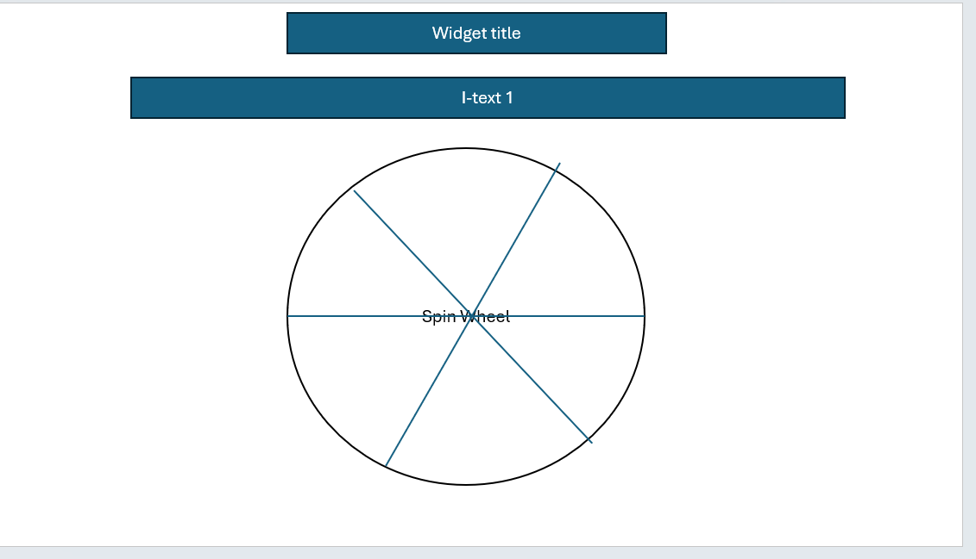

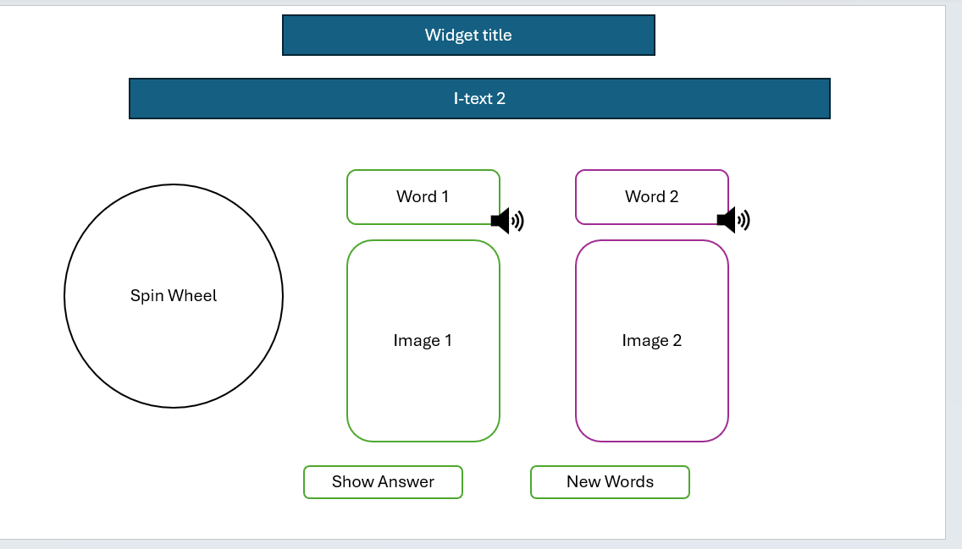
Data Table

Words for spinning wheel | Answer
दिन | रात
बड़ा | छोटा
अच्छा | बुरा
अंदर | बाहर
आना | जाना
ऊपर | नीचे
काला | सफ़ेद
पास | दूर
गरम | ठंडा
खुश | दुखी
सही | गलत
नया | पुराना
आगे | पीछे
खाली | भरा
हल्का | भारी
हँसना | रोना
जीत | हार
गीला | सूखा
तेज़ | धीमा
साफ़ | गंदा
खुला | बंद
एक | अनेक
दाँए | बाएँ
सुबह | शाम
कोमल | कठोर
उठना | बैठना
अँधेरा | उजाला
मोटा | पतला
पूरा | आधा
सोना | जागना

