Board | MHSB/CBSE/ICSE
Subject | English Literature
Grade | 9-10
Chapter | NA
TP Name | Build a Literary Device
TP ID | Can be mapped to multiple TPs

Learning Objective | Identify the components of a literary device to assemble them correctly.
Brief description | User selects a literary device. User chooses the correct components to build a sentence which contains the literary device.

Widget Title | Build a Literary Device
I-text | Tap to build a literary device.

Functionality | Wireframe
- A panel of literary devices comes on screen.  - Select a literary device to build.  I-text: Tap a literary device to begin. | 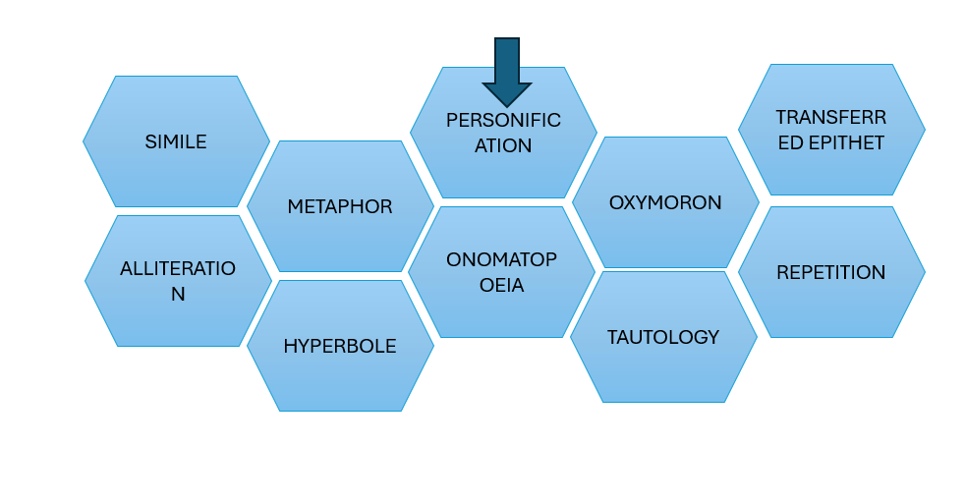
- A brief description comes on the side of the screen to explain how the literary device works.  - Show button ‘Launch Builder’.  - Add a blink to the button to draw user’s attention. | 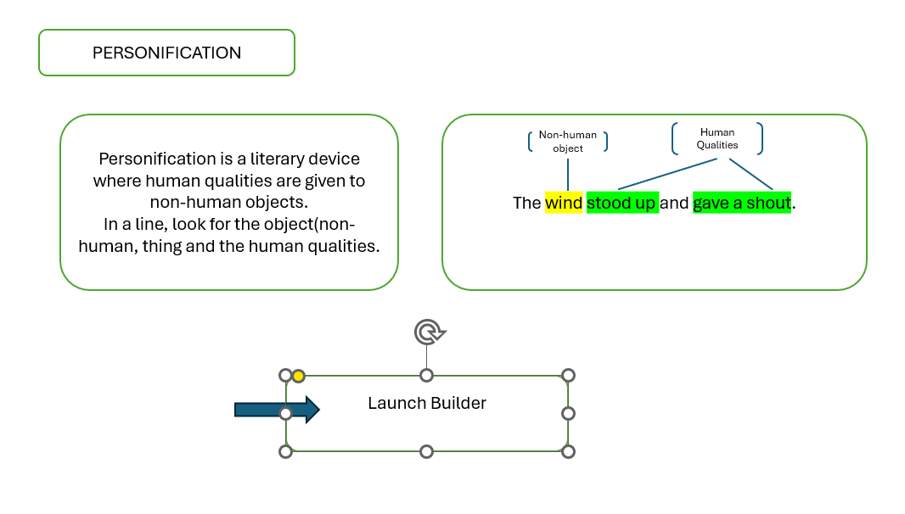
- I-text: Tap one phrase from each box to build a literary device. Watch your device come together as a complete sentence.  - Click submit to get feedback. | 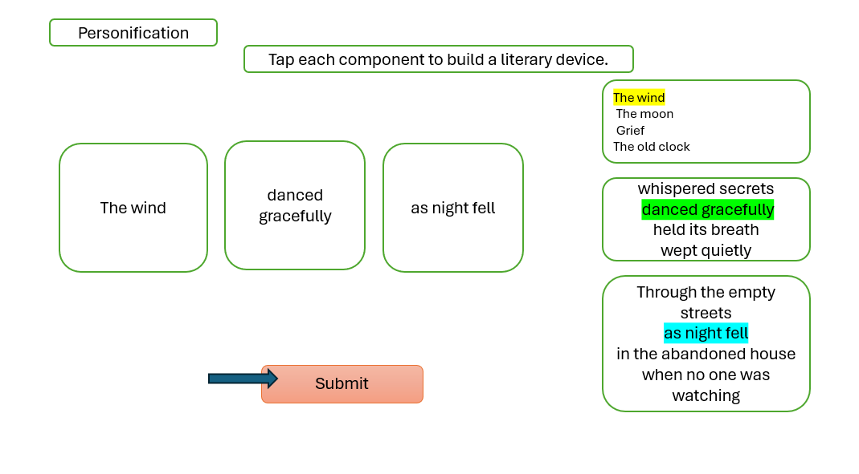
Explanation pop-up will come after user clicks submit. | 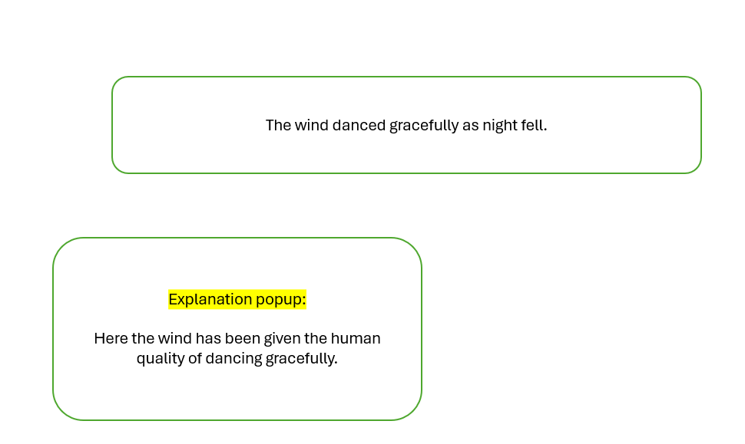
- Once feedback is given, the line goes to the side.  - The main box shows blank once again. Tap on other options provided to create a new sentence.  - Click Home to choose another device. | 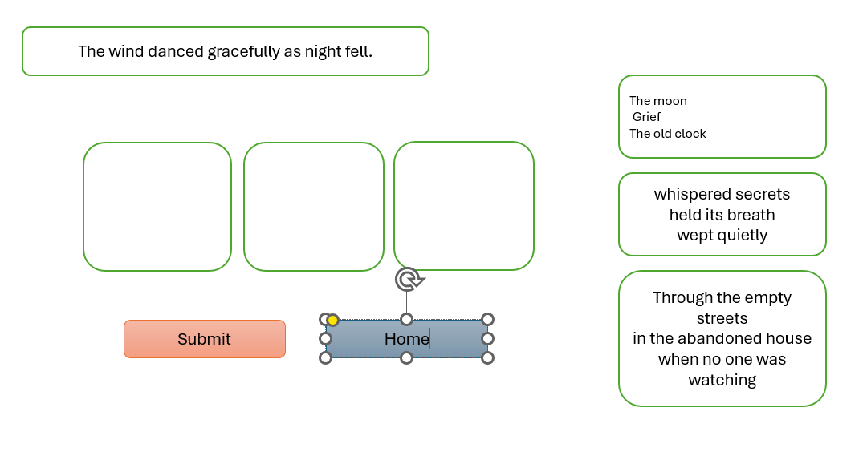

Literary Device | Example
Personification  Personification is a literary device where human qualities are given to non-human objects.  In a line, look for the non-human object/thing and the human qualities.  This device helps readers connect emotionally with objects or ideas. It creates vivid imagery and builds atmosphere. | Human qualities  Non-human object  The wind stood up and gave a shout.
Simile  A simile compares two unlike objects using the words ‘as’ or ‘like’.  In a line, look for two objects of comparison and for the words ‘as’ or ‘like’.  Similes create a significant impact by connecting unfamiliar ideas to familiar ones. | He was as heavy as a horse.  Text for annotation:  He – object  As – word of comparison  Heavy – compared quality  Horse - object
Metaphor  A metaphor directly compares two unlikely objects without using ‘as’ or ‘like’.  In a line look for two unlikely objects for comparison.  Metaphors create powerful imagery by merging two ideas into one. They add layers of meaning and invite readers to think deeply. | She has a heart of stone.  Text for annotation:  She – object  Heart of stone - metaphor
Tautology  Tautology is a literary device where there is unnecessary repetition of meaning using different words that say the same thing.  In a line or sentence, look for words similar in meaning which has been used in succession.  This device is used for emphasis, rhythm as well to stress the importance of an idea. | They gathered together for the ceremony.  Text for annotation:  Gathered together – words that sound similar in meaning
Onomatopoeia  This device refers to words that imitate the natural sounds they describe.  In a line, look for the words that mimic a particular sound.  This device is used to create an immersive experience for the reader by engaging their sense of hearing. | The food sizzled in the hot pan.  Text for annotation:  Sizzled – onomatopoeic word
Transferred Epithet  Transferred epithet is a literary device where an adjective used to describe a person’s feeling or state is placed next to an object or thing instead.  In a line, look for an adjective which is placed next to an object.  This device creates a striking description that reveals a character’s inner emotion through their surroundings. It adds depth and subtlety rather than telling how someone feels. | He took a thoughtful sip of his coffee.  Text for annotation:  Thoughtful – adjective  Sip – act of sipping
Oxymoron  Oxymoron is a literary device where two words with opposite meaning side by side in a line.  In a line, look for two contradicting words.  This device is used to capture complex emotions through contradiction. It surprises readers and provokes thought. | The comedian’s jokes were met with serious laughter.  Text for annotation:  Serious laughter – contradictory words
Hyperbole  Hyperbole is a literary device that is used to create emphasis through extreme exaggeration.  In a line for an object and the phrase which show exaggeration.  This device is used to add drama, humour and intensity. It helps readers feel the magnitude of an emotion or situation by stretching reality to its limits. | They cried an ocean of tears on the eve of their departure.  Text for annotation:  Ocean of tears – exaggerated phrase
Alliteration  Alliteration is a literary device where the words beginning with the same consonant sounds have been repeated in the line.  In a line, look for the words which begin with the same consonant sounds.  Alliteration is used to enhance the musical quality of the poem. | The camera captured her candid charm.  Please just show highlights. No text required here.

Content Library
Personification
The wind  The mountains  Time | danced gracefully  wept quietly  complained bitterly | through the empty streets.  during the long winter.  when no one was watching. |  | The wind danced gracefully through the empty streets.  The mountains wept quietly during the long winter  Time complained bitterly when no one was watching. | Here, the wind has been given the human quality of dancing and being graceful.  Here, the mountains have been given the human quality of weeping and being quiet.  Here, time has been given the human quality of complaining and being bitter.
Simile
Her anger  The silence  His words | was like  was as  hit like | a volcano about to erupt.  heavy as a thick blanket.  a tidal wave. |  | Her anger was like a volcano about to erupt.  The silence was as heavy as a thick blanket.  His words hit like a tidal wave. | Here, the woman’s anger has been compared to a volcano using like.  Here, silence has been compared to a thick blanket using as.  Here, his words has been compared to a tidal wave using like.
Metaphor
Time  Her heart  Life | is  was  can be | a thief.  a locked door.  a winding road. |  | Time is a thief.  Her heart was a locked door.  Life can be a winding road. | Here, time has been compared to being like a thief.  Here, her heart has been compared to a locked door.  Here, life has been compared to a winding road.
Alliteration
Peter  The serpent  Brave | picked  slithered  birds | peppers in the garden.  sinuously through the grass.  built nests on boards. |  | Peter picked peppers in the garden.  The serpent slithered sinuously through the grass.  Brave birds built nests on boards. | Here, the letter ‘p’ has been repeated in the sentence.  Here, the letter ‘s’ has been repeated in the sentence.  Here, the letter ‘b’ has been repeated in the sentence.
Onomatopoeia
The thunder  The bees  The door | crashed  buzzed  creaked | across the sky.  in the garden.  on its rusty hinges. |  | The thunder crashed across the sky.  The bees buzzed in the garden.  The door creaked on its rusty hinges. | In this line, the word ‘crashed’ mimics the sound of thunder.  Here, the word ‘buzzed’ mimics the sound of bees buzzing.  Here, the word ‘creaked’ mimics the sound the creaking when opened.
Hyperbole
I am so hungry  She was so tired  The bag was so heavy | I could  her bones  it weighed | eat a horse.  turned to dust.  more than the sun. |  | I am so hungry I could eat a horse.  She was so tired her bones turned to dust.  The bag was so heavy it weighed more than the sun. | The phrase ‘could eat a horse’ exaggerates the person’s hunger.  Here, the phrase ‘bones tuned to dust’ exaggerates the nature of tiredness felt by the woman.  Here, the heaviness of the bag has been exaggerated.
Oxymoron
They sat in  Their parting was  She looked like the | deafening  bitter  living | silence.  sweet.  dead. |  | They sat in deafening silence.  Their parting was bitter sweet.  She looked like the living dead. | Here, the words ‘deafening’ and ‘silence’ contradict each other in meaning.  Here, the ‘bitter’ and ‘sweet’ are opposite in meaning.  Here, the words ‘living’ and ‘dead’ are in complete contrast with each other.
Transferred epithet
The boy spent  They watched the  He worked with | sleepless  angry  anxious | night.  sky.  fingers. |  | The boy spent sleepless night.  They watched the angry sky.  He worked with anxious fingers. | Here, the quality of sleeplessness has been transferred. It is the boy who is sleep deprived rather than the night.  Here, the quality of anger has been transferred. The sky cannot feel angry but during a storm can look angry.  Here, the fingers are not anxious but the person working with him.
Tautology
The company offered a  The experiment had  Her promotion came as an | free gift  end results  unexpected surprise | to every employee.  that surprised everyone.  to the team. |  | The company offered a free gift to every employee.  The experiment had end results that surprised everyone  Her promotion came as an unexpected surprise to the team. | Gift by definition is free. So the phrasing is redundant here.  Results by definition mean an end. So, the phrasing is redundant.  ‘Unexpected’ and ‘surprise’ are very similar in meaning so the use of both the words is repetitive and redundant.

