**Solving the build issue of customer lenergy ( FRANCE)**  
  
1)**Problem -** Unable to find right tool to build the system because exiting ESP-IDF doesn’t find a tool chain for it   
  
***Solution*** : Switch to ESP IDF extension in VS code   
  
**2)Problem** : Vs code doesn’t understand the share the project   
  
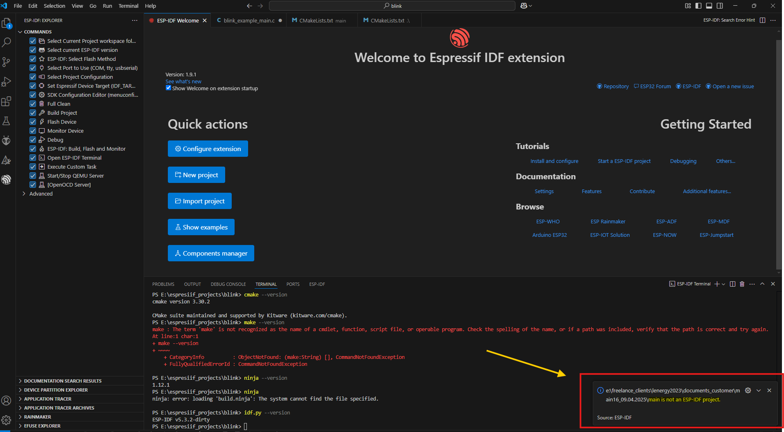  
 ***Solution*** : the code doesn’t have a wrapper it is just a main file , wrap the code with build sck config and build with an existing project to build it  
  
**3)Problem :** error thrown while building. Compiling works properly , there is a issue in linking because functions have declarations but not defined any where , those functions are   
  
  
st7701s_display_clear

st7701s_display_init

st7701s_display_distance_status

st7701s_draw_pixel

buzzer_beep_sujood

buzzer_beep_end

_trace_level

***Solution :***   
Here the trace_level is not a function it is a extern , it is solved after declaring inside the file 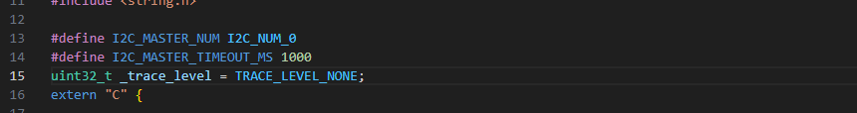  
  
 **Problem :** Other functions mentioned above are undeclared ,   
buzzer_beep_sujood

Buzzer_beep_end

***Solution***  
  
These two particular functions are user logic , since I don’t know what the application user has to take care of. I have declared the function in buzzer.c please check 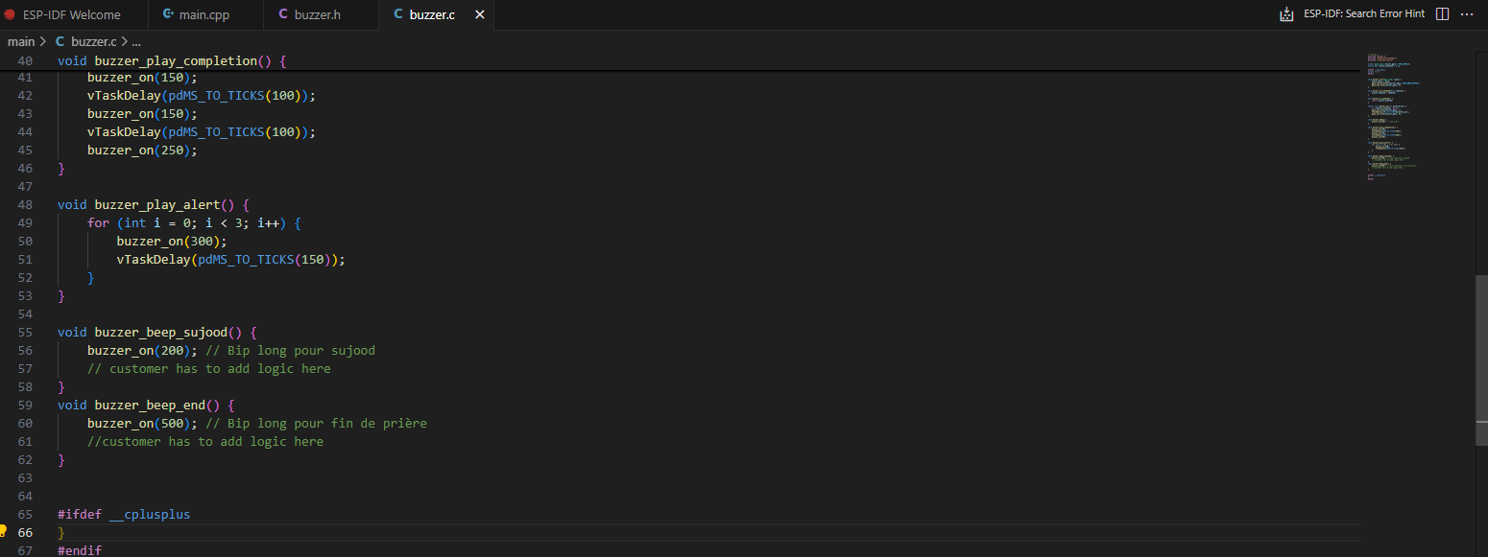

**Problem** other undeclared function  
st7701s_display_clear

st7701s_display_init

St7701s_display_distance_status

***Solution***

All these functions are driver code , since the driver code is not provided and also I cannot find a similar driver code in internet , i will declare the functions , user please fill the logic , if you want me to fill the logic provide the source for the driver  
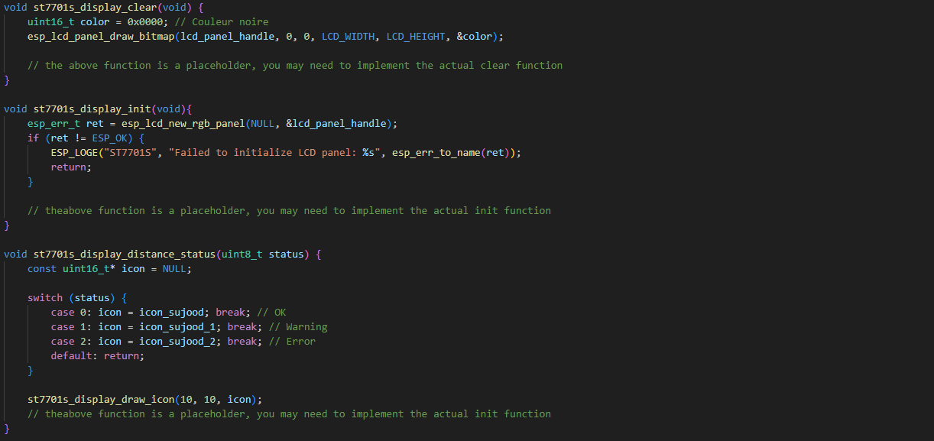

**Problem** : st7701s_draw_pixel function undeclared

***Solution :***

this function is custom logic and since I am not aware of the application , I have made a basic code , customer please fill the function with their logic :   
  
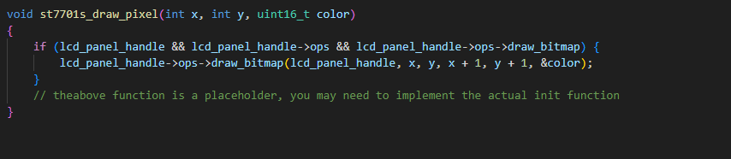  
  
  
  
After this, we are able to build the project and a bin file is generated in the project folder.  
  
  
Additional problem:  
  
The code is too big to fit in the factory app partition   
  
Solution : made a custom partition for it (flash configured to 4 MB)

Please check the partition file in the project   
  
