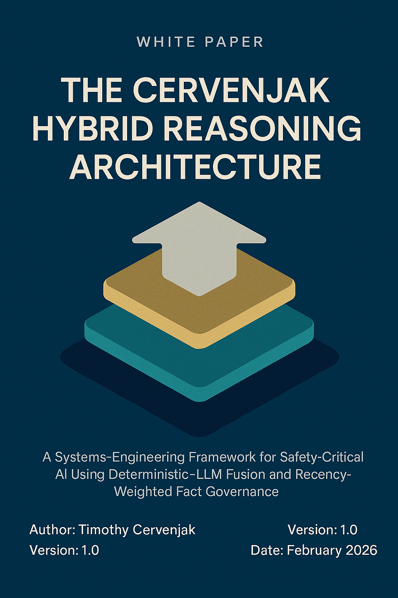

THE CERVENJAK HYBRID REASONING ARCHITECTURE
A Systems-Engineering Framework for Safety-Critical AI Using Deterministic–LLM Fusion and Recency-Weighted Fact Governance
Author: Timothy Cervenjak
Version: 1.0
Date: February 2026

ABSTRACT
AI systems are rapidly entering domains where failure is unacceptable — defence, aviation, energy, emergency response, and regulated infrastructure. Yet today’s large language models (LLMs) are inherently probabilistic, non-deterministic, and difficult to audit. This white paper introduces a novel hybrid architecture that fuses deterministic logic, recency-weighted fact governance, and constrained LLM reasoning into a unified safety-critical framework. The approach — termed the Cervenjak Hybrid Reasoning Architecture (CHRA) — provides a structured, traceable, and regulator-aligned method for deploying AI in high-assurance environments. A neutral descriptor, Deterministic–LLM Hybrid Safety Architecture (DLHSA), is also provided for standards adoption.

EXECUTIVE SUMMARY
AI is powerful, but power without control is risk. Safety-critical industries require systems that behave predictably, explain their reasoning, and operate within strict boundaries. LLMs alone cannot meet these requirements.
This white paper presents a new architecture that solves this gap by combining:
- Deterministic rule-based logic
- Recency-weighted fact sorting
- Constrained LLM reasoning
- A deterministic safety envelope
The result is a system that is:
- Traceable — every reasoning step is logged
- Auditable — deterministic layers enforce constraints
- Safe — hallucinations are contained and rejected
- Powerful — LLMs provide synthesis and contextual intelligence
- Regulator-friendly — aligns with safety-case methodologies
This framework defines a new discipline:
- AI Safety Engineering for Hybrid Reasoning Systems.

1. INTRODUCTION
AI adoption in safety-critical sectors is accelerating, but trust is lagging. Engineers, regulators, and operators need systems that behave like engineered components — predictable, testable, and bounded.
LLMs, however, behave like stochastic advisors. They are brilliant at synthesis, but unreliable as decision engines.
This paper introduces a structured, systems-engineering-aligned architecture that positions LLMs where they belong:
inside a controlled, deterministic safety envelope.

2. THE PROBLEM: WHY LLMs ALONE ARE UNSAFE
Safety-critical environments require:
- Deterministic behaviour
- Traceable reasoning
- Evidence-based decisions
- Temporal relevance (recency)
- Regulatory compliance
- Failure-mode containment
LLMs violate these requirements by design. They:
- Hallucinate
- Lack temporal awareness
- Cannot guarantee consistency
- Cannot self-validate
- Cannot enforce safety constraints
A new architecture is required — one that blends the strengths of LLMs with the guarantees of deterministic systems.

3. THE CERVENJAK HYBRID REASONING ARCHITECTURE (CHRA)
Also known neutrally as the Deterministic–LLM Hybrid Safety Architecture (DLHSA)
The architecture consists of four tightly integrated layers:

3.1 Deterministic Input Validation Layer
This layer ensures the system only reasons over safe, complete, and valid inputs.
Functions include:
- Schema validation
- Rule-based filtering
- Safety constraint checks
- Rejection of incomplete or unsafe inputs
This layer acts as the “front gate” of the system.

3.2 Recency-Weighted Fact Governance Engine (Novel Contribution)
This is the core innovation.
It ensures the system reasons over the most current, authoritative, and relevant information, using:
- Temporal decay functions
- Source-credibility weighting
- Conflict resolution
- Fact-locking for critical data
- Stale-data suppression
This solves one of the biggest weaknesses of LLMs. They cannot inherently prioritise recency or authority.

3.3 Constrained LLM Reasoning Layer
The LLM is not the decision-maker — it is the advisor.
It performs:
- Scenario modelling
- Synthesis
- Contextual interpretation
- Risk exploration
But it operates within strict constraints defined by deterministic layers. Outputs are treated as candidate suggestions, not final decisions.

3.4 Deterministic Safety Envelope
This is the final authority.
It:
- Validates LLM outputs
- Enforces rules, thresholds, and regulatory constraints
- Rejects unsafe or non-compliant outputs
- Logs every reasoning step for auditability
This layer ensures the system behaves like a safety-critical component, not a probabilistic black box.

4. ARCHITECTURE DIAGRAM (TEXTUAL)
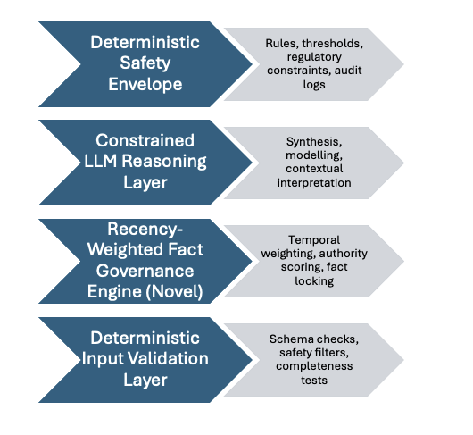

5. NOVEL CONTRIBUTIONS
The framework introduces several first-of-its-kind elements:
- Recency-Weighted Fact Governance
- A structured mechanism for temporal relevance — something LLMs cannot do natively.
- Deterministic–LLM Fusion for Safety-Critical Use
- A hybrid architecture that treats LLMs as constrained advisors, not autonomous agents.
- A Systems-Engineering Discipline for AI Safety
- A new field: AI Safety Engineering for Hybrid Reasoning Systems.

6. APPLICATIONS
This architecture is directly applicable to:
- Defence mission planning
- Aviation operations
- Energy grid stability
- Emergency response
- Medical triage support
- Regulatory compliance automation
- Infrastructure risk modelling
Any domain requiring traceability + intelligence benefits.

7. IMPLEMENTATION ROADMAP
- Phase 1 — Define deterministic rules and safety envelopes
- Phase 2 — Build the recency-weighted fact engine
- Phase 3 — Integrate LLM reasoning with constraint wrappers
- Phase 4 — Develop safety cases and validation protocols
- Phase 5 — Deploy into controlled operational environments

8. CONCLUSION
This white paper introduces a novel, practical, and regulator-aligned architecture for deploying AI in safety-critical environments. By combining deterministic logic with constrained LLM reasoning and recency-weighted fact governance, the Cervenjak Hybrid Reasoning Architecture provides a safe, traceable, and powerful foundation for the next generation of AI systems.
This is not just a framework, it is the beginning of a new discipline.

ABOUT THE AUTHOR
Timothy Cervenjak is an executive-level technical leader with deep expertise in systems engineering, risk management, and safety-critical decision frameworks. His work bridges deterministic engineering principles with modern AI capabilities, defining new standards for safe, auditable, and high-assurance AI architectures.

