CURRICULUM VITAE

ER. EKTA

Mobile no: 9818863647

Email ID: ektasaha2009@gmail.com

Boring road
Patna (BIHAR)

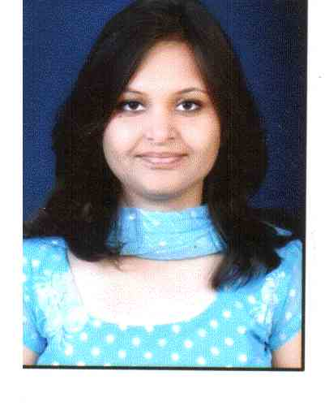

CAREER OBJECTIVE

I am willing to go in an environment, which will enhance my present skills and also prove my capabilities so as by performing on that platform to obtain challenging position in a professional organization.

WORK EXPERIENCE (7 Yrs.)
I have qualified UGC net in may 2019 .

I am working as an Assistant Prof. in Electronics & Telecommunication Dept. at SURABHI & SATYAM GROUP of INSTITUTIONS from 21 May 2014 to 30 Dec 2018

I have worked as a Lecturer from 10 AUGUST 2010 Electronics & Telecommunication Dept. at BANSAL INSTITUTE OF RESEARCH &TECHNOLOGY, BHOPAL (MP) till 20 JANUARY 2012.
EDUCATIONAL QUALIFICATION

COLLEGE | NAME OF UNIVERSITY | DEGREE | YEAR OF PASSING | PERCENTAGE
Lovely professional University | Lpu, Punjab | Phd | Running
Trinity College of technology | RGPV, bhopal | Mtech(vlsi) | 2015 | 84.5
Proff ram Meghe institute of technology and research | Sgbau, Amravati | B.e | 2010 | 65

CORPORATE TRAINING
- Training in html by itemage.
- Css, javascript by Itemage.
- Asp.net training by itemage
- Two weeks training at BSNL Patna

Technical Languages | Basic knowledge of C, C++ languages, html ,Css JavaScript, Asp.net

Research papers  2 International Papers Published

- Published an international research paper on Hyper-Spectral image processing.

- Published an international research paper on Floating point multiplier.

Thesis

- A Low Power Floating Point Multiplier using Column Bypass Technique.

UG Project & Seminar

- Project on three dimensional solar tracking system

- Seminar on wireless electricity transmission

PERSONAL DETAILS

Date of Birth: 29th December 1987
Fathers Name BINOD KUMAR SAH
Nationality Indian
Religion Hindu
Marital Status: Unmarried
Gender: Female
Languages Known: Hindi, English, Panjabi
Hobbies: Reading, Writing poems, Skating
Permanent Address: C/o Sri Binod Kumar Sah ,boring road, Patna

DECLARATION

I hereby declare that the information and facts stated above are true and correct to the best of my knowledge and belief.

Place: Bhopal Er. Ekta

