Cirriculum-Vitae

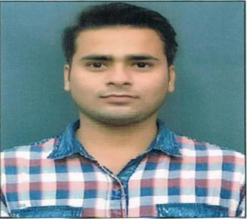

Name:MAYANK MANI PANDEY
Quant/Physics Trainer at EDUQUEST, Gurgaon
Address : CIMAP, Nagla dairy farm Pantnagar
U.S.Nagar(U.K.) 263149
Mobile : +91-9319255666,7408876022
Email : vips.mmp@gmail.com.

CAREER OBJECTIVE

Seeking a position to utilize my knowledge,skills and abilities in competitive environment and gain knowledge to exposure upcoming technologies while being resourseful,innovative and flexible.

EDUCATIONAL QUALIFICATION

Done M.tech inThermal Engineering in 2018 and secured “FIRST” division from

Faculty of Technology U.T.U. Campus Dehradun Affiliated to Uttarakhand Technical University Dehradun(UK).
Done B.tech in Mechanical Engineering in 2016 and secured “FIRST” division from

Uttaranchal Institute of Technology Dehradun Affiliated to Uttarakhand Technical University Dehradun(UK). With Internship from Century Pulp and Paper Lalkuan Nanital(UK).

Passed High school in 2009 with First Division from Campus School Pantnagar affiliated to CBSE.

Passed Intermediate in 2012 with First Division from Campus School Pantnagar affiliated to CBSE.

WORKING PROGRESS ON RESEARCH PROJECTS

Investigated “Parametric optimization of system parameters of impingements jets solar air heater with multiple protrusion arc obstacles” for M.Tech Research
Thesis.(Published in IRJET Journal in August 2018)

Made Project “Replantation of trees using mechanical hydraulics combination” in B.Tech.” (Published in IRJET Journal in July 2018)

PROFESSIONAL SKILLS

Student / Career counselling
Lesson Plans
Teaching offline and online
Content development
Moral Educator
Personality development training
Quantitative Aptitude Trainer
Trainer for test preparation such as SAT/PSAT/AP/GMAT/GRE
Content expert for Science/Maths upto secondary level & Physics for senior level.
E- learning,tech Savvy.

EXPERIENCE

- Done Summer internship in Century Pulp & Paper,Lalkuan,Nainital(UK) in the Maintenance and Safety Dept.

- 3 years experience of teaching in Apex academy vasant vihar Physics, Chemstry and Mathematics.
- Working as a faculty for MATHS /PHYSICs in Eduquest,Gurgaon since July 2018.

- Worked as a Subject Matter Expert of physics/mechanical in Graveiens Edu services Pvt.ltd Noida.

HOBBIES

Cooking

Singing.

Reading.

PERSONAL DETAILS

➢ Name | : | Mayank Mani Pandey
➢ Father Name | : | Mr. L P Pandey
➢ Date of Birth | : | 01/01/1994.
➢ Gender | : | Male.
➢ Languages Known | : | Hindi & English.
➢ Marital status | : | Unmarried.
➢ Nationality | : | Indian

Dated :

Place : Pantnagar (MAYANK MANI PANDEY)

