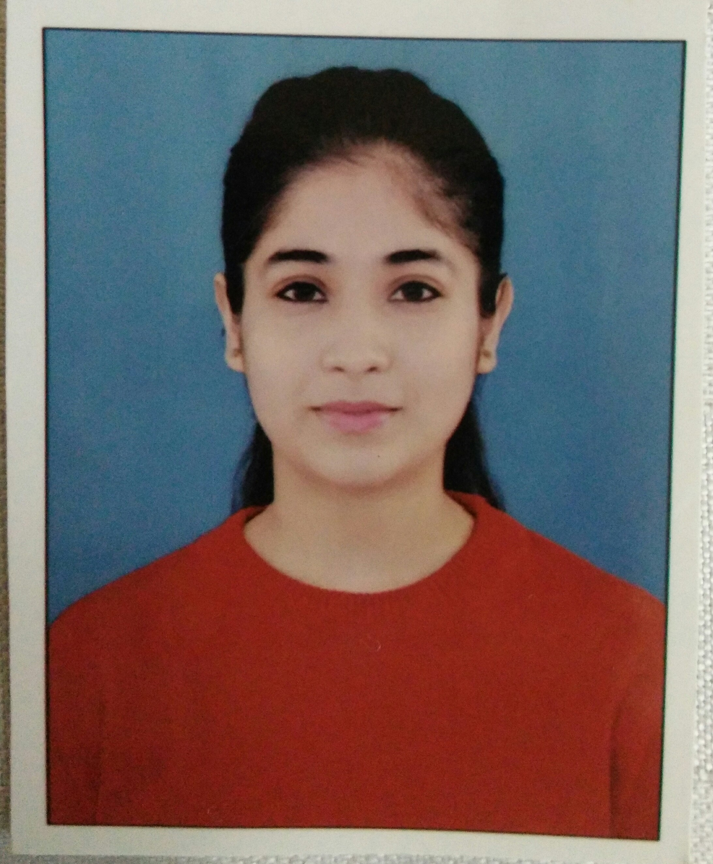

# SHIV SHAKTI MEHRA

**Contact No: - 7982130321, 8629862049**

**E-mail:-** [**mehra.shivshakti1996@gmail.com**](mailto:mehra.shivshakti1996@gmail.com)

## CAREEROBJECTIVE

Looking for the best job of relationship manager in fast paced environment where I can get chance to expand my learning, knowledge and skills. I look forward to develop and foster the appropriate skills and social abilities to enable the optimum development of the organization. Willingness to perform with customer service oriented organization with my ability to motivate coworkers and strong leadership qualities.

## BASIC ACADEMICCREDENTIALS

|  |  |  |  |
| --- | --- | --- | --- |
| **Qualification** | **Board/University** | **Year of passing** | **Percentage** |
| PhD in English | Manav Rachna International Institute of Research and Studies | Pursuing |  |
| M.A. ENGLISH | St. Bede’s College, Shimla | 2019 | 67% |
| B.A. ENGLISH  HONOURS | St. Bede’s College, Shimla | 2017 | 7.51 CGPA |
| 12th Standard | C.B.S.E  St. Joseph’s Convent, Faridabad | 2014 | 67% |
| 10th Standard | C.B.S.E  St. Joseph’s Convent, Faridabad | 2012 | 8.0 CGPA |

**ACHIEVEMENTS**

* TEFL/ TESOL certified from Asian College of Teachers, New Delhi.
* Paper got published for an International Conference on Resistance and Assimilation on 30th January, 2020.
* □pper of the college in M.A. English in 2017.
* Class representative of M.A. English.
* Participated in a symposium organized by UGC Centre for Australian and New Zealand Studies.
* S.S. Volunteer from 2015 to 2017.
* Won second prize in self composed poem competition on the occasion of ‘Hindi Divas’ in the year 2016 and 2017 consecutively.
* ‘Best poster of the day’ in Poster making competition on the occasion of breast feeding awareness day.(2015)
* Won 1st prize in self-composed poetry on the occasion of ‘Hindi Divas’ in year 2014 and 2015 consecutively.
* Won 1st prize in the Quiz Competition held on the occasion of Rabies day at St. Bede’s College. The Competition was sponsored by Indira Gandhi Medical College, Shimla.(2014).
* Miss Fresher first runner up 2014 at St. Bede’s College, Shimla.
* Won a bronze medal in ‘boogie-woogie’, a dance show in2002.
* Won 2nd prize in a Tee shirt designing competition hosted by Pearl academy, New Delhi(2015).
* A monthly magazine ‘Haryana Tarang’ published my self- composed poem “Ek Chehra” for their issue.
* Participated in a Hindi play ‘Chief ki dawat’ in 2011 which was also telecasted on national television.

## WORK EXPERIENCE

* Working as a home tutor since one year as an ESL trainer
* Worked as an intern in the **Times of India** under senior editor Mr. Saurabh Banerjee from January 6, 2016 to February 4, 2016.
* Secretary, Remedial Classes at St. Bede’s College which involves teaching underprivileged children in the college campus from 2015-16.

## INTERPERSONALSKILL

* Creative and innovative
* Public speaking
* Active listener- willing to learn and listen.
* Adaptability and tolerance
* Confident and determined
* Strong drive to success: Goal-oriented and Results driven

## PERSONALDETAILS

* + **Father’s Name : - Mr. Rajesh Mehra**
  + **Permanent Address :-1-A/118,NITFaridabad(121001)**
  + **Date of Birth : - 19 January,1996**
  + **Language Known : - Proficient User of English, Hindi and German.**

**Basic knowledge of French.**

* + **Marital Status : -Single**
  + **Nationality/Religion : -Indian**

**INTERESTSANDHOBBIES**

* Reading (Books, Blogs and Newspaper)
* Writing (Poems and stories)
* Dancing and Singing
* Badminton
* Yoga, meditation and aerobics
* Web designing
* Textile designing

## DECLARATION

I do hereby declare that the above information is true to the best of my knowledge**.**

## Place: Faridabad Shiv Shakti Mehra

**Date: February 25, 2020**