Kickstarter Analysis

Overview and Analysis of Project.

Louise a Theater enthusiast has had a desire to “kickstart” a production. In order to be successful, she approached her team to do a deep dive analysis, based on the industry data on what creates a successful campaign. On her first analysis, Louise fundraising for her play “fever” was successful. However, in order to continue her success, Louise has tasked her team to research with the objective of knowing how different campaigns did in relation to launch dates and funding goals. The results of this analysis will keep her on track to aid in launching of her play “Fever”.

Analysis and challenges

In order to get an accurate analysis of start dates, we had to sift through general data. We found that by generalizing “kick starters”

we were not able to justify the best Launch date. For example, While

some launch dates were successful within a generalized timeline, others

were not because of industry or country.

Analysis based on launch date.

Our analysis based on Lunch dates proved to be significant. We found that between the 1st and 3rd quarter the ratio between successful launch Dates and Failed Launch dates grew apart. Successful Launch dates grew and peaked in the 2nd quarter while maintaining a great success rate into the 3rd Quarter. We saw a sharper decline in success during the 4th Quarter. However, the success rate was better than the failed rate. The best way we were able to visualize a more accurate picture was to be more specific in our analysis. Separating theaters by Launch dates proved to be the best. We saw that we were on an accurate path, but more importantly we were able to be certain on our potential Lunch dates.

Analysis of Outcomes based on Goals.

During this research we decided to look at the quantitative aspect to minimize any failures. We filtered out our data into categories that gave us a better look at outcomes based on the total of numbers and percentages. According to the chart, one can find that the number of success dwarfed the failures by 75% when the goals for funding were less than $1000.00.

We were able to see the direct correlation to rise of failures. With each goal getting higher, so was the percentage of fails. As a result of the different research we did, One can see that the better success range are goals that were under the ten-thousand-dollar goal.

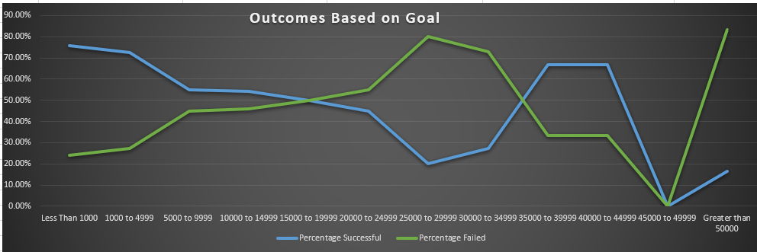

Challenges and Difficulties

There are a few challenges one can face while narrowing

data for a desired outcome. It is possible to come to results that may have outliers and thus skew the results. Another challenge and difficulty may be by assuming the same timeline would work in different countries not considering the special events that may surround that timeline. It may be best to analyze data in various industries to link potential information topics that could lead to a successful result.

Results

In conclusion: there are main highlights that can be drawn from our “Theater Outcomes by Launch Date” chart. For example, it is a great chart to compare numerical results and visualize your success and failed outcomes based on the month of the year. Secondly, we can draw two conclusions from this data set. First, it allows a more accurate approach to choosing a Launch date. Secondly, having the ability to be industry specific, creates a more thorough analysis. However, a potential limitation would be, not being able to know what day of the month the best Launch date is. A recommendation would be to not only to visualize the most successful day but the best time of the day.