Molecular BSA Immunodection Lab
Roy Ronalds and Jackie Lex
February 10th, 2005

Abstract

Antibodies can be used as a very specific tool to test for the presence of a unique structure on proteins. A Coomassie blue staining of a Gel Electrophoresis was used to determine the molecular weights of the proteins present in a sample that came from a Drosophila Larvae and two samples of Bovine Calf Serum in a 1 to 100 and 1 to 1000 dilution. Next a western blot of an identical Gel was used to attach the proteins to a membrane. The proteins were then probed with Rabbit Anti-BSA antibody and the membrane was washed with Alkaline phosphatase conjugated goat anti-rabbit IgG antibody, which selectively attached to the Rabbit Anti-BSA antibody and acted as a reporter, showing the locations on the membrane where the rabbit antibody bound to a positive match. The membrane showed the presence of two proteins homologous to BSA, at locations equivalent to 69 kD and 56 kD. Of the two, only the 69 kD band was also apparent in the 0.1% dilution. The 69 kD band indicated the presence of BSA in BCS, as well as a 56 kD BSA homologue.

Introduction

The central of dogma of biology consists of DNA to RNA to protein. This dogma essentially represents gene expression. Genes code DNA sequences, which in turn polymerize RNA. RNA is then transcribed to proteins based on the sequence the gene is coding for. The study of genes and gene expression has been a so called “hot spot” for scientists in the last few decades. Over the years, several techniques have evolved allowing for such studies.

Since proteins ultimately come from genes (DNA), one way to identify possible genes is through protein analysis, typically done via Western Blotting. Western blots are used to identify specific proteins, based on the presence of a particular amino acid sequence. (Weaver, 2005)This is not a quantitative technique. ELISA is an alternative to Western blotting that does allow for protein quantification. In order to do a Western blot, protein extracts are required. (Ream & Feild, 1999)

Several techniques are available for separating proteins. SDS gel electrophoresis has been used to separate molecules based on the respective molecular weights. SDS creates molecules with uniform charge and allows for the migration of these particles down a gel via electric conductivity. (Garrett & Grisham, 2005) Most times molecular weight standards are used for a baseline on migration related to molecular size. (Ream & Feild, 1999) Different bands develop which correspond to a different sized molecule. The thicker and more pronounced a band is typically is an indication of the prevalence of that molecule in the sample of interest. This is not a quantitative technique.(Weaver, 2005)

Detection of the protein molecules on the SDS gel becomes crucial. It does not help to separate proteins and not be able to see these proteins. Again, several techniques are available that allow for protein detection. (Weaver, 2005) Using stains such as Coomassie blue allow for a researcher to see the protein bands on a gel. (Ream & Feild, 1999) Such dyes/ detectors attach to the molecules of interest, producing a colored band where that molecule is present. This allows for detection by the naked eye. (Weaver, 2005)

It can also be of interest to know specifically which proteins are being transcribed (rather than just simply whether or not transcription is occurring). This is where the aforementioned Western blot can be applied. A SDS gel is run, and proteins are separated. Once separated, the gel is placed in an apparatus that allows for the transfer of the proteins from the gel to a membrane. Membranes can be made of various materials such as nitrocellulose. (Weaver, 2005) Proteins transfer from the gel to the membrane based on charge and electrical conductivity through the gel and membrane. Movement occurs from negative to positive. The membrane is the subjected to immunoassay techniques for specific protein identification. (Ream & Feild, 1999)

During immunoassays, proteins act as antigens to antibodies. Antibodies bind to antigens usually quite specifically based on amino acid sequencing, and allow for cellular detection and ultimately, destruction. (Weaver, 2005) During immunoassay, known proteins act as these markers, or antigens, to antibodies known to recognize such antigens. Typically, primary and secondary antibodies are used to get specific identification of particular proteins. Dyes or detection markers are added during these techniques to allow for detection. (Ream & Feild, 1999)

Materials and Methods

Protocol 1: Surface sterilization of Larvae
Wash 35 Drosophila Larvae of about 5 days in age sequentially in EBR solution for 1 min, then 70% Ethanol for 1 min, and then transfer to EBR.

Protocol 2: Preparation of protein samples for SDS PAGE
Transfer larvae to 200 microL of cold EBR, then add another 100 microL. Thoroughly grind larvae to a paste. Centrifuge for 1 minute at top speed in a microcentrifuge. Transfer the supernatant to a clean microcentrifuge tube and discard the pellet. Transfer 200 microL of the supernatant to another microcentrifuge tube, keeping the remainder in preparation for protocol 3. Add 100 microL of 3X SDS-Laemmli sample buffer, mix, and store on ice.
Prepare BCS samples by diluting BCS with distilled water to make 500 microL of 1% and 0.1% samples in separate tubes. Transfer 200 microL of each to new microcentrifuge tubes and add 100 microL of the sample buffer. Mix and store on ice, keeping the remainder of the samples for protocol 3.
Heat the three tubes containing the Laemmli-SDS sample buffer for 90 sec in a boiling water bath and store at -20 degrees.

Protocol 3: Bradford Protein Assay
Place six 5 mL tubes labeled 0, 20, 40, 60, 80, and 100 micrograms in a rack, adding the appropriate volume of 2 mg/mL BSA standard protein solution to each. Add three more tubes labeled Drosophila, 0.1% BCS and 1% BCS. Place 10 microL of the Drosophila supernatant and the 1% and 0.1% BCS samples into each, respectively. Bring the volume of every tube up to 100 microL with distilled water. Add 3 mL Coomassi Blue protein assay dye. Let stand 15 min. Read the OD595 of the BSA samples in the spectrophotometer. Prepare a standard curve from the known samples and the OD595 values. Read the OD595 of the Drosophila and BCS samples.

Protocol 5: Transfer of proteins to membranes (Western blotting)
Place gels in apparatus. Load samples from each group and markers into the wells. Add ~125 mL running buffer to inner chamber and 200 mL to the mini tank. Electrophorese at 100 V for ~1 hour until the tracking dye reaches the bottom. Remove gel plates. Place on getl in a dish with Coomassie Blue stain covering the gel. Cover. Shake for an hour. Pour out stain and destain with water for ½ hour and check for bands. Removed other gel plate and Blot at 100V for 1 hour. Transfer the membrane to a staining box and cover with Poinceau S stain. Allow to stand for several minutes. Rinse membrane with distilled water until no more stain washes off. Wrap membrane and store at 4 degrees C.

Results

The experiments completed worked to separate and identify proteins in a given sample. Figure 1 below depicts the standard curve obtained from the OD₅₉₅ readings. The equation of the line was calculated and used to determine the protein concentrations of the three samples: Drosophila, 1% BCS and 0.1% BCS.
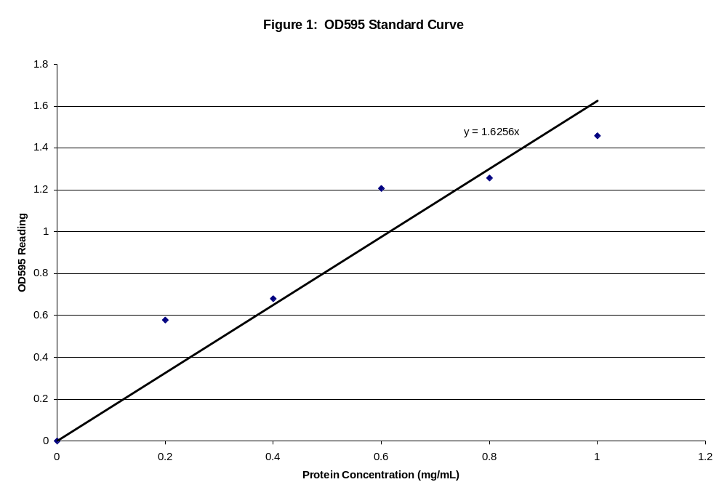
Figure 1: OD₅₉₅ Standard Curve
Dilutions of BSA protein samples were made and a Bradford assay conducted for these dilutions. Dilutions contained 0, 20, 40, 60, 80, and 100 μL of BSA standard protein solutions, and all were brought to 100 μL with distilled water. Bio-Rad protein dye was used added to each dilution, and the OD₅₉₅ readings were taken in a spectrometer. These values were used to construct the curve seen in this figure. The curve is used to determine the protein concentrations of the unknown samples, Drosophila, 1% BCS, and 0.1% BCS.

Figure 2 illustrates the SDS-Page gel done based on the data obtained in figure 1. Part (a) of this figure depicts the Coomassie Blue staining. Lane 1 represents a marker lane, lane 2 the protein extract from the Drosophila larvae, lane 3 the 1% BCS sample, and lane 4 the 0.1% BCS sample. Part (b) depicts the membrane from the Western Blot. In this membrane, lane 4 represents the marker gel, lane 3 the 0.1 % BCS, lane 2 the 1% BCS and lane 1 the Drosophila sample. In this figure, it is observed the 1% BCS contains more protein than either 0.1% BCS or Drosophila.
The marker lanes on the western blot membrane were measured and used to construct the standard curve shown in Figure 3. The Drosophila protein band traveled 2.8 cm. The BCS 1% revealed four bands, which traveled 0.7 cm, 2.3 cm, 2.7 cm and 4.4 cm. The BCS 0.1% protein band traveled 2.2 cm.

As can be seen by the trend line in black, the figure nicely depicts in the inverse relationship of molecular weight and distance of protein migration.

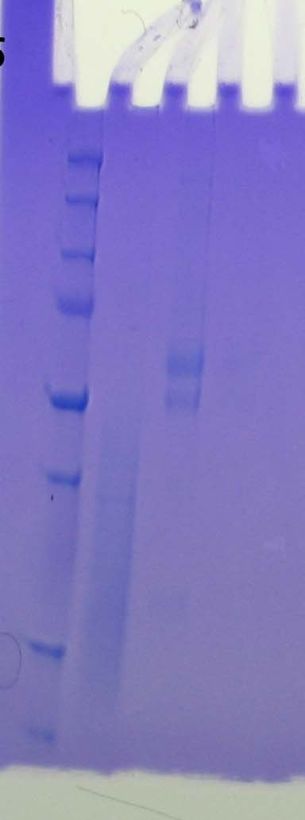(a) 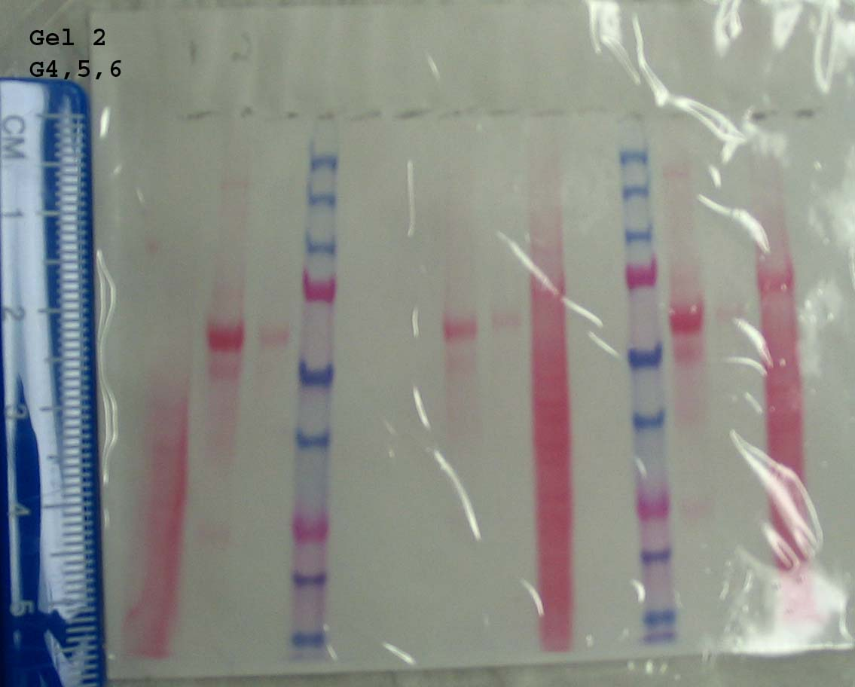(b)
Figure 2: SDS Page Gels
Figure 2 depicts two SDS-Polyacrylamide gel electrophoresis run on separating and stacking gels for one hour at 100 V. One of these gels was stained using Coomassie Blue to detect protein samples, which is shown in (a). Lane 1 (at the far left) shows molecular weight markers. Lane 2 is the drosophila protein extract. Lane 3 shows 1% BCS protein sample, and Lane 4 depicts 0.1% BCS protein sample. In Lane 4 the protein band is difficult to discern. The other gel run was transferred to a membrane (shown in (b)) via Western blotting. The gel was placed in the Western blot apparatus and blotted at 100V for 1 hour. Once blotted, they membrane was placed in a staining box and covered for several minutes with Poinceau S stain. On this membrane, Lane 1 depicts Drosophila protein extract, Lane 2 1% BCS sample, Lane 3 0.1% BCS sample, and Lane 4 shows molecular weight markers. This membrane was used to measure and construct a standard curve. Both the gel and membrane were stored at 4ºC. The Drosophila protein band traveled 2.8 cm. The BCS

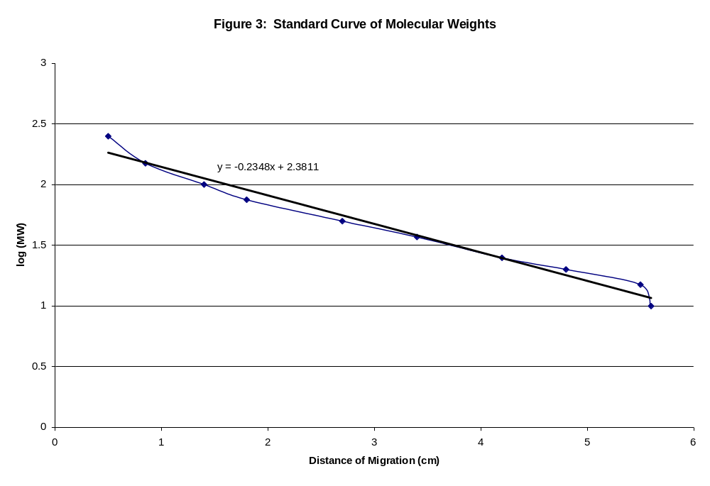
Figure 3: Standard Curve of Molecular Weights
The molecular marker lanes on the Western blot membrane seen in Figure 2 were used to construct this curve. Starting from the bottom of each well, which was marked on the membrane, the distance to the center of each band was measured in cm. The molecular weights of these bands were known, making the construction of the logarithmic curve possible. This standard curve provided the basis to determine the size of the protein bands observed in the unknown samples, Drosophila, 1% BCS and 0.1% BCS.

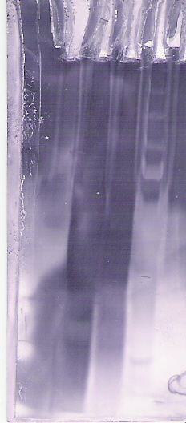(a) 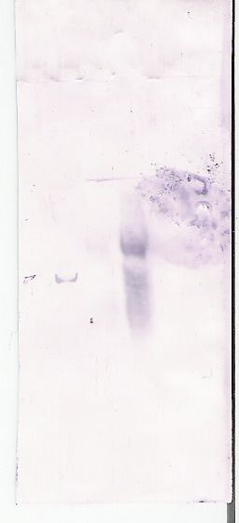(b)

Figure 4: Immunoassy of Western blotted proteins
This figure shows the Western blot membrane after subjected to immunoassay. Lane 1 is the Drosophila sample, Lane 2 1% BCS, Lane 3 0.1% BCS and Lane 4 is the marker lane. Figure 4(a) shows the front of the immunoassay membrane. The stain is very dark and makes band desertion difficult. It was observed that the back of the membrane showed the stained bands much more clearly. This is represented in Figure 4(b). There are two bands present in the 1% BCS sample, and one present in the 0.1% BCS sample.

Immunoassay of the western blot membrane returned the membrane seen in figure 4. The standard curve in Figure 3 was used to determine the molecular weights of these protein bands. As seen in the figure, only three bands are present, two in the 1% BCS lane which traveled 2.3 cm and 2.7 cm, and one in the 0.1% BCS lane which traveled 2.3 cm. No bands were observed in the Drosophila sample. The absence of bands suggests the given sample contained no proteins recognized by the anti-BSA antibody.

Discussion

This experiment was focused on separating proteins and identifying BSA protein. Protein separation involved the Drosophila larvae. Bradford Assay was used to determine the protein concentrations of the three unknown samples (Drosophila, 1% BCS and 0.1% BCS). Expected results were around 0.3 mg/mL for the protein concentration of Drosophila. According to the standard curve in Figure 1, the observed protein concentration was 0.18 mg/mL. This is a significant difference, probably due to an over-dilution when preparing the protein extract from the Drosophila larvae. The Coomassie blue stain still confirms the presence of protein in the Drosophila larvae, however, so the remaining results should not have been very skewed by this incorrect dilution.
Immunoassay revealed the presence of the BSA protein (or a protein with a very similar sequence to that of the BSA protein) in only the BCS protein samples. This was in accordance with expected results. It would be expected that bovine serum albumin protein would be found in bovine calf serum, since BCS is in fact bovine serum derived from calf. The 1% BCS protein sample showed two bands during immunodetection. Based on the curve in Figure 3, these bands traveled in accordance with proteins of molecular weights of 69 kD and 55.9 kD. According to an article in the periodical Biopolymers, BSA has a molecular weight of approximately 66 kD. It is therefore probable that the larger band in the 1% BCS contained BSA protein given its molecular weight. In the same location as the 1% BCS, the 0.1% BCS faintly showed one band indicating a protein of 69 kD. According to the protein standard curve, the first band protein registers slightly larger than would be expected for BSA, most likely as a result of variations in the movement through the gel affecting the distribution of the proteins that made up the standard curve. The band with the much smaller molecular weight of 56 kD was probably not the actual BSA protein. It is more likely that band 2 protein has a sequence homologous to that of BSA. During immunoassay, the antibodies are able to recognize the protein based on given amino acid sequence and resulting structure. A recognizable sequence, present in BSA, may also exist in other proteins. Proteins that have a similar enough sequence will cause antibody binding and consequently antibody detection. Since this smaller band was detected, its sequence must be close enough to that of BSA to still induce the rabbit anti-bovine serum albumin Ab to bind and, as a result, to allow the alkaline phosphatase conjugated goat anti-rabbit IgG Ab to bind.

This provisional specificity of immunoassay results in the detection of false positive proteins if their sequences are similar enough to the desired protein, but rules out the majority of proteins that lack similar sequences. This allows for exclusion of other proteins otherwise seen as possible candidates due to the results of the gel electrophoreses and staining. This is exactly what is seen with the BCS samples; Coomassie blue staining revealed a total of five protein bands for the 1%, and immunoassay eliminated three of these proteins as possible BSA protein (or similar proteins). Further experimentation could be done to test the other two protein bands to determine the probable sequences of these unknown proteins, but the sharp differences in molecular weights points towards the first band at approximately 69 kD being BSA.

As mentioned, the 0.1% BCS protein sample only showed one band during immunoassay, which corresponded to the more distinct 69 kD band observed in the 1% BCS sample. This is further evidence that the second, fainter band seen in the 1% BCS was in fact not BSA protein. Obviously, the protein of the second, 55.9 kD band was less concentrated in the 0.1% BCS. Since the band of the second protein was not observed under less concentrated conditions, it is not very likely this protein was the BSA protein. Similarly, it is also evidence that the larger protein band in the 1% BCS is probably BSA and reacts with the anti-BSA antibody with high enough affinity that it shows up even in the immunoassay of the 0.1% BCS sample.

As indicated by Figure 4, Drosophila showed no antibody recognition among the multiple protein smear observed in the Coomassie blue stain. The Drosophila protein smear seen in the Coomassie blue stain had faint protein traces in the 65 kD area (according to Figure 3) even though the strongest protein presence started at molecular weights of 51 kD and lower. Given that the molecular weight of the BSA protein is 65 kD, this protein band was a candidate for showing the presence of BSA in Drosophila. Immunoassay eliminated this possibility. Although the protein the Drosophila sample was similar in molecular weight to BSA, the actual amino acid sequence was not. The absence of the band in the immunoassay implies the sequence of that protein was not close enough to the BSA protein to even be recognized as a homologue by the rabbit anti-bovine serum albumin Ab. Since that antibody did not bind to the protein, neither would the second antibody, since that antibody binds to the rabbit anti-bovine serum albumin Ab.

Literature Cited

Garret R. H., & Grisham, C. M.. (2005). Biochemistry Third Edition. California: Thomson Brooks/Cole.

Ream, W., & Feild, K. G.. (1999). Molecular Biology Techniques An Intensive Laboratory Manual. New York: Academic Press.

Weaver, Robert F. (2005). Molecular Biology Third Edition. New
York: McGraw Hill.

Grdadolnik, J., Marechal, Y., (2001).
Bovine Serum Albumin observed by infrared spectrometry. I. Methodology, structural investigation, and water uptake, Biopolymers, 62, 40-53.
Retrieved February 10, 2005, from www.ncbi.nlm.nih.gov

