The Steamrolling Engine for War

Roy Ronalds

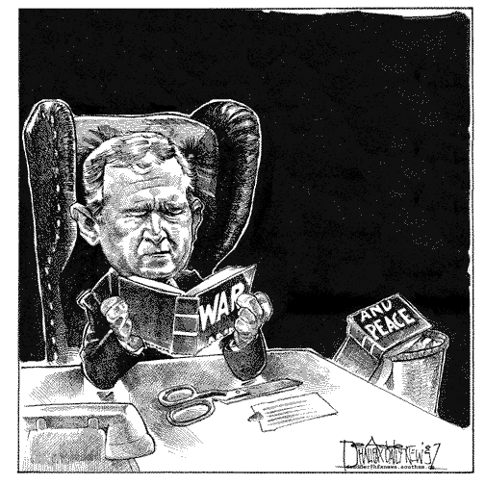

The subtle encroachments upon civil liberties as a result of the September 11th tragedy, brought about as a part of the stopgap erection of defenses just too slow and offensives just a bit too quickly, are less important, though no less notable, in their effects upon the relatively small group of individuals who had their freedoms directly and pervasively taken, than in the reversing of egalitarian trends, most of which have been brought about under the direction of the Bush administration.
The Bush Administration and President Bush in particular has gained an arena of what has so far been relatively unshakable and unopposable support after 9-11 for policies and actions, a drastic change from the level of support prior to the attacks. The administration has subsequently been able to implement policies, not abnormal for wartime, which have restricted and done away with certain personal freedoms. These losses have not affected such a large group as to be a concern of paramount importance to the American Public. More relevant and subtle is the fact that this anti-terrorism support has been extended seemingly unconditionally to the Bush Administration beyond issues relating to the original event, a fact that is being used to advance unrelated agendas. The strength of the Bush Administration’s position on defense is also being used to steamroll all other issues and viewpoints into obscurity and inconsequence. As Charles Krauthammer said of the 2002 midterm elections:
“What single issue proved the most politically deadly in this campaign? A bill to create a Department of Homeland Security. Who'd have thunk it? It had the appearance of mere bureaucratic shuffling. It had none of the drama of the war-and-peace Iraq vote. Democrats figured they could safely block the bill over a dispute about job protection. Big mistake. Republicans made the issue into a surrogate for post-9/11 national security. Everyone supports the war on terror. The homeland-security bill, however, made the platitude concrete by asking the question: Are you ready to put antiterrorism above everything else, even such desirable things as workers' rights?”
<<It’s the Terrorism, Stupid>>

As a result of this lack of a major opposition to the administrations policies, certain civil liberties have been curtailed, a small but telling effect of this new and diffuse war on “Terror”. The new creation of a nation-wide surveillance agency is less ominous for it’s own sake of the privacies that it might step on than for it’s indication of an undoing of the increased rights to individual privacy that have been advanced in the recent era of government. From the ability for suspected terrorists to be detained by border police without “due cause” to racial profiling to the creation by presidential order of military tribunals able to execute non-citizens in secret by majority vote, there are small instances
of the degradation of the freedoms that have come about due to the advancement of domestic security issues <<A Chain Reaction>>.
Even more important, however, is Bush’s powerful swelling of support, both from the American public and from congress, evinced both in the American people’s continued backing of Bush’s advancement from war in Afghanistan to war upon Iraq, and their support of his party as evinced in the recent sweep of the GOP overcoming the democratic party to unify both houses of congress under his rule, an event that seemed to be to a large degree fuelled by Bush’s influence and visibility in the campaigning itself.
The present expansion of the Bush Administration to encompass the main bases of power in the executive, legislative, and judicial are of the government is another aspect of this growth of power. The results of the midterm election bring into question whether the principles of checks and balances can be upheld if all branches are followers of the same general interest group, holding the same goals in common, and in essence the same man ruling all three groups. The USA patriot act, passed only a month and a half after the event itself, in a legislature that can take years to deliberate, is simply another example of the solidarity shown for Bush’s administration, and while the changes to policies of surveillance were relatively mild, they shows the willingness of the legislature to go with the public support for Bush so far as to begin curtailing individual freedoms, and should therefore indicate a need to closely watch the actions of the legislature and other arms of the government in their support for the Bush Administration.<<USA Patriot Act>>
Instead of advancing the policies through a global forum, the US seems to have shifted to a wish to circumvent, or rather ignore, the concerns of our own allies and other countries, in a thirst for a conclusive revenge for the tragedy of 9-11. In the Bush Administration’s haste to get a undeniable resolution to the “War on Terror,” they are ignoring the fact that when the combat dies down, the previous terrorists may no longer be there, but the world at large will, and we are trampling over any foreign dissent on our way to what may prove a hollow victory <<The World’s Fight>>.
In the modern world, communication and open dispensation of information is like a sword, able to slice its way to the truth, a powerful tool that is often well focused to obtain a goal. However, it can be double-edged, being able to be used to flood concepts and ideas of an interest group out upon the public until it becomes a propaganda effort.
The Bush Administration’s lack of Al Queda Targets, but continuing abundance of support seems to have caused a shift from one target to the next lest the impetus is lost, and where better to focus American than oil-rich, longtime enemy that is Iraq. When Bush was using his support from the American people in connection with enacting a war upon those who were suspected of being behind the bombing, the support thrown behind him for his handling of the issue at least seemed appropriate. Since Bush has now sighted and is attacking a new and unrelated target, however, the same level of intensity and unconditional support seems misplaced. In a speech at a conference in London, Sir Micheal Howard brought to the forefront the problem of the “War on Terror”:
“But to use, or rather to misuse, the term "war" is not simply a matter of legality or pedantic semantics. It has deeper and more dangerous consequences. To declare that one is "at war" is immediately to create a war psychosis that may be totally counterproductive for the objective that we seek. It will arouse an immediate expectation, and demand, for spectacular military action against some easily identifiable adversary, preferably a hostile state; action leading to decisive results. “
<<Stumbling into Battle>>

Supporters of the militarism of the Bush Administration may ride the wave of support of a war on “Fear” onto the battlefield… …in a war extended onto Iraq. And perhaps then a new target will be acquired and demonized, to fuel the machine of support. Bush reacted with an unfocused promise of “War upon Terror,” a concept that is as useful in gaining support as it is vague and misinformative of the truth of war, overlaying the death enacted upon the people on “the other side” with platitudes of Good and Evil. After all, who can champion such an obvious evil as “Terror”?
In the end, it can only be said that the effect of the events of 9-11 upon individual freedoms has been slight, and abuses by the government of extended powers have so far been nearly non-existent, but that no matter how many times such wartime measures have been used when the US was embroiled in a period of conflict, it should be considered no less disturbing, and should never be less closely watched for signs of government’s growth beyond the powers that it is meant to have.

Sources:

It’s the Terrorism, Stupid by Krauthammer, Charles
Time, 11/18/2002, Vol. 160 Issue 21, page 53

Questions for Mr. Bush By George McGovern
Nation, 4/22/2002, Vol. 274 Issue 15, page 7

Stumbling into Battle by Micheal Howard
Harper’s Magazine, January 2002, Vol. 304 Issue 1820, page 13

The World’s Fight by David Little
Christian Century, 2/27/2002, Vol. 119 Issue 5, page 22

A Chain Reaction by Jonathan Schrell
Nation, 12/24/2001, Vol. 273 Issue 21, page 9

USA Patriot Act
Section 106

