AIDL_B_AS01 - Signal Processing, Pattern Recognition and Machine Learning

Assignment #2 - Image Classification (MNIST)

Thodoris Charos mscaidl-0077

- Data inspection and acquisition

Data were downloaded from http://www.di.ens.fr/~lelarge/MNIST.tar.gz

Dataset shape

Training shape: (60000, 28, 28)
Testing shape: (10000, 28, 28)

Range and mean of the raw data to verify centering

Min pixel value: 0
Max pixel value: 255
Mean pixel value: 33.3184

Distribution of original digits (0-9)
Digit | Count | Percentage
-----------------------------------
0 | 5923 | 9.87%
1 | 6742 | 11.24%
2 | 5958 | 9.93%
3 | 6131 | 10.22%
4 | 5842 | 9.74%
5 | 5421 | 9.04%
6 | 5918 | 9.86%
7 | 6265 | 10.44%
8 | 5851 | 9.75%
9 | 5949 | 9.92%
-----------------------------------
Total | 60000 | 100.00%

Image resolution verification

Single image resolution: (28, 28)
Data type: uint8

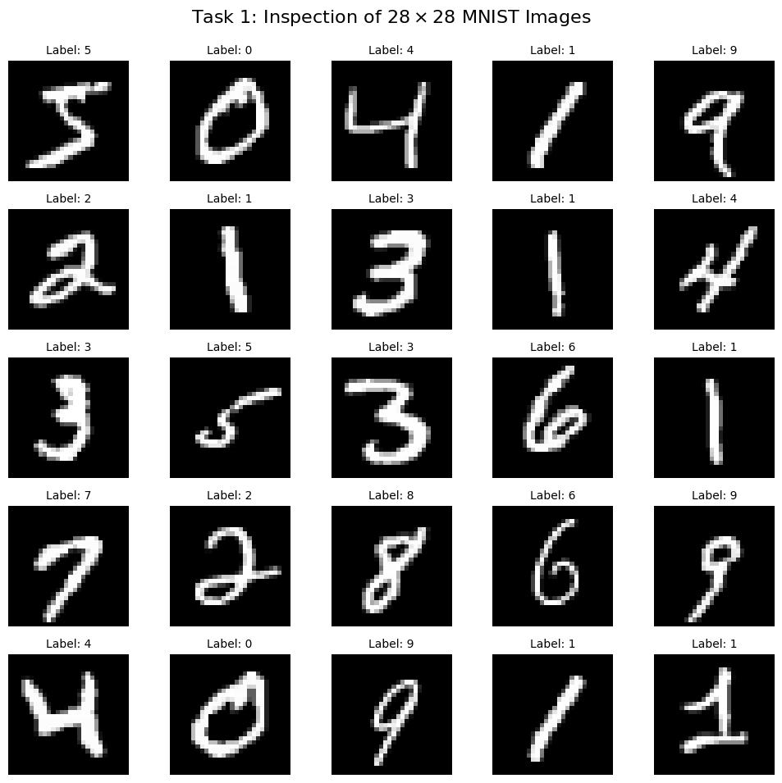
- Data Regroup

Original unique labels: [0 1 2 3 4 5 6 7 8 9]
New unique labels: [0 1]

Split verification

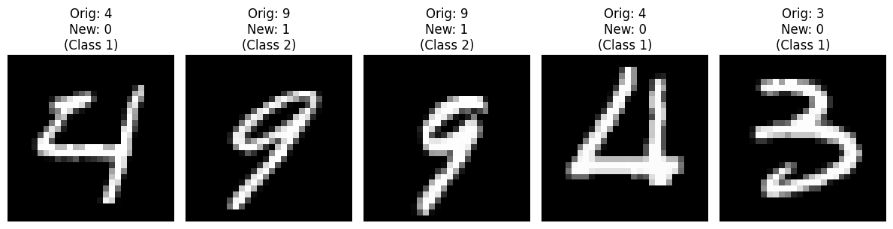

- SVM Benchmark

By applying Flattening (Vectorization) the spatial structure (28*28) is flattened to a 1D feature vector (784 dimension).

By applying Normalization (Feature Scaling) the original grayscale values [0-256] are scaled to the range [0-1] by dividing each value with 256. This helps SVM performance by introducing numerical stability and prevent features with high raw values to bias the SVM kernel calculations.

Hyperparameter C, polynomial degree parameter and Gamma were explored to find the optimal by applying grid search.

- Dimensionality reduction via PCA

- Dimensionality reduction via LDA

- Dimensionality reduction via PCA + LDA

- Naïve Bayes

The Zero Variance Problem
- The Reason: Many pixel areas in the 60,000 training images are identical (constant) across all samples (e.g., the 4 corners of the 28 * 28 image are almost always value 0).
- The Problem: The Gaussian Naïve Bayes formula involves dividing by the variance (σ). If σ^2 = 0, the calculation results in a division-by-zero error or an undefined probability.
Mitigation Strategies
To mitigate this, we can use Variance Smoothing. This involves adding a very small constant (epsilon) to all variances to ensure they are strictly positive. In scikit-learn, this is handled by the var_smoothing parameter. Alternatively, you could remove "constant" features (pixels with zero variance) during preprocessing.

