AIDL CS01 NLP Project
Step-by-Step Walkthrough: Tasks 1, 2, 3 & 5

Task 1 — LSTM Toxicity Detection
This notebook trains an LSTM neural network to classify text utterances as toxic or clean, comparing two different word embedding strategies.

Step-by-Step

Step 1: Environment Setup
Detects whether the notebook is running on Google Colab or locally (Mac). Installs the required libraries accordingly (TensorFlow, transformers, keras, etc.) and sets up the GPU device for PyTorch.

Step 2: Download the Dataset
Downloads three CSV files (train, valid, test) from a GitHub repository containing a toxicity detection dataset of spoken utterances. Each row has a 'text' column and a 'label2a' binary label (0 = clean, 1 = toxic).

Step 3: Text Preprocessing
- Limits vocabulary to the top 10,000 most frequent words.
- Tokenizes each sentence — converting words to integer IDs.
- Pads or truncates every sequence to exactly 60 tokens so all inputs are the same length.
- This produces padded integer matrices X_train_pad, X_valid_pad, X_test_pad ready to feed into the embedding layer.

Step 4: Build the LSTM Model
The same architecture is used for both experiments:
- Embedding layer — converts integer token IDs into dense 100-dimensional vectors.
- SpatialDropout1D(0.2) — randomly drops entire embedding dimensions to prevent overfitting.
- LSTM(64) with dropout=0.2 — processes the sequence and captures temporal patterns in the text.
- Dense(1, sigmoid) — outputs a single probability between 0 and 1 (toxic vs. clean).
- Compiled with binary crossentropy loss and the Adam optimiser.

Step 5: Train with Custom Embeddings
The embedding layer is randomly initialised and trained from scratch alongside the LSTM. The model learns what word vectors are useful specifically for toxicity detection. Trained for 5 epochs with batch size 32, validating on the validation set each epoch.

Step 6: Train with GloVe Embeddings
GloVe (Global Vectors for Word Representation) is a pre-trained embedding file trained on billions of words from Wikipedia and Common Crawl. The notebook loads the 100-dimensional GloVe vectors and builds an embedding matrix that maps the vocabulary words to their pre-trained vectors. The embedding layer is frozen (trainable=False) so these pre-learned relationships are preserved — only the LSTM and Dense layers are updated during training.

Step 7: Evaluate Both Models
Each model predicts probabilities on the test set. Predictions above 0.5 are classified as toxic. The F1-score and a confusion matrix are computed and displayed for both the Custom and GloVe models for comparison.

The Confusion Matrix (Task 1)
The confusion matrix is a 2x2 grid comparing actual labels (rows) vs. predicted labels (columns) for the binary toxicity classification:

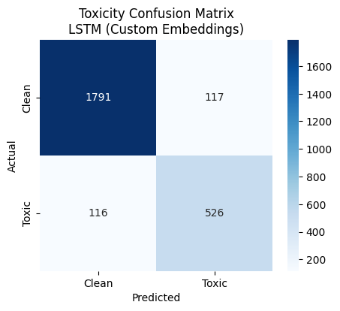

 | Predicted: Clean | Predicted: Toxic
Actual: Clean | True Negative (TN) Correctly said clean | False Positive (FP) Wrongly flagged as toxic
Actual: Toxic | False Negative (FN) Missed a toxic utterance | True Positive (TP) Correctly caught as toxic

The F1-score balances precision (of all utterances flagged toxic, how many truly were?) and recall (of all actually toxic utterances, how many did we catch?). It is the primary metric here because the dataset may be imbalanced — accuracy alone would be misleading if most examples are clean.

Why two models? Custom embeddings learn representations specifically for toxicity but need more data. GloVe embeddings bring in knowledge from billions of words and often generalise better, especially on smaller datasets.

Task 2 — Semantic Sentence Similarity (STS-B)
This notebook fine-tunes three pre-trained transformer models on the Semantic Textual Similarity Benchmark (STS-B), a regression task where the model must predict how similar two sentences are on a scale from 0 to 5.

Step-by-Step

Step 1: Environment Setup
Same environment detection as Task 1. The precision mode (FP32, FP16, or BF16) is chosen automatically based on the available GPU to maximise speed without sacrificing stability.

Step 2: Load the STS-B Dataset
Loads the mteb/stsbenchmark-sts dataset from HuggingFace. Each example contains two sentences (sentence1, sentence2) and a float score between 0.0 and 5.0 representing their semantic similarity. Examples: score 5.0 = nearly identical meaning; score 0.0 = completely unrelated.

Step 3: Define Preprocessing and Training Function
The preprocess_sts function tokenises both sentences together into a single input sequence separated by a special [SEP] token — the standard BERT input format for sentence-pair tasks. The train_transformer function wraps the full training pipeline: load tokeniser, tokenise dataset, load the model with a regression head (num_labels=1), configure TrainingArguments, and run Trainer.train().

Step 4: Train BERT-base-uncased
Fine-tunes bert-base-uncased with a learning rate of 2e-5 and batch size 16 for 3 epochs. The base BERT configuration is used with no modifications. After training, predictions are extracted on the validation set and analysed.

Step 5: Train RoBERTa-base
Fine-tunes roberta-base with a slightly higher learning rate of 3e-5 and a larger batch size of 32. RoBERTa was trained with more data and a more robust pre-training procedure than BERT, so it typically performs better on downstream tasks.

Step 6: Train DeBERTa-v3-base
Fine-tunes microsoft/deberta-v3-base with a conservative learning rate of 1e-5. DeBERTa uses disentangled attention (separate position and content embeddings) and a virtual adversarial training objective, making it one of the strongest BERT-family models available.

Step 7: Compare All Three Models
Pearson and Spearman correlations are computed between the predicted scores and true scores for each model. A confusion matrix is generated for visual comparison. The final cell prints a summary table of all three models side by side.

The Confusion Matrix (Task 2)
This confusion matrix is unusual — and worth understanding carefully. The task is regression (predicting a float 0–5), not classification. To visualise the results in a matrix, the code rounds both the true and predicted scores to the nearest integer, creating 6 buckets (0, 1, 2, 3, 4, 5).

So the axes are not 'Toxic / Clean' but rather the rounded similarity score bins. The diagonal (top-left to bottom-right) represents correct predictions — cases where the model's rounded score matches the true rounded score. Off-diagonal cells represent errors.

Example: True score = 3.7, predicted score = 3.9 → both round to 4 → on the diagonal (correct). True score = 1.2, predicted = 3.8 → rounds to 1 vs 4 → off diagonal (error).

The primary evaluation metrics are not accuracy from the matrix but Pearson and Spearman correlations, which measure how well the continuous predicted values track the true values — these are the standard STS-B benchmark metrics. The confusion matrix is more of a visual diagnostic than a primary evaluation tool here.

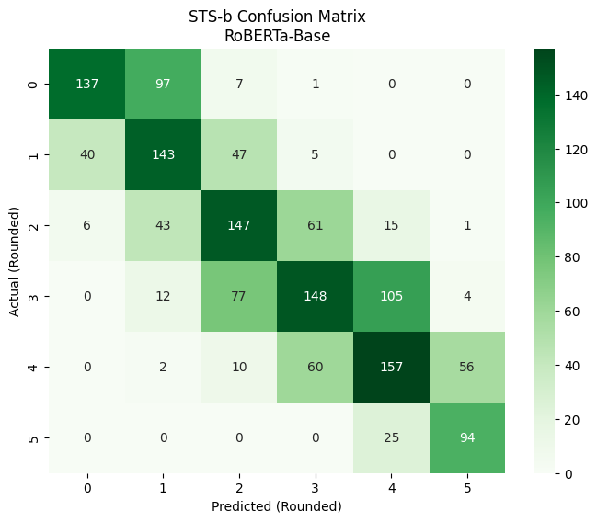

Task 3 — Custom RAG Pipeline
This notebook builds a Retrieval-Augmented Generation (RAG) system from scratch. Instead of relying on a model's built-in knowledge, RAG lets the LLM answer questions by first searching a document for relevant passages, then using those passages as context.

Step-by-Step

Step 1: Load and Segment a PDF
Downloads a deep learning textbook PDF directly from a URL using LangChain's PyPDFLoader. The text is then split into overlapping chunks of 1,000 characters with a 20-character overlap using RecursiveCharacterTextSplitter. The overlap ensures that a sentence split across two chunk boundaries doesn't lose context.

Step 2: Embed the Chunks
Each text chunk is converted into a 384-dimensional numerical vector (embedding) using the all-MiniLM-L6-v2 SentenceTransformer model. These vectors encode the semantic meaning of each chunk. Chunks about similar topics will have vectors that point in similar directions in the high-dimensional space. The embeddings are saved to a .npy file for reuse.

Step 3: Load the LLM and Generate Paraphrases
Loads Llama-3.2-3B-Instruct via Unsloth in 4-bit quantised form to minimise GPU memory. A get_paraphrases function prompts the LLM to rewrite the user's question in 2 different ways. For example, 'what is an RNN?' might become 'Could you explain the concept of a Recurrent Neural Network?' and 'What defines the architecture of an RNN?'. This query expansion improves retrieval coverage — different phrasings may match different relevant chunks.

Step 4: Retrieve Relevant Chunks
For each paraphrased version of the question, the question is also embedded using the same SentenceTransformer model. Cosine similarity is then computed between the question embedding and all chunk embeddings. The top 5 most similar chunks per query are selected, filtered to only keep those with similarity above 0.3 (the threshold), and deduplicated. The final 3 highest-scoring unique chunks are selected as the retrieved context.

Why cosine similarity? It measures the angle between two vectors, ignoring magnitude. Two sentences about RNNs will point in similar directions in embedding space even if they use slightly different words.

Step 5: Generate the Answer
The top 3 retrieved chunks are concatenated into a context block and inserted into a final prompt: 'Use the following context to answer the question. Context: [...] Question: [...] Answer:'. This prompt is sent to the Llama model, which generates an answer grounded in the retrieved textbook passages rather than relying purely on its pre-training knowledge.

Note: There is also a commented-out re-ranking step using a CrossEncoder model, which would score each chunk against the original question more precisely after the initial cosine retrieval. This is a common RAG enhancement but was marked as optional.

There is no confusion matrix in Task 3 — this is a generative task, not a classification task. The output is evaluated qualitatively by reading the generated answer.

Task 5 — DPO Fine-Tuning (Gordon Ramsay Alignment)
This notebook fine-tunes a language model using Direct Preference Optimisation (DPO) to make it respond in the aggressive, colourful style of Gordon Ramsay rather than politely. This is an example of RLHF-style alignment — teaching the model to prefer one style of response over another based on human-curated preference data.

Step-by-Step

Step 1: Environment Setup
Installs Unsloth (for fast quantised training), TRL (for DPO), PEFT (for LoRA), and SentenceTransformers. Verifies GPU availability — DPO training on a 3B model requires a GPU.

Step 2: Prepare the Dataset
The dataset was pre-assembled offline by combining multiple classmates' CSV files into a single test.csv. Each row has three columns:
- Question — a deep learning question (e.g., 'What is backpropagation?')
- Polite — a standard, professional answer (the 'rejected' response)
- Ramsay — a Gordon Ramsay-style answer using culinary metaphors and aggression (the 'chosen' response)

500 rows are sampled for training and 100 rows are reserved for evaluation.

Step 3: Load Llama-3.2-3B-Instruct with LoRA
The model is loaded in 4-bit quantisation to fit on a single GPU. LoRA (Low-Rank Adaptation) adapters are attached to the attention and feed-forward projection matrices (q_proj, k_proj, v_proj, o_proj, gate_proj, up_proj, down_proj). Only these small adapter weights (~1% of parameters) are updated during training — the original model weights are frozen. This is both memory-efficient and fast.

Step 4: Configure and Run DPO Training
DPO (Direct Preference Optimisation) is an alternative to Reinforcement Learning from Human Feedback (RLHF) that is simpler and more stable. Instead of training a separate reward model, DPO directly optimises the language model to prefer the 'chosen' (Ramsay) response over the 'rejected' (Polite) response using a contrastive loss. The beta parameter (0.1–0.2) controls how strongly the model is constrained to stay close to the original base model — lower beta allows more divergence.

Gradient Accumulation: Batch size is 2, accumulated over 4 steps — effectively simulating a batch size of 8 without needing the extra GPU memory.

Step 5: Generate Responses and Evaluate with Cosine Similarity
The fine-tuned model is switched to inference mode. For each of the 100 evaluation questions, the model generates a response. The SentenceTransformer model then computes the cosine similarity between the model's response and the original reference Ramsay-style answer. A high average similarity means the model has learned to produce responses that are semantically close to the target Ramsay style.

Step 6: LLM-as-Judge Evaluation with Prometheus
A separate 7B judge model (prometheus-eval/prometheus-7b-v2.0) scores each generated response on a 1–5 rubric:
- Score 1: Polite, boring, or technically wrong.
- Score 5: Aggressive, uses culinary metaphors (raw, bin it, donkey), and technically correct.

The judge is given the question, the model's response, and the reference Ramsay answer (as a score-5 example). It produces a score and written feedback. The average judge score across all 100 examples is the final quality metric.

Step 7: Save Results
The evaluation dataframe with columns Question, Model_Result, Similarity_Score_Ramsay, and Judge_Score is saved to a timestamped CSV. The LoRA adapter weights (or optionally the full merged model) can be saved and downloaded from Colab.

There is no confusion matrix in Task 5. Evaluation uses two continuous metrics: average cosine similarity to the target style, and average Prometheus judge score (1–5).

Summary: All Four Tasks at a Glance

Task | Goal | Key Technique | Evaluation Metric | Confusion Matrix?
Task 1 | Detect toxic utterances | LSTM + Custom / GloVe Embeddings | F1-Score + Confusion Matrix | Yes (2x2 Clean/Toxic)
Task 2 | Predict sentence similarity score | BERT, RoBERTa, DeBERTa fine-tuned on STS-B | Pearson & Spearman Correlation | Yes (6x6 rounded scores)
Task 3 | Answer questions from a PDF | RAG: chunk, embed, retrieve, generate | Qualitative (read the output) | No
Task 5 | Style-align LLM to Gordon Ramsay | DPO fine-tuning with LoRA adapters | Cosine Similarity + LLM Judge (1-5) | No

