COSC 304 – Introduction to Databases

Final Project Design Document:

Harvest Grocery Store

(26430827)

(41859166)

(54151162)

Stephen Ito-Dyck (26240151)

University of British Columbia

Submitted on November 30, 2019

# 1.0 Introduction

## 1.1 Mission Statement

The goal of our project is to create and implement a system that will be able to let local agriculturists, fishermen and livestock producers sell their products to a wider audience, using a website. We plan to create this website to allow customers to purchase these local goods and have them shipped to their door, all without leaving their house.

## 1.2 Purpose of Document

The purpose of this document is to outline the design requirements and underlying structure used to create Harvest Grocery. This will be done by showcasing a walkthrough of what the user’ experience would be.

## 1.3 Executive Summary

As the internet has become more prevalent in everyday life the number of people that do online shopping has increased. This trend of increased online purchases has had a huge impact on local businesses that depend on nearby residents to sell their products to. If one of these businesses were to create a website to sell their goods, this website would generally have too small of a catalogue to entice people to make purchases from it. Why would the average person make five purchases from different websites when they can make one with all the same products. To counteract this problem, we propose the creation of a single website that can list all the goods produced by local agriculturists, fishermen and livestock producers, Harvest Grocery.

Anyone would be able to browse the products and add them to a cart, however to purchase them the customer would be required to create an account. To create an account the customer would need to provide a first and last name, email, phone number, address city, state, postal code, country, username and a password.

Additionally, employees would be able to login to the website and would be able to view all customers and make modifications. The administrator privileges allow for the addition of new products, addition of a photo for a product, as well as, viewing the total sales/orders.

# 2.0 User Walkthrough

To navigate to our website Harvest Grocery, enter the URL https://cosc304.ok.ubc.ca/54151162/project/ in the web browser of your choice. This will take you to the homepage of our project.

## 2.1 Homepage

Upon visiting Harvest Grocery all users are directed to the homepage, which showcases the current top selling products. From the homepage a user can access the following pages:

* Login
* Begin Shopping
* Shopping Cart
* List All Orders
* Customer Info
* Administrators
* Log out
* Sign Up

## 2.2 Login/Log Out

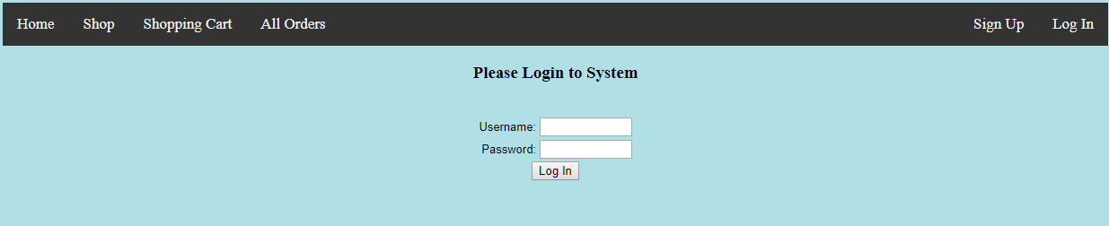

The Login menu allows the customer to enter their username and password to log into the website.

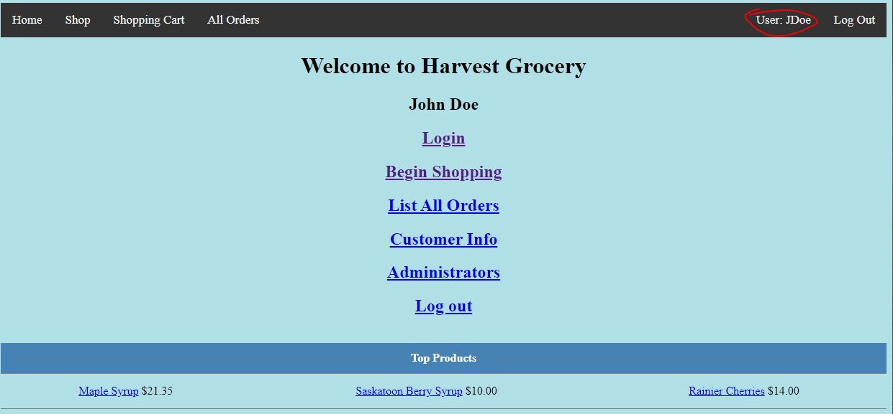

When a user is logged into the website their name is displayed in the navigation bar where the sign-up option was. In the event the user is logged in, pressing logout will cause the website to log them out, removing the customer’s access to the account until logged back in. Alternatively, if the user is not logged in, they will be taken to a new page that prompts them for their username and password. This page also allows for users without an account to create a new account. Attempting to login while logged in will display a notice that is already logged in.

### 2.2.1 Sign Up

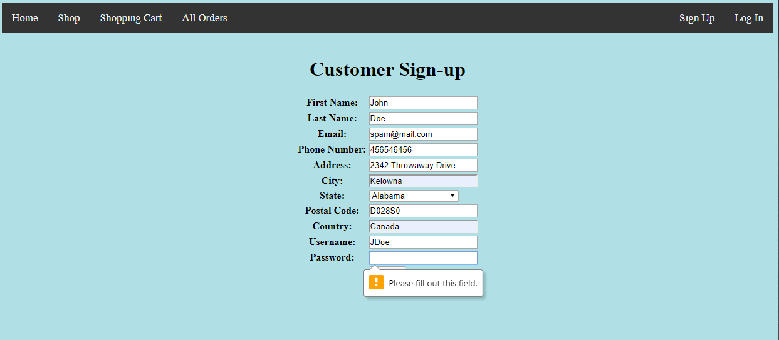

If the user wants to create a new account, they are redirected to another page that asks the user for all the required information to make an account. This information consists of a first and last name, email, phone number, address city, state, postal code, country, username and a password. When the user submits this information to create the account, it is first verified to contain valid information.

## 2.3 Products

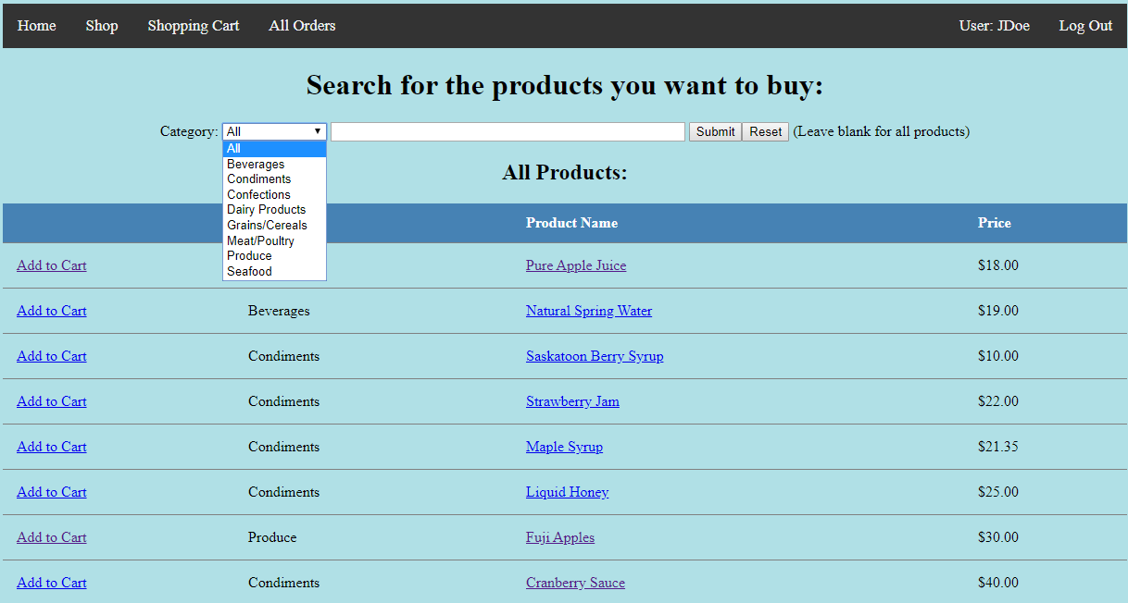

On the products page it is possible for the user to navigate the products by either scrolling through the list of available products or by filtering the products. The filtering options for the products are to search for a word or a phrase or by filtering the products based on their category. Both filtering methods can be used in conjunction to further narrow results. From this page it is also possible for the user to add the product to their cart.

### 2.3.1 Product Details

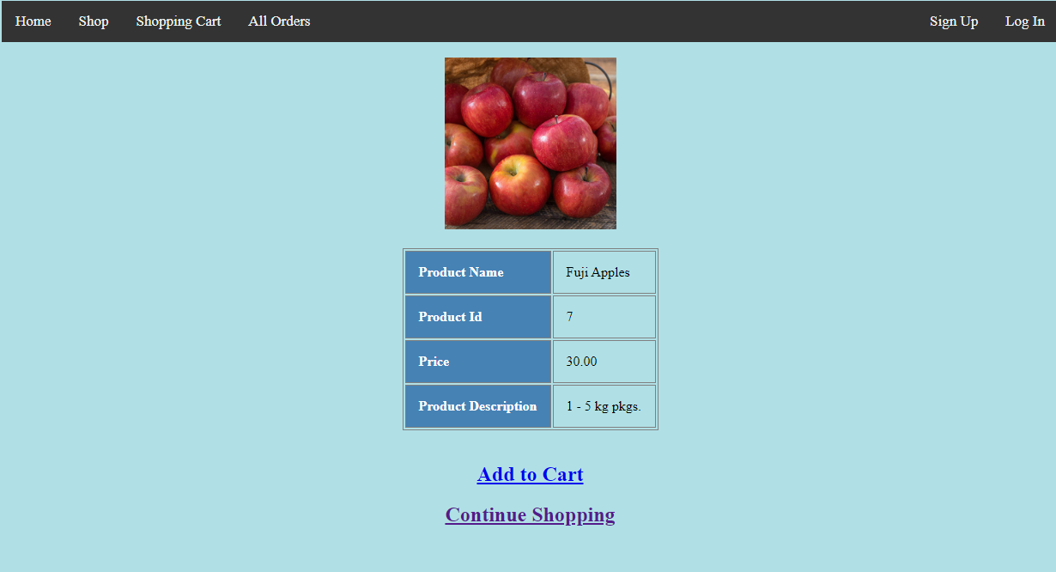

When a user wants a more details about the product, they can click on it to bring up details about it. This new page shows a picture of the product, along with a description to help the customer decide about the product. They can also add the product to the shopping cart or return to the product list from this page.

## 2.4 Shopping Cart

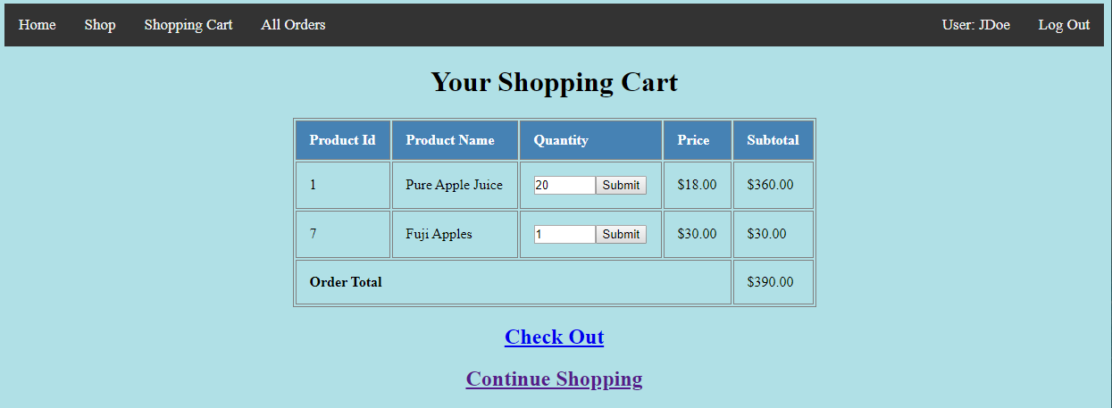

From this page it is possible to see all the items that you have added to your shopping cart. You can adjust the number for each item by changing the value in the quantity field and clicking “Submit” beside it. If you no longer want the item, you can remove it from the cart by changing the quantity to zero.

### 2.4.1. Check Out

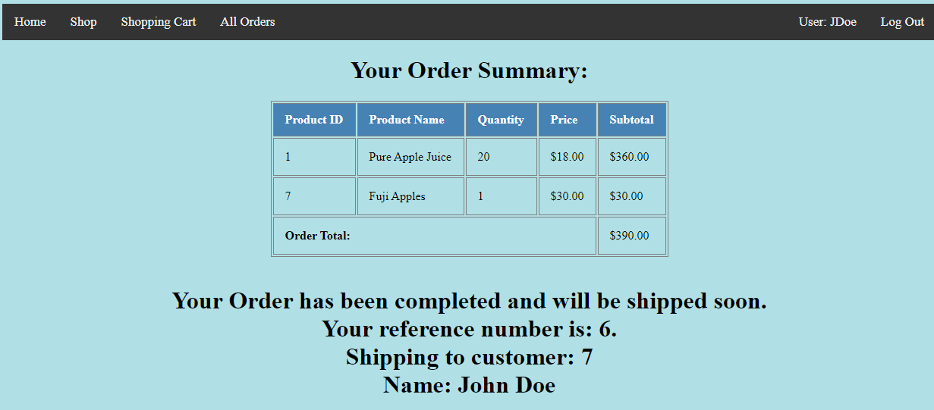

Once you are happy with the items in your shopping cart and choose to Check Out, the website uses the pre-stored payment and shipping address. With the order now placed you will receive an order summary showing all products, along with your name, order reference id and customer number.

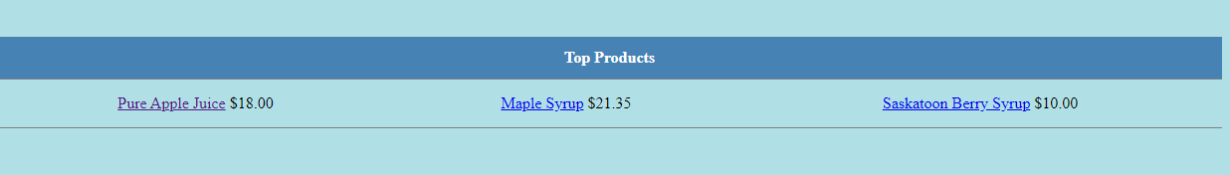

When an order contains a large quantity of a product, the “Top Products” on the Homepage will update to represent this change in popularity.

## 2.5 List All Orders

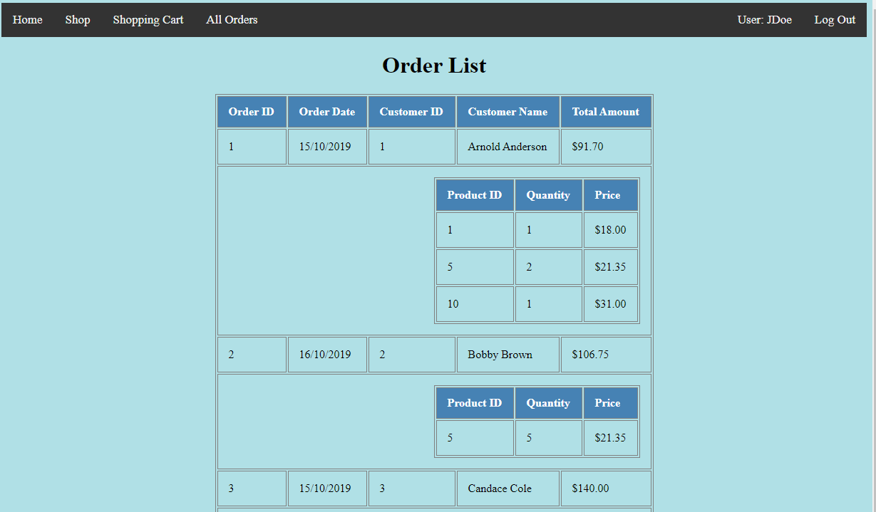

To help new customers find products that may interest them, we have chosen to let customers view a list of all orders. We hope that along with our “Top Products” this feature will help to showcase our wares.

## 2.6 Customer Information

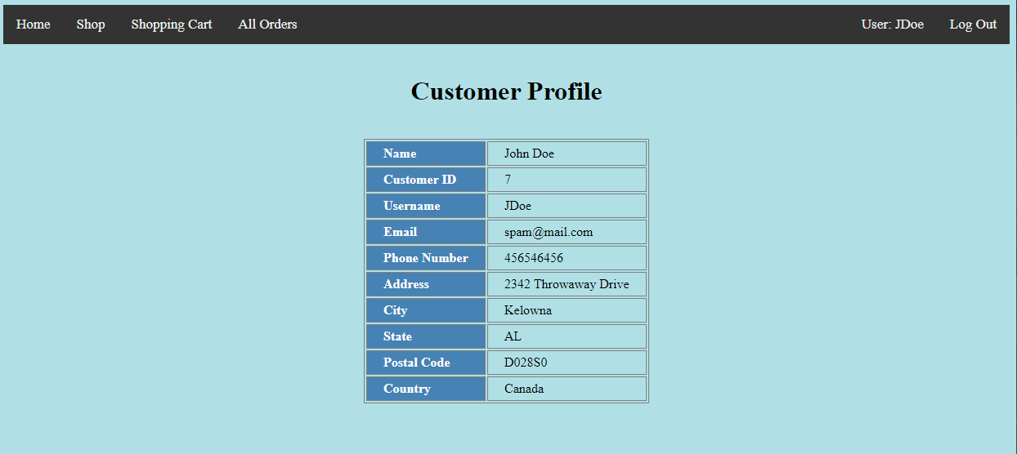

There are two ways for a customer to review their customer profile, by clicking on their username in the navigation bar or by selecting it from the homepage. Upon navigating to this page, the user can see all of the information that we have stored about them.

## 2.7 Administration

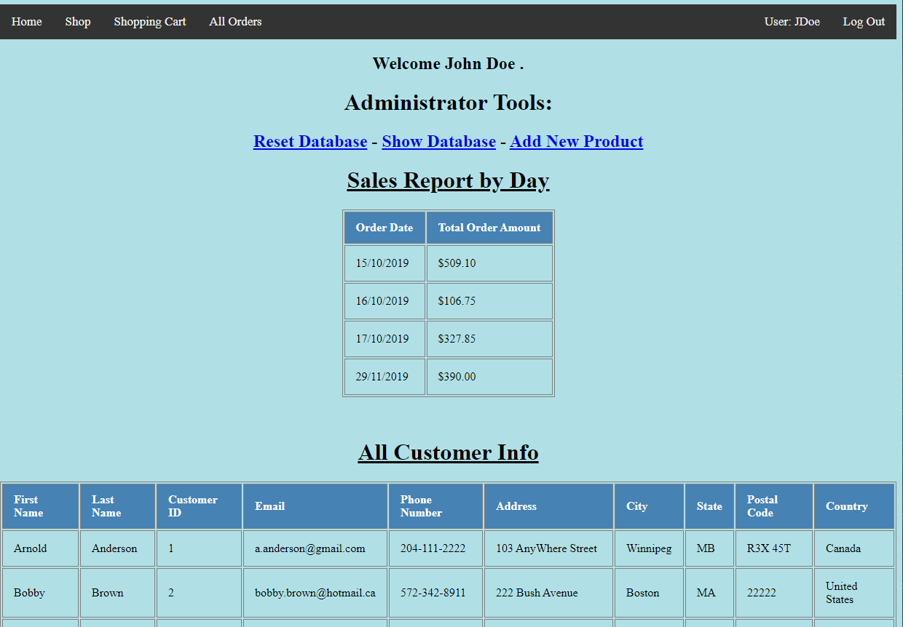

When a visitor to the website is an employee of the website, they are granted special administrator permissions upon logging in. These permissions allow for the employee to access a new portion of the website, the administration page.

### 2.7.1 Reset Database

Selecting to “Reset Database” removes all currently stored information and resets the database to a backup version found in orderdb_sql.ddl

### 2.7.2 Show Databases

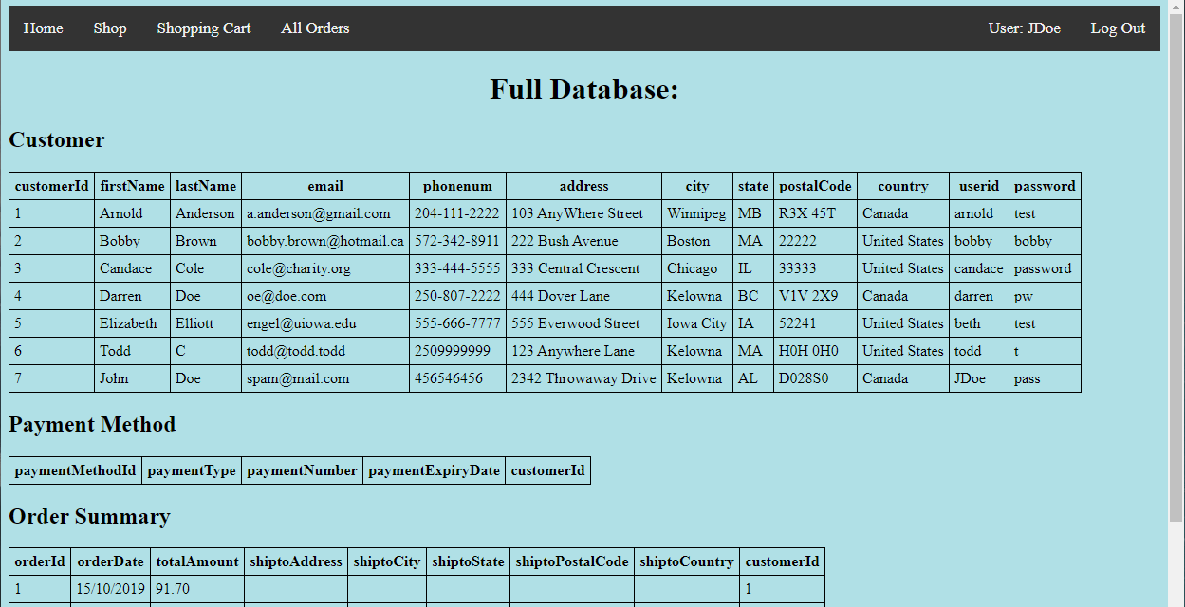

The “Show Database” option in the administrator tools displays all the currently existing databases and contents used by the website. These databases are Customer, Payment Method, Order Summary, Category, Product, Order Product, In Cart, Warehouse, Shipment, Product Inventory, and Review.

### 2.7.3 Add New Product

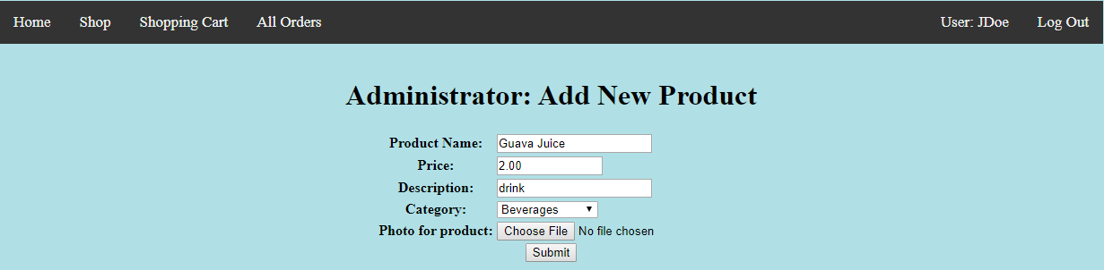

The “Add New Product” option in the administrator tools gives the administrator to add a new product to the product database. They are given a field to enter the product name, price, a brief description and to select a category for the item from the dropdown menu. Additionally, the administrator can optionally select a photo to display on the product page.

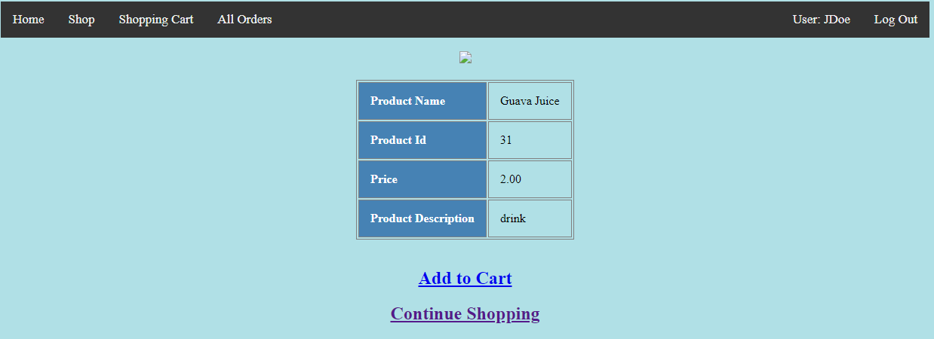

Once the new product is submitted, it appears in the product list and is available for purchase by customers.

# 3.0 System Features

Overall point count: 62

For a complete breakdown of points see below sections.

## 3.1 Documentation

|  |  |  |  |
| --- | --- | --- | --- |
| System Feature | Possible Points | Points | Comments/Code Files |
| Executive Summary | 2 | 2 | COSC304Documentation.docx |
| System Features | 2 | 2 | COSC304Documentation.docx |
| Walkthrough with screenshots | 6 | 6 | COSC304Documentation.docx |
| Total Points | | 10 |  |

## 3.2 Hosting

|  |  |  |  |
| --- | --- | --- | --- |
| System Feature | Possible Points | Points | Comments/Code Files |
| Running on Cosc304 or external server | 5 | 5 | Running on COSC304 |
| Total Points | | 5 |  |

## 3.3 Main/Home Page

|  |  |  |  |
| --- | --- | --- | --- |
| System Feature | Possible Points | Points | Comments/Code Files |
| Search for a product by name | 1 | 1 | listprod.php |
| Browse products by category | 1 | 1 | listprod.php |
| List products (by search/browse) | 1 | 1 | listprod.php |
| List products with image | 1 | 1 |  |
| Page header with menu | 1 | 2 | header.php |
| Page header shows currently logged in user | 1 | 2 | header.php |
| Dynamic products on page based on sales | 2 | 2 | index.php |
| Improved UI | 2 | 2 | header.php  index.php |
| Product recommnendation based on user | 4 | 4 | Based on users top purchased product and category. General top if not logged in |
| Total Points | | 14 |  |

## 3.4 Shopping Cart

|  |  |  |  |
| --- | --- | --- | --- |
| System Feature | Possible Points | Points | Comments/Code Files |
| Add to shopping cart | 1 | 1 | addcart.php |
| View shopping cart | 1 | 1 | showcart.php |
| Update quantity (with data validation) | 2 | 2 | addcart.php  showcart.php |
| Remove item from shopping cart | 1 | 1 | showcart.php |
| Total Points | | 5 |  |

## 3.5 Checkout

|  |  |  |  |
| --- | --- | --- | --- |
| System Feature | Possible Points | Points | Comments/Code Files |
| Checkout with customer id | 1 | 1 | checkout.php |
| Checkout with payment/shipment info | 2 | 2 | Must be logged in + sign up requires shipping info |
| Checkout with data validation | 2 | 2 | Must be logged in |
| Total Points | | 5 |  |

## 3.6 Product Detail Page

|  |  |  |  |
| --- | --- | --- | --- |
| System Feature | Possible Points | Points | Comments/Code Files |
| Product detail page and item description | 1 | 1 | product.php |
| Product detail page has an image | 1 | 1 | product.php |
| Product detail has an image from database | 1 | 1 | product.php |
| Total Points | | 3 |  |

## 3.7 User Accounts/Login

|  |  |  |  |
| --- | --- | --- | --- |
| System Feature | Possible Points | Points | Comments/Code Files |
| Create user account page | 3 | 3 | signup.php |
| Create account with data validation | 3 | 3 | signup.php |
| Edit a user account info (address/password) | 3 | 3 |  |
| Login/logout | 2 | 2 | login.php  logout.php |
| Total Points | | 11 |  |

## 3.8 Administrator Portal

|  |  |  |  |
| --- | --- | --- | --- |
| System Feature | Possible Points | Points | Comments/Code Files |
| Secured by login | 1 | 1 | auth.php |
| List all customers | 1 | 1 | admin.php |
| List report showing total sales/orders | 1 | 1 | admin.php |
| Add new product | 2 | 2 | newproduct.php |
| Upload a photo to file system for product | 2 | 2 | newproduct.php |
| Database restore with SQL script | 2 | 2 |  |
| Total Points | | 9 |  |

## 3.9 Database System/General

|  |  |  |  |
| --- | --- | --- | --- |
| System Feature | Possible Points | Points | Comments/Code Files |
| User interface and navigation/usability | 5 | 5 |  |
| Total Points | | 5 |  |