Make sure you have Microsoft Access downloaded, and then you just load our project in it.

How to use the app for finding deaths:

1. Double-click on 2020IllnessDeaths under “Forms” tab on the left.

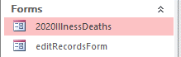

1. 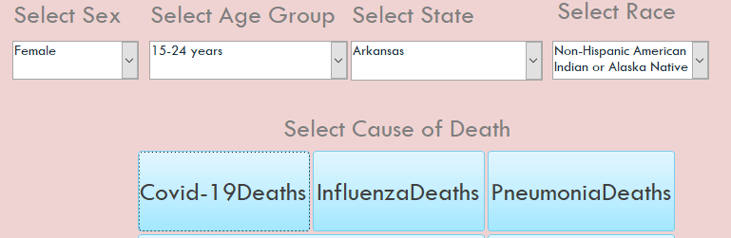In the form, you can select the sex, state, age group, and the race from the dropdown menu and then click on the corresponding cause of death button
2. 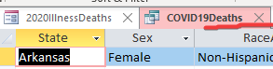After the query is done executing and the result is shown, in order to execute another query, you must close the current query tab on the top. If the form is not displaying after closing the results, simply click on the form again and go to form view.
3. 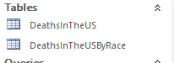If you want to look at the tables used in the queries, click on the tables under the “Tables” tab on the left.
4. 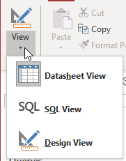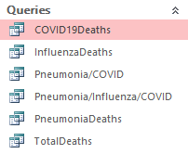If you want to see the queries written for the assignment, click on one of the queries under the “Queries” tab on the left. Then click on “View” on the top-left and click on “SQL View”.

How to edit existing records in the tables:

1. 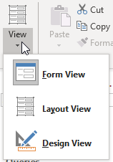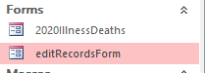Click on the form “editRecordsForm” under the “Forms” tab on the left and click “Form View” from “View” on the top-left.
2. 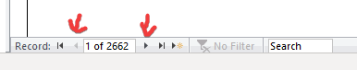To only edit an existing record, click the arrow buttons on the bottom to navigate through existing records. After doing so, edit the fields you want to edit and click on the “Save Record” button.
3. To create a new record for the table, make sure the “editRecordsForm” form is not open on the current tabs on the top. So if it was open like the picture: 

Make sure to close it. Afterwards, click on “addNewRecordMacro” under the “Macros” tab on the left.



A blank form should pop open and you would then type in the fields you want your new record to have. After you are done filling them in, click “Add new record” and “Save Record” in that order.

